At the onset of the project, a steering committee was set up to obtain advice on contextualizing the Food-EPI process to improve its implementation and relevance for Singapore. The steering committee comprised of academics who had expertise in the fields of policy and nutrition.
The overall process is summarized in Figure 1. 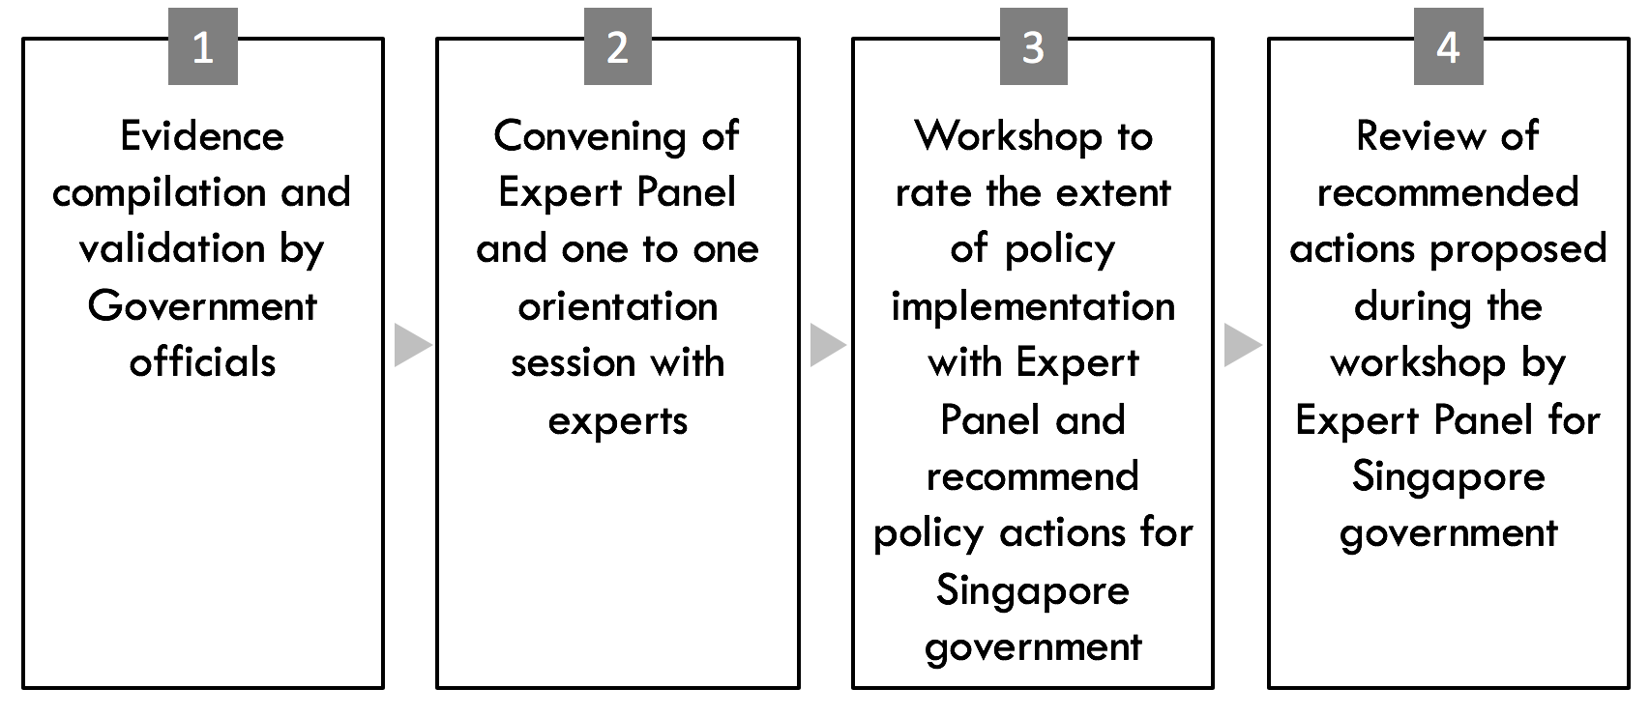
Figure 1 Study flow of the Singapore Food-EPI process, adapted from the INFORMAS Food-EPI process with an additional one-to-one orientation session.

Evidence compilation and validation by Government officials
Information on Singapore’s government actions and policies was compiled using publicly available, online information. Information sources generally included (i) government documents (press releases, governmental websites, parliamentary sessions, and budget speeches) and (ii) Singapore newspapers (TODAY and The Straits Times). These data were collected between May to December 2017. Prior to the full day workshop, information collected through personal communication (oral/email) with government officials was also included in the document. For the purpose of this study, government policies, actions and plans introduced from July 2016 onwards were included.
The evidence collected was sent to government officials in relevant ministries (Ministry of Health, Ministry of Social and Family Development, Ministry of Trade and Industry) and statutory boards (Health Promotion Board, Agri-food and Veterinary Authority, and SPRING Singapore) to verify its completeness and accuracy. Relevant input from the government officials were further incorporated into the evidence document. This process took place from May 2017 to March 2018. The document was shared with raters two weeks prior to the workshop.
Convening of Expert panel and one to one orientation sessions
An expert panel who represented the ‘public health nutrition community’ within Singapore was convened. Members of the expert panel had relevant expertise on the various areas of the food environment. The group included non-governmental public health and nutrition experts from academia, non-governmental organizations, and medical/professional associations. Persons working for the food industry or the government were excluded due to potential conflicts of interest. All experts who agreed to participate declared potential conflicts of interest and were given a 1-hour orientation session. In the orientation session, each expert was provided with the study background and the evidence for a policy domain to rate so as to facilitate familiarity with the rating process.
A total of 47 experts were invited to be part of the Food-EPI Singapore expert panel. Of these, 44 were eligible based on inclusion criteria. Reasons for ineligibility included working for the food industry (n=1), working overseas (n=1), and no longer working in a relevant field (n=1). Of those who were eligible, 21 provided informed consent and were oriented, and 20 participated in the full day workshop (1 was not able to participate due to medical reasons). Reasons for non-participation included (i) prior commitments (n=11), (ii) decline to participate (n=3) and (iii) did not respond to the invitation (n=9). Among the 20, 13 (65%) were academics, 4 (20%) were from non-governmental organizations and 3 (15%) were from medical/professional organizations.
Workshop to rate the extent of policy implementation with Expert Panel and recommend policy actions for Singapore government
The full day workshop was conducted in Singapore on 29 March 2018. All experts recruited were invited to participate in the workshop and government officials were invited as observers.
In the first half of the workshop, experts rated the current level of government policy implementation in Singapore against international best practices using a Likert scale from 1 to 10 (1 being ‘very little, if any’ implementation and 10 being ‘high’ implementation as compared with the benchmarks). When rating, experts were told to consider the various steps of the policy cycle. This included intention and plans of the government, such as the establishment of working and advisory groups, as well as government funding for implementation of actions. Differences in how the panel members interpreted the evidence presented may have introduced subjectivity. We addressed this by clarifying that assessment of the level of implementation should be based on documented evidence. However, it is possible that participants considered other information, based on personal and professional experiences, during their assessments.
Following the rating session, the median rating scores for all 47 indicators were provided to both experts and government observers. The expert panel was then asked to select up to 10 indicators to prioritize for further discussion on recommended actions. In selecting indicators, participants were asked to consider (i) the implementation gap identified from the rating session (ii) indicator areas that are viewed as being currently important and (iii) actions perceived to be feasible to implement by the Singapore government in the near future.
Review of recommended actions proposed during the workshop by Expert Panel for Singapore government
Discussions were audio recorded, transcribed, and all proposed actions were compiled and sent to the expert panel for review. Changes suggested by the expert panel were incorporated into the action list. A report (available online) detailing the rating results and recommended actions was shared with government officials who were invited as observers.

