**Supplemental Figure 1.** Screen shot of the ‘zoom in’ feature used in the online tasks to increase legibility of the FOP labels

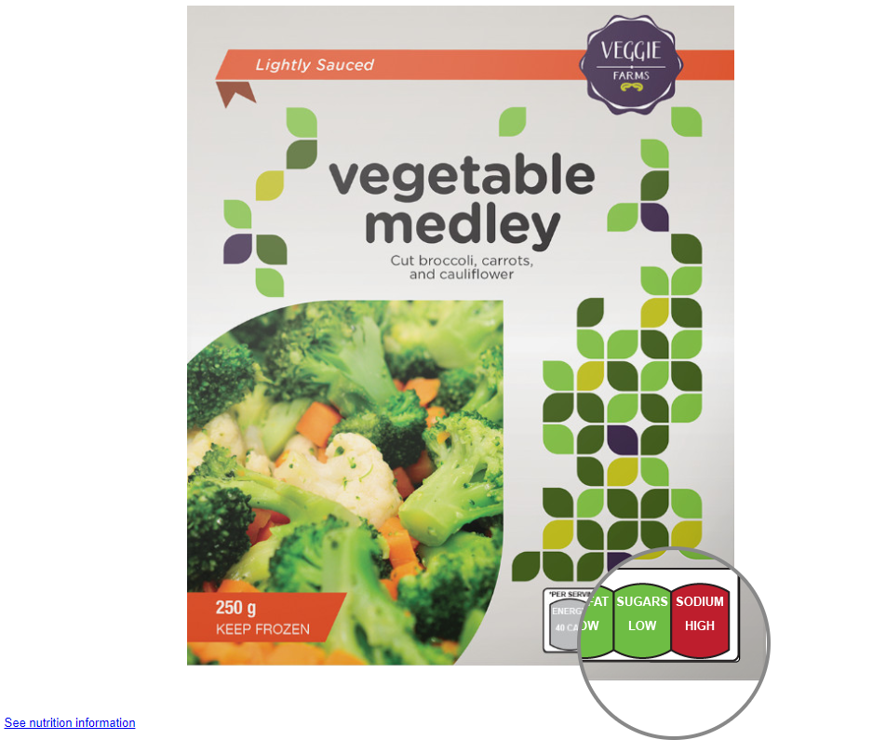

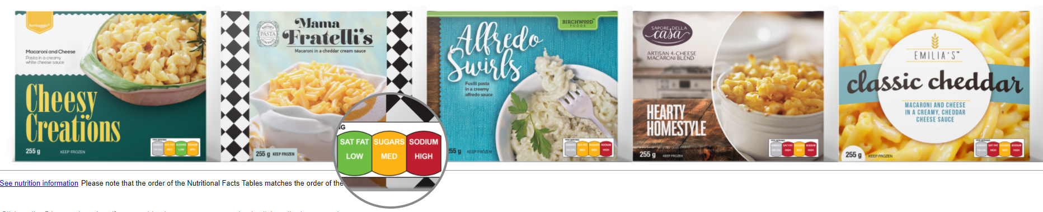

**Supplemental Figure 2.** Examples of the smartphone application images used in the educational task for the a) control\* b) ‘high in’ warning label (WL), c) traffic light label (TLL) and d) Health star rating (HSR)

**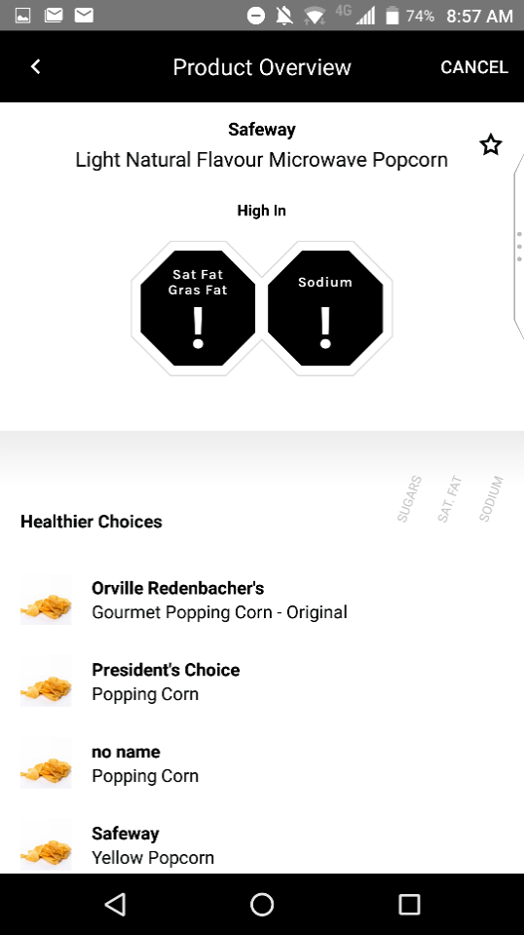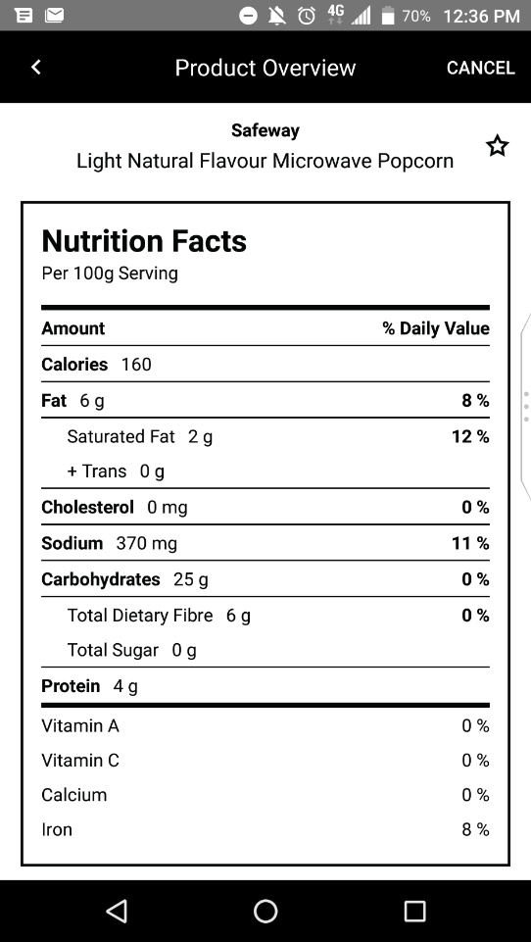**

b)

a)

**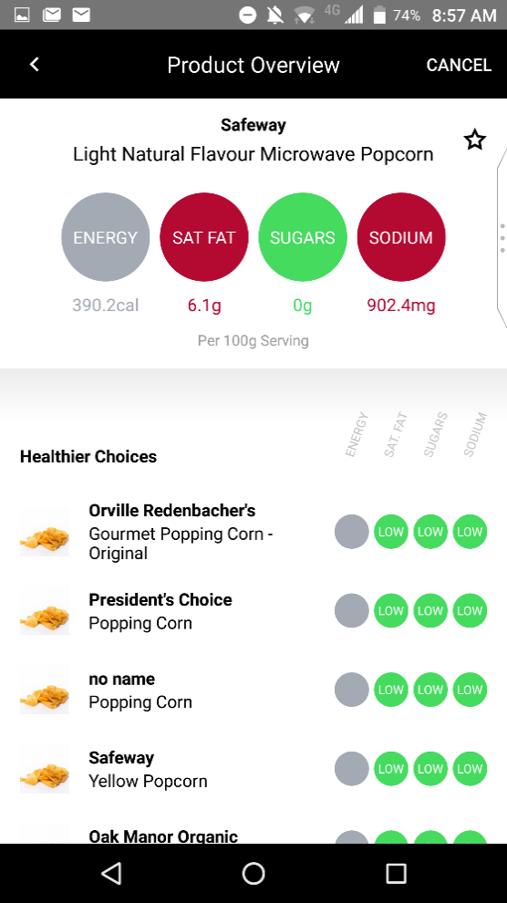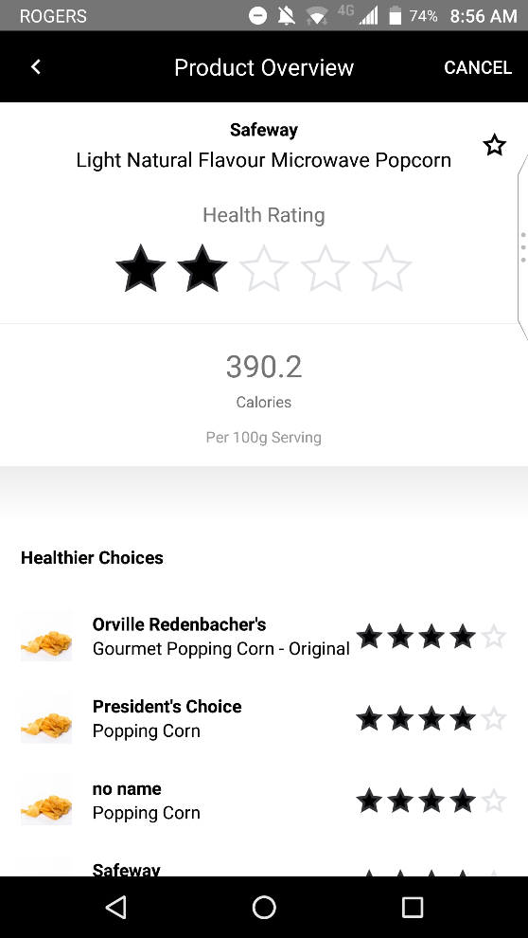**

c)

\*Participants were shown the NFT image for the purposes of the the education session only, and were not shown any interpretive FOP labelling in the experimental tasks. In all conditions, participants were able to click on supplementary nutritional information and view the NFT in the experimental tasks.

d)

**Supplemental Figure 3**. Task 1 – Identifying the relative healthiness of food product packages and the FOP labels for each of the systems. No FOP labels were shown in the control condition

|  |  |  |  |  |
| --- | --- | --- | --- | --- |
|  | **Package image** | **‘High in’ warning labels (WL)** | **Health star rating (HSR)** | **Traffic light labels (TLL)** |
| **HEALTHIER GRANOLA BAR** | C:\Users\Room 87\Desktop\Angela\Final PNG Files\1. Granola\Granola.control.healthy.png | **NO SYMBOL** |  | C:\Users\l2vander\AppData\Local\Microsoft\Windows\INetCache\Content.Word\granola healthy.png |
| **LESS HEALTHY GRANOLA BAR** |  |  | **C:\Users\l2vander\AppData\Local\Microsoft\Windows\INetCache\Content.Word\granola less healthy.png** |
| **HEALTHIER PIZZA** |  | **NO SYMBOL** |  | pizza healthy |
| **LESS HEALTHY PIZZA** |  |  | pizza unhealthy |
| **HEALTHIER VEGETABLES IN SAUCE** |  | **NO SYMBOL** |  | veggie healthy |
| **LESS HEALTHY VEGETABLES IN SAUCE** |  |  | veggie unhealthy |
| **HEALTHIER CANNED SOUP** |  | **NO SYMBOL** |  | soup healthy |
| **LESS HEALTHY CANNED SOUP** |  |  | sopu unhealthy |

**Supplemental Figure 4.** Nutritional information and Nutrition Facts tables shown for Task 1 products.

|  |  |  |
| --- | --- | --- |
| **Product category** | **Less Healthy Product** | **Healthier product** |
| C:\Users\Room 87\Desktop\Angela\Final PNG Files\1. Granola\Granola.control.healthy.png | E:\Angela PNG files\1. Granola\NFT.cereal.lesshealthy.png | E:\Angela PNG files\1. Granola\NFT.cereal.healthy.png |
|  | E:\Angela PNG files\2. Pizza\NFT.Pizza.lesshealthy.png | E:\Angela PNG files\2. Pizza\NFT.Pizza.healthy.png |
|  | E:\Angela PNG files\3. Vegetable\NFt.veggie.lesshealthy.png | E:\Angela PNG files\3. Vegetable\NFt.veggie.healthy.png |
|  | E:\Angela PNG files\4. Soup can\NFT.soupcan.lesshealthy.png | E:\Angela PNG files\4. Soup can\NFT.soupcan.healthy.png |

**Supplemental Figure 4.** Nutritional information and Nutrition Facts tables shown for Task 2 products.

**CEREAL**

|  |  |  |  |  |
| --- | --- | --- | --- | --- |
| C:\Users\lanav\AppData\Local\Microsoft\Windows\INetCache\Content.Word\NFT.cereal.1.png | C:\Users\lanav\AppData\Local\Microsoft\Windows\INetCache\Content.Word\NFT.cereal.5.png | C:\Users\lanav\AppData\Local\Microsoft\Windows\INetCache\Content.Word\NFT.cereal.3.png | C:\Users\lanav\AppData\Local\Microsoft\Windows\INetCache\Content.Word\NFT.cereal.4.png | C:\Users\lanav\AppData\Local\Microsoft\Windows\INetCache\Content.Word\NFT.cereal.2.png |
| C:\Users\lanav\Dropbox\FOP images\U of T HSF FOP study\Final FOP files\Z.Original Files from Accurate\Final FOP designs\17-183_Star-Rating_4.png | C:\Users\lanav\Dropbox\FOP images\U of T HSF FOP study\Final FOP files\Z.Original Files from Accurate\Final FOP designs\17-183_Star-Rating_2_half.png | C:\Users\lanav\Dropbox\FOP images\U of T HSF FOP study\Final FOP files\Z.Original Files from Accurate\Final FOP designs\17-183_Star-Rating_1_half.png | C:\Users\lanav\Dropbox\FOP images\U of T HSF FOP study\Final FOP files\Z.Original Files from Accurate\Final FOP designs\17-183_Star-Rating_2.png | C:\Users\lanav\Dropbox\FOP images\U of T HSF FOP study\Final FOP files\Z.Original Files from Accurate\Final FOP designs\17-183_Star-Rating_3_half.png |
| C:\Users\lanav\Dropbox\FOP images\U of T HSF FOP study\Final FOP files\Z.Working Files\Traffic light AI files\Individual Cereal Files\cereal.1st.png | C:\Users\lanav\Dropbox\FOP images\U of T HSF FOP study\Final FOP files\Z.Working Files\Traffic light AI files\Individual Cereal Files\cereal.3rd.png | C:\Users\lanav\Dropbox\FOP images\U of T HSF FOP study\Final FOP files\Z.Working Files\Traffic light AI files\Individual Cereal Files\cereal.5th.png | C:\Users\lanav\Dropbox\FOP images\U of T HSF FOP study\Final FOP files\Z.Working Files\Traffic light AI files\Individual Cereal Files\cereal.4th.png | C:\Users\lanav\Dropbox\FOP images\U of T HSF FOP study\Final FOP files\Z.Working Files\Traffic light AI files\Individual Cereal Files\cereal.2nd.png |
| **NO WARNINGS** | C:\Users\lanav\Dropbox\FOP images\U of T HSF FOP study\Final FOP files\Z.Original Files from Accurate\Final FOP designs\17-183_Warning_F.png | C:\Users\lanav\Dropbox\FOP images\U of T HSF FOP study\Final FOP files\Z.Original Files from Accurate\Final FOP designs\17-183_Warning_FSu.png | C:\Users\lanav\Dropbox\FOP images\U of T HSF FOP study\Final FOP files\Z.Original Files from Accurate\Final FOP designs\17-183_Warning_SS.png | C:\Users\lanav\Dropbox\FOP images\U of T HSF FOP study\Final FOP files\Z.Original Files from Accurate\Final FOP designs\17-183_Warning_Sugar.png |

**YOGURT\***

|  |  |  |  |  |
| --- | --- | --- | --- | --- |
| **C:\Users\lanav\AppData\Local\Microsoft\Windows\INetCache\Content.Word\Nft.yogurt.1.png** | C:\Users\lanav\Dropbox\FOP images\U of T HSF FOP study\Final FOP files\Z.Working Files\Section E.2.Yogurt\Nft.yogurt.4.png | C:\Users\lanav\AppData\Local\Microsoft\Windows\INetCache\Content.Word\Nft.yogurt.2.png | C:\Users\lanav\Dropbox\FOP images\U of T HSF FOP study\Final FOP files\Z.Working Files\Section E.2.Yogurt\Nft.yogurt.3.png | C:\Users\lanav\Dropbox\FOP images\U of T HSF FOP study\Final FOP files\Z.Working Files\Section E.2.Yogurt\Nft.yogurt.5.png |
| C:\Users\lanav\AppData\Local\Microsoft\Windows\INetCache\Content.Word\17-183_Star-Rating_5.png | C:\Users\lanav\Dropbox\FOP images\U of T HSF FOP study\Final FOP files\Z.Original Files from Accurate\Final FOP designs\17-183_Star-Rating_2_half.png | C:\Users\lanav\Dropbox\FOP images\U of T HSF FOP study\Final FOP files\Z.Original Files from Accurate\Final FOP designs\17-183_Star-Rating_4.png | C:\Users\lanav\Dropbox\FOP images\U of T HSF FOP study\Final FOP files\Z.Original Files from Accurate\Final FOP designs\17-183_Star-Rating_3_half.png | C:\Users\lanav\Dropbox\FOP images\U of T HSF FOP study\Final FOP files\Z.Original Files from Accurate\Final FOP designs\17-183_Star-Rating_half.png |
| C:\Users\lanav\AppData\Local\Microsoft\Windows\INetCache\Content.Word\yogurt.ggg.png | C:\Users\lanav\Dropbox\FOP images\yogurt.rag.png | C:\Users\lanav\Dropbox\FOP images\yogurt.gag.png | C:\Users\lanav\Dropbox\FOP images\yogurt.gag.png | C:\Users\lanav\Dropbox\FOP images\yogurt.rrg.png |
| **NO WARNINGS** | C:\Users\lanav\Dropbox\FOP images\U of T HSF FOP study\Final FOP files\Z.Original Files from Accurate\Final FOP designs\17-183_Warning_FSu.png | C:\Users\lanav\Dropbox\FOP images\U of T HSF FOP study\Final FOP files\Z.Original Files from Accurate\Final FOP designs\17-183_Warning_Sugar.png | C:\Users\lanav\Dropbox\FOP images\U of T HSF FOP study\Final FOP files\Z.Original Files from Accurate\Final FOP designs\17-183_Warning_Sugar.png | C:\Users\lanav\Dropbox\FOP images\U of T HSF FOP study\Final FOP files\Z.Original Files from Accurate\Final FOP designs\17-183_Warning_FSu.png |

\*Given that the different types of yogurt contained different berries (blackberry, blueberry, raspberry, strawberry and fieldberry), the ingredients list for each fruit type did not vary in the randomizations of NFT information. Ingredients lists not shown.

**PASTA**

|  |  |  |  |  |
| --- | --- | --- | --- | --- |
| C:\Users\lanav\Dropbox\FOP images\U of T HSF FOP study\Final FOP files\Z.Working Files\Section E.3.Pasta\NFt.pasta.5.png | C:\Users\lanav\Dropbox\FOP images\U of T HSF FOP study\Final FOP files\Z.Working Files\Section E.3.Pasta\NFt.pasta.2.png | C:\Users\lanav\Dropbox\FOP images\U of T HSF FOP study\Final FOP files\Z.Working Files\Section E.3.Pasta\NFt.pasta.1.png | C:\Users\lanav\Dropbox\FOP images\U of T HSF FOP study\Final FOP files\Z.Working Files\Section E.3.Pasta\NFt.pasta.4.png | C:\Users\lanav\Dropbox\FOP images\U of T HSF FOP study\Final FOP files\Z.Working Files\Section E.3.Pasta\NFt.pasta.3.png |
| C:\Users\lanav\Dropbox\FOP images\U of T HSF FOP study\Final FOP files\Z.Original Files from Accurate\Final FOP designs\17-183_Star-Rating_half.png | C:\Users\lanav\Dropbox\FOP images\U of T HSF FOP study\Final FOP files\Z.Original Files from Accurate\Final FOP designs\17-183_Star-Rating_2.png | C:\Users\lanav\Dropbox\FOP images\U of T HSF FOP study\Final FOP files\Z.Original Files from Accurate\Final FOP designs\17-183_Star-Rating_4.png | C:\Users\lanav\Dropbox\FOP images\U of T HSF FOP study\Final FOP files\Z.Original Files from Accurate\Final FOP designs\17-183_Star-Rating_1.png | C:\Users\lanav\Dropbox\FOP images\U of T HSF FOP study\Final FOP files\Z.Original Files from Accurate\Final FOP designs\17-183_Star-Rating_1_half.png |
| C:\Users\lanav\Dropbox\FOP images\U of T HSF FOP study\Final FOP files\Z.Working Files\Section E.3.Pasta\Individual Pasta packages\5th.png | C:\Users\lanav\Dropbox\FOP images\U of T HSF FOP study\Final FOP files\Z.Working Files\Section E.3.Pasta\Individual Pasta packages\2nd.png | C:\Users\lanav\Dropbox\FOP images\U of T HSF FOP study\Final FOP files\Z.Working Files\Section E.3.Pasta\Individual Pasta packages\1st.png | C:\Users\lanav\Dropbox\FOP images\U of T HSF FOP study\Final FOP files\Z.Working Files\Section E.3.Pasta\Individual Pasta packages\4th.png | C:\Users\lanav\Dropbox\FOP images\U of T HSF FOP study\Final FOP files\Z.Working Files\Section E.3.Pasta\Individual Pasta packages\3rd.png |
| **C:\Users\lanav\Dropbox\FOP images\U of T HSF FOP study\Final FOP files\Z.Original Files from Accurate\Final FOP designs\17-183_Warning_FSo.png** | C:\Users\lanav\Dropbox\FOP images\U of T HSF FOP study\Final FOP files\Z.Original Files from Accurate\Final FOP designs\17-183_Warning_Sodium.png | **NO WARNINGS** | C:\Users\lanav\Dropbox\FOP images\U of T HSF FOP study\Final FOP files\Z.Original Files from Accurate\Final FOP designs\17-183_Warning_FSo.png | C:\Users\lanav\Dropbox\FOP images\U of T HSF FOP study\Final FOP files\Z.Original Files from Accurate\Final FOP designs\17-183_Warning_Sodium.png |

**Supplementary Figure 5.** Study flow diagram**.**

**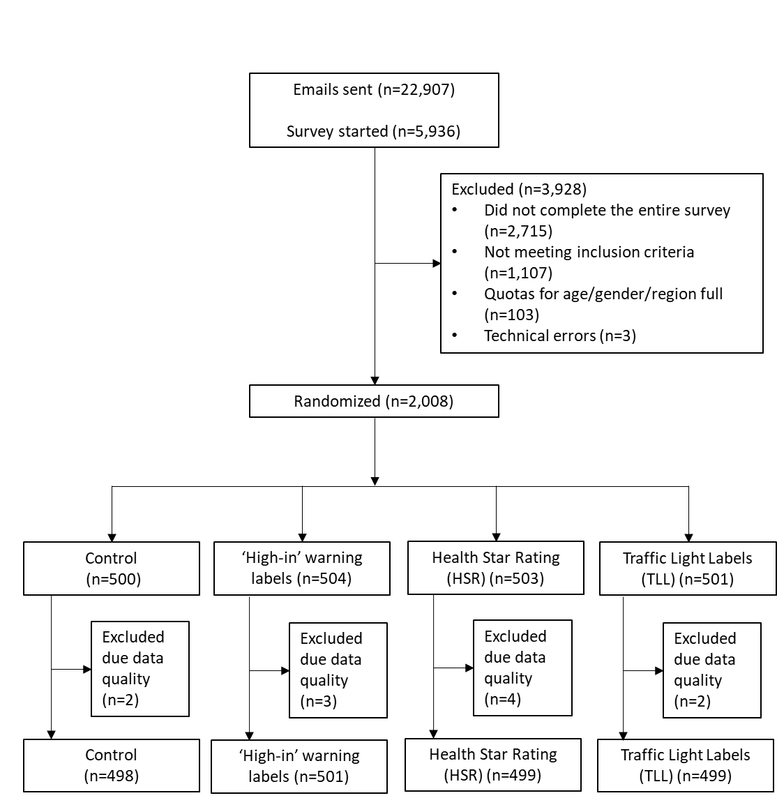**

**Supplemental Figure 6a and b.** Task 1 - Ratings of perceived healthiness and intention to purchase each of the food products stratified by low or adequate health literacy.

**6a. Perceived healthiness**

\*

\*

\*

\*

\*

\*

*Significant differences between those with low and adequate health literacy within product category are denoted by an asterisk (\*) in adjusted linear regression models, including a variable for FOP labelling condition and health literacy and adjusted for gender, income, education, BMI, ethnicity, and nutrition label use.*

**6b. Intention to purchase**

\*

\*

\*

\*

\*

\*

\*

\*

*Significant differences between those with low and adequate health literacy within product category are denoted by an asterisk (\*) in adjusted linear regression models, including a variable for FOP labelling condition and health literacy and adjusted for gender, income, education, BMI, ethnicity, and nutrition label use.*

**Supplemental Figure 7.** Task 2 - Mean number of correct responses in the ranking task for each food product (cereal, yogurt and pasta) according to level of health literacy.

**Supplemental Figure 8.** Percentage of participants that clicked on the link to access the Nutrition Facts table during Task 1 and Task 2.

b

b

b

a

c

b,c

b

a

Values not sharing a common superscript are significantly different (p<0.05).