Supplementary Material

Table S1. Description of breakfast food groups, food group contents and prevalence of consumers according to age group and BQI category. Sao Paulo, 2015.

Group | Content examples | Total population |  | Adults |  | Older Adults |  | Low BQI |  | Medium BQI |  | High BQI
 |  | % | SE | % | SE | % | SE | % | SE | % | SE | % | SE
Alcoholic beverages | Fermented and distilled alcoholic beverages | 0.27 | 0.00 | 0.24 | 0.00 | 0.24 | 0.00 | 0.29 | 0.00 | 0.33 | 0.00 | . | .
Breakfast cereals | Oatmeal, granola, corn flakes | 2.57 | 0.01 | 2.39 | 0.01 | 0.03 | 0.01 | 0.49 | 0.00 | 1.53 | 0.00 | 8.94 | 0.03
Butter and margarine | Butter and margarine | 43.43 | 0.02 | 42.91 | 0.02 | 44.63 | 0.02 | 35.73 | 0.03 | 48.53 | 0.02 | 30.38 | 0.04
Cakes | Cakes with or without topping and filling | 3.13 | 0.01 | 3.12 | 0.01 | 3.15 | 0.01 | 3.06 | 0.01 | 3.45 | 0.01 | 1.90 | 0.01
Coffee | Powder, instant, brewed coffee | 74.14 | 0.02 | 70.01 | 0.02 | 83.51 | 0.02 | 79.39 | 0.04 | 74.95 | 0.02 | 65.53 | 0.04
Cold cuts | Ham, salami, turkey ham | 6.01 | 0.01 | 6.57 | 0.01 | 4.75 | 0.01 | 6.13 | 0.02 | 5.62 | 0.01 | 7.50 | 0.02
Fruit drinks and sodas | Ready-to-drink or powder juices, regular or diet sodas | 2.77 | 0.01 | 3.64 | 0.01 | 0.78 | 0.00 | 7.43 | 0.02 | 2.30 | 0.01 | . | .
Dairy products | Cheeses, yogurt, cheese spread, cream cheese | 20.60 | 0.01 | 17.45 | 0.02 | 27.75 | 0.02 | 3.44 | 0.01 | 18.80 | 0.02 | 45.24 | 0.05
Eggs | Boiled, fried, scrambled eggs | 0.02 | 0.04 | 2.54 | 0.01 | 1.38 | 0.00 | 3.07 | 0.02 | 1.61 | 0.01 | 3.66 | 0.01
Flavored powder juices | Flavored powders or ready-to-drink beverages | 5.13 | 0.01 | 6.52 | 0.01 | 1.98 | 0.01 | 0.91 | 0.01 | 6.42 | 0.01 | 4.11 | 0.01
100% Fruit juices and smoothies | Lemonade, pineapple, strawberry juices or smoothies | 4.83 | 0.01 | 4.86 | 0.01 | 4.74 | 0.01 | . | . | 3.54 | 0.01 | 14.93 | 0.04
Fruits | Fresh fruits | 14.86 | 0.01 | 11.74 | 0.02 | 21.95 | 0.02 | . | . | 8.69 | 0.01 | 55.05 | 0.04
Meats | Fresh red or white meats | 0.76 | 0.00 | 0.71 | 0.00 | 0.90 | 0.00 | 1.92 | 0.01 | 0.50 | 0.00 | 0.70 | 0.01
Milk | Whole, low-fat or non-fat milk | 56.39 | 0.02 | 52.89 | 0.02 | 64.35 | 0.02 | 18.59 | 0.04 | 61.89 | 0.02 | 71.94 | 0.04
Nuts and seeds | Brazilian nuts, cashew nuts, chia seed, peanuts | 0.87 | 0.00 | 0.36 | 0.00 | 2.03 | 0.01 | 0.26 | 0.00 | 0.68 | 0.00 | 2.28 | 0.01
Others | Formulas, coconut milk, tapioca, dips, spices | 8.55 | 0.01 | 9.14 | 0.01 | 9.15 | 0.01 | 9.79 | 0.03 | 7.36 | 0.01 | 12.18 | 0.02
Savory snacks and pizza | Fried or baked pastries, e.g. "esfiha", "coxinha", croissant, cheese bread, pizza | 3.70 | 0.01 | 4.87 | 0.01 | 1.03 | 0.00 | 0.02 | 0.01 | 3.65 | 0.01 | 5.57 | 0.02
Sugar, honey and jam | Added sugar, white or brown sugar, honey, jams | 53.66 | 0.02 | 0.56 | 0.03 | 46.59 | 0.03 | 71.09 | 0.04 | 54.81 | 0.02 | 31.47 | 0.04
Sweeteners | Liquid or powder sweeteners | 16.35 | 0.01 | 10.72 | 0.01 | 29.16 | 0.02 | 9.88 | 0.03 | 14.89 | 0.01 | 28.85 | 0.04
Sweets and candies | Chocolate, cookies, puddings, candies | 2.50 | 0.01 | 3.11 | 0.01 | 1.27 | 0.01 | 2.02 | 0.01 | 2.95 | 0.01 | 1.44 | 0.01
Tea | Herbal, black tea | 3.64 | 0.01 | 3.57 | 0.01 | 3.81 | 0.01 | 5.19 | 0.02 | 3.05 | 0.01 | 4.52 | 0.02
Typical lunch dishes | Black and Pinto beans, white and brown rice, pasta | 0.99 | 0.00 | 0.88 | 0.00 | 1.25 | 0.005 | 1.58 | 0.01 | 0.1 | 0.00 | 0.56 | 0.04
Vegetables | Broccoli, kale, tomato, potato | 1.47 | 0.00 | 0.99 | 0.00 | 2.57 | 0.01 | . | . | 0.76 | 0.00 | 5.89 | 0.02
White bread and crackers | White bread and crackers | 71.18 | 0.02 | 71.95 | 0.02 | 69.44 | 0.02 | 52.50 | 0.04 | 76.33 | 0.02 | 68.99 | 0.04
Whole wheat bread and crackers | Whole wheat bread and crackers | 6.00 | 0.01 | 3.85 | 0.01 | 10.89 | 2.00 | 0.94 | 0.01 | 5.05 | 0.01 | 15.03 | 0.03

Abbreviations: BQI, Brazilian Breakfast Quality Index; SE, Standard Error.
Missing values: no observations

Figure S1 – Percentage of energy contribution (%) of foods groups to breakfast in the ISA-Nutrition according to (a) age group and (b) BQI category.

(a)
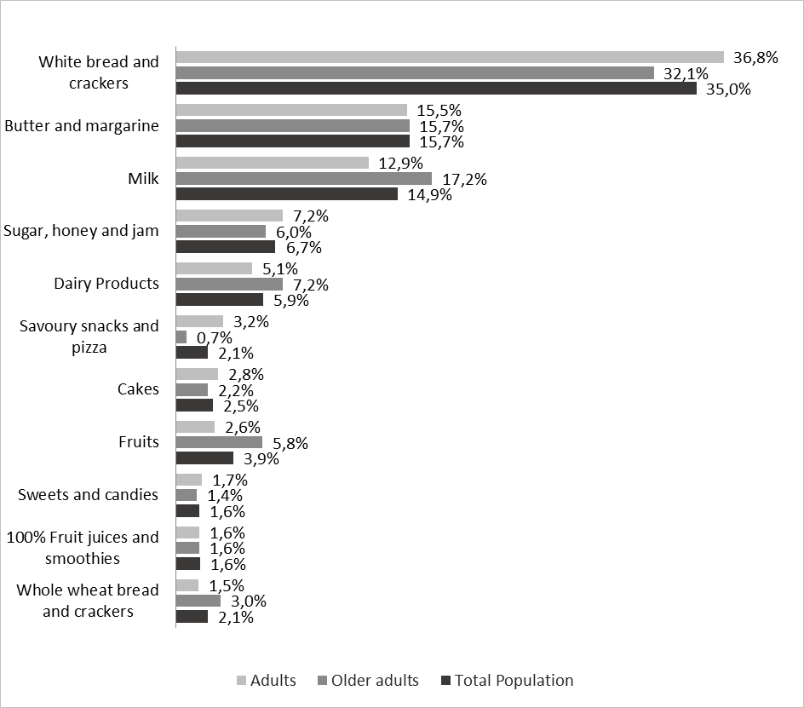

(b) 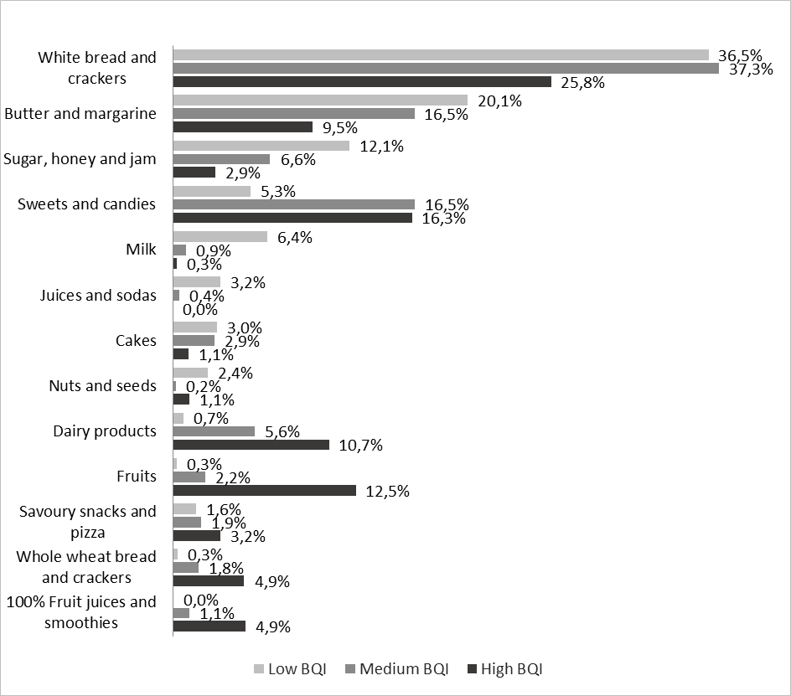
Abbreviation: BQI, Brazilian Breakfast Quality Index

