Supplemental file 1 Monitoring Availability, Placement and Promotion – Supermarkets (MAPP-S) Audit Tool (developed for this study).

- Store details
1a. Supermarket chain (circle one): Aldi Coles Woolworths Independent (specify store name): _____________________________
1b. Supermarket address: _____________________________________________________________________________________________________
1c. Auditor name: ____________________________ 1d. Date of audit:__________________ 1e. Start time:__________ 1f. Finish time:___________
1g. Store manager notified of data collection (circle one)? Yes / No
1h. Name of manager providing consent (Independents only): ________________________________________________________________________
1i. Total supermarket floor perimeter: ____________________ (metres (m))

- Shelf-space of selected healthy and unhealthy food
2a. Frozen products
- Frozen aisle/freezer containing frozen fruit shelf length _____________ x height_____________(m)
- Frozen aisle/freezer containing frozen vegetables shelf length _____________ x height^{ii}_____________(m)
- Frozen aisle/freezer containing ice cream shelf length _____________ x height^{ii}_____________(m)

2b. Fresh fruit and vegetables
- Refrigerated /chilled section containing fresh fruit and vegetables= shelf length _____________ x height^{ii}_____________(m)
- Display bins for fresh fruit and vegetables:
Bin no. | Length (m) | Width (m) |  | Bin no. | Length (m) | Width (m)
1 |  |  |  | 7
2 |  |  |  | 8
3 |  |  |  | 9
4 |  |  |  | 10
5 |  |  |  | 11
6 |  |  |  | 12

Free fruit available for children: Y / N
2c. Selected discretionary products
- Chocolate and confectionery: shelf length _____________ x height_____________(m)
- Chips, pretzels, popcorn (incl. multipacks): shelf length _____________ x height²_____________(m) *Check other aisles eg. Health Food aisle.
- Sweet biscuits: shelf length _____________ x height²_____________(m)
- Soft drinks and energy drinks: length __________ x height^{ii}__________(m) Sports drinks and iced tea length __________ x height^{ii}__________(m)

3. End-of-aisle (EOA) displays (See Addendum A for examples of EOA displays)
3a. EOA - FRONT (located directly opposite the front of the store / checkouts)
Aisle no. | Left wing of EOA - Front (record broad product type, including non-food) | Estimated % of space the product takes up in display | Price promotion type (1-9)  See price promotions (Addendum B) | Centre (main) section of EOA – Front (record broad product type, including non-food) | Estimated % of space the product takes up in display | Price promotion type (1-9)  See price promotions (Addendum B) | Right wing of EOA - Front  (record broad product type, including non-food) | Estimated % of space the product takes up in display | Price promotion type (1-9)  See price promotions (Addendum B)
3b. EOA - OTHER (EOA located anyway except opposite front of store, including rear of store or in the middle of store where aisles are separated)
Aisle no. | Left wing of EOA – Other (record broad product type, including non-food) | Estimated % of space the product takes up in display | Price promotion type (1-9)  See price promotions (Addendum B) | Centre (main) section of EOA - Other (record broad product type, including non-food) | Estimated % of space the product takes up in display | Price promotion type (1-9)  See price promotions (Addendum B) | Right wing of EOA - Other  (record broad product type, including non-food) | Estimated % of space the product takes up in display | Price promotion type (1-9)  See price promotions (Addendum B)
4. Island bins - food and beverages only (See Addendum A for examples of island bins)
Island bins - food and beverages only
Bin no. | Bin Size  S=Small (<1m²)  M=Medium 1-1.5m²)  L= Large (1.5-2m²)  XL=Extra-large (>2m²) | Product displayed (record broad product type) | Estimated % of space the product takes up in display | Location of island bin (specify no.)  - Near entrance  - Near checkout  - Near self-checkout  - Near end of aisle  - Elsewhere | Price promotion type (1-9)  See price promotions (Addendum B))

- CHECKOUTS (See Addendum A for examples of checkout displays)
5a. Staff-assisted checkouts
Check-out no. | End checkout display  (record broad product type, including non-food) | Estimated % of space the product takes up in display | Is there a promotional display?  T = Yes, temporary  P = Yes, permanent  N = No | Side checkout display  (record broad product type, including non-food) | Estimated % of space the product takes up in display | Is this product on price promotion?  T = Yes, temporary  P = Yes, permanent  N = No | Was this checkout promoted as ‘junk food/ confectionery-free’? (Y/N)

5b. Self- checkouts
Checkout no. | Checkout display  (record broad product type, including non-food) | Estimated % of space the product takes up in display | Is there a promotional display?  T = Yes, temporary  P = Yes, permanent  N = No
Self-checkouts (continued)
Checkout no. | Checkout display  (record broad product type, including non-food) | Estimated % of space the product takes up in display | Is there a promotional display?  T = Yes, temporary  P = Yes, permanent  N = No

- GENERAL OBSERVATIONS (eg. old format store, renovation underway, Mother’s Day specials present)

ADDENDUM A – EXAMPLES OF DISPLAYS
END-OF-AISLE DISPLAY ISLAND BINS
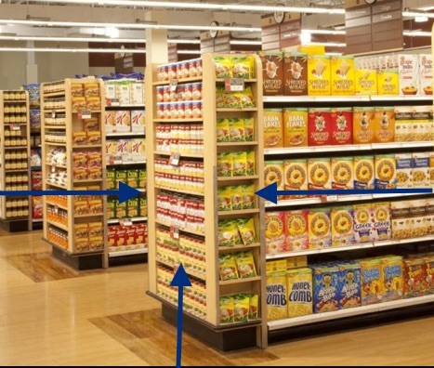
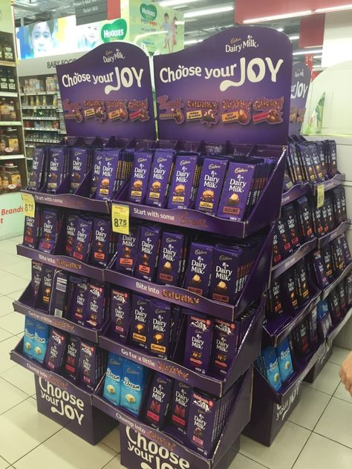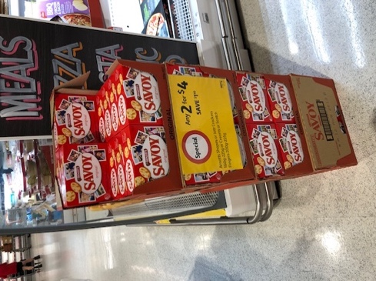
Right wing
Left wing
Centre (main) section

STAFF-ASSISTED CHECKOUT DISPLAYS SELF-CHECKOUT DISPLAYS
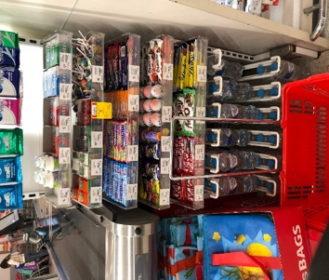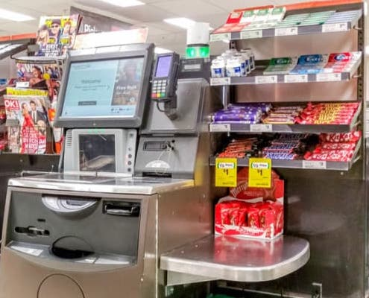
Side display

End display

ADDENDUM B - PRICE PROMOTION Codes

- No price promotion

Temporary
- 25% off
- 50% off/half price
- Other % discount quoted (specify discount eg. 33% off, if not quoted, record RRP and sale price)
- Multibuys (specify e.g. 2 for 1)
- Other price discount (specify e.g. buy 2 [RRP $1] get 50c off third one; introductory offer [$5.99] will be $7.99])
- “Fresh Specials” or similar (fruit/veg with no RRP)

Permanent
- “price dropped”, “down down”, or similar
- “Everyday low price” or similar

NOTES:
Temporary price promotions: Promotions that are valid for up to 1 week;
Permanent price promotions: promotions that are valid or have been offered for more than 1 week.
Note: items labelled “price dropped”, “specials”, or similar may fall into temporary or permanent categories.
Products reduced to clear/on sale based on expiry date are excluded.
Products that are on offer as part of an introductory offer are included

Starting at the entrance of the store, measure total floor space, using a measuring wheel, around the perimeter of the store only (inside the store and on the inside of the checkouts, where feasible to measure) – do not include aisles
Height is measured from the bottom of the lower shelf to the top of the upper shelf, using a tape measure. Shelf length measured using a measuring wheel.
Excluding frozen potato products and ready to eat meals
Icecream and ice lollies included. Frozen desserts excluded. Free-standing frozen display containing single serve ice-creams to be included as an Island Bin.
^{i} Including packaged herbs, chilli and garlic/ginger/herb puree display
Fruit and veg display include free standing and permanent displays, in the F&V section of the store only. Potatoes, onions, ginger and garlic are included. Nuts of all kinds are excluded.
Including gums and mints
Height is measured from the bottom of the lower shelf to the top of the upper shelf, using a tape measure. Shelf length measured using a measuring wheel.
Pretzels and popcorn are included. Check other aisles (e.g. health food section) for crisps
Sugar-sweetened and artificially-sweetened varieties are included
Island bins are defined as temporary displays separate from the main aisles or permanent displays. They include items that are elsewhere in the store – if the bin is the only location in the store for that product, then this is a permanent display and not an island bin, except for single serve items (eg. ice-creams and soft drink).
Measure height (H) and width (W) of island bins using measuring tape or measuring wheel and calculate area (HxW) in square metres.
End checkouts are located at the entrance of the checkout, facing the inside of the store. Displays that are located between two checkouts are recorded twice (at both checkouts)
Temporary promotions i.e. discounts valid up to a week. Permanent promotions i.e. promotion of non-temporary low price (e.g. “down down”). Refer to promotional display card
Side checkouts run alongside the checkout, usually above the conveyer belt.
Displays that are located between two checkouts are recorded twice (at both checkouts)

