Appendix A. List of Brands and Products Searched
Product
3 Musketeers
3Musketeers
5 hour Energy
5 hourEnergy
5-hour Energy
5-hourEnergy
5hourEnergy
7UP
A&W
AandW
Activia
Almond Board of California
Almond Joy
AlmondBoardofCalifornia
AlmondJoy
AMP Energy
AMPEnergy
Apple & Eve
Apple and Eve
Apple&Eve
AppleandEve
Arby’s
Arisona Iced Tea
Arisona Tea
ArisonaIcedTea
ArisonaTea
Arizona Iced Tea
Arizona Tea
ArizonaIcedTea
ArizonaTea
B&G Foods
B&GFoods
Baby Ruth
BabyRuth
BandG Foods
BandGFoods
Bard Valley
BardValley
Barq’s
Belvita
Betty Crocker
BettyCrocker
Blue Diamond Almonds
BlueDiamondAlmonds
Bolthouse Farms
BolthouseFarms
Boston Market
BostonMarket
Bug Juice
BugJuice
Burger King
BurgerKing
Butterfinger
Cactus Cooler
CactusCooler
California Almonds
California Table Grape Commission
CaliforniaAlmonds
CaliforniaTableGrapeCommission
Campbells
Canada Dry
CanadaDry
Capri Sun
CapriSun
Carl’s Jr.
Carl’sJr.
Cheerwine
Chees It
Chees-It
CheesIt
Cheetos
Cheez It
Cheez-It
CheezIt
Chex
Chick fil A
Chick-fil-A
ChickfilA
Chipotle
Chips Ahoy
ChipsAhoy
Chobani
CiCi’s Pissa
CiCi’s Pizza
CiCi’sPissa
CiCi’sPizza
Clif
Coca Cola
Coca-Cola
CocaCola
Coke
ConAgra Foods
ConAgraFoods
Dairy Queen
DairyQueen
Danimals
Dannon
Del Monte
DelMonte
Diamond Foods
DiamondFoods
Dole
Domino’s
Dominos
Doritos
Dove Chocolate
DoveChocolate
Dr Pepper
DrPepper
Dunkin’ Donuts
Dunkin’Donuts
Emerald Cocoa Roasted Almonds
EmeraldCocoaRoastedAlmonds
Fanta
Faygo
Ferrero Rocher
FerreroRocher
Fiber One
FiberOne
Fig Newtons
FigNewtons
Frito Lay
FritoLay
Fritos
Fruit Fulls
Fruit Rush
Fruit-Fulls
FruitFulls
FruitRush
FruYo
Full Throttle
FullThrottle
Game Fuel
GameFuel
Gamer Fuel
GamerFuel
Gatorade
General Mills
GeneralMills
Gfuel
Gfuel
Ghiradelli
GoGo Squeese
GoGo Squeeze
GoGoSqueese
GoGoSqueeze
GoGurt
Gold Peak
Goldfish Crackers
GoldfishCrackers
GoldPeak
Goya
Grapes from California
GrapesfromCalifornia
Grase Snack Boxes
GraseSnackBoxes
Graze Snack Boxes
GrazeSnackBoxes
GrubHub
Hardee’s
Hawaiian Punch
HawaiianPunch
Hershey's
Hersheys
Hi C
Hi-C
HiC
Honest Tea
HonestTea
Honey Maid
HoneyMaid
Huberts
IBC
Jack in the Box
Jack Links
JackintheBox
JackLinks
Jarritos
Java Monster
JavaMonster
Jersey Mike's
Jersey Mikes
JerseyMike's
JerseyMikes
Jif
Johanna Foods
JohannaFoods
Jones Soda
JonesSoda
Jumex
Kashi
Kashi
Keebler
Kellogg
Kellogg's
Kelloggs
KFC
Kit Kat
KitKat
Kool Aid
Kool-Aid
KoolAid
Kosy Shak
KosyShak
Kozy Shak
KozyShak
Kraft
Langers
Laughing Cow
LaughingCow
Lay's
Lay's
Lays
Lays
Link Snacks
LinkSnacks
Lipton
Little Caesars
Little Debbie
Little Hug Fruit Barrels
LittleCaesars
LittleDebbie
LittleHugFruitBarrels
Long John Silver’s
LongJohnSilver’s
M&M's
M&Ms
Madrinas Coffee
MadrinasCoffee
MandM's
MandMs
Mansita Sol
MansitaSol
Manzita Sol
ManzitaSol
Martinelli’s
Materne
McD's
McDonald’s
McDs
McKee Foods
McKeeFoods
Mello Yello
MelloYello
META Health
METAHealth
Milky Way
MilkyWay
Minute Maid
MinuteMaid
Mondeles
Mondelez
Mondo Fruit Squeesers
Mondo Fruit Squeezers
MondoFruitSqueesers
MondoFruitSqueezers
Monster Energy
MonsterEnergy
Mott’s
Mountain Dew
MountainDew
Mtn Dew
MtnDew
Natural Delights
NaturalAmericanSprit
NaturalDelights
Nature Delivered
Nature Valley
NatureDelivered
NatureValley
Nestea
Nestle
Newman’s Own
Newman’sOwn
NoDos
NoDoz
NOS energy
NOSenergy
Novamex
Nutella
Nutri Grain
Nutri-Grain
NutriGrain
Oberto
Ocean Spray
OceanSpray
Oikos
Oreo
Oreos
Oscar Mayer
OscarMayer
Panera Bread
PaneraBread
Papa John’s
PapaJohn’s
Peace Tea
PeaceTea
Pepperidge Farm
PepperidgeFarm
Pepsi
Pibb
Pissa Hut
PissaHut
Pizza Hut
PizzaHut
Planters Nuts
PlantersNuts
Poland Springs
PolandSprings
Polar Beverages
PolarBeverages
Popchips
Popeyes
PopTarts
Powerade
Pringles
Procter & Gamble
Procter and Gamble
Procter&Gamble
ProcterandGamble
Quaker Snack
QuakerSnack
Quisnos
Quiznos
RC Cola
RCCola
RedBull
Reed's
Reed’s
Reese's
Reese's
Reeses
Reeses
Rits
Ritz
Robinsons Fruit Shoot
RobinsonsFruitShoot
Rockstar Energy
RockstarEnergy
RW Knudsen
RWKnudsen
Santa Crus Organics
Santa Cruz Organics
SantaCrusOrganics
SantaCruzOrganics
Schweppes
Seagram’s
Shasta
Sheila G
SheilaG
SK Energy
SKEnergy
Skittles
Slim Jim
SlimJim
Smuckers
Snapple
Snickers
Snyder’s
SoBe
Sprite
Ssips
Stacker 2 Xtra
Stacker2Xtra
Stacy's Pita Chips
Stacy'sPitaChips
Stacys Pita Chips
StacysPitaChips
Starbucks
Stewart’s Fountain Classics
Stewart’sFountainClassics
Stremick’s Heritage Foods
Stremick’sHeritageFoods
Subway
Sun Belt Bakery
Sun Valley Dairy
SunBeltBakery
Sundrop
Sunkist
Sunny D
Sunny Delight
SunnyD
SunnyDelight
SunValleyDairy
Swedish Fish
SwedishFish
Sweet Leaf
SweetLeaf
Taco Bell
TacoBell
Tahitian Treat
TahitianTreat
Tampico
Taso
Tazo
Teddy Grahams
TeddyGrahams
The Wonderful Company
TheWonderfulCompany
ThinkThin
Tootsie Rolls
TootsieRolls
Tornado Energy
TornadoEnergy
Tostitos
Totino's
Totinos
Triscuit
Tropicana
Tum E Yummies
TumEYummies
Turkey Hill
TurkeyHill
Tuscan Dairy Farms
TuscanDairyFarms
Twisslers
Twix
Twizzlers
Two If By Tea
TwoIfByTea
Ubereats
Ubr
Unilever
USA Pears
USAPears
V8 Fusion
V8 Splash
V8Fusion
V8Splash
Vernors
Virgil’s
Vita Coco
VitaCoco
Vitamin Water
VitaminWater
Voskos
Weight Watchers
WeightWatchers
Welch Foods
Welch’s
WelchFoods
Wendy’s
West Coast Chill
WestCoastChill
Wheat Thins
WheatThins
Wonderful Halos
Wonderful Pistachios
WonderfulHalos
WonderfulPistachios
XINGtea
Yoplait
York Peppermint Patties
YorkPeppermintPatties

Appendix B.
Top five brands in terms of hours of viewership within each category for streamer profiles. Note that scales are different between categories in order to better demonstrate trends. For categories with two figures, the left figure shows the entire hours of viewership while the right figure is limited to 500,000 hours of viewership per month. This is intended to better show the nuanced trends that occur in categories where one brand may dominate the rest. For “Energy Drinks, Coffee, and Tea,” note that “Mountain Dew” refers to the series of energy drinks made by the product (e.g., Game Fuel).
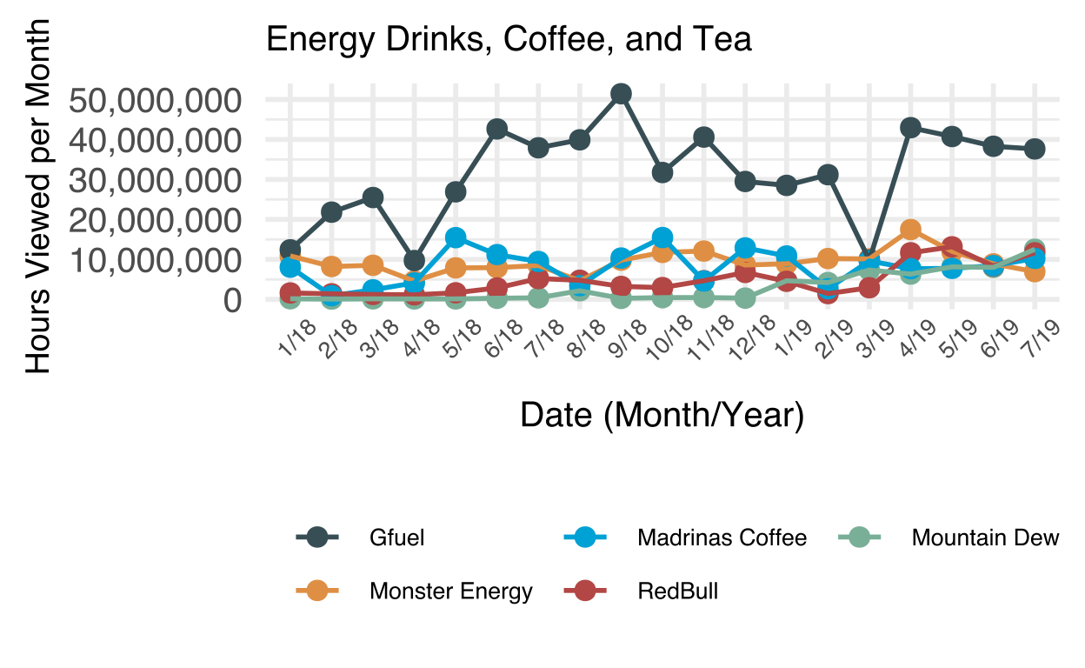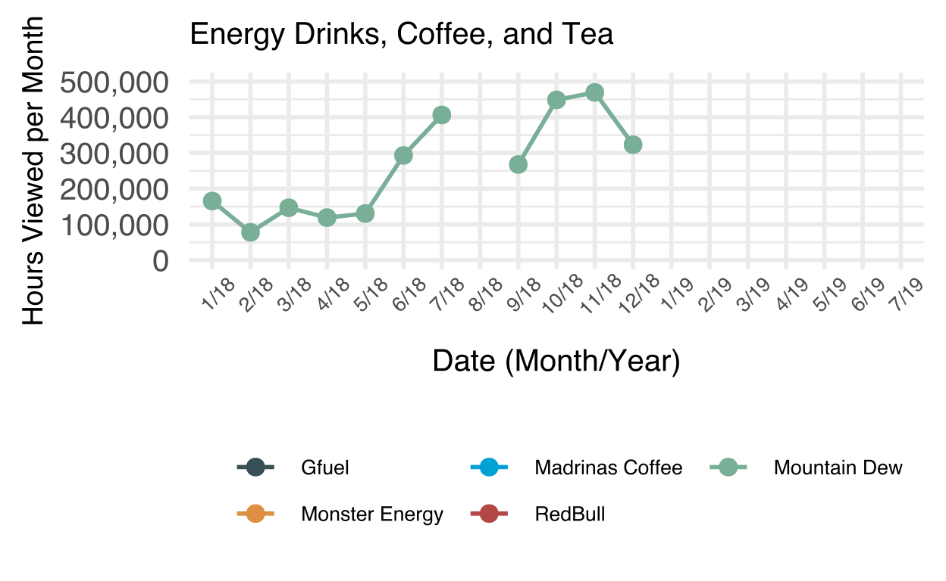
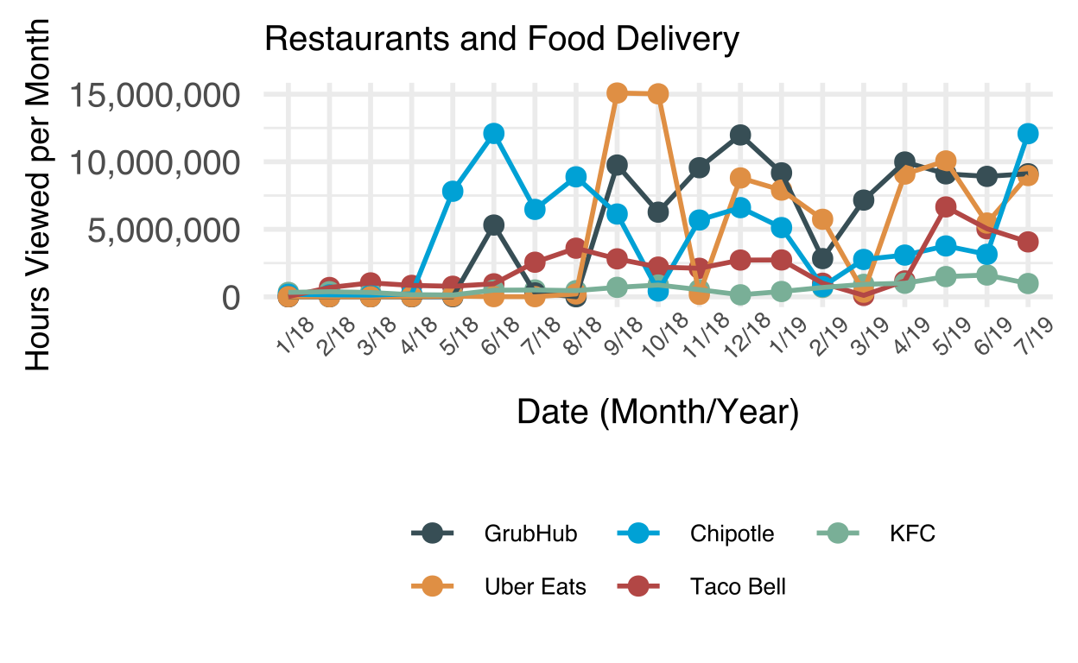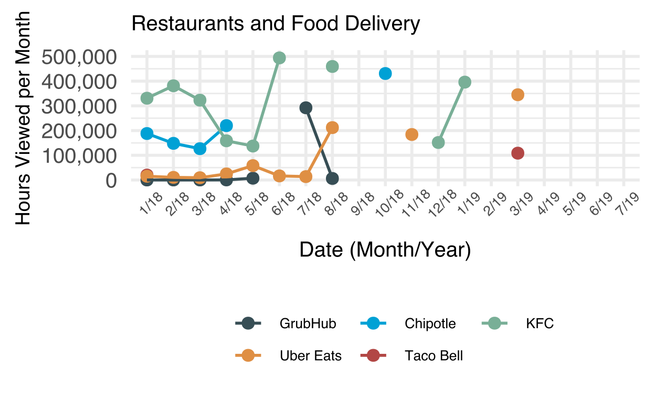
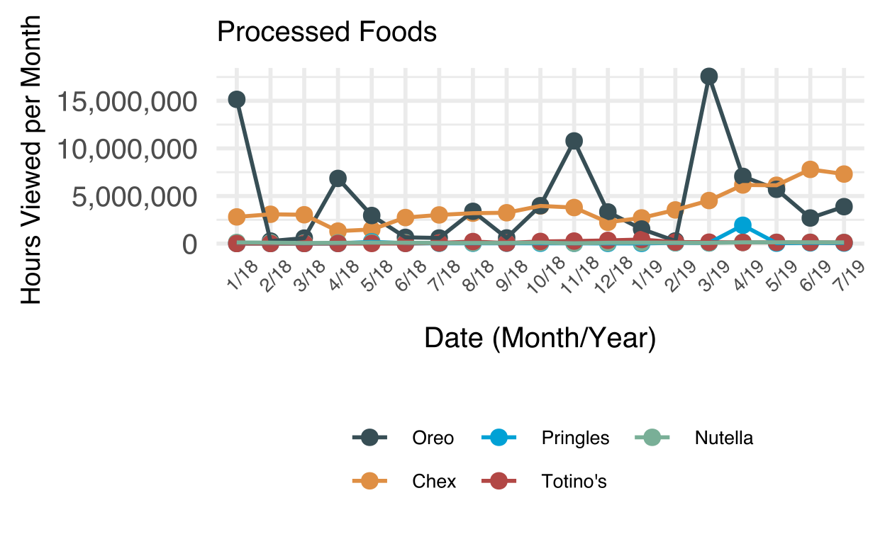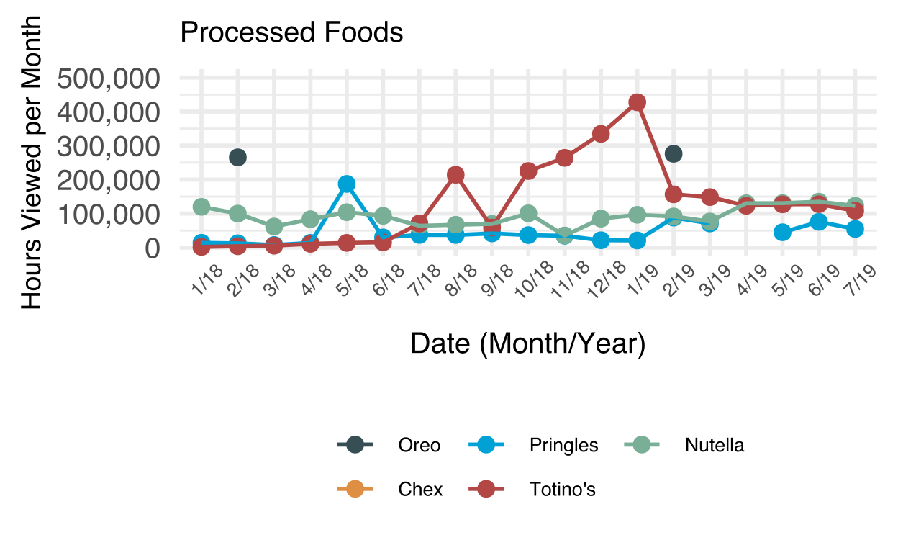
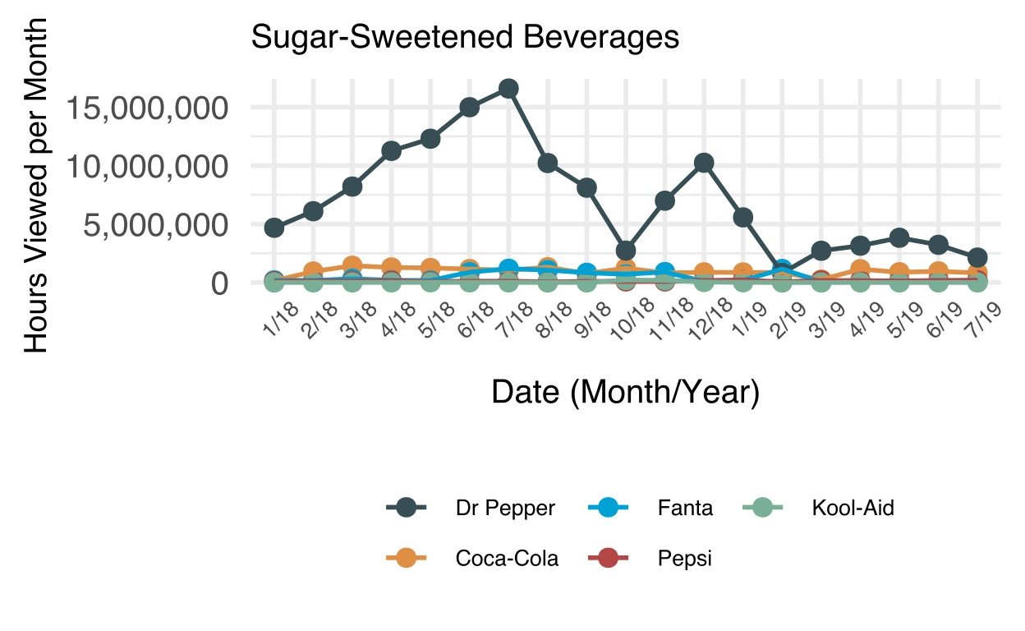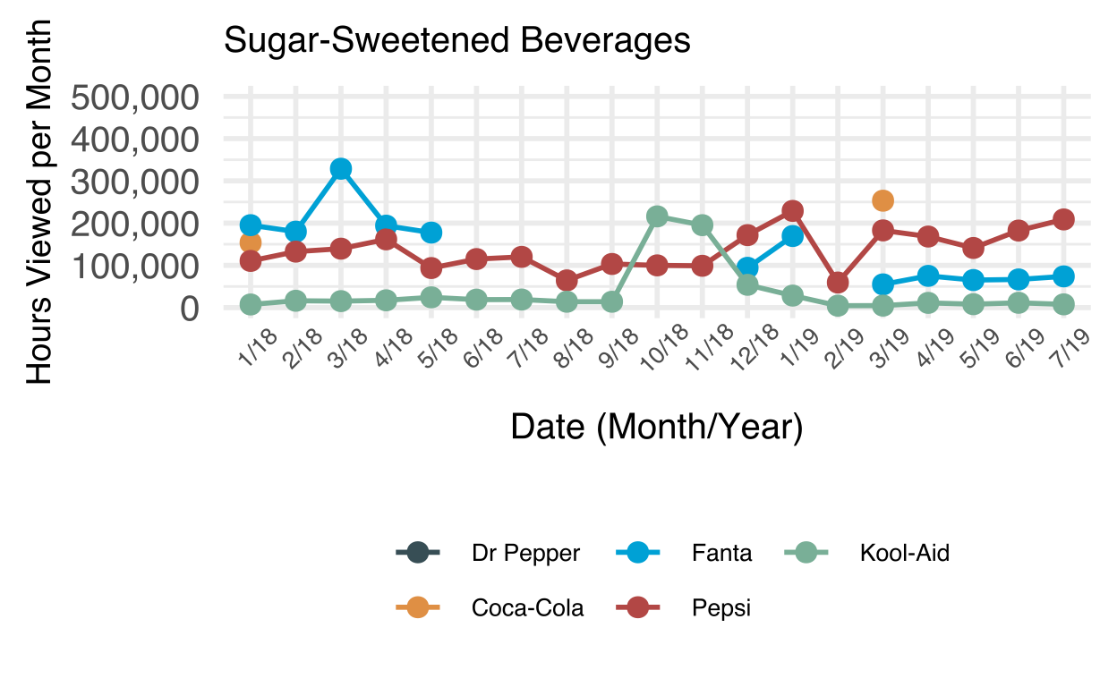
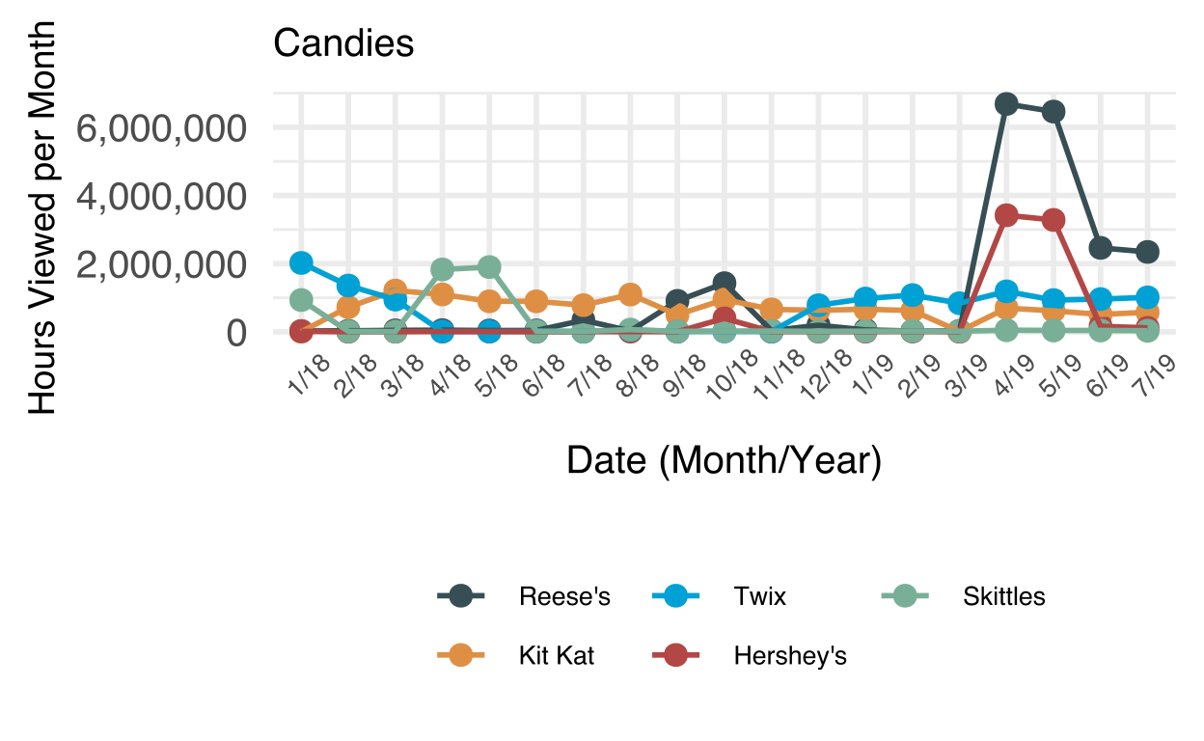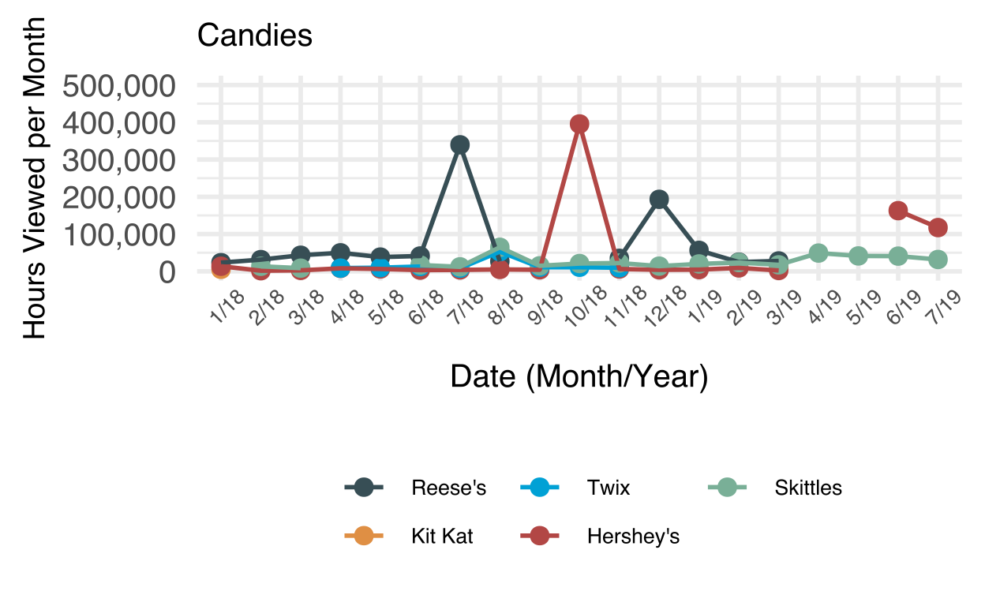

Appendix C.
Top five brands in terms of hours of viewership within each category for stream titles. Note that scales are different between categories in order to better demonstrate trends. For categories with two figures, the left figure shows the entire hours of viewership while the right figure is limited to 500,000 hours of viewership per month. This is intended to better show the nuanced trends that occur in categories where one brand may dominate the rest. For “Energy Drinks, Coffee, and Tea,” note that “Mountain Dew” refers to the series of energy drinks made by the product (e.g., Game Fuel).
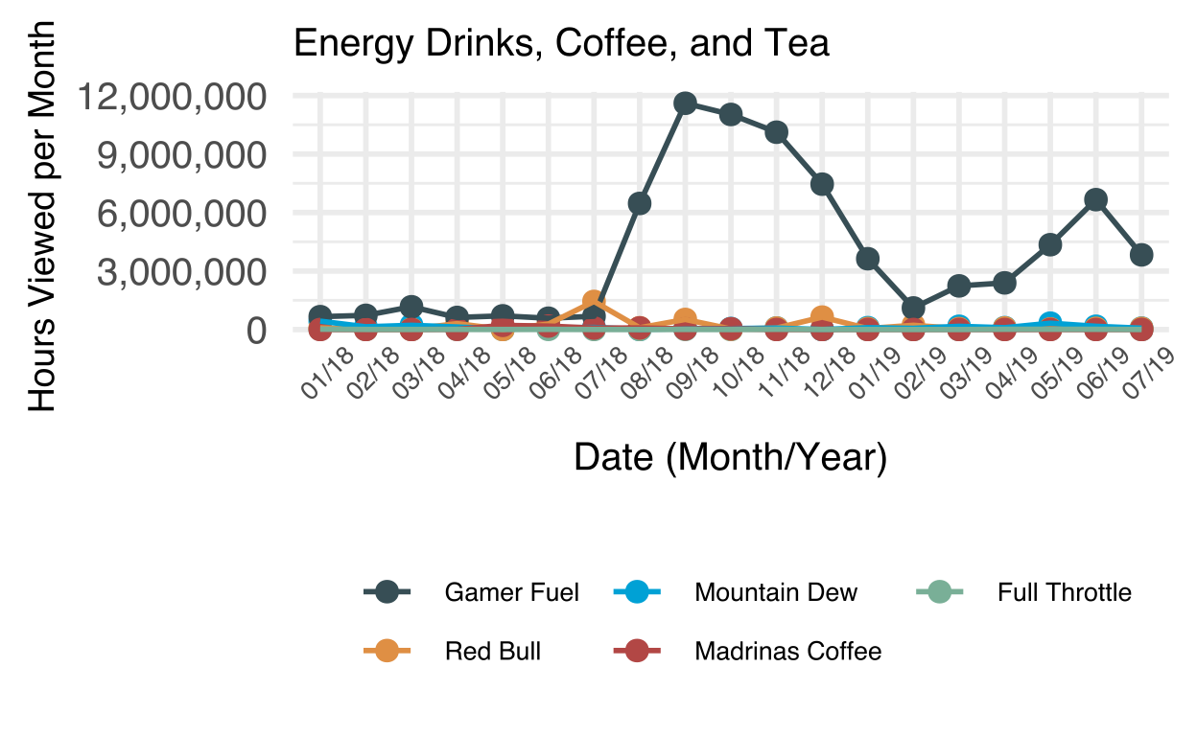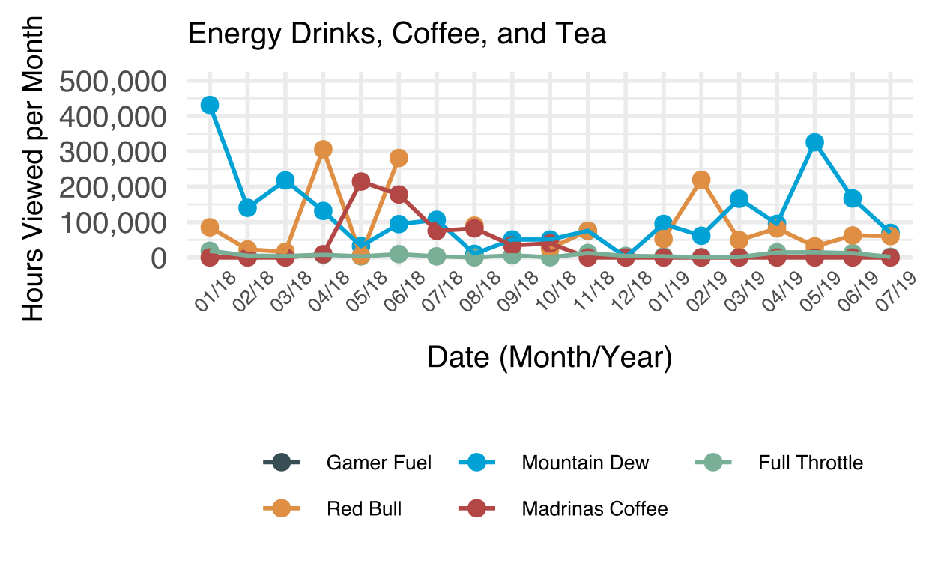
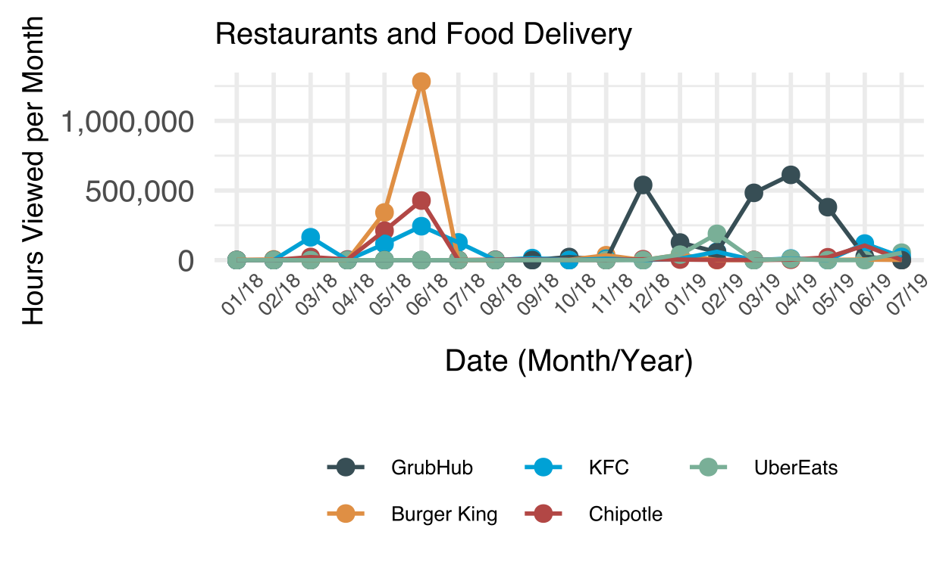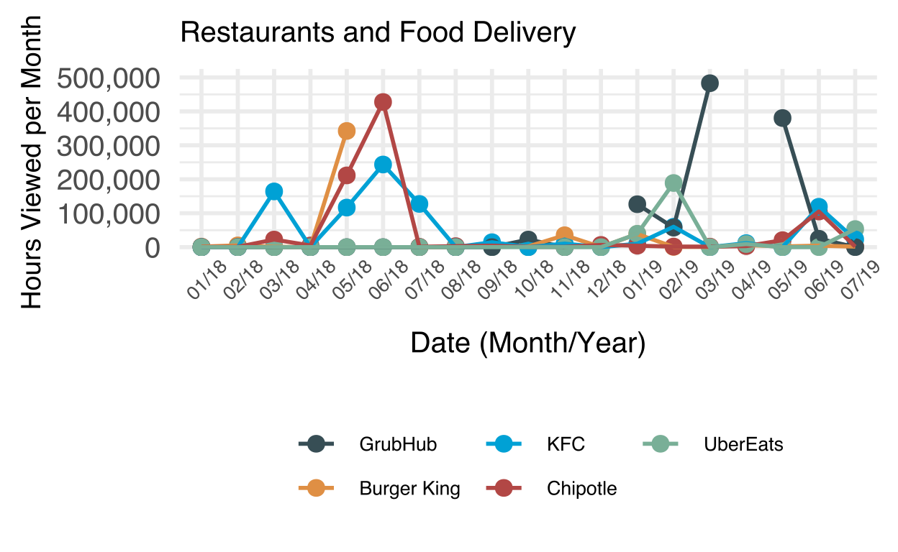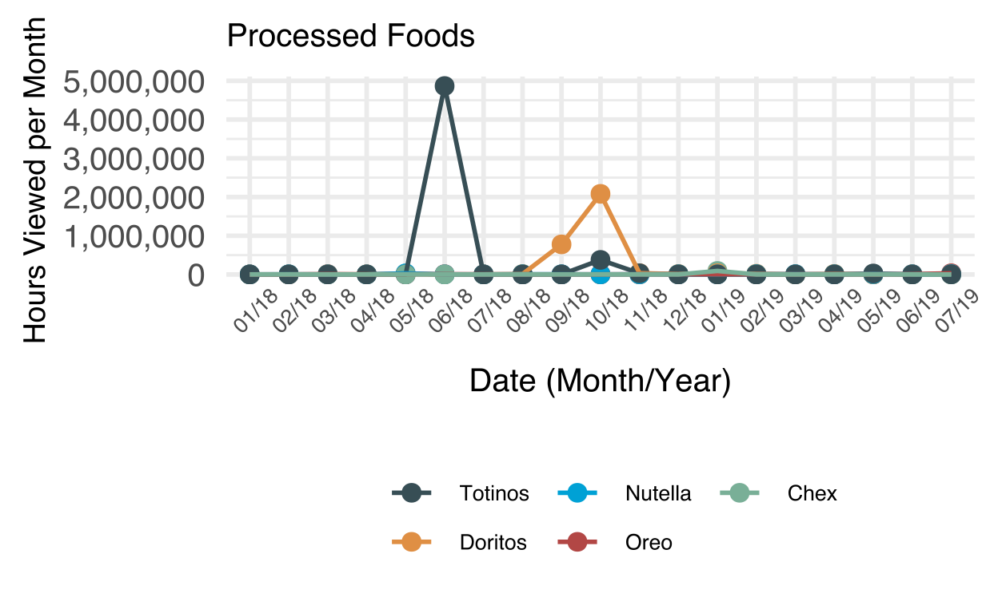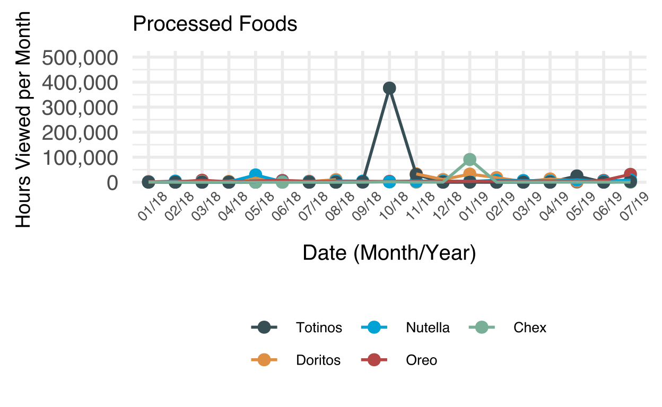
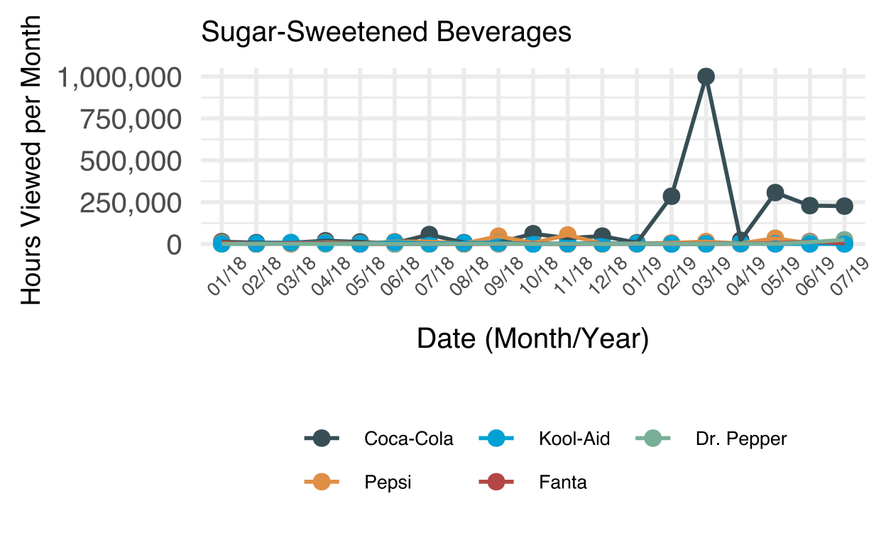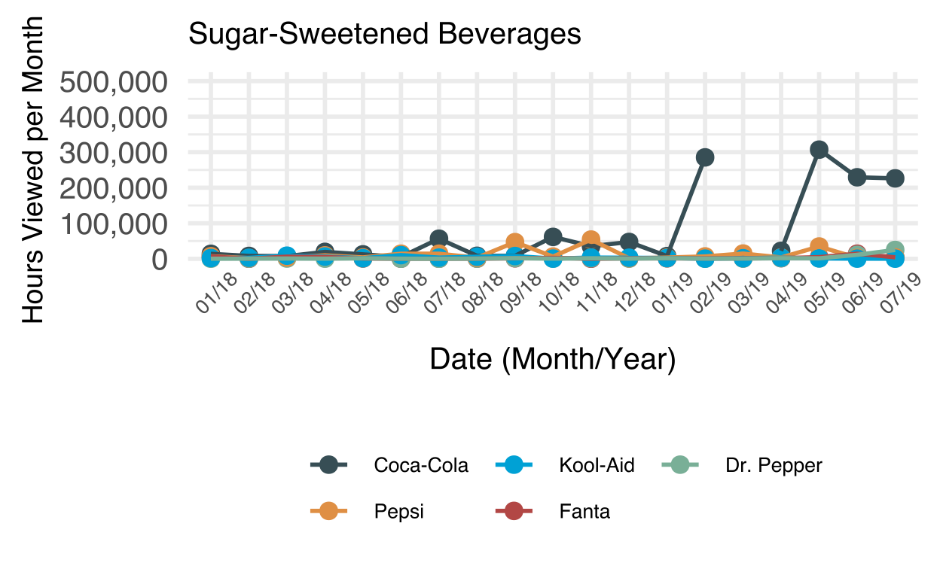
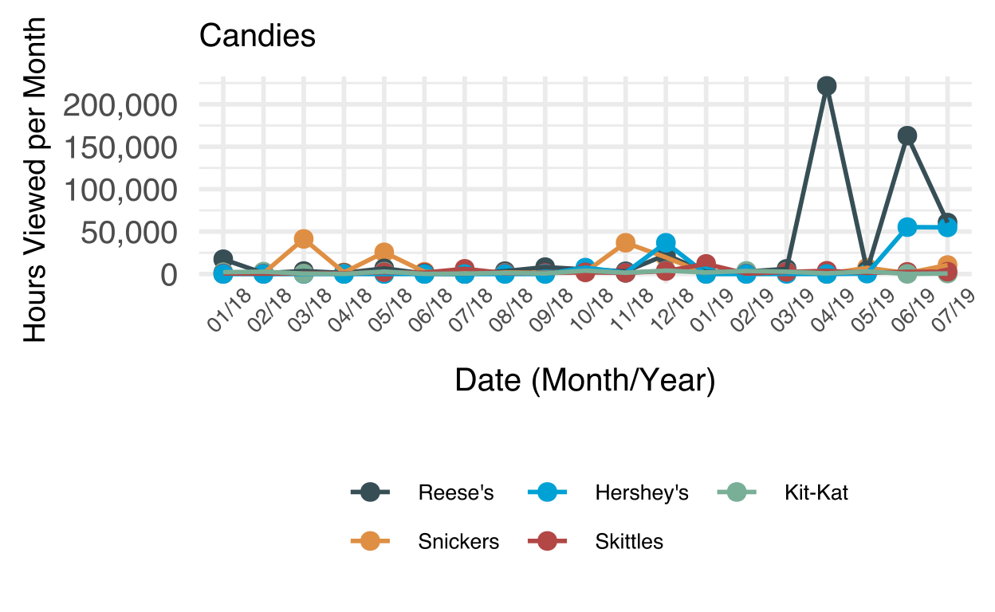

Appendix D.
Top five brands in terms of hours of viewership within each category for chat room messages. Note that scales are different between categories in order to better demonstrate trends. For “Energy Drinks, Coffee, and Tea,” note that “Mountain Dew” refers to the series of energy drinks made by the product (e.g., Game Fuel).
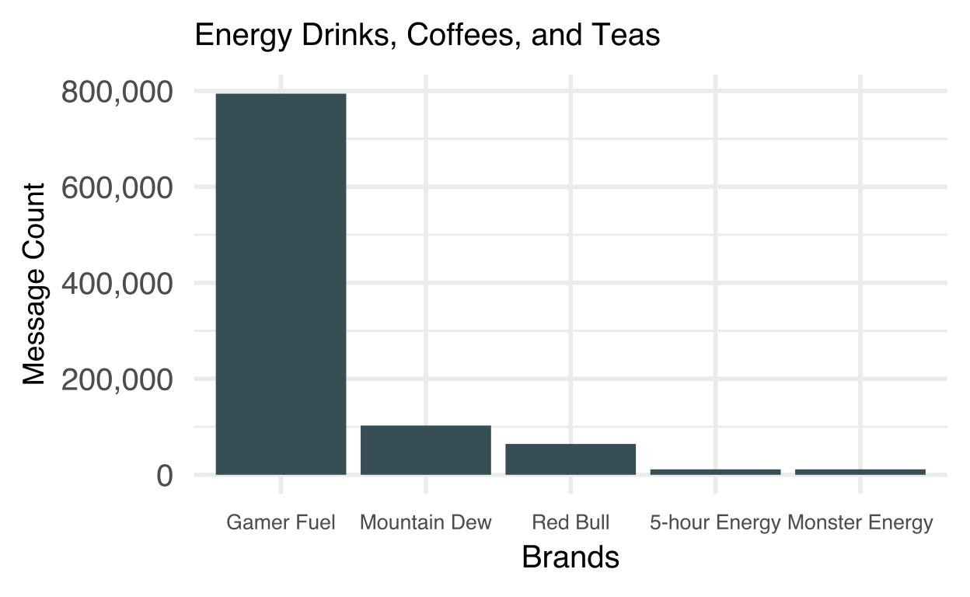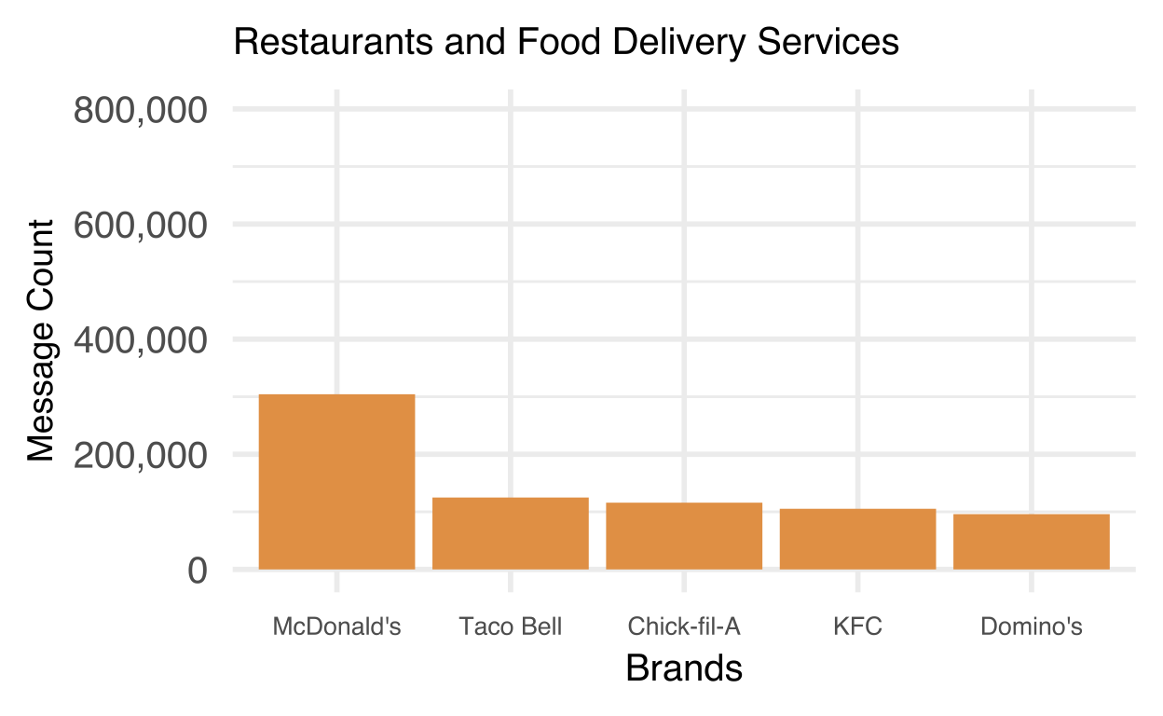
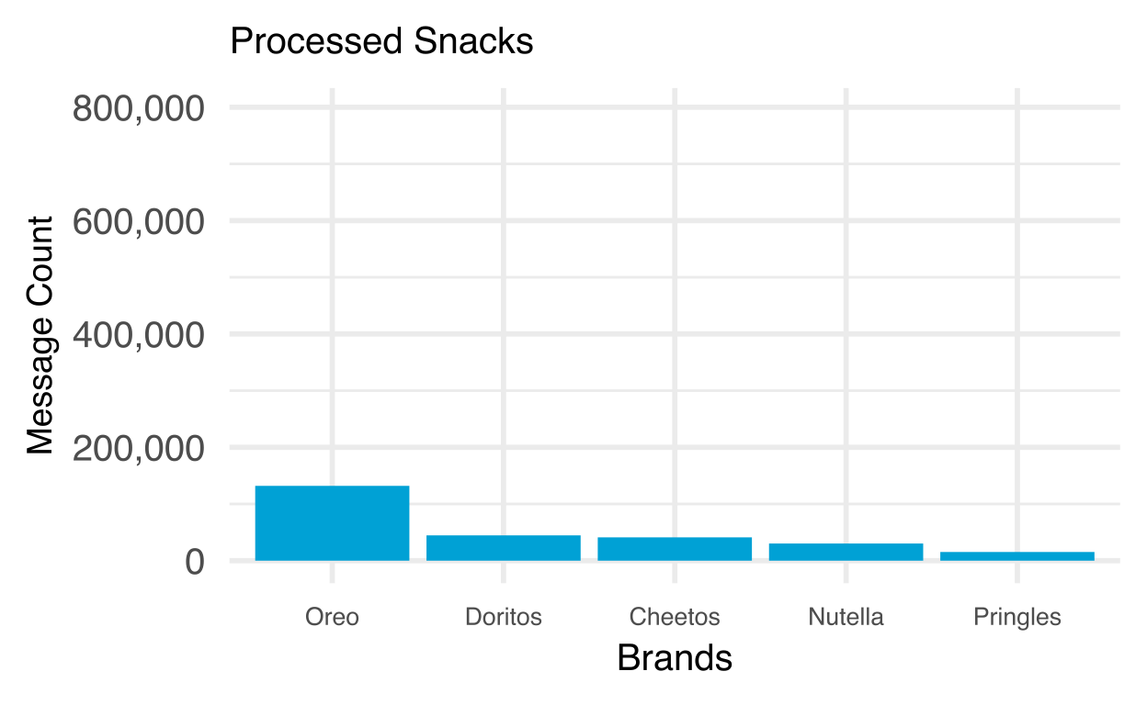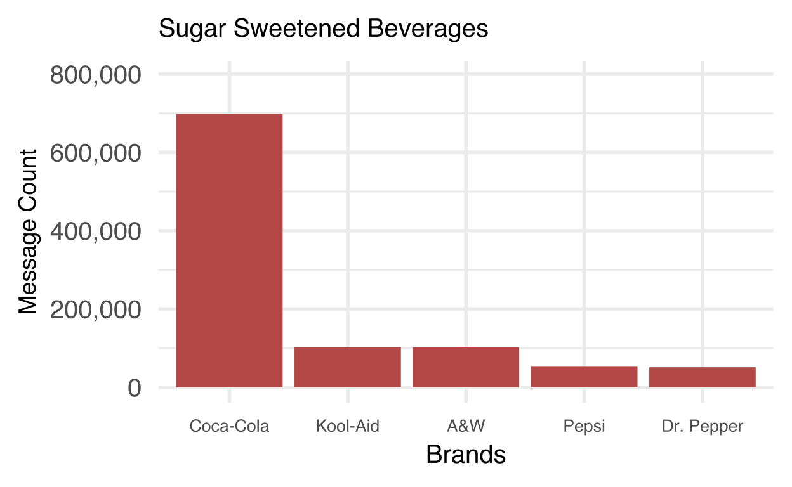
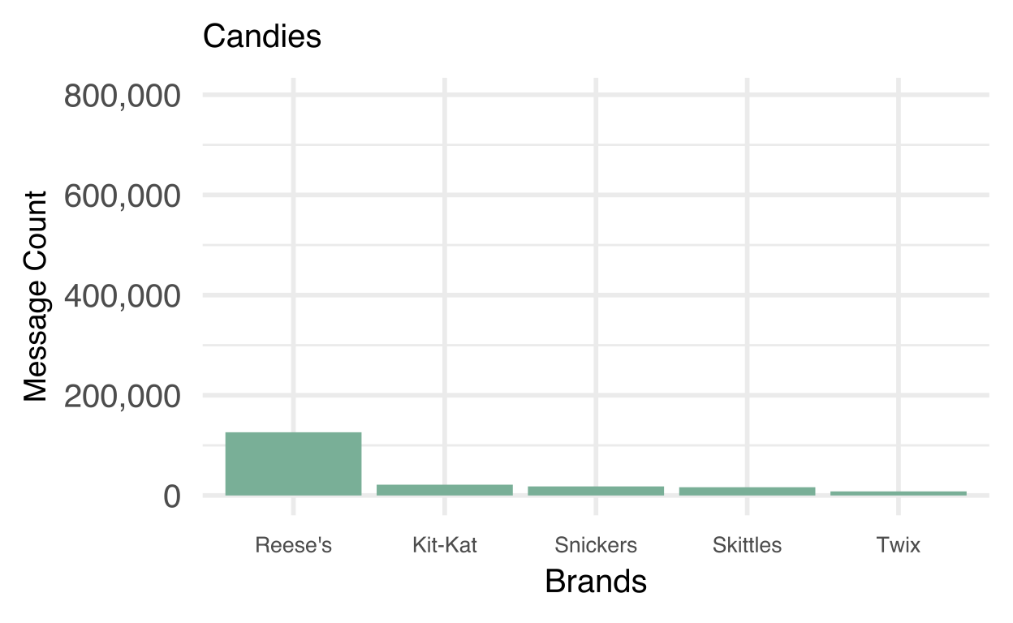

Appendix E.
Top five brands in terms of hours of viewership within each category for views of chat room messages. Note that scales are different between categories in order to better demonstrate trends. For “Energy Drinks, Coffee, and Tea,” note that “Mountain Dew” refers to the series of energy drinks made by the product (e.g., Game Fuel).
