Supplementary material

Unique Study ID number

 | d | d | m | m | y | y | y | y
Date of interview

Name of interviewer |  | Interviewer code

IDENTIFYING DETAILS

1. Name

2. Sex | 1 Male 2 Female

3. Date of birth

4. Father’s/Guardian’s name

5. Mother’s/Guardian’s name
6. Address

7. Guardian mobile phone number

8. Alternative phone number and relationship

EDUCATION

9. Total number of years of schooling/education (Mother)

10. Total number of years of schooling/education (Head of household)

Specify head of household (and relationship)

OCCUPATION

11. Occupation status of mother
- Paid employment
- Self-employed
- Not employed
12. Occupation status of head of household
- Paid employment
- Self-employed
- Not employed

SOCIO-ECONOMIC STATUS

13. Household composition – record number of people living in the same house
Adults

Children
14. What is the main source of drinking water for the household?
- Piped water  - Hand pump  - Well  - Public tap |  | - River/stream  - Tanker  - Other (specify)
15. What kind of toilet facility does your household have?
- Own flush toilet  - Shared flush toilet  - Public flush toilet  - Own pit toilet |  | - Shared pit toilet  - Public pit toilet  - Non/fields  - Other (specify)
 | 16. How many rooms are there in your house?

17. Does this household own this house, or any other house? | 1 Yes 0 No
18. Does this household own any of the following?

1. Mattress | 1 Yes 0 No
2. Chair | 1 Yes 0 No
3. Cot/bed | 1 Yes 0 No
4. Table | 1 Yes 0 No
5. Clock/watch | 1 Yes 0 No
6. Electric fan | 1 Yes 0 No
7. Bicycle | 1 Yes 0 No
8. Radio/transistor/music player | 1 Yes 0 No
9. Television | 1 Yes 0 No
10. Two-wheeler (moped/scooter/motorcycle) | 1 Yes 0 No
11. Car/jeep | 1 Yes 0 No
12. Water pump | 1 Yes 0 No
13. Animal-drawn cart | 1 Yes 0 No
14. Thresher | 1 Yes 0 No
15. Tractor | 1 Yes 0 No
16. Refrigerator | 1 Yes 0 No
17. Air conditioner | 1 Yes 0 No
18. Washing machine | 1 Yes 0 No
19. Computer/laptop | 1 Yes 0 No
20. Broadband internet | 1 Yes 0 No
21. Geyser/water heater | 1 Yes 0 No
DIETARY INFORMATION

19. Yesterday during the day or at night, did you eat or drink:
How often did you eat these foods over the past one month?
- Every day
- 2-4 times per week
- 5-6 times per week
- Once a week
- Less than once a week
Any foods made from grains, like: | Porridge, bread, rice, pasta/noodles, ragi or other foods made from grains | 1 Yes  0 No
Any vegetables or roots that are orange-coloured inside, like: | Pumpkin, carrots, squash or sweet potatoes that are yellow or orange inside | 1 Yes  0 No
Any white roots and tubers or plantains, such as: | White potatoes, white yams, cassava/radish, or any other foods made from white-fleshed roots or tubers, or plantains | 1 Yes  0 No
Any dark green leafy vegetables, such as: | Any medium-to-dark green leafy vegetables, including wild/foraged leaves | 1 Yes  0 No
Any fruits that are dark yellow or orange inside, like: | Ripe mango, ripe papaya [ | 1 Yes  0 No
Any other fruits | Any other fruits | 1 Yes  0 No
Any other vegetables | Any other vegetables | 1 Yes  0 No
Any meat made from animal organs, such as: | Liver, kidney, heart or other organ meats or blood-based foods, including from wild game | 1 Yes  0 No
Any other types of meat or poultry, like: | Beef, pork, lamb, goat, rabbit, wild game meat, chicken, duck, other birds | 1 Yes  0 No
Any eggs | Eggs from poultry or any other bird | 1 Yes  0 No
Any fish or seafood, whether fresh or dried | Fresh or dried fish, shellfish or seafood | 1 Yes  0 No
Any beans or peas, such as: | Mature beans or peas (fresh or dried seed), lentils or bean/ pea products, including hummus, tofu and tempeh | 1 Yes  0 No
Any nuts or seeds, like: | Any tree nut, ground nut, peanut, or certain seeds or nut/seed “butters” or pastes | 1 Yes  0 No
Any milk or milk products, such as: | Milk, cheese, yoghurt or other milk products, but NOT including butter, ice cream, cream or sour cream | 1 Yes  0 No
Any condiments and seasonings, such as: | Condiments and seasonings: Ingredients used in small quantities for flavour, such as chilies, spices, herbs, fish powder, tomato paste, flavour cubes or seeds | 1 Yes  0 No
Freshly cooked fried snacks, like: | Samosa, wada, fritter | 1 Yes  0 No
Savoury snacks in packets, like: | Potato crisps and other similar snacks | 1 Yes  0 No
Bakery items, such as: | Cake, biscuits, puffs | 1 Yes  0 No
Sweets |  | 1 Yes  0 No
Fast food/street food/restaurant food |  | 1 Yes  0 No
Fizzy drinks, such as: | Coca Cola, Fanta, Limca | 1 Yes  0 No
MOBILE PHONES

- Do you have your own mobile phone? | 1 Yes 0 No

- If yes, is it a smartphone? | 1 Yes 0 No
SCREEN TIME

- How much time do you spend watching entertainment programmes on average every day (TV/computer/mobile phone) (hrs)

- How much do you spend playing computer games on average every day (on a computer/laptop/game console/mobile phone) (hrs)

- How much time do you spend doing school work on a computer on average every day (hrs)

Supplementary Figure 1: Proportions of adolescents in each setting whose households owned the following assets (sexes and age groups pooled)
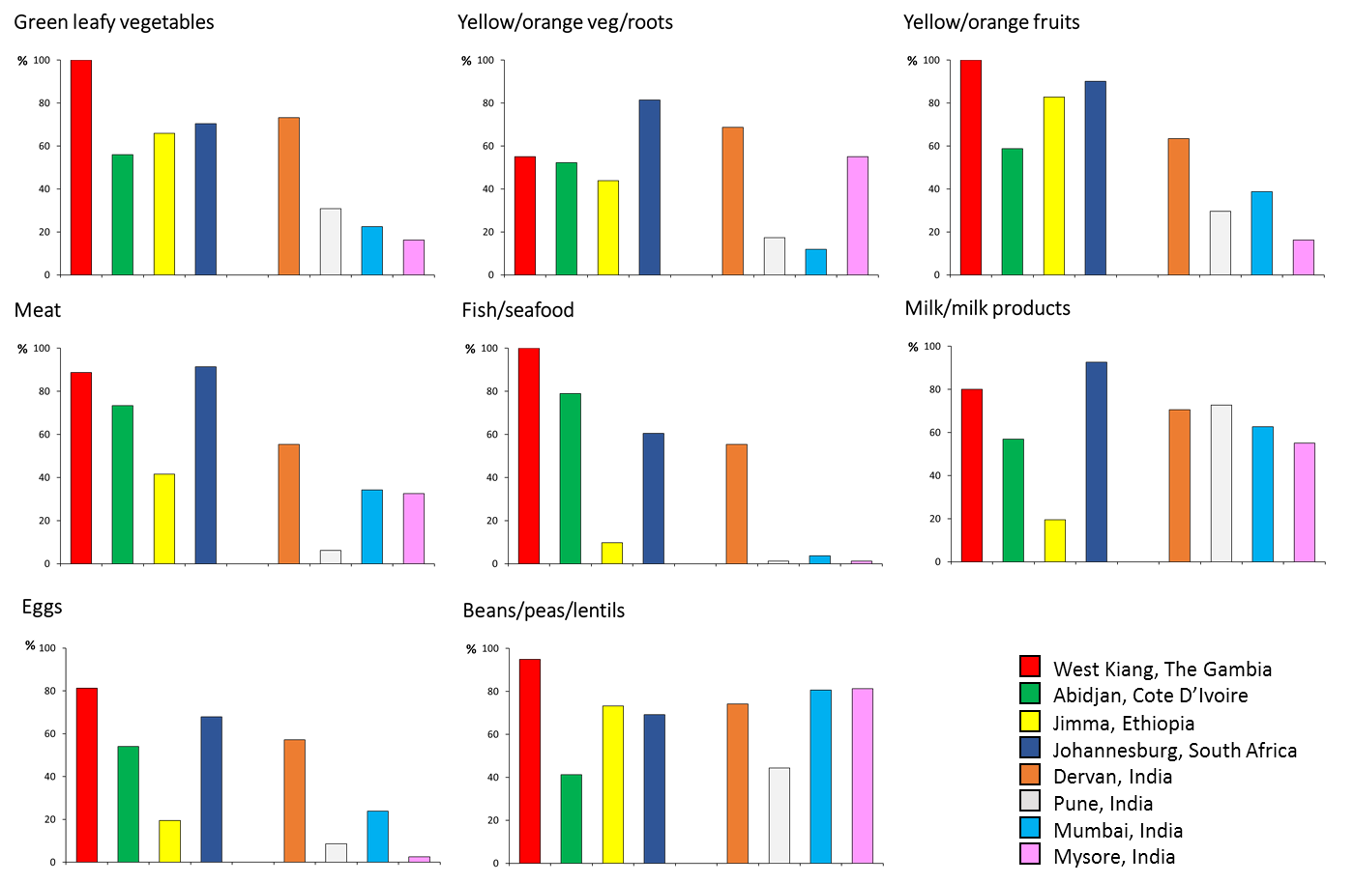
Supplementary Figure 2: Percentages of adolescents in each setting who had eaten foods from selected food groups in the past 24 hours (sexes and age groups pooled)

Supplementary Figure 3: Frequencies of intake of selected food groups in each setting (sexes and age groups pooled)
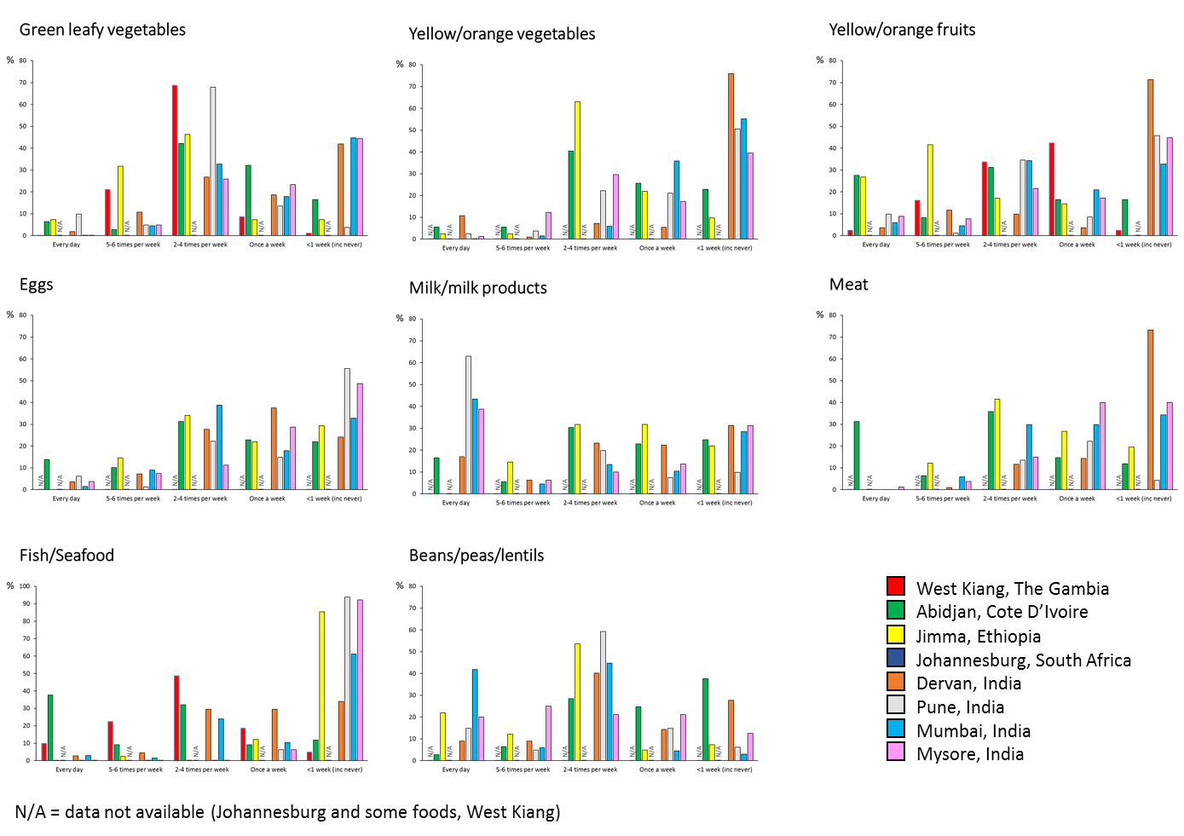
Supplementary Figure 4: Frequencies of intake of snack foods in each setting (sexes and age groups pooled)
