

Online Supplemental Figure 1. Relative frequency of incorrect responses (stating that the labeled option was healthier or both options were equally healthy), in trials of hypothetical product pairs for which the unlabeled option was healthier. There were 3 randomly-assigned variations of the label within each of the 3 product categories: cereal (1 Made with WG, 2 Multigrain, 3 WG stamp), crackers (1 Made with WG, 2 Multigrain, 3 WG stamp), and bread (1 Multigrain, 2 Wheat, 3 WG stamp), as shown in Online Supplemental Figure 2. Each respondent received only 1 variation within each product category, as shown in Online Supplemental Figure 3. Standard errors and further details in Online Supplemental Table 1.

**Which of the following statements best applies to the product in the image?**

* All the grain is whole grain
* Half or more than half the grain is whole grain
* Less than half the grain is whole grain
* There is little or no whole grain
* Other

|  |  |  |  |
| --- | --- | --- | --- |
| WG corn is 3rd ingredient | WG corn is 6th ingredient | WG corn is 6th ingredient | WG corn is 6th ingredient |
| Sugar is 5th ingredient | Sugar is 2nd ingredient | Sugar is 2nd ingredient | Sugar is 2nd ingredient |
| 3g added sugars | 13g added sugars | 13g added sugars | 13g added sugars |
| **More WG and less sugar** | **Less WG, more sugar, and a WG label** | | |

(a) Cereal1

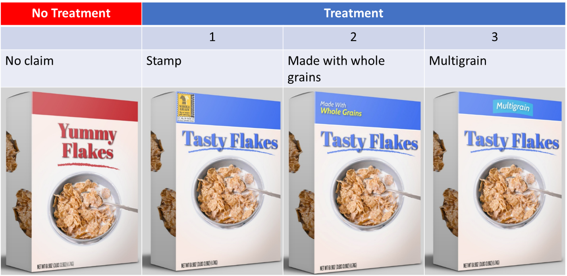

(b) Crackers

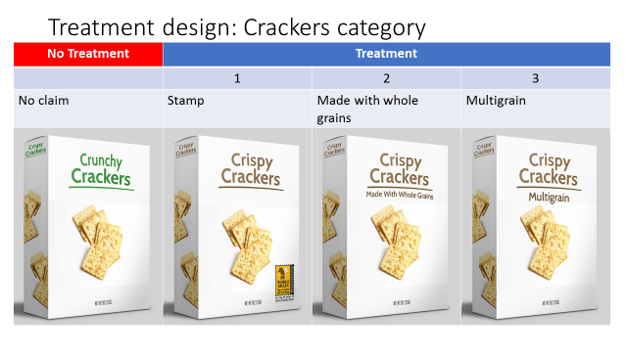

|  |  |  |  |
| --- | --- | --- | --- |
| Whole wheat flour is 4th ingredient | Whole wheat flour is 5th ingredient | Whole wheat flour is 5th ingredient | Whole wheat flour is 5th ingredient |
| Salt is 5th ingredient | Salt is 3rd ingredient | Salt is 3rd ingredient | Salt is 3rd ingredient |
| 80 mg sodium | 280 mg sodium | 280 mg sodium | 280 mg sodium |
| **More WG and less salt** | **Less WG, more salt, and a WG label** | | |

(c) Bread

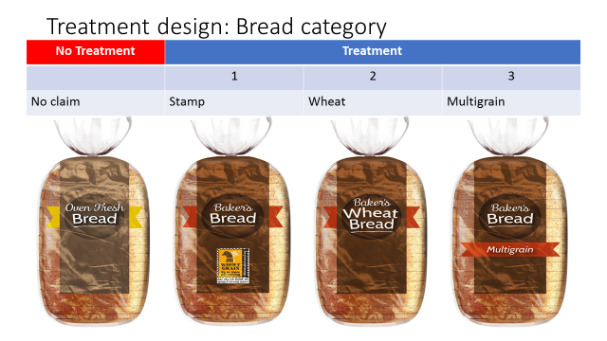

|  |  |  |  |
| --- | --- | --- | --- |
| Whole wheat flour 1st ingredient | Whole wheat flour 5th ingredient | Whole wheat flour 5th ingredient | Whole wheat flour 5th ingredient |
| 4g fiber | 2g fiber | 2g fiber | 2g fiber |
| **More WG** | **Less WG and a WG label** | | |

1Each respondent was presented with just 1 of the treatment options.

Online Supplemental Figure 2. Unlabeled (no treatment) and 3 randomly-assigned variations of WG labeled (treatment) images and descriptions, for hypothetical products in 3 product categories (cereal, crackers, bread).

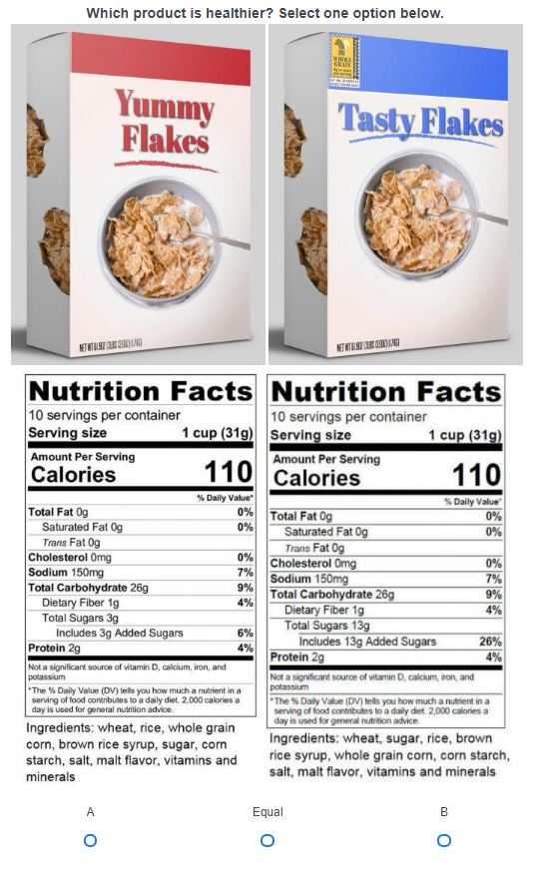

Online Supplemental Figure 3. Example of a comparison presented to respondents.

(a) Honey Wheat Bread

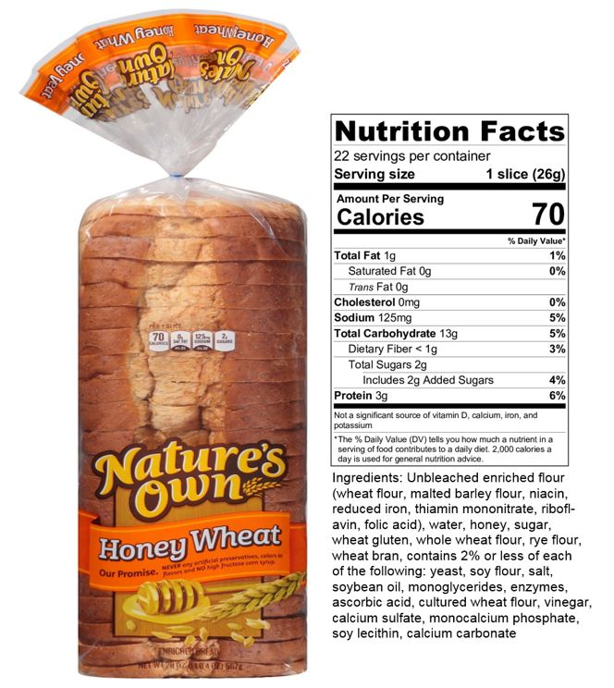

**Which of the following statements best applies to the product in the image?**

* All the grain is whole grain
* Half or more than half the grain is whole grain
* Less than half the grain is whole grain
* There is little or no whole grain
* Other

(b) Multigrain Cracker

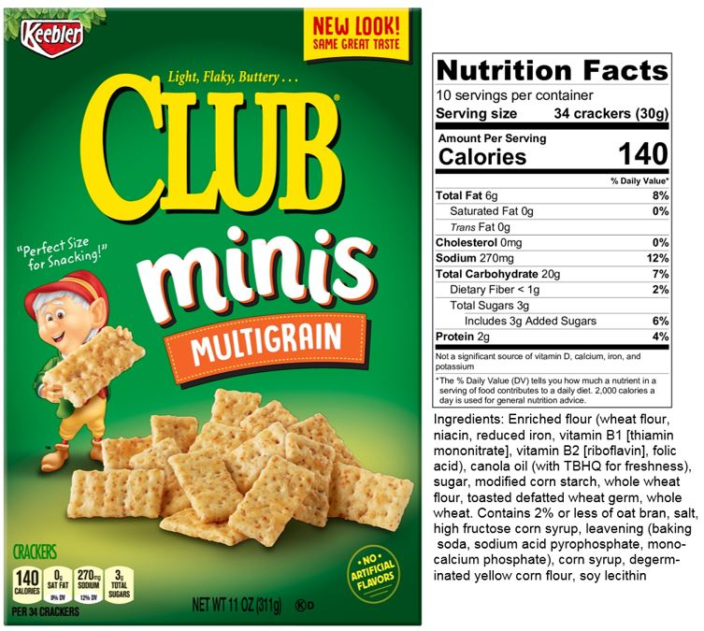

**Which of the following statements best applies to the product in the image?**

* All the grain is whole grain
* Half or more than half the grain is whole grain
* Less than half the grain is whole grain
* There is little or no whole grain
* Other

(c) Apple Cinnamon Oat Cereal

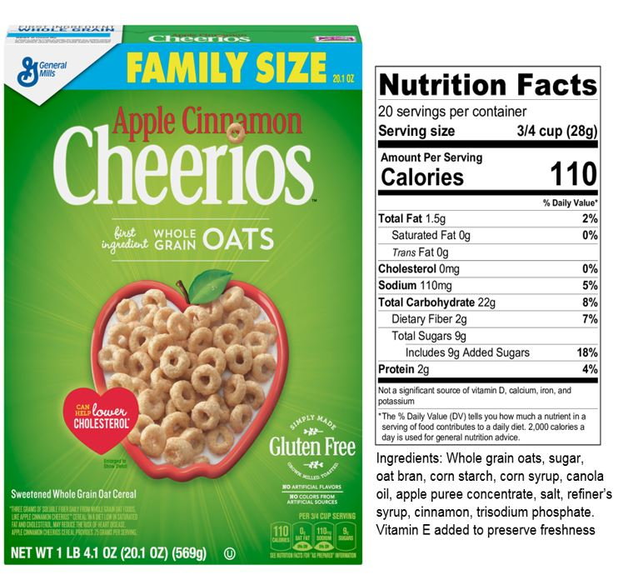

**Which of the following statements best applies to the product in the image?**

* All the grain is whole grain
* Half or more than half the grain is whole grain
* Less than half the grain is whole grain
* There is little or no whole grain
* Other

(d) Farmhouse 12 Grain Bread

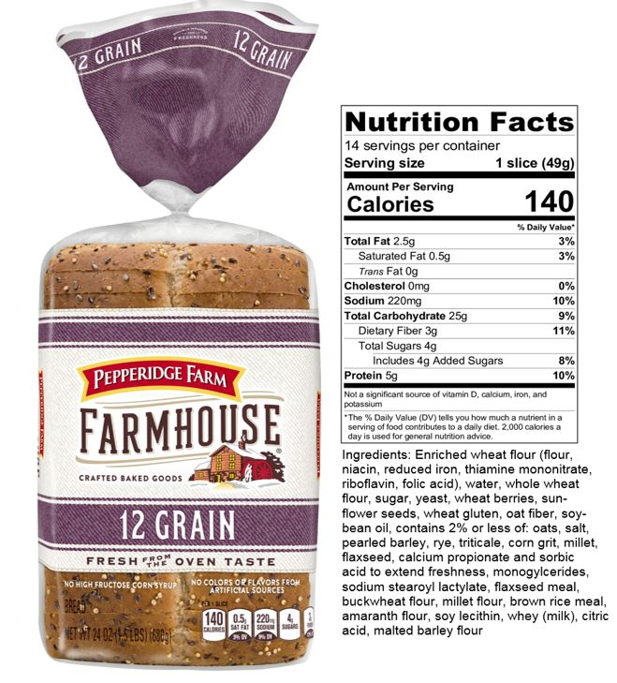

**Which of the following statements best applies to the product in the image?**

* All the grain is whole grain
* Half or more than half the grain is whole grain
* Less than half the grain is whole grain
* There is little or no whole grain
* Other

Online Supplemental Figure 4. Product images and survey questions for WG content of 4 actual products