Supplemental figures
Figure S1. Average intake reported by week of data collection, components of total dairy over two-year data collection period (2017-2019).

Milk
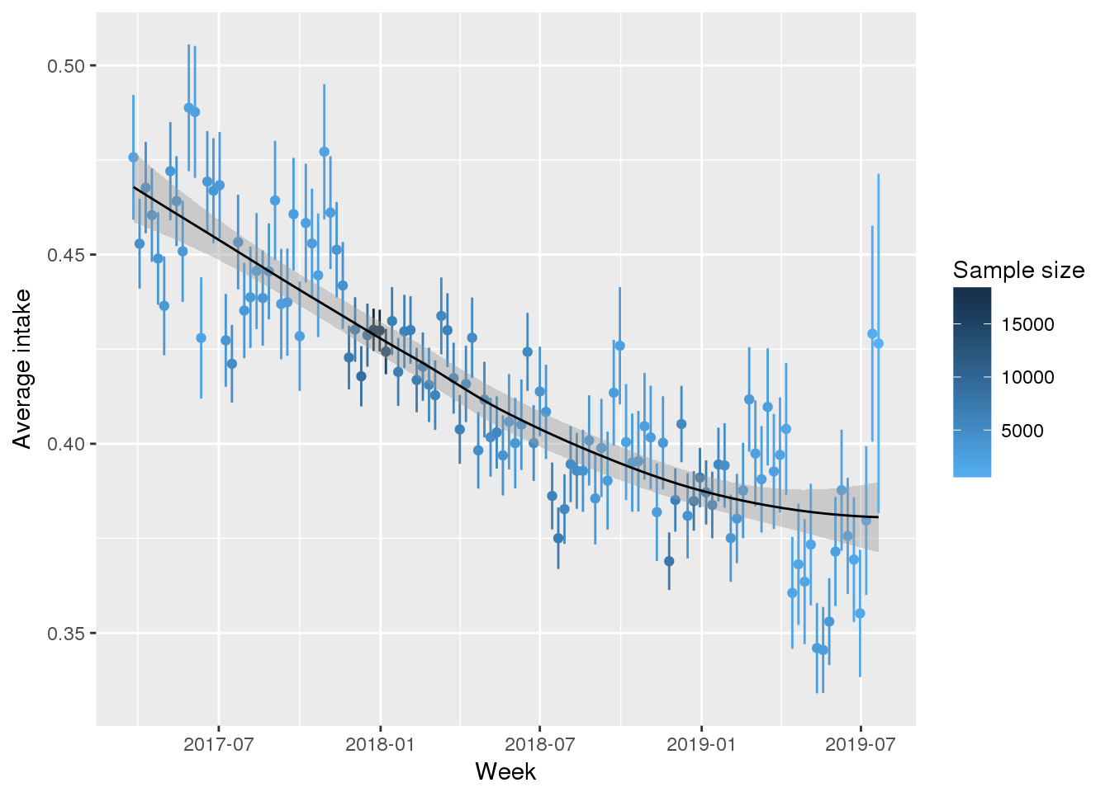
Cheese
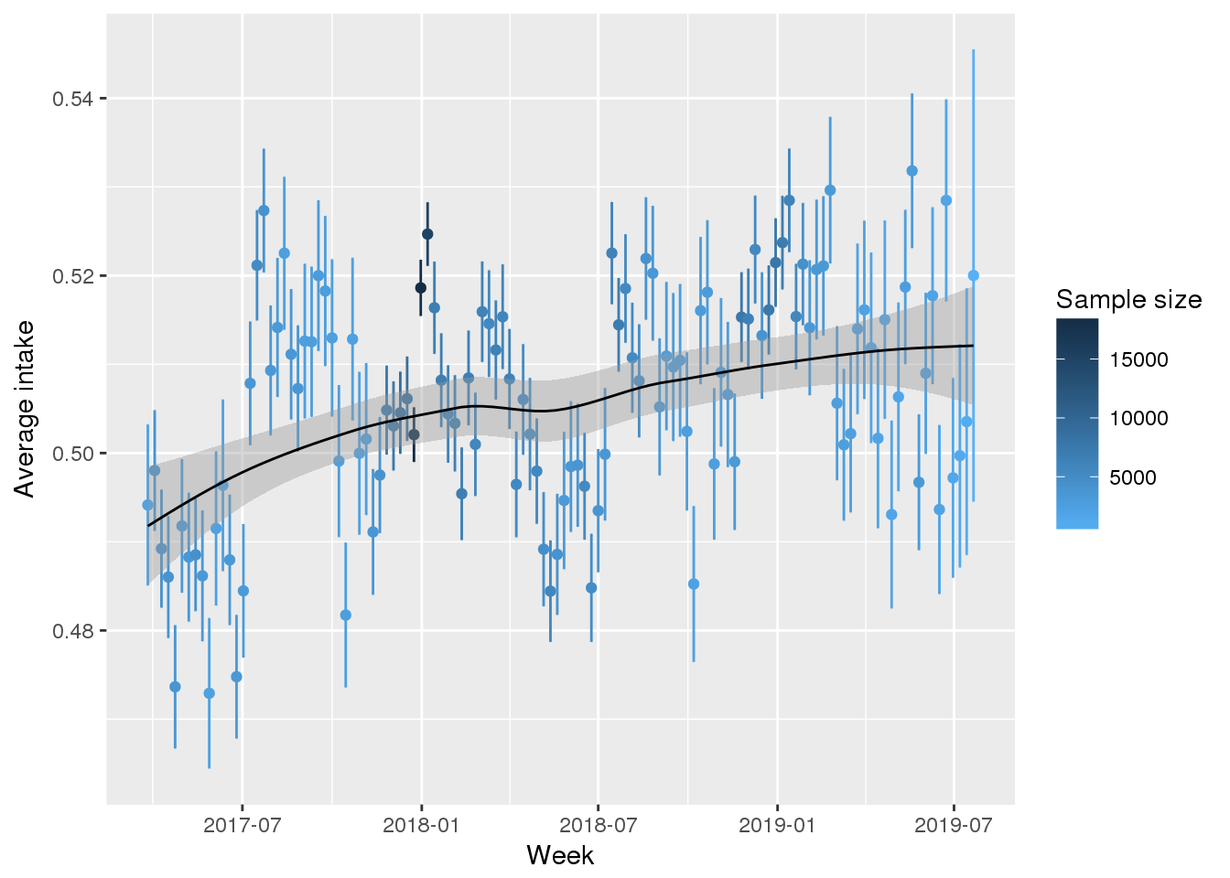
Pizza
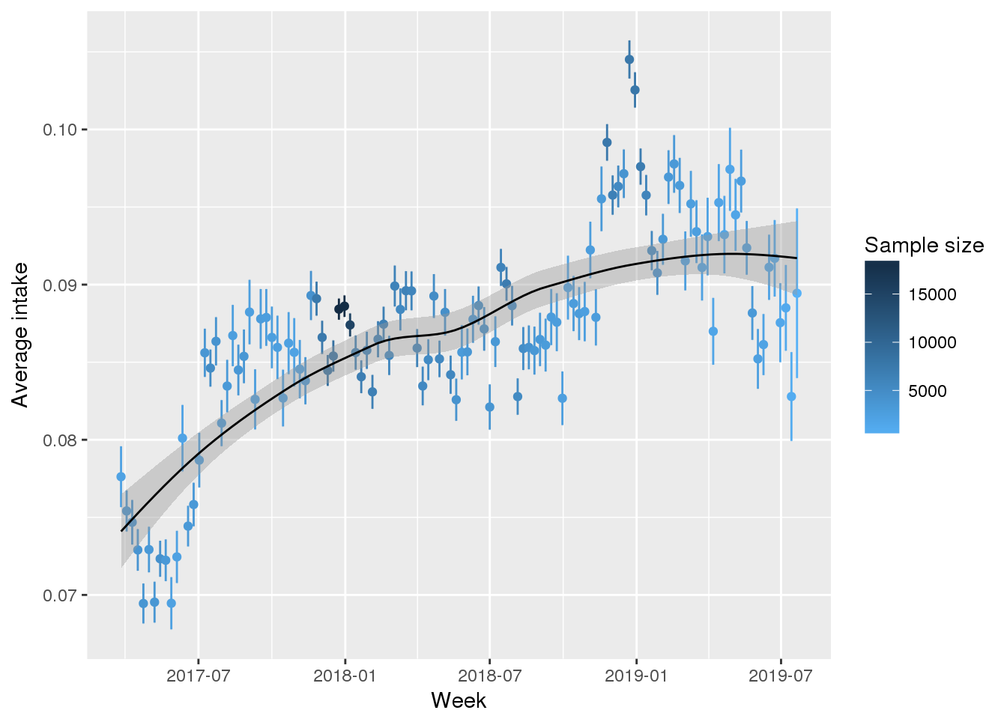

Ice cream
