THE CARDIO-MED SURVEY TOOL

INSTRUCTIONS

The following questions ask about your lifestyle, background, medical history and current diet that relate to your health.

When answering questions please tick one box only unless otherwise specified. Please mark your response as follows

If you find that your answer will not fit the answer categories provided, please tick the box named ‘other, please specify’ and briefly describe your answer.

If you don’t feel comfortable answering any of these questions, please leave the answer blank.

Kucianski et al.

Image source: 1. www.suneeldhand.com/tag/medication-reconciliation-best-practice/; 2. www.massey.ac.nz/massey/about-massey/news/article.cfm; 3. www.diabetessmart.net/physical-activity-in-diabetes-prevention/
The following questions will ask you about your lifestyle, background and medical history.
1. What is your postcode? _______________________

2. What is your gender?
- Male
- Female

3. What is your date of birth? _ _ /_ _ / 19 _ _
4. What country were you born in?
- Australia (Skip to Question 5)
- Other please specify _____________________
What year did you migrate to Australia? ________________________________(Skip to Question 6)

5. Are you of Aboriginal or Torres Strait Islander origin? (Tick ALL that apply)
- No
- Yes Aboriginal
- Yes Torres Strait Islander

6. What country were your parents born in?
Mother
- Australia
- Other please specify______________________
Father
- Australia
- Other please specify ______________________

7. Do you speak a language other than English at home?
- No, English only
- Yes, please specify_________________________

8. What is your marital status?
- Married
- Not married but in a long term relationship.
- Widowed
- Separated
- Divorced
- Single
9. Including yourself, how many people live in your household?
- 1
- 2
- Other, please specify _______________________

10. What is the highest level of education you have completed?
- Never attended school
- Primary school
- Secondary school up to year 10
- Secondary school up to year 12 (or equivalent)
- Trade school / TAFE
- University

11. Do you have a paid job at present?
- No
- Yes (Skip to Question 13)

12. How would you describe yourself?
- Homemaker
- Retired
- Unemployed
- Student
- Permanently unable to work / ill
- Other, please specify _______________________

13. Which of the following categories best describes your current area of employment OR previous employment if not currently working?
- Managers e.g. general manager, school principle, director of nursing, farm manager
- Professionals e.g. doctor, teacher, nurse, scientist, accountant
- Associate professionals e.g. police officer, technician, youth worker
- Tradespersons and related workers e.g. hairdresser, gardener, florist, mechanic, cook
(Continue to next column)
- Clerical and services worker e.g. receptionist, flight attendant, hospitality worker, sales assistant, child care worker, telemarketer
- Intermediate production and transport workers e.g. machine operator, bus driver
- Labourers and related workers e.g. cleaner, factory worker
- I have never worked

Income is very important in understanding health, as it may influence the health services a person can access

14. Which number best describes your total household income before tax?
- $3000+ per week ($156,000)
- $2000-$2,999 per week ($104,000-$155,999per year)
- $1500-$1999 per week ($78,000-$103,999 per year)
- $1000-$1499 per week ($52,000-$77,999 per year)
- $600-$999 per week ($31,200-$51,999 per year)
- $200-$599 per week ($10,400-$31,199 per year)
- $1-$199 per week ($1,000-$10,399 per year)
- $0

The following questions ask you about your health and medical history

15. In general would you say your health is?
- Excellent
- Very Good
- Good
- Fair
- Poor

The next question asks about your heart health
16. Has the doctor ever told you that you have had any of the following medical conditions?
Tick as many boxes that apply and please specify how old you were when you found out.
- Angina
How old were you? _______________________
- Heart attack
How old were you? _______________________
(Continue to next column)
- Other heart condition e.g. heart failure

Please specify condition_____________________
_________________________________
How old were you?___________________
- Hypertension (high blood pressure)
How old were you? ____________________
- High cholesterol
How old were you? ________________________
- High triglycerides
How old were you? ________________________

The next question asks about your other medical conditions?
17. Has the doctor ever told you that you have any of the following medical conditions? (Tick ALL that apply)
- Stroke
- Kidney failure or having dialysis
- Inflammatory conditions e.g. Rheumatoid arthritis, Chron’s disease.
- Liver failure
- Fatty liver
- Cancer (currently receiving treatment)
- Diabetes (Type 2)
- Diabetes (Type 1)
- Thyroid overactive
- Thyroid underactive
- Depression
- Other please specify ________________________
____________________________________
____________________________________

18. Have any of your immediate relatives (parents, brothers or sisters) ever been diagnosed with the following medical conditions? (Tick ALL that apply)
- Angina
- Heart attack
- Stroke
- High blood pressure
- High cholesterol
- Diabetes (Type 2)
- Thyroid (either over or underactive)
19. Do you currently take any prescription medications?
- Yes
- No (Skip to Question 22)

20. Please list all the names of the prescription medications you take.
Name | Strength | How many tablets per day
e.g. Lipitor | 80mg | 1 tablet

21. In the past month how often did you take your medication as the doctor prescribed?
- All of the time (100%)
- Nearly all of the time (90%)
- Most of the time (75%)
- About half of the time (50%)
- Less than half of the time (<50%)

22. Do you take any supplements e.g. vitamins, minerals, fish oil, fibre supplements etc.
- Yes
- No (Skip to Question 23)

Please list ALL the supplements that you take in the table below and include brand name and dose.
Type | Brand name | Dose – How many tablets do you take per day
E.g. Vitamin D | E.g. Ostelin | E.g. 1 per day
(Continue to next column)

Type | Brand name | Dose

The following questions ask you about your smoking history

23. Have you ever smoked?
- Yes
- No (Skip to Question 30)

24. Have you ever smoked at least 100 cigarettes or the equivalent amount of tobacco in your lifetime?
- Yes
- No

25. Have you ever smoked daily?
- Yes
- No

26. Do you now smoke?
- daily
- occasionally
- not at all

27. On average, what number of cigarettes do/did you smoke per day?
_____________________________________________________

28. How many years have you smoked/did you smoke daily?
_____________________________________________________

29. How long has it been since you last smoked daily?
- Less than one month
- One month or longer but less than six months
- Six months or longer but less than one year
- One year or longer but less than five years
- Five years or longer but less than 10 years
- 10 years or longer
30. The following questions ask you about the
kinds of physical activities that people do as part of their everyday lives.
The questions will ask you about the time you spent being physically active in the last 7 days. Please answer each question even if you do not consider yourself to be an active person. Please think about the activities you do at work, as part of your house and yard work, to get from place to place, and in your spare time for recreation, exercise or sport.

Think about all the vigorous activities that you did in the last 7 days. Vigorous physical activities refer to activities that take hard physical effort and make you breathe much harder than normal. Think only about those physical activities that you did for at least 10 minutes at a time.

During the last 7 days, on how many days did you do vigorous physical activities like heavy lifting, digging, aerobics, or fast bicycling?
_____ days per week
- No vigorous physical activities (Skip to question 32)
31. How much time did you usually spend doing vigorous physical activities on one of those days?
_____ hours per day
_____ minutes per day
- Don’t know/Not sure

32. Think about all the moderate activities that you did in the last 7 days. Moderate activities refer to activities that take moderate physical effort and make you breathe somewhat harder than normal. Think only about those physical activities that you did for at least 10 minutes at a time.

During the last 7 days, on how many days did you do moderate physical activities like carrying light loads, bicycling at a regular pace, or doubles tennis? Do not include walking.

_______ days per week
- No moderate physical activities (Skip to question 34)
33. How much time did you usually spend doing moderate physical activities on one of those days?
_____ hours per day
_____ minutes per day
- Don’t know/Not sure

34. Think about the time you spent walking in the last 7 days. This includes at work and at home, walking to travel from place to place, and any other walking that you have done solely for recreation, sport, exercise, or leisure.
During the last 7 days, on how many days did you walk for at least 10 minutes at a time?
_____ days per week
- No walking (Skip to question 36)

35. How much time did you usually spend walking on
one of those days?
_____ hours per day
_____ minutes per day
- Don’t know/Not sure

36. The last question is about the time you spent sitting on weekdays during the last 7 days. Include time spent at work, at home, while doing course work and during leisure time. This may include time spent sitting at a desk, visiting friends, reading, or sitting or lying down to watch television.
During the last 7 days, how much time did you spend
sitting on a week day?
_____ hours per day
_____ minutes per day
- Don’t know/Not sure

You have now finished the first part of this survey. Next we would like to ask you some questions about what you like to eat and drink.

The following table asks you how often you have eaten certain foods over the last 12 months

Please estimate your average food intake as best you can, place ONE tick per line for every food in the table.
How often do you eat | Never | Time per month |  |  |  | Times per week |  |  |  | Times per day
 |  | 1 | 2 -3 |  |  | 1 | 2 | 3 -4 | 5 -6 | 1 | 2 |  | 3
VEGETABLES
Salad vegetables (e.g. lettuce, tomato, cucumber)

Green leafy vegetables (e.g. spinach, bok choy etc)

Potato excluding fried chips

All other vegetables

Onion or foods cooked with onion

Garlic or foods cooked with garlic

Meals made with a tomato-based sauce (made from fresh/paste/tinned tomatoes with onion or garlic)

Olives

Legumes (e.g. baked beans, lentils, chickpeas etc.)

Tofu/tempeh or vegetarian products (e.g. Quorn,
Vegetarian sausages etc.)
FRUIT
Fruit

MEAT & FISH
Fresh or canned fish excluding battered fish e.g. fish and chips
Red meat i.e. beef, lamb, pork or goat (exclude processed meats e.g. salami, ham etc.)
White meat i.e. chicken, turkey etc. (exclude processed meats e.g. chicken loaf, bacon etc.)
Processed meat (e.g. sausages, bacon, salami, ham, devon etc.)
Game meat (e.g. rabbit, venison etc.)

Game birds (e.g. turkey, duck, quail etc.)

Offal (e.g. kidney, liver, intestine etc.)

CEREAL FOODS
Breakfast cereal

Rice

How often do you eat | Never | Time per month |  |  |  | Times per week |  |  |  | Times per day
 |  | 1 |  |  | 2-3 | 1 | 2 | 3-4 | 5-6 | 1 | 2 |  |  | 3
Pasta

Noodles

DAIRY
Yoghurt

Cheese

OTHER
Nuts and/or seeds

Snacks (e.g. potato crisps, sweet/savoury biscuits, lollies, cakes and sweet pastries)
Chocolate

Meals that aren’t prepared at home (take away and restaurant food)
HERBS & SPICES
Oregano (fresh or dried)

Curry powder

Turmeric

Cinnamon

Ginger

Chilli (fresh or dried)

CONDIMENTS ADDED TO MEALS
Lemon juice

Vinegar (any type)

Tomato sauce

Soy sauce

Salt

Pepper

The following questions ask you about how much you eat of certain foods over the last 12 months.

Please estimate the amount you eat on average as best as you can using the following pictures as a guide and attempt to answer every question by placing a tick in the box.

1. On average when you eat salad vegetables, do you eat?
I don’t eat salad vegetables
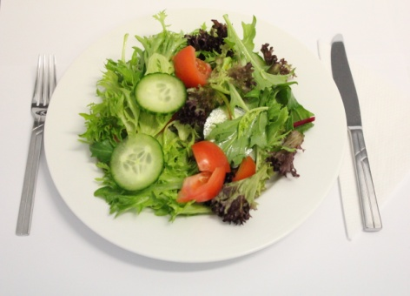
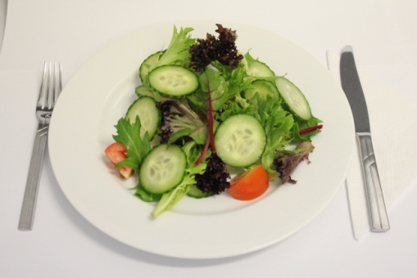
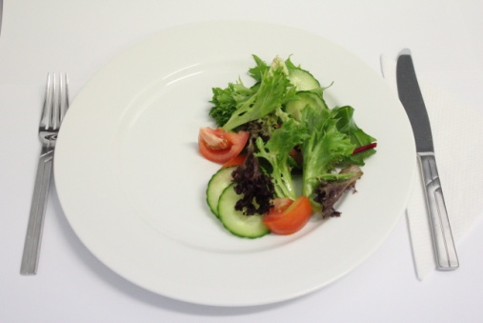
Less than A A Between A & B B Between B & C C More than C
C
B
A

2. On average when you eat green leafy vegetables, do you eat?
I don’t eat green leafy vegetables
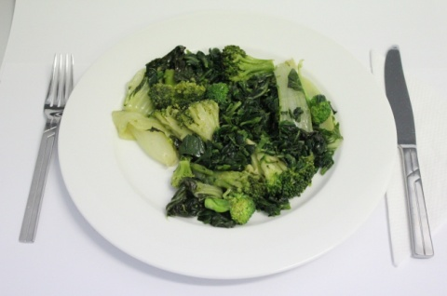
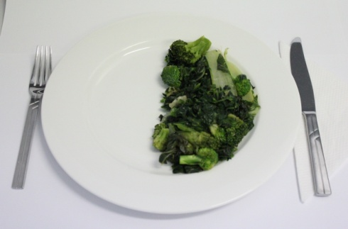
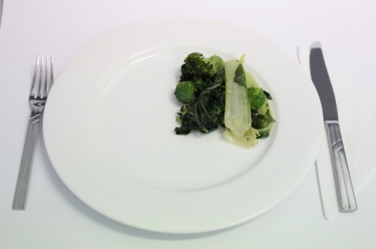
C
B
A
Less than A A Between A & B B Between B & C C More than C

3. On average when you eat potato, do you eat?
I don’t eat potato
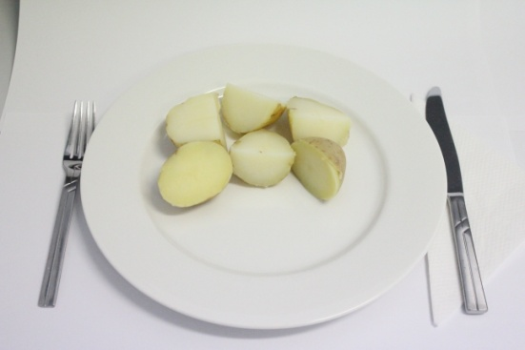
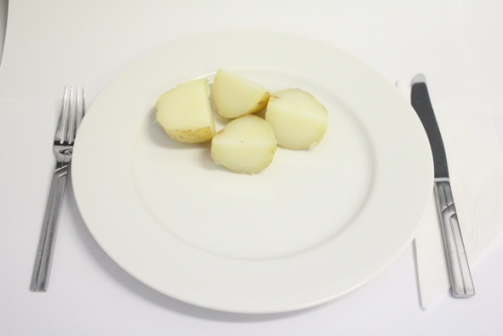
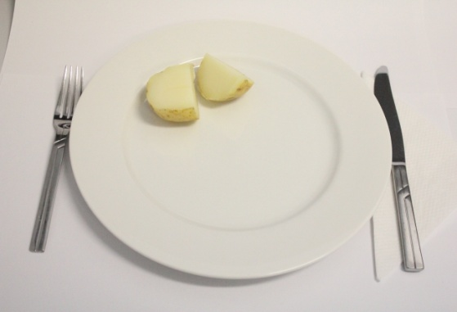
A
C
B
Less than A A Between A & B B Between B & C C More than C

4. On average when you eat vegetables, do you eat?
I don’t eat vegetables
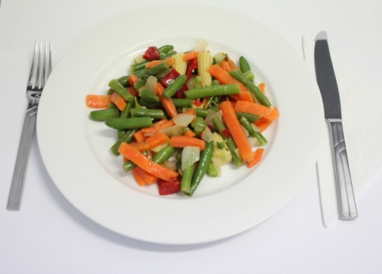
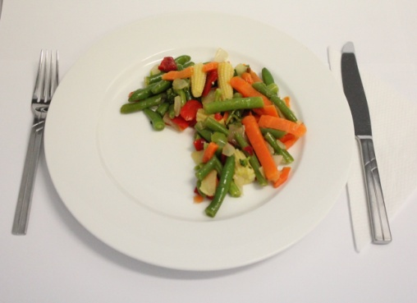
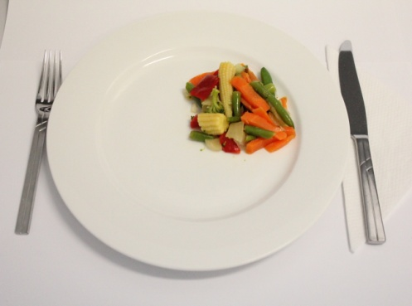
C
A
B
Less than A A Between A & B B Between B & C C More than C
5. On average when you eat legumes, do you eat?
I don’t eat legumes
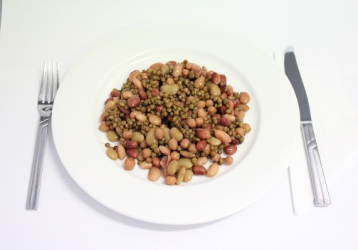
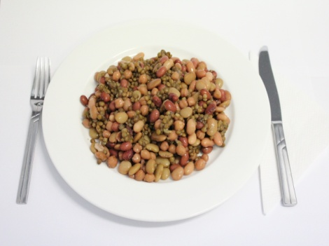
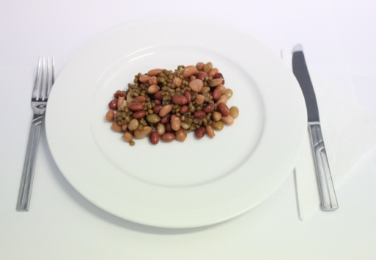
C
B
A
Less than A A Between A & B B Between B & C C More than C
6. On average when you eat fish, do you eat?
I don’t eat fish
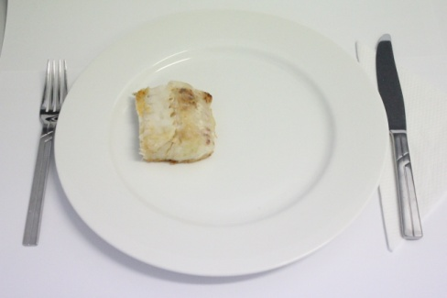
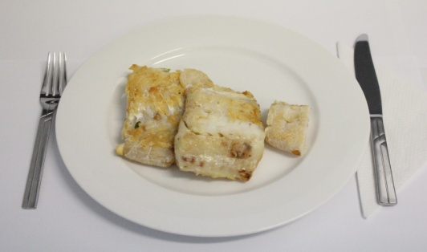
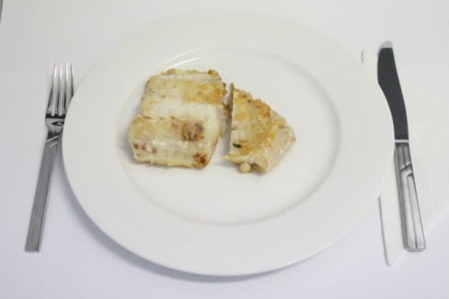
A
C
B
Less than A A Between A & B B Between B & C C More than C
7. On average when you eat red meat, do you eat? (Include meat from mixed dishes e.g. casseroles)
I don’t eat red meat
A
B
C
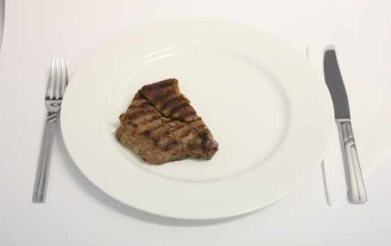
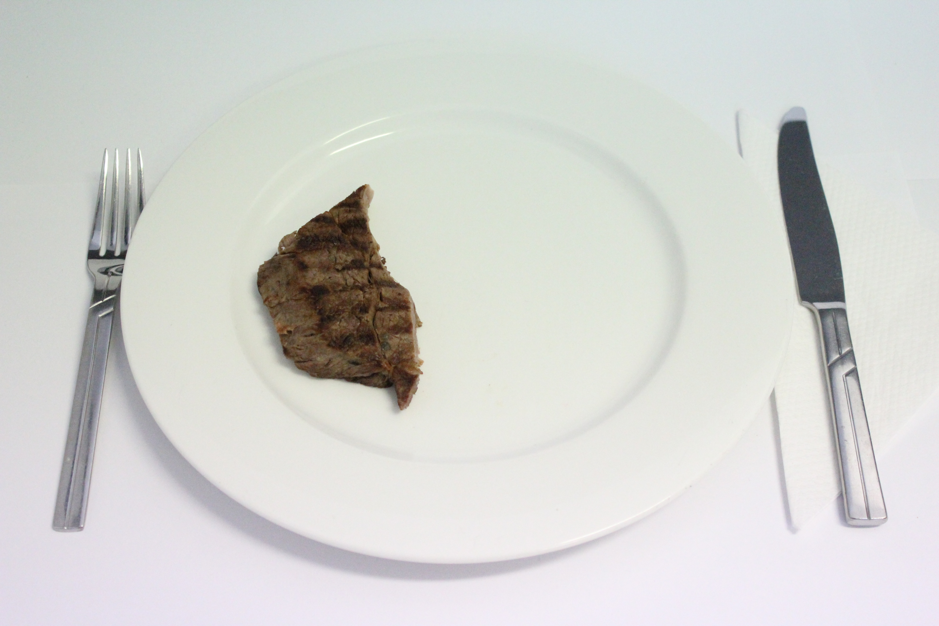
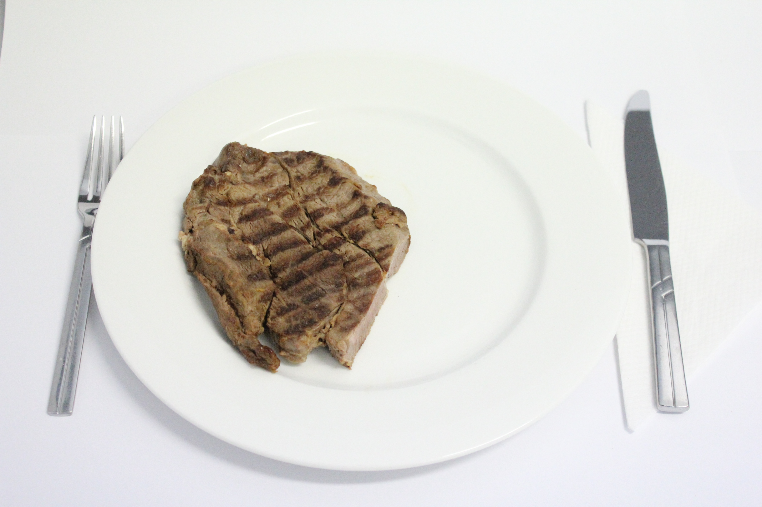
Less than A A Between A & B B Between B & C C More than C
8. On average when you eat white meat, do you eat? (Include meat from mixed dishes e.g. casseroles)
I don’t eat white meat
C
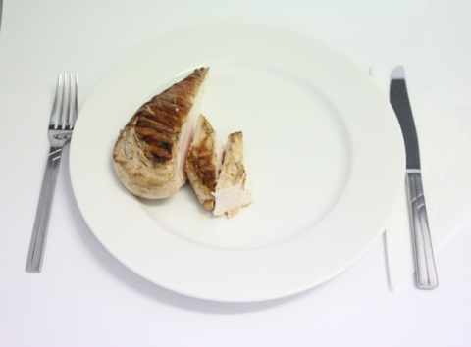
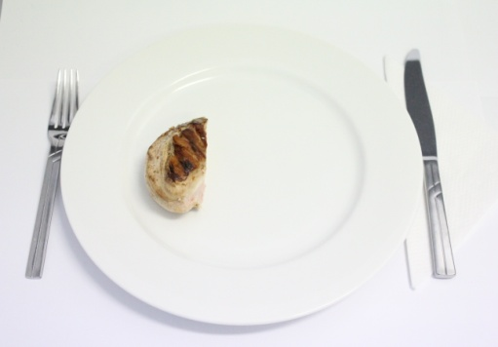
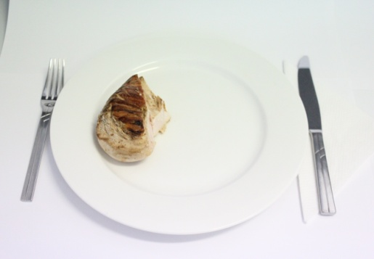
B
A
Less than A A Between A & B B Between B & C C More than C
9. On average when you eat breakfast cereal, do you eat?
I don’t eat breakfast cereal

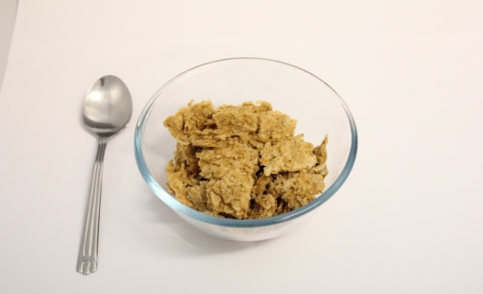
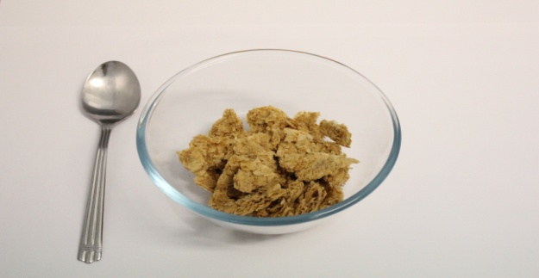
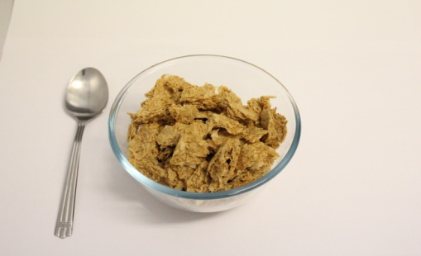
B
C
A
Less than A A Between A & B B Between B & C C More than C
10. On average when you eat rice, do you eat?
I don’t eat rice

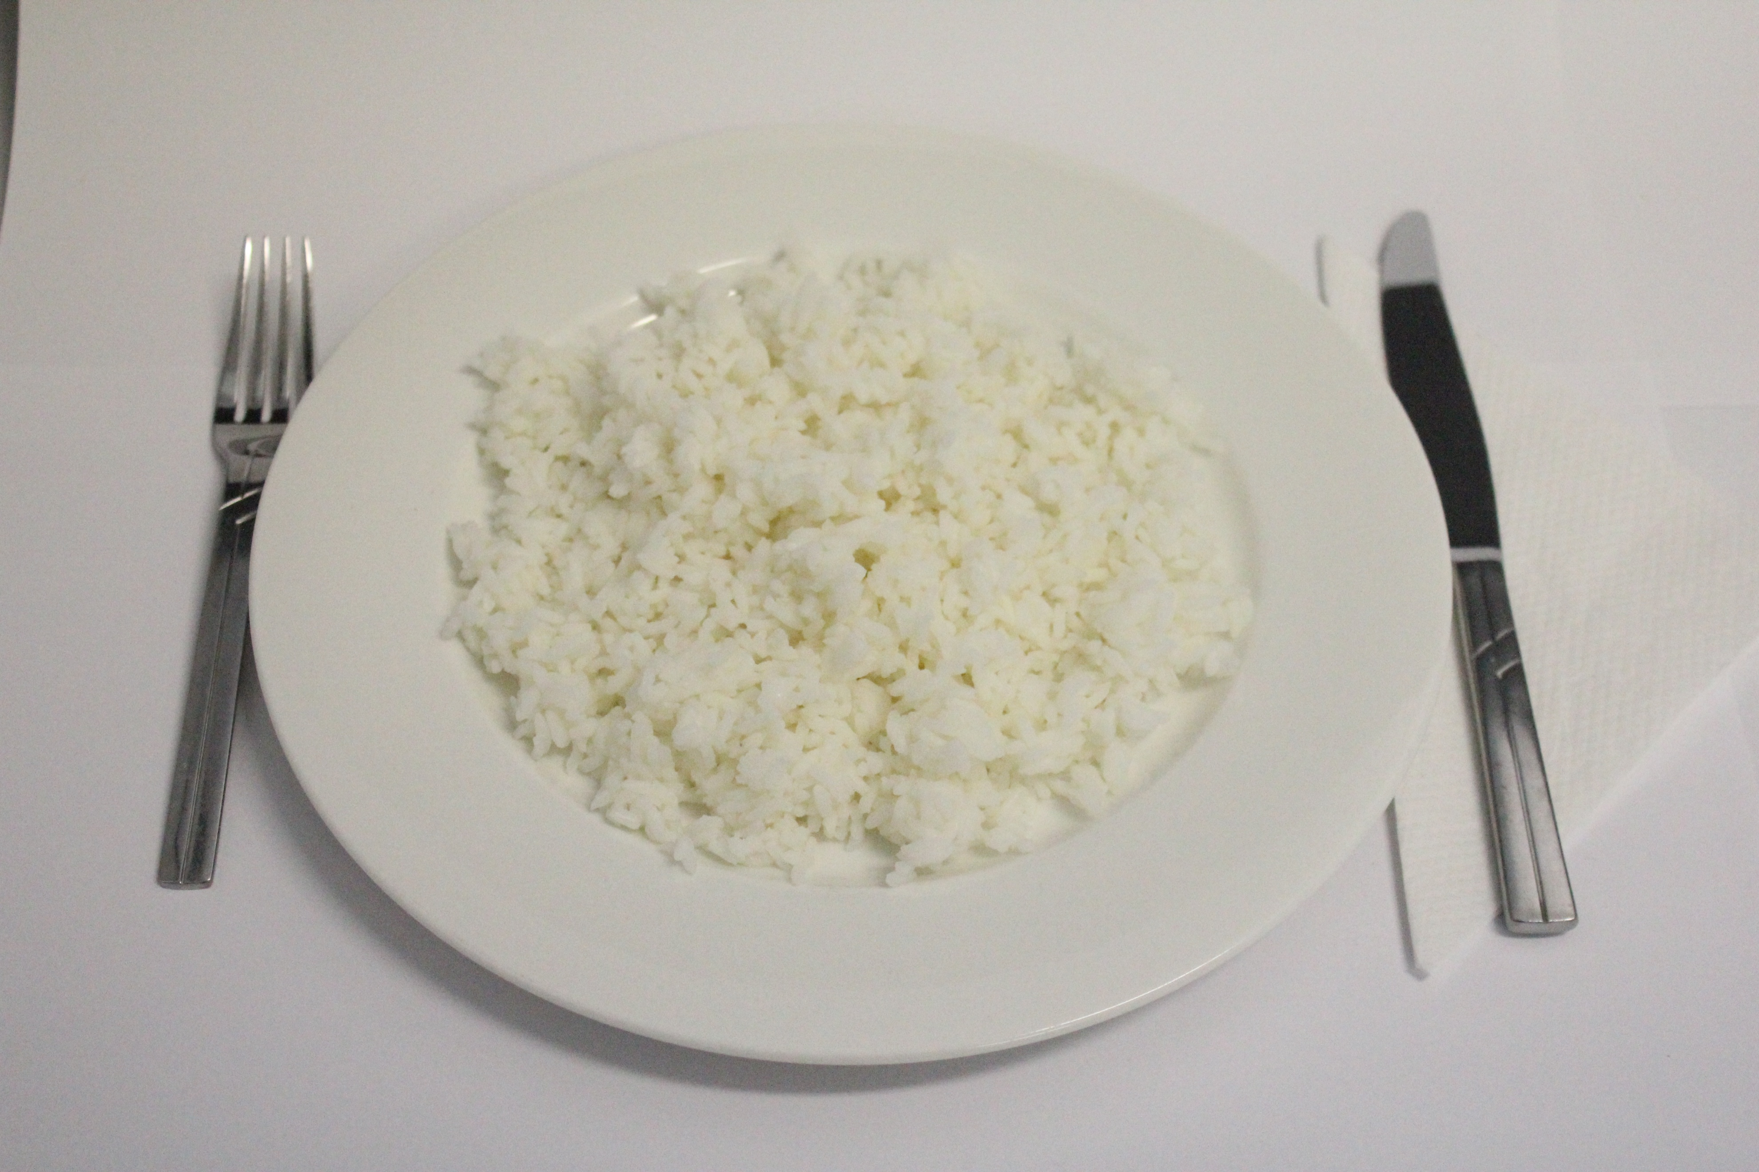
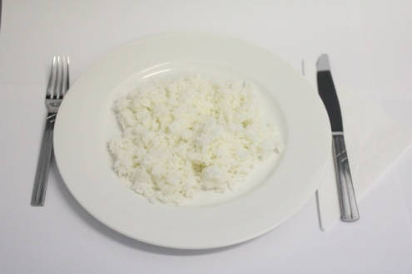
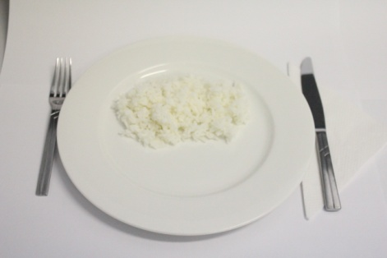
C
B
A
Less than A A Between A & B B Between B & C C More than C
11. On average when you eat pasta and/or noodles, do you eat?
I don’t eat pasta and/or noodles
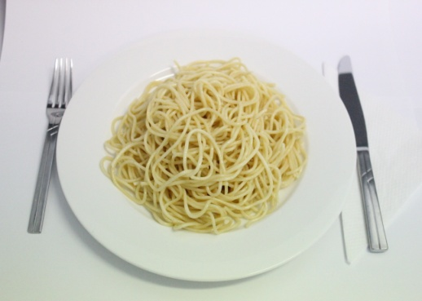
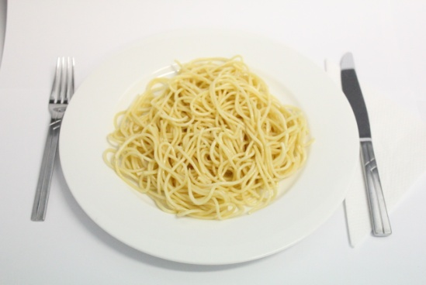
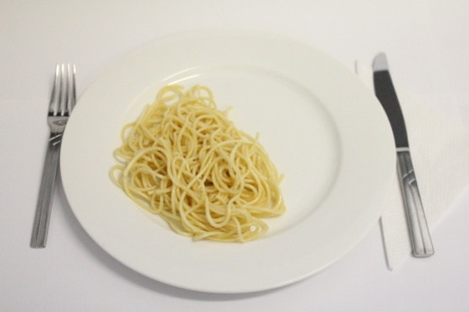
C
B
A
Less than A A Between A & B B Between B & C C More than C
12. On average when you eat yoghurt, do you eat?
I don’t eat yoghurt

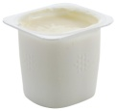
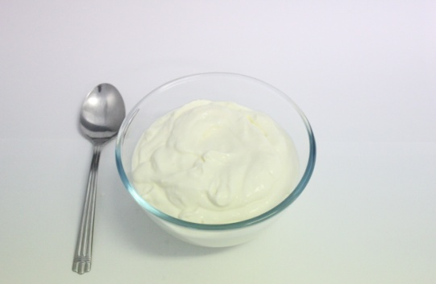
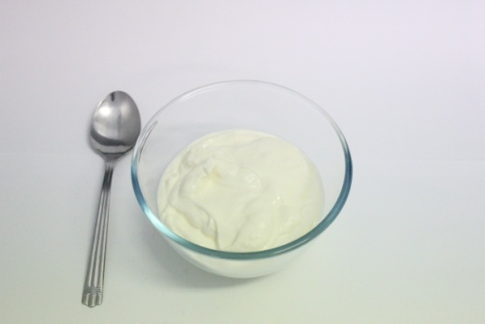
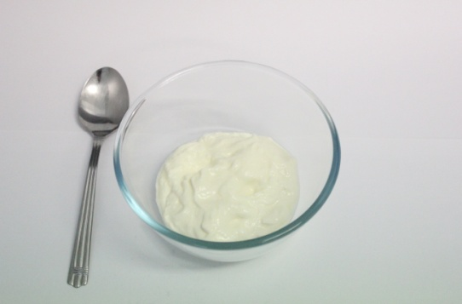
=
C
B
A
Less than A A Between A & B B Between B & C C More than C

13. On average when you eat cheese, do you eat?
I don’t eat cheese
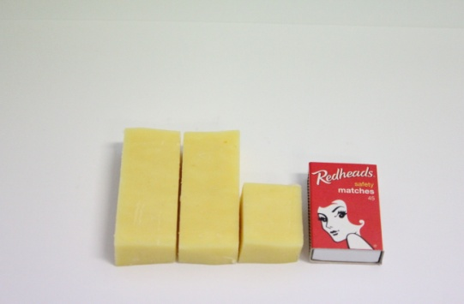
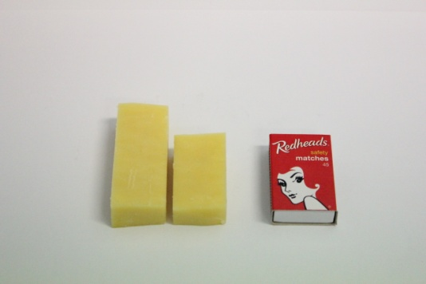
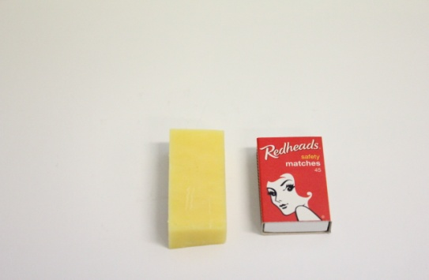
C
B
A
Less than A A Between A & B B Between B & C C More than C

14. On average, when you eat nuts, do you eat?
I don’t eat nuts

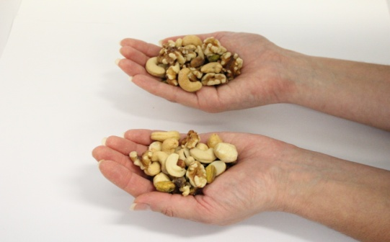
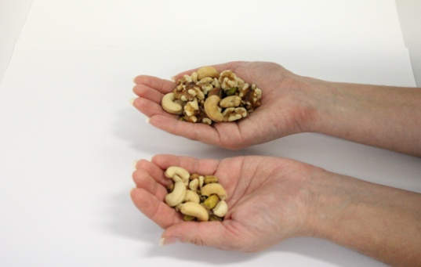
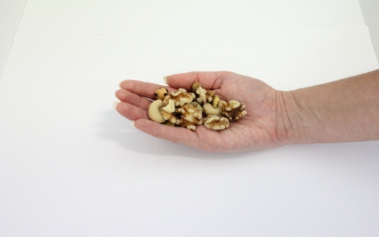
C
B
A
Less than A A Between A & B B Between B & C C More than C

The following questions ask you about the types of food that you prefer to eat and your dietary habits over the last 12 months.
Please estimate your average food intake as best as you can and please attempt to answer every question

1. What is the MAIN type of fat or oil that you use for COOKING? (Please tick ONE option)
- I don’t use anything
- Extra virgin olive oil
- Other olive oil e.g. light
- Canola, peanut, sesame, rice bran oil
- Vegetable, sunflower, safflower, grapeseed oil
- Ghee, butter, palm oil, lard, dripping
- Coconut oil
Margarine
- Monounsaturated e.g. Olive Grove, Meadow Lea
- Polyunsaturated e.g. Flora, Nuttelex
- Cholesterol lowering e.g. Flora Pro Activ, Meadow Lea Logicol

2. What is the MAIN type of fat or oil that you add to COOKED VEGETABLES? (Please tick ONE option)
- I don’t use anything
- Extra virgin olive oil
- Other olive oil e.g. light
- Canola, peanut, sesame, rice bran oil
- Vegetable, sunflower, safflower, grapeseed oil
- Ghee, butter, palm oil, lard, dripping
- Coconut oil
Margarine
- Monounsaturated e.g. Olive Grove, Meadow Lea
- Polyunsaturated e.g. Flora, Nuttelex
- Cholesterol lowering e.g. Flora Pro Activ, Meadow Lea Logicol

3. What type of dressings do you usually add to SALAD vegetables? (Tick ALL that apply)
- No dressing
- Extra virgin olive oil
- Other olive oil e.g. light
- Canola, peanut, sesame, rice bran oil
(Continue to next column)

- Vegetable, sunflower, safflower, grapeseed oil
- Vinegar
- Mayonnaise
- Lemon juice
- Other, please specify______________________

4. What is the MAIN type of spread that you usually put on BREAD? (Please tick ONE option)
- I don’t use anything
Margarine
- Monounsaturated e.g. Olive Grove,
Meadow Lea
- Polyunsaturated e.g. Flora, Nuttelex
- Cholesterol lowering e.g. Flora Pro Activ, Meadow Lea Logicol
Butter
Nut spreads e.g. peanut butter, tahini

5. How much fat and/or oil (in total) do you consume on average per day? (Think about all the types of fat and/or oil you use daily e.g. in cooking/on bread etc.)
- 1 teaspoon (5mL)
- 1 tablespoon (20mL)
- 2 tablespoons (40mL)
- 3 tablespoons (60mL)
- Other, please specify how much___________

6. How often is the meat that you eat trimmed of fat before or after cooking?
- Never/ rarely
- Sometimes
- Usually
- Always

7. How many teaspoons of sugar do you add to your food and drink each day? (Include sugar in tea, coffee, cereal etc.)
- I don’t add sugar 6-7 teaspoons
- 1-2 teaspoons 8-9 teaspoons
- 3-4 teaspoons 10-11 teaspoons
- 5-6 teaspoons 12+ teaspoons
8. What is the MAIN type of milk that you usually drink? (Please tick ONE option)
- I don’t drink milk (Skip to Question 11)
- Cow’s milk
- Goat’s milk
- Evaporated milk/condensed milk
- Soy milk
- Rice milk
- Other, please specify_____________________

9. What is the fat content of the MAIN type of milk you usually drink? (Please tick ONE option)
- Full cream
- Reduced fat milk
- Skim milk
- I don’t know

10. How much milk do you usually drink per day? (Include milk added to tea, coffee, cereal etc)
- Less than 250ml (1 large cup or glass)
- Between 250 and 500ml (1-2 cups)
- Between 500 and 750ml (2-3 cups)
- 750ml (3 cups) or more

11. What is the MAIN type of yoghurt that you usually eat? (Please tick ONE option)
- I don’t eat yoghurt (Skip to Question 13)
- Natural
- Vanilla
- Fruit flavoured

12. What is the fat content of the MAIN type of yoghurt you usually eat?
- Full fat
- Low fat
- I don’t know

13. What is the MAIN type of CHEESE that you usually eat? (Please tick ONE option)
- I don’t eat cheese (Skip to Question 15)
- White cheese e.g. fetta
- Hard cheeses e.g. parmesan
(Continue to next column)

- Firm cheeses e.g. cheddar and edam
- Soft cheeses e.g. camembert and brie
- Ricotta or cottage cheese
- Cream cheese

14. What is the fat content of the MAIN type of cheese you usually consume? (Please tick ONE option)
- Full fat
- Low fat
- I don’t know

15. On average how many eggs do you eat per week?
- I don’t eat eggs
- Less than one egg
- 1 - 2 eggs
- 3 - 5 eggs
- 6 or more eggs

16. How many pieces of fresh fruit do you usually eat on average per day? (1 piece = 1 cup of diced fruit or 2 small pieces of fruit)
- I don’t eat fruit
- Less than 1 piece
- 1 piece
- 2 pieces
- 3 pieces
- More than 3 pieces, please specify__________

17. What is the MAIN type of bread you usually eat? (Please tick ONE option)
- I don’t eat bread (Skip to Question 19)
- Hi fibre white bread
- White bread
- Wholemeal bread
- Multi-grain bread
- Rye bread
- Gluten free bread
- Flat bread (e.g. Roti, Pita, Wraps, Pide etc.)
- Other, please specify_____________________

18. How many slices of bread do you usually eat per day? (Include all types, fresh or toasted and count one bread roll/flat bread as 2 slices)
- 1 slice per day
- 2 slices per day
- 3 slices per day
- 4 slices per day
- 5-7 slices per day
- 8 or more slices per day

19. What type of cereal do you usually consume?
- I don’t eat cereal
- Porridge
- Wholegrain (e.g Muesli, Weetbix, Hi-Fibre flakes)
- Other (e.g. Cornflakes, Coco Pops, Nutri-grain)

20. What is the MAIN type of fish you usually eat? (You can tick up to TWO options)
- I don’t eat fish
- Canned fish
- White flesh fish e.g. flake, whiting etc.
- Oily fish e.g. salmon, tuna, sardines etc.
- Shellfish e.g. prawns, lobster, crab etc.
- Molluscs e.g. calamari, oyster, octopus etc.
- Other, please specify_________________

21. What are the MAIN types of nuts and/or seeds that you usually eat? (Tick ALL that apply)
- I don’t eat nuts and seeds (Skip to Question 23)
- Almonds
- Walnuts
- Peanuts
- Pistachio
- Sunflower seeds
- Pepitas (pumpkin seeds)
- Other, please specify _________________

22. Are the main type of nuts that you eat
- Raw / Natural
- Roasted
- Salted
- Sugar coated
- Chocolate coated
23. When you eat takeaway food, which of these foods do you USUALLY choose? (Tick ALL that apply)
- I never eat takeaway foods
- Meat pie, pastie, quiche & savoury pastries
- Hamburger with a bun
- Chicken and chips
- Battered/fried fish (include takeaway)
- Pasta
- Stir-fry
- Curry
- Kebab
- Pizza
- Dim sims or spring rolls
- Hot dog
- Hot chips, wedges, french fries
- Sushi
- Other, please specify_________________

24. When you eat snack food, which of these foods do you USUALLY choose? (Tick ALL that apply)
- Corn chips, potato chips, twisties etc.
- Popcorn
- Sweet biscuits
- Savoury biscuits
- Cakes or sweet pastries
- Puddings
- Confectionary containing chocolate
- Lollies
- Ice cream
- Muesli bar
- Muffin
- Other, please specify_________________

25. When you eat chocolate, which type of chocolate do you USUALLY choose? (Please tick ONE option)
- I don’t eat chocolate
- Milk chocolate
- Dark chocolate
- White chocolate

26. What type of coffee do you MOST OFTEN drink? (Please tick ONE option)
- I don’t drink coffee
- Greek/Turkish
- Regular cappuccino / latte
- Filter
- Espresso
- Plunger
- Other, please specify ___________________

27. What type of tea do you MOST OFTEN drink?
(Please tick ONE option)
- I don’t drink tea
- Black Tea
- Green Tea
- Other, please specify______________________

28. What is the MAIN method you use for cooking vegetables? (You can tick up to TWO options)
- I don’t eat cooked vegetables
- Barbeque / Grill
- Deep frying
- Fry pan / Stir fry
- Casserole / Curry
- Steaming / Boiling / Microwaving
- Roasting / Baking

29. What is the MAIN method you use for cooking fish? (You can tick up to TWO options)
- I don’t eat fish
- Barbeque / Grill
- Deep frying
- Fry pan / Stir fry
- Casserole / Curry
- Steaming / Poaching
- Roasting / Baking

30. What is the MAIN method you use for cooking meat? (You can tick up to TWO options)
- I don’t eat meat
- Barbeque / Grill
- Deep frying
- Fry pan / Stir fry
- Casserole / Curry
- Steaming / Poaching
- Roasting / Baking

31. How often do you add salt to your food after it is cooked?
- Never/rarely
- Sometimes
- Usually

32. How often is salt added to your food during cooking?
- Never/rarely
- Sometimes
- Usually

33. Do you grow your own fruits and/or vegetables?
- Yes
- No (Skip to Question 35)

34. What proportion of fruits and/or vegetables that you eat comes from your garden?
- Less than 25%
- 25%
- 50%
- 75%
- More than 75%

35. Who does the food shopping in your household? (Tick ALL that apply)
- I do
- Family member
- Other, please specify who_________________

36. Who does the cooking in your household?
(Tick ALL that apply)
- I do
- Family member
- Other, please specify who_________________

37. In the last 12 months have you been on a special diet for any of these reasons?
(Tick ALL that apply)
- No, I haven’t been on a special diet
- High blood pressure
- Stomach problems e.g. ulcer, reflux
- Bowel problems e.g. IBS
- Allergies e.g. skin rash
- Concern over a family history or illness
- High blood cholesterol
- Overweight or obesity
- Diabetes
- Concern over eating a healthy diet
- Other, please specify_______________________
________________________________________________________________________

Reason | I do not wish to change | Cost too much | Cheap | Availability | Storage | Quality | Like the  taste | Do not like | Cooking  skills | Convenient | Other reason, please specify
Type of food
Fruit & vegetables

Breads & cereals

Food high in fat

Food high in sugar

38. Would you like to change the amount you eat of any of the foods listed in the table below? If yes, what is stopping you from making this change?
Please tick ALL options that apply and attempt to answer every question.

The following questions ask you about the type of drinks that you regularly consume.

39. Please estimate how many glasses or cups you drink per day on average for ALL of the following options.

How many glasses or cups do you drink of the following per day? 1 glass or cup = 250mL | Glasses or cups per day
 | None | 1-2 | 3-4 | 5-6 | 7-8 | 8+
E.g. Water

Water

Coffee

Tea

Pure fruit juice

Regular fizzy soft drink

Regular cordial

Diet drinks e.g. cordial, fizzy soft drink

Sports drink e.g. Gatorade

Flavoured milk e.g. Milo, Big M

Hot chocolate e.g. made with cocoa powder

Finally, we would like to ask you some questions about alcohol.

40. About how much alcohol do you drink on average each week?
Please put a number in the box below
(HINT: one drink = 1 glass of wine, 1 pot/stubbie/can of beer, 1 nip of spirits or 1 pre-mixed drink)
drinks
If you put “0” – You have now finished, thank you!

41. If you have more than one drink of alcohol each week, is it usually with meals?
- Yes
- No
- It varies

42. On how many days each week do you usually drink?
- 1 day 5 days
- 2 days 6 days
- 3 days Everyday
- 4 days

43. What type of alcohol is your MAIN drink, the one you drink most often? (Please tick ONE option)
- Red wine
- White wine
- Regular strength beer
- Low alcohol beer
- Pre-mixed spirits
- Bottled spirits and liqueurs
- Cider
- Other_________________________________

You have now finished the
questionnaire.
Thank you for your participation!

