SUPPLEMENTAL MATERIAL

Impact of diet on cardiovascular disease and diabetes mortality in Latin America and the Caribbean: a comparative risk assessment analysis.

Table of Contents

FIGURES………………………………………………………………………………………………………..............4

Figure S1. Intake change (%) in dietary factor level between 1990 and 2010, in Latin America, Andean……………………………………………………………………………………………………..5
Figure S2. Intake change (%) in dietary factor level between 1990 and 2010, in Latin America, Central……………………………………………………………………………………………………..6
Figure S3. Intake change (%) in dietary factor level between 1990 and 2010, in Latin America, Southern…………………………………………………………………………………………………..7
Figure S4. Intake change (%) in dietary factor level between 1990 and 2010, in Latin America, Tropical…………………………………………………………………………………………………....8
Figure S5. Intake change (%) in dietary factor level between 1990 and 2010, in Latin America, Caribbean…………………………………………………………………………………………………9
Figure S6. Distribution of fruit intake in countries in Latin America and Caribbean by age and sex in 2010.………………………………………………………………………………………………10
Figure S7. Distribution of vegetables and beans intake in countries in Latin America and Caribbean by age and sex in 2010..…………………………………………………………………..11
Figure S8. Distribution of nuts and seeds intake in countries in Latin America and Caribbean by age and sex in 2010...………………………………………………………………………..12
Figure S9. Distribution of whole grains intake in countries in Latin America and Caribbean by age and sex in 2010...………………………………………………………………………..13
Figure S10. Distribution of PUFA intake in countries in Latin America and Caribbean by age and sex in 2010....……………………………………………………………………………………….14
Figure S11. Distribution of Omega-3 intake in countries in Latin America and Caribbean by age and sex in 2010.....………………………………………………………………………15
Figure S12. Distribution of processed meat intake in countries in Latin America and Caribbean by age and sex in 2010.......……………………………………………………………………..16
Figure S13. Distribution of red meat intake in countries in Latin America and Caribbean by age and sex in 2010.......……………………………………………………………………..17
Figure S14. Distribution of trans fatty acids intake in countries in Latin America and Caribbean by age and sex in 2010.......……………………………………………………………………..18

Table of Contents continued

Figure S15. Distribution of SSBs intake in countries in Latin America and Caribbean by age and sex in 2010.......……………………………………………………………………………………..19
Figure S16. Distribution of sodium intake in countries in Latin America and Caribbean by age and sex in 2010.......……………………………………………………………………..20
Figure S17. Premature (<70 y) cardiometabolic deaths attributable to dietary factors in 32 countries in Latin America and Caribbean……………………………………………………..21
Figure S18. Cardiometabolic deaths (per million adults) in 32 countries in Latin America and Caribbean in 2010........……………………………………………………………………….22
Figure S19. Cardiometabolic deaths (per year per million adults) attributable to dietary factors in countries in Latin America and Caribbean in 1990 and 2010………..23
Figure S20. Change in percentage of cardiometabolic disease mortality between 1990 and 2010........………………………………………………………………………………………………………...24
Figure S21. Cardiometabolic deaths attributable to sodium in countries in Latin America and Caribbean in different optimal levels (2010)………………………………………25

TABLES………………………………………………………………………………………………………………..26

Table S1. Cause-specific cardiometabolic deaths attributable to dietary factors in countries in Latin America and Caribbean (2010)…………………………………………………..27
Table S2. Cause-specific cardiometabolic deaths attributable to dietary factors in countries in Latin America and Caribbean (1990)…………………………………………………. 30
Table S3. Cardiometabolic deaths attributable to dietary factors in countries in Latin America and Caribbean (1990)……………………………………………………………………………...33
Table S4. Cardiometabolic deaths (per year per million adults) attributable to dietary risk factors in 32 countries in Latin American and Caribbean (1990)…………………..35
Table S5. Cardiometabolic death rates associated with suboptimal fruit intake in countries in Latin America and Caribbean and change between 1990 and 2010……....38
Table S6. Cardiometabolic death rates associated with suboptimal whole grains intake in countries in Latin America and Caribbean and change between 1990 and 2010…...............................................................................................................................................................39
Table S7. Cardiometabolic death rates associated with suboptimal nuts/seeds intake in countries in Latin America and Caribbean and change between 1990 and 2010……………………………………………………………………………………………………………………40

Table of Contents continued

Table S8. Cardiometabolic death rates associated with suboptimal seafood ω-3 fats intake in countries in Latin America and Caribbean and change between 1990 and 2010……………………………………………………………………………………………………………………..41
Table S9. Cardiometabolic death rates associated with suboptimal PUFA intake in countries in Latin America and Caribbean and change between 1990 and 2010…………………………………………………………………………………………………………………….42
Table S10. Cardiometabolic death rates associated with suboptimal vegetables intake in countries in Latin America and Caribbean and change between 1990 and 2010……………………………………………………………………………………………………………………..43
Table S11. Cardiometabolic death rates associated with suboptimal unprocessed red meat intake in countries in Latin America and Caribbean and change between 1990 and 2010…………………………………………………………………………………........................................44
Table S12. Cardiometabolic death rates associated with suboptimal processed meats intake in countries in Latin America and Caribbean and change between 1990 and 2010 ……..........................................................................................................................................................45
Table S13. Cardiometabolic death rates associated with suboptimal trans-fatty acids intake in countries in Latin America and Caribbean and change between 1990 and 2010……………………………………………………………………………………………………………………..46
Table S14. Cardiometabolic death rates associated with suboptimal sodium intake in countries in Latin America and Caribbean and change between 1990 and 2010……………………………………………………………………………………………………………………..47
Table S15. Cardiometabolic death rates associated with suboptimal sugar-sweetened beverages intake in countries in Latin America and Caribbean and change between 1990 and 2010……………………………………………………………………………………………………...48
Table S16. Cardiometabolic deaths attributable to sodium in countries in Latin America and Caribbean in different optimal levels (2010)………………………………….......49

FIGURES

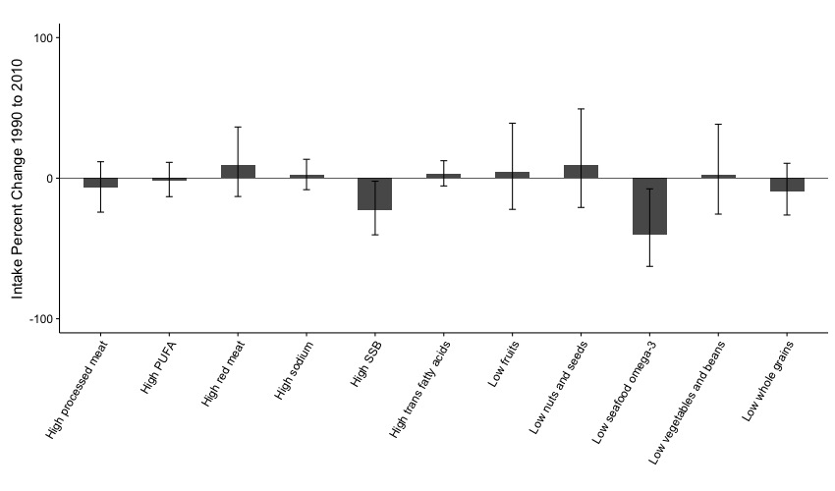
Figure S1. Intake change (%) in dietary factor level between 1990 and 2010, in Latin America, Andean
The bars represent the changes in percentage of intake associated with 11 dietary factors between 1990 and 2010 in Latin America, Andean countries (Colombia, Ecuador, Peru, and Bolivia). These percentage changes correspond to (2010_{intake} – 1990_{intake})/1990_{intake} ^{x} 100.

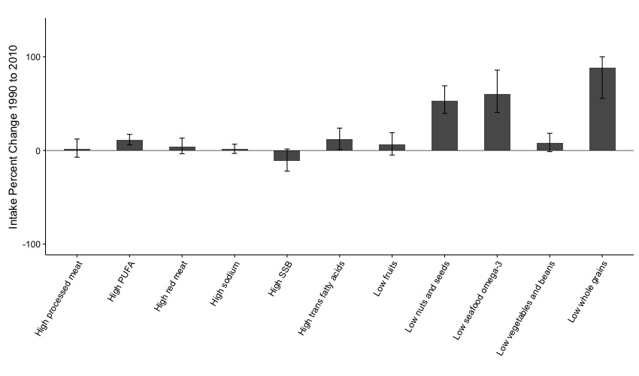
Figure S2. Intake change (%) in dietary factor level between 1990 and 2010, in Latin America, Central
The bars represent the changes in percentage of intake associated with 11 dietary factors between 1990 and 2010 in Latin America, Central countries (Belize, Costa Rica, El Salvador, Guatemala, Honduras, Nicaragua, Mexico, and Panama). These percentage changes correspond to (2010_{intake} – 1990_{intake})/1990_{intake} ^{x} 100.

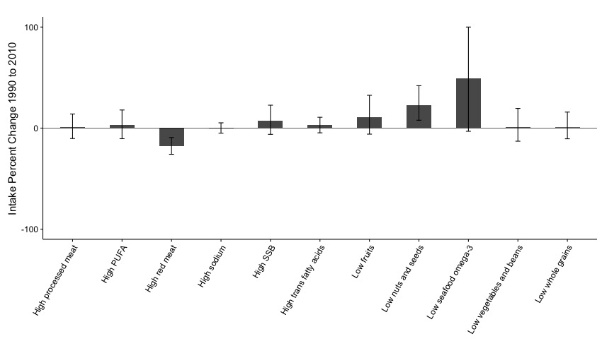
Figure S3. Intake change (%) in dietary factor level between 1990 and 2010, in Latin America, Southern
The bars represent the changes in percentage of intake associated with 11 dietary factors between 1990 and 2010 in Latin America, Southern countries (Argentina, Chile, Paraguay, and Uruguay). These percentage changes correspond to (2010_{intake} – 1990_{intake})/1990_{intake} ^{x} 100.

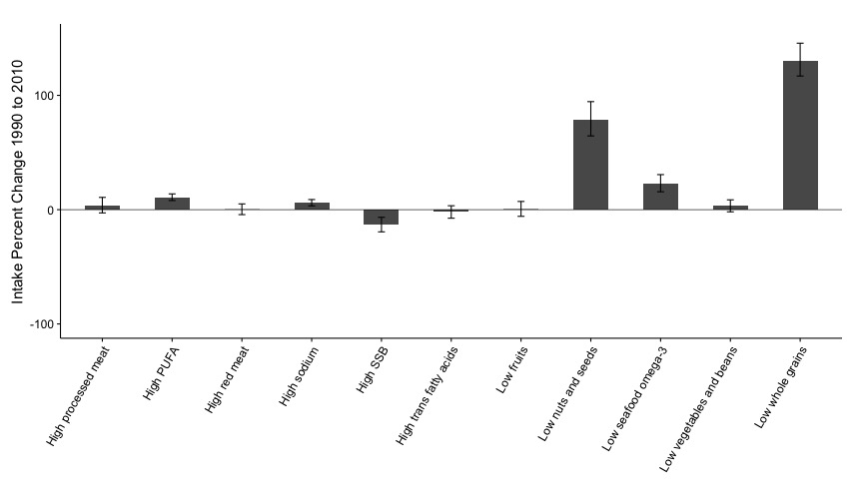
Figure S4. Intake change (%) in dietary factor level between 1990 and 2010, in Latin America, Tropical
The bars represent the changes in percentage of intake associated with 11 dietary factors between 1990 and 2010 in Latin America, Tropical countries (Suriname, Guyana, Venezuela, and Brazil). These percentage changes correspond to (2010_{intake} – 1990_{intake})/1990_{intake} ^{x} 100.

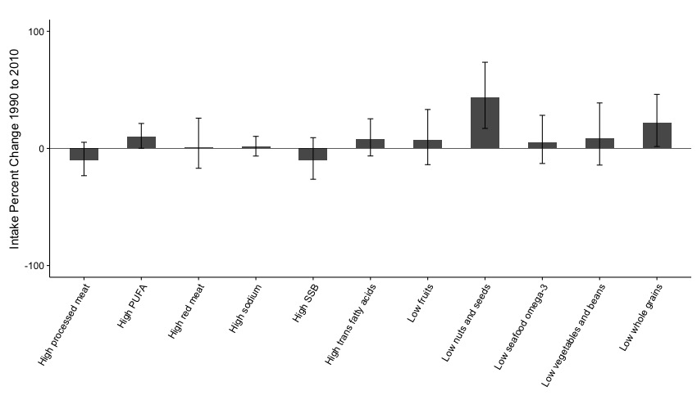
Figure S5. Intake change (%) in dietary factor level between 1990 and 2010, in Latin America, Caribbean
The bars represent the changes in percentage of intake associated with 11 dietary factors between 1990 and 2010 in Latin America, Caribbean countries (Antigua and Barbuda, Bahamas, Belize, Barbados, Costa Rica, Cuba, Dominica, Dominican Republic, Grenada, Haiti, Jamaica, Saint Lucia, Trinidad and Tobago, Saint Vincent, and the Grenadines). These percentage changes correspond to (2010_{intake} – 1990_{intake})/1990_{intake} ^{x} 100. Error bars indicate the spread of the dietary distribution.

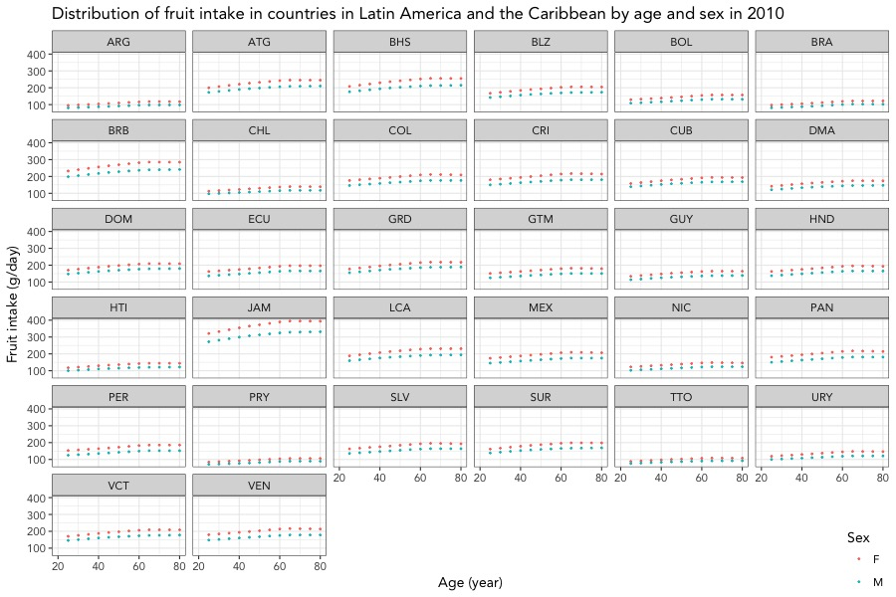

Figure S6. Distribution of fruit intake in countries in Latin America and Caribbean by age and sex in 2010.
Data are from 32 countries in LAC and the age of the participants raged from 25 to 80+ years. Each circle represents one age and sex strata within a particular country. The optimal level of fruit intake is 300±30 g/day. ARG: Argentina, ATG: Antigua and Barbuda, BHS: The Bahamas, BLZ: Belize, BOL: Bolivia, BRA: Brazil, BRB: Barbados, CHL: Chile, COL: Colombia, CRI: Costa Rica, CUB: Cuba, DMA: Dominica, DOM: Dominican Republic, ECU: Ecuador, GRD: Grenada, GTM: Guatemala, GUY: Guyana, HND: Honduras, HTI: Haiti, JAM: Jamaica, LCA: Saint Lucia, MEX: Mexico, NIC: Nicaragua, PAN: Panama, PER: Peru, PRY: Paraguay, SLV: El Salvador, SUR: Suriname, TTO: Trinidad and Tobago, URY: Uruguay, VCT: Saint Vincent and the Grenadines, and VEN: Venezuela.

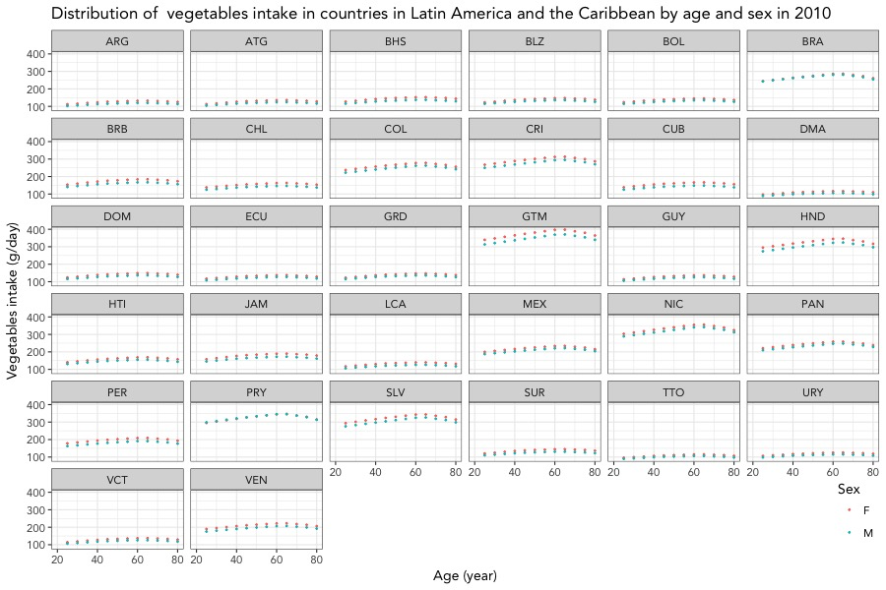

Figure S7. Distribution of vegetables and beans intake in countries in Latin America and Caribbean by age and sex in 2010.
Data are from 32 countries in LAC and the age of the participants raged from 25 to 80+ years. Each circle represents one age and sex strata within a particular country. The optimal level of vegetables intake is 400±40 g/day . ARG: Argentina, ATG: Antigua and Barbuda, BHS: The Bahamas, BLZ: Belize, BOL: Bolivia, BRA: Brazil, BRB: Barbados, CHL: Chile, COL: Colombia, CRI: Costa Rica, CUB: Cuba, DMA: Dominica, DOM: Dominican Republic, ECU: Ecuador, GRD: Grenada, GTM: Guatemala, GUY: Guyana, HND: Honduras, HTI: Haiti, JAM: Jamaica, LCA: Saint Lucia, MEX: Mexico, NIC: Nicaragua, PAN: Panama, PER: Peru, PRY: Paraguay, SLV: El Salvador, SUR: Suriname, TTO: Trinidad and Tobago, URY: Uruguay, VCT: Saint Vincent and the Grenadines, and VEN: Venezuela.

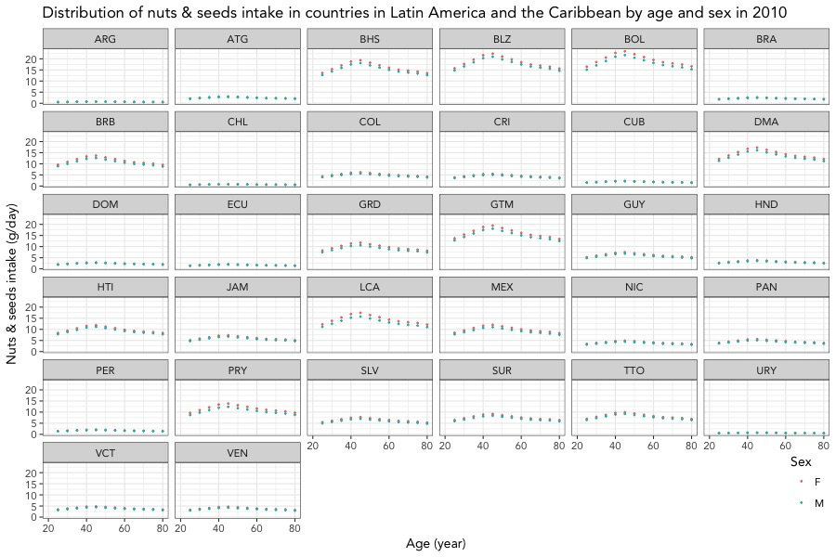

Figure S8. Distribution of nuts and seeds intake in countries in Latin America and Caribbean by age and sex in 2010.
Data are from 32 countries in LAC and the age of the participants raged from 25 to 80+ years. Each circle represents one age and sex strata within a particular country. The optimal level of nuts and seeds intake is 20.2±2 g/day. ARG: Argentina, ATG: Antigua and Barbuda, BHS: The Bahamas, BLZ: Belize, BOL: Bolivia, BRA: Brazil, BRB: Barbados, CHL: Chile, COL: Colombia, CRI: Costa Rica, CUB: Cuba, DMA: Dominica, DOM: Dominican Republic, ECU: Ecuador, GRD: Grenada, GTM: Guatemala, GUY: Guyana, HND: Honduras, HTI: Haiti, JAM: Jamaica, LCA: Saint Lucia, MEX: Mexico, NIC: Nicaragua, PAN: Panama, PER: Peru, PRY: Paraguay, SLV: El Salvador, SUR: Suriname, TTO: Trinidad and Tobago, URY: Uruguay, VCT: Saint Vincent and the Grenadines, and VEN: Venezuela.

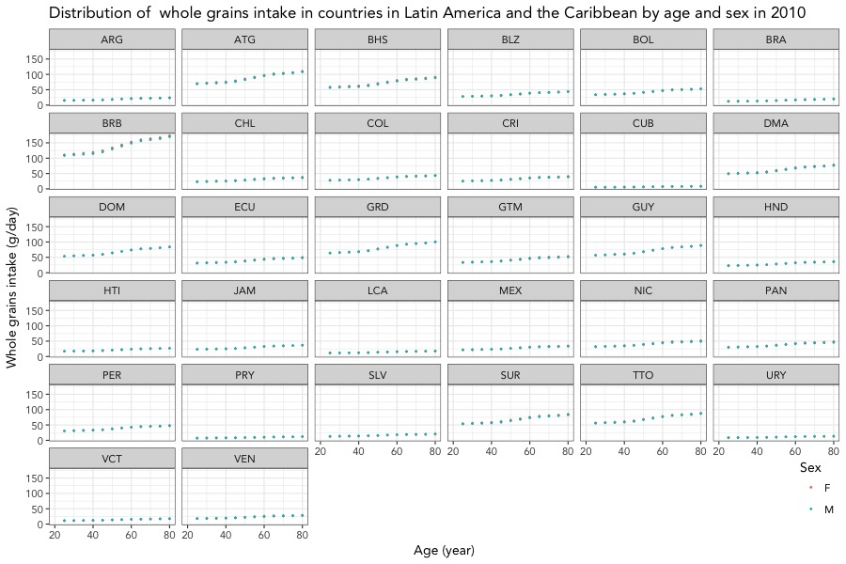

Figure S9. Distribution of whole grains intake in countries in Latin America and Caribbean by age and sex in 2010.
Data are from 32 countries in LAC and the age of the participants raged from 25 to 80+ years. Each circle represents one age and sex strata within a particular country. The optimal level of whole grains is >125 g/day. ARG: Argentina, ATG: Antigua and Barbuda, BHS: The Bahamas, BLZ: Belize, BOL: Bolivia, BRA: Brazil, BRB: Barbados, CHL: Chile, COL: Colombia, CRI: Costa Rica, CUB: Cuba, DMA: Dominica, DOM: Dominican Republic, ECU: Ecuador, GRD: Grenada, GTM: Guatemala, GUY: Guyana, HND: Honduras, HTI: Haiti, JAM: Jamaica, LCA: Saint Lucia, MEX: Mexico, NIC: Nicaragua, PAN: Panama, PER: Peru, PRY: Paraguay, SLV: El Salvador, SUR: Suriname, TTO: Trinidad and Tobago, URY: Uruguay, VCT: Saint Vincent and the Grenadines, and VEN: Venezuela.

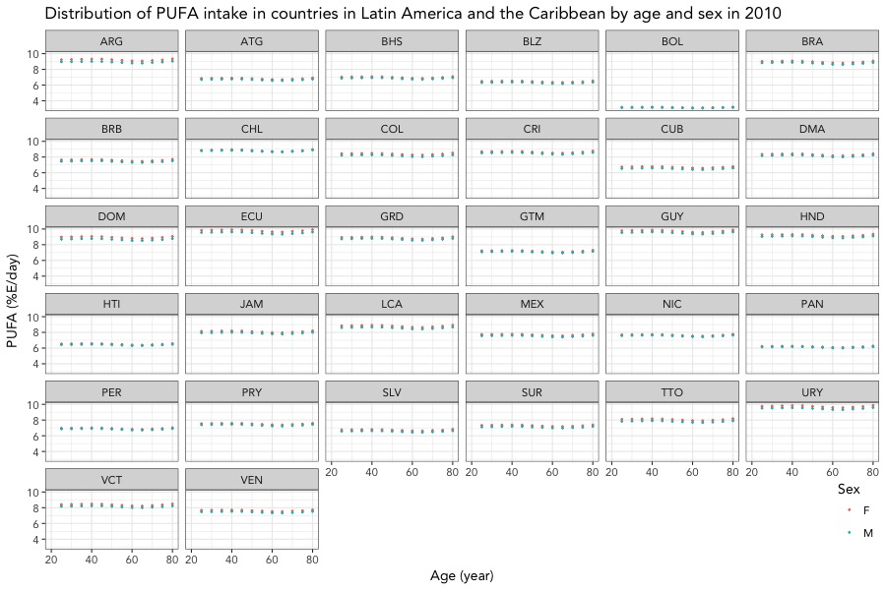

Figure S10. Distribution of PUFA intake in countries in Latin America and Caribbean by age and sex in 2010.
Data are from 32 countries in LAC and the age of the participants raged from 25 to 80+ years. Each circle represents one age and sex strata within a particular country. The optimal level of polyunsaturated fatty acids (PUFA) intake is 12±1.2% E/day. ARG: Argentina, ATG: Antigua and Barbuda, BHS: The Bahamas, BLZ: Belize, BOL: Bolivia, BRA: Brazil, BRB: Barbados, CHL: Chile, COL: Colombia, CRI: Costa Rica, CUB: Cuba, DMA: Dominica, DOM: Dominican Republic, ECU: Ecuador, GRD: Grenada, GTM: Guatemala, GUY: Guyana, HND: Honduras, HTI: Haiti, JAM: Jamaica, LCA: Saint Lucia, MEX: Mexico, NIC: Nicaragua, PAN: Panama, PER: Peru, PRY: Paraguay, SLV: El Salvador, SUR: Suriname, TTO: Trinidad and Tobago, URY: Uruguay, VCT: Saint Vincent and the Grenadines, and VEN: Venezuela.

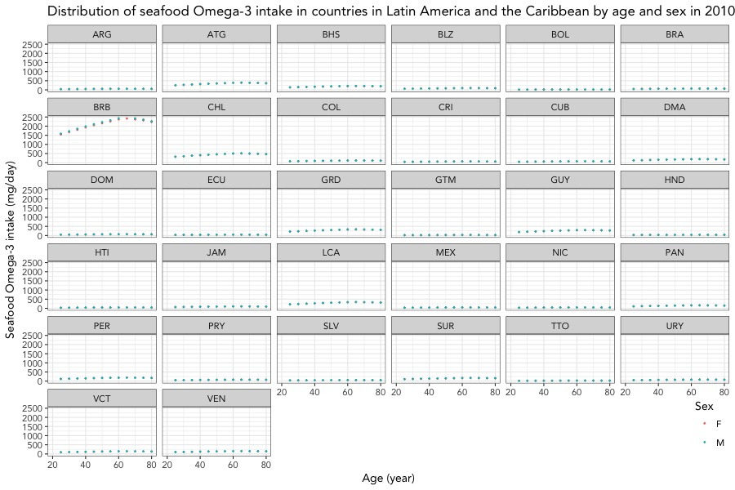

Figure S11. Distribution of Omega-3 intake in countries in Latin America and Caribbean by age and sex in 2010.
Data are from 32 countries in LAC and the age of the participants raged from 25 to 80+ years. Each circle represents one age and sex strata within a particular country. The optimal level of Omega-3 intake is 250±25 mg/day. ARG: Argentina, ATG: Antigua and Barbuda, BHS: The Bahamas, BLZ: Belize, BOL: Bolivia, BRA: Brazil, BRB: Barbados, CHL: Chile, COL: Colombia, CRI: Costa Rica, CUB: Cuba, DMA: Dominica, DOM: Dominican Republic, ECU: Ecuador, GRD: Grenada, GTM: Guatemala, GUY: Guyana, HND: Honduras, HTI: Haiti, JAM: Jamaica, LCA: Saint Lucia, MEX: Mexico, NIC: Nicaragua, PAN: Panama, PER: Peru, PRY: Paraguay, SLV: El Salvador, SUR: Suriname, TTO: Trinidad and Tobago, URY: Uruguay, VCT: Saint Vincent and the Grenadines, and VEN: Venezuela.

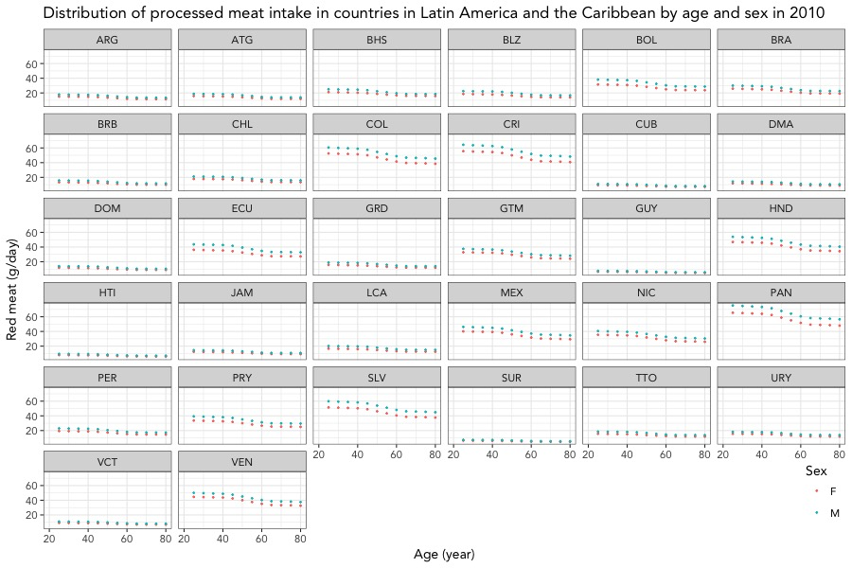

Figure S12. Distribution of processed meat intake in countries in Latin America and Caribbean by age and sex in 2010.
Data are from 32 countries in LAC and the age of the participants raged from 25 to 80+ years. Each circle represents one age and sex strata within a particular country. The optimal level of processed meat intake is 0 g/day. ARG: Argentina, ATG: Antigua and Barbuda, BHS: The Bahamas, BLZ: Belize, BOL: Bolivia, BRA: Brazil, BRB: Barbados, CHL: Chile, COL: Colombia, CRI: Costa Rica, CUB: Cuba, DMA: Dominica, DOM: Dominican Republic, ECU: Ecuador, GRD: Grenada, GTM: Guatemala, GUY: Guyana, HND: Honduras, HTI: Haiti, JAM: Jamaica, LCA: Saint Lucia, MEX: Mexico, NIC: Nicaragua, PAN: Panama, PER: Peru, PRY: Paraguay, SLV: El Salvador, SUR: Suriname, TTO: Trinidad and Tobago, URY: Uruguay, VCT: Saint Vincent and the Grenadines, and VEN: Venezuela.

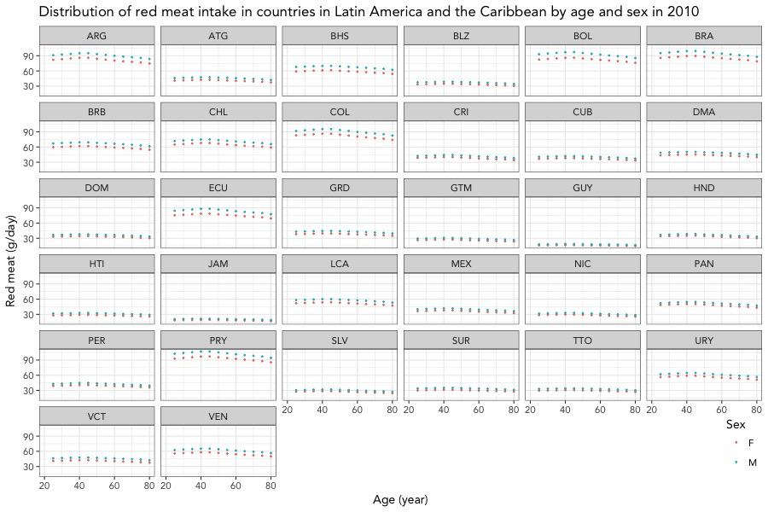

Figure S13. Distribution of red meat intake in countries in Latin America and Caribbean by age and sex in 2010.
Data are from 32 countries in LAC and the age of the participants raged from 25 to 80+ years. Each circle represents one-age and sex strata within a particular country. The optimal level of unprocessed meat is <14 g/day. ARG: Argentina, ATG: Antigua and Barbuda, BHS: The Bahamas, BLZ: Belize, BOL: Bolivia, BRA: Brazil, BRB: Barbados, CHL: Chile, COL: Colombia, CRI: Costa Rica, CUB: Cuba, DMA: Dominica, DOM: Dominican Republic, ECU: Ecuador, GRD: Grenada, GTM: Guatemala, GUY: Guyana, HND: Honduras, HTI: Haiti, JAM: Jamaica, LCA: Saint Lucia, MEX: Mexico, NIC: Nicaragua, PAN: Panama, PER: Peru, PRY: Paraguay, SLV: El Salvador, SUR: Suriname, TTO: Trinidad and Tobago, URY: Uruguay, VCT: Saint Vincent and the Grenadines, and VEN: Venezuela.

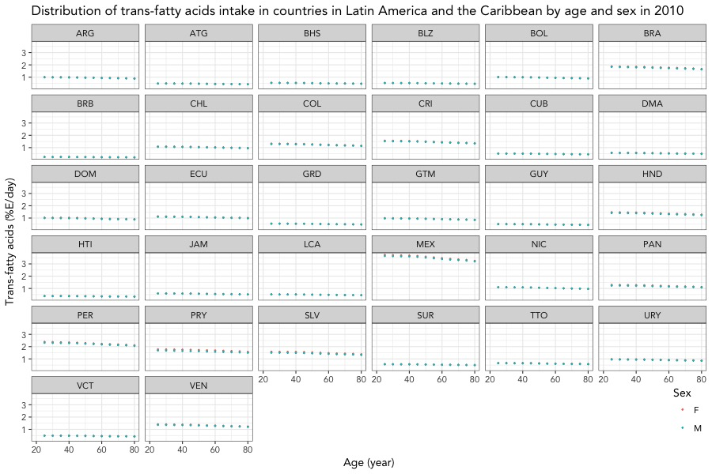

Figure S14. Distribution of trans fatty acids intake in countries in Latin America and Caribbean by age and sex in 2010.
Data are from 32 countries in LAC and the age of the participants raged from 25 to 80+ years. Each circle represents one age and sex strata within a particular country. The optimal level of trans-fatty acids intake is <0.5%E/day. ARG: Argentina, ATG: Antigua and Barbuda, BHS: The Bahamas, BLZ: Belize, BOL: Bolivia, BRA: Brazil, BRB: Barbados, CHL: Chile, COL: Colombia, CRI: Costa Rica, CUB: Cuba, DMA: Dominica, DOM: Dominican Republic, ECU: Ecuador, GRD: Grenada, GTM: Guatemala, GUY: Guyana, HND: Honduras, HTI: Haiti, JAM: Jamaica, LCA: Saint Lucia, MEX: Mexico, NIC: Nicaragua, PAN: Panama, PER: Peru, PRY: Paraguay, SLV: El Salvador, SUR: Suriname, TTO: Trinidad and Tobago, URY: Uruguay, VCT: Saint Vincent and the Grenadines, and VEN: Venezuela.

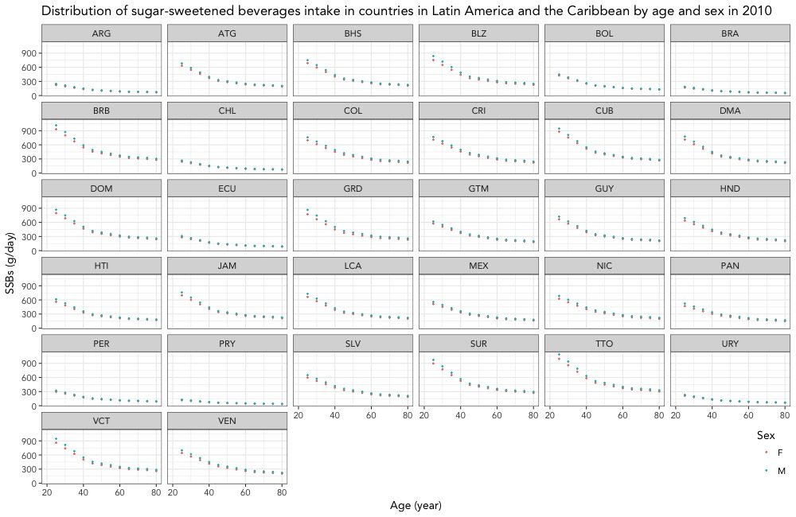

Figure S15. Distribution of SSBs intake in countries in Latin America and Caribbean by age and sex in 2010.
Data are from 32 countries in LAC and the age of the participants raged from 25 to 80+ years. Each circle represents one age and sex strata within a particular country. The optimal level of sugar-sweetened beverages intake is 0 g/day. ARG: Argentina, ATG: Antigua and Barbuda, BHS: The Bahamas, BLZ: Belize, BOL: Bolivia, BRA: Brazil, BRB: Barbados, CHL: Chile, COL: Colombia, CRI: Costa Rica, CUB: Cuba, DMA: Dominica, DOM: Dominican Republic, ECU: Ecuador, GRD: Grenada, GTM: Guatemala, GUY: Guyana, HND: Honduras, HTI: Haiti, JAM: Jamaica, LCA: Saint Lucia, MEX: Mexico, NIC: Nicaragua, PAN: Panama, PER: Peru, PRY: Paraguay, SLV: El Salvador, SUR: Suriname, TTO: Trinidad and Tobago, URY: Uruguay, VCT: Saint Vincent and the Grenadines, and VEN: Venezuela.

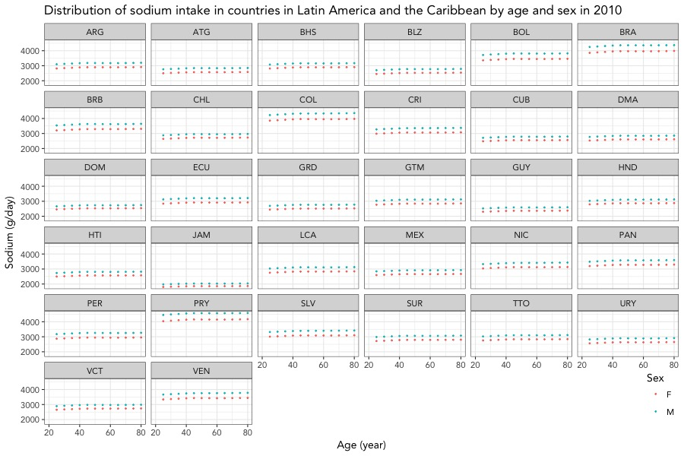

Figure S16. Distribution of sodium intake in countries in Latin America and Caribbean by age and sex in 2010.
Data are from 32 countries in LAC and the age of the participants raged from 25 to 80+ years. Each circle represents one age and sex strata within a particular country. The optimal level of sodium intake is 2000±200 mg/day. ARG: Argentina, ATG: Antigua and Barbuda, BHS: The Bahamas, BLZ: Belize, BOL: Bolivia, BRA: Brazil, BRB: Barbados, CHL: Chile, COL: Colombia, CRI: Costa Rica, CUB: Cuba, DMA: Dominica, DOM: Dominican Republic, ECU: Ecuador, GRD: Grenada, GTM: Guatemala, GUY: Guyana, HND: Honduras, HTI: Haiti, JAM: Jamaica, LCA: Saint Lucia, MEX: Mexico, NIC: Nicaragua, PAN: Panama, PER: Peru, PRY: Paraguay, SLV: El Salvador, SUR: Suriname, TTO: Trinidad and Tobago, URY: Uruguay, VCT: Saint Vincent and the Grenadines, and VEN: Venezuela.

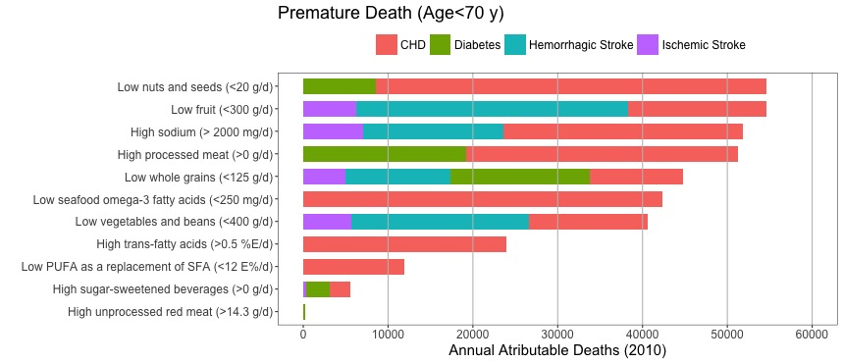

Figure S17. Premature (<70 y) cardiometabolic deaths attributable to dietary factors in 32 countries in Latin America and Caribbean
The bars represent absolute cardiometabolic deaths associated with 11 dietary factors and the age of the participants is less than 70 years. Data are stratified by disease outcome. CHD: Coronary heart disease

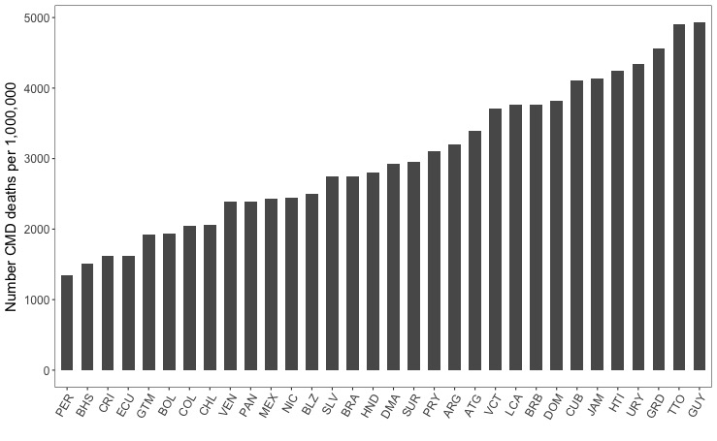

Figure S18. Cardiometabolic deaths (per million adults) in 32 countries in Latin America and Caribbean in 2010.
The bars represent age-sex standardized to account for changes in population structure by standardizing the 2010 population per million adults. The Latin America and the Caribbean region includes 32 countries: ARG: Argentina, ATG: Antigua and Barbuda, BHS: The Bahamas, BLZ: Belize, BOL: Bolivia, BRA: Brazil, BRB: Barbados, CHL: Chile, COL: Colombia, CRI: Costa Rica, CUB: Cuba, DMA: Dominica, DOM: Dominican Republic, ECU: Ecuador, GRD: Grenada, GTM: Guatemala, GUY: Guyana, HND: Honduras, HTI: Haiti, JAM: Jamaica, LCA: Saint Lucia, MEX: Mexico, NIC: Nicaragua, PAN: Panama, PER: Peru, PRY: Paraguay, SLV: El Salvador, SUR: Suriname, TTO: Trinidad and Tobago, URY: Uruguay, VCT: Saint Vincent and the Grenadines, and VEN: Venezuela.

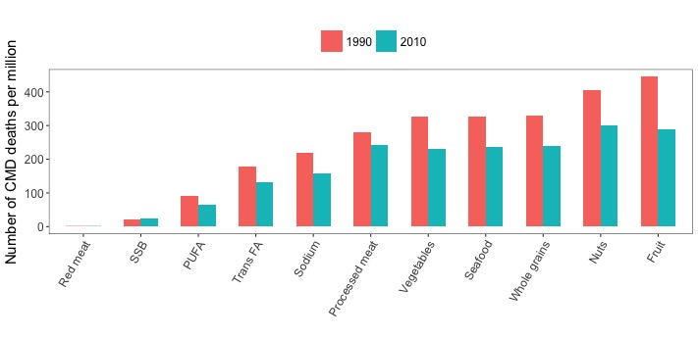

Figure S19. Cardiometabolic deaths (per year per million adults) attributable to dietary factors in countries in Latin America and Caribbean in 1990 and 2010
The bars represent the estimated cardiometabolic death rate associated with 11 dietary factors in 1990 and 2010. Death rates were age-sex standardized to account for changes in population structure by standardizing the 1990 and 2010 population per million adults. Trans FA: Trans fatty acids, SSBs: sugar-sweetened beverages, PUFA: polyunsaturated fats.

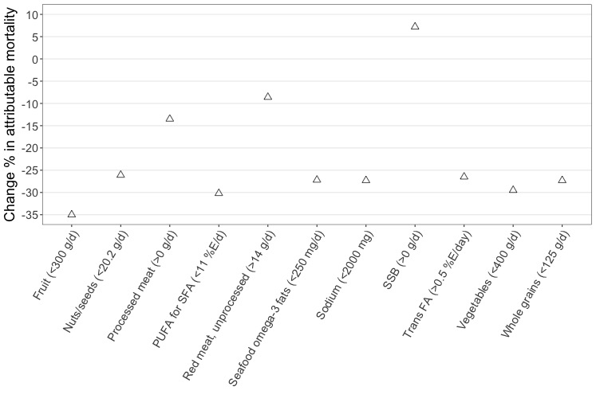

Figure S20. Change in percentage of cardiometabolic disease mortality between 1990 and 2010
The triangles represent the estimated relative changes in percent cardiometabolic deaths associated with 11 dietary factors between 1990 and 2010 in countries in Latin America and Caribbean. These percentage changes correspond to (2010_{estimates} – 1990_{estimates})/1990_{estimates} ^{x} 100.

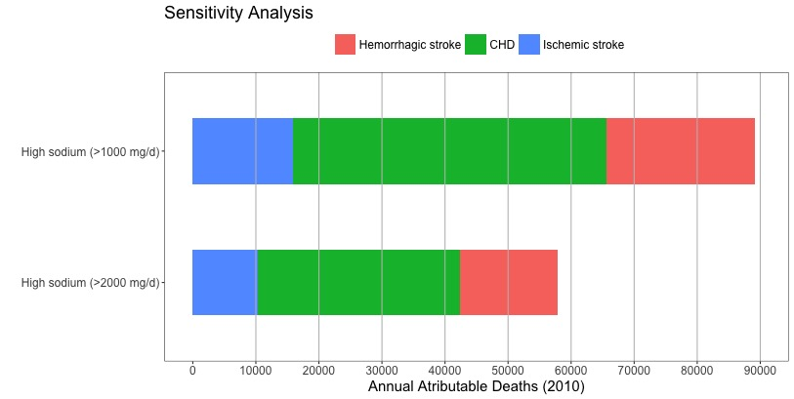

Figure S21. Cardiometabolic deaths attributable to sodium in countries in Latin America and Caribbean in different optimal levels (2010)
The bars represent absolute cardiometabolic deaths associated with sodium intake at different optimal levels in 2010. Data is stratified by disease outcome. CHD: Coronary heart disease

TABLES

Table S1. Cause-specific cardiometabolic deaths attributable to dietary factors in countries in Latin America and Caribbean (2010)

 | Total | Men | Women | 25-44 y | 45-70 y | 70+ y
Total CHD death | 465 406 | 251 074 | 214 332 | 16 547 | 200 498 | 248 361
Total ischemic stroke deaths | 166 411 | 78 598 | 87 813 | 2000 | 46 794 | 117 617
Total hemorrhagic stroke deaths | 154 622 | 77 031 | 77 591 | 9377 | 82 970 | 62 275
Total diabetes deaths | 166 938 | 74 391 | 92 547 | 6375 | 89 244 | 71 319
Protective dietary factors
Low fruits (<300 g/d)
CHD
No. of deaths | 32 024 | 19 097 | 12 814 | 2353 | 18 342 | 11 259
95% UI | (28542-34844) | (16535-21552) | (11023-14656) | (1878-2743) | (15891-20496) | (9257-13136)
% total CHD deaths | 7 | 7.6 | 6 | 14.2 | 9.1 | 4.5
Ischemic stroke
No. of deaths | 20 741 | 10 680 | 10 025 | 574 | 8642 | 11 509
95% UI | (17967-23028) | (8557-12222) | (8366-12014) | (468-658) | (7317-9675) | (9153-13774)
% total ischemic stroke deaths | 12.5 | 13.6 | 11.4 | 28.7 | 18.5 | 9.8
Hemorrhagic stroke
No. of deaths | 53 332 | 28 232 | 25 022 | 5258 | 34 076 | 13 871
95% UI | (47626-57095) | (24126-31157) | (21952-27784) | (4311-6041) | (29691-37176) | (11391-16198)
% total hemorrhagic stroke deaths | 34.5 | 36.6 | 32.2 | 56 | 41 | 22.3
Low vegetables and beans (<400 g/d)
CHD
No. of deaths | 28 749 | 16 833 | 11 887 | 2065 | 15 814 | 10 840
95% UI | (26593-30934) | (15204-18532) | (10543-13401) | (1788-2342) | (14440-17326) | (9440-12390)
% total CHD deaths | 6.2 | 6.7 | 5.5 | 12.5 | 8 | 4.4
Ischemic stroke
No. of deaths | 20 330 | 10 092 | 10 207 | 541 | 7965 | 11 846
95% UI | (18012-23014) | (8600-11761) | (8561-12427) | (456-631) | (6984-8964) | (9789-14284)
% total ischemic stroke deaths | 12.2 | 12.8 | 11.6 | 27 | 17 | 10.1
Hemorrhagic stroke
No. of deaths | 35 164 | 18 233 | 16 806 | 3604 | 22 115 | 9343
95% UI | (32024-37884) | (16213-20462) | (14713-18854) | (3048-4183) | (19762-24487) | (7887-11130)
% total hemorrhagic stroke deaths | 22.7 | 23.7 | 21.6 | 38.4 | 26.6 | 15
Low nuts and seeds (<20.2 g/d)
CHD
No. of deaths | 94 261 | 54 046 | 40 022 | 5992 | 52 804 | 35 358
95% UI | (60720-104608) | (33622-60394) | (24698-45512) | (3799-6804) | (33133-58313) | (20355-41086)
% total CHD deaths | 20.2 | 21.5 | 18.7 | 36.2 | 26.3 | 14.2
Diabetes
No. of deaths | 15 364 | 7189 | 8070 | 1017 | 9958 | 4279
95% UI | (10860-17167) | (4908-8250) | (5651-9294) | (704-1192) | (7000-11382) | (2527-5244)
% total diabetes deaths | 9.2 | 9.7 | 8.7 | 16 | 11 | 6
Low whole grains (<125 g/d)
CHD
No. of deaths | 21 331 | 12 355 | 8959 | 1540 | 12 245 | 7548
95% UI | (16616-24039) | (9279-14149) | (6723-10502) | (1057-1906) | (9068-14063) | (5608-9096)
% total CHD deaths | 4.6 | 5 | 4.2 | 9.3 | 6 | 3
Ischemic stroke
No. of deaths | 16 896 | 8333 | 8453 | 455 | 6973 | 9416
95% UI | (12398-19168) | (5733-9945) | (6044-10117) | (295-543) | (5007-8033) | (6542-11383)
% total ischemic stroke deaths | 10 | 10.6 | 9.6 | 22.7 | 15 | 8
Hemorrhagic stroke
No. of deaths | 20 100 | 10 310 | 9670 | 2135 | 12 961 | 4863
95% UI | (15263-22174) | (7567-11784) | (7077-10998) | (1390-2560) | (9579-14760) | (3594-5791)
% total hemorrhagic stroke deaths | 13 | 13.4 | 12.5 | 22.8 | 15.6 | 7.8
Diabetes
No. of deaths | 28 742 | 13 488 | 15 150 | 1965 | 18 835 | 7863
95% UI | (22903-30956) | (10329-14841) | (11836-16878) | (1388-2303) | (14469-20561) | (5929-8997)
% total diabetes deaths | 17.2 | 18 | 16.4 | 31 | 21 | 11
Low PUFA as a replacement for SFA (<12% E/d)
CHD
No. of deaths | 23 348 | 13 697 | 9652 | 1639 | 13 465 | 8185
95% UI | (21778-25185) | (12414-15015) | (8688-10855) | (1444-1870) | (12349-14775) | (7125-9400)
% total CHD deaths | 5 | 5.4 | 4.5 | 10 | 6.7 | 3.3
Low seafood omega-3 fatty acids (<250 mg/d)
CHD
No. of deaths | 87 007 | 49 525 | 36 825 | 5750 | 48 369 | 32 176
95% UI | (34330-93991) | (19936-54601) | (14597-41531) | (2185-6689) | (19399-53114) | (12280-36669)
% total CHD deaths | 18.7 | 19.7 | 17.2 | 34.7 | 24 | 13
Harmful dietary factors
High processed med (>0 g/d)
CHD
No. of deaths | 58 427 | 36 378 | 21 800 | 5270 | 34 398 | 18 633
95% UI | (53261-64417) | (32261-40615) | (18910-25618) | (4487-6160) | (30591-38656) | (15539-22440)
% total CHD deaths | 12.5 | 14.5 | 10.2 | 31.8 | 17.1 | 7.5
Diabetes
No. of deaths | 30 970 | 15 964 | 14 947 | 2747 | 20 903 | 7313
95% UI | (28531-33603) | (14328-17801) | (13237-16829) | (2312-3243) | (18845-23274) | (6022-8617)
% total diabetes deaths | 18.5 | 21.4 | 16.1 | 43 | 23.4 | 10.2
High unprocessed red meat (>14.3 g/d)
Diabetes
No. of deaths | 383 | 161 | 221 | 28 | 251 | 101
95% UI | (323-526) | (128-245) | (178-309) | (21-43) | (203-353) | (74-168)
% total diabetes deaths | 0.2 | 0.2 | 0.2 | 0.4 | 0.2 | 0.1
High trans-fatty acids (>0.5 %E/d)
CHD
No. of deaths | 48 470 | 27 856 | 20 695 | 3217 | 27 333 | 17 909
95% UI | (45628-51390) | (25720-29832) | (18822-22657) | (2880-3578) | (25360-29276) | (16189-19922)
% total CHD deaths | 10.4 | 11 | 9.6 | 19.4 | 13.6 | 7.2
High sodium (>2000 mg/day)
CHD
No. of deaths | 32 119 | 20 517 | 11 459 | 1398 | 21 252 | 9294
95% UI | (19915-43499) | (12810-27817) | (7064-16093) | (578-2250) | (13831-27980) | (5364-13954)
% total CHD deaths | 7 | 8.2 | 5.3 | 8.4 | 10.6 | 3.7
Ischemic stroke
No. of deaths | 10 274 | 6013 | 4234 | 220 | 6288 | 3824
95% UI | (6548-14111) | (3879-8329) | (2681-5997) | (87-348) | (4106-8207) | (2296-5679)
% total ischemic stroke deaths | 6.2 | 7.6 | 4.8 | 11 | 13.4 | 3.2
Hemorrhagic stroke
No. of deaths | 15 423 | 9051 | 6377 | 1087 | 11 917 | 2364
95% UI | (9623-21026) | (5607-12248) | (3977-8888) | (456-1798) | (7681-15836) | (1366-3792)
% total hemorrhagic stroke deaths | 10 | 11.7 | 8.2 | 11.6 | 14.4 | 3.8
High sugar-sweetened beverages (>0 g/day)
Diabetes
No. of deaths | 3906 | 1984 | 1917 | 514 | 2666 | 712
95% UI | (2474-5493) | (1247-2763) | (1185-2717) | (327-731) | (1683-3775) | (441-1004)
% total diabetes deaths | 2.3 | 2.7 | 2 | 8 | 3 | 1
CHD
No. of deaths | 3853 | 2384 | 1470 | 535 | 2403 | 931
95% UI | (2461-5305) | (1503-3256) | (934-2079) | (336-738) | (1517-3306) | (606-1301)
% total CHD deaths | 0.8 | 1 | 0.6 | 3 | 1 | 0.4
Ischemic stroke
No. of deaths | 723 | 398 | 326 | 70 | 470 | 183
95% UI | (464-994) | (250-537) | (207-462) | (45-96) | (297-648) | (113-260)
% total ischemic stroke deaths | 0.4 | 0.5 | 0.4 | 3 | 1 | 0.1
CHD, coronary heart disease; CMD, cardiometabolic disease; PUFA, polyunsaturated fatty acids as a replacement of SFA; UI, uncertainty interval

Table S2. Cause-specific cardiometabolic deaths attributable to dietary factors in countries in Latin America and Caribbean (1990)

 | Total | Men | Women | 25-44 y | 45-70 y | 70+ y
Total CHD death | 305 663 | 171 075 | 134 588 | 15 179 | 154 021 | 136 463
Total ischemic stroke deaths | 118 758 | 57 474 | 61 284 | 2187 | 42 737 | 73 833
Total hemorrhagic stroke deaths | 120 141 | 60 991 | 59 150 | 12 265 | 74 331 | 33 545
Total diabetes deaths | 80 348 | 34 145 | 46 203 | 4566 | 49 588 | 26 194
Protective dietary factors
Low fruits (<300 g/d)
CHD
No. of deaths | 23 226 | 14 287 | 8935 | 2228 | 14 635 | 6384
95% UI | (21034-25110) | (12299-15842) | (7947-9974) | (1790-2613) | (12740-16144) | (5451-7340)
% total CHD deaths | 7.6 | 8.3 | 6.6 | 14.7 | 9.5 | 4.7
Ischemic stroke
No. of deaths | 16 288 | 8617 | 7626 | 642 | 8171 | 7445
95% UI | (14518-17670) | (7342-9641) | (6637-8731) | (528-723) | (7076-8977) | (6381-8582)
% total ischemic stroke deaths | 13.7 | 15 | 12.4 | 29.3 | 19.1 | 10
Hemorrhagic stroke
No. of deaths | 46 075 | 24 597 | 21 561 | 7026 | 31 483 | 7601
95% UI | (41472-49221) | (21096-27038) | (19340-23363) | (5943-7856) | (27819-34383) | (6406-8571)
% total hemorrhagic stroke deaths | 38.3 | 40.3 | 36.4 | 57.3 | 42.3 | 22.6
Low vegetables and beans (<400 g/d)
CHD
No. of deaths | 19 347 | 11 700 | 7649 | 1760 | 11 689 | 5889
95% UI | (17988-20652) | (10576-12772) | (6922-8388) | (1516-2024) | (10645-12793) | (5148-6610)
% total CHD deaths | 6.3 | 7 | 5.7 | 11.6 | 7.5 | 4.3
Ischemic stroke
No. of deaths | 15 074 | 7700 | 7384 | 565 | 7031 | 7490
95% UI | (13539-16535) | (6632-8725) | (6302-8395) | (483-649) | (6108-7870) | (6281-8735)
% total ischemic stroke deaths | 12.7 | 13.4 | 12 | 26 | 16.4 | 10
Hemorrhagic stroke
No. of deaths | 28 381 | 14 941 | 13 422 | 4434 | 19 085 | 4847
95% UI | (25865-30472) | (13103-16780) | (12066-14784) | (3691-5175) | (16992-21105) | (4159-5521)
% total hemorrhagic stroke deaths | 23.6 | 24.4 | 22.7 | 36 | 25.6 | 14.4
Low nuts and seeds (<20.2 g/d)
CHD
No. of deaths | 69 502 | 41 020 | 28 517 | 5958 | 42 919 | 20 565
95% UI | (45571-76148) | (26257-45557) | (18364-31522) | (3619-6589) | (27907-47240) | (12990-23451)
% total CHD deaths | 22.7 | 24 | 21.2 | 39.2 | 27.8 | 15
Diabetes
No. of deaths | 8673 | 3818 | 4832 | 829 | 6110 | 1687
95% UI | (6190-9556) | (2699-4306) | (3449-5410) | (580-952) | (4375-6856) | (1142-1972)
% total diabetes deaths | 10.8 | 11.2 | 10.4 | 18 | 12.3 | 6.4
Low whole grains (<125 g/d)
CHD
No. of deaths | 15 836 | 9373 | 6376 | 1458 | 9829 | 4416
95% UI | (10341-18160) | (5887-11209) | (4110-7508) | (818-1838) | (6110-11700) | (2641-5263)
% total CHD deaths | 5.2 | 5.5 | 4.7 | 9.6 | 6.4 | 3.2
Ischemic stroke
No. of deaths | 13 310 | 6778 | 6444 | 504 | 6500 | 6207
95% UI | (8620-15216) | (3972-8068) | (4014-7659) | (285-617) | (4012-7668) | (3536-7382)
% total ischemic stroke deaths | 11.2 | 11.8 | 10.5 | 23 | 15.2 | 8.4
Hemorrhagic stroke
No. of deaths | 17 617 | 9128 | 8373 | 2837 | 11928 | 2714
95% UI | (11210-19860) | (5493-10736) | (5334-9702) | (1563-3480) | (7401-13863) | (1620-3229)
% total hemorrhagic stroke deaths | 14.7 | 15 | 14.1 | 23.1 | 16 | 8
Diabetes
No. of deaths | 15 662 | 6904 | 8666 | 1460 | 11003 | 3090
95% UI | (10371-17000) | (4382-7718) | (5681-9565) | (888-1684) | (7075-12115) | (1880-3511)
% total diabetes deaths | 19.5 | 20.2 | 18.7 | 32 | 22.2 | 11.8
Low PUFA as a replacement for SFA
(<12% E/d)
CHD
No. of deaths | 17 557 | 10 531 | 7009 | 1600 | 11 099 | 4817
95% UI | (16340-18791) | (9573-11522) | (6373-7799) | (1395-1833) | (10106-12184) | (4298-5469)
% total CHD deaths | 5.7 | 6.1 | 5.2 | 10.5 | 7.2 | 3.5
Low seafood omega-3 fatty acids (<250 mg/d)
CHD
No. of deaths | 62 744 | 36 781 | 25 561 | 5448 | 38 543 | 18 162
95% UI | (23955-67597) | (14381-40131) | (10008-28299) | (1989-6238) | (14920-42264) | (6788-20477)
% total CHD deaths | 20.5 | 21.5 | 19 | 36 | 25 | 13.3
Harmful dietary factors
High processed med (>0 g/d)
CHD
No. of deaths | 39 030 | 24 631 | 14 352 | 4573 | 24 659 | 9713
95% UI | (35801-42833) | (22008-27850) | (12651-16247) | (3851-5371) | (22027-27521) | (8349-11513)
% total CHD deaths | 12.8 | 14.4 | 10.7 | 30.1 | 16 | 7.1
Diabetes
No. of deaths | 15 270 | 7435 | 7849 | 1833 | 10 896 | 2550
95% UI | (14126-16395) | (6652-8192) | (7023-8705) | (1616-2051) | (9784-11930) | (2167-3023)
% total diabetes deaths | 19 | 21.8 | 17 | 40.1 | 22 | 9.7
High unprocessed red meat (>14.3 g/d)
Diabetes
No. of deaths | 220 | 88 | 132 | 20 | 156 | 156
95% UI | (186-291) | (70-126) | (104-181) | (15-28) | (125-215) | (125-216)
% total diabetes deaths | 0.3 | 0.2 | 0.3 | 0.4 | 0.3 | 0.6
High trans-fatty acids (>0.5 %E/d)
CHD
No. of deaths | 34 609 | 20 425 | 14 112 | 3044 | 21 479 | 10 049
95% UI | (32662-36381) | (18944-21824) | (13047-15209) | (2689-3357) | (19970-22938) | (9011-10958)
% total CHD deaths | 11.3 | 12 | 10.4 | 20 | 14 | 7.4
High sodium (>2000 mg/day)
CHD
No. of deaths | 21 552 | 14 101 | 7396 | 1317 | 15 188 | 4908
95% UI | (13544-28839) | (8814-18989) | (4599-10123) | (508-2137) | (9929-19900) | (2890-7170)
% total CHD deaths | 7 | 8.2 | 5.4 | 8.6 | 9.8 | 3.5
Ischemic stroke
No. of deaths | 7800 | 4693 | 3073 | 245 | 5229 | 2314
95% UI | (4940-10495) | (2953-6328) | (1931-4217) | (93-396) | (3414-6829) | (1420-3330)
% total ischemic stroke deaths | 6.5 | 8.2 | 5 | 11.2 | 12.2 | 3
Hemorrhagic stroke
No. of deaths | 12 568 | 7372 | 5196 | 1425 | 9812 | 1278
95% UI | (7670-17142) | (4539-10025) | (3258-7090) | (554-2409) | (6326-12974) | (745-1917)
% total hemorrhagic stroke deaths | 10.4 | 12 | 8.7 | 11.6 | 13.2 | 3.8
High sugar-sweetened beverages (>0 g/day)
Diabetes
No. of deaths | 1797 | 766 | 1031 | 287 | 1335 | 175
95% UI | (1192-2441) | (527 – 1038) | (660-1422) | (194 – 392) | (854 – 1847) | (117 – 237)
% total diabetes deaths | 2.2 | 2.2 | 2.2 | 6 | 2.6 | 0.7
CHD
No. of deaths | 1920 | 1033 | 881 | 314 | 1318 | 283
95% UI | (1343 – 2541) | (717 – 1378) | (589-1194) | (224 – 420) | (921 – 1765) | (184 – 391)
% total CHD deaths | 0.6 | 0.6 | 0.6 | 2 | 0.8 | 0.2
Ischemic stroke
No. of deaths | 445 | 204 | 242 | 51 | 314 | 80
95% UI | (310 – 592) | (136 – 272) | (161-329) | (35 – 68) | (217 – 421) | (53 – 112)
% total ischemic stroke deaths | 0.4 | 0.3 | 0.4 | 2.3 | 0.7 | 0.1

CHD, coronary heart disease; CMD, cardiometabolic disease; PUFA, polyunsaturated fatty acids as a replacement of SFA; UI, uncertainty interval

Table S3. Cardiometabolic deaths attributable to dietary factors in countries in Latin America and Caribbean (1990) *

 | Total | Women | Men | 25-44 years | 45-70 years | 70+ years
Total CMD† | 624 911 | 301 226 | 323 685 | 34 197 | 320 678 | 270 036
Low fruits (<300 g/day)
Deaths (n) | 85 794 | 38 173 | 47 704 | 9928 | 54 386 | 21 467
95% UI | (77 743 – 89 931) | (34 757 – 40 736) | (41 300 – 51 267) | (8415 – 10 891) | (48 461 – 58 038) | (18 838 – 23 703)
% of total CMD deaths | 13.7 | 12.7 | 14.7 | 29 | 17 | 8
Low whole grains (<125 g/day)
Deaths (n) | 63 352 | 30 349 | 32 802 | 6341 | 40 016 | 16 708
95% UI | (41 022 – 68 313) | (19 759 – 33 078) | (20 448 – 36 095) | (3629 – 7304) | (25 488 – 43 549) | (9920 – 18 534)
% of total CMD deaths | 10.1 | 10 | 10.1 | 18.5 | 12.5 | 6.2
Low nuts and seeds (<20.2 g/day)
Deaths (n) | 78 086 | 33 440 | 44 913 | 6813 | 49 188 | 22 297
95% UI | (51 795 – 85 340) | (21 920 – 36 659) | (29 028 – 49 668) | (4275-7453) | (32 159 – 53 683) | (14 099 – 25 241)
% of total CMD deaths | 12.5 | 11 | 14 | 20 | 15.3 | 8.2
Low vegetables and beans (<250 mg/day)
Deaths (n) | 62 841 | 28 464 | 34 374 | 6771 | 37 854 | 18 201
95% UI | (58 663 – 66 098) | (26 059 – 30 526) | (31 201 – 37 154) | (5908 – 7598) | (34 777 – 40 662) | (16 110 – 20 065)
% of total CMD deaths | 10 | 9.4 | 10.6 | 19.8 | 11.8 | 6.7
Low seafood ω-3 fatty acids (<250 mg/day)
Deaths (n) | 62 744 | 25 561 | 36 781 | 5448 | 38 543 | 18 162
95% UI | (23 955 – 67 597) | (10 008 – 28 299) | (14 381 – 40 131) | (1989 – 6238) | (14 920 – 42 264) | (6788 – 20 477)
% of total CMD deaths | 10 | 8.5 | 11.4 | 16 | 12 | 6.7
Low PUFA (<12 %E/day)
Deaths (n) | 17 557 | 7009 | 10 531 | 1600 | 11 099 | 4817
95% UI | (16 340 – 18 791) | (6373 – 7799) | (9573 – 11 522) | (1395 – 1833) | (10 106 – 12 184) | (4298 – 5469)
% of total CMD deaths | 3 | 2.3 | 3.2 | 4.7 | 3.5 | 1.8
High processed meat (>0g/day)
Deaths (n) | 54 235 | 22 179 | 32 018 | 6415 | 35 508 | 12 241
95% UI | (50 755 – 58 607) | (20 220 – 24 717) | (29 145 – 35 474) | (5655 – 7248) | (32 433 – 39 098) | (10 713 – 14 289)
% of total CMD deaths | 8.7 | 7.4 | 9.9 | 18.7 | 11.1 | 4.5
High unprocessed red meat (>14.2 g/day)
Deaths (n) | 220 | 132 | 88 | 20 | 156 | 44
95% UI | (186 – 291) | (104 – 181) | (70 – 126) | (15 – 28) | (125 – 216) | (31 – 71)
% of total CMD deaths | 0.03 | 0.04 | 0.03 | 0.06 | 0.05 | 0.02
High trans-fatty acids (>0.5%E/day)
Deaths (n) | 34 609 | 14 112 | 20 425 | 3044 | 21 479 | 10 049
95% UI | (32 662 – 36 381) | (13 047 – 15 209) | (18 944 – 21 824) | (2689 – 3357) | (19 970 – 22 938) | (9011 – 10 958)
% of total CMD deaths | 5.5 | 4.6 | 6.3 | 9 | 6.7 | 3.7
High sodium (>2,000 mg/day) ‡
Deaths (n) § | 42 003 | 15 651 | 26 295 | 2980 | 30 248 | 8583
95% UI | (26 029 – 56 412) | (9672 – 21 151) | (16 278 – 35 121) | (1185 – 4886) | (19 761 – 39 834) | (5183 – 12 218)
% of total CMD deaths | 6.7 | 5.2 | 8 | 8.7 | 9.4 | 3.2
High sugar-sweetened beverages (>0 g/day) ||
Deaths (n) | 4151 | 2159 | 2007 | 654 | 2966 | 537
95% UI | (2887 – 5549) | (1413 – 2928) | (1410 – 2662) | (461 – 874) | (2006 – 3992) | (358 – 727)
% of total CMD deaths | 0.7 | 0.7 | 0.6 | 2 | 0.9 | 0.2

* The Latin America and the Caribbean region includes 32 countries: Argentina, Antigua and Barbuda, The Bahamas, Belize, Bolivia, Brazil, Barbados, Chile, Colombia, Costa Rica, Cuba, Dominica, Dominican Republic, Ecuador, Grenada, Guatemala, Guyana, Honduras, Haiti, Jamaica, Saint Lucia, Mexico, Nicaragua, Panama, Peru, Paraguay, El Salvador, Suriname, Trinidad and Tobago, Uruguay, Saint Vincent and the Grenadines, and Venezuela.
† Total cardiometabolic deaths include CHD (ICD-10 codes I20-I25), ischemic stroke (I63, I65-I67, I69.3), haemorrahagic/other non-ischemic stroke (I60-62, I69.0-2), and diabetes mellitus (E10-E14)
‡ In following the US Institute of Medicine’s recommendation and to be consistent with prior studies evaluating the CMD burden we used the level of 2,000 mg/day
§ Mediated effect throught blood pressure
|| Mediated effect through BMI
CMD, cardiometabolic disease; PUFA, polyunsaturated fatty acids as a replacement of SFA; UI, uncertainty interval

Table S4. Cardiometabolic deaths (per year per million adults) attributable to dietary risk factors in 32 countries in Latin American and Caribbean (1990)
 | Low fruits (<300 g/day) | Low whole grains (<125 g/day) | Low nuts and seeds (<20.2 g/day) | Low vegetables and beans (<400 g/day) | Low seafood ω-3 fatty acids (<250 mg/day) | Low PUFA as a replacement for SFA (<12% E/day) | High trans-fatty acids (>0.5% E/day) | High processed meat (>0 g/day) | High unprocessed red meat (>14.3 g/day) | High sodium (>2,000 mg/day) | High SSB (>0 g/day)
High income
The Bahamas | 158 | 105 | 172 | 213 | 116 | 54 | 95 | 123 | 0 | 79 | 32
 | (140 - 176) | (95 - 117) | (156 - 190) | (176 - 239) | (68 - 133) | (46 - 63) | (77 - 108) | (101 - 148) | (0 - 1) | (49 - 108) | (20 - 44)
Barbados | 296 | 75 | 394 | 426 | 14 | 84 | 170 | 154 | 1 | 184 | 56
 | (256 - 351) | (67 - 90) | (303 - 434) | (350 - 497) | (12 - 16) | (69 - 103) | (94 - 199) | (115 - 223) | (1 - 2) | (113 - 253) | (37 - 76)
Trinidad and Tobago | 453 | 344 | 532 | 456 | 353 | 81 | 210 | 194 | 6 | 122 | 99
 | (354 - 510) | (310 - 376) | (335 - 578) | (348 - 505) | (106 - 443) | (67 - 95) | (174 - 236) | (149 - 292) | (4 - 9) | (72 - 163) | (63 - 137)
Upper middle income
Argentina | 430 | 282 | 316 | 433 | 307 | 65 | 174 | 134 | 0 | 149 | 11
 | (346 - 481) | (149 - 322) | (159 - 430) | (345 - 485) | (100 - 358) | (54 - 79) | (148 - 197) | (103 - 188) | (0 - 1) | (92 - 202) | (7 - 16)
Antigua and Barbuda | 269 | 114 | 244 | 338 | 82 | 59 | 105 | 96 | 1 | 72 | 18
 | (232 - 313) | (102 - 128) | (141 - 272) | (268 - 391) | (69 - 100) | (50 - 69) | (76 - 121) | (73 - 124) | (1 - 2) | (45 - 99) | (12 - 24)
Brazil | 302 | 197 | 233 | 148 | 186 | 48 | 98 | 130 | 0 | 180 | 5
 | (250 - 332) | (98 - 224) | (126 - 262) | (127 - 172) | (65 - 214) | (40 - 56) | (86 - 109) | (108 - 153) | (0 - 1) | (113 - 244) | (3 - 6)
Chile | 272 | 120 | 176 | 256 | 81 | 47 | 101 | 66 | 0 | 70 | 7
 | (227 - 305) | (106 - 135) | (76 - 260) | (210 - 290) | (67 - 100) | (39 - 57) | (87 - 117) | (47 - 93) | (0 - 1) | (44 – 95) | (5 - 10)
Colombia | 155 | 117 | 195 | 108 | 170 | 43 | 97 | 238 | 0 | 141 | 14
 | (139 - 172) | (95 - 129) | (162 - 212) | (94 - 125) | (67 - 195) | (36 - 50) | (87 - 109) | (205 - 272) | (0 - 1) | (88 - 188) | (10 - 19)
Costa Rica | 99 | 81 | 152 | 67 | 131 | 22 | 70 | 144 | 0 | 44 | 10
 | (86 - 114) | (66 - 90) | (104 - 169) | (56 - 83) | (41 - 155) | (18 – 28) | (61 - 80) | (121 - 168) | (0 - 1) | (27 - 61) | (7 - 13)
Cuba | 306 | 268 | 496 | 389 | 370 | 120 | 241 | 156 | 1 | 120 | 35
 | (272 - 348) | (128 - 328) | (263 - 559) | (310 - 443) | (154 - 426) | (100 - 142) | (195 - 275) | (119 - 215) | (0 - 1) | (74 - 164) | (24 - 47)
Dominica | 304 | 265 | 279 | 354 | 140 | 49 | 122 | 80 | 2 | 64 | 24
 | (257 - 347) | (197 - 297) | (211 - 306) | (260 - 406) | (86 - 164) | (39 - 59) | (98 - 140) | (60 - 133) | (1 - 3) | (39 - 87) | (16 - 32)
Dominican Republic | 216 | 168 | 231 | 239 | 185 | 51 | 105 | 54 | 1 | 42 | 9
 | (191 - 241) | (116 - 185) | (141 - 253) | (201 - 268) | (66 - 211) | (43 - 59) | (93 - 118) | (40 - 97) | (0 - 1) | (26 - 57) | (4 - 14)
Ecuador | 139 | 86 | 128 | 149 | 96 | 14 | 55 | 86 | 0 | 42 | 5
 | (124 - 157) | (77 - 95) | (76 - 141) | (126 - 166) | (34 - 110) | (11 - 17) | (48 - 63) | (74 - 100) | (0 - 1) | (26 - 58) | (4 – 17)
Grenada | 492 | 208 | 416 | 617 | 202 | 72 | 224 | 155 | 2 | 94 | 43
 | (429 - 568) | (183 - 236) | (364 - 462) | (489 - 712) | (160 - 240) | (58 - 88) | (175 - 256) | (94 - 217) | (1 - 3) | (58 - 127) | (31 - 58)
Jamaica | 206 | 358 | 308 | 405 | 184 | 47 | 111 | 118 | 6 | 3 | 22
 | (180 - 241) | (292 - 395) | (162 - 342) | (329 - 474) | (63 - 219) | (38 - 59) | (83 - 131) | (76 - 161) | (3 - 9) | (2 - 5) | (16 - 30)
Saint Lucia | 346 | 339 | 290 | 449 | 146 | 52 | 131 | 106 | 2 | 115 | 28
 | (301 - 398) | (228 - 377) | (243 - 317) | (364 - 516) | (97 - 169) | (42 - 63) | (102 - 152) | (79 - 160) | (1 - 3) | (72 - 154) | (19 - 37)
Mexico | 101 | 151 | 155 | 92 | 117 | 37 | 50 | 184 | 2 | 33 | 21
 | (91 - 115) | (94 - 166) | (130 - 168) | (80 - 106) | (33 - 139) | (32 - 43) | (43 - 57) | (159 - 206) | (1 - 2) | (20 - 45) | (14 - 30)
Panama | 157 | 135 | 183 | 134 | 123 | 51 | 81 | 222 | 0 | 89 | 9
 | (138 - 181) | (92 - 150) | (108 - 204) | (115 - 156) | (56 - 142) | (42 - 60) | (70 - 93) | (192 - 258) | (0 - 1) | (55 - 119) | (6 - 12)
Peru | 120 | 79 | 125 | 118 | 45 | 33 | 47 | 81 | 0 | 50 | 5
 | (106 - 133) | (71 - 86) | (72 - 137) | (101 - 132) | (38 - 53) | (28 - 39) | (41 - 53) | (67 - 94) | (0 - 1) | (31 - 67) | (4 - 7)
Suriname | 311 | 255 | 319 | 366 | 225 | 79 | 160 | 103 | 2 | 86 | 27
 | (275 - 351) | (185 - 281) | (254 - 350) | (287 - 415) | (113 - 258) | (67 - 93) | (131 - 181) | (48 - 158) | (1 - 3) | (54 - 116) | (19 - 36)
Uruguay | 591 | 365 | 411 | 645 | 409 | 81 | 231 | 203 | 0 | 153 | 11
 | (496 - 660) | (257 - 412) | (200 - 573) | (486 - 741) | (152 - 488) | (65 - 100) | (198 - 264) | (155 - 251) | (0 - 1) | (93 - 209) | (7 - 15)
Saint Vincent and the Grenadines | 405 | 383 | 336 | 476 | 239 | 51 | 161 | 90 | 2 | 99 | 41
 | (353 - 468) | (197 - 431) | (286 - 370) | (373 - 544) | (92 - 279) | (42 - 62) | (119 - 184) | (64 - 163) | (2 - 4) | (61 - 134) | (28 - 54)
Venezuela | 133 | 133 | 208 | 133 | 140 | 60 | 91 | 205 | 1 | 88 | 18
 | (120 - 151) | (84 - 148) | (123 - 229) | (116 - 150) | (62 - 158) | (52 - 69) | (80 - 101) | (176 - 235) | (0 - 1) | (55 - 118) | (12 - 25)
Lower middle income
Belize | 158 | 126 | 188 | 184 | 150 | 51 | 92 | 87 | 1 | 44 | 16
 | (136 - 181) | (92 - 140) | (135 - 205) | (154 - 208) | (56 - 175) | (43 - 60) | (71 - 105) | (68 - 108) | (0 - 1) | (27 - 60) | (10 - 21)
Bolivia | 222 | 123 | 113 | 200 | 113 | 70 | 80 | 132 | 0 | 111 | 7
 | (194 - 250) | (110 - 135) | (100 - 127) | (174 - 230) | (42 - 182) | (59 - 82) | (68 - 93) | (112 - 156) | (0 - 1) | (69 - 151) | (4 – 9)
Guatemala | 110 | 92 | 97 | 45 | 82 | 39 | 56 | 84 | 1 | 34 | 5
 | (97 - 123) | (44 - 106) | (87 - 106) | (39 - 54) | (29 - 125) | (34 - 45) | (49 - 64) | (71 - 97) | (0 - 1) | (21 - 47) | (3 - 8)
Guyana | 775 | 581 | 541 | 832 | 173 | 96 | 252 | 154 | 5 | 107 | 34
 | (687 - 864) | (322 - 645) | (385 - 589) | (679 - 931) | (147 - 206) | (82 - 113) | (197 - 286) | (59 - 249) | (2 - 7) | (65 - 144) | (21 - 46)
Honduras | 161 | 118 | 203 | 84 | 148 | 30 | 94 | 185 | 0 | 62 | 8
 | (144 - 180) | (57 - 152) | (125 - 226) | (73 - 100) | (49 - 219) | (25 - 36) | (83 - 105) | (157 - 214) | (0 - 1) | (38 - 84) | (5 - 12)
Nicaragua | 158 | 125 | 135 | 54 | 96 | 42 | 64 | 141 | 1 | 66 | 12
 | (140 - 177) | (57 - 144) | (109 - 147) | (45 - 66) | (32 - 146) | (36 - 49) | (56 - 73) | (122 - 162) | (0 - 1) | (41 - 88) | (8 - 17)
Paraguay | 244 | 109 | 164 | 88 | 131 | 31 | 69 | 140 | 0 | 141 | 2
 | (198 - 270) | (51 - 193) | (114 - 181) | (74 - 109) | (45 - 153) | (26 - 37) | (60 - 78) | (120 - 161) | (0 - 1) | (88 - 187) | (1 -2)
El Salvador | 201 | 150 | 209 | 97 | 193 | 60 | 109 | 235 | 1 | 88 | 11
 | (178 - 232) | (69 - 198) | (182 - 229) | (81 - 122) | (57 - 247) | (50 - 69) | (95 - 123) | (197 - 272) | (1 - 2) | (54 - 121) | (7 - 15)
Lower income
Haiti | 571 | 185 | 209 | 522 | 178 | 56 | 109 | 95 | 3 | 75 | 4
 | (491 - 641) | (164 - 211) | (187 - 230) | (427 - 603) | (52 - 237) | (46 - 66) | (81 - 127) | (40 - 151) | (2 - 4) | (47 - 100) | (2 - 7)

Table S5. Cardiometabolic death rates associated with suboptimal fruit intake in countries in Latin America and Caribbean and change between 1990 and 2010

Dietary factor | Country | Associated deaths per 1 million (median, 95% UI) |  | Percent change between 1990 and 2010*
 |  | 1990 | 2010
Fruit (<300 g/d) | The Bahamas | 158 (140, 176) | 118 (104,139) | -25.32
 | Barbados | 296 (256, 351) | 214 (177, 266) | -27.81
 | Trinidad and Tobago | 453 (354, 510) | 487 (376, 555) | 7.40
 | Haiti | 571 (491, 641) | 758 (650, 886) | 32.83
 | Belize | 158 (136, 181) | 199 (172, 232) | 25.68
 | Bolivia | 222 (194, 250) | 257 (219, 297) | 15.88
 | Guatemala | 110 (97, 123) | 171 (150, 192) | 55.62
 | Guyana | 775 (687, 864) | 627 (539, 709) | -19.13
 | Honduras | 161 (144, 180) | 295 (255, 345) | 83.51
 | Nicaragua | 158 (140, 177) | 264 (218, 300) | 67.19
 | Paraguay | 244 (198, 270) | 444 (346, 500) | 82.07
 | El Salvador | 201 (178, 232) | 207 (178, 248) | 3.13
 | Argentina | 430 (346, 481) | 378 (292, 436) | -11.99
 | Antigua and Barbuda | 269 (232, 314) | 245 (201, 300) | -8.74
 | Brazil | 302 (250, 332) | 379 (307, 421) | 25.56
 | Chile | 272 (227, 305) | 250 (203, 288) | -8.00
 | Colombia | 155 (139, 172) | 183 (159, 210) | 17.97
 | Costa Rica | 99 (86, 114) | 139 (117, 166) | 40.40
 | Cuba | 306 (272, 348) | 345 (297, 405) | 12.74
 | Dominica | 304 (257, 347) | 273 (233, 328) | -10.09
 | Dominican Republic | 216 (191, 241) | 361 (311, 421) | 67.31
 | Ecuador | 139 (124, 157) | 175 (149, 201) | 26.18
 | Grenada | 492 (429, 568) | 369 (319, 433) | -25.10
 | Jamaica | 206 (180, 241) | 196 (166, 235) | -4.84
 | Saint Lucia | 346 (301, 398) | 285 (240, 341) | -17.55
 | Mexico | 101 (91, 115) | 168 (146, 193) | 66.07
 | Panama | 157 (138, 181) | 218 (187, 252) | 38.72
 | Peru | 120 (106, 133) | 145 (125, 168) | 20.49
 | Suriname | 311 (275, 351) | 363 (317, 421) | 16.85
 | Uruguay | 591 (49, 660) | 507 (413, 593) | -14.29
 | Saint Vincent and Grenadines | 405(353, 468) | 312 (269, 367) | -22.86
 | Venezuela | 133(120, 151) | 219 (192, 247) | 64.65
*Percent changes correspond to ((2010_{estimates} – 1990_{estimates})/ 1990_{estimates})100

Table S6. Cardiometabolic death rates associated with suboptimal whole grains intake in countries in Latin America and Caribbean and change between 1990 and 2010

Dietary factor | Country | Associated deaths per 1 million (median, 95% UI) |  | Percent change between 1990 and 2010*
 |  | 1990 | 2010
Whole grains (<125 g/d) | The Bahamas | 105 (95, 117) | 88 (77, 100) | -16.20
 | Barbados | 75 (67, 90) | 61 (53, 75) | -18.49
 | Trinidad and Tobago | 344 (310, 376) | 315 (283, 356) | -8.35
 | Haiti | 185 (164, 211) | 537 (386, 602) | 190.14
 | Belize | 126 (92, 140) | 224 (193, 251) | 78.15
 | Bolivia | 123 (110, 135) | 167 (148, 186) | 36.13
 | Guatemala | 92 (44, 106) | 179 (159, 198) | 94.07
 | Guyana | 581 (322, 645) | 337 (298, 382) | -41.98
 | Honduras | 118 (57, 152) | 218 (176, 244) | 84.54
 | Nicaragua | 125 (57, 144) | 182 (160, 202) | 45.33
 | Paraguay | 109 (51, 193) | 334 (175, 391) | 206.49
 | El Salvador | 150 (69, 198) | 232 (145, 264) | 54.84
 | Argentina | 282 (149, 322) | 258 (172, 294) | -8.35
 | Antigua and Barbuda | 114 (102, 128) | 139 (121, 163) | 21.69
 | Brazil | 197 (98, 224) | 276 (178, 309) | 40.23
 | Chile | 120 (106, 135) | 163 (135, 183) | 35.78
 | Colombia | 117 (95, 129) | 147 (124, 164) | 25.81
 | Costa Rica | 81 (66, 90) | 107 (89, 122) | 32.13
 | Cuba | 268 (128, 328) | 291 (137, 378) | 8.59
 | Dominica | 265 (197, 297) | 183 (160, 209) | -31.09
 | Dominican Republic | 168 (116, 185) | 185 (164, 209) | 10.28
 | Ecuador | 86 (77, 95) | 134 (116, 147) | 55.45
 | Grenada | 208 (183, 236) | 216 (190, 251) | 3.80
 | Jamaica | 358 (292, 395) | 404 (326, 457) | 12.87
 | Saint Lucia | 339 (228, 377) | 411 (233, 470) | 21.17
 | Mexico | 151 (94, 166) | 246 (199, 271) | 63.19
 | Panama | 135 (92, 150) | 185 (162, 207) | 37.37
 | Peru | 79 (71, 86) | 101 (88, 112) | 28.04
 | Suriname | 255 (185, 281) | 181 (160, 204) | -28.85
 | Uruguay | 365 (257, 412) | 359 (190, 432) | -1.55
 | Saint Vincent and Grenadines | 383 (197, 431) | 377 (227, 424) | -1.52
 | Venezuela | 133 (84, 148) | 213 (161, 235) | 60.51
*Percent changes correspond to ((2010_{estimates} – 1990_{estimates})/ 1990_{estimates})100

Table S7. Cardiometabolic death rates associated with suboptimal nuts/seeds intake in countries in Latin America and Caribbean and change between 1990 and 2010

Dietary factor | Country | Associated deaths per 1 million (median, 95% UI) |  | Percent change between 1990 and 2010*
 |  | 1990 | 2010
Nuts/seeds (<20.2 g/d) | The Bahamas | 172 (156 ,190) | 127 (112 ,145) | -26.41
 | Barbados | 394 (303 ,434) | 291 (246 ,333) | -26.02
 | Trinidad and Tobago | 532 (335 ,578) | 558 (446 ,615) | 4.93
 | Haiti | 209 (187 ,230) | 302 (249 ,359) | 44.38
 | Belize | 188 (135 ,205) | 186 (167 ,211) | -1.25
 | Bolivia | 113 (100 ,127) | 140 (122 ,160) | 24.09
 | Guatemala | 97 (87 ,106) | 172 (155 ,190) | 76.81
 | Guyana | 541 (385 ,589) | 573 (413 ,631) | 5.87
 | Honduras | 203 (125 ,226) | 382 (212 ,444) | 88.31
 | Nicaragua | 135 (109 ,147) | 301 (165 ,337) | 123.07
 | Paraguay | 164 (114 ,181) | 257 (221 ,285) | 56.78
 | El Salvador | 209 (182 ,229) | 357 (255 ,398) | 70.63
 | Argentina | 316 (159 ,430) | 323 (132 ,485) | 2.11
 | Antigua and Barbuda | 244 (141 ,272) | 384 (183 ,437) | 57.40
 | Brazil | 233 (126 ,262) | 332 (157 ,375) | 42.61
 | Chile | 176 (76 ,260) | 183 (77 ,272) | 4.12
 | Colombia | 195 (162 ,212) | 264 (169 ,292) | 35.43
 | Costa Rica | 152 (104 ,169) | 217 (134 ,246) | 42.70
 | Cuba | 496 (263 ,559) | 526 (215 ,627) | 6.12
 | Dominica | 279 (211 ,306) | 202 (178 ,229) | -27.68
 | Dominican Republic | 231 (141 ,253) | 489 (237 ,562) | 111.51
 | Ecuador | 128 (76 ,141) | 191 (84 ,227) | 49.49
 | Grenada | 416 (364 ,462) | 396 (333 ,438) | -4.77
 | Jamaica | 308 (162 ,342) | 319 (203 ,365) | 3.49
 | Saint Lucia | 290 (243 ,317) | 233 (206 ,267) | -19.65
 | Mexico | 155 (130 ,168) | 263 (230 ,291) | 69.39
 | Panama | 183 (108 ,204) | 265 (161 ,301) | 44.72
 | Peru | 125 (72 ,137) | 168 (71 ,203) | 34.76
 | Suriname | 319 (254 ,350) | 263 (203 ,288) | -17.50
 | Uruguay | 411 (200 ,573) | 352 (129 ,528) | -14.33
 | Saint Vincent and Grenadines | 336 (286 ,370) | 412 (234 ,466) | 22.70
 | Venezuela | 208 (123 ,229) | 352 (201 ,390) | 69.06
*Percent changes correspond to ((2010_{estimates} – 1990_{estimates})/ 1990_{estimates})100

Table S8. Cardiometabolic death rates associated with suboptimal seafood ω-3 fats intake in countries in Latin America and Caribbean and change between 1990 and 2010

Dietary factor | Country | Associated deaths per 1 million (median, 95% UI) |  | Percent change between 1990 and 2010*
 |  | 1990 | 2010
Seafood ω-3 fats (<250 mg/d) | The Bahamas | 116 (68 ,133) | 92 (55 ,111) | -20.31
 | Barbados | 14 (12 ,16) | 10 (8 ,12) | -27.44
 | Trinidad and Tobago | 353 (106 ,443) | 415 (129 ,553) | 17.43
 | Haiti | 178 (52 ,237) | 242 (80 ,328) | 35.92
 | Belize | 150 (56 ,175) | 198 (76 ,231) | 31.91
 | Bolivia | 113 (42 ,182) | 163 (54 ,244) | 43.88
 | Guatemala | 82 (29 ,125) | 172 (56 ,229) | 109.74
 | Guyana | 173 (147 ,206) | 241 (178 ,282) | 39.43
 | Honduras | 148 (49 ,219) | 324 (101 ,414) | 118.95
 | Nicaragua | 96 (32 ,146) | 239 (74 ,287) | 148.47
 | Paraguay | 131 (45 ,153) | 229 (80 ,269) | 74.61
 | El Salvador | 193 (57 ,247) | 303 (87 ,368) | 57.23
 | Argentina | 307 (100 ,358) | 327 (105 ,396) | 6.45
 | Antigua and Barbuda | 82 (69 ,100) | 105 (87 ,132) | 27.94
 | Brazil | 186 (65 ,214) | 248 (87 ,287) | 33.24
 | Chile | 81 (67 ,100) | 58 (48 ,76) | -28.12
 | Colombia | 170 (67 ,195) | 195 (85 ,228) | 14.75
 | Costa Rica | 131 (41 ,155) | 185 (64 ,220) | 41.30
 | Cuba | 370 (154 ,426) | 432 (156 ,521) | 16.70
 | Dominica | 140 (86 ,164) | 129 (69 ,154) | -8.03
 | Dominican Republic | 185 (66 ,211) | 387 (138 ,456) | 109.14
 | Ecuador | 96 (34 ,110) | 146 (48 ,177) | 52.20
 | Grenada | 202 (160 ,240) | 161 (126 ,197) | -20.06
 | Jamaica | 184 (63 ,219) | 183 (63 ,224) | -0.40
 | Saint Lucia | 146 (97 ,169) | 94 (74 ,116) | -35.41
 | Mexico | 117 (33 ,139) | 221 (64 ,266) | 88.97
 | Panama | 123 (56 ,142) | 157 (81 ,186) | 27.76
 | Peru | 45 (38 ,53) | 96 (54 ,114) | 113.30
 | Suriname | 225 (113 ,258) | 172 (95 ,199) | -23.57
 | Uruguay | 409 (152 ,488) | 338 (117 ,404) | -17.29
 | Saint Vincent and Grenadines | 239 (92 ,279) | 236 (114 ,279) | -1.46
 | Venezuela | 140 (62 ,158) | 222 (117 ,256) | 58.47
*Percent changes correspond to ((2010_{estimates} – 1990_{estimates})/ 1990_{estimates})100

Table S9. Cardiometabolic death rates associated with suboptimal PUFA intake in countries in Latin America and Caribbean and change between 1990 and 2010

Dietary factor | Country | Associated deaths per 1 million (median, 95% UI) |  | Percent change between 1990 and 2010*
 |  | 1990 | 2010
PUFA replacing SFA† (<12% E/d) | The Bahamas | 54 (46 ,63) | 47 (39 ,58) | -12.28
 | Barbados | 84 (69 ,103) | 72 (57 ,88) | -14.86
 | Trinidad and Tobago | 81 (67 ,95) | 118 (98 ,141) | 46.23
 | Haiti | 56 (46 ,66) | 92 (70 ,115) | 64.13
 | Belize | 51 (43 ,60) | 80 (67 ,95) | 56.78
 | Bolivia | 70 (59 ,82) | 104 (87 ,123) | 48.21
 | Guatemala | 39 (34 ,45) | 58 (49 ,67) | 48.71
 | Guyana | 96 (82 ,113) | 82 (67 ,100) | -15.01
 | Honduras | 30 (25 ,36) | 67 (54 ,83) | 121.69
 | Nicaragua | 42 (36 ,49) | 68 (56 ,83) | 61.71
 | Paraguay | 31 (26 ,37) | 74 (61 ,88) | 138.12
 | El Salvador | 60 (50 ,69) | 104 (86 ,125) | 73.79
 | Argentina | 65 (54 ,79) | 68 (54 ,87) | 4.56
 | Antigua and Barbuda | 59 (50 ,69) | 87 (71 ,106) | 47.69
 | Brazil | 48 (40 ,56) | 56 (46 ,67) | 16.98
 | Chile | 47 (39 ,57) | 40 (32 ,50) | -15.49
 | Colombia | 43 (36 ,50) | 57 (47 ,69) | 32.46
 | Costa Rica | 22 (18 ,28) | 44 (36 ,54) | 101.21
 | Cuba | 120 (100 ,142) | 157 (130 ,190) | 30.97
 | Dominica | 49 (39 ,59) | 47 (38 ,59) | -3.38
 | Dominican Republic | 51 (43 ,59) | 87 (71 ,105) | 71.28
 | Ecuador | 14 (11 ,17) | 26 (21 ,32) | 82.50
 | Grenada | 72 (58 ,88) | 74 (60 ,90) | 2.27
 | Jamaica | 47 (38 ,59) | 54 (43 ,68) | 15.68
 | Saint Lucia | 52 (42 ,63) | 45 (35 ,57) | -12.95
 | Mexico | 37 (32 ,43) | 64 (53 ,76) | 72.69
 | Panama | 51 (42 ,60) | 80 (67 ,94) | 55.92
 | Peru | 33 (28 ,39) | 45 (38 ,54) | 37.49
 | Suriname | 79 (67 ,93) | 73 (61 ,87) | -7.29
 | Uruguay | 81 (65 ,100) | 63 (50 ,80) | -21.98
 | Saint Vincent and Grenadines | 51 (42 ,62) | 74 (61 ,91) | 44.86
 | Venezuela | 60 (52 ,69) | 85 (72 ,100) | 41.00
*Percent changes correspond to ((2010_{estimates} – 1990_{estimates})/ 1990_{estimates})100
† Saturated fats

Table S10. Cardiometabolic death rates associated with suboptimal vegetables intake in countries in Latin America and Caribbean and change between 1990 and 2010

Dietary factor | Country | Associated deaths per 1 million (median, 95% UI) |  | Percent change between 1990 and 2010*
 |  | 1990 | 2010
Vegetables (<400 g/d) | The Bahamas | 213 (176,239) | 171 (144 ,199) | -19.73
 | Barbados | 426 (350,497) | 325 (257 ,399) | -23.81
 | Trinidad and Tobago | 456 (348,505) | 514 (389 ,587) | 12.73
 | Haiti | 522 (427,603) | 695 (576 ,810) | 33.23
 | Belize | 184 (154,208) | 254 (209 ,286) | 37.83
 | Bolivia | 200 (174,230) | 274 (230 ,309) | 36.87
 | Guatemala | 45 (39,54) | 70 (60 ,85) | 55.74
 | Guyana | 832 (679,931) | 691 (582 ,783) | -16.91
 | Honduras | 84 (73,100) | 167 (140 ,202) | 98.78
 | Nicaragua | 54 (45,66) | 118 (100 ,144) | 119.17
 | Paraguay | 88 (74,109) | 178 (150 ,215) | 102.05
 | El Salvador | 97 (81,122) | 117 (96 ,147) | 20.65
 | Argentina | 433 (345,485) | 394 (310 ,455) | -8.97
 | Antigua and Barbuda | 338 (268,391) | 356 (275 ,421) | 5.47
 | Brazil | 148 (127,172) | 221 (186 ,260) | 49.30
 | Chile | 256 (210,290) | 250 (213 ,291) | -2.24
 | Colombia | 108 (94,125) | 149 (126 ,176) | 37.92
 | Costa Rica | 67 (56,83) | 98 (81 ,122) | 46.53
 | Cuba | 389 (310,443) | 441 (368 ,513) | 13.28
 | Dominica | 354 (260,406) | 334 (248 ,388) | -5.77
 | Dominican Republic | 239 (201,268) | 468 (390 ,531) | 95.76
 | Ecuador | 149 (126,166) | 211 (170 ,241) | 41.30
 | Grenada | 617 (489,712) | 496 (407 ,570) | -19.57
 | Jamaica | 405 (329,474) | 412 (330 ,493) | 1.81
 | Saint Lucia | 449 (364,516) | 403 (319 ,481) | -10.15
 | Mexico | 92 (80,106) | 164 (142 ,190) | 78.52
 | Panama | 134 (115,156) | 191 (160 ,229) | 42.50
 | Peru | 118 (101,132) | 144 (124 ,165) | 21.76
 | Suriname | 366 (287,415) | 442 (368 ,504) | 20.75
 | Uruguay | 645 (486,741) | 585 (452 ,691) | -9.32
 | Saint Vincent and Grenadines | 476 (373,544) | 409 (327 ,472) | -14.03
 | Venezuela | 133 (116,150) | 223 (192 ,255) | 67.47
*Percent changes correspond to ((2010_{estimates} – 1990_{estimates})/ 1990_{estimates})100

Table S11. Cardiometabolic death rates associated with suboptimal unprocessed red meat intake in countries in Latin America and Caribbean and change between 1990 and 2010

Dietary factor | Country | Associated deaths per 1 million (median, 95% UI) |  | Percent change between 1990 and 2010*
 |  | 1990 | 2010
Red meat, unprocessed (>14.2 g/d) | The Bahamas | 0 (0 ,1) | 1 (0 ,1) | -
 | Barbados | 1 (1 ,2) | 1 (1 ,3) | 47.65
 | Trinidad and Tobago | 6 (4 ,9) | 8 (5 ,12) | 27.20
 | Haiti | 3 (2 ,4) | 5 (3 ,7) | 61.71
 | Belize | 1 (0 ,1) | 3 (2 ,4) | 169.67
 | Bolivia | 0 (0 ,0) | 0 (0 ,0) | -
 | Guatemala | 1 (0 ,1) | 3 (2 ,5) | 232.78
 | Guyana | 5 (2 ,7) | 10 (5 ,14) | 106.28
 | Honduras | 0 (0 ,1) | 1 (1 ,2) | -
 | Nicaragua | 1 (0 ,1) | 2 (1 ,3) | 105.75
 | Paraguay | 0 (0 ,0) | 0 (0 ,1) | -
 | El Salvador | 1 (1 ,2) | 3 (2 ,4) | 163.93
 | Argentina | 0 (0 ,0) | 0 (0 ,0) | -
 | Antigua and Barbuda | 1 (1 ,2) | 2 (2 ,4) | 149.57
 | Brazil | 0 (0 ,0) | 0 (0 ,0) | -
 | Chile | 0 (0 ,0) | 0 (0 ,0) | -
 | Colombia | 0 (0 ,0) | 0 (0 ,0) | -
 | Costa Rica | 0 (0 ,1) | 0 (0 ,1) | -
 | Cuba | 1 (1 ,1) | 1 (1 ,1) | -23.11
 | Dominica | 2 (1 ,3) | 2 (1 ,4) | -1.95
 | Dominican Republic | 1 (1 ,1) | 2 (1 ,3) | 67.47
 | Ecuador | 0 (0 ,0) | 0 (0 ,0) | -
 | Grenada | 2 (1 ,3) | 3 (2 ,6) | 73.48
 | Jamaica | 6 (3 ,9) | 8 (4 ,12) | 34.40
 | Saint Lucia | 2 (1 ,3) | 2 (1 ,4) | 0.23
 | Mexico | 2 (1 ,2) | 3 (2 ,5) | 38.56
 | Panama | 0 (0 ,1) | 1 (1 ,2) | -
 | Peru | 0 (0 ,1) | 0 (0 ,1) | -
 | Suriname | 2 (1 ,3) | 2 (1 ,3) | -0.74
 | Uruguay | 0 (0 ,0) | 0 (0 ,1) | -
 | Saint Vincent and Grenadines | 2 (2 ,4) | 2 (2 ,4) | 23.31
 | Venezuela | 0 (0 ,1) | 1 (0 ,1) | -
*Percent changes correspond to ((2010_{estimates} – 1990_{estimates})/ 1990_{estimates})100

Table S12. Cardiometabolic death rates associated with suboptimal processed meats intake in countries in Latin America and Caribbean and change between 1990 and 2010

Dietary factor | Country | Associated deaths per 1 million (median, 95% UI) |  | Percent change between 1990 and 2010*
 |  | 1990 | 2010
Processed meats (>0 g/d) | The Bahamas | 123 (101 ,148) | 118 (95 ,147) | -4.04
 | Barbados | 154 (115 ,223) | 152 (107 ,232) | -1.32
 | Trinidad and Tobago | 194 (149 ,292) | 319 (252 ,426) | 64.68
 | Haiti | 95 (40 ,151) | 104 (75 ,227) | 9.31
 | Belize | 87 (68 ,108) | 172 (139 ,214) | 97.27
 | Bolivia | 132 (112 ,156) | 199 (165 ,237) | 51.00
 | Guatemala | 84 (71 ,97) | 256 (221 ,291) | 204.83
 | Guyana | 154 (59 ,249) | 139 (103 ,335) | -9.46
 | Honduras | 185 (157 ,214) | 381 (321 ,450) | 105.78
 | Nicaragua | 141 (122 ,162) | 262 (217 ,306) | 86.08
 | Paraguay | 140 (120 ,161) | 297 (248 ,344) | 112.43
 | El Salvador | 235 (197 ,272) | 464 (399 ,534) | 97.40
 | Argentina | 134 (103 ,188) | 140 (105 ,193) | 4.85
 | Antigua and Barbuda | 96 (73 ,124) | 171 (126 ,230) | 78.19
 | Brazil | 130 (108 ,153) | 207 (169 ,247) | 59.08
 | Chile | 66 (47 ,93) | 97 (71 ,129) | 46.99
 | Colombia | 238 (205 ,272) | 313 (266 ,359) | 31.42
 | Costa Rica | 144 (121 ,168) | 261 (219 ,307) | 81.58
 | Cuba | 156 (119 ,215) | 109 (73 ,228) | -30.18
 | Dominica | 80 (60 ,133) | 107 (76 ,170) | 33.80
 | Dominican Republic | 54 (40 ,97) | 137 (102 ,224) | 154.11
 | Ecuador | 86 (74 ,100) | 183 (158 ,212) | 113.24
 | Grenada | 155 (94 ,217) | 218 (168 ,303) | 40.37
 | Jamaica | 118 (76 ,161) | 139 (100 ,210) | 17.91
 | Saint Lucia | 106 (79 ,160) | 181 (140 ,245) | 71.22
 | Mexico | 184 (159 ,206) | 375 (327 ,429) | 103.88
 | Panama | 222 (192 ,258) | 424 (361 ,487) | 91.03
 | Peru | 81 (67 ,94) | 79 (62 ,99) | -2.91
 | Suriname | 103 (48 ,158) | 59 (42 ,160) | -43.17
 | Uruguay | 203 (155 ,251) | 152 (106 ,216) | -25.27
 | Saint Vincent and Grenadines | 90 (64 ,163) | 114 (82 ,200) | 26.62
 | Venezuela | 205 (176 ,235) | 369 (315 ,432) | 79.91
*Percent changes correspond to ((2010_{estimates} – 1990_{estimates})/ 1990_{estimates})100

Table S13. Cardiometabolic death rates associated with suboptimal trans-fatty acids intake in countries in Latin America and Caribbean and change between 1990 and 2010

Dietary factor | Country | Associated deaths per 1 million (median, 95% UI) |  | Percent change between 1990 and 2010*
 |  | 1990 | 2010
Trans-fatty acids (>0.5% E/d) | The Bahamas | 95 (77 ,108) | 85 (68 ,100) | -10.53
 | Barbados | 170 (94 ,199) | 145 (75 ,178) | -14.71
 | Trinidad and Tobago | 210 (174 ,236) | 256 (216 ,293) | 21.90
 | Haiti | 109 (81 ,127) | 151 (98 ,191) | 38.53
 | Belize | 92 (71 ,105) | 131 (104 ,153) | 42.39
 | Bolivia | 80 (68 ,93) | 107 (90 ,124) | 33.75
 | Guatemala | 56 (49 ,64) | 105 (92 ,120) | 87.50
 | Guyana | 252 (197 ,286) | 270 (215 ,308) | 7.14
 | Honduras | 94 (83 ,105) | 181 (153 ,211) | 92.55
 | Nicaragua | 64 (56 ,73) | 135 (115 ,154) | 110.94
 | Paraguay | 69 (60 ,78) | 131 (113 ,152) | 89.86
 | El Salvador | 109 (95 ,123) | 166 (141 ,192) | 52.29
 | Argentina | 174 (148 ,197) | 190 (159 ,221) | 9.20
 | Antigua and Barbuda | 105 (76 ,121) | 153 (116 ,180) | 45.71
 | Brazil | 98 (86 ,109) | 136 (119 ,153) | 38.78
 | Chile | 101 (87 ,117) | 104 (88 ,120) | 2.97
 | Colombia | 97 (87 ,109) | 128 (109 ,146) | 31.96
 | Costa Rica | 70 (61 ,80) | 104 (89 ,120) | 48.57
 | Cuba | 241 (195 ,275) | 272 (198 ,316) | 12.86
 | Dominica | 122 (98 ,140) | 113 (87 ,131) | -7.38
 | Dominican Republic | 105 (93 ,118) | 229 (196 ,260) | 118.10
 | Ecuador | 55 (48 ,63) | 83 (71 ,95) | 50.91
 | Grenada | 224 (175 ,256) | 201 (162 ,232) | -10.27
 | Jamaica | 111 (83 ,131) | 123 (98 ,150) | 10.81
 | Saint Lucia | 131 (102 ,152) | 122 (90 ,144) | -6.87
 | Mexico | 50 (43 ,57) | 94 (80 ,107) | 88.00
 | Panama | 81 (70 ,93) | 119 (100 ,138) | 46.91
 | Peru | 47 (41 ,53) | 68 (59 ,79) | 44.68
 | Suriname | 160 (131 ,181) | 137 (114 ,159) | -14.38
 | Uruguay | 231 (198 ,264) | 208 (172 ,246) | -9.96
 | Saint Vincent and Grenadines | 161 (119 ,184) | 177 (139 ,205) | 9.94
 | Venezuela | 91 (80 ,101) | 160 (138 ,182) | 75.82
*Percent changes correspond to ((2010_{estimates} – 1990_{estimates})/ 1990_{estimates})100

Table S14. Cardiometabolic death rates associated with suboptimal sodium intake in countries in Latin America and Caribbean and change between 1990 and 2010

Dietary factor | Country | Associated deaths per 1 million (median, 95% UI) |  | Percent change between 1990 and 2010*
 |  | 1990 | 2010
Sodium (>2000 mg/d) | The Bahamas | 79 (49 ,108) | 62 (39 ,85) | -21.29
 | Barbados | 184 (113 ,253) | 147 (89 ,203) | -20.19
 | Trinidad and Tobago | 122 (75 ,163) | 173 (108 ,233) | 41.41
 | Haiti | 75 (47 ,100) | 151 (94 ,204) | 101.37
 | Belize | 44 (27 ,60) | 57 (34 ,78) | 29.70
 | Bolivia | 111 (69 ,151) | 139 (88 ,192) | 25.55
 | Guatemala | 34 (21 ,47) | 64 (40 ,89) | 88.14
 | Guyana | 107 (65 ,144) | 121 (75 ,161) | 12.82
 | Honduras | 62 (38 ,84) | 124 (76 ,170) | 99.72
 | Nicaragua | 66 (41 ,88) | 116 (71 ,160) | 75.91
 | Paraguay | 141 (88 ,187) | 288 (177 ,387) | 104.46
 | El Salvador | 88 (54 ,121) | 108 (65 ,153) | 22.87
 | Argentina | 149 (92 ,202) | 133 (83 ,185) | -10.71
 | Antigua and Barbuda | 72 (45 ,99) | 77 (47 ,107) | 7.02
 | Brazil | 180 (113 ,244) | 251 (157 ,340) | 39.51
 | Chile | 70 (44 ,95) | 70 (44 ,95) | -0.71
 | Colombia | 141 (88 ,188) | 179 (112 ,242) | 26.93
 | Costa Rica | 44 (27 ,61) | 76 (46 ,105) | 71.71
 | Cuba | 120 (74 ,164) | 112 (69 ,156) | -6.73
 | Dominica | 64 (39 ,87) | 68 (41 ,94) | 6.24
 | Dominican Republic | 42 (26 ,57) | 104 (65 ,141) | 148.11
 | Ecuador | 42 (26 ,58) | 66 (41 ,90) | 56.72
 | Grenada | 94 (58 ,127) | 100 (60 ,139) | 6.10
 | Jamaica | 3 (2 ,5) | 7 (4 ,10) | 148.22
 | Saint Lucia | 115 (72 ,154) | 105 (64 ,144) | -8.80
 | Mexico | 33 (20 ,45) | 64 (39 ,88) | 93.16
 | Panama | 89 (55 ,119) | 132 (83 ,179) | 48.10
 | Peru | 50 (31 ,67) | 61 (37 ,84) | 22.28
 | Suriname | 86 (54 ,116) | 126 (79 ,171) | 47.01
 | Uruguay | 153 (93 ,209) | 129 (79 ,177) | -15.74
 | Saint Vincent and Grenadines | 99 (61 ,134) | 108 (67 ,150) | 9.36
 | Venezuela | 88 (55 ,118) | 166 (104 ,225) | 88.49
*Percent changes correspond to ((2010_{estimates} – 1990_{estimates})/ 1990_{estimates})100

Table S15. Cardiometabolic death rates associated with suboptimal sugar-sweetened beverages intake in countries in Latin America and Caribbean and change between 1990 and 2010

Dietary factor | Country | Associated deaths per 1 million (median, 95% UI) |  | Percent change between 1990 and 2010*
 |  | 1990 | 2010
SSBs (>0 g/d) | The Bahamas | 32 (20 ,44) | 29 (18 ,42) | -8.33
 | Barbados | 56 (37 ,76) | 75 (46 ,107) | 34.66
 | Trinidad and Tobago | 99 (63 ,137) | 144 (90 ,203) | 45.42
 | Haiti | 4 (2 ,7) | 15 (7 ,24) | 278.35
 | Belize | 16 (10 ,21) | 49 (31 ,68) | 204.05
 | Bolivia | 7 (4 ,9) | 16 (11 ,22) | 133.52
 | Guatemala | 5 (3 ,8) | 35 (22 ,49) | 604.29
 | Guyana | 34 (21 ,46) | 68 (45 ,90) | 98.87
 | Honduras | 8 (5 ,12) | 30 (20 ,40) | 276.41
 | Nicaragua | 12 (8 ,17) | 33 (21 ,45) | 171.49
 | Paraguay | 2 (1 ,2) | 9 (5 ,12) | 341.21
 | El Salvador | 11 (7 ,15) | 37 (23 ,50) | 233.27
 | Argentina | 11 (7 ,16) | 14 (8 ,19) | 24.50
 | Antigua and Barbuda | 18 (12 ,24) | 45 (28 ,63) | 152.67
 | Brazil | 5 (3 ,6) | 11 (7 ,15) | 115.43
 | Chile | 7 (5 ,10) | 9 (6 ,13) | 27.54
 | Colombia | 14 (10 ,19) | 30 (19 ,43) | 117.25
 | Costa Rica | 10 (7 ,13) | 21 (14 ,30) | 112.40
 | Cuba | 35 (24 ,47) | 43 (29 ,57) | 22.58
 | Dominica | 24 (16 ,32) | 33 (22 ,44) | 36.51
 | Dominican Republic | 9 (4 ,14) | 49 (32 ,66) | 441.64
 | Ecuador | 5 (4 ,7) | 10 (6 ,14) | 96.30
 | Grenada | 43 (31 ,58) | 75 (47 ,103) | 74.24
 | Jamaica | 22 (16 ,30) | 40 (26 ,53) | 81.94
 | Saint Lucia | 28 (19 ,37) | 54 (34 ,76) | 93.24
 | Mexico | 21 (14 ,30) | 42 (26 ,60) | 100.30
 | Panama | 9 (6 ,12) | 25 (15 ,34) | 176.13
 | Peru | 5 (4 ,7) | 7 (5 ,10) | 47.64
 | Suriname | 27 (19 ,36) | 54 (34 ,74) | 100.71
 | Uruguay | 11 (7 ,15) | 13 (8 ,19) | 21.13
 | Saint Vincent and Grenadines | 41 (28 ,54) | 71 (44 ,99) | 73.11
 | Venezuela | 18 (12 ,25) | 41 (26 ,57) | 126.77
*Percent changes correspond to ((2010_{estimates} – 1990_{estimates})/ 1990_{estimates})100

Table S16. Cardiometabolic deaths attributable to sodium in countries in Latin America and Caribbean in different optimal levels (2010)*
 | Total | Women | Men | 25-44 years | 45-70 years | 70+ years
Total CMD† | 953 377 | 472 283 | 481 094 | 34 299 | 419 506 | 499 572
High sodium (>2,000 mg/day)
Deaths (n) † | 58 121 | 22 181 | 35 829 | 2715 | 39 519 | 15 662
95% UI | (35 806 – 78 257) | (13 602 – 30 167) | (22 298 – 48 057) | (1136 – 4344) | (25 760 – 52 055) | (9452 – 22 600)
% of total CMD deaths | 6.1 | 4.7 | 7.4 | 7.9 | 9.4 | 3.1
High sodium (>1,000 mg/day)
Deaths (n) ‡ | 89 326 | 35 961 | 53 165 | 4287 | 59 575 | 25 042
95% UI | (55 778 – 118 683) | (29 419 – 48 424) | (33 654 – 70 189) | (1780 – 6766) | (39 399 – 77 271) | (14 939 – 35 910)
% of total CMD deaths | 9.4 | 7.6 | 11 | 12.5 | 14.2 | 5
* The Latin America and the Caribbean region includes 32 countries: Argentina, Antigua and Barbuda, The Bahamas, Belize, Bolivia, Brazil, Barbados, Chile, Colombia, Costa Rica, Cuba, Dominica, Dominican Republic, Ecuador, Grenada, Guatemala, Guyana, Honduras, Haiti, Jamaica, Saint Lucia, Mexico, Nicaragua, Panama, Peru, Paraguay, El Salvador, Suriname, Trinidad and Tobago, Uruguay, Saint Vincent and the Grenadines, and Venezuela.
† Total cardiometabolic deaths include CHD (ICD-10 codes I20-I25), ischemic stroke (I63, I65-I67, I69.3), haemorrahagic/other non-ischemic stroke (I60-62, I69.0-2), and diabetes mellitus (E10-E14)
‡ Mediated effect throught blood pressure
CMD, cardiometabolic disease; UI, uncertainty interval

