Protein intake patterns over the day and its association with low total protein intake in Dutch community-dwelling older adults - Supplementary material

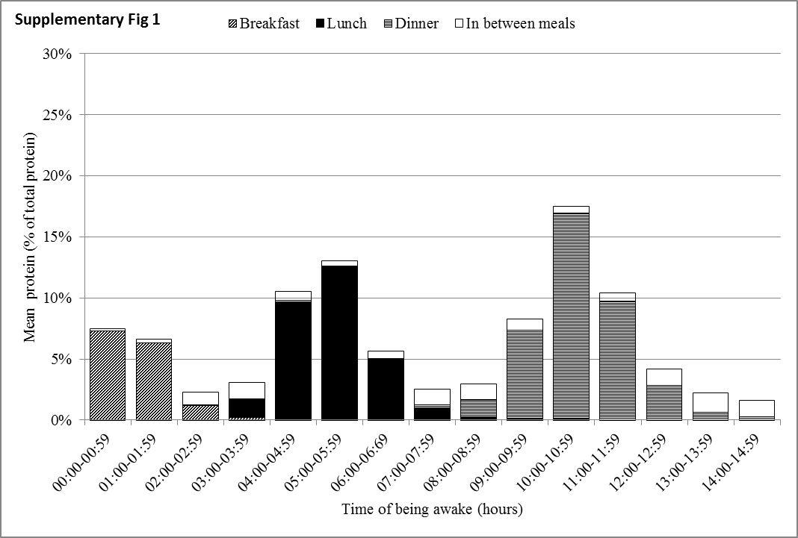
Supplementary Figure 1: Proportion of total protein intake of Dutch community-dwelling older adults aged 70 years and older across time since wake-up and specified for breakfast, lunch, dinner and in between meals (DNFCS-Older adults 2010-2012).

