Supplementary Table 1A Food-level analysis for input into principal components analysis (PCA) for dietary patterns derivation among women of reproductive age (18-54 y old) in Ghana
Food | Description of local food | Consumed in past 24 h (N) | Percent of total (%) | Reason to exclude from PCA
Cereals and grains
Cereal, koko or porridge | Koko is a spiced millet porridge | 550 | 31.5
Bread |  | 938 | 53.7
Rice |  | 1048 | 59.7
Roots and tubers
Starchy vegetables (e.g. maize, yams, potatoes, cassava and plantains) |  | 1456 | 83.3
Legumes and pulses
Cooked beans (e.g. black-eyed peas, beans and koose) | Koose is a spicy bean fritter | 447 | 25.6
Nuts and seeds
Agushie | Seed of cucurbitaceous plants (e.g. squash, watermelon) dried and ground for use in West African dishes | 154 | 8.8 | Excluded due to low proportion of respondents consuming the item.
Ground nuts |  | 251 | 14.4
Nuts (e.g. cashews, seeds or other nuts) |  | 150 | 8.6 | Excluded due to low proportion of respondents consuming the item.
Dairy
Yogurt |  | 95 | 5.5 | Excluded due to low proportion of respondents consuming the item.
Meat
Red meat (e.g. beef, pork, goat, grasscutter or bush meat) |  | 560 | 32.1
Poultry
Chicken |  | 336 | 19.3
Fish
Fish |  | 1314 | 75.3
Eggs
Eggs |  | 445 | 25.5
Dark green leafy vegetables
Dark leafy vegetables (e.g. kontomire, aleefu, ayoyo, kale and cassava leaves) | Konotmire is an indigenous leaf, often called purple taro or purple elephant’s ear  Aleefu is an indigenous amaranth leaf  Ayoyo is an indigenous green leaf, often called West African sorrel | 356 | 20.4
Other fruits
Fruit (e.g. pawpaw, apple, mango, orange or pineapple) |  | 619 | 35.4
100% fruit juice (e.g. orange and grapefruit juice) |  | 162 | 9.3 | Excluded due to low proportion of respondents consuming the item.
Other vegetables
Fresh vegetables or salad (e.g. lettuce, carrots and tomatoes) |  | 436 | 25.0
Oils and fats
Butter or margarine (on breads or on foods) |  | 183 | 10.5
Savoury and fried snacks
Fried chicken, fish or vegetables |  | 471 | 30.0
Fast food snacks |  | 174 | 9.9 | Excluded due to low proportion of respondents consuming the item.
Sugar-sweetened beverages
Sweetened drinks (e.g. regular soda, tea with sugar, or fruit flavoured drinks) |  | 826 | 47.3

Supplementary Table 1B Food-level analysis for input into principal components analysis (PCA) for dietary patterns derivation among women of reproductive age (19-48 y old) in Malawi
Food | Description of local food | Consumed in past 7 d (N) | Percent of total (%) | Reason to exclude from PCA
Cereals and grains
White bread |  | 82 | 59.4
African bread |  | 14 | 10.1
Doughnut, fritters, wheat dough deep fried |  | 60 | 43.5
Green maize |  | 17 | 12.3
Nsima, mgaiwa | Whole grain stiff maize porridge | 28 | 20.3
Nsima, ufawoyera | Refined stiff maize porridge | 81 | 58.7
Nsima, gramil | Partially refined maize thick porridge | 34 | 64.2
Nsima, madeya | Maize husk flour stiff porridge | 1 | 1.9 | Excluded due to low proportion of respondents consuming the item.
Rice |  | 78 | 56.5
Phala, mgaiwa | Whole grain regular (e.g., watery) maize porridge | 34 | 24.6
Phala, ufawoyera | Refined regular maize porridge | 1 | 0.7 | Excluded due to low proportion of respondents consuming the item.
Rice phala | Rice porridge | 41 | 29.7
Likuni phala | Micronutrient-fortified packaged maize and soy porridge | 3 | 5.7 | Excluded due to low proportion of respondents consuming the item.
Spaghetti/pasta/macaroni |  | 12 | 8.7 | Excluded due to low proportion of respondents consuming the item.
Breakfast cereals, like cornflakes or other packaged cereals |  | 6 | 4.3 | Excluded due to low proportion of respondents consuming the item.
Maize grits |  | 1 | 1.9 | Excluded due to low proportion of respondents consuming the item.
Sweet beer, thobwa | Home-made grain fermented drink usually made from white maize and millet or sorghum | 57 | 41.3
Roots and tubers
Irish potato |  | 66 | 47.8
Cassava |  | 38 | 27.5
Cocoyam |  | 0 | 0.0 | Excluded because nobody consumed the item.
Plantain |  | 0 | 0.0 | Excluded because nobody consumed the item.
Legumes and pulses
Green beans, stewed in relish |  | 15 | 10.9
Fresh pea/bean relish, plain |  | 3 | 2.2 | Excluded due to low proportion of respondents consuming the item.
Fresh pea/bean relish with groundnut flour |  | 0 | 0.0 | Excluded because nobody consumed the item.
Fresh pea/bean relish with oil |  | 15 | 10.9
Fresh pea/bean relish with groundnut flour and oil |  | 3 | 2.2 | Excluded due to low proportion of respondents consuming the item.
Dried pea/bean relish, plain |  | 19 | 13.8
Dried pea/bean relish with groundnut flour |  | 1 | 0.7 | Excluded due to low proportion of respondents consuming the item.
Dried pea/bean relish with oil |  | 97 | 70.3
Dried pea/bean relish with groundnut flour and oil |  | 1 | 0.7 | Excluded due to low proportion of respondents consuming the item.
Soya pieces |  | 52 | 37.7
Soya phala | Regular soy porridge | 67 | 48.6
Nuts and seeds
Soup made with groundnuts |  | 4 | 2.9 | Excluded due to low proportion of respondents consuming the item.
Fresh, boiled groundnuts |  | 11 | 8.0 | Excluded due to low proportion of respondents consuming the item.
Dried, roasted groundnuts |  | 62 | 44.9
Peanut butter |  | 16 | 11.6
Sibusiso | Locally produced soya-groundnut high energy food supplement | 0 | 0.0 | Excluded because nobody consumed the item.
Cashew nut |  | 1 | 0.7 | Excluded due to low proportion of respondents consuming the item.
Pumpkin seeds, sunflower seeds |  | 0 | 0.0 | Excluded because nobody consumed the item.
Raw groundnuts |  | 2 | 3.8 | Excluded due to low proportion of respondents consuming the item.
Dairy
Yoggie, yoghurt | Yoggie is a usually sweetened liquid yogurt | 22 | 16.1
Cheese |  | 3 | 2.2 | Excluded due to low proportion of respondents consuming the item.
Fresh milk |  | 34 | 24.6
Milk powder |  | 36 | 26.1
Meat
Roasted beef, beef liver, beef offal |  | 0 | 0.0 | Excluded because nobody consumed the item.
Fried beef, beef liver, beef offal |  | 10 | 7.2 | Excluded due to low proportion of respondents consuming the item.
Stewed beef, beef liver, beef offal in relish |  | 32 | 23.2
Roasted pork |  | 1 | 0.7 | Excluded due to low proportion of respondents consuming the item.
Fried pork |  | 5 | 3.6 | Excluded due to low proportion of respondents consuming the item.
Stewed pork in relish |  | 5 | 3.6 | Excluded due to low proportion of respondents consuming the item.
Roasted goat, goat offal |  | 1 | 0.7 | Excluded due to low proportion of respondents consuming the item.
Fried goat, goat offal |  | 12 | 8.7 | Excluded due to low proportion of respondents consuming the item.
Stewed goat in relish |  | 40 | 29.0
Roasted sheep |  | 1 | 0.7 | Excluded due to low proportion of respondents consuming the item.
Fried sheep |  | 0 | 0.0 | Excluded because nobody consumed the item.
Stewed sheep in relish |  | 1 | 0.7 | Excluded due to low proportion of respondents consuming the item.
Sausage |  | 6 | 4.4 | Excluded due to low proportion of respondents consuming the item.
Roasted mice, rats |  | 8 | 5.8 | Excluded due to low proportion of respondents consuming the item.
Roasted guinea pig |  | 0 | 0.0 | Excluded because nobody consumed the item.
Poultry
Roasted chicken, chicken liver, chicken gizzard, dove, pigeon, guinea fowl, duck |  | 10 | 7.2 | Excluded due to low proportion of respondents consuming the item.
Fried chicken, chicken liver, chicken gizzard, dove, pigeon, guinea fowl, duck |  | 33 | 23.9
Stewed chicken, chicken liver, chicken gizzard, dove, pigeon, guinea fowl, duck |  | 47 | 34.3
Fish
Roasted medium or large fresh fish |  | 15 | 10.9
Fried medium or large fresh fish |  | 21 | 15.2
Stewed medium or large fresh fish in relish |  | 20 | 14.6
Fried medium or large dried fish |  | 8 | 5.8 | Excluded due to low proportion of respondents consuming the item.
Stewed medium or large dried fish in relish |  | 32 | 23.2
Roasted small fresh fish |  | 11 | 8.0 | Excluded due to low proportion of respondents consuming the item.
Fried small fresh fish |  | 21 | 15.2
Stewed small fresh fish in relish |  | 18 | 13.0
Fried small dried fish |  | 29 | 21.2
Stewed small dried fish in relish |  | 40 | 29.0
Insects |  | 1 | 0.7 | Excluded due to low proportion of respondents consuming the item.
Eggs
Egg |  | 91 | 65.9
Dark green leafy vegetables
Green leafy vegetable relish, plain |  | 81 | 58.7
Green leafy vegetable relish with groundnut powder |  | 97 | 70.3
Green leafy vegetable relish with oil |  | 96 | 69.6
Green leafy vegetable relish with groundnut powder and oil |  | 3 | 2.2 | Excluded due to low proportion of respondents consuming the item.
Pumpkin leaves |  | 18 | 34.0
Vitamin A-rich vegetables
Carrot, raw |  | 20 | 14.5
Carrot, stewed in relish |  | 13 | 9.5 | Excluded due to low proportion of respondents consuming the item.
Sweet potato |  | 81 | 58.7
Vitamin A-rich fruits
Papaya, pawpaw |  | 20 | 14.5
Mango |  | 17 | 12.3
Other fruits
Apple |  | 17 | 12.3
Avocado |  | 7 | 5.1 | Excluded due to low proportion of respondents consuming the item.
Banana |  | 78 | 56.9
Baobab |  | 17 | 12.3
Tamarind |  | 6 | 4.3 | Excluded due to low proportion of respondents consuming the item.
Coconut |  | 0 | 0.0 | Excluded because nobody consumed the item.
Custard apple |  | 0 | 0.0 | Excluded because nobody consumed the item.
Guava |  | 18 | 13.0
Lemon, lime, orange, tangerine |  | 54 | 39.1
Masau | Small, sour fruit | 10 | 7.2 | Excluded due to low proportion of respondents consuming the item.
Loquat |  | 5 | 3.6 | Excluded due to low proportion of respondents consuming the item.
Passion fruit |  | 0 | 0.0 | Excluded because nobody consumed the item.
Pineapple |  | 2 | 1.4 | Excluded due to low proportion of respondents consuming the item.
Watermelon |  | 1 | 0.7 | Excluded due to low proportion of respondents consuming the item.
Flacourtina Indica | Fruit native to tropical Africa | 0 | 0.0 | Excluded because nobody consumed the item.
Other vegetables
Cabbage salad |  | 34 | 24.6
Boiled cabbage |  | 30 | 21.7
Cucumber |  | 10 | 7.2 | Excluded due to low proportion of respondents consuming the item.
Eggplant, stewed in relish |  | 19 | 13.8
Green pepper, stewed in relish |  | 36 | 26.1
Tomato, stewed in relish |  | 136 | 98.6 | Excluded due to high proportion of respondents consuming the item.
Mushroom, stewed in relish |  | 2 | 1.4 | Excluded due to low proportion of respondents consuming the item.
Pumpkin, boiled |  | 10 | 7.2 | Excluded due to low proportion of respondents consuming the item.
Okra relish |  | 47 | 34.1
Onions |  | 44 | 83.0
Hibiscus |  | 1 | 1.9 | Excluded due to low proportion of respondents consuming the item.
Potato leaves |  | 5 | 9.4
Gourd |  | 0 | 0.0 | Excluded because nobody consumed the item.
Chew okra |  | 0 | 0.0 | Excluded because nobody consumed the item.
Red pepper |  | 5 | 9.4 | Excluded due to low proportion of respondents consuming the item.
Oils and fats
Butter, margarine |  | 34 | 24.6
Cooking oil |  | 131 | 94.9 | Excluded due to high proportion of respondents consuming the item.
Savoury and fried snacks
Chips (French fries) |  | 53 | 38.7 | Excluded due to high proportion of respondents consuming the item.
Kamba puffs | Highly processed snack food made of maize | 26 | 19.0
Potato chips (crisps) |  | 4 | 2.9 | Excluded due to low proportion of respondents consuming the item.
Samosa |  | 15 | 10.9
Maize popcorn |  | 44 | 31.9
Jigs | Highly processed snack food made of maize | 17 | 12.9
Zigege | Local type of fritter | 13 | 24.5
Raja/ royco | Raja is curry powder  Royco is bouillon cubes | 13 | 24.5
Sweets
Biscuits |  | 21 | 15.2
Custard |  | 0 | 0.0 | Excluded because nobody consumed the item.
Freezies | Frozen popsicles | 30 | 21.7
Jam |  | 4 | 2.9 | Excluded due to low proportion of respondents consuming the item.
Brown sugar, white sugar |  | 130 | 94.2 | Excluded due to high proportion of respondents consuming the item.
Sugarcane |  | 51 | 37.0
Candies/sweets/lollipop |  | 18 | 13.0
Chocolate |  | 2 | 1.4 | Excluded due to low proportion of respondents consuming the item.
Honey |  | 6 | 4.3 | Excluded due to low proportion of respondents consuming the item.
African cake |  | 14 | 10.1
Other cakes and pastries |  | 5 | 3.6 | Excluded due to low proportion of respondents consuming the item.
Ice cream |  | 4 | 2.9 | Excluded due to low proportion of respondents consuming the item.
Sugar-sweetened beverages
Fruit juice |  | 17 | 12.3
Sobo | Locally produced soft drink | 22 | 15.9
Soft drinks (Coca Cola, Fanta, Sprite) |  | 33 | 23.9
Frozy | Locally produced soft drink | 10 | 18.9
Other beverages
Traditional beer |  | 2 | 1.4 | Excluded due to low proportion of respondents consuming the item.
Chibuku | Commercial sorghum beer | 0 | 0.0 | Excluded because nobody consumed the item.
Bottled/canned beer |  | 1 | 0.7 | Excluded due to low proportion of respondents consuming the item.
Mahewu | Sweetened non-alcoholic grain drink | 12 | 8.7 | Excluded due to low proportion of respondents consuming the item.
Coffee |  | 7 | 5.1 | Excluded due to low proportion of respondents consuming the item.
Brewed tea |  | 119 | 86.2
Water |  | 126 | 91.3 | Excluded because item does not contribute to energy and macronutrient intake.

Supplementary Table 1C Food-level analysis for input into principal components analysis (PCA) for dietary patterns derivation among older women (≥55 y old) in Ghana
Food | Description of local food | Consumed in past 24 h (N) | Percent of total (%) | Reason to exclude from PCA
Cereals and grains
Cereal, koko or porridge | Koko is a spiced millet porridge | 211 | 37.9
Bread |  | 329 | 59.0
Rice |  | 256 | 45.9
Roots and tubers
Starchy vegetables (e.g. maize, yams, potatoes, cassava and plantains) |  | 497 | 89.1
Legumes and pulses
Cooked beans (e.g. black-eyed peas, beans and koose) | Koose is a spicy bean fritter | 82 | 14.7
Nuts and seeds
Agushie | Seed of cucurbitaceous plants (e.g. squash, watermelon) dried and ground for use in West African dishes | 38 | 6.8 | Excluded due to low proportion of respondents consuming the item.
Ground nuts |  | 55 | 9.9 | Excluded due to low proportion of respondents consuming the item.
Nuts (e.g. cashews, seeds or other nuts) |  | 33 | 5.9 | Excluded due to low proportion of respondents consuming the item.
Dairy
Yogurt |  | 4 | 0.7 | Excluded due to low proportion of respondents consuming the item.
Meat
Red meat (e.g. beef, pork, goat, grasscutter or bush meat) |  | 102 | 18.3
Poultry
Chicken |  | 60 | 10.8
Fish
Fish |  | 477 | 85.5
Eggs
Eggs |  | 66 | 11.8
Dark green leafy vegetables
Dark leafy vegetables (e.g. kontomire, aleefu, ayoyo, kale and cassava leaves) | Konotmire is an indigenous leaf, often called purple taro or purple elephant’s ear  Aleefu is an indigenous amaranth leaf  Ayoyo is an indigenous green leaf, often called West African sorrel | 120 | 21.5
Other fruits
Fruit (e.g. pawpaw, apple, mango, orange or pineapple) |  | 171 | 30.7
100% fruit juice (e.g. orange and grapefruit juice) |  | 31 | 5.6 | Excluded due to low proportion of respondents consuming the item.
Other vegetables
Fresh vegetables or salad (e.g. lettuce, carrots and tomatoes) |  | 121 | 21.7
Oils and fats
Butter or margarine (on breads or on foods) |  | 21 | 3.8 | Excluded due to low proportion of respondents consuming the item.
Savoury and fried snacks
Fried chicken, fish or vegetables |  | 127 | 22.8
Fast food snacks |  | 32 | 5.8 | Excluded due to low proportion of respondents consuming the item.
Sugar-sweetened beverages
Sweetened drinks (e.g. regular soda, tea with sugar, or fruit flavoured drinks) |  | 249 | 44.6

Supplementary Table 1D Food-level analysis for input into principal components analysis (PCA) for dietary patterns derivation among older women (≥50 y old) in Tanzania
Food | Consumed in the past 7 d (N) | Percent of total (%) | Reason to exclude from PCA
Cereals and grains
Oat porridge or oatmeal | 1 | 0.4 | Excluded due to low proportion of respondents consuming the item.
Wheat porridge | 6 | 2.4 | Excluded due to low proportion of respondents consuming the item.
Millet meal porridge | 39 | 15.5
Corn porridge | 50 | 19.9
Cassava porridge | 8 | 3.2 | Excluded due to low proportion of respondents consuming the item.
Rice porridge | 26 | 10.4
Sorghum ugali (stiff porridge) | 10 | 4.0 | Excluded due to low proportion of respondents consuming the item.
Rice ugali | 24 | 9.6 | Excluded due to low proportion of respondents consuming the item.
Millet porridge or ugali | 4 | 1.6 | Excluded due to low proportion of respondents consuming the item.
Mixed grain porridge | 47 | 18.7
Grain from factory | 10 | 4.0 | Excluded due to low proportion of respondents consuming the item.
Maize (roasted or boiled, on the cob) | 70 | 27.9
Maize meal, cooked (ugali) | 229 | 91.2 | Excluded due to high proportion of respondents consuming the item.
Corn/sugar derived from corn juice | 11 | 4.4 | Excluded due to low proportion of respondents consuming the item.
Maize cooked with beans | 56 | 22.3
Maize cooked with beans and rice | 6 | 2.4 | Excluded due to low proportion of respondents consuming the item.
Rice, mixed in pilau, fried | 97 | 38.7
Plain rice, boiled | 122 | 48.6
Pasta, cooked (spaghetti, macaroni) | 75 | 29.9
Flat bread (Chapati) | 169 | 67.3
Pancakes | 41 | 16.3
Roots and tubers
Potato, boiled or baked | 75 | 29.9
Cassava, boiled | 67 | 26.7
Cassava stiff porridge | 30 | 12.0
Cassava (in a mixed dish) | 35 | 13.9
Sweet potato (alone) | 68 | 27.1
Sweet potato (in a mixed dish) | 39 | 15.5
Taro (alone) | 30 | 12.0
Taro (in a mixed dish) | 22 | 8.8 | Excluded due to low proportion of respondents consuming the item.
Yam (boiled, alone) | 24 | 9.6 | Excluded due to low proportion of respondents consuming the item.
Yam (fried) | 22 | 8.8 | Excluded due to low proportion of respondents consuming the item.
Yam (in a mixed dish) | 8 | 3.2 | Excluded due to low proportion of respondents consuming the item.
Pounded yam or other root vegetable | 43 | 17.1
Plantain (boiled or steamed) | 74 | 29.5
Plantain (roasted) | 55 | 21.9
Plantain (fried, or chips) | 62 | 24.7
Plantain (in a mixed dish) | 99 | 39.4
Legumes and pulses
Beans/legumes, alone | 105 | 41.8
Beans in mixed dish | 150 | 59.8
Bean soup | 42 | 16.7
Bean cakes | 55 | 21.9
Soya drink | 46 | 18.3
Nuts and seeds
Bambara nuts | 42 | 16.7
Groundnuts (alone) | 100 | 39.8
Groundnuts (added to food) | 71 | 28.3
Cashew nuts | 25 | 9.9 | Excluded due to low proportion of respondents consuming the item.
Dairy
Powdered cow’s milk, whole or full cream | 31 | 12.4
Powdered cow’s milk, fat free or non-fat | 10 | 4.0 | Excluded due to low proportion of respondents consuming the item.
Cow’s milk; full cream, whole, or direct from the cow | 95 | 37.9
Cow’s milk; low fat or 2% | 3 | 1.2 | Excluded due to low proportion of respondents consuming the item.
Cow’s milk; fat-free, or non-fat | 4 | 1.6 | Excluded due to low proportion of respondents consuming the item.
Non-dairy creamer (Cremora) | 6 | 2.4 | Excluded due to low proportion of respondents consuming the item.
Yogurt, plain | 54 | 21.5
Yogurt, artificially sweetened | 31 | 12.4
Yogurt, sweetened | 33 | 13.2
Cheese, soft but not in liquid | 22 | 8.8 | Excluded due to low proportion of respondents consuming the item.
Cheese, in liquid | 9 | 3.6 | Excluded due to low proportion of respondents consuming the item.
Other types of cheese | 9 | 3.6 | Excluded due to low proportion of respondents consuming the item.
Meat
Beef (not minced) | 182 | 72.5
Beef mince | 10 | 4.0 | Excluded due to low proportion of respondents consuming the item.
Goat | 22 | 8.8 | Excluded due to low proportion of respondents consuming the item.
Pork | 21 | 8.4 | Excluded due to low proportion of respondents consuming the item.
Lamb/mutton | 5 | 2.0 | Excluded due to low proportion of respondents consuming the item.
Sausage | 23 | 9.2 | Excluded due to low proportion of respondents consuming the item.
Bacon | 2 | 0.8 | Excluded due to low proportion of respondents consuming the item.
Processed meat (bologna) | 4 | 1.6 | Excluded due to low proportion of respondents consuming the item.
Processed meat (Vienna sausages) | 4 | 1.6 | Excluded due to low proportion of respondents consuming the item.
Ham | 8 | 3.2 | Excluded due to low proportion of respondents consuming the item.
Canned beef | 3 | 1.2 | Excluded due to low proportion of respondents consuming the item.
Organ meat
Offal/tripe | 1 | 0.4 | Excluded due to low proportion of respondents consuming the item.
Liver | 63 | 25.1
Poultry
Chicken | 123 | 49.0
Fish
Dried fish | 112 | 44.6
Anchovies/Sardines | 157 | 62.6
Canned tuna in saltwater | 3 | 1.2 | Excluded due to low proportion of respondents consuming the item.
Canned tuna in oil | 3 | 1.2 | Excluded due to low proportion of respondents consuming the item.
Fish curry/stew | 177 | 70.5
Fish, fresh | 43 | 17.1
Eggs
Eggs | 100 | 39.8
Dark green leafy vegetables
Spinach, cooked | 145 | 57.8
Amaranth leaves, cooked | 166 | 66.1
Pumpkin leaves, cooked | 171 | 68.1
Cow pea leaves, cooked | 127 | 50.6
Cassava leaves | 146 | 58.2
Other green leafy vegetables, cooked | 173 | 68.9
Vitamin A-rich vegetables
Carrot (fresh, not in salad) | 105 | 41.8
Carrot (fresh, as in salad) | 0 | 0.0 | Excluded because nobody consumed the item.
Vitamin A-rich fruits
Mango | 61 | 24.3
Papaya | 68 | 27.1
Passion fruit (fruit only, not juice) | 29 | 11.6
Sweet melon | 41 | 16.3
Other fruits
Ripe banana | 157 | 62.6
Tamarind | 10 | 4.0 | Excluded due to low proportion of respondents consuming the item.
Plum | 12 | 4.9 | Excluded due to low proportion of respondents consuming the item.
Tangerine | 17 | 6.8 | Excluded due to low proportion of respondents consuming the item.
Lemon or lime | 36 | 14.3
Jackfruit | 17 | 6.8 | Excluded due to low proportion of respondents consuming the item.
Baobab | 29 | 11.6
Watermelon | 121 | 48.2
Guava | 26 | 10.4
Peaches | 7 | 2.8 | Excluded due to low proportion of respondents consuming the item.
Avocado | 131 | 52.2
Pineapple (fruit only, not juice) | 26 | 10.4
Orange (fruit only, not juice) | 110 | 43.8
Orange juice | 38 | 15.1
Other fruit juice | 125 | 49.8
Apple | 24 | 9.6 | Excluded due to low proportion of respondents consuming the item.
Grapes | 25 | 9.9 | Excluded due to low proportion of respondents consuming the item.
Apricot | 7 | 2.8 | Excluded due to low proportion of respondents consuming the item.
Pear | 50 | 19.9
Local berries | 12 | 4.8 | Excluded due to low proportion of respondents consuming the item.
Berries (strawberries, raspberries) | 9 | 3.6 | Excluded due to low proportion of respondents consuming the item.
Fruit canned in syrup | 5 | 2.0 | Excluded due to low proportion of respondents consuming the item.
Raisins, and other dried fruit | 9 | 3.6 | Excluded due to low proportion of respondents consuming the item.
Other vegetables
Cucumber | 116 | 46.2
Lettuce | 38 | 15.1
Cabbage | 121 | 48.2
Pumpkin, or butternut, cooked | 20 | 8.0 | Excluded due to low proportion of respondents consuming the item.
Okra (alone) | 131 | 52.2
Okra (in a mixed dish) | 162 | 64.5
Green peas (alone) | 73 | 29.1
Green peas (in a mixed dish) | 89 | 35.5
Bitter tomato (alone) | 95 | 37.9
Bitter tomato (in a mixed dish) | 154 | 61.4
Tomato (fresh, not in salad) | 40 | 16.0
Tomato (fresh, as in salad) | 112 | 44.6
Tomato, cooked | 130 | 51.8
Green pepper (fresh, not in salad) | 16 | 6.4 | Excluded due to low proportion of respondents consuming the item.
Green pepper (fresh, as in salad) | 127 | 50.6
Zucchini, cooked | 11 | 4.4 | Excluded due to low proportion of respondents consuming the item.
Green beans, cooked | 35 | 13.9
Beetroot, cooked | 16 | 6.4 | Excluded due to low proportion of respondents consuming the item.
Broccoli, cooked | 10 | 4.0 | Excluded due to low proportion of respondents consuming the item.
Cauliflower, cooked | 13 | 5.2 | Excluded due to low proportion of respondents consuming the item.
Eggplant (alone), cooked | 68 | 27.1
Eggplant (in a mixed dish), cooked | 82 | 32.7
Mushrooms, cooked | 16 | 6.4 | Excluded due to low proportion of respondents consuming the item.
Onions (cooked) | 64 | 25.5
Chinese cabbage, cooked | 10 | 4.0 | Excluded due to low proportion of respondents consuming the item.
Other cabbage, cooked | 23 | 9.2 | Excluded due to low proportion of respondents consuming the item.
Oils and fats
Ghee | 10 | 4.0 | Excluded due to low proportion of respondents consuming the item.
Butter | 29 | 11.6
Margarine | 14 | 5.6 | Excluded due to low proportion of respondents consuming the item.
Animal fat | 36 | 14.3
Peanut butter | 28 | 11.2
Coconut milk | 42 | 16.7
Savoury and fried snacks
Potato, crisps, Cassava crisps, French fries | 78 | 31.1
Small pieces of roasted corn (crisps) | 26 | 10.4
Pie, pastry with meat filling (meat samosa) | 61 | 24.3
Pie, pastry with vegetable filling (vegetable samosa) | 43 | 17.1
Sweets
Bread, bread rolls, buns | 152 | 60.6
Scones, muffins | 104 | 41.4
Donut, fried dough, samosa | 167 | 66.5
Rice cakes | 35 | 13.9
Cookies (biscuits) | 23 | 9.2 | Excluded due to low proportion of respondents consuming the item.
Cake | 28 | 11.2
Sugar added to foods (include in tea & coffee) | 113 | 45.0
Honey or jam | 62 | 24.7
Chocolate bar | 11 | 4.4 | Excluded due to low proportion of respondents consuming the item.
Other sweets or candy | 23 | 9.2 | Excluded due to low proportion of respondents consuming the item.
Ice cream | 26 | 10.4
Squash or syrup mixed with water (with sugar) | 7 | 2.8 | Excluded due to low proportion of respondents consuming the item.
Squash or syrup mixed with water (with artificial sweetener) | 6 | 2.4 | Excluded due to low proportion of respondents consuming the item.
Sugar-sweetened beverages
Soda (Coke, Fanta, etc.) | 134 | 53.4
Diet soda | 14 | 5.58 | Excluded due to low proportion of respondents consuming the item.
Other beverages
Fermented mealie pap drink | 4 | 1.6 | Excluded due to low proportion of respondents consuming the item.
Tea with milk | 109 | 43.4
Tea without milk | 222 | 88.5
Coffee with milk | 15 | 6.0 | Excluded due to low proportion of respondents consuming the item.
Coffee without milk | 25 | 9.9 | Excluded due to low proportion of respondents consuming the item.
Beer, commercially prepared | 24 | 9.6 | Excluded due to low proportion of respondents consuming the item.
Beer, homemade or locally brewed | 9 | 3.6 | Excluded due to low proportion of respondents consuming the item.
Wine, commercially prepared | 9 | 3.6 | Excluded due to low proportion of respondents consuming the item.
Wine, homemade or locally brewed | 5 | 2.0 | Excluded due to low proportion of respondents consuming the item.
Distilled alcoholic beverages, commercially prepared (examples: whisky, rum, vodka, gin) | 7 | 2.8 | Excluded due to low proportion of respondents consuming the item.
Distilled alcoholic beverages, homemade or locally brewed | 2 | 0.8 | Excluded due to low proportion of respondents consuming the item.
Condiments
Mayonnaise or salad dressing | 13 | 5.2 | Excluded due to low proportion of respondents consuming the item.

Supplemental Table 2A Socio-economic and demographic characteristics by PCA-derived dietary pattern quantiles among women of reproductive age (18-54 y old) in Ghana

 | Protein dietary pattern
 | Q1 |  | Q2 |  | Q3 |  | Q4 |  | Q5
 | Mean or percentage (%) | SD | Mean or percentage (%) | SD | Mean or percentage (%) | SD | Mean or percentage (%) | SD | Mean or percentage (%) | SD | p-trendª
Age group
18-24 years | 34.1 |  | 35.1 |  | 33.7 |  | 43.3 |  | 43.5 |  | <0.001
25-34 years | 29.6 |  | 27.0 |  | 33.3 |  | 24.7 |  | 28.7
35-54 years | 36.3 |  | 37.9 |  | 33.0 |  | 32.0 |  | 27.9
Has primary education or higher | 87.8 |  | 89.0 |  | 87.8 |  | 87.8 |  | 92.5 |  | 0.12
Married or lives with partner | 54.2 |  | 55.7 |  | 60.5 |  | 54.0 |  | 54.3 |  | 0.86
Number of assets owned by household (0-10) | 5.2 | 1.9 | 5.1 | 1.9 | 5.1 | 2.0 | 5.3 | 1.8 | 5.3 | 1.8 | 0.33

 | Healthy dietary pattern
 | Q1 |  | Q2 |  | Q3 |  | Q4 |  | Q5
 | Mean or percentage (%) | SD | Mean or percentage (%) | SD | Mean or percentage (%) | SD | Mean or percentage (%) | SD | Mean or percentage (%) | SD | p-trendª
Age group
18-24 years | 37.0 |  | 37.5 |  | 36.5 |  | 40.5 |  | 38.2 |  | 0.46
25-34 years | 26.2 |  | 32.3 |  | 28.4 |  | 25.7 |  | 29.5
35-54 years | 36.7 |  | 30.2 |  | 35.1 |  | 33.8 |  | 32.3
Has primary education or higher | 88.5 |  | 88.0 |  | 88.4 |  | 89.9 |  | 90.3 |  | 0.31
Married or lives with partner | 57.5 |  | 52.0 |  | 57.0 |  | 54.1 |  | 57.4 |  | 0.81
Number of assets owned by household (0-10) | 5.0 | 2.0 | 5.2 | 1.8 | 5.3 | 1.8 | 5.2 | 1.9 | 5.3 | 1.9 | 0.07
PCA, principal components analysis; Q, quintile.
ª Non-parametric test for linear trend across ordered quintiles. Considered significant at p<0.05.

Supplemental Table 2B Socio-economic and demographic characteristics by PCA-derived dietary patterns quantiles among women of reproductive age (19-48 y old) in Malawi

 | Protein dietary pattern
 | Q1 |  | Q2 |  | Q3 |  | Q4 |  | p-trendª
 | Mean or percentage (%) | SD | Mean or percentage (%) | SD | Mean or percentage (%) | SD | Mean or percentage (%) | SD
Age group
18-24 years | 31.4 |  | 35.3 |  | 38.2 |  | 14.7 |  | 0.22
25-34 years | 54.3 |  | 58.8 |  | 47.1 |  | 70.6
35-54 years | 14.3 |  | 5.9 |  | 14.7 |  | 14.7
Has primary education or higher | 37.1 |  | 71.4 |  | 55.9 |  | 70.6 |  | 0.02
Number of assets owned by household (0-12) | 3.6 | 2.5 | 4.9 | 3.0 | 6.2 | 2.6 | 6.5 | 2.7 | <0.001

 | Healthy dietary pattern
 | Q1 |  | Q2 |  | Q3 |  | Q4 |  | p-trendª
 | Mean or percentage (%) | SD | Mean or percentage (%) | SD | Mean or percentage (%) | SD | Mean or percentage (%) | SD
Age group
18-24 years | 20.0 |  | 21.2 |  | 37.1 |  | 41.2 |  | 0.04
25-34 years | 65.7 |  | 63.6 |  | 54.3 |  | 47.1
35-54 years | 14.3 |  | 15.2 |  | 8.6 |  | 11.8
Has primary education or higher | 48.6 |  | 55.9 |  | 65.7 |  | 64.7 |  | 0.12
Number of assets owned by household (0-12) | 4.6 | 3.2 | 5.6 | 3.2 | 5.6 | 2.8 | 5.5 | 2.6 | 0.25
PCA, principal components analysis; Q, quartile.
ª Non-parametric test for linear trend across ordered quartiles. Considered significant at p<0.05.
Supplemental Table 2C Socio-economic and demographic characteristics by PCA-derived dietary pattern quantiles among older women (≥55 y old) in Ghana

 | Cereal dietary pattern
 | Q1 |  | Q2 |  | Q3 |  | Q4 |  | p-trendª
 | Mean or percentage (%) | SD | Mean or percentage (%) | SD | Mean or percentage (%) | SD | Mean or percentage (%) | SD
Has primary education or higher | 43.8 |  | 55.1 |  | 54.7 |  | 61.3 |  | 0.01
Married or lives with partner | 25.9 |  | 26.8 |  | 26.2 |  | 24.8 |  | 0.83
Number of assets owned by household (0-12) | 4.4 | 2.5 | 4.9 | 2.5 | 4.7 | 2.4 | 5.1 | 2.3 | 0.06

 | Protein dietary pattern
 | Q1 |  | Q2 |  | Q3 |  | Q4 |  | p-trendª
 | Mean or percentage (%) | SD | Mean or percentage (%) | SD | Mean or percentage (%) | SD | Mean or percentage (%) | SD
Has primary education or higher | 40.9 |  | 53.7 |  | 56.7 |  | 63.8 |  | <0.001
Married or lives with partner | 23.6 |  | 23.8 |  | 26.3 |  | 30.7 |  | 0.16
Number of assets owned by household (0-12) | 5.1 | 2.3 | 4.5 | 2.4 | 5.3 | 2.4 | 4.4 | 2.4 | 0.01

 | Healthy dietary pattern
 | Q1 |  | Q2 |  | Q3 |  | Q4 |  | p-trendª
 | Mean or percentage (%) | SD | Mean or percentage (%) | SD | Mean or percentage (%) | SD | Mean or percentage (%) | SD
Has primary education or higher | 47.7 |  | 51.7 |  | 63.1 |  | 54.1 |  | 0.07
Married or lives with partner | 24.4 |  | 27.3 |  | 31.1 |  | 22.5 |  | 0.99
Number of assets owned by household (0-12) | 4.4 | 2.4 | 4.2 | 2.9 | 5.3 | 2.3 | 5.1 | 2.2 | <0.001
PCA, principal components analysis; Q, quartile.
ª Non-parametric test for linear trend across ordered quartiles. Considered significant at p<0.05.

Supplemental Table 2D Socio-economic and demographic characteristics by PCA-derived dietary pattern quantiles among older women (≥50 y old) in Tanzania

 | Protein dietary pattern
 | Q1 |  | Q2 |  | Q3 |  | Q4 |  | p-trendª
 | Mean or percentage (%) | SD | Mean or percentage (%) | SD | Mean or percentage (%) | SD | Mean or percentage (%) | SD
Age group
50-54 years | 45.7 |  | 35.3 |  | 38.2 |  | 41.2 |  | 0.77
≥55 years | 54.3 |  | 64.7 |  | 61.8 |  | 58.8
Married or lives with partner | 54.3 |  | 38.2 |  | 50.0 |  | 41.2 |  | 0.46
Number of assets owned by household (0-12) | 5.8 | 3.5 | 7.9 | 4.1 | 9.1 | 4.0 | 9.2 | 4.1 | <0.001

 | Healthy dietary pattern
 | Q1 |  | Q2 |  | Q3 |  | Q4 |  | p-trendª
 | Mean or percentage (%) | SD | Mean or percentage (%) | SD | Mean or percentage (%) | SD | Mean or percentage (%) | SD
Age group
50-54 years | 34.3 |  | 41.2 |  | 35.3 |  | 50.0 |  | 0.27
≥55 years | 65.7 |  | 58.8 |  | 64.7 |  | 50.0
Married or lives with partner | 51.4 |  | 41.2 |  | 29.4 |  | 61.8 |  | 0.46
Number of assets owned by household (0-12) | 7.5 | 4.0 | 6.7 | 4.1 | 8.2 | 4.2 | 9.6 | 3.8 | 0.02
PCA, principal components analysis; Q, quartile.
ª Non-parametric test for linear trend across ordered quartiles. Considered significant at p<0.05.

Supplemental Table 3A Association between principal components analysis derived dietary patterns and body mass index (BMI), overweight and obesity among women of reproductive age (18-54 y) in Ghana

Panel A Protein dietary patternª

 | Protein dietary pattern
 | Q2 |  |  | Q3 |  |  | Q4 |  |  | Q5
 | β or OR | 95% CI | P value | β or OR | 95% CI | P value | β or OR | 95% CI | P value | β or OR | 95% CI | P value
BMI (kg/m²)
Unadjusted | 1.04 | -0.06, 2.13 | 0.06 | -0.35 | -1.41, 0.72 | 0.52 | -0.40 | -1.38, 0.58 | 0.42 | -0.51 | -1.52, 0.51 | 0.33
Adjusted | 0.92 | -0.12, 1.96 | 0.08 | -0.44 | -1.45, 0.56 | 0.39 | -0.07 | -1.00, 0.86 | 0.88 | -0.18 | -1.15, 0.79 | 0.72
Overweight (BMI≥25 kg/m² and BMI<30 kg/m²)
Unadjusted | 1.88 | 1.25, 2.84 | <0.01 | 1.07 | 0.71, 1.61 | 0.75 | 1.50 | 1.03, 2.19 | 0.04 | 1.09 | 0.73, 1.61 | 0.68
Adjusted | 1.87 | 1.23, 2.83 | <0.01 | 1.06 | 0.70, 1.60 | 0.80 | 1.67 | 1.12, 2.48 | 0.01 | 1.13 | 0.76, 1.69 | 0.55
Obesity (BMI≥30 kg/m²)
Unadjusted | 1.79 | 1.22, 2.63 | <0.01 | 1.00 | 0.68, 1.45 | 0.99 | 0.90 | 0.63, 1.30 | 0.58 | 0.94 | 0.65, 1.35 | 0.72
Adjusted | 1.79 | 1.19, 2.70 | <0.01 | 0.95 | 0.64, 1.41 | 0.79 | 1.03 | 0.69, 1.52 | 0.90 | 1.04 | 0.71, 1.53 | 0.85
Overweight or obesity (BMI≥25 kg/m²)
Unadjusted | 1.83 | 1.29, 2.58 | <0.01 | 1.03 | 0.74, 1.43 | 0.88 | 1.14 | 0.83, 1.56 | 0.43 | 1.00 | 0.72, 1.37 | 0.98
Adjusted | 1.82 | 1.27, 2.60 | <0.01 | 0.98 | 0.69, 1.40 | 0.92 | 1.32 | 0.94, 1.85 | 0.11 | 1.11 | 0.79, 1.56 | 0.53
PCA, principal components analysis; BMI, body mass index; Q, quintile.
ª Estimates from a multinomial logistic model controlling for age, education, marital status and wealth. For each dietary pattern comparisons were to quintile 1 (Q1).

Panel B Healthy dietary patternª

 | Healthy dietary pattern
 | Q2 |  |  | Q3 |  |  | Q4 |  |  | Q5
 | β or OR | 95% CI | P value | β or OR | 95% CI | P value | β or OR | 95% CI | P value | β or OR | 95% CI | P value
BMI (kg/m²)
Unadjusted | -0.30 | -1.31, 0.72 | 0.56 | 0.66 | -0.47, 1.79 | 0.25 | -0.06 | -1.07, 0.95 | 0.91 | 1.00 | -0.09, 2.09 | 0.07
Adjusted | -0.18 | -1.13, 0.78 | 0.72 | 0.50 | -0.57, 1.57 | 0.36 | -0.05 | -1.00, 0.91 | 0.93 | 0.93 | -0.09, 1.95 | 0.08
Overweight (BMI≥25 kg/m² and BMI<30 kg/m²)
Unadjusted | 1.31 | 0.89, 1.93 | 0.17 | 1.33 | 0.87, 2.02 | 0.18 | 1.33 | 0.90, 1.97 | 0.15 | 1.02 | 0.67, 1.55 | 0.93
Adjusted | 1.30 | 0.88, 1.93 | 0.19 | 1.29 | 0.84, 1.98 | 0.25 | 1.31 | 0.88, 1.96 | 0.19 | 1.02 | 0.67, 1.55 | 0.93
Obesity (BMI≥30 kg/m²)
Unadjusted | 1.03 | 0.71, 1.50 | 0.86 | 1.37 | 0.92, 2.06 | 0.12 | 1.20 | 0.83, 1.74 | 0.34 | 1.49 | 1.02, 2.19 | 0.04
Adjusted | 1.07 | 0.72, 1.59 | 0.74 | 1.30 | 0.85, 1.99 | 0.23 | 1.19 | 0.80, 1.77 | 0.39 | 1.48 | 0.99, 2.22 | 0.06
Overweight or obesity (BMI≥25 kg/m²)
Unadjusted | 1.15 | 0.83, 1.60 | 0.40 | 1.35 | 0.95, 1.93 | 0.09 | 1.26 | 0.90, 1.75 | 0.18 | 1.28 | 0.91, 1.81 | 0.15
Adjusted | 1.14 | 0.81, 1.60 | 0.45 | 1.33 | 0.92, 1.93 | 0.13 | 1.24 | 0.88, 1.75 | 0.22 | 1.23 | 0.86, 1.75 | 0.25
BMI, body mass index; Q, quintile.
ª Estimates from a multinomial logistic model controlling for age, education, marital status and wealth. For each dietary pattern comparisons were to quintile 1 (Q1).

Supplemental Table 3B Association between principal components analysis derived dietary patterns and body mass index (BMI), overweight and obesity among women of reproductive age (19-48 y) in Malawi

Panel A Protein dietary patternª

 | Protein dietary pattern
 | Q2 |  |  | Q3 |  |  | Q4
 | β or OR | 95% CI | P value | β or OR | 95% CI | P value | β or OR | 95% CI | P value
BMI (kg/m²)
Unadjusted | 0.76 | -1.74, 3.26 | 0.55 | 1.69 | -0.87, 4.24 | 0.20 | 0.32 | -2.21, 2.86 | 0.80
Adjusted | 0.45 | -1.99, 2.89 | 0.72 | 0.21 | -2.30, 2.72 | 0.87 | -1.85 | -4.40, 0.71 | 0.16
Overweight (BMI≥25 kg/m² and BMI<30 kg/m²)
Unadjusted | 1.02 | 0.29, 3.59 | 0.97 | 6.06 | 1.42, 25.88 | 0.02 | 3.17 | 0.89, 11.30 | 0.08
Adjusted | 0.95 | 0.25, 3.62 | 0.94 | 5.04 | 1.07, 23.76 | 0.04 | 1.62 | 0.40, 6.48 | 0.50
Obesity (BMI≥30 kg/m²)
Unadjusted | 1.34 | 0.40, 4.49 | 0.63 | 3.77 | 0.85, 16.78 | 0.08 | 1.53 | 0.40, 5.90 | 0.53
Adjusted | 0.87 | 0.20, 3.67 | 0.85 | 1.53 | 0.27, 8.53 | 0.63 | 0.27 | 0.05, 1.46 | 0.13
Overweight or obesity (BMI≥25 kg/m²)
Unadjusted | 1.20 | 0.42, 3.43 | 0.74 | 4.88 | 1.29, 18.54 | 0.02 | 2.31 | 0.74, 7.22 | 0.15
Adjusted | 0.97 | 0.30, 3.16 | 0.97 | 3.36 | 0.78, 14.51 | 0.10 | 0.89 | 0.25, 3.19 | 0.86
PCA, principal components analysis; BMI, body mass index; Q, quartile.
ª Estimates from a multinomial logistic model controlling for age, education, and wealth. For each dietary pattern comparisons were to quartile 1 (Q1).

Panel B Healthy dietary patternª

 | Healthy dietary pattern
 | Q2 |  |  | Q3 |  |  | Q4
 | β or OR | 95% CI | P value | β or OR | 95% CI | P value | β or OR | 95% CI | P value
BMI (kg/m²)
Unadjusted | -0.43 | -2.88, 2.01 | 0.73 | -0.45 | -2.95, 2.05 | 0.72 | 0.80 | -1.77, 3.37 | 0.54
Adjusted | -0.61 | -2.90, 1.69 | 0.60 | 0.10 | -2.25, 2.46 | 0.93 | 1.42 | -0.99, 3.84 | 0.25
Overweight (BMI≥25 kg/m² and BMI<30 kg/m²)
Unadjusted | 0.33 | 0.09, 1.17 | 0.09 | 0.40 | 0.11, 1.43 | 0.16 | 0.51 | 0.13, 2.07 | 0.35
Adjusted | 0.36 | 0.10, 1.32 | 0.12 | 0.51 | 0.14, 1.89 | 0.31 | 0.66 | 0.16, 2.75 | 0.57
Obesity (BMI≥30 kg/m²)
Unadjusted | 0.82 | 0.22, 2.99 | 0.76 | 0.65 | 0.16, 2.60 | 0.55 | 1.13 | 0.26, 4.86 | 0.87
Adjusted | 0.84 | 0.20, 3.58 | 0.81 | 1.06 | 0.23, 4.93 | 0.94 | 2.04 | 0.40, 10.38 | 0.39
Overweight or obesity (BMI≥25 kg/m²)
Unadjusted | 0.50 | 0.16, 1.54 | 0.23 | 0.49 | 0.15, 1.58 | 0.23 | 0.73 | 0.20, 2.62 | 0.62
Adjusted | 0.48 | 0.14, 1.62 | 0.24 | 0.61 | 0.18, 2.12 | 0.44 | 0.94 | 0.24, 3.64 | 0.93
BMI, body mass index; Q, quartile.
ª Estimates from a multinomial logistic model controlling for age, education, and wealth. For each dietary pattern comparisons were to quartile 1 (Q1).

Supplemental Table 3C Association between principal components analysis derived dietary patterns and body mass index (BMI), overweight and obesity among older women (≥55 y) in Ghana

Panel A Cereal dietary patternª

 | Cereal dietary pattern
 | Q2 |  |  | Q3 |  |  | Q4
 | β or OR | 95% CI | P value | β or OR | 95% CI | P value | β or OR | 95% CI | P value
BMI (kg/m²)
Unadjusted | 0.60 | -1.66, 2.85 | 0.60 | 0.08 | -1.69, 1.85 | 0.93 | -0.78 | -2.70, 1.14 | 0..43
Adjusted | 0.45 | -1.86, 2.77 | 0.70 | -0.03 | -1.79, 1.72 | 0.97 | -1.08 | -3.00, 0.83 | 0.27
Overweight (BMI≥25 kg/m² and BMI<30 kg/m²)
Unadjusted | 1.02 | 0.44, 2.36 | 0.97 | 0.93 | 0.47, 1.83 | 0.83 | 0.79 | 0.37, 1.70 | 0.55
Adjusted | 0.88 | 0.37, 2.11 | 0.78 | 0.84 | 0.41, 1.70 | 0.63 | 0.70 | 0.31, 1.53 | 0.36
Obesity (BMI≥30 kg/m²)
Unadjusted | 1.28 | 0.58, 2.84 | 0.54 | 1.11 | 0.59, 2.11 | 0.74 | 0.89 | 0.44, 1.78 | 0.74
Adjusted | 1.13 | 0.49, 2.59 | 0.77 | 1.01 | 0.52, 1.95 | 0.98 | 0.72 | 0.35, 1.49 | 0.38
Overweight or obesity (BMI≥25 kg/m²)
Unadjusted | 1.17 | 0.56, 2.42 | 0.68 | 1.03 | 0.58, 1.84 | 0.92 | 0.84 | 0.44, 1.61 | 0.60
Adjusted | 1.03 | 0.48, 2.20 | 0.95 | 0.93 | 0.51, 1.71 | 0.83 | 0.71 | 0.36, 1.39 | 0.32
PCA, principal components analysis; BMI, body mass index; Q, quartile.
ª Estimates from a multinomial logistic model controlling for age, education, and wealth. For each dietary pattern comparisons were to quartile 1 (Q1).

Panel B Protein dietary patternª

 | Protein dietary pattern
 | Q2 |  |  | Q3 |  |  | Q4
 | β or OR | 95% CI | P value | β or OR | 95% CI | P value | β or OR | 95% CI | P value
BMI (kg/m²)
Unadjusted | 2.97 | 0.73, 5.20 | <0.01 | 2.97 | 1.09, 4.86 | <0.01 | 1.86 | 0.11, 3.60 | 0.04
Adjusted | 2.76 | 0.54, 4.99 | 0.02 | 2.83 | 0.95, 4.71 | <0.01 | 1.38 | -0.39, 3.15 | 0.13
Overweight (BMI≥25 kg/m² and BMI<30 kg/m²)
Unadjusted | 1.57 | 0.66, 3.77 | 0.31 | 1.89 | 0.91, 3.91 | 0.09 | 1.84 | 0.90, 3.79 | 0.10
Adjusted | 1.62 | 0.66, 3.97 | 0.29 | 1.82 | 0.87, 3.81 | 0.11 | 1.68 | 0.79, 3.54 | 0.18
Obesity (BMI≥30 kg/m²)
Unadjusted | 2.46 | 1.11, 5.44 | 0.03 | 2.39 | 1.22, 4.68 | 0.01 | 1.71 | 0.87, 3.37 | 0.12
Adjusted | 2.32 | 1.02, 5.30 | 0.05 | 2.29 | 1.17, 4.48 | 0.02 | 1.46 | 0.73, 2.94 | 0.29
Overweight or obesity (BMI≥25 kg/m²)
Unadjusted | 2.08 | 0.99, 4.34 | 0.75 | 2.17 | 1.17, 4.02 | 0.80 | 1.77 | 0.96, 3.27 | 0.15
Adjusted | 2.02 | 0.94, 4.34 | 0.07 | 2.08 | 1.12, 3.86 | 0.02 | 1.55 | 0.82, 2.93 | 0.18
BMI, body mass index; Q, quartile.
ª Estimates from a multinomial logistic model controlling for age, education, and wealth. For each dietary pattern comparisons were to quartile 1 (Q1).

Panel C Healthy dietary patternª

 | Healthy dietary pattern
 | Q2 |  |  | Q3 |  |  | Q4
 | β or OR | 95% CI | P value | β or OR | 95% CI | P value | β or OR | 95% CI | P value
BMI (kg/m²)
Unadjusted | -0.26 | -2.38, 1.86 | 0.81 | 0.46 | -1.15, 2.08 | 0.57 | 1.44 | -0.25, 3.14 | 0.10
Adjusted | -0.56 | -2.65, 1.53 | 0.60 | 0.23 | -1.38, 1.84 | 0.78 | 1.15 | -0.55, 2.84 | 0.19
Overweight (BMI≥25 kg/m² and BMI<30 kg/m²)
Unadjusted | 0.92 | 0.43, 2.00 | 0.84 | 1.17 | 0.59, 2.33 | 0.66 | 1.44 | 0.72, 2.90 | 0.31
Adjusted | 0.90 | 0.41, 1.99 | 0.79 | 1.03 | 0.50, 2.10 | 0.93 | 1.30 | 0.64, 2.64 | 0.48
Obesity (BMI≥30 kg/m²)
Unadjusted | 0.88 | 0.43, 1.83 | 0.74 | 1.03 | 0.55, 1.92 | 0.94 | 1.63 | 0.86, 3.10 | 0.13
Adjusted | 0.78 | 0.37, 1.65 | 0.52 | 0.92 | 0.48, 1.77 | 0.81 | 1.43 | 0.75, 2.72 | 0.28
Overweight or obesity (BMI≥25 kg/m²)
Unadjusted | 0.90 | 0.47, 1.73 | 0.75 | 1.08 | 0.60, 1.93 | 0.80 | 1.55 | 0.86, 2.82 | 0.15
Adjusted | 0.83 | 0.42, 1.63 | 0.59 | 0.96 | 0.53, 1.76 | 0.90 | 1.37 | 0.75, 2.51 | 0.30
BMI, body mass index; Q, quartile.
ª Estimates from a multinomial logistic model controlling for age, education, and wealth. For each dietary pattern comparisons were to quartile 1 (Q1).

Supplementary Table 3D Association between principal components analysis derived dietary patterns and body mass index (BMI), overweight and obesity among older women (≥50 y) in Tanzania

Panel A Protein dietary patternª

 | Protein dietary pattern
 | Q2 |  |  | Q3 |  |  | Q4
 | β or OR | 95% CI | P value | β or OR | 95% CI | P value | β or OR | 95% CI | P value
BMI (kg/m²)
Unadjusted | 0.34 | -3.30, 3.98 | 0.86 | 1.42 | -2.24, 5.07 | 0.45 | 1.27 | -2.58, 5.11 | 0.52
Adjusted | -0.70 | -4.57, 3.16 | 0.72 | 0.27 | -3.65, 4.20 | 0.89 | 0.81 | -3.29, 4.90 | 0.70
Overweight (BMI≥25 kg/m² and BMI<30 kg/m²)
Unadjusted | 1.09 | 0.30, 4.06 | 0.89 | 1.73 | 0.44, 6.82 | 0.44 | 2.03 | 0.43, 9.64 | 0.37
Adjusted | 0.54 | 0.12, 2.40 | 0.42 | 0.99 | 0.19, 5.13 | 0.99 | 1.62 | 0.27, 9.80 | 0.60
Obesity (BMI≥30 kg/m²)
Unadjusted | 0.96 | 0.28, 3.22 | 0.95 | 1.40 | 0.39, 5.07 | 0.60 | 2.59 | 0.64, 10.59 | 0.18
Adjusted | 0.50 | 0.13, 1.95 | 0.32 | 0.76 | 0.16, 3.62 | 0.74 | 2.17 | 0.42, 11.32 | 0.36
Overweight or obesity (BMI≥25 kg/m²)
Unadjusted | 1.01 | 0.33, 3.07 | 0.98 | 1.53 | 0.47, 5.01 | 0.48 | 2.40 | 0.63, 9.08 | 0.20
Adjusted | 0.51 | 0.14, 1.79 | 0.29 | 0.84 | 0.19, 3.61 | 0.81 | 1.92 | 0.40, 9.28 | 0.42
PCA, principal components analysis; BMI, body mass index; Q, quartile.
ª Estimates from a multinomial logistic model controlling for age, marital status, and wealth. For each dietary pattern comparisons were to quartile 1 (Q1).

Panel B Traditional dietary patternª

 | Traditional dietary pattern
 | Q2 |  |  | Q3 |  |  | Q4
 | β or OR | 95% CI | P value | β or OR | 95% CI | P value | β or OR | 95% CI | P value
BMI (kg/m²)
Unadjusted | 0.58 | -3.02, 4.17 | 0.75 | 3.62 | -0.06, 7.30 | 0.05 | 1.28 | -2.53, 5.09 | 0.51
Adjusted | 1.00 | -2.71, 4.72 | 0.60 | 3.60 | -0.15, 7.35 | 0.06 | 0.75 | -3.21, 4.70 | 0.71
Overweight (BMI≥25 kg/m² and BMI<30 kg/m²)
Unadjusted | 0.59 | 0.15, 2.24 | 0.44 | 0.74 | 0.17, 3.14 | 0.68 | 0.40 | 0.09, 1.72 | 0.22
Adjusted | 0.70 | 0.15, 3.24 | 0.65 | 0.56 | 0.11, 2.93 | 0.50 | 0.18 | 0.03, 1.01 | 0.05
Obesity (BMI≥30 kg/m²)
Unadjusted | 0.76 | 0.21, 2.75 | 0.68 | 1.36 | 0.35, 5.28 | 0.66 | 0.69 | 0.18, 2.65 | 0.59
Adjusted | 0.85 | 0.20, 3.67 | 0.83 | 1.05 | 0.22, 4.97 | 0.95 | 0.31 | 0.06, 1.54 | 0.15
Overweight or obesity (BMI≥25 kg/m²)
Unadjusted | 0.68 | 0.21, 2.19 | 0.52 | 1.06 | 0.30, 3.76 | 0.93 | 0.55 | 0.16, 1.91 | 0.35
Adjusted | 0.77 | 0.20, 3.02 | 0.71 | 0.82 | 0.19, 3.55 | 0.79 | 0.25 | 0.05, 1.14 | 0.07
BMI, body mass index; Q, quartile.
ª Estimates from a multinomial logistic model controlling for age, marital status, and wealth. For each dietary pattern comparisons were to quartile 1 (Q1).

Supplementary Figure 1A Food groups retained in the dietary pattern scores for women of reproductive age (18-54 y old) in Ghana
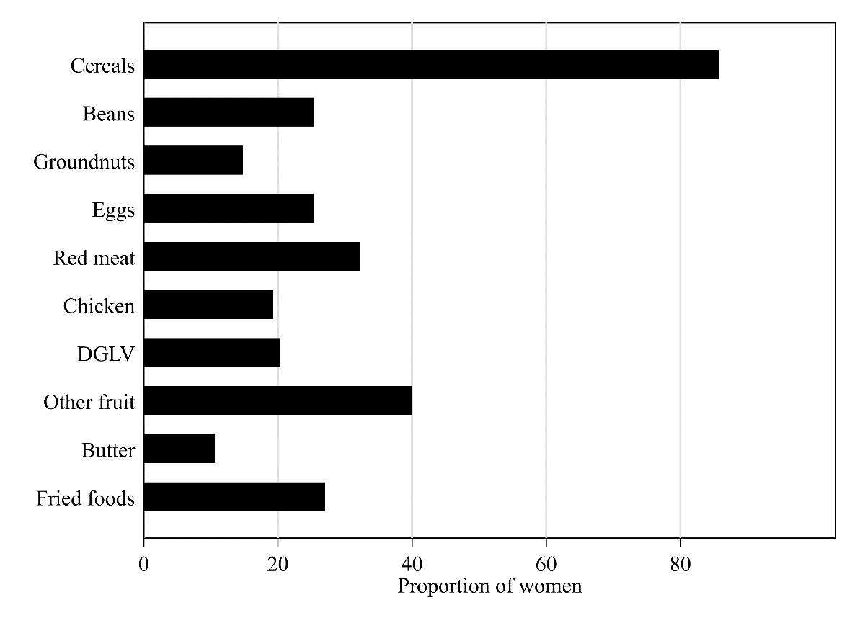
DGLV, dark green leafy vegetables. Fried foods included fried chicken, fish or vegetables, including plantains, yams, potatoes and cassava.

Supplementary Figure 1B Food groups retained in the dietary pattern scores for women of reproductive age (19-48 y old) in Malawi
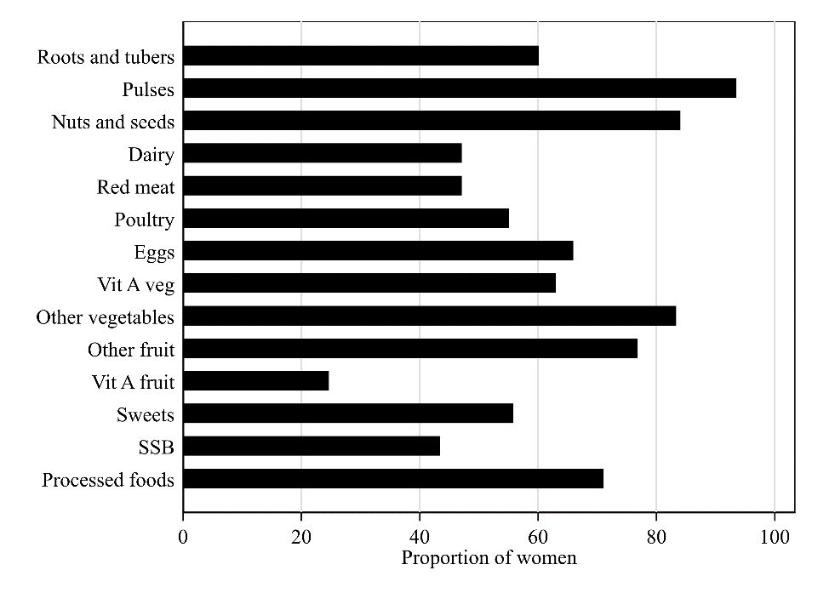
Vit A veg, vitamin A-rich vegetables; Vit A, vitamin A-rich; SSB, sugar sweetened beverages. Processed foods included chips, Kamba puffs, samosas, maize popcorn, Jigs, Zigega, and Raja/Royco.

Supplementary Figure 1C Food groups retained in the dietary pattern scores for older women (≥55 y old) in Ghana
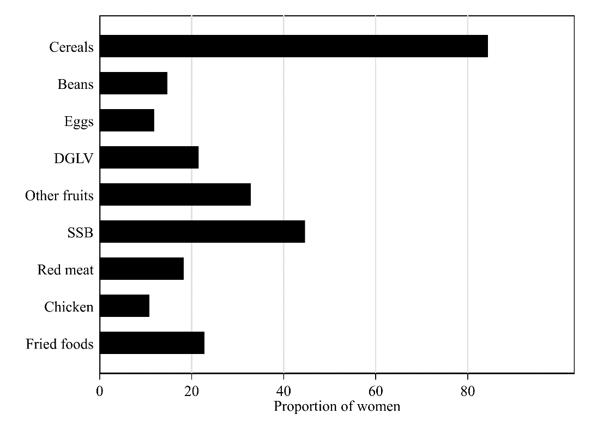
DGLV, dark green leafy vegetables; SSB, sugar sweetened beverages. Fried foods included fried chicken, fish or vegetables, including plantains, yams, potatoes and cassava.

Supplementary Figure 1D Food groups retained in the dietary pattern scores for older women (≥50 y old) in Tanzania
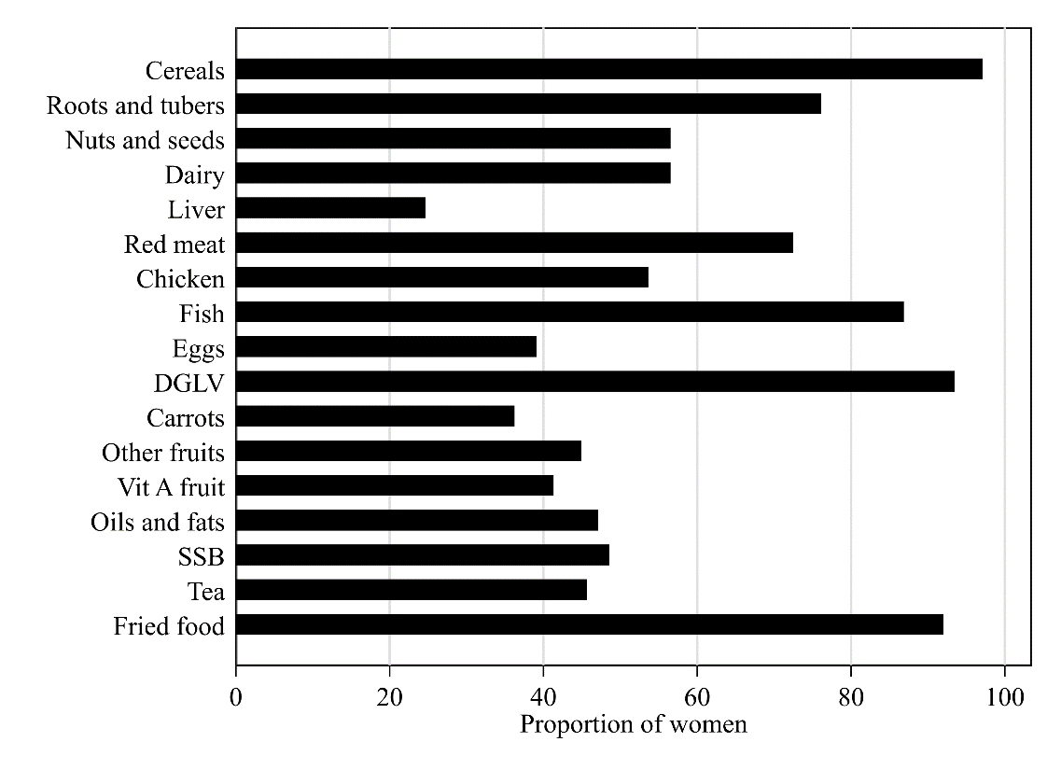
DGLV, dark green leafy vegetables; Vit A, vitamin A; SSB, sugar sweetened beverages. Fried foods included vegetable samosas, crisps, Cassava chips and French fries.

Supplementary Figure 2A Scree plot of eigenvalues after principal components analysis deriving dietary patterns among women of reproductive age (18-54 y old) in Ghana
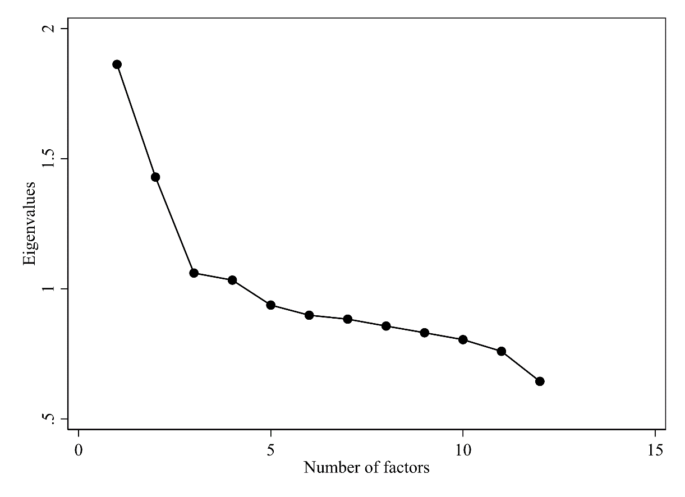

Supplementary Figure 2B Scree plot of eigenvalues after principal components analysis deriving dietary patterns among women of reproductive age (19-48 y old) in Malawi
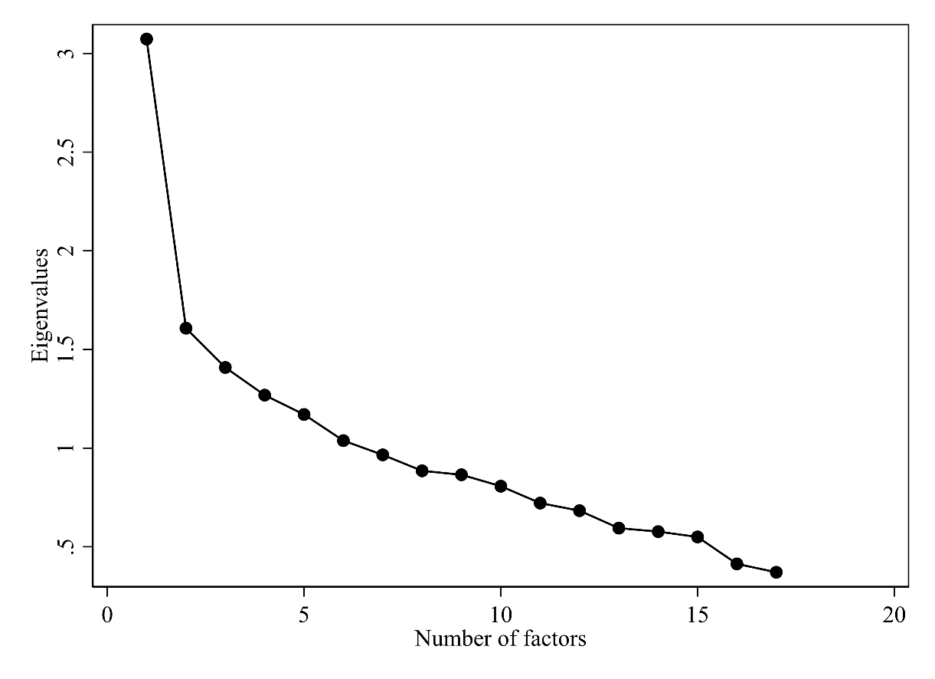

Supplementary Figure 2C Scree plot of eigenvalues after principal components analysis deriving dietary patterns among older women of (≥55 y old) in Ghana
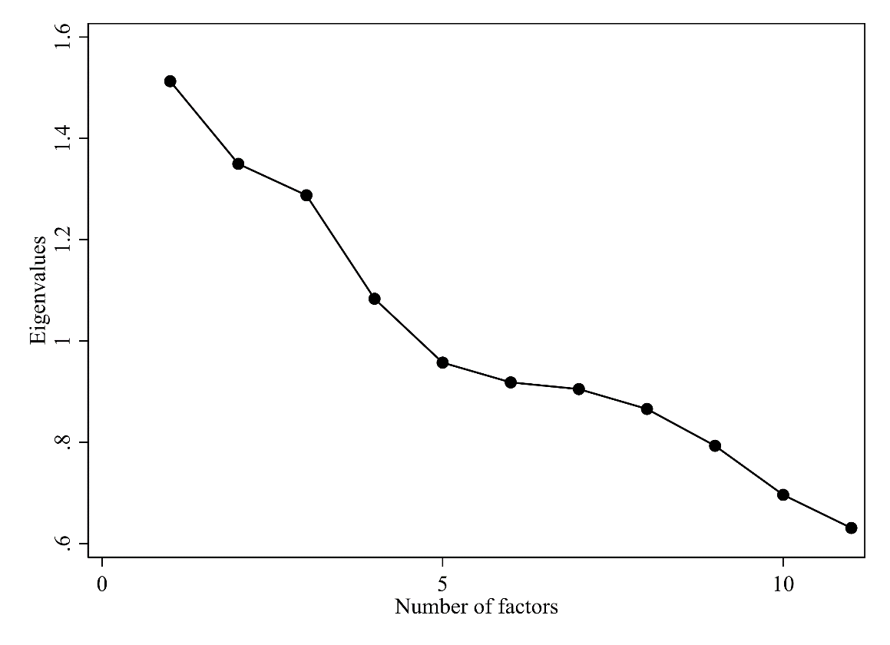

Supplementary Figure 2D Scree plot of eigenvalues after principal components analysis deriving dietary patterns among older (≥50 y old) in Tanzania
