Appendix
Control Condition:
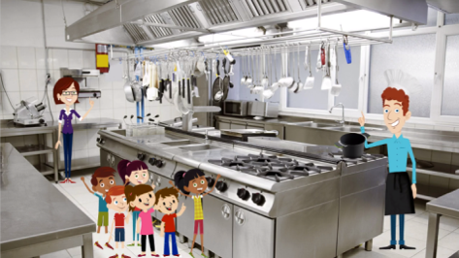
Gain and Loss Condition:
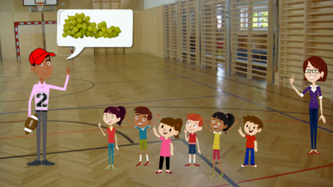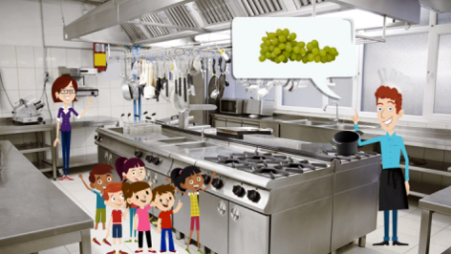

Snacks presented in gain and loss conditions:
Appendix
Gain Condition: Throughout the story grapes and mandarins were connected six times with gain arguments. Additionally, three times characters talked about fruit in general. The school nurse stated these two arguments: “If you eat healthy foods, such as this mandarin, then you provide your whole body with lots of vitamins. Then you have a lot of power for your school day.”/ “If you eat a lot of fruit, then you can concentrate better in school.” The physical education teacher stated the following arguments: “If you eat a lot of healthy foods, such as grapes, you get a lot of strength to get along well in physical education.”/ “If you eat a lot of healthy foods, such as mandarins, then you always have enough endurance to play with your friends.” Also, the school cook provided two gain arguments: “Eating a lot of healthy foods, like grapes, is good for your health.”/ “Eating fruit is very good for the tummy.” Additionally, after the job presentations children walked back into the classroom. Then, the teacher asked the children what they remembered about the three presentations. Three different children stated the following arguments: “If we eat healthy foods, such as mandarins, then we provide our whole bodies with a lot of vitamins. Then we have a lot of power for our school day.”/ “If we eat a lot of healthy foods, such as mandarins, then we always have enough endurance to play with our friends.”/ “Eating fruit is very good for your tummy”.
Loss Condition: Throughout the story, grapes and mandarins were connected six times with loss arguments to eat them specifically. Additionally, three times characters talked about fruit in general. The school nurse stated these two arguments: “If you do not eat healthy foods, such as this mandarin, then you do not provide your whole body with enough vitamins. Then you have no power for your school day.”/ “If you eat no fruit, then you cannot concentrate better in school.” The physical education teacher stated the following arguments: “If you do not eat a lot of healthy foods, such as grapes, you do not have strength to get along well in physical education.”/ “If you eat no healthy foods, such as mandarins, then you do not have enough endurance to play with your friends.” Also, the school cook provided two loss arguments: “Eating no healthy foods, like grapes, is bad for your health.”/ “Eating no fruit is very bad for your tummy.” Additionally, after the job presentations children walked back into the classroom. Then, the teacher asked the children what they remembered about the three presentations. Three different children stated the following arguments: “If we do not eat healthy foods, such as mandarins, then we do not provide our whole bodies with enough vitamins. Then we have no power for our school day.”/ “If we do not eat a lot of healthy foods, such as mandarins, then we do not have enough endurance to play with our friends.”/ “Eating no fruit is very bad for your tummy”.

