Supplementary materials

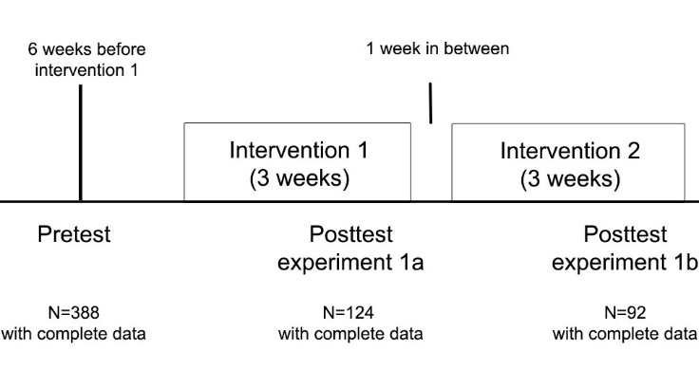

Figure A Schematic overview of the design of Intervention 1 and Intervention 2.

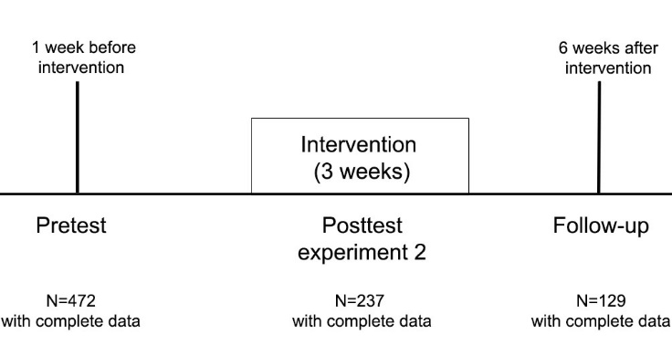
Figure B schematic overview of the design of Intervention 3

Table A Demographic characteristics of students from a Dutch university who were initially included at pretest and those who were included in the statistical analyses of Interventions 1 and Intervention 2

 |  | Included at Pretest |  |  | Intervention 1 |  |  |  | Intervention 2
 |  | n 388 |  |  | n 124 |  |  |  | n 92
 |  | %  or Means (SD) | n |  | %  or Means (SD) | n | p-value * |  | %  or Means (SD) | n | p-value *
Gender | Male | 50·9 | 172 |  | 37·1 | 46 | <0·001 |  | 32·6 | 30 | <0·001
 | Female | 49·1 | 166 |  | 62·9 | 78 |  |  | 67·4 | 62
Age | Younger than 20 years | 52·4 | 177 |  | 50 | 62 | 0·39 |  | 56·5 | 52 | 0·45
 | 20 years or older | 47·0 | 159 |  | 50 | 62 |  |  | 43·5 | 40
Housing situation | With parents/guardians | 66·3 | 224 |  | 62·9 | 78 | 0·28 |  | 66·3 | 61 | 0·94
 | Other | 33·7 | 114 |  | 37·1 | 46 |  |  | 33·7 | 31
Study program | Food-related studies | 28·1 | 95 |  | 37·1 | 46 | 0·03 |  | 37 | 34 | 0·07
 | Environment studies | 27·5 | 93 |  | 28·2 | 35 |  |  | 28·3 | 26
 | Green business studies | 26·0 | 88 |  | 18·5 | 23 |  |  | 17·4 | 16
 | Environmental design studies | 16·6 | 56 |  | 16·1 | 20 |  |  | 17·4 | 16
Study year | First year | 55·3 | 187 |  | 52·4 | 65 | 0·56 |  | 51·1 | 47 | 0·29
 | Second year | 43·2 | 146 |  | 46·8 | 58 |  |  | 46·7 | 43
Pretest fruit intake |  | 0·77 (0·51) |  |  | 0·84 (0·54) |  | 0·03 |  | 0·87 (0·57) |  | 0·02
Pretest snack vegetable intake |  | 34·56 (56) |  |  | 37·11 (43·07) |  | 0·34 |  | 40·76 (44·15) |  | 0·07

* p-value derived from chi-square test or t-test, testing the differences between students who initially participated at pretest (n 388) and those included in the statistical analyses of Intervention 1 (n 124) or Intervention 2 (n 92).
Table A Demographic characteristics of students from a Dutch university who were initially included at pretest and those who were included in the statistical analyses of Intervention 3

 |  | Included at Pretest |  |  | Intervention 3
 |  | n 472 |  |  | n 237
 |  | %  or Means (SD) | n |  | %  or Means (SD) | n | p-value *
Gender | Male | 52·1 | 246 |  | 49·8 | 118 | 0·31
 | Female | 47·9 | 226 |  | 50·2 | 119
Age | Younger than 20 years | 67·6 | 319 |  | 69·6 | 165 | 0·31
 | 20 years or older | 32·2 | 152 |  | 29·5 | 70
Housing situation | With parents/guardians | 75·2 | 355 |  | 78·5 | 186 | 0·09
 | Other | 24·8 | 117 |  | 21·5 | 51
Study program | Food-related studies | 25·8 | 122 |  | 26·2 | 62 | <0·001
 | Environment studies | 32·0 | 151 |  | 22·4 | 53
 | Green business studies | 30·3 | 143 |  | 36·3 | 86
 | Environmental design studies | 11·9 | 56 |  | 15·2 | 36
Pretest fruit intake |  | 0·65 (0·48) |  |  | 0·68 (0·49) |  | 0·21
Pretest snack vegetable intake |  | 26·77 (0·65) |  |  | 28·15 (37·49) |  | 0·42

* p-value derived from chi-square test or t-test, testing the differences between students who initially participated at pretest (n 472) and those included in the statistical analyses of Intervention 3 (n 237)

Table C Results of statistical models testing interactions with between time and demographic characteristics in Intervention 1
 | Fruit (portions per day) |  |  |  |  | Snack vegetables (grams per day)
 | B | SE | 95% CI lower | 95%CI higher |  | B | SE | 95% CI lower | 95%CI higher
Gender
Pre-test (ref)
Posttest | 0·16 | 0·07 | 0·03 | 0·29 |  | 15·71 | 5·49 | 4·94 | 26·47
Male (ref)
Female | 0·08 | 0·10 | -0·12 | 0·27 |  | 21·82 | 7·40 | 7·31 | 36·33
Female * time | -0·09 | 0·08 | -0·25 | 0·08 |  | -4·45 | 6·90 | -17·98 | 9·09
Age
Pre-test (ref)
Posttest | 0·02 | 0·06 | -0·09 | 0·13 |  | 11·40 | 4·72 | 2·14 | 20·66
Younger than 20 years (ref)
20 years or older | -0·03 | 0·03 | -0·08 | 0·02 |  | 1·84 | 7·34 | -12·54 | 16·22
20 years or older * time | 0·04 | 0·02 | 0·00 | 0·08 |  | 2·88 | 6·66 | -10·17 | 15·93
Housing situation
Pre-test (ref)
Posttest | 0·10 | 0·07 | -0·03 | 0·22 |  | 7·14 | 5·41 | -3·47 | 17·75
Other (ref)
With parents / guardians | -0·02 | 0·10 | -0·22 | 0·17 |  | -4·57 | 7·58 | -19·42 | 10·29
With parents * time | 0·02 | 0·08 | -0·15 | 0·18 |  | 9·10 | 6·84 | -4·30 | 22·51
Study year
Pre-test (ref)
Posttest | 0·10 | 0·09 | -0·08 | 0·29 |  | 13·53 | 4·63 | 4·45 | 22·61
Year 1 (ref)
Year 2 | 0·03 | 0·10 | -0·16 | 0·22 |  | 1·59 | 7·41 | -12·94 | 16·11
Year 2 * time | 0·01 | 0·08 | -0·15 | 0·17 |  | -1·59 | 6·72 | -14·76 | 11·59
Study program
Pre-test (ref)
Posttest | 0·05 | 0·07 | -0·08 | 0·18 |  | 11·18 | 5·41 | 0·58 | 21·78
Food related studies (ref)
Environment studies | 0·09 | 0·12 | -0·15 | 0·32 |  | -6·47 | 9·07 | -24·24 | 11·31
Green business studies | -0·13 | 0·14 | -0·39 | 0·13 |  | 3·42 | 10·27 | -16·71 | 23·54
Environmental design studies | -0·09 | 0·14 | -0·37 | 0·18 |  | -16·35 | 10·77 | -37·46 | 4·76
Environment * time | 0·09 | 0·10 | -0·11 | 0·29 |  | 9·19 | 8·28 | -7·04 | 25·42
Green business * time | 0·09 | 0·11 | -0·13 | 0·32 |  | -3·73 | 9·36 | -22·08 | 14·63
Environmental * time | 0·06 | 0·12 | -0·17 | 0·30 |  | -1·18 | 9·82 | -20·43 | 18·07

Table D Results of statistical models testing interactions with between time and demographic characteristics in Intervention 2
 | Fruit (portions per day) |  |  |  |  | Snack vegetables (grams per day)
 | B | SE | 95% CI lower | 95%CI higher |  | B | SE | 95% CI lower | 95%CI higher
Gender
Pre-test (ref)
Posttest | 0·25 | 0·15 | -0·05 | 0·54 |  | 32·14 | 10·83 | 10·93 | 53·36
Male (ref)
Female | 0·24 | 0·13 | -0·02 | 0·49 |  | 34·69 | 9·32 | 16·42 | 52·97
Female * time | 0·15 | 0·18 | -0·21 | 0·51 |  | -27·19 | 13·19 | -53·03 | -1·34
Age
Pre-test (ref)
Posttest | 0·14 | 0·12 | -0·08 | 0·37 |  | 9·20 | 8·47 | -7·40 | 25·80
Younger than 20 years (ref) | -0·07 | 0·12 | -0·31 | 0·18
20 years or older |  |  |  |  |  | 4·66 | 9·08 | -13·14 | 22·46
20 years or older * time | 0·00 | 0·18 | -0·35 | 0·34 |  | 10·62 | 12·84 | -14·56 | 35·79
Housing situation
Pre-test (ref)
Posttest | 0·12 | 0·15 | -0·17 | 0·41 |  | 23·96 | 10·99 | 2·42 | 45·51
Other (ref)
With parents / guardians | -0·08 | 0·13 | -0·33 | 0·18 |  | 1·01 | 9·55 | -17·70 | 19·72
With parents * time | 0·03 | 0·18 | -0·33 | 0·39 |  | -15·30 | 13·50 | -41·76 | 11·16
Study year
Pre-test (ref)
Posttest | 0·08 | 0·01 | 0·06 | 0·11 |  | 14·74 | 9·07 | -3·04 | 32·52
Year 1 (ref)
Year 2 | 0·07 | 0·13 | -0·18 | 0·31 |  | -1·79 | 9·28 | -19·97 | 16·40
Year 2 * time | 0·13 | 0·18 | -0·22 | 0·47 |  | -1·62 | 13·12 | -27·34 | 24·10
Study program
Pre-test (ref)
Posttest | 0·13 | 0·14 | -0·14 | 0·40 |  | 11·13 | 10·43 | -9·30 | 31·57
Food related studies (ref)
Environment studies | 0·05 | 0·15 | -0·24 | 0·35 |  | -12·72 | 11·20 | -34·67 | 9·23
Green business studies | -0·20 | 0·17 | -0·54 | 0·14 |  | 3·39 | 13·03 | -22·16 | 28·93
Environmental design studies | -0·18 | 0·17 | -0·52 | 0·16 |  | -18·93 | 13·03 | -44·48 | 6·61
Environment * time | 0·10 | 0·21 | -0·32 | 0·51 |  | 11·67 | 15·84 | -19·38 | 42·71
Green business * time | 0·03 | 0·25 | -0·45 | 0·51 |  | -8·46 | 18·43 | -44·58 | 27·67
Environmental * time | -0·14 | 0·25 | -0·62 | 0·34 |  | 4·94 | 18·43 | -31·19 | 41·06

Table E Results of statistical models testing interactions with between time and demographic characteristics in Intervention 3
 | Fruit (portions per day) |  |  |  |  | Snack vegetables (grams per day)
 | B | SE | 95% CI lower | 95%CI higher |  | B | SE | 95% CI lower | 95%CI higher
Gender
Pre-test (ref)
Posttest | 0·11 | 0·06 | -0·02 | 0·23 |  | 15·69 | 5·04 | 5·81 | 25·57
Follow-up | 0·06 | 0·07 | -0·09 | 0·20 |  | 6·42 | 5·83 | -5·00 | 17·84
Male (ref)
Female | 0·07 | 0·06 | -0·05 | 0·19 |  | 18·24 | 5·03 | 8·38 | 28·10
Female*posttest | -0·06 | 0·09 | -0·24 | 0·12 |  | -9·51 | 7·12 | -23·47 | 4·45
Female*follow-up | 0·01 | 0·11 | -0·20 | 0·22 |  | -3·26 | 8·50 | -19·91 | 13·40
Age
Pre-test (ref)
Posttest | 0·11 | 0·05 | 0·00 | 0·21 |  | 10·31 | 4·36 | 1·78 | 18·85
Follow-up | 0·09 | 0·06 | -0·03 | 0·21 |  | 3·38 | 5·08 | -6·59 | 13·34
Younger than 20 years (ref)
20 years or older | 0·06 | 0·07 | -0·07 | 0·20 |  | 2·83 | 5·61 | -8·17 | 13·83
20 years or older * posttest | -0·10 | 0·10 | -0·29 | 0·09 |  | 2·04 | 7·94 | -13·52 | 17·59
20 years or older * follow-up | -0·13 | 0·12 | -0·37 | 0·11 |  | 3·33 | 9·72 | -15·73 | 22·39
Housing situation
Pre-test (ref)
Posttest | 0·10 | 0·10 | -0·09 | 0·29 |  | 2·66 | 7·75 | -12·53 | 17·85
Follow-up | 0·02 | 0·13 | -0·23 | 0·26 |  | -3·22 | 10·14 | -23·10 | 16·66
Other (ref)
With parents / guardians | -0·03 | 0·08 | -0·18 | 0·13 |  | -10·74 | 6·19 | -22·87 | 1·40
With parents * posttest | -0·04 | 0·11 | -0·25 | 0·18 |  | 10·52 | 8·76 | -6·65 | 27·68
With parents *follow-up | 0·05 | 0·14 | -0·23 | 0·32 |  | 9·38 | 11·20 | -12·58 | 31·34
Study program
Pre-test (ref)
Posttest | 0·03 | 0·09 | -0·15 | 0·20 |  | 5·85 | 6·96 | -7·80 | 19·50
Follow-up | 0·01 | 0·12 | -0·22 | 0·24 |  | 1·34 | 9·30 | -16·90 | 19·57
Food related studies (ref)
Environment studies | -0·04 | 0·09 | -0·22 | 0·14 |  | -8·51 | 7·25 | -22·72 | 5·70
Green business studies | -0·12 | 0·08 | -0·28 | 0·04 |  | -10·97 | 6·48 | -23·67 | 1·73
Environmental design studies | -0·11 | 0·10 | -0·31 | 0·09 |  | -12·70 | 8·11 | -28·60 | 3·21
Environment * posttest | 0·04 | 0·13 | -0·21 | 0·30 |  | 15·58 | 10·23 | -4·48 | 35·64
Environment * follow-up | -0·05 | 0·16 | -0·35 | 0·26 |  | 2·07 | 12·54 | -22·51 | 26·65
Green business * posttest | 0·07 | 0·12 | -0·15 | 0·30 |  | -2·98 | 9·16 | -20·94 | 14·99
Green business * follow-up | 0·07 | 0·15 | -0·22 | 0·36 |  | 0·34 | 11·81 | -22·82 | 23·49
Environmental * posttest | 0·09 | 0·15 | -0·20 | 0·37 |  | 16·37 | 11·46 | -6·08 | 38·83
Environmental * follow-up | 0·19 | 0·17 | -0·15 | 0·52 |  | 15·79 | 13·53 | -10·73 | 42·32

