Supplement to Wininger M & Muñoz CX, Models of hydration and nutrition require environmental data, Public Health Nutrition. Accepted for publication: July 26, 2019.
SUPPLEMENT 1: CODE
This code can be copy-pasted directly into R without alteration, and will yield a result. User-specific inputs are shown in blue for ease of case-testing.
################################################################
### wx_retriever_complete.R
### <author redacted for blinded peer review>
###
### -This code requires 4 data elements to be inputted by the
### user: latitude, longitude, participant identifier, and date
### of interest, and one additional operational parameter: total
### number of loops permitted on a given record of interest.
### this code will then retrieve weather station information
### from the national climate data center with a best-match to
### the weather station nearest to the specified coordinates.
### if no record exists for the specified day, this code will
### loop through nearby stations (up to the pre-specified loop
### limit) until a valid record is found. output will be a
### matrix containing the following additional data points:
### station identifiers, station elevation, distance between
### specified lat-lon and the matched station (meters), three
### weather variables (temperature, dew-point, and precipita-
### tion amount), and length-of-day information (hours between
### dawn and dusk).
###
### NOTE: In order to sustain loop operation, all web errors
### are handled similarly, by targeting the next station. This
### applies both to non-existent files, and also busy server
### errors. This, operating this code at a time of high web
### traffic may yield different results (server denial loops to
### a farther weather station), versus operating code at a time
### of low-traffic (nearest station is accessed on first
### attempt).
###
################################################################

### close all, clear all
rm(list=ls(all=TRUE))
graphics.off()

### load library
library(GSODR) # reformat_GSOD
library(geosphere) # distm
library(suncalc) # getSunlightTimes

###~~~~~~~~~~~~~~~~~~~~~~~~~~~~~~~~~~~~~~~~~~~~~~~~~~~~~~~~~~###
### USER INPUT ~~~~~~~~~~~~~~~~~~~~~~~~~~~~~~~~~~~~~~~~~~~~~~###
###~~~~~~~~~~~~~~~~~~~~~~~~~~~~~~~~~~~~~~~~~~~~~~~~~~~~~~~~~~###
### declare the latitude and longitude and dates of interest,
### set a maximum number of attempts to retrieve data from the
### web

### declare lat-lon
latlon=rbind( c(+034.0522,-118.2437), # los angeles
c(-000.1807,-078.4678), # quito
c(+008.9806,+038.7578), # addis ababa
c(+035.6762,+139.6503), # tokyo
c(+027.7172,+085.3240), # kathmandu
c(-000.1807,-078.4678), # quito
c(-025.7479,+028.2293)) # pretoria

colnames(latlon)=c("lat","lon")
rownames(latlon)=c("Pt_001","Pt_002","Pt_003","Pt_004","Pt_005","Pt_006","Pt_007")

### declare dates
date=c("04/15/2015","5/5/2018","03/15/2016","7/18/2012","10/16/2014","11/30/2018","5/5/2018")

### declare a maximumum number of web retrievals
max_retr=20

###~~~~~~~~~~~~~~~~~~~~~~~~~~~~~~~~~~~~~~~~~~~~~~~~~~~~~~~~~~###
### SUB-ROUTINES ~~~~~~~~~~~~~~~~~~~~~~~~~~~~~~~~~~~~~~~~~~~~###
###~~~~~~~~~~~~~~~~~~~~~~~~~~~~~~~~~~~~~~~~~~~~~~~~~~~~~~~~~~###
### function to test ncdc.gov for file access, will seamlessly
### return to calling function if URL yields error

webReader<- function(url){
tryCatch(
expr = {
webinfo=reformat_GSOD(file_list=url)
return(webinfo)
},
error = function(e){
return(NA)
},
warning = function(w){
return(NA)
}
)
}

###~~~~~~~~~~~~~~~~~~~~~~~~~~~~~~~~~~~~~~~~~~~~~~~~~~~~~~~~~~###
### DATA RETRIEVAL ~~~~~~~~~~~~~~~~~~~~~~~~~~~~~~~~~~~~~~~~~~###
###~~~~~~~~~~~~~~~~~~~~~~~~~~~~~~~~~~~~~~~~~~~~~~~~~~~~~~~~~~###
### retreive weather archive data from the web

### retrieve station meta-data from source (29778 x 11)
meta_data=read.table("ftp://ftp.ncdc.noaa.gov/pub/data/noaa/isd-history.csv",sep=",",header=TRUE,fill=TRUE)

### merge user-specified data into a single data-frame
info_frame=as.data.frame(cbind(latlon,date),check.names=FALSE)
info_frame$date=as.Date(info_frame$date,format="%m/%d/%Y")
info_frame$lat=as.numeric(as.character(info_frame$lat))
info_frame$lon=as.numeric(as.character(info_frame$lon))

### declare prefix for URL
url_pr="ftp://ftp.ncdc.noaa.gov/pub/data/gsod"

### initialize vectors for storing weather data
t=NULL # temperature
d=NULL # dew point
p=NULL # precipitation
lt=NULL # latitude
ln=NULL # longitude
u=NULL # usaf
w=NULL # wban

### for each row-item of user-specified data
for (i in 1:nrow(info_frame)){

### sort all stations in distance order
i_latlon=cbind(info_frame$lon[i],info_frame$lat[i])
d_latlon=cbind(meta_data$LON,meta_data$LAT)
dist_vals=distm(i_latlon,d_latlon)
meta_sort=meta_data[order(dist_vals,decreasing="FALSE"),]
### initialize a loop flag
loop_flag=TRUE
### initialize a retriever tally
retr_tally=1

### while flag permits looping
while (loop_flag){

### construct URL for next-nearest station
year_val=substr(info_frame$date[i],1,4)
usaf=meta_sort$USAF[retr_tally]
wban=meta_sort$WBAN[retr_tally]
read_url=paste(url_pr,"/",year_val,"/",usaf,"-",wban,"-",year_val,".op.gz",sep="")

### attempt to retrieve data from this station-year
sttn_data=webReader(read_url)

### if there is no station-year data
if (is.na(sttn_data)){
### continue looping
loop_flag=TRUE
### else, if there is station-year data
}else{
### continue to loop if no station-day found
loop_flag=length(which(sttn_data$YEARMODA %in% info_frame$date[i]))==0
}

### if no station-day found
if (loop_flag){

### increment retriever tally
retr_tally=retr_tally+1

### if loop limit reached
if (retr_tally>max_retr){
### stop looping
loop_flag=FALSE
### log empty values
t=c(t,NA)
d=c(d,NA)
p=c(p,NA)
lt=c(lt,NA)
ln=c(ln,NA)
u=c(u,NA)
w=c(w,NA)
}
### else, if a station-day was found
}else{
### extract weather and station information
row_idx=which(sttn_data$YEARMODA %in% info_frame$date[i])
t=c(t,sttn_data$TEMP[row_idx])
d=c(d,sttn_data$DEWP[row_idx])
p=c(p,sttn_data$PRCP[row_idx])
lt=c(lt,sttn_data$LAT[row_idx])
ln=c(ln,sttn_data$LON[row_idx])
u=c(u,sttn_data$USAF[row_idx])
w=c(w,sttn_data$WBAN[row_idx])
### and stop looping
loop_flag=FALSE

} #~~ end-if on valid station-day result
} #~~ end-while on loop through nearby stations
} #~~ end-for on loop through location-days of interest

###~~~~~~~~~~~~~~~~~~~~~~~~~~~~~~~~~~~~~~~~~~~~~~~~~~~~~~~~~~###
### DATA CONDITIONING & DATA FUSION ~~~~~~~~~~~~~~~~~~~~~~~~~###
###~~~~~~~~~~~~~~~~~~~~~~~~~~~~~~~~~~~~~~~~~~~~~~~~~~~~~~~~~~###
### clean data and merge datasets

### compile information onto information frame
info_frame=cbind(info_frame,t,d,p,lt,ln,u,w)
repl_names=c("TEMP","DEWP","PRCP","LAT","LON","USAF","WBAN")
names(info_frame)[(ncol(info_frame)-6):ncol(info_frame)]=repl_names

### compute distance between location and station
dist_matx=distm(cbind(info_frame$lon,info_frame$lat),cbind(info_frame$LON,info_frame$LAT))
info_frame$DIST=diag(dist_matx)

### add elevation information
info_paste=paste(info_frame$USAF,info_frame$WBAN,sep="")
meta_paste=paste(meta_data$USAF,meta_data$WBAN,sep="")
meta_inds=match(info_paste,meta_paste)
info_frame$ELEV=meta_data$ELEV[meta_inds]

### obtain day-length information
daylight=NULL
for (i in 1:nrow(info_frame)){
d=date = info_frame$date[i]
lat=info_frame$lat[i]
lon=info_frame$lon[i]
sunlight=getSunlightTimes(date = d, lat = lat, lon = lon)
daylight=c(daylight,as.numeric(sunlight$dusk-sunlight$dawn))
}
info_frame$DAYL=daylight

###~~~~~~~~~~~~~~~~~~~~~~~~~~~~~~~~~~~~~~~~~~~~~~~~~~~~~~~~~~###
### OUTPUT ~~~~~~~~~~~~~~~~~~~~~~~~~~~~~~~~~~~~~~~~~~~~~~~~~~###
###~~~~~~~~~~~~~~~~~~~~~~~~~~~~~~~~~~~~~~~~~~~~~~~~~~~~~~~~~~###
### print matrix of final merged data

### display information
print(info_frame)

SUPPLEMENT 2: CODE NOTES
- This code takes for items as input from the investigator: Participant identifier, Latitude- and Longitude of participant’s location, and Date of interest.
- Input is currently posed as manual entry into the R-code, but can be readily reconfigured as import from a spreadsheet
- Output is currently posed as display at the command prompt, but can be readily reconfigured as export to a spreadsheet
- Routine will make 20 attempts to retrieve web-data for a given location-date. If no valid data are obtained after 20 attempts, empty data will be supplied. Note that this is most likely to depend on two factors: whether station data exist for the target date, and whether the NCDC servers are open for connection. Routine success is sensitive to web traffic at NCDC; it will be best to run this routine at a low-traffic time. NCDC will provide temperature, dew-point and precipitation information; NCDC meta-data will be used to find the distance between the participant’s location and the weather station used to provide the environmental data; meta-data will also be used to provide elevation information. Daylight information will be provided through the suncalc library in R, using latitude, longitude, and day information.
- Upon completion, empirical data can be added as new columns, yielding a new dataset in long-format with environmental data as explanatory co-variates
- Code requires a working internet connection, and assumes stability of web-resources.
- To use dates in other formats, modify the line of code as:
info_frame$date=as.Date(info_frame$date,format="%m/%d/%Y")

- Note that the provided example will yield different weather stations for Participant 2 versus Participant 6 (from identical latitude-longitude). Weather station 840720-99999 is closer (2.2km), but did not report on 5/5/18; instead, station 840725-99999 (2.4km) was accessed. This serves to demonstrate the functionality of the code in the case of contingency (missing station-day).

SUPPLEMENT 3: CODE FLOW DIAGRAM
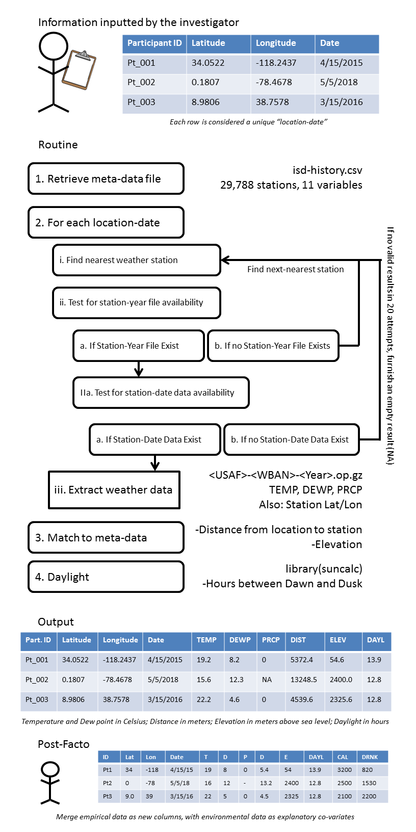
SUPPLEMENT 4: OUTPUT AND EMPIRICAL DATA MERGER
