SUPPLEMENTAL TABLES AND FIGURES

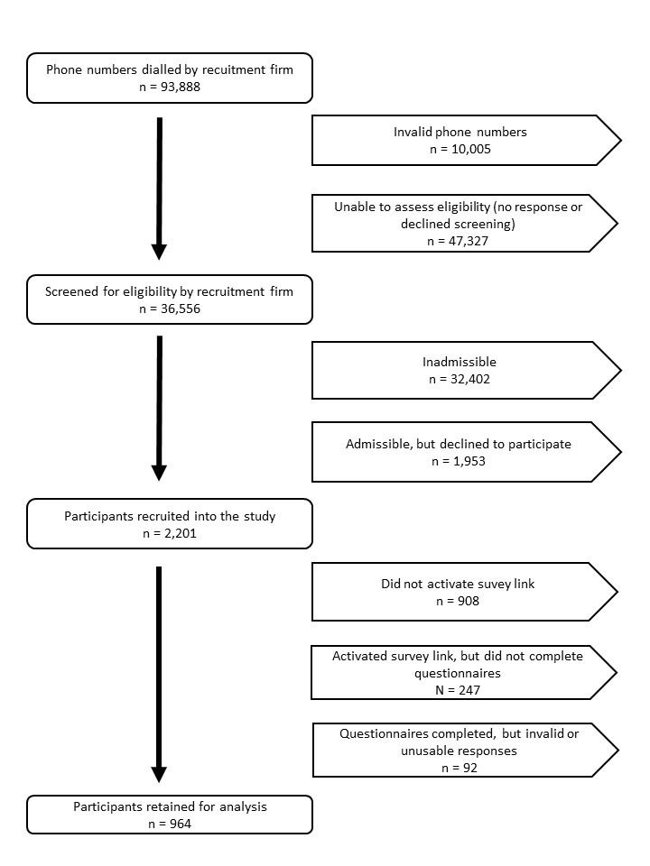
Supplemental figure 1. Recruitment and participant flow chart

Supplemental table 1. Items about perceptions about the campaign effects and general meal planning
Items about perceived effectiveness of the Eat Well Campaign (n = 390) |  |  | Proportions of respondents aware of the campaign in agreement
 | Beliefs and attitudes:
 |  | 1. As a result of the campaign, I have believed it more important to plan meals in order to make healthier food choices (a lot more or more vs. not more nor less, less, a lot less). | 61.1%
 |  | 2. As a result of the campaign, I have believed it more important to involve my family in meal planning in order to make healthier food choices (a lot more or more vs. not more nor less, less or a lot less). | 58.2%
 |  | 3. How relevant do you find the messages of the “Eat Well” campaign for planning your family meals (very relevant or relevant vs. somewhat relevant, not very relevant or not at all relevant)? | 42.1%
 |  | 4. How relevant do you find the messages of the “Eat Well” campaign in order to prepare your family meals (very relevant or relevant vs. somewhat relevant, not very relevant or not at all relevant)? | 38.3%
 |  | 5. How have the messages disseminated during the “Eat Well” campaign been useful for planning your family meals (very useful or useful vs. somewhat useful, nor very useful, or not at all useful)? | 26.8%
 |  | 6. How have the messages disseminated during the “Eat Well” campaign been useful for preparation your family meals (very useful or useful vs. somewhat useful, nor very useful, or not at all useful)? | 27.6%
 | Knowledge:
 |  | 7. As a result of the campaign, I feel more knowledgeable about how to plan meals in order to make healthier food choices (a lot more or more vs. not more nor less, less, a lot less). | 32.2%
 | Behaviors: As a result of the campaign…
 |  | 8. As a result of the campaign, I have planned more of our family meals in order to make healthier choices (a lot more or more vs. not more nor less, less, a lot less). | 31.9%
 |  | 9. As a result of the campaign, I have cooked more of our family meals (a lot more or more vs. not more nor less, less, a lot less). | 22.8%
 |  | 10. I have discussed the “Eat Well” campaign with friends and family (yes vs. no)? | 12.2%
Items about positive and negative effects of the Eat Well Campaign (n = 390) |  |  | Proportions of respondents aware of the campaign in agreement
 | Positive effects of the Eat Well Campaign
 |  | 1. For me and my family, the “Eat Well” campaign has made family meals more enjoyable. | 10.6%
 |  | 2. For me and my family, the “Eat Well” campaign has inspired me to take time to plan family meals. | 20.6%
 |  | 3. For me and my family, the “Eat Well” campaign has provided tips and tricks to increase my children’s involvement in mealtime activities. | 25.2%
 |  | 4. For me and my family, the “Eat Well” campaign has given my family an occasion to discuss healthy eating. | 18.4%
 |  | 5. For me and my family, the “Eat Well” campaign has been a source of information to help improve the quality of our meals. | 27.4%
 |  | 6. For me and my family, the “Eat Well” campaign has helped me plan family meals more effective. | 13.3%
 | Negative effects of the Eat Well Campaign
 |  | 7. For me and my family, the “Eat Well” campaign has increased my sense of guilt as a parent. | 8.6%
 |  | 8. For me and my family, the “Eat Well” campaign has created more frustration. | 1.6%
 |  | 9. For me and my family, the “Eat Well” campaign has led to family conflicts over food. | 1.6%
 |  | 10. For me and my family, the “Eat Well” campaign has given me more responsibilities. | 1.9%
Items about meal planning attitudes, behaviors and self-efficacy (n = 883) |  |  | Proportions of all respondents in agreement
 | 1. Attitudes: Planning makes it possible to eat well by ensuring a range of food choices
 |  | Totally agree or agree  Neither agree nor disagree, disagree or totally disagree | 84.7%  15.3%
 | 2. Behaviors: Which statement best applies to you
 |  | I have been planning our family meals.  I do not plan our family meals, but think I may start in the near future or may start in the next six months or I do not think I will start in the near future | 88.9%  21.1%
 | 3. Self-efficacy: As a parent, I feel very competent in planning our meals
 |  | Strongly agree or disagree  Neither agree nor disagree, disagree or strongly disagree | 76.4%  23.6%

Supplemental table 2. Exposed parent's comments about the Eat Well Campaign
Category | Frequency
No real impact | 47
Not really aware of the campaign | 46
Already health conscious | 24
Already planning | 23
Helped with healthy eating | 19
EWC was a good concept | 17
Validated current practices | 9
EWC needed more visibility | 5
Should be disseminated in schools | 3
Limited time is a problem | 3
Plans more because of the campaign | 1
EWC is similar to other campaigns | 1
Children talked about it | 1
EWC information frustrating - not for fathers | 1

