Dental Nutrition Knowledge ID: _______________
Check ALL that apply for #1-8.

- Which foods cause/promote dental cavities?
- candies, chocolate | - carbonated soft drinks | - dried cranberries
- plain yogurt | - green vegetables | - peanuts

- Which factors are associated with increased dental cavities?
- dietary sugars | - crowded teeth | - sugarless chewing gum
- flossing | - dry mouth | - acidic foods like lemons

- Which market food products cause/promote dental cavities?
- potato chips | - blueberry muffins | - fresh fruits
- salted crackers | - pizza | - cheese

- Which breakfast items can cause/promote dental cavities?
- frosted flakes cereals | - cheese | - white bread
- eggs | - cereal bars | - fruit jam

- Which of these market foods contain added sugars?
- orange drink from 5% juice | - orange soda | - cranberry juice cocktail
- lemonade | - 100% orange juice | - whole milk

- Which food products usually contain added sugars?
- plain yogurt | - canned fruits in heavy syrup | - barbeque sauce
- salad dressing | - 100% fruit juice | - frozen pizza

- Which nutrients are required for good dental health?
- vitamin D | - vitamin A | - selenium
- phosphorus | - calcium | - chromium

- Which statements regarding sugars are correct?
- added sugars can cause dental cavities | - soda containing artificial sugars does not cause dental caries | - natural sugars can cause dental cavities if consumed very often
- 100% fruit contains added sugar | - “no added sugar” and “sugar free” are same | - natural sugars cannot cause cavities

Check only ONE correct answer for #9-20.

- Which food item contains added sugar?
- apple | - pure honey | - sweet potato
- flavored yogurt | - plain milk | - pure maple syrup

- Which fruit product option is least risky for dental cavities?
- dried raisins | - apple juice | - whole apple
- canned peaches in heavy syrup | - 100% fruit juice | - apple cinnamon cereal

- Which dessert option is less risky for causing dental cavities?
- milkshake | - apple pie | - plain yogurt with strawberries
- banana split sundae | - vanilla ice cream | - cake

- What factors is important regarding sugar consumption to prevent dental cavities?
- Total amount of sugar consumed in the day | - Whether sugar is consumed with meals or between meals | - All of the above
- The form of the food-whether it is liquid, solid, sticky, or slow to be cleared from the mouth | - How often/frequently the sugar is consumed in the day | - None of these

- Which of the following is protective against dental caries?
- soda | - energy drink | - sweetened coffee
- orange juice | - sports drinks | - plain milk

- According to U.S Dietary Guidelines of 2015-2020, the amount of added sugar one consumes should be_______ percent of the total daily calories?
- 0 | - 1-10 | - 11-20
- 21-40 | - 41-60 | - 61-80

- If one eats sugary foods and drinks, when is the best time to eat them?
- between meals | - with meals
- evening snack | - timing does not matter

- Which item is required by the newly revised 2016 United States nutrition facts label?
- vegetable oil | - unsaturated fat | - carbohydrates
- added sugars | - animal proteins | - proteins

- Which mineral in toothpaste reduces the risk of dental cavities?
- manganese | - fluoride | - iodine
- iron | - chromium | - boron

- What is the recommended number of times one should BRUSH every day?
- 0 | - 1 | - 2
- 3 | - 4 | - 5

- What is the recommended number of times one should FLOSS?
- 1 time per day | - 2 times per day | - 1 time per week
- 2 times per week | - 1 time per month | - 2 times per month

- What is the recommended number of times one needs to visit a dentist?
- once every year | - two times a year | - once every four months
- once every three months | - once every two months | - every month

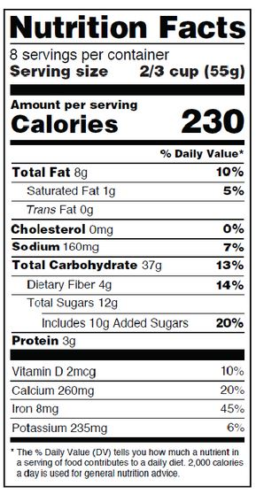
Use the nutrition facts label on the right to answer #21-22
- According to this food label, how many grams of ADDED sugar does one serving of this product contain?
- 8 | - 10 | - 12

- According to this nutrition facts label, what % Daily value (DV) for added sugars does one serving of this product provide?
- 10 | - 12 | - 20

Use the ingredients listed on the right to answer #23-24
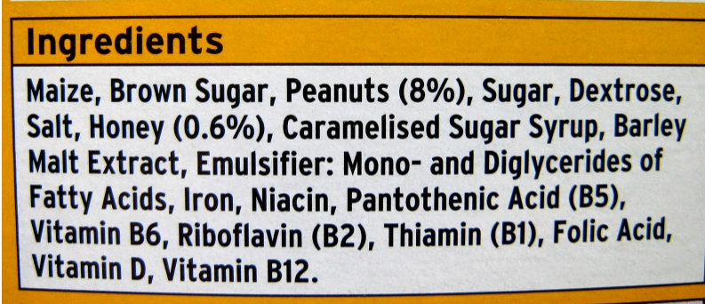
- What is the second main ingredient in this food product?

- List the added sugars in this food product?

