Supplemental Table 1: Description of the Takeaway Masterclass using the template for intervention description and replication (TIDieR) checklist

- Name | Healthy Takeaway Masterclass
- Rationale, theory, goal | Takeaway food = poor nutrient content and consumption has been linked to weight gain and adverse metabolic outcomes.  The behaviour change techniques used during the training are:  - Providing information on behavioural outcomes  - Instructions on how to perform a behaviour.  - Demonstration of Behaviour/credible source/ vicarious consequences  - Prompt practice/behavioural experiment  - SMART goal setting (behaviour) and action planning with problem solving/coping planning  - Prompt/cue for action  Aim: Healthier cooking practices are implemented and/or healthier menu options are provided in each takeaway
- Materials | Information provision on: consequences of behaviour and behaviour change opportunities presented on slides. Using tasting experiences of alternative low sugar, low salt, and low fat ingredients as alternative condiments/produces. Modelling accurate forms of managing frying oil prolonging its quality and life using a video highlighting how to do this step by step. These materials are used during one session (approx. 3 hours). Printed handouts of the slides, a tips booklet on how to increase healthiness of their takeaway produces, a notebook (for goal setting and action planning with problem solving) and a pledge sheet (acting as a prompt/cue for action) are provided to participants to use on the day and take to the business with instructions to place in the kitchen in a easy to look at place.
- Procedures | Takeaway owners and managers were invited via an official headed letter from the public health team at Redcar & Cleveland (R&C) Borough Council approx. 6 weeks prior to class. Leaflets advertising the training were also distributed in the borough.  On day – training approx. 3 hours that includes: introduction from R&C Health Improvement Commissioning Lead including information on health context nationally and locally; slides providing information on how to increase the healthiness of the food choices offered by the business with real life examples of previous implementations and the benefits of this. This was designed and delivered by three Kirklees Food Initiatives and Nutrition Education (FINE) Project* team members. A video (approximately 7 minutes) with step by step instructions on how to care for frying oil designed, introduced and commented on by one industry representative (National Federation of Fish Fryers [NFFF]); practical activities 1) tasting of regular and ‘healthier’ options (e.g. low vs normal fat mayonnaise) and 2) sugar quantity estimation (in drinks); and goal setting (behaviour) and action planning with problem solving activity.
- Who provided | Educational materials delivered by three FINE team members and one industry representative (NFFF). Members of the FINE team and R&C Public Health team assisted with the practical sessions. The goal setting and action planning activity was introduced by VAS (Health Psychology, Newcastle University) and support provided by research staff (morning) with FINE and R&C team (afternoon).
- How | Training delivered in person in a group session
- Where | Central location in the local authority. Two sessions offered (morning and afternoon)
- When and how much | One session approx. 3 hours.
- Tailoring | Businesses of varying type (cuisine) and location attended. Goal setting and action planning was tailored to the business as business set these.
- Modifications | Modifications to what had previously been delivered in Kirklees: Local context information changed from Kirklees to Redcar and Cleveland; more emphasis made on case study examples; inclusion of video (approximately 7 minutes) on oil filtering; and goal setting with action planning activity significantly enhanced.
- Planning/fidelity (ways to maintain fidelity) | The same experienced intervention deliverers delivered both sessions, using the same materials. The enhanced goal setting and action planning activity was a new component and the plan was to deliver training to FINE and R&C staff on how to deliver this.
- Actual fidelity | The parts of the sessions delivered by the FINE team NFFF rep were delivered as intended. It was intended that the enhanced goal setting and action planning activity was also delivered by the FINE team or R&C staff; however, this was introduced and supported by the research team, solely in the morning, and along with FINE and R&C staff in the afternoon.
*The Kirklees Food Initiatives and Nutrition Education (FINE) Project is a Kirklees Public Health commissioned provider service located within the Environmental Health Department of Kirklees Council. Its main remit is to improve nutrition literacy amongst professionals, staff as well as volunteers. In addition a proportion of their work is to engage in healthy eating interventions with the out of home food sector in Kirklees.

Supplemental Table 2: Classification of the health promoting practices evaluated before and after the Takeaway Masterclass using the Typology of Interventions in Proximal and Physical Micro-environments (TIPPME)

Health promoting practice | TIPPME classification
Reduce saturated fat
Use vegetable oil rather than lard or ghee OR Polyunsaturated or monounsaturated fat or oil used for cooking | Product, Placement: availability
Polyunsaturated or monounsaturated fat or oil used for preparation
Excess fat drained from food before serving
Use a lower fat cheese alternative e.g. mozzarella or half fat cheddar
Low fat sauces e.g. light mayo
Use lean meats or mince
Trim visible fat off meat
Take the skin off the chicken before cooking
Low fat spreads/margarine
Ensure alternatives to chips are not fried
If chips are served, there is always a healthier starchy alternative
Offer thick cut or steak cut chips
Use straight cut chips rather than crinkle cut
Use healthier cooking methods for at least one main menu item e.g. stir frying, poaching, boiling, grilling, dry frying and baking
Where rice is served, boiled/steamed is available as an alternative
Where sandwiches served at least two lower fat fillings are available
Semi-skimmed (or skimmed) milk used in cooking
Semi-skimmed (or skimmed) milk available for drinks
Reduce salt
Reduce the quantity of salt used in cooking² | Product, Placement: availability
Reduce the quantity of sauce used in cooking e.g. curry sauce, soy sauce²
Salt not added to water used for cooking vegetable, rice & pasta
Buy ‘no added salt’ canned vegetables and pulses
Rinse canned vegetables and pulses in water before use
Do not have salt cellars out on display | Related product, Placement: position
Customers can add own salt | Product, Properties: functionality
Reduced hole salt shaker is used | Related product, Properties: functionality
Use reduced salt options e.g. gravy, ketchup, soy sauce, baked beans, stock cubes | Product, Placement: availability
Reduce sugar
Offer reduced sugar drink alternative instead if or as well as regular products e.g. diet fizzy drinks, water | Product, Placement: availability
Offer a reduced sugar product alternative instead of or as well as regular products e.g. reduced sugar ketchup, reduced sugar baked beans
Reduce sugar used in cooking²
Use sweeteners as a substitute for sugar
Lower sugar snacks are available as alternative to biscuits, chocolate etc
Increase fruit and vegetables
Provide a salad garnish with each meal | Product, Placement: availability
Offer salad as an alternative to chips
Include salad as an option on sides menu
Include fresh fruit juice as a drink option (150ml carton)
Incorporate more vegetables in recipes where appropriate
Serve baked beans or sweetcorn as a side (e.g. with fish and chips)
Fresh fruit is always available and prominently displayed | Product, Placement: availability and position
Increase fibre
Use wholemeal pasta and/or noodles | Product, Placement: availability
Use brown rice
Use part wholemeal flour in Naan
Use wholemeal bread e.g. rolls, pittas, wraps
Reduce portion size
Reduce ‘standard’ portion sizes (e.g. portion of chips)² | Product, Properties: size
Offer a smaller portion size option as well as a regular portion size | Product, Placement: availability
Smaller portions are available for children
Overall health promoting practices
Incorporate healthier options as part of meal deals | Product, Placement: availability
Healthy eating is promoted by staff (*HCC 22) | Wider environment, Properties: information
Improve oil management² | Related objects, Properties: functionality

Supplemental Table 3: Goals set by owners and managers of the takeaway food outlets

1 | Reduce sugar - change ketchup
2 | Swap to lower sodium salt | Buy reduce sugar and salt ketchup | Buy reduced sugar and salt baked beans | Increase fibre - buy brown rolls | Put poached fish on the menu
3 | Increase fruit and vegetable | Reduce saturated fat
4 | Add a bigger portion of salad | Remove the salt shaker | Add more healthy drinks to menu | Use less fat products | Refill the oil tank regularly
5 | Reduce salt (e.g. sauces) | Reduce sugar (Buy sugar free drinks) | Reduce fat (Buy low fat cheese) | Buy brown rice and brown bread buns
6 | Less salt | Low fat mayo | Low sugar tom sauce | Increase veg | Introduce smaller portions
7 | Reduce salt
8 | Reduce salt and sugar in cooking | Reduced sugar contained drink to water (???)
9 | Reduce salt | Reduce sugar | Change ??? ??? Oil
10 | Offer a fruit and salad option in kid's box | Give option of wholemeal bread bun and pitta's | Reduce the fat in the bechamel sauce | Don't offer to put salt and vinegar to food
11 | Reduce salt in ketchup and beans | Reduce sugar in ketchup and beans | Reduce saturated fat (in fryers) | Use wholemeal pasta/flour | Promote smaller portion sizes more | Include water as part of meal deal | Put water at eye level in fridge
12 | Remove salt from counter | Stock bottled water and more zero sugar | Offer a poached fish | Offer alternative to kid's meal | OAP/child portions(?) | Try some cuscus as an alternative to chips
13 | Reduce salt - less hole shakers | Reduce sugar - reduced sugar ketchup
14 | Reduce sugar and salt on the products | Might add a new salad on menu | Change oil more often | Put on menu healthier products (such as vegetable ???) | Reduce portions on ingredients/meat that contain fats | Change the milk
15 | Reduce salt (remove(?) salt shaker) | Reduce sugar (low sugar ketchup) | Healthier option (salad(?)/chips in olive oil) | Reduce fat (green top milk)
16 | Reduce salt - change salt shaker | Reduce sugar - introduce fruit juice | Reduce saturated fat - trim fat from meat | Increase fruit and veg - salad option (instead of just side salad) | Small portion - introduce lite bite | Healthier options - introduce baked potatoes
17 | Reduce salt in dough | Recommend water/water on meal deal as opposed to cola | Cucumber sticks with kid's meal | Grilled chicken kid's option | More salad with kebab
18 | Reduce my sugar by 10-20% in flapjacks/cakes

Supplemental Fig. 1: Takeaway Masterclass intervention logic model
INPUT/RESOURCES

ACTIVITY

OUTPUT

SHORT TERM OUTCOMES

MEDIUM TERM OUTCOMES

LONG TERM OUTCOMES

Delivery of interactive workshop, providing training and guidance to takeaway owners/manager to deliver a healthier choice of product
Owner/manager implements one or more of the covert interventions
Owner/manager implements one or more of the overt interventions
Customers accept changes
Customers reject changes
Owner/manager rejects all suggested interventions
Intervention fails
Increased provision of healthier food in takeaway
Decrease in diet related diseases
Healthier diet consumed overall by customers
Decrease in preference for unhealthier foods in customers
More unhealthy foods consumed elsewhere in diet (compensation)
No change in preference for unhealthy foods in customers
PURPOSE: To improve dietary intake of takeaway food customers by increasing the availability of ‘healthier’ food within takeaways
CONTEXT: Regular consumption

Supplemental Fig. 2: Takeaway Masterclass Notebook

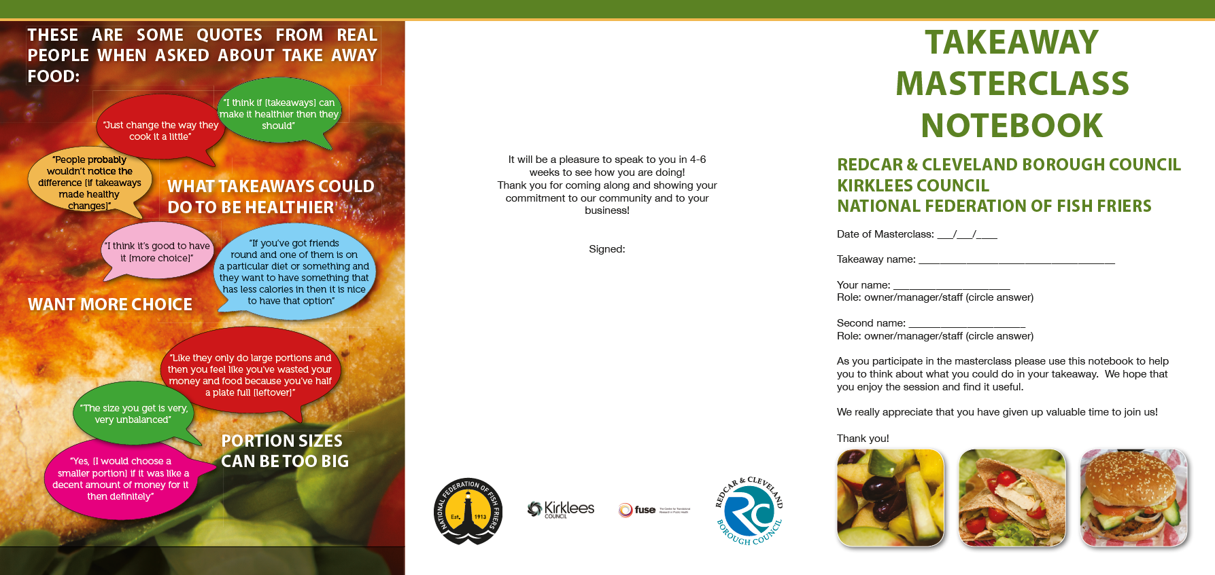

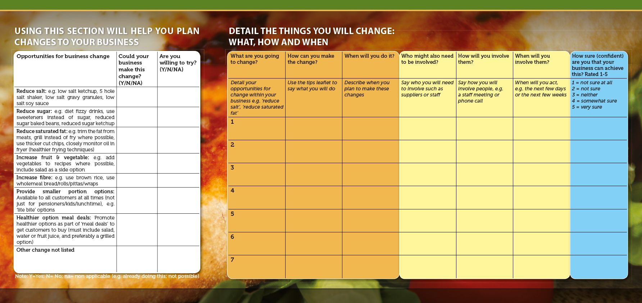

Supplemental Fig. S3: Takeaway Masterclass Tips Leaflet

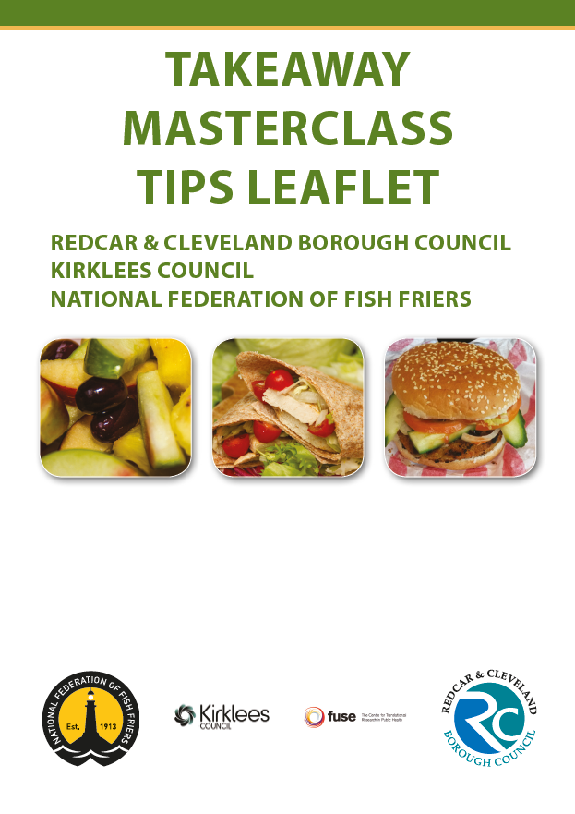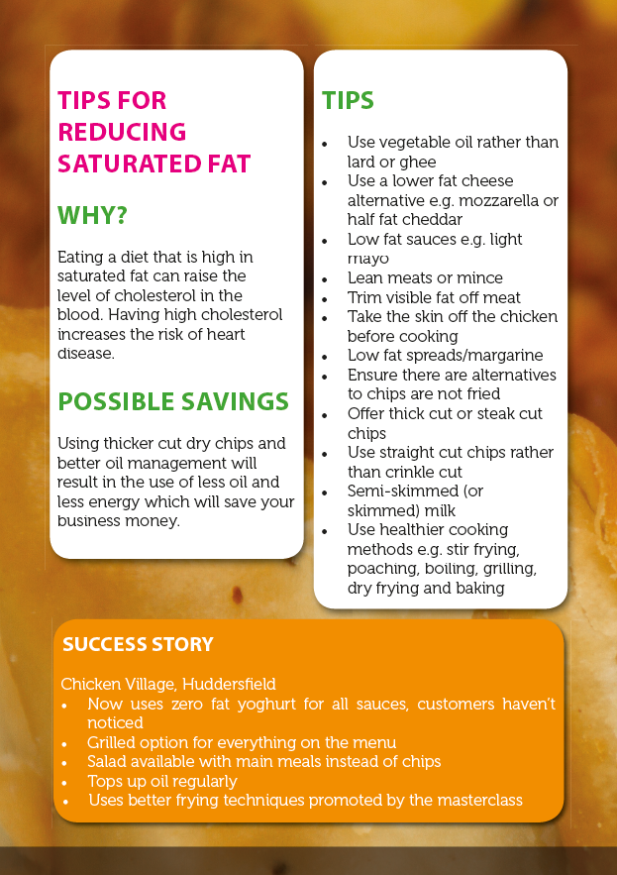
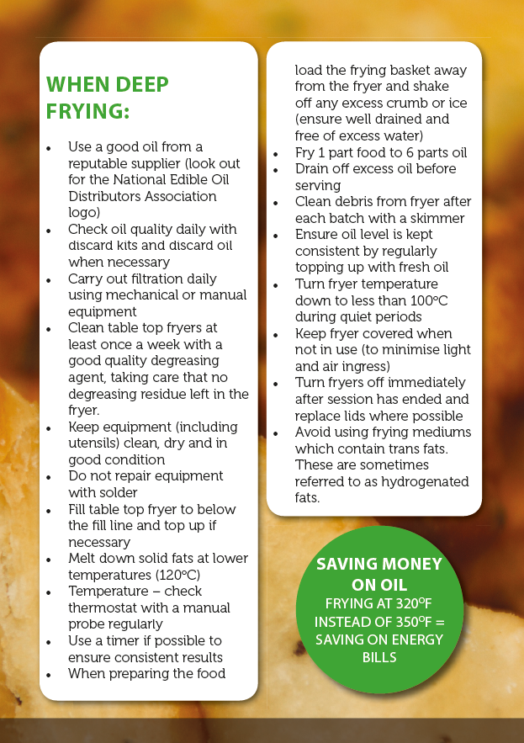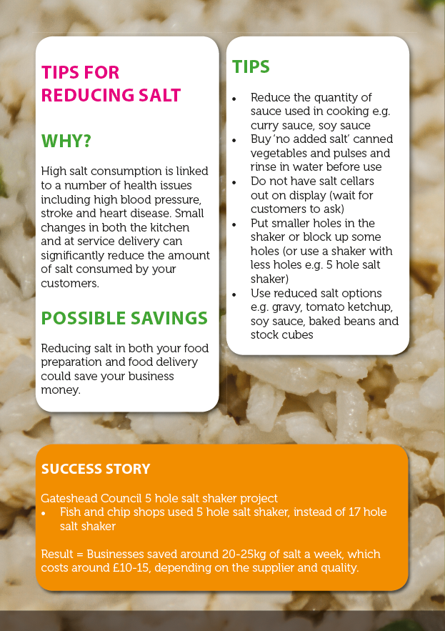
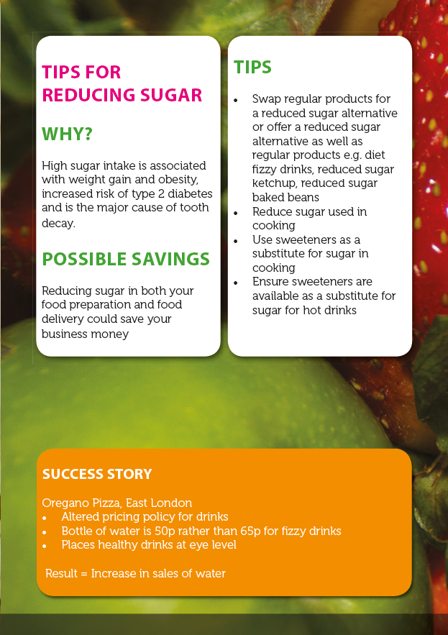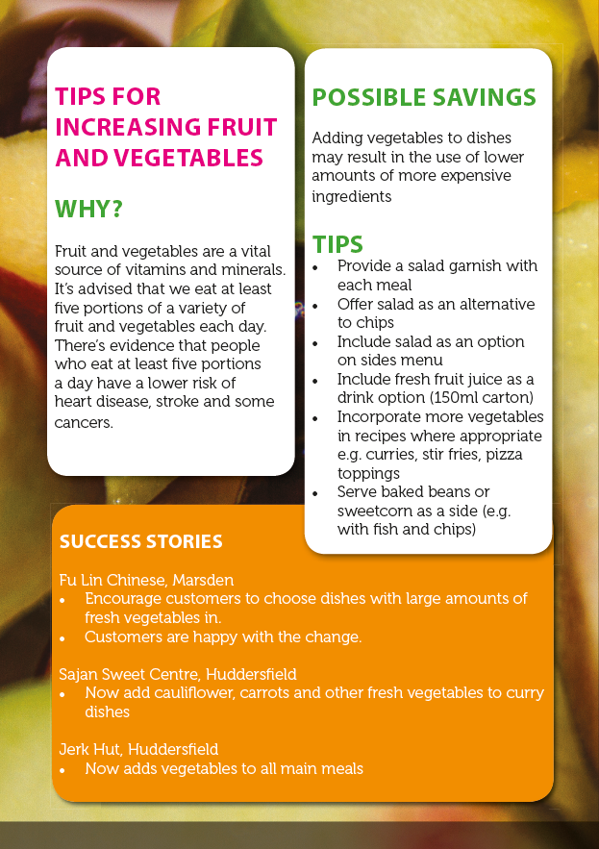
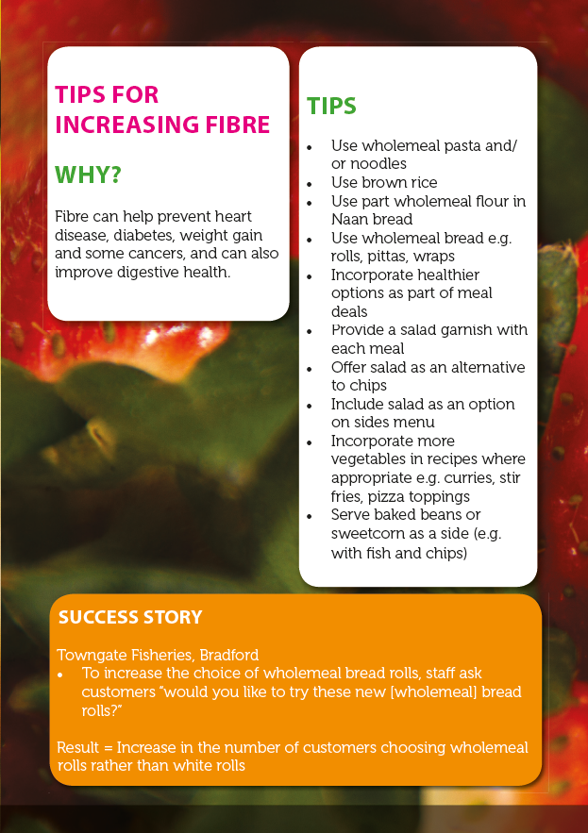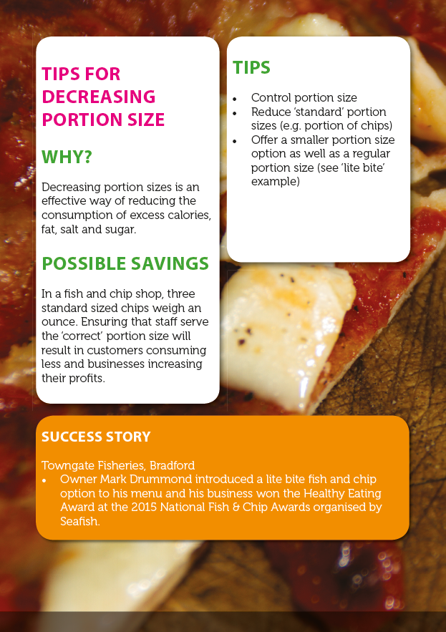

Supplemental Fig. S4: Takeaway Masterclass Pledge Form

