KAP questionnaire
Dietary Diversification
- Why different types of foods should be consumed? (select any one option)
1. AWW/ doctor said to do so
2. Different nutrients are present in different foods
3. It makes meal tastier
4. Don’t know

- According to you, which of the following foods are good to be given daily in your children’s diet?
Food groups | 1.Compulsory | 2.Not compulsory
1.Pulses / egg
2.GLV (at least one variety)
3.Vegetables (at least one variety)
4.Fruits
5.Milk & milk products

- How do the following foods are useful to our body (please select any one option)
Food groups | 1.Protein | 2.Vitamins & Minerals | 3.Energy | 4.Don’t Know
- Oil , Sugar
- Pulses, Milk and Flesh Foods
- Fruits, Green Leafy Vegetables, other Vegetables

- How many types of oil) do you use for cooking at home regularly (eg: sunflowere/ palm/ groundnut?
1. One type of oil
2. two types of oil

- From the following displayed plates, which one do you think has foods in required quantities for your child’s health? (plate A,B,C for vegetarians & plate 1,2,3 for non-vegetarians)

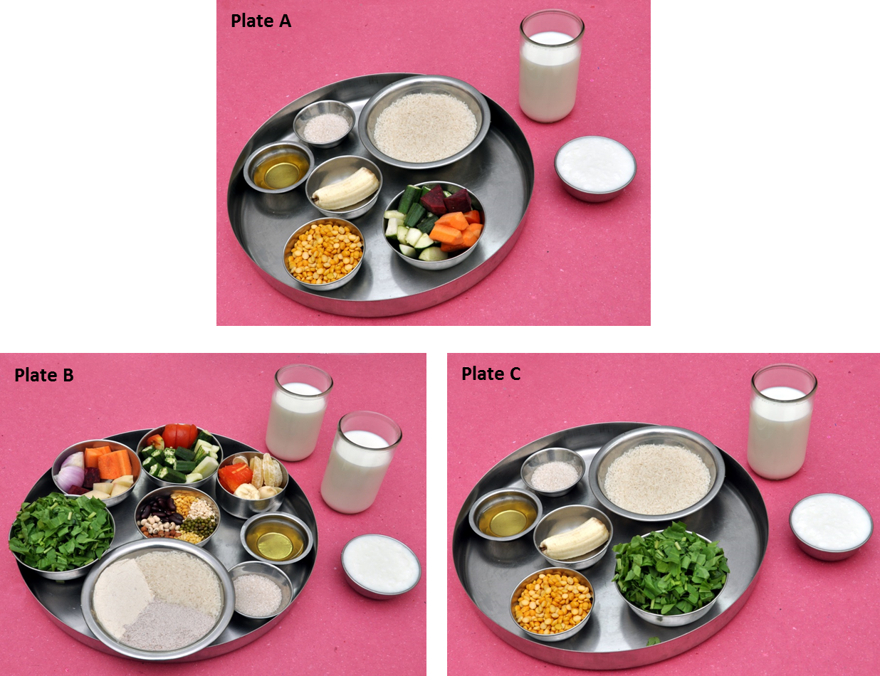

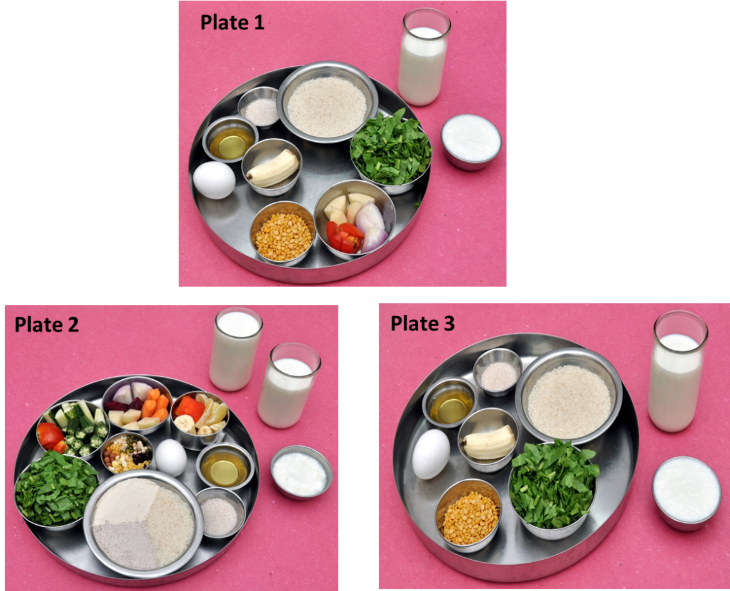

Micronutrients

- Can you name one vitamin?

- Can you name one mineral?

- Where do you get vitamins and minerals from
- They are produced in the body
- They are not produced in the body and obtained by consuming different types of foods
- Don’t know

- Why iodized salt should be used?
1. It enhances flavor/ taste of food
2. It prevents heart disease and prevents bone fracture
3. It prevents thyroid disorder and improves intelligence
4. Don’t know

- Do you think you are meeting your vitamins and minerals requirement from food you eat daily?
1. Yes, we are meeting
2. No, we are not meeting
3. Don’t know

a) Do you think your children are getting the required vitamins and minerals from the food they are eating?
1. Yes, they are meeting
2. No, they are not meeting
3. Don’t know

b) Do you think your husband is getting the required vitamins and minerals from the food they are eating?
1. Yes, he is meeting
2. No, he is not meeting
3. Don’t know

- Do you think you are having vitamin or mineral deficiency?
1.Yes
2. No
3. Don’t know

- Do you think your children are having vitamin and minerals deficiency?
1.Yes
2. No
3. Don’t know

b) Do you think your husband is having vitamin and minerals deficiency?
1.Yes
2. No
3. Don’t know

- By consuming a variety of foods, can the following vitamin and mineral deficinecies be prevented or cannot be prevented?
 | 1.Can be prevented | 2. Cannot be prevented | 3. Don’t know
- Night blindness
- Anemia leading to Fatigue/ tiredness
- Bow shaped legs
- Bleeding gums
- Cracks around lips
- Low birth weight

- Identify food items that help in proper vision (select any one option)
- Yellow orange colored fruits and vegetables(carrot, pumpkin, mango)
- Organ meat (Liver)
- Dark green leafy vegetables
- All the above
- Don’t know

- What is the best way of eating raw carrots for better nutrition?
- Peel and eat
- Peel and eat with curd (as raita)
- Should not be consumed raw
- Don’t know

- Why do you add oil to the food while cooking?
1. It makes food tastier by retaining colour and flavor of the food
2. It makes meal nutritious
3. It increases storage time of the food
4. To avoid indigestion

- Anemia, that is, decreased level of hemoglobin is caused due to deficiency of which mineral (select any one option)?
- Iron
- Calcium
- Vitamin D
- Don’t know

- Identify food items that are rich in iron.
 | 1.Yes | 2.No | 3.Dont know
1.Cereals (rice, wheat)
2.Pulses
3.Millets
4.Dry fruits (dried dates, cashew)
5.Organ meat (liver)

- Eating which food along with habitual meal improves iron status in the body
- Fruits like guava, papaya, orange
- Ghee
- Curd
- Don’t know

- Identify sources that help in building strong bones
- Rice, wheat
- Nuts, oil seeds
- Milk, milk products and sunlight
- Don’t know

- Which of the following foods help in increasing height, weight and mental development in children?
- Cereals and milk
- Fruits and vegetables
- Oil, Nuts and legumes
- Sea foods, sun exposure
- Organ meat/ flesh foods
- Iodized salt
- All the above
- Don’t know

- After having a meal, which one of the following items would your child like
to have
- Fruits
- Sweets
- Tea/ coffee
- If anything else, please specify____________________
- None

- Drinking tea/coffee along with meals (select one option)
- Gives satiety
- Makes you active
- Reduces absorption of nutrients
- Improves digestion
- None of the above

Cooking and dietary practices

- Which of the following does your child eat every day?
 | - Yes | - No
- Breakfast
- Lunch
- Dinner

- Can you name three snack items you give to your children? (qualitative information, not analysied for internal consistency)

- How do you wash fruits and vegetables

 | 1. 2-3 times in a bowl of water | 2.Once in a bowl of water | 3.Don’t wash at all
1.GLV
2.Vegetables
3.Roots & tubers
4.Fruits

- The following, list of practices leads to loss of nutrients from food or not?
 | 1.Nutrients get lost | 2.Nutrients does not get lost | 3.Don’t know
1.If vegetables are washed after cutting
2.If food grains are repeatedly washed
3.During fermentation and germination
4.While cooking with lid open
5.Using iodized salt

- Do you practice the following listed practices?
 | - Yes | - No
1.Wash vegetables after cutting
2.Wash food grains repeatedly
3.Fermentating and germinating foods (Ex:pulses)
4.Cook with lid open/open vessel
5.Use iodized salt

- Which of the following do you feed your child everyday?
 | - Yes | - No | If no, Why?
1.Atleast one fruit a day
2.A glass full of milk daily
3.Green leafy vegetables daily
4.At least one vegetable daily
5.Pulses/ one egg/ any flesh foods daily

If no (to the above question), can you tell the reason? (qualitative data, not analysed for internal consistency)
- You don’t have time to prepare all these items
- Not available at your home
- Foods are expensive
- Your children do not like to have
- Other reason, please specify
Sunlight exposure

- Sunlight is essential for? (Choose one option from the following)
- A healthy hair
- To improves eye sight
- To make bones stronger
- Don’t know

- What time in a day do you think is good to take sunlight for good health?
- 6 am- 10 am
- 11 am- 2 pm
- Any time in a day
- Don’t know

- Do your children play outdoor games?
 | - At home | - At school
1.Yes /No
2.At which time of the day
a.11 am to 2 pm
b.<11 a.m -> 2 p.m
3.For how many min/hrs per day
a. >45 minutes
b. <45 minutes
4.How many times in a week
a.>5 times
b. <5 times

- Which part of the body gets sunlight?
 | 1.Face & neck | 2.Full hands | 3. Knee to feet | 4. Fore hand | 5.Only feet
1.Yourself
2.Husband
3.Child

