Supplementary material

Supplemental Table 1. Demographic characteristics of focus group participants in Myanmar

 |  | Yangon upper income (n=8) | Yangon lower income (n=8)_ | Magway (n=8) | Dawei  (n=8)
Highest level of education completed (n) | Less than primary school | 0 | 2 | 6 | 3
 | Primary school | 0 | 2 | 0 | 1
 | Secondary school | 4 | 0 | 0 | 0
 | High school | 0 | 4 | 0 | 4
 | College | 4 | 0 | 2 | 0
Employment status (n) | Government employee | 3 | 0 | 0 | 1
 | Employed by a non-government organization | 0 | 0 | 0 | 0
 | Self-employed | 0 | 2 | 3 | 2
 | Homemaker | 5 | 6 | 2 | 5
 | Farm/casual worker | 0 | 0 | 3 | 0
Age (years) | Mean (range) | 40 (21-55) | 39 (30-50) | 40 (24-57) | 42 (27-61)
Ethnic group (n) | Burmese | 7 | 8 | 8 | 0
 | Chin | 1 | 0 | 0 | 0
 | Indian | 0 | 0 | 0 | 0
 | Dawei | 0 | 0 | 0 | 8

Supplemental Table 2. Demographic characteristics of consumer survey participants in Myanmar

 |  | Yangon upper income (n=71) | Yangon lower income (n=91)_ | Magway (n=100) | Dawei  (n=100) | p-value
% Female |  | 56% | 48% | 50% | 50% | .767
Highest level of education completed | Less than primary school | 4% | 18% | 7% | 28% | <.001
 | Primary school | 17% | 38% | 31% | 31%
 | Secondary school | 32% | 31% | 30% | 29%
 | High school | 10% | 4% | 7% | 2%
 | College | 37% | 9% | 25% | 10%
Employment status | Government employee | 1% | 3% | 8% | 5% | .277
 | Employed by a non-government organization | 16% | 11% | 15% | 17%
 | Self-employed | 68% | 75% | 67% | 69%
 | Homemaker | 13% | 4% | 8% | 8%
 | Other | 2% | 7% | 2% | 1%
Age | Mean ± SD | 39 ± 12 | 41 ± 12 | 39 ± 13ª | 43 ± 11^{b} | .039
Ethnic group | Burmese | 73% | 64% | 96% | 85% | <.001
 | Karen | 6% | 18% | 0% | 1%
 | Indian | 16% | 6% | 2% | 2%
 | Other | 5% | 12% | 2% | 12%

Supplemental Fig. 1. Food environment maps from participatory social mapping in four food environments in Myanmar
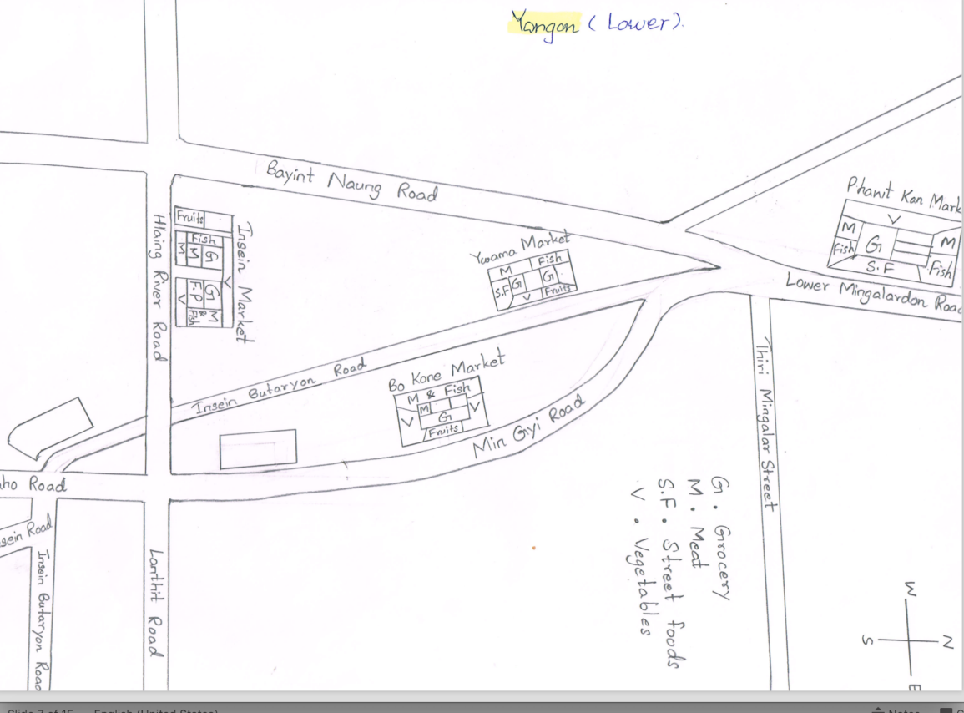
Yangon Lower Income (urban)

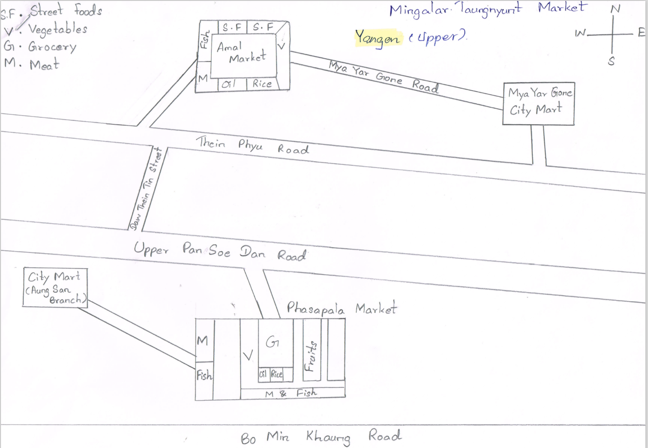
Yangon Upper Income (urban)
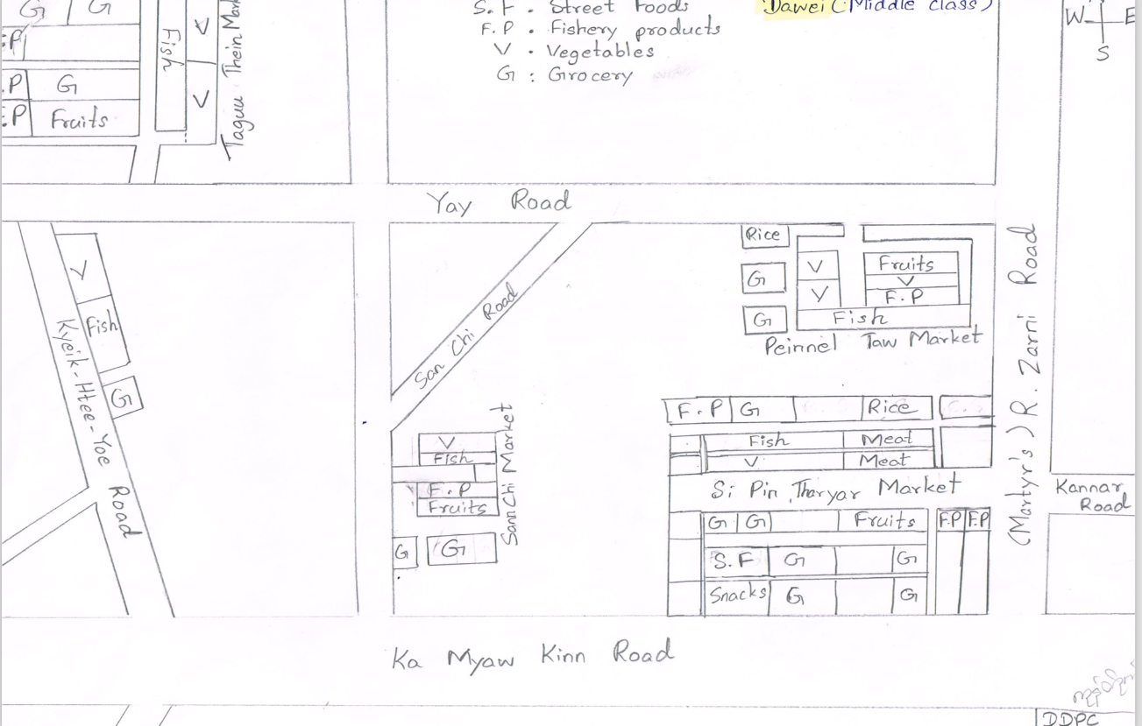
Middle Income Dawei (coastal)

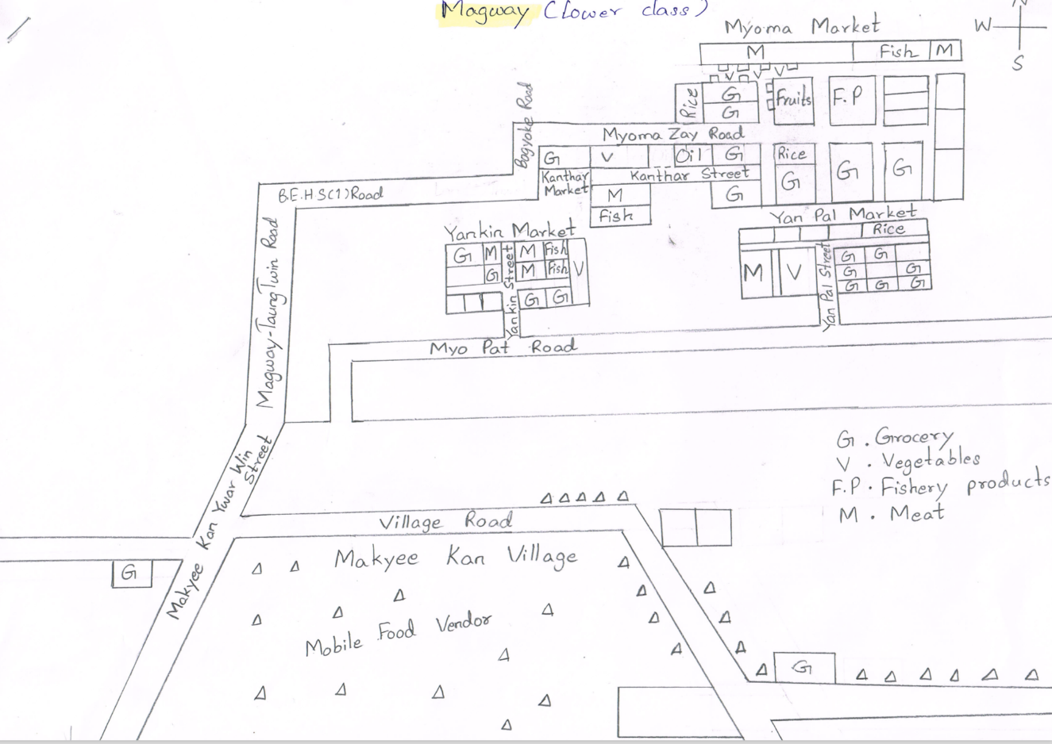
Lower Income Magway (rural)

