Annex 1

1. Analytical framework 1
2. Scoping assessment of Lidl’s international operations 5
3. Identification and retrieval of primary sources 10
4. Data analysis 12
5. Coding files 16
6. Locating Lidl’s pledge in context 16
7. Research team 18
References 20

Analytical framework
Overview
The INFORMAS (International Network for Food and Obesity/non-communicable diseases Research, Monitoring and Action Support) framework is a framework for monitoring, analyzing, evaluating and comparing food environments around the world. It has been developed by an international network of researchers and public interest organizations under the auspices of World Obesity (formerly the International Association for the Study of Obesity). In the context of INFORMAS, food environments are defined as “the collective physical, economic, policy and sociocultural surroundings, opportunities and conditions that influence people’s food and beverage choices and nutritional status” ⁽¹⁾.

The framework comprises the following 12 modules (cf. Figure 1):
- two upstream process modules covering public and private sector policies and practices which influence food environments;
- seven impact modules covering various dimensions of food environments; and
- three downstream outcome modules, covering population diets, physiological and metabolic risk factors, and non-communicable disease morbidity and mortality.

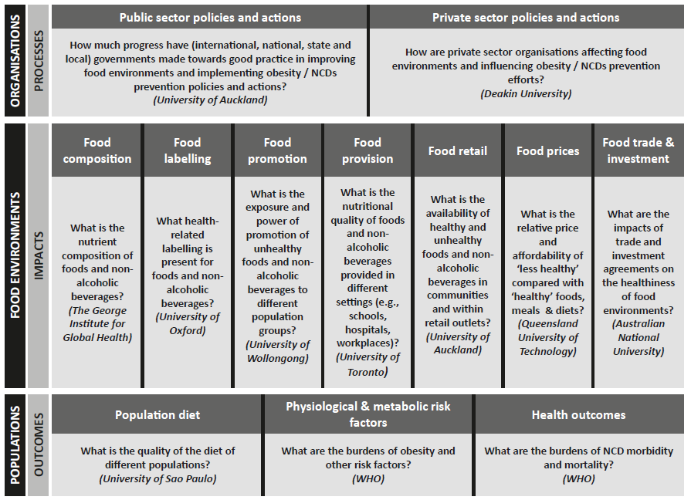
Figure 1 Overview of the INFORMAS modular framework including process, impact and outcome modules, each with its main research question and current lead organization. Reproduced from Swinburn et al. 2013 ⁽¹⁾.

For the process and impact modules, data collection and analysis is carried out on a national or regional level by independent research groups and civil society organizations, whose work is supported and coordinated by a central secretariat, which is currently based at the University of Auckland. For each module a step-wise approach to data collection and analysis is recommended, ranging from minimal to optimal, depending on country priorities and resources. Methodological guidance and standardized research protocols are provided for some modules, and can be adapted to local circumstances and needs ^{(1; 2)}.

The INFORMAS module on private-sector policies and practices

The INFORMAS module on private-sector policies and practices has been developed to monitor the influence of companies, business groups and other industry stakeholders on food environments. This primarily includes the food and beverage industry, i.e. all organizations involved in producing, packaging, distributing and marketing foods and beverages, but may extend to entertainment and media companies ⁽³⁾.

As part of an initial priority-setting, organizations of interest should be chosen based on their potential influence on the food environment in a given country or region. In the present analysis, we chose Lidl based on its role as Europe’s largest food retailer ⁽⁴⁾, and due to the relative comprehensiveness of its healthy nutrition strategy as compared to the activities of its main European competitors.

Once organizations of interest are identified, data collection and analysis may follow a step-wise approach (cf. Figure 2). As part of our step 1 analysis of Lidl, we cover company policies regarding the following domains:
- food composition with respect to the reduction of salt, trans-fatty acids, saturated fat and added sugars;
- marketing and promotion;
- nutrition information and education;
- product availability; and
- affordability and pricing.

Following the recommendations of the INFORMAS framework we also included a number of further issues of relevance to food retailing environments, which we identified during the initial, inductive coding of our primary sources and the subsequent discussion of the created codes. These issues are:
- food composition with respect to energy density and dietary fiber;
- relative share of different food groups in overall sales, in particular with regard to non and minimally processed foods vs. highly and ultra-processed foods, and with regard to fruit and vegetables and sugar-sweetened beverages in particular; and
- portion and package size;

Of note, the INFORMAS framework aims to allow for a comparative analysis of the private sector organizations most relevant for a specific country, region or industry segment. By contrast, the present paper focuses on one organization only. We will consider expanding our analysis to other leading European retailers, and/or to other private sector organizations that strongly influence food environments and population diet in Europe. Moreover, we will consider to broaden our analysis to partially or fully cover steps 2 and 3 of the INFORMAS framework once sufficient data become publicly available.

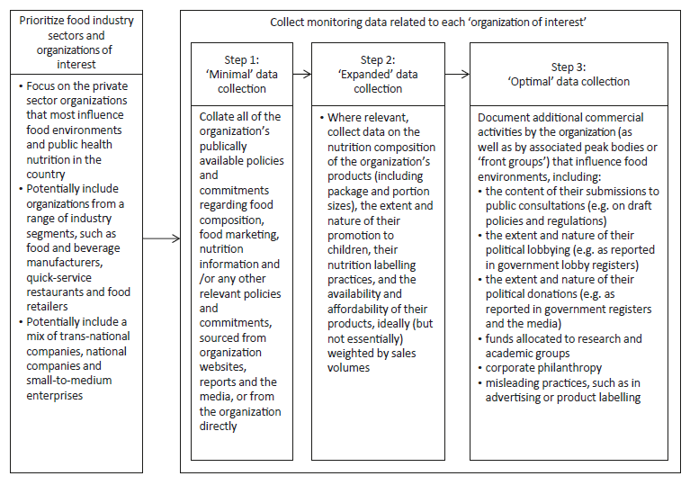
Figure 2: Proposed step-wise data collection approach for monitoring private-sector policies and practices that affect food environments and influence obesity/non-communicable disease prevention efforts. Reproduced from Sacks et al. ⁽³⁾.

Assessment of Lidl’s international operations

To determine the geographic scope of our analysis, we undertook an assessment of statements made by Lidl’s international operations with regard to nutrition and health, paying particular attention to the issues covered by our analytical framework.

We analyzed the following countries of operation: United States, Great Britain, Northern Ireland, Ireland, Austria, Switzerland, Luxemburg, France, Belgium, Spain, Malta, and Hong Kong. We were not able to assess the following countries with a national division of Lidl due to language barriers of the author team: Italy, Netherlands, Denmark, Sweden, Finland, Poland, Lithuania, Czech Republic, Slovakia, Hungary, Slovenia, Croatia, Romania, Serbia, Bulgaria, Greece, and Cyprus.

All links listed below were active as of March 20, 2017.

Lidl international:
- Main page: https://www.info.lidl/en-gb/index.html
- Specific statements with regard to nutrition and health: None (The website of Lidl international contains only a small number of generic statements on the company, and links to its national divisions)

Lidl USA:
- Main page: https://www.lidl.com/
- Specific statements with regard to nutrition and health: None (Lidl’s operations in the US are still under development, and no stores have been opened as of March 2017)

Lidl Great Britain:
- Main page: https://www.lidl.co.uk/en/index.htm
- Specific statements with regard to nutrition and health:
  - Healthy checkout initiative: https://www.lidl.co.uk/en/Championing-a-healthy-society-752.htm
  - Use of sunflower oil and hydrogenated fats: https://www.lidl.co.uk/en/Healthier-products-749.htm
  - Partnership with anti-hunger charities: https://www.lidl.co.uk/en/Neighbourly-4038.htm
  - Partnership with sporting associations: https://www.lidl.co.uk/en/Football-929.htm and https://www.lidl.co.uk/en/Partnership-with-the-English-FA-The-FAW-and-Scottish-FA-3486.htm

Lidl Northern Ireland:
- Main page: http://www.lidl-ni.co.uk/en/index.htm
- Specific statements with regard to nutrition and health:
  - Partnership with cancer charities: http://www.lidl-ni.co.uk/en/5180.htm
  - Partnership with local community initiatives: http://www.lidl-ni.co.uk/en/5252.htm

Lidl Ireland:
- Main page: http://www.lidl.ie/en/index.htm
- Specific statements with regard to nutrition and health:
  - Partnership with anti-hunger charities: http://www.lidl.ie/en/4506.htm
  - Partnership with cancer charities: http://www.lidl.ie/en/barretstown.htm
  - Partnership with sporting organizations: http://www.lidl.ie/en/lgfa.htm

Lidl Austria:
- Main page: http://www.lidl.at/de/index.htm
- Specific statements with regard to nutrition and health:
  - Healthy checkouts (“Vitale Kassa”): https://aufdemwegnachmorgen.at/massnahmen/ and https://aufdemwegnachmorgen.at/wp-content/uploads/2016/09/Lidl-Oesterreich_NHB_2015.pdf (p. 46)
  - Partnership with anti-hunger, youth and health charities: https://aufdemwegnachmorgen.at/wp-content/uploads/2016/09/Lidl-Oesterreich_NHB_2015.pdf (p. 43ff)

Lidl Switzerland:
- Main page: https://www.lidl.ch/de/index.htm
- Specific statements with regard to nutrition and health:
  - Healthy checkouts (“Alternative Kasse”): https://www.verantwortung-lidl.ch/de/sortiment/bewusste-ernaehrung/alternative-kasse/
  - Promotional material with healthy recipes and physical activity programs: https://www.lidl.ch/de/Fit-mit-Anita-Buri-483.htm
  - Partnership with anti-hunger charities: https://www.lidl.ch/de/Darum-Lidl-2598.htm and https://www.verantwortung-lidl.ch/de/gesellschaft/zusammenarbeit-tafeln-und-co/
  - Partnership with health and youth charities: https://www.verantwortung-lidl.ch/de/gesellschaft/sponsoring_spenden/

Lidl France:
- Main page: https://www.lidl.fr/fr/index.htm
- Specific statements with regard to nutrition and health:
  - Partnership with anti-hunger charities: https://enrouteversdemain-lidl.fr/nos-actions-solidaires/ and https://enrouteversdemain-lidl.fr/page-categorie/lutter-contre-le-gaspillage/
  - Fruit and vegetable lottery for students: https://enrouteversdemain-lidl.fr/nos-engagements-avec-les-etudiants/

Lidl Luxemburg:
- Main page: http://www.lidl.lu/de/home.htm
- Specific statements with regard to nutrition and health:
  - Healthy checkouts: http://www.lidl.lu/de/5620.htm
  - Promotion of fruits, vegetables, vegetarian and other healthy foods: http://www.lidl.lu/de/5612.htm
  - Partnership with sporting organizations: http://www.lidl.lu/de/5742.htm

Lidl Spain:
- Main page: https://www.lidl.es/es/index.htm
- Specific statements with regard to nutrition and health:
  - Offering of low-salt products: https://www.lidl.es/es/nutricion-bajo-sal.htm
  - Partnership with medical and scientific organizations: https://www.lidl.es/es/sostenibilidad-alimentacion-colaboraciones.htm
  - Partnership with sporting and youth organizations: https://www.lidl.es/es/sostenibilidad-sociedad-habitos-saludables.htm and https://www.lidl.es/es/titan-desert.htm
  - Partnership with anti-hunger charities: https://www.lidl.es/es/sostenibilidad-sociedad-bancos-alimentos.htm

Lidl Belgium:
- Main page: http://www.lidl.be/fr/home.htm
- Specific statements with regard to nutrition and health:
  - Promotion of fruits, vegetables and other healthy foods: http://www.lidl.be/fr/7530.htm
  - Partnership with anti-hunger charities: http://www.lidl.be/fr/7434.htm

Lidl Malta:
- Main page: https://www.lidl.com.mt/en/index.htm
- Specific statements with regard to nutrition and health: None

Lidl Hong Kong:
- Main page: http://www.lidl.com.hk
- Specific statements with regard to nutrition and health: None (Lidl Hong Kong currently acts as a sourcing company only, and does not operate stores)

Identification and retrieval of primary sources

To identify relevant primary sources we started with Lidl’s “Position Paper Healthy Nutrition”, which outlines the pledges made by Lidl, and conducted internet searches with related search terms, retrieved documents cited in Lidl’s position paper. We included all documents discussing Lidl’s pledge, or other activities by Lidl regarding the issues covered by our analytical framework, namely product composition with respect to salt, added sugar, saturated fat, trans-fatty acids, and energy density, as well as policies regarding marketing and promotion, product availability, portion and package sizes, pricing, and nutrition information and education. We conducted the search in February 2017, and included a limited number of additional documents published after this date based on comments by experts whom we asked for feedback on our draft manuscript. In doing so we identified the following documents, which we subsequently retrieved and analyzed:

Documents by Lidl

https://www.lidl.de/de/asset/other/170125_Positionspapier_Bewusste_Ernaehrung.pdf
https://www.lidl.de/de/unternehmensgrundsaetze-fuehrungsleitlinien/s1246
https://www.lidl.de/de/verantwortung/s841
https://www.lidl.de/de/sortiment/s850
https://www.lidl.de/de/gehaertete-fette/s868
https://www.lidl.de/de/unterstuetzung-der-deutschen-krebshilfe-e-v/s3724
https://www.lidl.de/de/brotzeit-e-v/s7373717
https://www.lidl.de/de/lidl-deutschlandcup/s7374923
https://www.lidl.de/de/lidl-spendet-500-000-euro-an-ein-herz-fuer-kinder/s7373982
https://www.lidl.de/de/unterstuetzung-der-tafeln/s843

Documents by DiabetesDE - German Diabetes Aid

http://www.diabetesde.org/system/files/documents/pm_gesund_einkaufen_lohnt_sich_online.pdf
http://www.diabetesde.org/system/files/documents/positionspapier_diabetesde_nationale_reduktionsstrategie_14.03.2016.pdf
http://www.diabetesde.org/system/files/documents/150817_position_dag_ddg_dde_zum_eu_pledge_final.pdf
http://www.diabetesde.org/pressemitteilung/fortschritt-bekaempfung-nichtuebertragbarer-krankheiten-gefaehrdet
http://www.diabetesde.org/ueber_uns/transparenz
http://www.diabetesde.org/system/files/documents/corporate_giving_policy.pdf
http://www.diabetesde.org/rezept/bunte-stullen
http://www.diabetesde.org/rezept/overnight-oats-apfel-skyr
http://www.diabetesde.org/rezept/schnelle-fruehstuecks-frittata
https://www.diabetesde.org/rezept/bunter-reissalat-avocadocreme
https://www.diabetesde.org/system/files/documents/pm_nach_ostern_online.pdf
https://www.diabetesde.org/system/files/documents/pm_tag_der_gesunden_ernaehrung_online.pdf

Press reports

https://www.aerzteblatt.de/nachrichten/72728/Deutsche-Diabetes-Hilfe-und-Lidl-arbeiten-bei-Verbraucheraufklaerung-zusammen
http://www.presseportal.de/pm/58227/3543890

Data analysis

The full code tree and the number of codings (i.e. the number of text passages to which each code has been assigned) is provided below. In short, the code tree has three domains: i. nutrient and food groups; ii. issues related to the specification of targets; and iii. other issues. Within the first domain, we created codes for all nutrient and food groups mentioned in Lidl’s pledge, and for energy density. In the second domain, we created codes for: qualitative targets; quantitative targets; timelines; baseline assessments; intervention types; references to scientific evidence, guidelines or policy documents; and examples for past and future actions. The third domain contains codes for issues related to: geographic coverage; transparency, monitoring and evaluation; cooperation with civil society; relationship to government policies; general framing of nutrition and health; and unclassified codes.

Code name |  |  |  |  | Number of codings*
Nutrient and food groups |  |  |  |  | 0
 | Nutrient groups |  |  |  | 0
 |  | Macronutrients |  |  | 0
 |  |  | Sugar |  | 39
 |  |  | Fats |  | 12
 |  |  |  | Saturated fats | 11
 |  |  |  | Trans fats | 7
 |  |  |  | PUFAs | 4
 |  | Micronutrients |  |  | 2
 |  |  | Minerals |  | 2
 |  |  |  | Iode | 1
 |  |  |  | Iron | 2
 |  |  |  | Calcium | 3
 |  |  | Vitamins |  | 1
 |  |  |  | Vitamin B12 | 1
 |  |  |  | Vitamin A | 1
 |  |  |  | Vitamin C | 1
 |  | Other issues |  |  | 1
 |  |  | Salt reduction |  | 34
 |  |  | Dietary fibre |  | 0
 |  |  | Energy density |  | 4
 | Food groups |  |  |  | 0
 |  | Produce |  |  | 0
 |  |  | Fruits and vegetables |  | 8
 |  |  |  | Vegetables | 8
 |  |  |  | Fruits | 7
 |  |  | Unprocessed meat |  | 3
 |  |  | Seafood |  | 2
 |  |  | Dairy |  | 10
 |  |  | Cereals |  | 1
 |  |  | Eggs |  | 1
 |  | Sweet foods |  |  | 6
 |  |  | Pastry |  | 3
 |  |  | Desserts |  | 1
 |  |  | Ice cream |  | 1
 |  |  | Sweet spreads |  | 6
 |  |  | Sweets / candy |  | 4
 |  |  | Breakfast cereals |  | 14
 |  |  | Honey |  | 2
 |  | Savoury foods |  |  | 4
 |  |  | Ready-to-eat meals |  | 4
 |  |  | Ketchup and other sauces |  | 2
 |  |  | Frozen pizza |  | 8
 |  |  | Savoury snacks |  | 7
 |  |  | Processed meat |  | 1
 |  |  | Bread & other bakery goods |  | 3
 |  |  | Soups |  | 1
 |  | Other food groups |  |  | 0
 |  |  | Packaged foods |  | 1
 |  |  | Oils and fats |  | 7
 |  |  |  | Margarine | 2
 |  |  |  | Animal fats | 1
 |  |  |  | Sunflower oil | 4
 |  |  |  | Rapeseed oil | 6
 |  |  |  | Palm oil | 6
 |  |  | Nuts and seeds |  | 1
 |  |  | Beverages |  | 3
 |  |  |  | Milk | 1
 |  |  |  | Juice | 3
 |  |  |  | Water | 1
 |  |  |  | SSB | 1
Specification of targets on nutrient and food groups |  |  |  |  | 0
 | Qualitative target |  |  |  | 18
 | Quantitative target |  |  |  | 32
 | Baseline assessment |  |  |  | 15
 | Timeline specification |  |  |  | 23
 | Intervention types |  |  |  | 2
 |  | Labelling |  |  | 4
 |  | Pricing |  |  | 2
 |  | Fortification |  |  | 1
 |  | Marketing / Promotion |  |  | 5
 |  | Product range / Stocking / Availability |  |  | 5
 |  | Portion and package sizes |  |  | 2
 |  | Reformulation |  |  | 11
 | Example actions |  |  |  | 1
 |  | Examples for future actions |  |  | 10
 |  | Examples for past actions |  |  | 12
 | Evidence base / reference |  |  |  | 2
 |  | Nutrition guidance |  |  | 11
 |  |  | German Nutrition Society |  | 5
 |  |  | WHO |  | 4
 |  |  | Others |  | 0
 |  | Policy documents |  |  | 11
 |  |  | National regulation / thresholds |  | 4
 |  |  | National reduction strategies |  | 7
 |  |  | EU Roadmap |  | 2
 |  |  | EU nutrition profile |  | 2
 |  |  | WHO nutrition profile |  | 11
 |  | Scientific publications |  |  | 6
Other issues |  |  |  |  | 0
 | Geographic coverage |  |  |  | 1
 | Transparency, Monitoring, Evaluation |  |  |  | 4
 | Cooperation with civil society |  |  |  | 3
 |  | Public health / medicine |  |  | 4
 |  |  | 5 am Tag e.V. |  | 3
 |  |  | diabetesDE |  | 12
 |  |  | German Cancer Fund |  | 1
 |  |  | Other |  | 0
 |  | Sport |  |  | 6
 |  |  | Lidl-Deutschlandcup |  | 1
 |  |  | Deutsche Schulsportstiftung |  | 2
 |  |  | Others |  | 1
 |  | Youth projects |  |  | 1
 |  |  | Ein Herz für Kinder |  | 1
 |  | School projects |  |  | 2
 |  |  | Lidl-Fruchtschule |  | 3
 |  |  | brotZeit e.V. |  | 1
 |  |  | Other |  | 1
 |  | Anti-hunger |  |  | 0
 |  |  | Die Tafeln |  | 1
 | Motives of Lidl and its partners |  |  |  | 4
 |  | Lidl's motives |  |  | 19
 |  |  | Caring for the ill |  | 2
 |  |  | Promoting healthy diets |  | 3
 |  |  | Complying with government wishes |  | 5
 |  |  | Preventing disease |  | 2
 |  |  | Positive statements about Lidl |  | 11
 |  | Motives of Lidl's partners |  |  | 3
 | Relationship to government policies |  |  |  | 10
 | Unclassified codes |  |  |  | 0
 |  | Physical activity |  |  | 11
 |  | Identification of targeted food groups |  |  | 10
 |  | Definition of terms |  |  | 1
 |  | Food chain issues |  |  | 3
 |  | Testing of products and interventions |  |  | 5
 |  | Preconditions |  |  | 9
 |  | Nutrition education |  |  | 5
 |  | General framing of nutrition and health |  |  | 27
Total number of codings |  |  |  |  | 656

Coding files

The full coding files on which our analysis is based are available from the authors upon request. The coding files can be opened and viewed with the free MAXQDA Viewer program (http://www.maxqda.com/products/maxqda-reader).

Locating Lidl’s pledge in context

We searched MEDLINE with the Ovid search interface, using the search syntax provided below. The search was conducted with English search terms and was performed on March 6, 2017; it yielded 713 unique results.

# | Search term | Nr. of hits
Industry self-regulation search set
1 | pledge*.af. | 1837
2 | self-regulation*.af. | 5369
3 | (voluntary or industry or business).af. | 254281
4 | (commitment* or initiative*).af. | 98333
5 | 3 and 4 | 5705
6 | 1 or 2 or 5 | 12848
Food and beverage industry search set
7 | (food* or beverage* or drink*).af. | 722843
8 | (industr* or retail* or manufactur* or compan* or store* or business*).af. | 621972
9 | supermarket*.af. | 2227
10 | 7 and 8 | 84128
11 | 9 or 10 | 85542
Joint search set
12 | 6 and 10 and 11 | 713

Moreover, we did a citing-/cited-studies search in Scopus. A citing-/cited-studies search is a snowballing technique, in which all studies cited by, or citing a specific study are included in the search for further relevant studies. We used Scopus because it offers features for convenient snowballing searches while covering a wide range of medical and interdisciplinary sources. We conducted the snowball search on March 6, 2017, and retrieved 508 unique results, as well as 199 duplicates.

We used the following references to conduct the search:
Finn S: Now and again: the food and beverage industry demonstrates its commitment to a healthy America. Am J Clin Nutr 2005, 82:253s-255s.
Taillie LS, Ng SW, Popkin BM: Gains Made By Walmart’s Healthier Food Initiative Mirror Preexisting Trends. Health Aff 2015, 34:1869-1876.
Koplan JP, Brownell KD: Response of the food and beverage industry to the obesity threat. JAMA 2010, 304:1487-1488.
Mialon M, Swinburn B, Sacks G: A proposed approach to systematically identify and monitor the corporate political activity of the food industry with respect to public health using publicly available information. Obes Rev 2015, 16:519-530.
Brownell KD: Thinking forward: the quicksand of appeasing the food industry. PLoS Med 2012, 9:e1001254.
Ng SW, Popkin BM: The Healthy Weight Commitment Foundation pledge: calories purchased by U.S. households with children, 2000-2012. Am J Prev Med 2014, 47:520-530.
Ng SW, Slining MM, Popkin BM: The Healthy Weight Commitment Foundation Pledge: Calories Sold from U.S. Consumer Packaged Goods, 2007–2012. Am J Prev Med 2014, 47:508-519.
Nixon L, Mejia P, Cheyne A, Wilking C, Dorfman L, Daynard R: "We're Part of the Solution": Evolution of the Food and Beverage Industry's Framing of Obesity Concerns Between 2000 and 2012. Am J Public Health 2015, 105:2228-2236.
Sacks G, Swinburn B, Kraak V, Downs S, Walker C, Barquera S, Friel S, Hawkes C, Kelly B, Kumanyika S, et al: A proposed approach to monitor private-sector policies and practices related to food environments, obesity and non-communicable disease prevention. Obes Rev 2013, 14:38-48.
Scott C, Hawkins B, Knai C: Food and beverage product reformulation as a corporate political strategy. Soc Sci Med 2017, 172:37-45.
Sharma LL, Teret SP, Brownell KD: The food industry and self-regulation: standards to promote success and to avoid public health failures. Am J Public Health 2010, 100:240-246.

Research team

Following the recommendations of the Consolidated Criteria for Reporting Qualitative Studies (COREQ) checklist, we report details on the composition of our research team, using the domains proposed in the COREQ checklist.

Credentials: What were the researcher’s credentials? E.g. PhD, MD
PvP: MA (Politics, Economics and Law), MSc (Global Politics), cand. med.
JMS: MD, BSc (Geography), PhD candidate (Public Health and Epidemiology)
TLH: Dipl; MSc equivalent (Health Economics)
RL: MD, Professor of Internal Medicine
HH: MD, Professor of Nutritional Medicine
EAR: BA and MA (Oxon, Biological Sciences), PhD (Public Health and Epidemiology)

Occupation: What was their occupation at the time of the study?
PvP: Medical student
JMS: PhD candidate
TLH: Junior researcher
RL: Emeritus professor
HH: University professor
EAR: Senior Scientist, Adjunct professor

Gender: Was the researcher male or female?
PvP: Male
JMS: Male
TLH: Male
RL: Male
HH: Male
EAR: Female

Experience and training: What experience or training did the researcher have?
PvP: Evidence-based public health; nutrition and health; qualitative and quantitative social science research methods.
JMS: Social science research methods, including qualitative methods (content analysis, grounded theory); geographical research methods; public health and clinical medicine.
TLH: Health economics; social science research methods, including qualitative methods; public health.
RL: Clinical medicine and research; preventive medicine and public health.
HH: Internal medicine; endocrinology and metabolism; clinical nutrition; nutrition research; preventive medicine and public health.
EAR: Evidence-based public health; evaluation of complex interventions; quantitative and qualitative methods.

References

1. Swinburn B, Sacks G, Vandevijvere S et al. (2013) INFORMAS (International Network for Food and Obesity/non-communicable diseases Research, Monitoring and Action Support): Overview and key principles. Obesity Reviews 14, 1-12.
2. INFORMAS (2017) INFORMAS. https://www.fmhs.auckland.ac.nz/en/soph/global-health/projects/informas.html (accessed 2017-03-09
3. Sacks G, Swinburn B, Kraak V et al. (2013) A proposed approach to monitor private-sector policies and practices related to food environments, obesity and non-communicable disease prevention. Obesity Reviews 14, 38-48.
4. Deloitte (2017) Global Powers of Retailing 2017: The art and science of customers. https://www2.deloitte.com/content/dam/Deloitte/global/Documents/consumer-industrial-products/gx-cip-2017-global-powers-of-retailing.pdf

