Supplement Figure 1 Association between quartiles of dietary patterns and BMI in 2005 and 2009
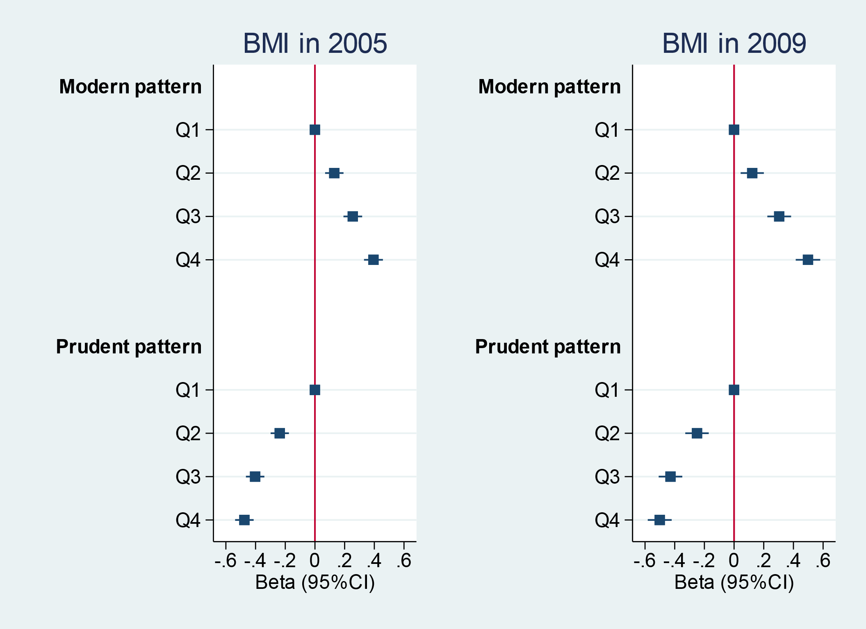
Values represent age and sex adjusted regression coefficients (Beta) and 95%CI.

