SUPPLEMENTAL FILE 2: ANALYTIC HIERARCHY PROCESS METHOD
  - The Analytic Hierarchy Process (AHP)
The Analytic Hierarchy Process (AHP), developed by Thomas L. Saaty in 1977 (1) was chosen for this study as it provided a simpler, transparent and validated method of assigning weightings to criteria compared with other methods. AHP is a structured technique for organizing and analysing complex decisions using pairwise comparisons (2). It is a research method that yields ratio-level weightings created from ratings made by each respondent for all possible pairs of items under consideration (2). It provides a hierarchal structure by decomposing a decision problem into its element and constituent parts.
The AHP supports group-decision making by aggregating individual preferences or priorities from paired comparison matrices into group preferences (3). In the first step of the AHP, the goal, attributes and alternatives are arranged into a hierarchal structure which provides an overall view of the inter-relationships amongst factors (2, 4, 5). It thereby provides an effective way to assess elements at each level of the hierarchy through pair-wise comparisons.
The two elements in each comparison are compared using a 1-9 ratio scale in order to provide a priority weighting of both factors within the comparison matrices and within the hierarchal structure (2, 4, 5).
The structure of a hierarchy tree includes up to four potential layers (2, 4, 5):
  - Top layer- Goal setting
  - Second layer- Criteria
  - Third layer- Sub-criteria
  - Bottom layer- Alternatives
- For this research study, the main goal is set as “Improving population nutrition” shown in Figure 1 below. In order to achieve this main goal, there is a set of criteria established in the Healthy Food Environment Policy Index (Food-EPI) framework in the form of food policy domains: Food Retail, Food Promotion, Food Trade, Food Price, Food Provision, Food Labelling, and Food Composition. Within these criteria, there are sub-criteria which in this case are the “good practice statements” of the policy domains. The alternatives were not evaluated in this study as this is beyond the scope of the study.

Figure 1: Analytic Hierarchy Process Framework for this study

- The next three sections describe the processes used for obtaining the pairwise comparison matrices, for collecting the data, and the extraction of the weightings from these matrices.
- 1.2. Pairwise Comparisons
- To determine the relative importance of these criteria (i.e. policy domains) and sub-criteria (i.e. good practice statements within policy domains) to improve population nutrition, participants were asked to rate the pairwise comparisons of the criteria and sub-criteria. Thomas Saaty (1) developed a 1 to 9 ratio scale of the relative importance (shown in Table 1), with the odd numbers 1,3,5,7,9 representing five of these attributes respectively: equal, moderate, strong, very strong and extreme importance. Even numbers are designed for intermediate values between two adjacent odd numbers. The reciprocals of these numbers reflect the same attributes but in the opposite direction e.g., ‘moderate importance’ refers to a criterion being three times as important as the paired criterion and moderately less important is the reciprocal (with the criterion being 1/3 as important as the paired criterion).

Table 1: Scale of relative importance developed by Saaty (2)
Saaty and Ozdemir (6) stated that the optimum number of elements to be compared, which provides a compromise between validity and inconsistency is seven comparisons or less. The following equation provides the total number of comparisons (p) which could achieve validity.
n: number of elements to be compared
p: number of paired comparisons
These paired comparisons are then transformed into a reciprocal matrix. For example, if you were to compare four criteria against each other, a square matrix of 4 x 4 is constructed of which the six comparisons that need to be made are positioned in the top triangular position shaded in yellow. The reciprocal of these comparisons are located in the bottom triangular position shaded in green. The following matrix (Figure 2) illustrates this as an example for the food labelling policy domain with good practice statements on nutrition information panels, nutrition and health claims, front-of-pack labelling and menu labelling.

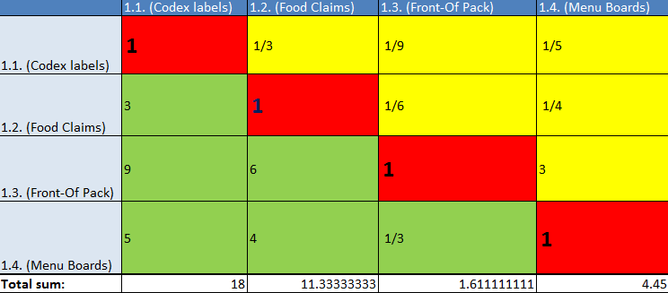
Figure 2: An example of a 4 x 4 pair-wise comparison matrix for the food labelling domain
1.3. Deriving priority weightings
Using Figure 2 as an illustrative example to compare the good practice statements from the Food Labelling policy domain, it could be observed that this participant rates the “Front of Pack” statement as having “moderate importance” with a rating of 3 compared with the “Menu Boards” statement. The reciprocal of this is 1/3, whereby the Menu Boards statement is rated as “moderately less important” than the Front-of Pack label statement.
The next step is to derive priority weightings from this pairwise comparison matrix. That is, how important are the four good practice statements or policy options within the Food Labelling domain to improve population nutrition. In order to compute the priority weightings for each criterion, the principal eigenvector is used.
1.4. AHP Eigenvector developed by Saaty (1)
First, the comparison matrix needs to be normalised. This is done by multiplying each rating (judgement) in the matrix across each row and then taking the n^{th} root of that product as shown by the equation below (n=number of elements to be compared):
n^{th} root of product = $\sqrt[n]{product of each row}$
Using Figure 2 as an illustrative example, this calculation is demonstrated Table 2 below. In this case there are 4 elements/criteria to be compared and thus n=4.
Table 2: Example of how to derive n^{th} root of product
The n^{th} roots are then summed. This sum is then used to normalize the eigenvector elements to add to 1.00, to provide the priority weightings for each element as shown by the equation below.
Priority weighting for element =$\frac{nth root of product}{∑(nth root of product) }$
For this example, the total sum of the 4th root of products is 0.2934 + 0.5946 + 3.5676 + 1.6069 = 6.0625 The priority weighting for each element is therefore:

Codex Labels =$\frac{0.2934}{6.0625}=0.0484$
Food Claims =$\frac{0.5946}{6.0625}$ = 0.0981
Front-of-pack =$\frac{3.5676}{6.0625}=0.5885$
Menu Boards =$\frac{1.6069}{6.0625}$ = 0.2651
The eigenvector of the relative importance for Codex Labels, Food Claims, Front-of-pack and Menu Boards is 0.0484, 0.0981, 0.5885 and 0.2651 respectively. Thus, Front-of-pack is the most important, followed by Menu Boards and Food Claims, while Codex Labels is considered the least important to improve population nutrition.
1.5. Consistency Check
Sometimes judgements made by participants are inconsistent. For example: Let’s say a participant considers the “Codex Labels” statement (B) as more important than the “Front-of Pack” statement (A). Thus, we say that for this participant, the “Codex Labels” statement has a greater value than the “Front-of Pack” statement. So, B >A. Next, this participant rates “Front-of-Pack” statement (A) more important compared to the “Food Claims” statement (C). Therefore, A> C
Since, B>A and A>C, logically, B>C or “Codex Labels” must be more important than “Food Claims”. If this participant rates the “Codex Labels” statement more highly than the “Food Claims” statement, then this participant’s judgment is consistent. If, however, the participant rates the Food Claims statement higher than the Codex Labels statement then the rating is inconsistent.
Within the AHP process a “consistency ratio” (developed by Saaty (1,2,5) is generated to reflect the confidence of the resulting priorities derived from the comparisons. According to Saaty (1), this consistency ratio should be below 0.10 and if it is above, participants need to revise their judgments.
The following equation shows the calculation for the consistency ratio (CR):

λ max = maximum eigenvalue of matrix
n= size of matrix (number of elements that are being compared)
C.I. = Consistency index ((λ max - n) / (n-1))
R.I. = random index of matrix (shown in Table 3)

Table 3: Random Index developed by Saaty (1977)
In order to compute λ max, the following equation was used:
λ max = ∑(∑ 𝑐𝑜𝑙𝑢𝑚𝑛 𝑜𝑓 𝑒𝑎𝑐h 𝑒𝑙𝑒𝑚𝑒𝑛𝑡 𝑥 𝑝𝑟𝑖𝑜𝑟𝑖𝑡𝑦 𝑤𝑒𝑖𝑔h𝑡)
The first step is to calculate the total sum of each column in the original judgement matrix such as that shown in Figure 2. Then the sum of each column is multiplied by the element’s priority weighting. For example, using priority weightings from section 1.4. and total sum for each column illustrated in Figure 2, the following was derived.
Codex Labels = 0.0484 x 18 = 0.8710
Food Claims = 0.0981 x 11.33 = 1.1116
Front-of-pack = 0.5885 x 1.611 = 0.9481
Menu Boards = 0.2651 x 4.45 = 1.1795
The next step is to sum all the values to obtain λ max which in this case is 4.1102. If any of the estimates for λ max turns out to be less than ‘n’ (4 in this case), then there has been an error in the calculation. This provides a useful check.
The Consistency Index is then calculated from (λ max - n) / (n-1). In this case, n=4 for the matrix. Thus the CI is 0.03673. The final step is to compute the Consistency Ratio given by the equation above. In this case the Random Index value is 0.89. The following calculation illustrates this final step:
CR=$\frac{0.03673}{0.89}=0.041$
This indicates that the judgement made by this participant is consistent as 0.041 <0.10.
1.6. Data Collection Questionnaire
Using the basic principles and mathematical calculations of the Analytic Hierarchy Process (AHP) method, a questionnaire was constructed in Microsoft Excel 2013. Seven sheets within an excel spreadsheet were created. Each sheet like the one shown in Figure 3, represented a policy domain with their respective good practice statements, and had different square matrixes depending on the number of good practice statements included within the policy domain (refer to supplementary material 1 ). The Food Composition domain did not have a separate sheet because it did not need pair-wise comparisons as it only had one good practice statement. The last sheet had a square matrix of 7 x 7 to compare the food policy domains. The ratio scale was provided on the left, along with a set of instructions at the bottom of the matrix. A consistency check was also created within the excel sheet, whereby if the consistency ratio was under 0.10, it would signal “good” and if above, it would signal “check again”. Participants were only able to fill in values using a drop-down list in the cells shaded yellow. An automated reciprocal number would be generated in the reciprocal green shaded cell.
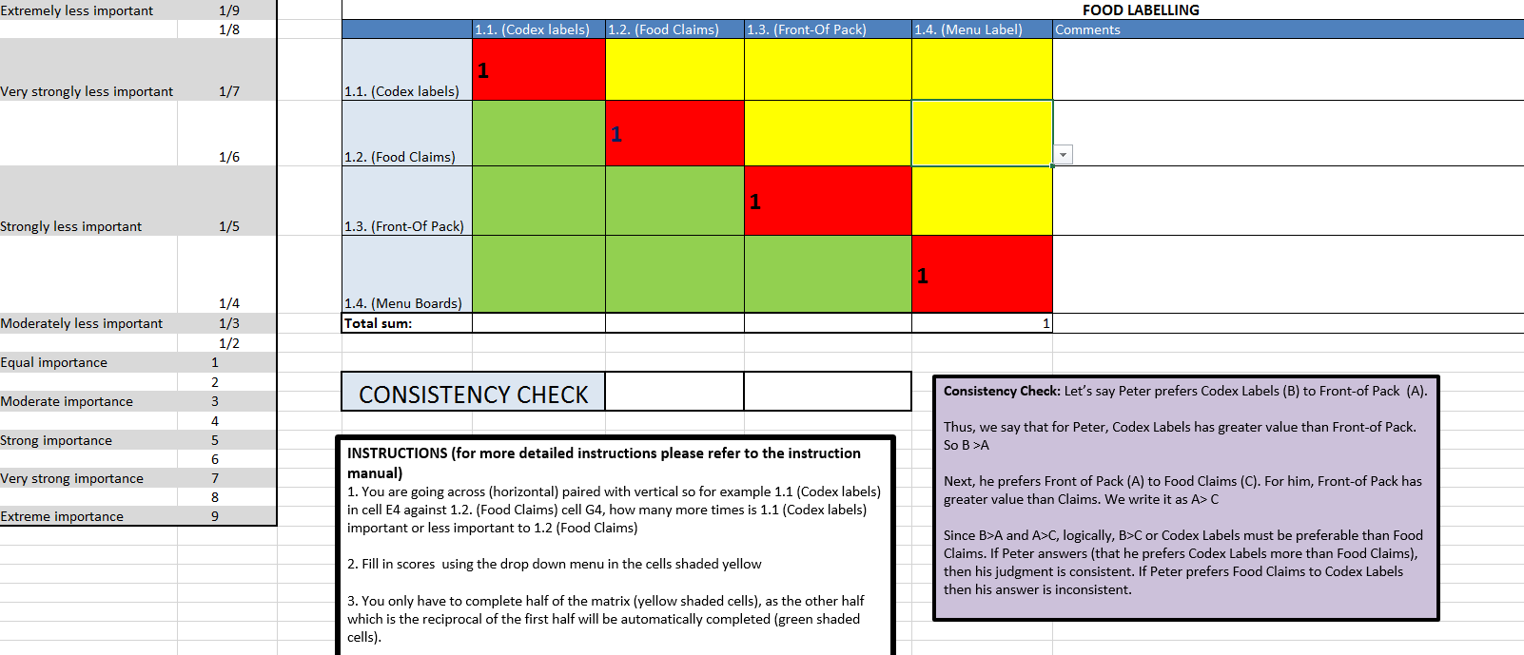
Figure 3: Example of the pair-wise comparisons questionnaire created in Microsoft Excel 2013
Participants were asked to make a series of judgements using pair-wise comparisons about the relative importance of each policy domain (or statements within domains) in improving population nutrition compared with each other policy domain (or statements within domains). They were asked to use the rating scale (refer to Table 1) to assign a number or fraction to the spreadsheet cell using the dropdown menu. It was stated that their judgements when completing the questionnaire should be based on their expertise and knowledge and supplemented by the evidence summaries where appropriate.
1.7. Aggregation of weightings
In order to assess the relative contribution of each domain and their respective good practice statements to improving population nutrition, expert opinions were aggregated into indicators (good practice statements) and composite indicators (domains).
Ssebuggwawo et al., (3) noted that two issues need to be addressed when aggregating expert opinions– “how to combine the individual judgements from a group of participants into group judgement and how to construct a group preference from the individual preferences”. Escobar and Moreno- jiménez (7), note that different aggregation procedures have been proposed in the literature, although the most frequently used is the geometric mean. These authors note that this procedure satisfies principles and assumptions of the method. Two methods commonly used to aggregate expert opinions are the aggregation of individual judgments (AIJ) and the aggregation of the individual priorities (AIP) (3, 8). AIJ is usually performed using the geometric mean, while AIP is usually performed using the arithmetic mean. The choice of method is dependent on whether the group is assumed to act together as a unit or as separate individuals (3, 8). In the AIJ approach individuals are said to act together and pool their judgments in such a way that the group becomes a new individual and behaves like one. In the AIP approach individuals are said to be acting in their own right, with different value systems.
This research used the AIJ method to combine individual judgements into a group judgement. This method was chosen as the experts were assumed to act together as a group and so that extreme values given by participants would not be able to affect the priorities given which is often the case for calculation of the arithmetic mean. The geometric mean is also more consistent with the meaning of priorities in AHP. In particular, preferences in AHP represent ratios of how many times more important one factor is compared to another.
In this AIJ approach, individual judgements/ratings from each of their pairwise comparison matrices are aggregated (3). The geometric mean of all the individual ratings is then inserted into a new group matrix (using the weighted geometric mean method) (3) and then the priority vector was obtained from this new matrix using calculations from above. Only consistent judgements were aggregated, so that the resultant group matrix is also consistent. These analyses were conducted in Microsoft Excel 2013.

1.8. Normalising weightings
Since each food policy domain did not have an equal number of good practice statements, a decision was made to normalise each good practice statement so that the global priority weightings take into account the number of other good practice statements that are being compared with. This was done by multiplying the local priority by the number of good practice statements within each domain. From the normalized weightings, relative weightings were created by comparing the weightings of each policy to the lowest good practice policy weighting.
References:

- Saaty TL. A scaling method for priorities in hierarchical structures. Journal of mathematical psychology. 1977;15(3):234-81.

- Saaty TL. Decision making with the analytic hierarchy process. International journal of services sciences. 2008;1(1):83-98.
- Ssebuggwawo D, Hoppenbrouwers S, Proper E. Group decision making in collaborative modeling: Aggregating individual preferences with AHP. 2009.
- Ramanathan R. A note on the use of the analytic hierarchy process for environmental impact assessment. Journal of environmental management. 2001;63(1):27-35.
- Saaty TL, Vargas LG. The seven pillars of the analytic hierarchy process. Models, Methods, Concepts & Applications of the Analytic Hierarchy Process: Springer; 2012. p. 23-40.
- Saaty TL, Ozdemir MS. Why the magic number seven plus or minus two. Mathematical and Computer Modelling. 2003;38(3–4):233-44.
- Escobar MT, Moreno-jiménez JM. Aggregation of individual preference structures in AHP- group decision making. Group Decision and Negotiation. 2007;16(4):287-301.
- Forman E, Peniwati K. Aggregating individual judgments and priorities with the analytic hierarchy process. European Journal of Operational Research. 1998;108(1):165-9.

