Online Supplementary Material

Validity of a Food Frequency Questionnaire to Measure Nutrient and Food Intake in Tanzania

Page Content
2 Composition of food groups from food frequency questionnaire (FFQ) food items in the Dar es Salaam Urban Cohort Hypertension Study (DUCS-HTN), 2014
3 Portion size images used by interviewers to conduct 24-hour diet recalls and FFQs
8 Dar es Salaam Urban Cohort Hypertension Study (DUCS-HTN) food frequency questionnaire

Supplemental Table 1. Composition of food groups from food frequency questionnaire (FFQ) food items in the Dar es Salaam Urban Cohort Hypertension Study (DUCS-HTN), 2014
Foods or food groups | Food items from the Food Frequency Questionnaire (FFQ)
Cereals | Oat porridge or oatmeal, wheat porridge, millet meal porridge, corn porridge, rice porridge, millet porridge or stiff porridge (ugali), porridge with grain from factory, grain from factory, maize on cob, maize meal cooked as in stiff porridge (ugali), corn/sugar derived from corn juice, maize cooked with beans (kande), maize cooked with beans (kande) and rice, pilau rice, plain boiled rice, pasta, bread, scones, chapatti, pancakes, donut, rice cakes
Root vegetables | Cassava porridge, potato boiled or baked, cassava boiled, cassava stiff porridge (ugali), cassava in a mixed dish, sweet potato alone, sweet potato in a mixed dish, yam boiled alone, yam fried, yam in a mixed dish, pounded yam or other root vegetable
Legumes & nuts | Beans/legumes alone, beans in mixed dish, bean soup, bean cakes, bambara nuts, groundnuts alone, groundnuts with food, cashew nuts
Unprocessed red meat | Beef not minced, beef minced, goat, pork, lamb, offal, liver, meat samosa
Chicken | Chicken
Eggs | Eggs
Fish | Dried fish, anchovies (dagaa), canned tuna in salt water, canned tuna in oil, canned fish in salt water, canned fish in tomato broth, fish curry, fresh fish
Dairy | Powdered whole fat cows milk, powdered fat free cows milk, cow’s milk full fat, cow’s milk low fat, cow’s milk fat-free, non-dairy creamer, plain yogurt, artificially sweetened yogurt, ice cream, cheese soft but not in liquid, cheese in liquid, other types of cheese, ghee, butter
Fruit | Ripe banana, mango, tamarind, plum, papaya, tangerine, lemon or lime, jackfruit, baobab, watermelon, guava, peaches, pineapple, passion fruit, orange, apple, grapes, apricot, pears, sweet melon, blood fruit (matunda damu), berries, fruit canned in syrup, raisins and other dried fruit, avocado
Vegetables | Cucumber, spinach, lettuce, cabbage, amaranth leaves, pumpkin leaves, cow pea leaves, cassava leaves, chinese cabbage, other cabbage, other green leafy vegetables, pumpkin, okra alone, okra in mixed dish, green peas alone, green peas in mixed dish, tomato fresh not in salad, tomato fresh in salad, tomato cooked, carrot fresh not in salad, green pepper fresh not in salad, green pepper fresh as in salad, vegetable samosa, zucchini, green beans, beet, broccoli, cauliflower, eggplant alone, eggplant in mixed dish, mushrooms, onions
Sugar-sweetened beverages | Soda, squash or syrup
Alcohol | Fermented mealie pap drink, beer commercially prepared, beer locally brewer or homemade, wine commercially prepared, wine homemade or locally brewed, distilled alcoholic beverages commercially prepared, distilled alcoholic beverages
Tea | Tea with milk, tea without milk

Portion size images used by interviewers to conduct 24-hour diet recalls and FFQs
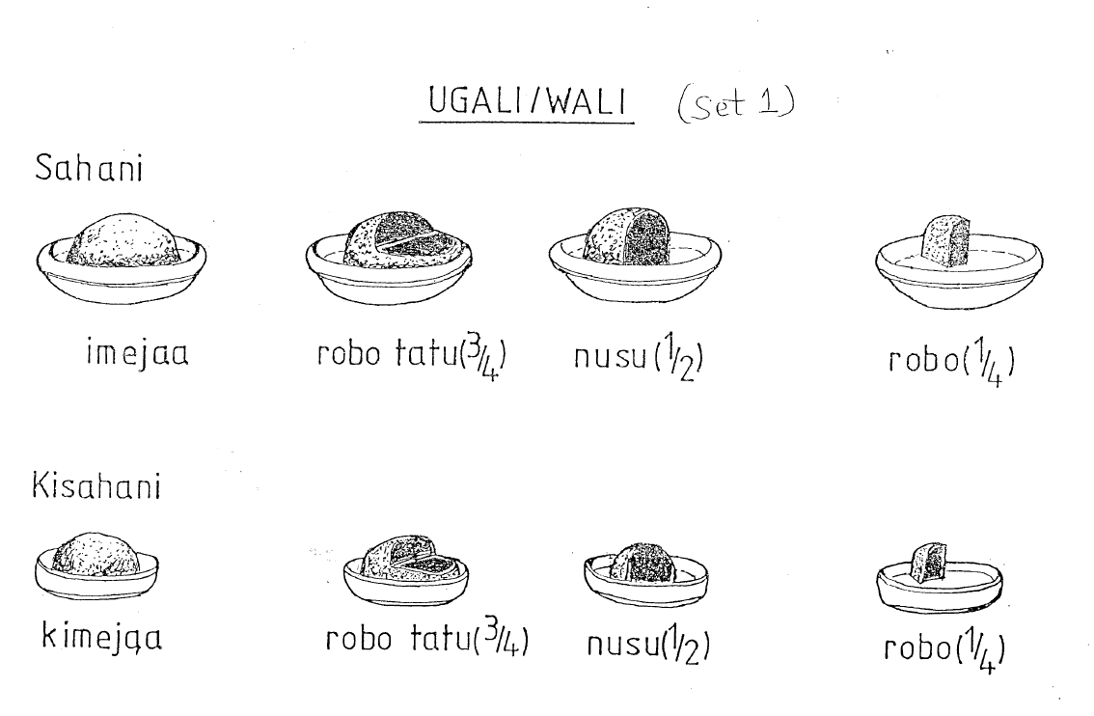
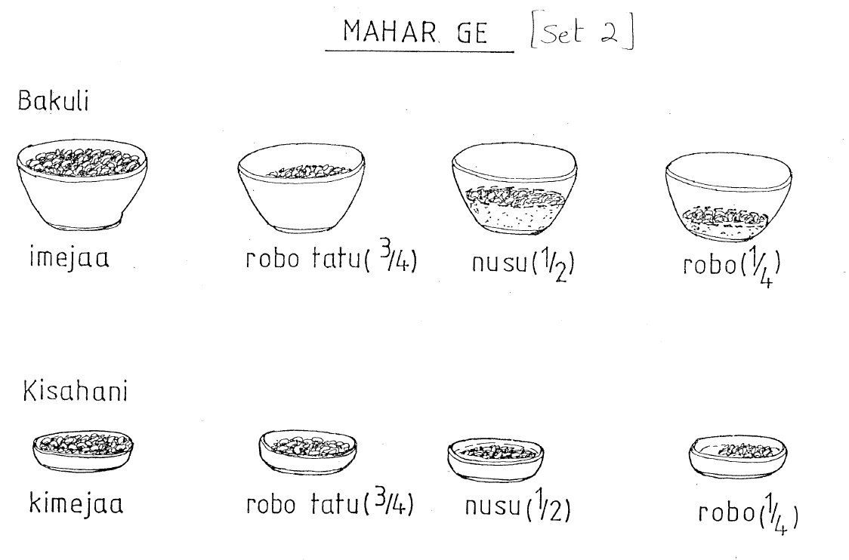
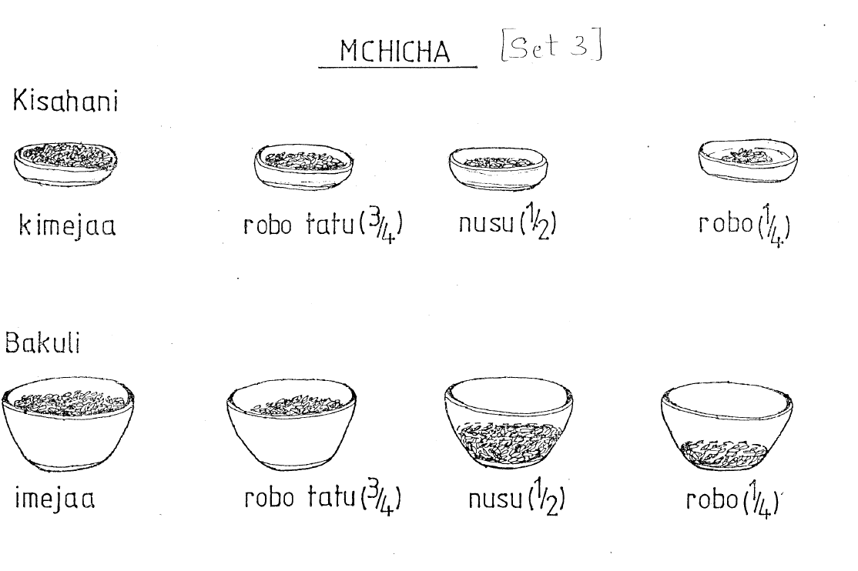
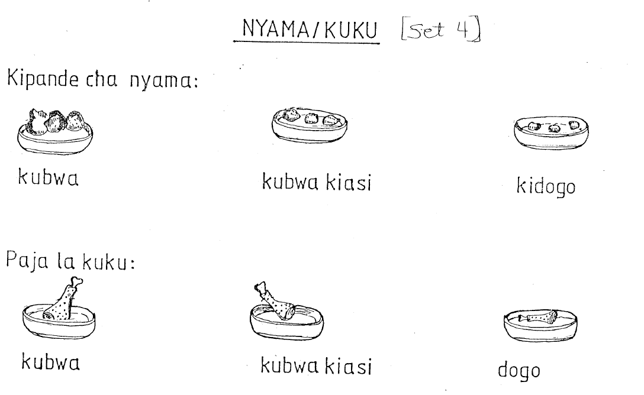
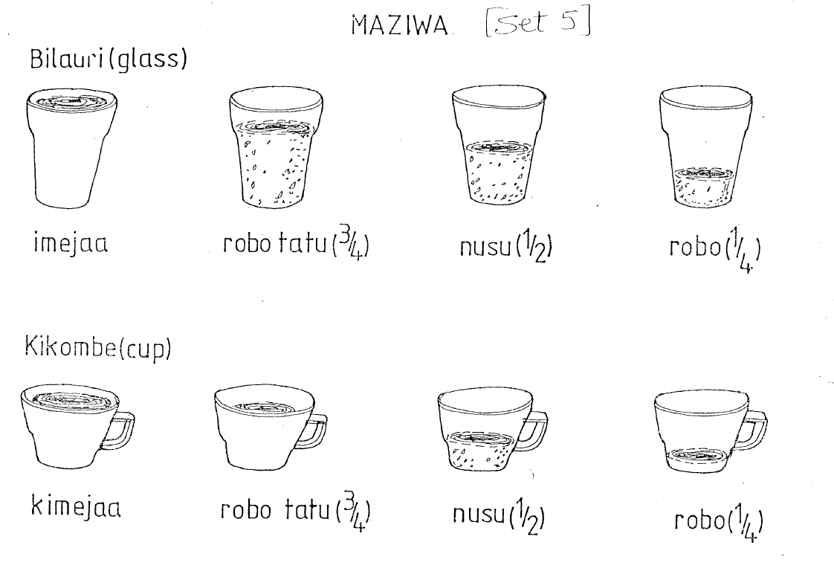Dar es Salaam Urban Cohort Hypertension Study (DUCS-HTN) Food Frequency Questionnaire

How often have you eaten the following foods in the past 30 days?
Do not count periods of fasting, such as Ramadan. Please pick only one frequency for each food. A note about serving sizes: 1 serving spoon = ½ cup. If you eat 2 servings of a food once a week, then you will check “2-4 per week.” If participants eat using handfuls from a shared container, change the serving size to number of handfuls. For the seasonal fruits and vegetable column, check the column if the participant eats the food only when it is in season.

Grain, Potatoes, and Related Foods
Code | Food | Serving  Size | Never | 1-3 per month | 1  per week | 2-4 per week | 5-6 per week | 1 per day | 2-3 per day | 4-5 per day | 6+ per day
FFQ001 | Oat porridge or oatmeal (uji) | 1 cup
FFQ002 | Wheat porridge (uji) | 1 cup
FFQ003 | Millet meal porridge (uji) | 1 cup
FFQ004 | Corn porridge (uji) | 1 cup
FFQ005 | Cassava porridge (uji) | 1 cup
FFQ006 | Rice porridge (uji) | 1 cup
FFQ007 | Sorghum stiff porridge (ugali) | 1 cup
FFQ008 | Millet porridge or stiff porridge (uji or ugali) | 1 cup
FFQ009 | Pearl millet stiff porridge (ugali) | 1 cup
FFQ010 | Mixed grain porridge (uji) | 1 cup
FFQ011 | Grain from factory | 1 cup
Code | Food | Serving  Size | Never | 1-3 per month | 1  per week | 2-4 per week | 5-6 per week | 1 per day | 2-3 per day | 4-5 per day | 6+ per day
FFQ012 | Maize (roasted or boiled, on the cob) | 1 whole cob
FFQ013 | Maize meal, cooked, as in stiff porridge (ugali) | 1 plate
FFQ014 | Corn / sugar derived from corn juice | ½ cup
FFQ015 | Maize cooked with beans (Kande) | 1 plate
FFQ016 | Maize cooked with beans (Kande) and rice | 1 plate
FFQ017 | Rice, mixed as in a pilau, fried | 1 plate
FFQ018 | Plain rice, boiled | 1 plate
FFQ019 | Potato, boiled or baked | 1 potato, fist-sized
FFQ020 | Cassava, boiled (alone) | 1 medium size piece
FFQ021 | Cassava stiff porridge (ugali) | 1 piece, fist-sized
FFQ022 | Cassava (in a mixed dish) | 1 plate
FFQ023 | Sweet potato (alone) | 1 medium size
FFQ024 | Sweet potato (in a mixed dish) | 1 plate
FFQ025 | Taro (alone) | 1 piece, fist-sized
FFQ026 | Taro (in a mixed dish) | 1 plate
Code | Food | Serving  Size | Never | 1-3 per month | 1  per week | 2-4 per week | 5-6 per week | 1 per day | 2-3 per day | 4-5 per day | 6+ per day
FFQ027 | Yam (boiled, alone) | 1 piece, fist-sized
FFQ028 | Yam (fried) | 1 piece, fist-sized
FFQ029 | Yam (in a mixed dish) | 1 plate
FFQ030 | Pounded Yam or other root vegetable | 1 serving, fist-sized
FFQ031 | Plantain (boiled or steamed) (Ndizi) | 1 banana finger
FFQ032 | Plantain (roasted) (Ndizi) | 1 banana finger
FFQ033 | Plantain (fried, or chips) (Ndizi) | 1 banana finger
FFQ034 | Plantain (in a mixed dish) (Ndizi) | 1 plate
FFQ035 | Pasta, cooked (spaghetti, macaroni) | 1 plate
FFQ036 | Bread, breadrolls, buns | 1 slice/roll
FFQ037 | Scones, muffins | 1 medium size
FFQ038 | Flat bread (Chapati) | 1 round piece
FFQ039 | Pancakes (Chapati ya maji) | 1 piece
FFQ040 | Donut, fried dough (maandazi, kalimati, half-cake) | 1 piece
FFQ041 | Rice cakes (mkate kumimina) | 2 pieces
Code | Food | Serving  Size | Never | 1-3 per month | 1  per week | 2-4 per week | 5-6 per week | 1 per day | 2-3 per day | 4-5 per day | 6+ per day
FFQ042 | Cookies (biscuits) | 2 pieces
FFQ043 | Cake | 1 medium slice

Fruits
Code | Food | Serving  size | Never | 1-3 per month | 1  per week | 2-4 per week | 5-6 per week | 1 per day | 2-3 per day | 4-5 per day | 6+ per day
FFQ044 | Ripe banana | 1 banana finger
FFQ045 | Mango | 1 medium fruit
FFQ046 | Tamarind | 1 medium fruit
FFQ047 | Plum | 1 medium fruit
FFQ048 | Papaya | 1 slice
FFQ049 | Tangerine | 1 medium fruit
FFQ050 | Lemon or lime | 1 medium fruit
FFQ051 | Jackfruit | 1 finger piece
FFQ052 | Baobab | 1 handful
FFQ053 | Watermelon | 1 slice
FFQ054 | Guava | 1 medium fruit
FFQ055 | Peaches | 1 medium fruit
FFQ056 | Avocado | ½ medium fruit
FFQ057 | Pineapple (fruit only, not juice) | 1 thick slice
Code | Food | Serving  size | Never | 1-3 per month | 1  per week | 2-4 per week | 5-6 per week | 1 per day | 2-3 per day | 4-5 per day | 6+ per day
FFQ058 | Passion fruit (fruit only, not juice) | 1 medium fruit
FFQ059 | Orange (fruit only, not juice) | 1 medium fruit
FFQ060 | Orange juice | One 250 ml glass
FFQ061 | Other fruit juice | One 250 ml glass
FFQ062 | Apple | 1 medium fruit
FFQ063 | Grapes | 1 medium bunch
FFQ064 | Apricot | 3 medium
FFQ065 | Pears | 1 medium fruit
FFQ066 | Sweet melon | 1 slice
FFQ067 | Blood fruit (matunda damu) | 1 medium fruit
FFQ068 | Berries (strawberries, raspberries) | ½ cup
FFQ069 | Fruit canned in syrup | ½ cup
FFQ070 | Raisins, and other dried fruit | 1 handful

Legumes, Vegetables and Nuts: Please note that 1 ladle or large serving spoon is equal to ½ cup
Code | Food | Serving  size | Never | 1-3 per month | 1  per week | 2-4 per week | 5-6 per week | 1 per day | 2-3 per day | 4-5 per day | 6+ per day
FFQ071 | Beans/legumes alone (Examples: mung & soybeans; pigeon, cow & chick peas, split peas, lentils, dried beans) | ½ plate
FFQ072 | Beans in mixed dish | 1 plate
FFQ073 | Bean soup | 1 plate
FFQ074 | Bean cakes (Bhajia) | 1
FFQ075 | Bambara nuts | ½ plate
FFQ076 | Groundnuts (alone) | ½ plate
FFQ077 | Groundnuts (added to food) | 1 plate
FFQ078 | Cashew nuts | ½ cup
FFQ079 | Cucumber | ½ plate
FFQ080 | Spinach, cooked | ½ plate
FFQ081 | Lettuce | 1 plate
FFQ082 | Cabbage | 1 plate
FFQ083 | Amaranth leaves, cooked | ½ cup
Code | Food | Serving  size | Never | 1-3 per month | 1  per week | 2-4 per week | 5-6 per week | 1 per day | 2-3 per day | 4-5 per day | 6+ per day
FFQ084 | Pumpkin leaves, cooked | ½ cup
FFQ085 | Cow pea leaves, cooked | ½ cup
FFQ086 | Cassava leaves | ½ cup
FFQ087 | Chinese cabbage, cooked | ½ cup
FFQ088 | Other cabbage, cooked | ½ cup
FFQ089 | Other green leafy vegetables, cooked | ½ cup
FFQ090 | Pumpkin, or Butternut, cooked | ½ plate
FFQ091 | Okra (alone) | ½ cup
FFQ092 | Okra (in a mixed dish) | 1 cup
FFQ093 | Green peas (alone) | ½ plate
FFQ094 | Green peas (in a mixed dish) | 1 plate
FFQ095 | Bitter tomato (alone) | ½ cup
FFQ096 | Bitter tomato (in a mixed dish) | 1 cup
FFQ097 | Tomato (fresh, not in salad) | 1 fruit
FFQ098 | Tomato (fresh, as in salad) | 2 slices
Code | Food | Serving  size | Never | 1-3 per month | 1  per week | 2-4 per week | 5-6 per week | 1 per day | 2-3 per day | 4-5 per day | 6+ per day
FFQ099 | Tomato, cooked | ½ cup
FFQ100 | Carrot (fresh, not in salad) | 1 carrot
FFQ101 | Carrot (fresh, as in salad) | ½ carrot
FFQ102 | Green pepper (fresh, not in salad) | ½ cup
FFQ103 | Green pepper (fresh, as in salad) | ¼ small
FFQ104 | Pie, pastry with vegetable filling (vegetable samosa) | 1 piece
FFQ105 | Zucchini, cooked | ½ cup
FFQ106 | Green beans, cooked | ½ cup
FFQ107 | Beetroot, cooked | ½ cup
FFQ108 | Broccoli, cooked | ½ cup
FFQ109 | Cauliflower, cooked | ½ cup
FFQ110 | Eggplant (alone), cooked | 1 slice
FFQ111 | Eggplant (in a mixed dish), cooked | ½ cup
FFQ112 | Mushrooms, cooked | ½ cup
FFQ113 | Onions (cooked with oil) | 1/2 cup

Meat, fish and eggs
Code | Food | Serving  Size | Never | 1-3 per month | 1  per week | 2-4 per week | 5-6 per week | 1 per day | 2-3 per day | 4-5 per day | 6+ per day
FFQ114 | Beef (not minced) | 1 palm-sized serving
FFQ115 | Beef mince | ½ cup
FFQ116 | Goat | 1 palm-sized serving
FFQ117 | Pork | 1 palm-sized serving
FFQ118 | Lamb/Mutton | 1 palm-sized serving
FFQ119 | Offal/Tripe | 1 palm-sized serving
FFQ120 | Liver | 1 palm-sized serving
FFQ121 | Chicken | 1 palm-sized serving
FFQ122 | Sausage | 1 piece (length of a hand)
FFQ123 | Bacon | 3-4 rashers
FFQ124 | Processed meat (bologna) | 2 pieces
FFQ125 | Processed meat (Vienna sausages) | 2 pieces
FFQ126 | Ham | 2 pieces
FFQ127 | Canned beef | ½ plate/bowl
Code | Food | Serving  Size | Never | 1-3 per month | 1  per week | 2-4 per week | 5-6 per week | 1 per day | 2-3 per day | 4-5 per day | 6+ per day
FFQ128 | Pie, pastry with meat filling (meat samosa) | 1 piece
FFQ129 | Dried fish | 1 palm-sized serving
FFQ130 | Anchovies/sardines (dagaa) | 4-5 sardines or ½ cup
FFQ131 | Canned tuna in salt water | ½ bowl
FFQ132 | Canned tuna in oil | ½ bowl
FFQ133 | Canned fish in salt water | ½ cup or two fish
FFQ134 | Canned fish in tomato water | ½ cup or two fish
FFQ135 | Fish curry/stew | ½ cup
FFQ136 | Fish, fresh  (Other forms of fish - not canned) | 1 palm-sized serving
FFQ137 | Eggs | 1 egg

Dairy Foods
Code | Food | Serving  Size | Never | 1-3 per month | 1  per week | 2-4 per week | 5-6 per week | 1 per day | 2-3 per day | 4-5 per day | 6+ per day
FFQ138 | Powdered cow’s milk, whole or full cream | One 250 ml glass
FFQ139 | Powdered cow’s milk, fat free or non-fat | One 250 ml glass
FFQ140 | Cow’s milk; full cream, whole, or direct from the cow | One 250 ml glass
FFQ141 | Cow’s milk; low fat or 2% | One 250 ml glass
FFQ142 | Cow’s milk; fat-free, or non-fat | One 250 ml glass
FFQ143 | Non-dairy creamer (Cremora) | 2 heaped teaspoons
FFQ144 | Yogurt, plain | 1 cup
FFQ145 | Yogurt, artificially sweetened | 1 cup
FFQ146 | Yogurt, sweetened | 1 cup
FFQ147 | Ice cream | 1 cup
FFQ148 | Cheese, soft but not in liquid | ½ cup
FFQ149 | Cheese, in liquid | 28 g or about the size of a small matchbox
FFQ150 | Other types of cheese, | 1 slice or 28 g or about the size of a small matchbox

Beverages
Code | Food | Serving  Size | Never | 1-3 per month | 1  per week | 2-4 per week | 5-6 per week | 1 per day | 2-3 per day | 4-5 per day | 6+ per day
FFQ151 | Tea with milk | 1 cup
FFQ152 | Tea without milk | 1 cup
FFQ153 | Coffee with milk | 1 cup
FFQ154 | Coffee without milk | 1 cup
FFQ155 | Soda (Coke, Fanta, etc) | One 350 ml bottle
FFQ156 | Diet soda | One 350 ml bottle
FFQ157 | Squash or syrup mixed with water (with sugar) | One 250 ml glass
FFQ158 | Squash or syrup mixed with water (with artificial sweetener) | One 250 ml glass
FFQ159 | Soya drink | 1 cup
FFQ160 | Fermented mealie pap drink (mageu, amahewu, amarhewu) | 1 cup
FFQ161 | Coconut milk | 1 cup
FFQ162 | Beer, commercially prepared | One 250 ml glass
FFQ163 | Beer, homemade or locally brewed | One 250 ml glass
FFQ164 | Wine, commercially prepared | One-half 250 ml glass
Code | Food | Serving  Size | Never | 1-3 per month | 1  per week | 2-4 per week | 5-6 per week | 1 per day | 2-3 per day | 4-5 per day | 6+ per day
FFQ165 | Wine, homemade or locally brewed | One 250 ml glass
FFQ166 | Distilled alcoholic beverages, commercially prepared (examples: whisky, rum, vodka, gin) | 1 drink or shot or tot
FFQ167 | Distilled alcoholic beverages, homemade or locally brewed | 1 drink or shot or tot

Other foods
Code | Food | Serving  size | Never | 1-3 per month | 1 per week | 2-4 per week | 5-6 per week | 1 per day | 2-3 per day | 4-5 per day | 6+ per day
FFQ168 | Sugar added to foods (include in tea & coffee) | 1 teaspoon
FFQ169 | Honey or jam | 1 teaspoon
FFQ170 | Peanut butter | 1 heaped tsp
FFQ171 | Mayonnaise or salad dressing | 1 heaped tsp
FFQ172 | Chocolate bar | 1 bar
FFQ173 | Other sweets or candy | 1 handful, or 4-5 pieces
FFQ174 | Small pieces of roasted corn (crisps) | 1 cup
FFQ175 | Potato, crisps, Cassava crisps  French fries (Irish potato) | 1 cup
FFQ176 | Ghee (samli) | 1 heaped tsp
FFQ177 | Hard (unmelted) butter | 1 heaped tsp
FFQ178 | Soft (melted) butter | 1 heaped tsp
FFQ179 | Animal fat | 1 heaped tsp

Vitamins
FFQ180: Do you currently take multi-vitamin tablets?
- No
- Yes, 2 or less per week
- Yes, 3-5 per week
- Yes, 6-9 per week
- Yes, 10 or more per week

FFQ181: Not counting multi-vitamins, do you take any other vitamins or supplements on a regular basis?
- No
- Yes

FFQ181a: If yes, which? _ _ _ _ _ _ _ _ _ _ _ _ _ _ _ _ _

Eating Behaviors
Code | Food | Never | 1-3 per month | 1  per week | 2-4 per week | 5-6 per week | 1 per day | 2-3 per day | 4-5 per day | 6+ per day
FFQ182 | How many times per day do you eat?
FFQ183 | How often do you eat food prepared away from home, for example in a restaurant, cafeteria, or from a street stall?
FFQ184 | How often do you eat food that has been fried, at home?
FFQ185 | How often do you eat food that has been fried, away from home?
FFQ186 | How often do you add salt to foods on your plate?
FFQ187 | How often do you (or your partner) add salt to foods during cooking?
FFQ188 | How often do you (or your partner) use Maggi cubes, Aromat, Soy sauce, Vegemite when cooking at home?
FFQ189 | How often do you eat food rich in salt such as salted fish (Nguru), salted meat (Mishikaki), salami, salted peanuts, pizza, etc)?

FFQ190: Do you think that a high salt intake can cause serious health problems?
- Yes
- No
- Refused
- Don’t know

FFQ191: If yes, can you mention one or two health problems that are related to high salt intake (if the participant doesn’t know, write “don’t know”):

_ _ _ _ _ _ _ _ _ _ _ _ _ _ _ _ _ _ _ _ _ _ _ _ _ _ _ _ _ _ _ _

_ _ _ _ _ _ _ _ _ _ _ _ _ _ _ _ _ _ _ _ _ _ _ _ _ _ _ _ _ _ _ _

FFQ192: Is it important for you to limit salt in your diet?
- Not really
- Somewhat important
- Really important
- Refused
- Don’t know

FFQ193: Do you do anything to limit your salt intake, e.g. avoid salty products or avoid adding salt in your food?
- Yes, often
- Yes, sometimes
- Not really
- Refused
- Don’t know

FFQ194: If yes, what do you do to control your salt intake?

_ _ _ _ _ _ _ _ _ _ _ _ _ _ _ _ _ _ _ __ _ _ _ _ _ _ _ _ _ _ _

_ _ _ _ _ _ _ _ _ _ _ _ _ _ _ _ _ _ _ __ _ _ _ _ _ _ _ _ _ _ _

Cooking Oil
FFQ195: What is the main cooking oil used at home for frying? (Choose one)
- Butter
- Margarine
- Ghee
- Olive oil
- Sunflower oil (SA: “fish oil”
- Groundnut oil
- Corn oil
- Soy oil
- Other vegetable oil (Korie)
- Other (specify) _ _ _ _ _ _ _ _ _ _ _ _
- Do not use oil

