Supplement 2: Tables and Figures

Supplemental Table 1: Quality assessment of included studies
Cross-sectional studies
 | (Macfarlane et al., 2005) | (Duell et al., 2008) | (Hicks et al., 2008) | (Ahmed et al., 2009) | (Golan et al., 2009) | (Linde et al., 2010) | (McBeth et al., 2010) | (Backes et al., 2011) | (Kjaergaard et al., 2012) | (Riphagen et al., 2012) | (e Silva et al., 2013) | (Eisen et al., 2014) | (Madani et al., 2014) | (Hirani et al., 2015) | (Alipour et al, 2015) | (Morioka et al., 2015) | (Tasoglu et al., 2015) | (Virtanen et al, 2017)
Selection
1) Representativeness of the exposed group | b (+1) | d | b (+1) | b (+1) | a (+1) | d (0) | b (+1) | c (0) | a (+1) | b (+1) | a (+1) | b (+1) | b (+1) | b (+1) | b (+1) | a (+1) | c (0) | b (+1)
a) Truly representative of the average pain patients in the hospital or community*
b) Somewhat representative of the average pain patient In the community*
c) Selected group of users
d) No description of the derivation of the group
2) Selection of the non-exposed group | a (+1) | a (+1) | a (+1) | a (+1) | a (+1) | a (+1) | a (+1) | a (+1) | a (+1) | a (+1) | a (+1) | a (+1) | a (+1) | a (+1) | a (+1) | a (+1) | a (+1) | a (+1)
a) Drawn from the same community or hospital as the exposed group*
b) Drawn from a different source
c) No description of the derivation of the non-exposed group
3) Ascertainment of exposure | a (+1) | d (0) | a (+1) | a (+1) | a (+1) | a (+1) | a (+1) | a (+1) | a (+1) | a (+1) | a (+1) | a (+1) | a (+1) | a (+1) | a (+1) | a (+1) | a (+1) | a (+1)
a) Secured record (eg. lab) *
b) Structured interview or questionnaire*
c) Written self-reports
d) No description
Confounder
1) Comparability of groups on the basis of the design or analysis | 0 | 0 | a (+1) | a (+1) | a (+1) | 0 | a (+1) | 0 | a (+1) | a (+1) | a (+1) | a (+1) | a (+1) | a (+1) | 0 | 0 | 0 | a (+1)
a) Study controls for age and sex*
b) Study controls for any additional factor*
Outcome
1) Assessment of outcome | c (0) | d (0) | c (0) | c (0) | c (0) | d (0) | c (0) | c (0) | c (0) | c (0) | c (0) | c (0) | c (0) | c (0) | c (0) | c (0) | b (1) | c (0)
a) Independent blind assessment*
b) Record linkage*
c) Self reports
d) No description
Overall Score | 3/5 Satisfactory | 1/5 Unsatisfactory | 4/5 Good | 4/5 Good | 4/5 Good | 2/5 Unsatisfactory | 4/5 Good | 2/5 Unsatisfactory | 4/5 Good | 4/5 Good | 4/5 Good | 4/5 Good | 4/5 Good | 4/5 Good | 3/5 Satisfactory | 3/5 Satisfactory | 3/5 Satisfactory | 4/5 Good
*, Plus one point.

Case-control studies
 | (Pietschmann et al., 1989) | (Muller et al., 1995) | (Al-Allaf et al., 2003) | (Benson et al., 2006) | (Cutolo et al., 2006) | (Lotfi et al., 2007) | (Tandeter et al., 2009) | De Rezende Pena, et al, 2010) | (Heidari et al., 2010) | (Turhanoglu et al., 2011) | (Heidari et al., 2012) | (Attar, 2012) | (Baykal et al., 2012) | (Dong et al., 2012) | (Kostoglou-Athanassiou et al., 2012) | (Al-Jarallah et al., 2013) | (Atwa et al., 2013) | (Azali et al., 2013)
Selection
1) Is the case definition adequate? | a (+1) | a (+1) | b (0) | c (0) | c(0) | b (0) | b (0) | a (+1) | a (+1) | a (+1) | a (+1) | a (+1) | a (+1) | a (+1) | a (+1) | a (+1) | a (+1) | b (0)
a) Yes, with independent validation *
b) Yes, eg record linkage or based on self-reports
c) No description
2) Representativeness of the cases | a (+1) | b(0) | b (0) | c (0) | b(0) | a (+1) | a (+1) | b (0) | a (+1) | b (0) | a (+1) | b (0) | a (+1) | b (0) | b (0) | a (+1) | b (0) | a (+1)
a) Consecutive or obviously representative series of cases *
b) Potential for selection biases or not stated
3) Selection of Controls | c(0) | c(0) | a (+1) | c (0) | c(0) | c (0) | b (0) | b (0) | b (0) | c (0) | b (0) | c (0) | c (0) | b (0) | c (0) | b (0) | a (+1) | a (+1)
a) Community controls *
b) Hospital controls
c) No description
4) Definition of Controls | a (+1) | a (+1) | a (+1) | a (+1) | a (+1) | a (+1) | a (+1) | a (+1) | a (+1) | a (+1) | a (+1) | a (+1) | a (+1) | a (+1) | b (0) | a (+1) | a (+1) | a (+1)
a) No history of disease (endpoint) *
b) No description of source
Confounder
1) Comparability of cases and controls on the basis of the design or analysis | 0 | 0 | a (+1) | a (+1) | a (+1) | a (+1) | a (+1) | a (+1) | 0 | 0 | 0 | a (+1) | a (+1) | 0 | a (+1) | a (+1) | b (0) | a (+1)
a) Study controls for age and sex (Select the most important factor.) *
b) Study controls for any additional factor * (This criteria could be modified to indicate specific control for a second important factor.)
Outcome
1) Ascertainment of exposure | a (+1) | a (+1) | a (+1) | a (+1) | a (+1) | a (+1) | a (+1) | a (+1) | a (+1) | a (+1) | a (+1) | a (+1) | a (+1) | a (+1) | a (+1) | a (+1) | a (+1) | a (+1)
a) Secure record (eg lab test) *
b) Structured interview where blind to case/control status *
c) Interview not blinded to case/control status
d) Written self-report or medical record only
e) No description
2) Same method of ascertainment for cases and controls | a (+1) | a (+1) | a (+1) | a (+1) | a (+1) | a (+1) | a (+1) | a (+1) | a (+1) | a (+1) | a (+1) | a (+1) | a (+1) | a (+1) | a (+1) | a (+1) | a (+1) | a (+1)
a) Yes *
b) No
3) Non-Response rate | b(0) | b(0) | c (0) | b (0) | b(0) | b (0) | b (0) | b (0) | b (0) | b (0) | b (0) | b (0) | b (0) | b (0) | b (0) | b (0) | b (0) | b (0)
a) Same rate for both groups *
b) Non respondents described
c) Rate different and no designation
Overall score | 5/8 Good | 4/8 Satisfactory | 5/8 Good | 4/8 Satisfactory | 4/8 Satisfactory | 5/8 Good | 5/8 Good | 5/8 Good | 5/8 Good | 4/8 Satisfactory | 5/8 Good | 5/8 Good | 6/8 Good | 4/8 Satisfactory | 4/8 Satisfactory | 6/8 Good | 5/8 Good | 6/8 Good
*, Plus one point.
Case-control studies continuous
 | (Olama et al., 2013) | (Orgaz-Molina et al., 2013) | (Rkain et al., 2013) | (Yazmalar et al., 2013) | (Baykara et al., 2014) | (Celikbilek et al., 2014) | (Chen et al., 2014) | (Cote et al., 2014) | (Heidari et al., 2014) | (Hiraki et al., 2014) | (Hong et al., 2014) | (Mateos et al., 2014) | (Sezgin Ozcan et al., 2014) | (Sharma et al., 2014) | (Zandifar et al., 2014) | (Brance et al, 2015) | (Cen et al., 2015) | (Gullo et al, 2015)
Selection
1) Is the case definition adequate? | a (+1) | a (+1) | b (0) | a (+1) | a (+1) | a (+1) | a (+1) | a (+1) | a (+1) | a (+1) | a (+1) | c (0) | a (+1) | a (+1) | a (+1) | a (+1) | a (+1) | a (+1)
a) Yes, with independent validation *
b) Yes, eg record linkage or based on self-reports
c) No description
2) Representativeness of the cases | a (+1) | a (+1) | b (0) | a (+1) | b (0) | b (0) | b (0) | b (0) | b (0) | a (+1) | b (0) | b (0) | b (0) | b (0) | a (+1) | b (0) | b (0) | a (+1)
a) Consecutive or obviously representative series of cases *
b) Potential for selection biases or not stated
3) Selection of Controls | b (0) | b (0) | a (+1) | c(0) | c (0) | c (0) | c (0) | c (0) | b (0) | a (+1) | a (+1) | a (+1) | c (0) | a (+1) | a (+1) | a (+1) | c (0) | b (0)
a) Community controls *
b) Hospital controls
c) No description
4) Definition of Controls | a (+1) | a (+1) | a (+1) | a (+1) | a (+1) | a (+1) | a (+1) | a (+1) | a (+1) | a (+1) | a (+1) | a (+1) | a (+1) | a (+1) | a (+1) | a (+1) | a (+1) | b (0)
a) No history of disease (endpoint) *
b) No description of source
Confounder
1) Comparability of cases and controls on the basis of the design or analysis | a (+1) | a (+1) | a (+1) | 0 | 0 | a (+1) | a (+1) | a (+1) | 0 | a (+1) | a (+1) | a (+1) | a (+1) | a (+1) | a (+1) | a (+1) | 0 | a (+1)
a) Study controls for age and sex (Select the most important factor). *
b) Study controls for any additional factor * (This criteria could be modified to indicate specific control for a second important factor.)
Outcome
1) Ascertainment of exposure | a (+1) | a (+1) | a (+1) | a (+1) | a (+1) | a (+1) | a (+1) | a (+1) | a (+1) | a (+1) | a (+1) | a (+1) | a (+1) | a (+1) | a (+1) | a (+1) | a (+1) | a (+1)
a) Secure record (eg lab test) *
b) Structured interview where blind to case/control status *
c) Interview not blinded to case/control status
d) Written self-report or medical record only
e) No description
2) Same method of ascertainment for cases and controls | a (+1) | a (+1) | a (+1) | a (+1) | a (+1) | a (+1) | a (+1) | a (+1) | a (+1) | a (+1) | a (+1) | a (+1) | a (+1) | a (+1) | a (+1) | a (+1) | a (+1) | a (+1)
a) Yes *
b) No
3) Non-Response rate | b (0) | a (+1) | b (0) | a (+1) | b (0) | b (0) | b (0) | b (0) | b (0) | b (0) | b (0) | b (0) | b (0) | b (0) | b (0) | b (0) | b (0) | a (+1)
a) Same rate for both groups *
b) Non respondents described
c) Rate different and no designation
Overall score | 6/8 Good | 7/8 Very good | 5/8 Good | 6/8 Good | 4/8 Satisfactory | 5/8 Good | 5/8 Good | 5/8 Good | 4/8 Satisfactory | 7/8 Very good | 6/8 Good | 5/8 Good | 5/8 Good | 6/8 Good | 7/8 Very good | 6/8 Good | 4/8 Satisfactory | 6/8 Good
*, Plus one point.

Case-control studies continuous
 | (Lodh et al., 2015) | (Matsumoto et al., 2015) | (Park et al., 2015) | (Petho et al., 2015) | (Yagiz et al., 2015) | (Askari et al, 2016) | (Elbassiony et al, 2016) | (Gamal et al, 2016) | (Gheita et al, 2016) | (Kasapoğlu Aksoy et al, 2017) | (Liao et al, 2016) | (Maafi et al, 2016) | (Okyay et al, 2016) | (Thorneby et al, 2016) | (Wang et al, 2016) | (Yildirim et al, 2016) | (Brennan-Speranzaa et al, 2017) | (Wong et al, 2017)
Selection
1) Is the case definition adequate? | b (0) | a (+1) | a (+1) | a (+1) | a (+1) | a (+1) | a (+1) | a (+1) | a (+1) | a (+1) | a (+1) | a (+1) | a (+1) | b (0) | a (+1) | a (+1) | c (0) | a (+1)
a) Yes, with independent validation *
b) Yes, eg record linkage or based on self-reports
c) No description
2) Representativeness of the cases | a (+1) | a (+1) | a (+1) | a (+1) | a (+1) | a (+1) | a (+1) | a (+1) | a (+1) | a (+1) | a (+1) | a (+1) | a (+1) | a (+1) | a (+1) | b (0) | b (0) | a (+1)
a) Consecutive or obviously representative series of cases *
b) Potential for selection biases or not stated
3) Selection of Controls | b (0) | a (+1) | c(0) | a (+1) | c (0) | c (0) | a (+1) | b (0) | a (+1) | a (+1) | c (0) | a (+1) | c (0) | c (0) | c (0) | c (0) | c (0) | b (0)
a) Community controls *
b) Hospital controls
c) No description
4) Definition of Controls | a (+1) | a (+1) | a (+1) | a (+1) | a (+1) | a (+1) | a (+1) | a (+1) | a (+1) | a (+1) | a (+1) | a (+1) | a (+1) | a (+1) | a (+1) | a (+1) | a (+1) | a (+1)
a) No history of disease (endpoint) *
b) No description of source
Confounder
1) Comparability of cases and controls on the basis of the design or analysis | 0 | a (+1) | a (+1) | a (+1) | 0 | a (+1) | a (+1) | a (+1) | a (+1) | a (+1) | 0 | 0 | 0 | a (+1) | a (+1) | a (+1) | a (+1) | a (+1)
a) Study controls for age and sex (Select the most important factor.) *
b) Study controls for any additional factor * (This criteria could be modified to indicate specific control for a second important factor.)
Outcome
1) Ascertainment of exposure | a (+1) | a (+1) | a (+1) | a (+1) | a (+1) | a (+1) | a (+1) | a (+1) | a (+1) | a (+1) | a (+1) | a (+1) | a (+1) | a (+1) | a (+1) | a (+1) | a (+1) | a (+1)
a) Secure record (eg lab test) *
b) Structured interview where blind to case/control status *
c) Interview not blinded to case/control status
d) Written self-report or medical record only
e) No description
2) Same method of ascertainment for cases and controls | a (+1) | a (+1) | a (+1) | a (+1) | a (+1) | a (+1) | a (+1) | a (+1) | a (+1) | a (+1) | a (+1) | a (+1) | a (+1) | a (+1) | a (+1) | a (+1) | a (+1) | a (+1)
a) Yes *
b) No
3) Non-Response rate | b (0) | a (+1) | b(0) | b(0) | b(0) | b(0) | b(0) | b(0) | b(0) | a (+1) | b(0) | b (0) | b (0) | a (+1) | b (0) | b (0) | b (0) | b (0)
a) Same rate for both groups *
b) Non respondents described
c) Rate different and no designation
Overall score | 4/8 Satisfactory | 8/8 Very good | 6/8 Good | 7/8 Very good | 5/8 Good | 6/8 Good | 7/8 Very Good | 6/8 Good | 7/8 Very good | 8/8 Very good | 5/8 Good | 6/8 Good | 5/8 Good | 6/8 Good | 6/8 Good | 5/8 Good | 4/8 Satisfactory | 6/8 Good
*, Plus one point.

Cohort studies
 | (Laroche et al., 2014) | (Mergenhagen et al., 2014) | (Shantha et al., 2014) |  | (Singer et al., 2014) |  | (Ovesjo et al, 2016) |  | (Calza et al, 2017)
Selection
1) Representativeness of the exposed group | b (+1) | b (+1) | b (+1) |  | b (+1) |  | d (0) |  | b (+1)
a) Truly representative of the average pain subjects In the community *
b) Somewhat representative of the average pain subjects In the community *
c) Selected group of users
d) No description of the derivation of the group
2) Selection of the non-exposed group | a (+1) | a (+1) | a (+1) |  | a (+1) |  | a (+1) |  | a (+1)
a) Drawn from the same community as the exposed group *
b) Drawn from a different source
c) No description of the derivation of the non-exposed group
3) Ascertainment of exposure | a (+1) | a (+1) | a (+1) |  | a (+1) |  | a (+1) |  | a (+1)
a) Secured record (eg lab ) *
b) Structured interview or questionnaire
c) Written self-reports
d) No description
4) Demonstration that outcome of interest was not present at start of study | a (+1) | a (+1) | a (+1) |  | a (+1) |  | a (+1) |  | a (+1)
a) Yes *
b) No
Confounders
1) Comparability of groups on the basis of the design or analysis | a (+1) | a (+1) | 0 |  | a (+1) |  | 0 |  | b (+1)
a) Study controls for age and sex *
b) Study controls for any additional factor *
Outcome
1) Assessment of outcome | c (0) | b (+1) | c (0) |  | c (0) |  | d (0) |  | b (+1)
a) Independent blind assessment *
b) Record linkage *
c) Self reports
d) No description
2) Was follow-up long enough for outcomes to occur | a (+1) | 0 | a (+1) |  | a (+1) |  | a (+1) |  | b (+1)
a) Yes (select an adequate follow up period for outcome of interest) *
b) No
3) Adequacy of follow up of cohorts | b (+1) | d (0) | d (0) |  | b (+1) |  | b (+1) |  | d (0)
a) Complete follow up - all subjects accounted for *
b) Subjects lost to follow up unlikely to introduce bias - small number lost - > 70 % * (select an adequate %) follow up, or description provided of those lost)
c) Follow up rate < 70 % (select an adequate %) and no description of those lost
d) No statement
Overall score | 7/8 Very good | 6/8 Good | 5/8 Good |  | 7/8 Very good |  | 5/8 Good |  | 7/8 Very good
*, Plus one point.

Supplemental Table 2: Primary aim information: difference in mean serum vitamin D concentration (nmol/l) between participants with and without pain-related conditions
Study, year | Number of subjects |  |  | 25(OH)D levels, Mean (SD), nmol/l
 | Total | With  pain | Without  pain | With  pain | Without  pain
(Pietschmann et al., 1989) | 59 | 29 | 30 | 27.35 (19.66) | 37.50 (21.39)
(Muller et al., 1995) | 113 | 41 | 72 | 65.91 (35.80) | 64.06 (26.44)
(Benson et al., 2006) | 16 | 8 | 8 | 40.88 (3.52) | 58.25 (15.90)
(Cutolo et al., 2006) * | 88 | 53 | 35 | 58.90 (39.31) | 54.50 (32.54)
(Cutolo et al., 2006) * | 94 | 64 | 30 | 35.10 (15.20) | 43.30 (14.24)
(Lotfi et al., 2007) | 80 | 60 | 20 | 90.36 (15.48) | 99.34 (17.22)
(Duell et al., 2008) | 99 | 38 | 61 | 51.17 (24.96) | 75.13 (31.20)
(Ahmed et al., 2009) | 621 | 128 | 493 | 71.39 (32.95) | 85.36 (34.44)
(Golan et al., 2009) | 100 | 51 | 49 | 43.43 (23.46) | 49.67 (26.46)
(Tandeter et al., 2009) | 150 | 68 | 82 | 54.29 (25.46) | 48.50 (19.49)
(De Rezende Pena et al, 2010) | 179 | 87 | 92 | 93.62 (46.87) | 95.42 (40.39)
(Heidari et al., 2010) | 478 | 276 | 202 | 59.4 (72.63) | 82.62 (70.89)
(Linde et al., 2010) | 64 | 39 | 25 | 70.39 (28.95) | 60.65 (26.21)
(McBeth et al., 2010) | 3075 | 1813 | 1262 | 61.58 (31.82) | 63.90 (31.20)
(Backes et al., 2011) | 129 | 57 | 72 | 53.41 (24.21) | 54.41 (30.20)
(Turhanoglu et al., 2011) | 105 | 65 | 40 | 104.87 (60.08) | 105.72 (38.06)
(Attar, 2012) | 200 | 100 | 100 | 32.30 (14.40) | 31.4 (16.40)
(Baykal et al., 2012) | 100 | 55 | 45 | 30.45 (19.47) | 48.17 (21.96)
(Dong et al., 2012) | 130 | 72 | 58 | 55.91 (12.98) | 95.85 (17.22)
(Heidari et al., 2012) | 386 | 147 | 239 | 84.47 (87.11) | 82.87 (71.39)
(Kjaergaard et al., 2012) * | 2339 | 907 | 1432 | 69.00 (21.99) | 68.80 (20.40)
(Kjaergaard et al., 2012) * | 9275 | 3154 | 6121 | 53.50 (17.10) | 55.80 (17.90)
(Kostoglou-Athanassiou et al., 2012) | 88 | 44 | 44 | 38.09 (17.72) | 64.40 (26.49)
(Riphagen et al., 2012) | 75 | 22 | 53 | 45.34 (20.58) | 41.10 (13.31)
(Al-Jarallah et al., 2013) | 206 | 124 | 82 | 27.61 (13.06) | 25.82 (15.06)
(Atwa et al., 2013) | 95 | 55 | 40 | 38.56 (16.02) | 61.28 (27.98)
(Azali et al., 2013) | 439 | 149 | 290 | 63.75 (29.96) | 88.00 (31.18)
(Olama et al., 2013) | 100 | 50 | 50 | 37.69 (15.23) | 46.92 (13.48)
(Orgaz-Molina et al., 2013) | 122 | 61 | 61 | 84.91 (31.13) | 75.83 (24.66)
(Rkain et al., 2013) | 149 | 105 | 44 | 42.18 (17.47) | 46.92 (23.46)
(Yazmalar et al., 2013) | 215 | 145 | 70 | 72.38 (63.65) | 74.43 (47.90)
(Baykara et al., 2014) | 90 | 60 | 30 | 27.21 (19.84) | 59.90 (27.18)
(Celikbilek et al., 2014) | 101 | 52 | 49 | 95.05 (43.13) | 119.88 (53.74)
(Chen et al., 2014) | 220 | 110 | 110 | 35.62 (17.27) | 52.04 (18.35)
(Cote et al., 2014) | 1611 | 270 | 1341 | 76.54 (31.63) | 77.38 (29.64)
(Eisen et al., 2014) | 272 | 106 | 166 | 47.80 (10.20) | 50.40 (15.0)
(Heidari et al., 2014) | 453 | 167 | 286 | 52.17 (71.88) | 74.88 (75.63)
(Hong et al., 2014) | 210 | 130 | 80 | 43.12 (15.59) | 57.97 (15.95)
(Madani et al., 2014) | 200 | 178 | 22 | 39.31 (50.27) | 66.14 (65.40)
(Mateos et al., 2014) | 410 | 205 | 205 | 57.41 (23.71) | 60.15 (23.96)
(Mergenhagen et al., 2014) | 450 | 50 | 400 | 65.40 (22.46) | 90.36 (29.45)
(Sezgin Ozcan et al., 2014) | 90 | 60 | 30 | 41.68 (23.71) | 53.91 (14.73)
(Shantha et al., 2014) | 1160 | 276 | 884 | 55.66 (17.72) | 84.36 (11.23)
(Sharma et al., 2014) | 160 | 80 | 80 | 43.00 (26.85) | 55.97 (35.07)
(Singer et al., 2014) | 52 | 28 | 24 | 110.32 (46.28) | 122.9 (39.34)
(Zandifar et al., 2014) | 215 | 105 | 110 | 33.82 (23.27) | 32.92 (31.15)
(Alipour et al, 2015) | 857 | 666 | 191 | 73.63 (67.64) | 70.14 (69.89)
(Brance et al, 2015) | 75 | 34 | 41 | 50.92 (13.10) | 65.64 (30.37)
(Cen et al., 2015) | 166 | 116 | 50 | 35.99 (12.59) | 54.35 (8.20)
(Gullo et al, 2015) | 68 | 27 | 41 | 57.41 (18.97) | 79.12 (12.98)
(Hirani et al., 2015) | 1616 | 480 | 1136 | 54.30 (21.00) | 56.70 (22.7)
(Lodh et al., 2015) | 400 | 200 | 200 | 88.01 (70.60) | 109.55 (16.88)
(Matsumoto et al., 2015) | 362 | 176 | 186 | 42.18 (9.40) | 48.92 (11.81)
(Park et al., 2015) | 202 | 101 | 101 | 37.77 (17.65) | 42.52 (22.15)
(Petho et al., 2015) | 106 | 53 | 53 | 51.90 (21.80) | 67.20 (29.37)
(Tasoglu et al., 2015) | 40 | 17 | 23 | 86.86 (27.68) | 79.62 (27.41)
(Yagiz et al., 2015) | 154 | 92 | 62 | 35.47 (19.97) | 33.52 (14.45)
(Askari et al, 2016) | 393 | 131 | 262 | 20.22 (8.24) | 72.88 (24.46)
(Elbassiony et al, 2016) | 300 | 150 | 150 | 54.91 (22.96) | 71.64 (23.96)
(Gamal et al, 2016) | 80 | 55 | 25 | 48.70 (13.50) | 49.10 (20.30)
(Gheita et al, 2016) | 125 | 63 | 62 | 57.66 (31.70) | 81.37 (32.70)
(Kasapoğlu Aksoy et al, 2017) | 100 | 53 | 47 | 55.66 (32.2) | 65.64 (38.44)
(Liao et al, 2016) | 114 | 82 | 32 | 32.95 (16.72) | 66.39 (13.23)
(Maafi et al, 2016) | 142 | 74 | 68 | 42.93 (33.70) | 24.71 (16.22)
(Okyay et al, 2016) | 159 | 79 | 80 | 32.45 (20.97) | 40.19 (23.46)
(Ovesjo et al, 2016) | 127 | 16 | 111 | 50.00 (16.00) | 60.00 (21.07)
(Thorneby et al, 2016) | 88 | 44 | 44 | 81.00 (27.00) | 80.00 (25.00)
(Wang et al, 2016) | 214 | 154 | 60 | 48.67 (20.47) | 57.91 (16.72)
(Yildirim et al, 2016) | 198 | 99 | 99 | 39.19 (17.97) | 51.42 (15.23)
(Brennan-Speranzaa et al, 2017) | 29 | 19 | 10 | 72.80 (19.62) | 76.50 (17.71)
(Calza et al, 2017) | 487 | 42 | 445 | 48.42 (23.96) | 80.12 (37.19)
(Virtanen et al, 2017) | 2601 | 250 | 2351 | 38.30 (18.80) | 43.90 (18.90)
(Wong et al, 2017) | 106 | 77 | 29 | 43.30 (23.10) | 41.00 (17.90)
*, One publication reported two studies; SD, Standard Deviation.
Supplemental Table 3: Meta-regression analysis for the primary aim
Co-variables | Unadjusted meta-regression |  | Adjusted meta-regression
 | No. of studies | P value | No. of studies | P value
Pain conditions | 73 | 0.17 | 57 | 0.34
Study design | 73 | 0.003 | 57 | 0.05
Statin use | 73 | 0.78 | 57 | 0.43
Year | 73 | 0.30 | 57 | 0.71
Sample size | 73 | 0.34 | 57 | 0.79
Mean age | 62 | 0.96 | 57 | 0.85
Female proportion | 65 | 0.99 | 57 | 0.93
Type of study | 73 | 0.20 | 57 | 0.79
Note, Type of study, community or hospital based.

Supplemental Table 4: Secondary aim information: the proportion of hypovitaminosis D between participants with and without pain-related conditions
Study, year | Number of subjects |  |  | Vitamin D deficiency
 | Total | With  pain | Without  pain | With  pain, n (%) | Without  pain, n (%) | Cut-off  point (nmol/l)
(Al-Allaf et al., 2003) | 77 | 40 | 37 | 18 (45.00) | 7 (18.92) | 20
(Macfarlane et al., 2005) | 109 | 8 | 101 | 7 (87.50) | 71 (70.30) | 25
(Benson et al., 2006) | 16 | 8 | 8 | 8 (100.00) | 1 (12.50) | 50
(Lotfi et al., 2007) | 80 | 60 | 20 | 49 (81.67) | 12 (60.00) | 100
(Duell et al., 2008) | 99 | 38 | 61 | 24 (63.16) | 11 (18.03) | 50
(Hicks et al., 2008) | 958 | 420 | 538 | 99 (23.57) | 107 (19.89) | 25
(Ahmed et al., 2009) | 621 | 128 | 493 | 82 (64.06) | 214 (43.41) | 80
(Tandeter et al., 2009) | 150 | 68 | 82 | 30 (44.12) | 42 (51.22) | 50
(De Rezende Pena et al, 2010) | 179 | 87 | 92 | 15 (17.24) | 10 (10.87) | 50
(Heidari et al., 2010) | 478 | 276 | 202 | 175 (63.41) | 73 (36.14) | 50
(Linde et al., 2010) | 64 | 39 | 25 | 22 (56.41) | 15 (60.00) | 75
(McBeth et al., 2010) | 3075 | 1813 | 1262 | 426 (23.50) | 235 (18.62) | 37.5
(Backes et al., 2011) | 129 | 57 | 72 | 30 (52.63) | 39 (54.17) | 50
(Attar, 2012) | 200 | 100 | 100 | 90 (90.00) | 89 (89.00) | 50
(Dong et al., 2012) | 130 | 72 | 58 | 43 (59.72) | 19 (32.76) | 50
(Heidari et al., 2012) | 386 | 147 | 239 | 66 (44.90) | 85 (35.56) | 50
(Atwa et al., 2013) | 95 | 55 | 40 | 47 (85.45) | 16 (40.00) | 50
(Azali et al., 2013) | 439 | 149 | 290 | 96 (64.43) | 60 (20.67) | 50
(e Silva et al., 2013) | 9276 | 6284 | 2992 | 1580 (25.14) | 682 (22.79) | 50
(Olama et al., 2013) | 100 | 50 | 50 | 28 (56.00) | 15 (30.00) | 50
(Orgaz-Molina et al., 2013) | 122 | 61 | 61 | 25 (40.98) | 29 (47.54) | 75
(Rkain et al., 2013) | 149 | 105 | 44 | 83 (79.05) | 27 (61.36) | 50
(Cote et al., 2014) | 1611 | 270 | 1341 | 55 (20.37) | 245 (18.27) | 50
(Eisen et al., 2014) | 272 | 106 | 166 | 13 (12.26) | 20 (12.05) | 30
(Heidari et al., 2014) | 453 | 167 | 286 | 118 (70.66) | 127 (44.41) | 50
(Hiraki et al., 2014) NHS * | 477 | 120 | 357 | 37 (30.83) | 116 (32.49) | 50
(Hiraki et al., 2014) NHSII* | 179 | 46 | 133 | 18 (39.13) | 46 (34.59) | 50
(Hong et al., 2014) | 210 | 130 | 80 | 85 (65.38) | 26 (32.50) | 50
(Laroche et al., 2014) | 135 | 77 | 57 | 62 (80.52) | 44 (77.19) | 75
(Madani et al., 2014) | 200 | 178 | 22 | 162 (91.01) | 16 (72.73) | 75
(Sezgin Ozcan et al., 2014) | 90 | 60 | 30 | 45 (75.00) | 12 (40.00) | 50
(Sharma et al., 2014) | 160 | 80 | 80 | 72 (90.00) | 56 (70.00) | 75
(Singer et al., 2014) | 52 | 28 | 24 | 2 (7.14) | 1 (4.17) | 50
(Zandifar et al., 2014) | 215 | 105 | 110 | 84 (80.00) | 90 (81.82) | 50
(Brance et al, 2015) | 75 | 34 | 41 | 12 (35.29) | 17 (41.46) | 50
(Cen et al., 2015) | 166 | 116 | 50 | 100 (86.21) | 15 (30.00) | 50
(Morioka et al., 2015) | 5247 | 1429 | 3818 | 1193 (83.48) | 3064 (80.25) | 75
(Park et al., 2015) | 202 | 101 | 101 | 76 (75.25) | 66 (65.35) | 50
(Petho et al., 2015) | 106 | 53 | 53 | 27 (50.94) | 15 (28.30) | 50
(Yagiz et al., 2015) | 154 | 92 | 62 | 73 (79.35) | 53 (85.48) | 50
(Elbassiony et al, 2016) | 300 | 150 | 150 | 64 (42.67) | 34 (22.67) | 50
(Gamal et al, 2016) | 80 | 55 | 25 | 12 (21.82) | 5 (20.00) | 37.5
(Gheita et al, 2016) | 125 | 63 | 62 | 32 (50.79) | 8 (12.90) | 50
(Kasapoğlu Aksoy et al, 2017) | 100 | 53 | 47 | 33 (62.26) | 27 (57.45) | 75
(Liao et al, 2016) | 114 | 82 | 32 | 80 (97.56) | 24 (75.00) | 75
(Maafi et al, 2016) | 142 | 74 | 68 | 48 (64.86) | 63 (92.65) | 50
(Okyay et al, 2016) | 159 | 79 | 80 | 63 (79.75) | 51 (63.75) | 50
(Ovesjo et al, 2016) | 127 | 16 | 111 | 9 (56.25) | 21 (18.92) | 50
(Thorneby et al, 2016) | 88 | 44 | 44 | 3 (6.82) | 4 (9.09) | 50
(Wang et al, 2016) | 214 | 154 | 60 | 75 (48.7) | 18 (30.00) | 50
*: One publication reported two studies.

Supplemental Table 5: Meta-regression analysis for the secondary aim
Co-variables | Unadjusted meta-regression |  | Adjusted meta-regression
 | No. of studies | P value | No. of studies | P value
Pain conditions | 50 | 0.29 | 43 | 0.22
Study design | 50 | 0.37 | 43 | 0.38
Statin use | 50 | 0.94 | 43 | 0.28
Cut-off point of vitamin D deficiency | 50 | 0.82 | 43 | 0.52
Year | 50 | 0.52 | 43 | 0.27
Mean age | 46 | 0.41 | 43 | 0.80
Sample size | 50 | 0.24 | 43 | 0.73
Female proportion | 47 | 0.95 | 43 | 0.84
Type of study | 50 | 0.08 | 43 | 0.26
Note, Type of study, community or hospital based.

Supplemental Table 6: Sensitivity analyses for the association between 25(OH)D concentration and pain-related conditions
Method | Excluded study(s) | With Pain | Without Pain | Mean differences  (95%CI) | P value
1.1.1 Arthritis
Leave one out | Pietschmann 1989 | 2989 | 3895 | -12.40 (-18.14, -6.66) | <0.001
 | Muller 1995 | 2977 | 3853 | -12.75 (-18.46, -7.04) | <0.001
 | Cutolo 2 2006 | 2954 | 3895 | -12.46 (-18.25, -6.68) | <0.001
 | Cutolo 1 2006 | 2965 | 3890 | -12.79 (-18.50, -7.09) | <0.001
 | Turhanoglu 2011 | 2953 | 3885 | -12.62 (-18.32, -6.91) | <0.001
 | Kostoglou-Athanassiou2012 | 2974 | 3881 | -11.90 (-17.64, -6.16) | <0.001
 | Heidari 2012 | 2871 | 3686 | -12.70 (-18.41, -6.99) | <0.001
 | Attar 2012 | 2918 | 3825 | -12.78 (-18.50, -7.06) | <0.001
 | Baykal 2012 | 2963 | 3880 | -12.16 (-17.92, -6.39) | <0.001
 | Dong 2012 | 2946 | 3867 | -11.44 (-17.01, -5.87) | <0.001
 | Yazmalar 2013 | 2873 | 3855 | -12.62 (-18.33, -6.90) | <0.001
 | Orgaz-Molina 2013 | 2957 | 3864 | -13.00 (-18.68, -7.32) | <0.001
 | Atwa 2013 | 2963 | 3885 | -11.98 (-17.79, -6.18) | <0.001
 | Heidari 2014 | 2851 | 3639 | -12.04 (-17.77, -6.32) | <0.001
 | Chen 2014 | 2908 | 3815 | -12.18 (-18.05, -6.32) | <0.001
 | Sharma 2014 | 2938 | 3845 | -12.31 (-18.06, -6.56) | <0.001
 | Hong 2014 | 2888 | 3845 | -12.23 (-18.12, -6.35) | <0.001
 | Cote 2014 | 2748 | 2584 | -12.72 (-18.47, -6.96) | <0.001
 | Park 2015 | 2917 | 3824 | -12.58 (-18.36, -6.80) | <0.001
 | Gullo 2015 | 2991 | 3884 | -12.03 (-17.79, -6.27) | <0.001
 | Yagiz 2015 | 2926 | 3863 | -12.81 (-18.52, -7.10) | <0.001
 | Matsumoto 2015 | 2842 | 3739 | -12.49 (-18.56, -6.42) | <0.001
 | Brance 2015 | 2984 | 3884 | -12.26 (-18.01, -6.51) | <0.001
 | Petho 2015 | 2965 | 3872 | -12.24 (-17.99, -6.49) | <0.001
 | Cen 2015 | 2902 | 3875 | -12.10 (-18.10, -6.10) | <0.001
 | Gheita 2016 | 2955 | 3863 | -11.99 (-17.73, -6.26) | <0.001
 | Wang 2016 | 2864 | 3865 | -12.43 (-18.24, -6.61) | <0.001
 | Elbassiony 2016 | 2868 | 3775 | -12.18 (-18.01, -6.35) | <0.001
 | Gamal 2016 | 2963 | 3900 | -12.71 (-18.44, -6.98) | <0.001
 | Liao 2016 | 2936 | 3893 | -11.64 (-17.34, -5.95) | <0.001
 | Askari 2016 | 2887 | 3663 | -11.21 (-15.16, -7.27) | <0.001
 | Wong 2017 | 2941 | 3896 | -12.80 (-18.52, -7.09) | <0.001
 | Brennan-Speranzaa 2017 | 2999 | 3915 | -12.58 (-18.30, -6.86) | <0.001
Excluded studies which reported the results of subgroup analyses | Cutolo 1 2006; Cutolo 2 2006 | 2901 | 3860 | -12.94 (-18.81, -7.08) | <0.001
Excluded cross-sectional studies | None | 3018 | 3925 | -12.34 (-17.97, -6.71) | <0.001
Excluded unsatisfactory and satisfactory studies | Muller 1995; Cutolo 1 2006; Cutolo 2 2006; Turhanoglu 2011; Kostoglou-Athanassiou 2012; Dong 2012; Heidari 2014; Cen 2015; Brennan-Speranzaa 2017 | 2377 | 3300 | -11.92 (-18.79, -5.05) | <0.001
Excluded studies with sample < 100 | Pietschmann 1989; Cutolo 1 2006; Cutolo 2 2006; Kostoglou-Athanassiou 2012; Atwa 2013; Brance 2015; Gullo 2015; Gamal 2016; Brennan-Speranzaa 2017 | 2638 | 3629 | -12.48 (-19.43, -5.52) | <0.001
Excluded cross-sectional studies or unsatisfactory/satisfactory studies or sample size < 100 | Pietschmann 1989; Muller 1995; Cutolo 1 2006; Cutolo 2 2006;  Turhanoglu 2011; Dong 2012; Kostoglou-Athanassiou 2012;  Atwa 2013; Heidari 2014; Brance 2015; Cen 2015; Gullo 2015; Gamal 2016; Brennan-Speranzaa 2017 | 2177 | 3123 | -11.35 (-19.44, -3.26) | 0.006
1.1.2 Muscle pain
Leave one out | Benson 2006 | 1715 | 3776 | -8.59 (-14.72, -2.46) | 0.006
 | Duell 2008 | 1685 | 3723 | -8.30 (-14.41, -2.18) | 0.008
 | Ahmed 2009 | 1595 | 3291 | -8.71 (-14.94, -2.47) | 0.006
 | Tandeter 2009 | 1655 | 3702 | -9.71 (-15.71, -3.72) | 0.001
 | De Rezende Pena 2010 | 1636 | 3692 | -9.28 (-15.37, -3.19) | 0.003
 | Linde 2010 | 1684 | 3759 | -9.75 (-15.78, -3.73) | 0.002
 | Backes 2011 | 1666 | 3712 | -9.35 (-15.45, -3.24) | 0.003
 | Riphagen 2012 | 1701 | 3731 | -9.60 (-15.65, -3.55) | 0.002
 | Azali 2013 | 1574 | 3494 | -8.19 (-14.37, -2.01) | 0.009
 | Olama 2013 | 1673 | 3734 | -8.94 (-15.20, -2.69) | 0.005
 | Eisen 2014 | 1617 | 3618 | -9.30 (-15.46, -3.15) | 0.003
 | Mateos 2014 | 1518 | 3579 | -9.29 (-15.47, -3.11) | 0.003
 | Mergenhagen 2014 | 1673 | 3384 | -8.17 (-14.32, -2.02) | 0.009
 | Sezgin Ozcan 2014 | 1663 | 3754 | -8.81 (-14.99, -2.62) | 0.005
 | Shantha 2014 | 1447 | 2900 | -8.07 (-12.87, -3.26) | 0.001
 | Tasoglu 2015 | 1706 | 3761 | -9.57 (-15.61, -3.53) | 0.002
 | Kasapoglu Aksoy 2017 | 1670 | 3737 | -8.93 (-15.03, -2.83) | 0.004
 | Maafi 2016 | 1649 | 3716 | -10.32 (-16.09, -4.55) | <0.001
 | Okyay 2016 | 1644 | 3704 | -9.02 (-15.22, -2.83) | 0.004
 | Ovesjo 2016 | 1707 | 3673 | -8.92 (-15.08, -2.75) | 0.005
 | Yildirim 2016 | 1624 | 3685 | -8.78 (-15.14, -2.42) | 0.007
 | Calza 2017 | 1681 | 3339 | -7.87 (-13.93, -1.82) | 0.01
Excluded cross-sectional studies | Duell 2008; Ahmed 2009; Linde 2010; Backes 2011; Riphagen 2012; Eisen 2014; Tasoglu 2015 | 1316 | 2891 | -11.43 (-18.65, -4.21) | 0.002
Excluded unsatisfactory studies | Duell 2008; Linde 2010; Backes 2011 | 1589 | 3626 | -9.50 (-15.87, -3.13) | 0.003
Excluded unsatisfactory and satisfactory studies | Benson 2006; Duell 2008; Linde 2010; Backes 2011; Tasoglu 2015 | 1564 | 3595 | -9.82 (-16.54, -3.11) | 0.004
Excluded studies with sample < 100 | Benson 2006; Duell 2008; Linde 2010; Riphagen 2012; Sezgin Ozcan 2014; Tasoglu 2015 | 1539 | 3584 | -9.99 (-16.96, -3.02) | 0.005
Excluded cross-sectional studies or unsatisfactory/satisfactory studies or sample size < 100 | Benson 2006; Duell 2008; Ahmed 2009; Linde 2010; Backes 2011; Riphagen 2012; Eisen 2014; Sezgin Ozcan 2014; Tasoglu 2015 | 1248 | 2853 | -10.94 (-18.94, -2.93) | 0.007
1.1.3 Chronic widespread pain
Leave one out | Lotfi 2007 | 4025 | 3286 | -7.70 (-12.14, -3.26) | <0.001
 | Golan 2009 | 4034 | 3257 | -7.96 (-12.40, -3.52) | <0.001
 | Heidari 2010 | 3809 | 3104 | -6.66 (-10.77, -2.55) | 0.001
 | McBeth 2010 | 2272 | 2044 | -9.17 (-14.66, -3.68) | 0.001
 | Al-Jarallah 2013 | 3961 | 3224 | -9.13 (-13.75, -4.52) | <0.001
 | Rkain 2013 | 3980 | 3262 | -8.17 (-12.69, -3.65) | <0.001
 | Baykara 2014 | 4025 | 3276 | -5.18 (-8.62, -1.74) | 0.003
 | Madani 2014 | 3907 | 3284 | -7.38 (-11.58, -3.18) | <0.001
 | Singer 2014 | 4057 | 3282 | -7.66 (-11.94, -3.38) | <0.001
 | Alipour 2015 | 3419 | 3115 | -8.62 (-13.00, -4.24) | <0.001
 | Hirani 2015 | 3605 | 2170 | -9.16 (-14.64, -3.67) | 0.001
 | Lodh 2015 | 3885 | 3106 | -6.39 (-10.43, -2.35) | 0.002
 | Thorneby 2016 | 4041 | 3262 | -8.48 (-12.89, -4.07) | <0.001
Excluded cross-sectional studies | Golan 2009; McBeth 2010; Madani 2014; Alipour 2015;  Hirani 2015 | 897 | 646 | -12.08 (-21.16, -3.00) | 0.009
Excluded unsatisfactory and satisfactory studies, only keep studies with good and very good quality | Baykara 2014; Alipour 2015; Lodh 2015 | 3159 | 2885 | -3.82 (-6.82, -0.82) | 0.01
Excluded studies with sample < 100 | Lotfi 2007; Singer 2014; Baykara 2014; Thorneby 2016 | 3893 | 3188 | -5.19 (-9.06, -1.33) | 0.009
Excluded cross-sectional studies or unsatisfactory/satisfactory studies or sample size < 100 | Lotfi 2007; Golan 2009; McBeth 2010; Baykara 2014; Madani 2014; Singer 2014; Alipour 2015;  Hirani 2015; Lodh 2015; Thorneby 2016 | 505 | 328 | -7.19 (-18.84, 4.46) | 0.23
1.1.4 Headache or migraine
Leave one out | Kjaergaard1 2012 | 3561 | 8631 | -3.75 (-7.28, -0.22) | 0.04
 | Kjaergaard2 2012 | 1314 | 3942 | -3.24 (-8.39, 1.91) | 0.22
 | Celikbilek 2014 | 4416 | 10014 | -2.15 (-4.47, 0.16) | 0.07
 | Zandifar 2014 | 4363 | 9953 | -2.90 (-5.69, -0.11) | 0.04
 | Virtanen 2017 | 4218 | 7712 | -1.40 (-4.23, 1.42) | 0.33
Excluded cross-sectional studies | Kjaergaard1 2012; Kjaergaard2 2012; Virtanen 2017 | 157 | 159 | -10.40 (-35.42, 14.63) | 0.42
Excluded studies which reported the results of subgroup analyses | Kjaergaard1 2012; Kjaergaard2 2012 | 407 | 2510 | -5.80 (-13.91, 2.31) | 0.16
Excluded studies with sample < 100 | None | 4468 | 10063 | -2.53 (-5.13, 0.07) | 0.06
Excluded cross-sectional studies or unsatisfactory/satisfactory studies or sample size < 100 | Kjaergaard1 2012; Kjaergaard2 2012; Virtanen 2017 | 157 | 159 | -10.40 (-35.42, 14.63) | 0.42
Notes, CI, confidence intervals.

Supplemental Table 7: Sensitivity analyses for the association between Vitamin D deficiency and pain-related conditions
Method | Excluded study(s) | With Pain | Without Pain | Odds ratio (95%CI) | P value
2.1.1 Arthritis
Leave one out | Attar 2012 | 2048 | 3311 | 2.23 (1.60, 3.13) | <0.001
 | Dong 2012 | 2076 | 3353 | 2.13 (1.52, 2.99) | <0.001
 | Heidari 2012 | 2001 | 3172 | 2.22 (1.57, 3.16) | <0.001
 | Atwa 2013 | 2093 | 3371 | 2.04 (1.48, 2.81) | <0.001
 | Orgaz-Molina 2013 | 2087 | 3350 | 2.28 (1.64, 3.18) | <0.001
 | Cote 2014 | 1878 | 2070 | 2.26 (1.60, 3.19) | <0.001
 | Heidari 2014 | 1981 | 3125 | 2.13 (1.51, 3.00) | <0.001
 | Hiraki NHS 2014 | 2028 | 3054 | 2.28 (1.63, 3.18) | <0.001
 | Hiraki NHSII 2014 | 2102 | 3278 | 2.24 (1.59, 3.14) | <0.001
 | Hong 2014 | 2018 | 3331 | 2.10 (1.50, 2.93) | <0.001
 | Sharma 2014 | 2068 | 3331 | 2.11 (1.51, 2.95) | <0.001
 | Brance 2015 | 2114 | 3370 | 2.27 (1.63, 3.16) | <0.001
 | Cen 2015 | 2032 | 3361 | 1.96 (1.46, 2.64) | <0.001
 | Park 2015 | 2047 | 3310 | 2.21 (1.57, 3.11) | <0.001
 | Petho 2015 | 2095 | 3358 | 2.15 (1.53, 3.01) | <0.001
 | Yagiz 2015 | 2056 | 3349 | 2.29 (1.64, 3.18) | <0.001
 | Elbassiony 2016 | 1998 | 3261 | 2.15 (1.52, 3.04) | <0.001
 | Gamal 2016 | 2093 | 3386 | 2.22 (1.59, 3.10) | <0.001
 | Gheita 2016 | 2085 | 3349 | 2.05 (1.48, 2.84) | <0.001
 | Liao 2016 | 2066 | 3379 | 2.07 (1.49, 2.86) | <0.001
 | Wang 2016 | 1994 | 3351 | 2.17 (1.54, 3.05) | <0.001
Excluded cross-sectional studies | None | 2148 | 3411 | 2.17 (1.56, 3.00) | <0.001
Excluded unsatisfactory and satisfactory studies, only keep studies with good and very good quality | Dong 2012; Heidari 2014; Cen 2015 | 1793 | 3017 | 1.85 (1.35, 2.55) | <0.001
Excluded studies with sample < 100 | Atwa 2013; Brance 2015; Gamal 2016 | 2004 | 3305 | 2.18 (1.56, 3.06) | <0.001
Excluded studies with cut-off point of vitamin D deficiency not equal 50 nmol/l | Orgaz-Molina 2013; Sharma 2014; Gamal 2016; Liao 2016 | 1870 | 3213 | 2.17 (1.53, 3.08) | <0.001
Excluded cross-sectional studies or unsatisfactory/satisfactory studies or sample < 100 or cut-off point of vitamin D deficiency not equal 50 nmol/l | Dong 2012; Atwa 2013; Orgaz-Molina 2013; Heidari 2014; Brance 2015; Cen 2015; Gamal 2016; Liao 2016 | 1506 | 2818 | 1.81 (1.32, 2.50) | <0.001
2.1.2 Muscle pain
Leave one out method | Al-Allaf 2003 | 1012 | 1675 | 1.96 (1.17, 3.30) | 0.01
 | Benson 2006 | 1044 | 1704 | 1.90 (1.16, 3.11) | 0.01
 | Duell 2008 | 1014 | 1651 | 1.85 (1.12, 3.07) | 0.02
 | Ahmed 2009 | 924 | 1219 | 2.03 (1.15, 3.57) | 0.01
 | Tandeter 2009 | 984 | 1630 | 2.19 (1.32, 3.62) | 0.002
 | De Rezende Pena 2010 | 965 | 1620 | 2.06 (1.22, 3.48) | 0.007
 | Linde 2010 | 1013 | 1687 | 2.14 (1.28, 3.58) | 0.004
 | Backes 2011 | 995 | 1640 | 2.15 (1.28, 3.60) | 0.004
 | Azali 2013 | 903 | 1422 | 1.81 (1.14, 2.88) | 0.01
 | Olama 2013 | 1002 | 1662 | 1.98 (1.17, 3.35) | 0.01
 | Eisen 2014 | 946 | 1546 | 2.14 (1.27, 3.59) | 0.004
 | Sezgin Ozcan 2014 | 992 | 1682 | 1.93 (1.15, 3.23) | 0.01
 | Kasapoglu Aksoy 2017 | 999 | 1665 | 2.11 (1.25, 3.55) | 0.005
 | Maafi 2016 | 978 | 1644 | 2.36 (1.52, 3.67) | <0.001
 | Okyay 2016 | 973 | 1632 | 2.02 (1.19, 3.44) | 0.009
 | Ovesjo 2016 | 1036 | 1601 | 1.91 (1.15, 3.19) | 0.01
Excluded cross-sectional studies | Duell 2008; Ahmed 2009; Linde 2010; Backes 2011; Eisen 2014 | 684 | 895 | 2.25 (1.12, 4.53) | 0.0002
Excluded unsatisfactory studies | Duell 2008; Linde 2010; Backes 2011 | 918 | 1554 | 2.08 (1.20, 3.61) | 0.009
Excluded unsatisfactory or satisfactory studies, only keep good and very good studies | Benson 2006; Duell 2008; Linde 2010; Backes 2011 | 910 | 1546 | 1.92 (1.11, 3.32) | 0.02
Excluded studies with sample < 100 | Al-Allaf 2003; Benson 2006; Duell 2008; Linde 2010; Sezgin Ozcan 2014 | 867 | 1551 | 1.59 (0.89, 2.84) | 0.11
Excluded studies with cut-off point of vitamin D deficiency not equal 50 nmol/l | Al-Allaf 2003; Ahmed 2009; Linde 2010; Eisen 2014; Kasapoglu Aksoy 2017 | 686 | 944 | 2.37 (1.15, 4.90) | 0.02
Excluded cross-sectional studies or unsatisfactory/satisfactory studies or sample < 100 or cut-off point of vitamin D deficiency not equal 50 nmol/l | Al-Allaf 2003; Benson 2006; Duell 2008; Ahmed 2009; Linde 2010; Backes 2011; Eisen 2014; Sezgin Ozcan 2014; Kasapoglu Aksoy 2017 | 523 | 773 | 1.77 (0.70, 4.52) | 0.23
2.1.3 Chronic widespread pain
Leave one out method | Macfarlane 2005 | 10714 | 9023 | 1.51 (1.23, 1.85) | <0.001
 | Lotfi 2007 | 10662 | 9104 | 1.48 (1.21, 1.81) | <0.001
 | Hicks 2008 | 10302 | 8586 | 1.58 (1.26, 1.99) | <0.001
 | Heidari 2010 | 10446 | 8922 | 1.28 (1.13, 1.44) | <0.001
 | McBeth 2010 | 8909 | 7862 | 1.59 (1.24, 2.05) | <0.001
 | e Silva 2013 | 4438 | 6132 | 1.65 (1.29, 2.12) | <0.001
 | Rkain 2013 | 10617 | 9080 | 1.47 (1.20, 1.80) | <0.001
 | Laroche 2014 | 10645 | 9067 | 1.53 (1.24, 1.89) | <0.001
 | Madani 2014 | 10544 | 9102 | 1.46 (1.20, 1.78) | <0.001
 | Singer 2014 | 10694 | 9100 | 1.52 (1.23, 1.86) | <0.001
 | Morioka 2015 | 9293 | 5306 | 1.63 (1.26, 2.12) | <0.001
 | Thorneby 2016 | 10678 | 9080 | 1.53 (1.25, 1.88) | <0.001
Excluded cross-sectional studies | Macfarlane 2005; Hicks 2008; McBeth 2010; e Silva 2013; Madani 2014; Morioka 2015 | 590 | 391 | 2.24 (1.51, 3.34) | <0.001
Excluded unsatisfactory or satisfactory studies, only keep good and very good studies | Macfarlane 2005; Morioka 2015 | 9285 | 5205 | 1.62 (1.24, 2.11) | <0.001
Excluded studies with sample < 100 | Lotfi 2007; Singer 2014; Thorneby 2016 | 10590 | 9036 | 1.50 (1.22, 1.85) | <0.001
Excluded studies with cut-off point of vitamin D deficiency not equal 50 nmol/l | Macfarlane 2005; Lotfi 2007; Hicks 2008; McBeth 2010; Laroche 2014; Madani 2014; Morioka 2015 | 6737 | 3306 | 1.74 (0.89, 3.38) | 0.001
Excluded cross-sectional studies or unsatisfactory/satisfactory studies or sample < 100 or cut-off point of vitamin D deficiency not equal 50 nmol/l | Macfarlane 2005; Lotfi 2007; Hicks 2008; McBeth 2010; e Silva 2013; Laroche 2014; Madani 2014; Singer 2014; Morioka 2015; Thorneby 2016 | 381 | 246 | 2.91 (2.08, 4.09) | <0.001
Notes, No pool results were shown in headache or migraine conditions, due to only 1 study were identified.

Supplemental Table 8: GRADE summary of findings table on primary aims
Quality assessment of body of evidence |  |  |  |  |  |  |  | Summary of findings |  | Overall quality of evidence
Number of studies | Design | Risk of bias | Inconsistency | Indirectness | Imprecision | Publication bias | Considerations | Participants | MD (95% CI), nmol/l
Arthritis
33 | Case-control | Low | High | None/some | None | Undetected | Strong association | 6943 | -12.34 (-17.97, -6.71) | ⊕⊕⊕  Moderate
Muscle pain
22 | Observational studies | Low | High | None/some | None | Undetected | Strong association | 5507 | -8.97 (-14.92, -3.024) | ⊕⊕⊕  Moderate
Chronic widespread pain
13 | Observational studies | Low | High | None/some | None | Undetected | Strong association | 7391 | -7.77 (-11.97, -3.57) | ⊕⊕⊕  Moderate
Headache or migraine
5 | Case-control and cross-sectional studies | Low | High | None/some | None | Undetected | Weak association | 14531 | -2.53 (-5.13, 0.07) | ⊕⊕⊕  Moderate
MD: mean difference; CI: Confidence interval.

Supplemental Table 9: GRADE summary of findings table on secondary aims
Quality assessment of body of evidence |  |  |  |  |  |  |  | Summary of findings |  | Overall quality of evidence
Number of studies | Design | Risk of bias | Inconsistency | Indirectness | Imprecision | Publication bias | Considerations | Participants | OR (95% CI)
Arthritis
21 | Case-control | Low | High | None/some | None | Undetected | Strong association | 6943 | 2.17 (1.56, 3.00) | ⊕⊕⊕  Moderate
Muscle pain
16 | Observational studies | Low | High | None/some | None | Undetected | Strong association | 5206 | 2.03 (1.24, 3.33) | ⊕⊕⊕  Moderate
Chronic widespread pain
12 | Observational studies | Low | High | None/some | None | Undetected | Weak association | 7692 | 1.51 (1.24, 1.85) | ⊕⊕⊕  Moderate
OR: odds ratio; CI: Confidence interval.

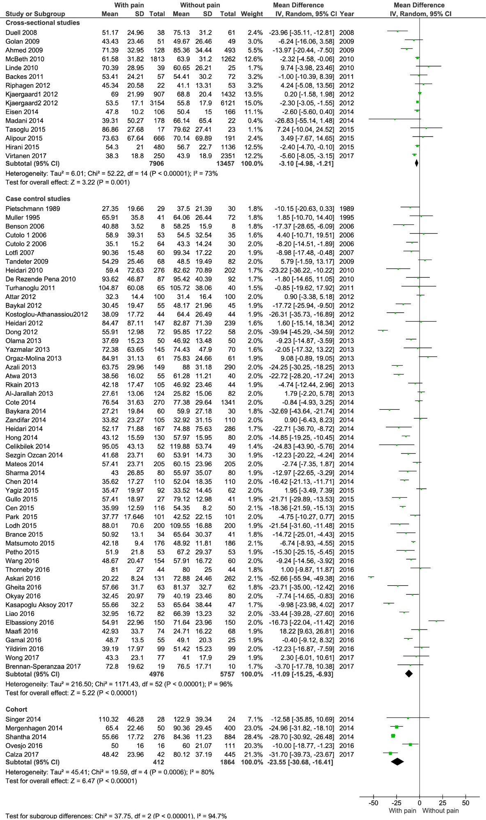

Supplemental Fig. 1: Association between 25(OH)D concentration and pain among different study designs
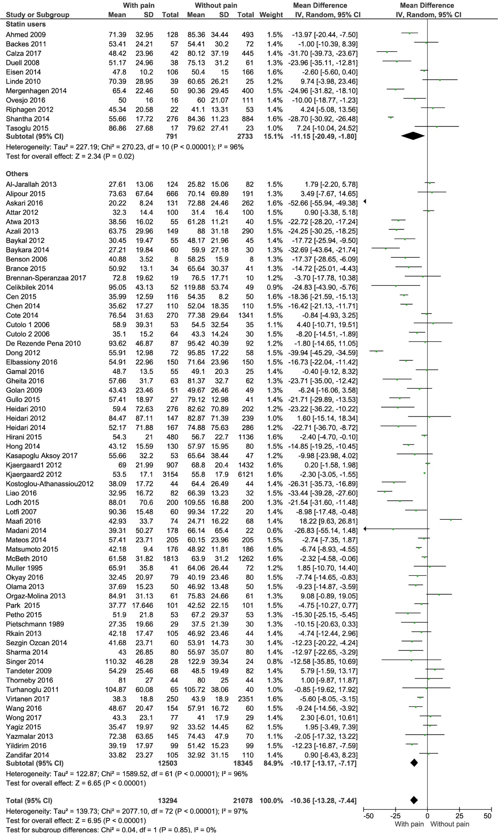
Supplemental Fig. 2: Association between 25(OH)D concentration and pain between statin user and non-statin user
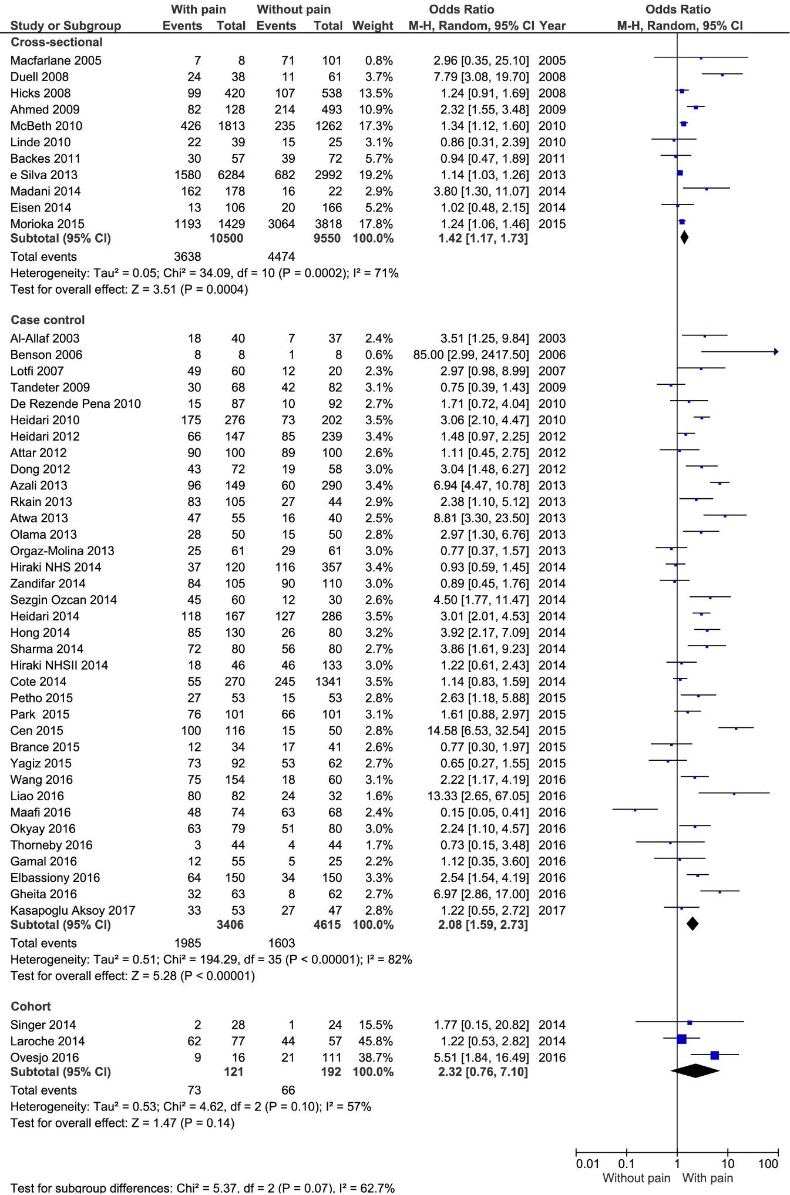
Supplemental Fig. 3: Association between vitamin D deficiency and pain among different study designs
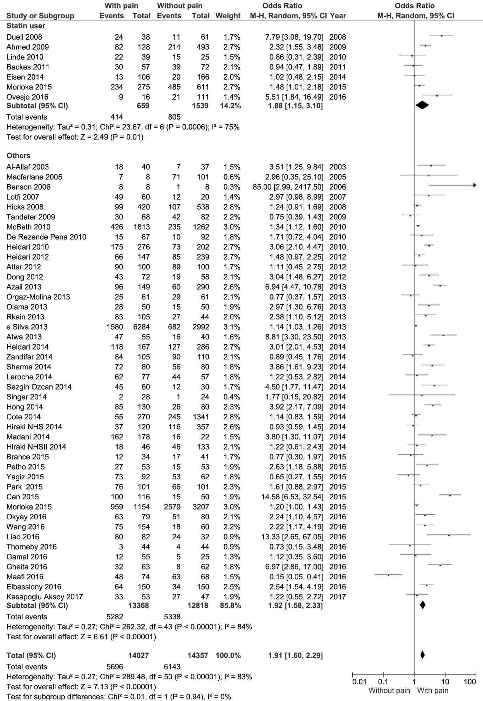
Supplemental Fig. 4: Association between vitamin D deficiency and pain between statin user and non-statin user
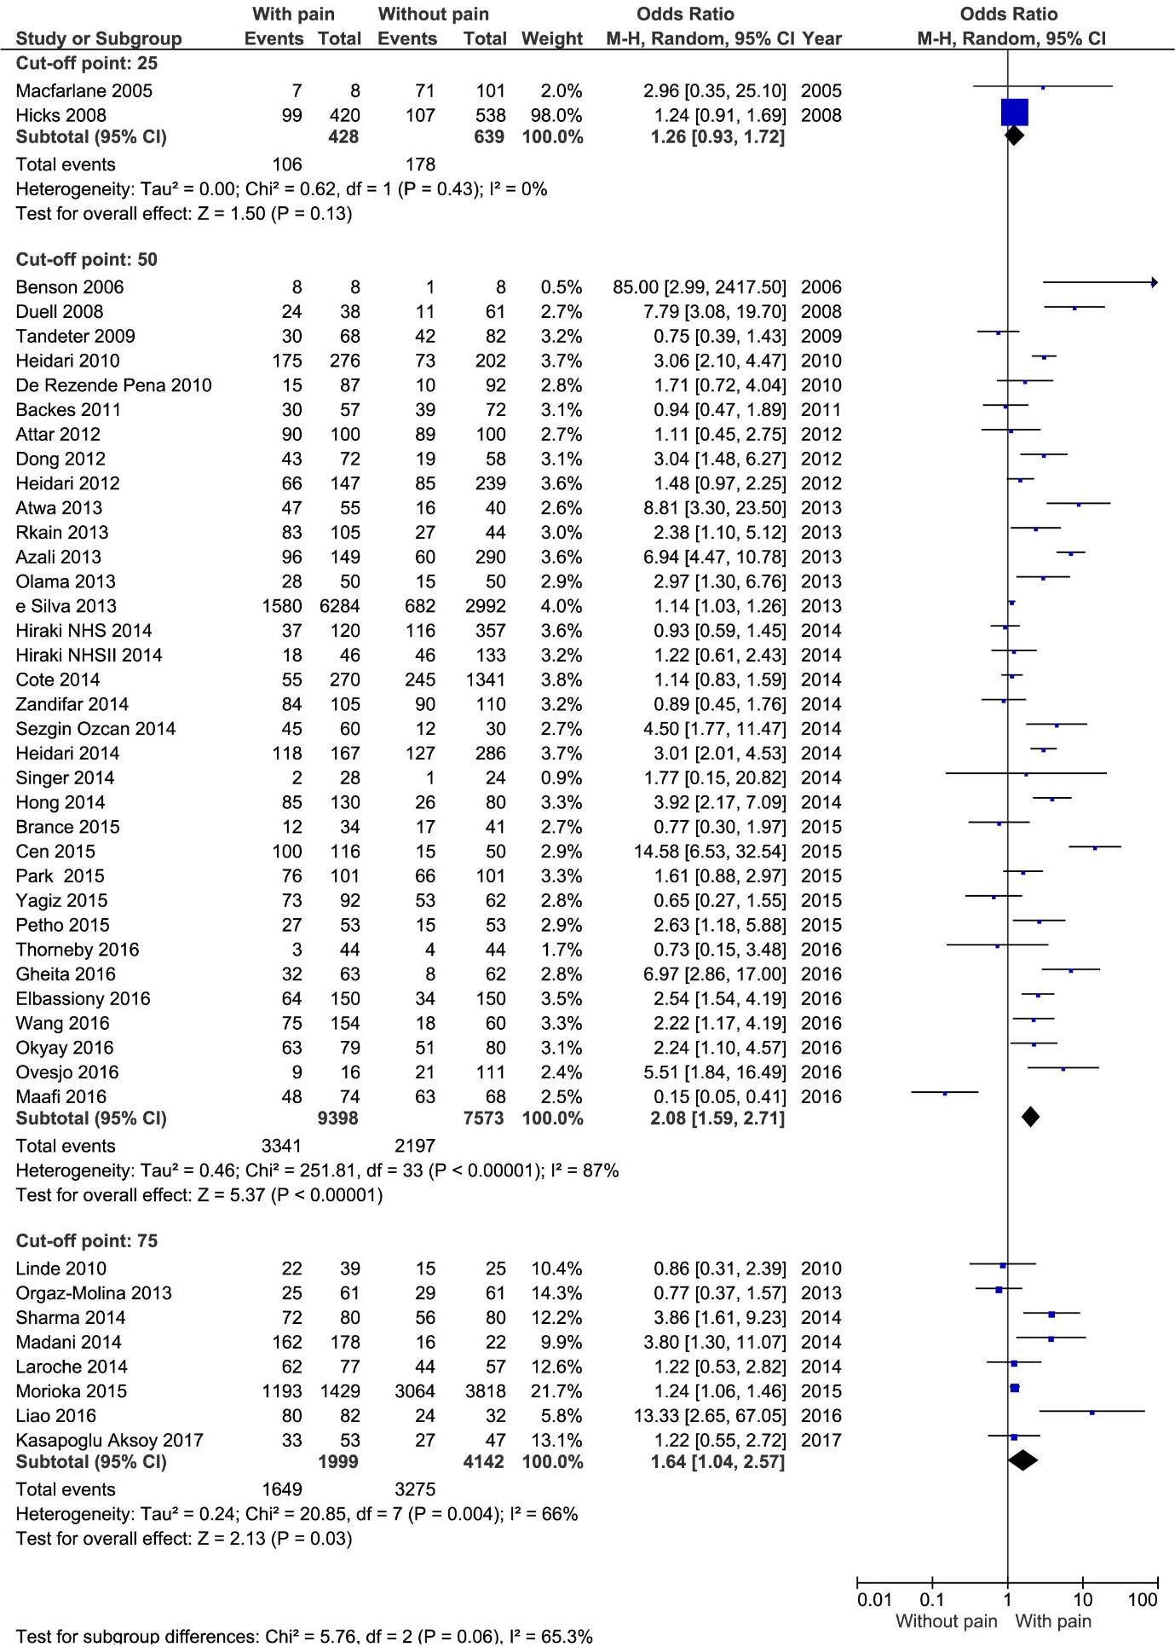
Supplemental Fig. 5: Association between vitamin D deficiency and pain between different cut-off points of vitamin D
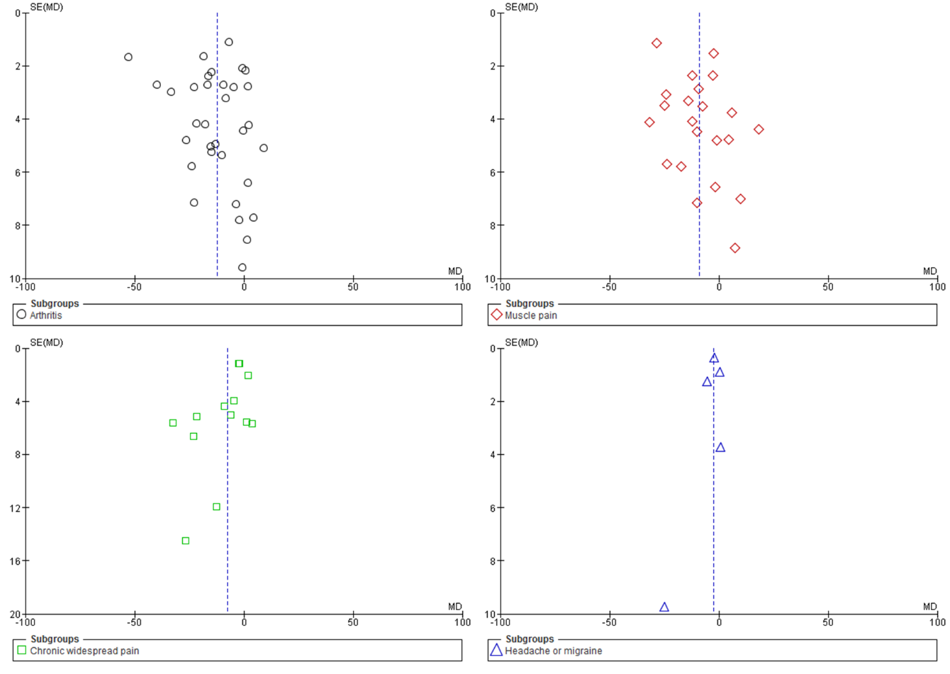
Supplemental Fig. 6: Funnel plot for the primary aim: the difference in mean circulating 25(OH)D concentration (nmol/l) between participants with and without pain-related conditions.

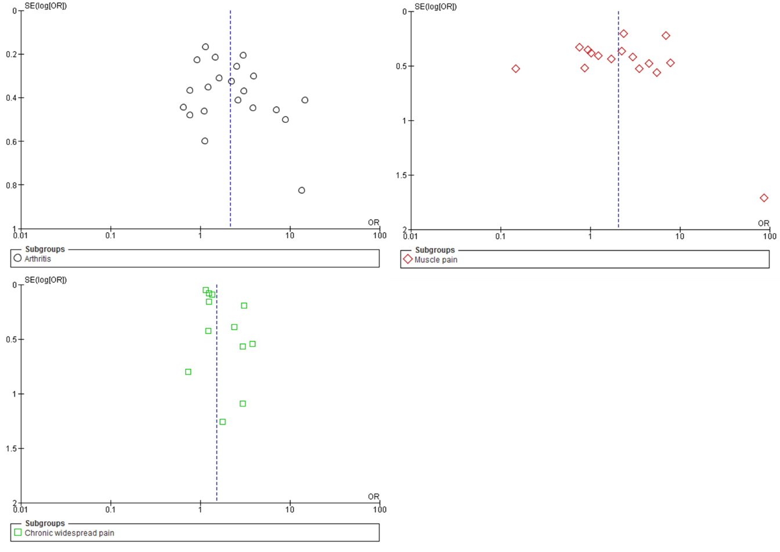
Supplemental Fig. 7: Funnel plot for the secondary aim: the difference in proportions of hypovitaminosis D in the participants with and without pain-related conditions.

