**Examples of ad creatives for the five most advertised products viewed on child preferred websites**

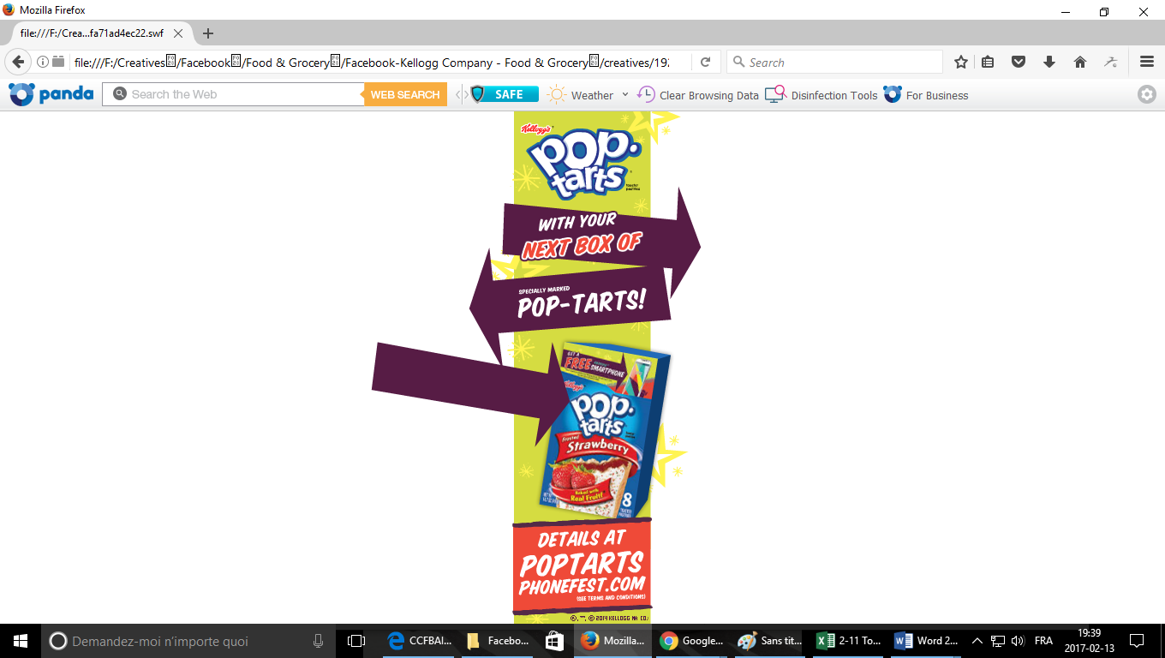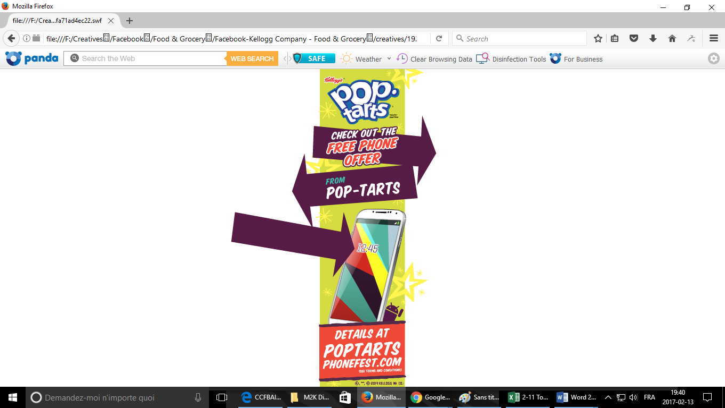

**Figure 1** Kellogg’s Pop Tarts Ad Creative, 2 still images of the same ad, viewed on Roblox.com among other websites

**Source:** comScore

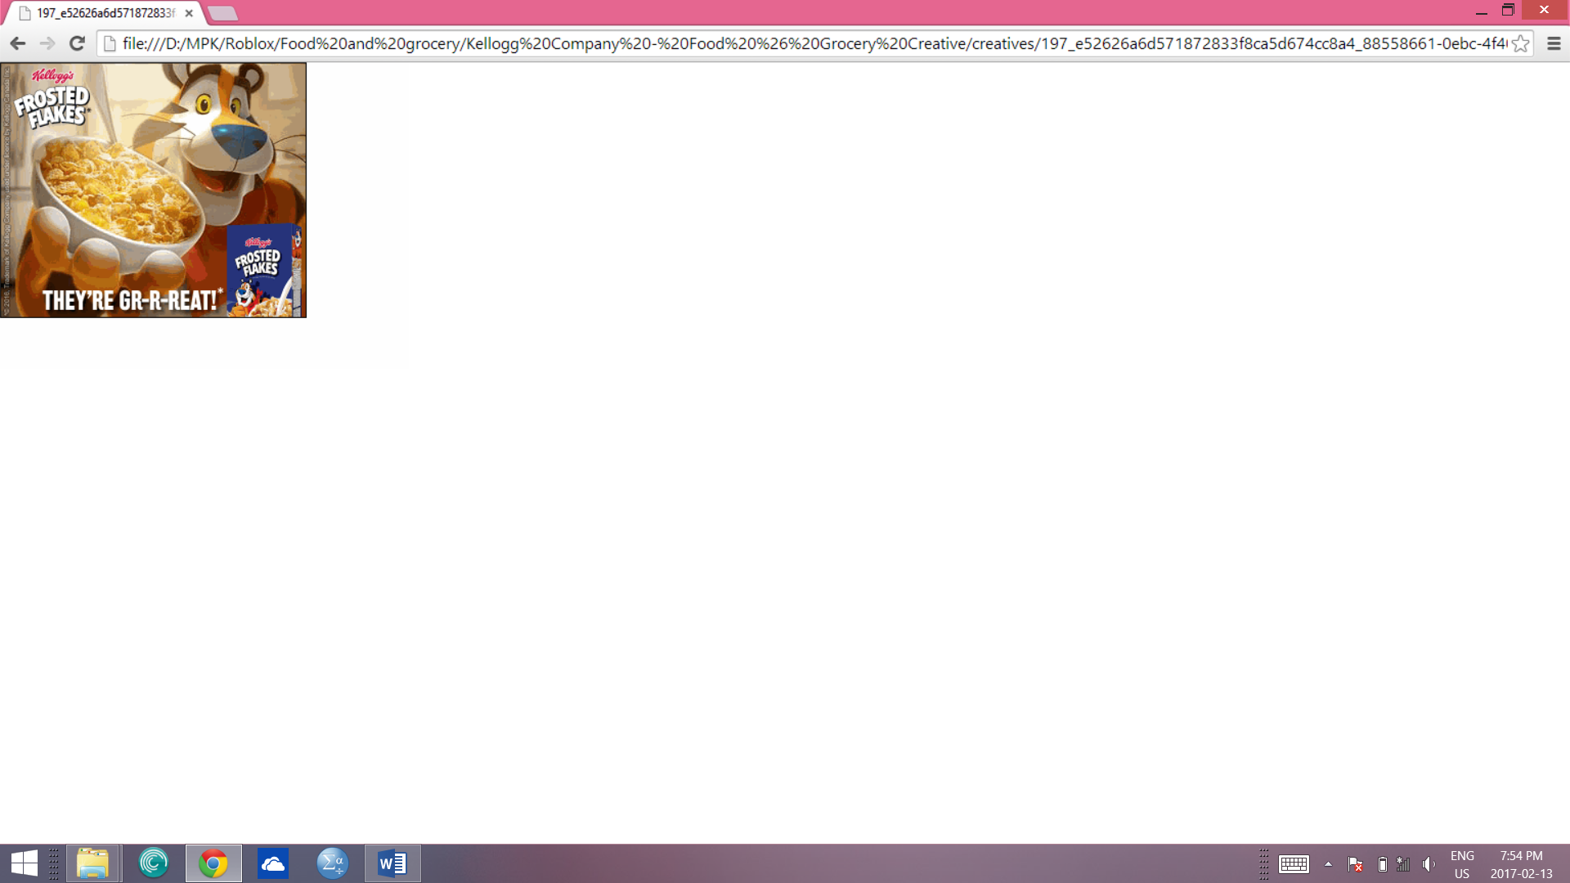

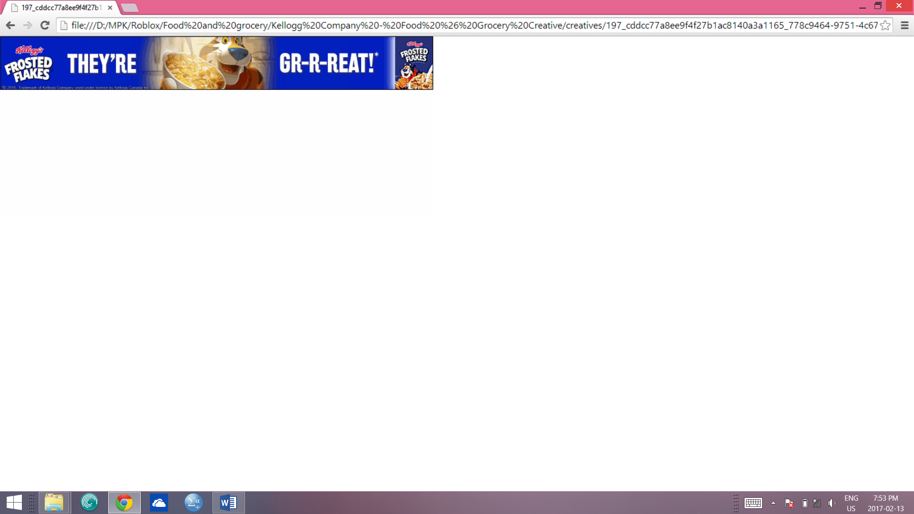

**Figure 2** Kellogg’s Frosted Flakes Ad Creatives(examples)viewed Roblox.com among other websites

**Source:** comScore

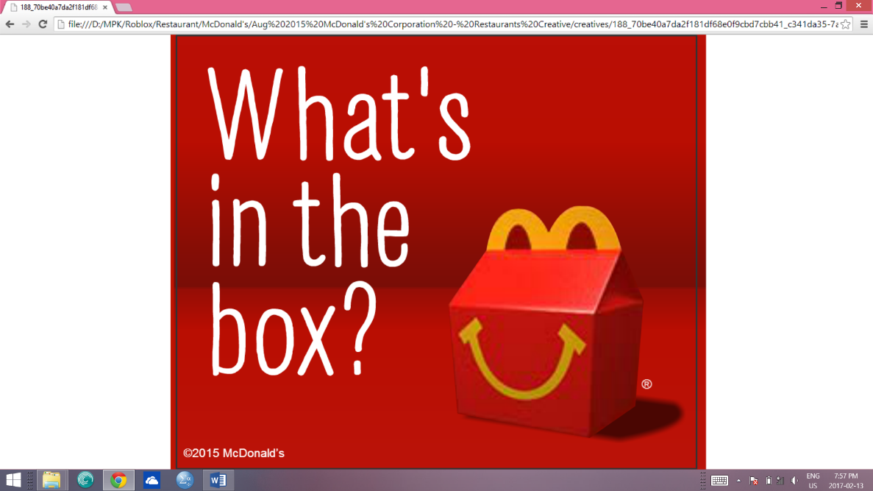

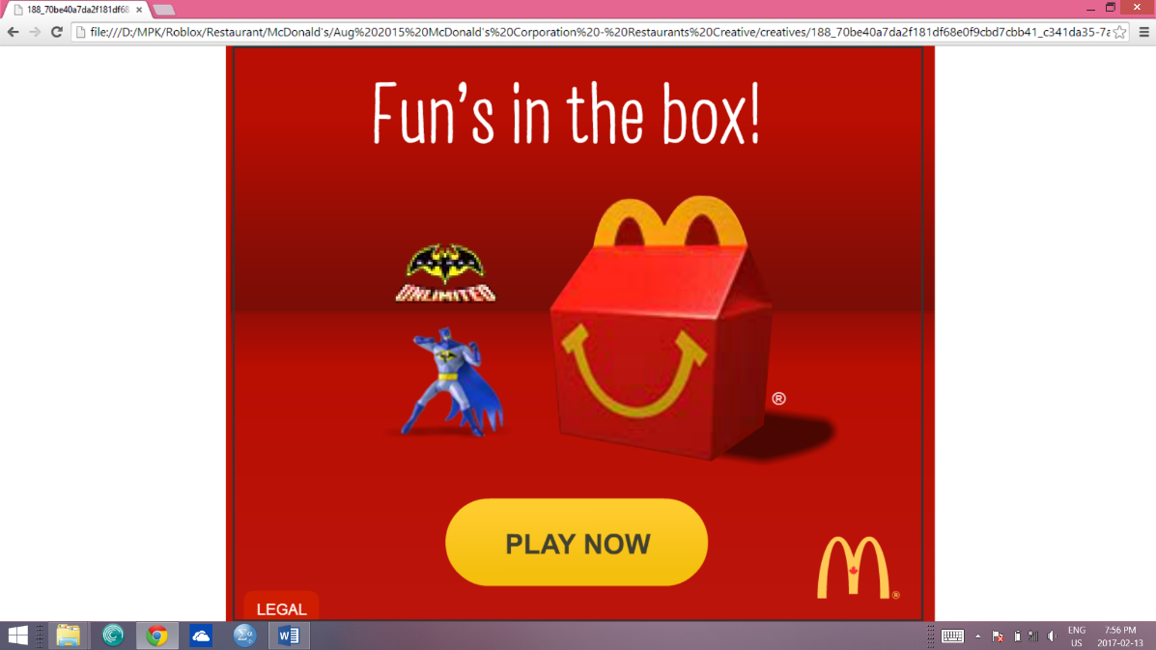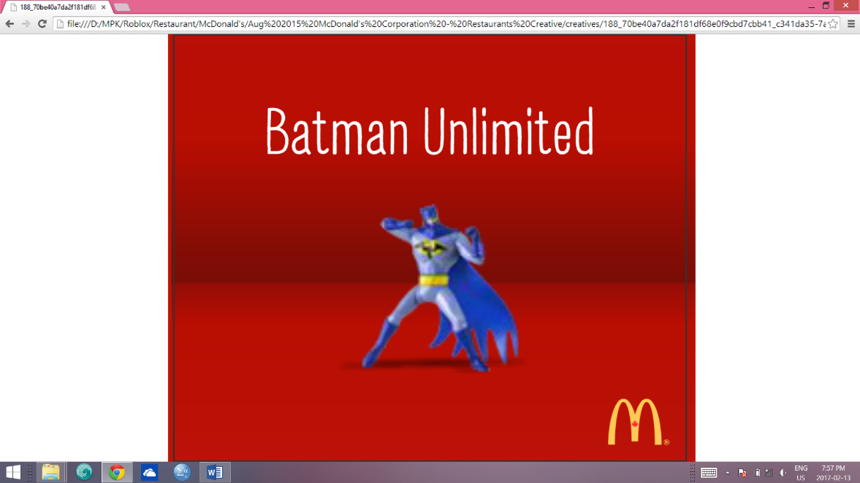

**Figure 3** McDonald’s Happy Meal Ad Creative (example),3 still images from the same ad, viewed Roblox.com among other websites

**Source:** comScore

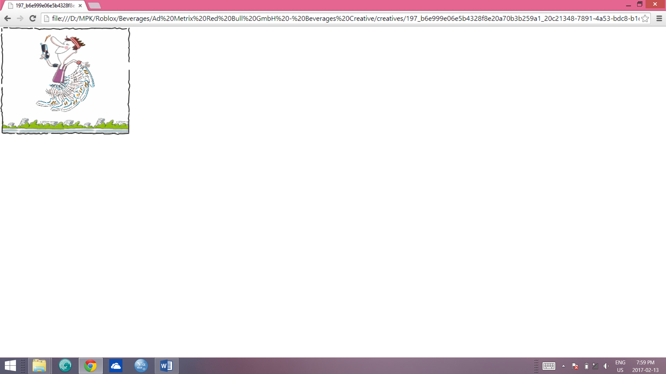

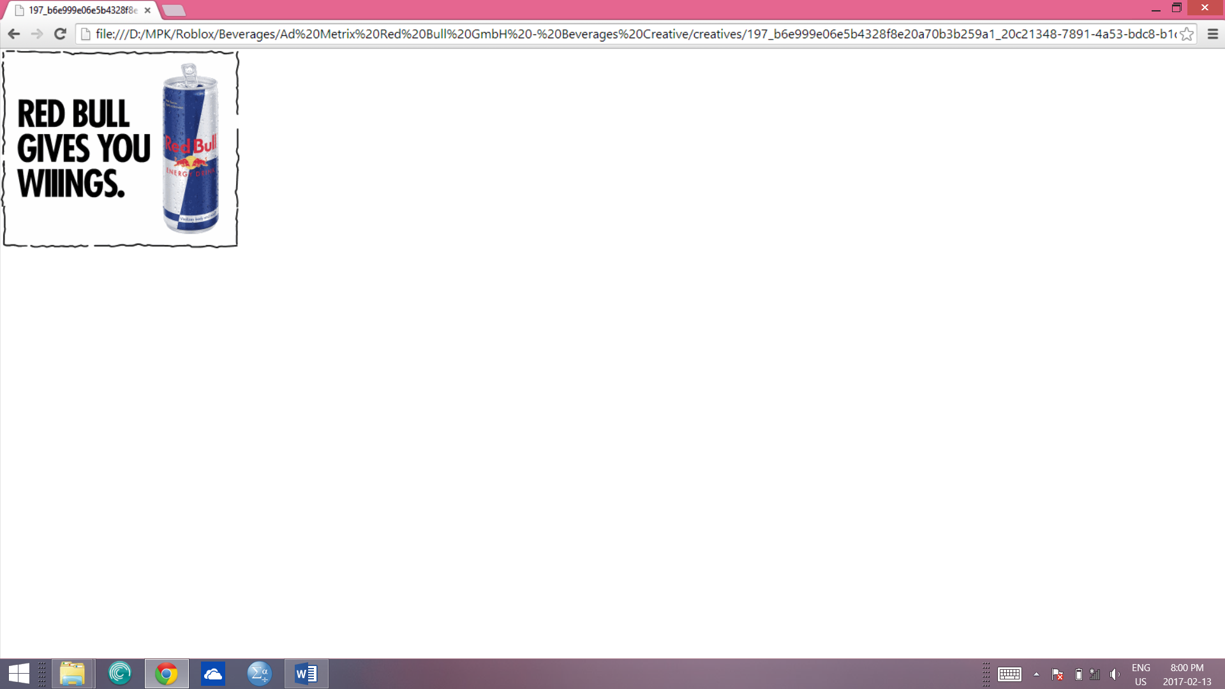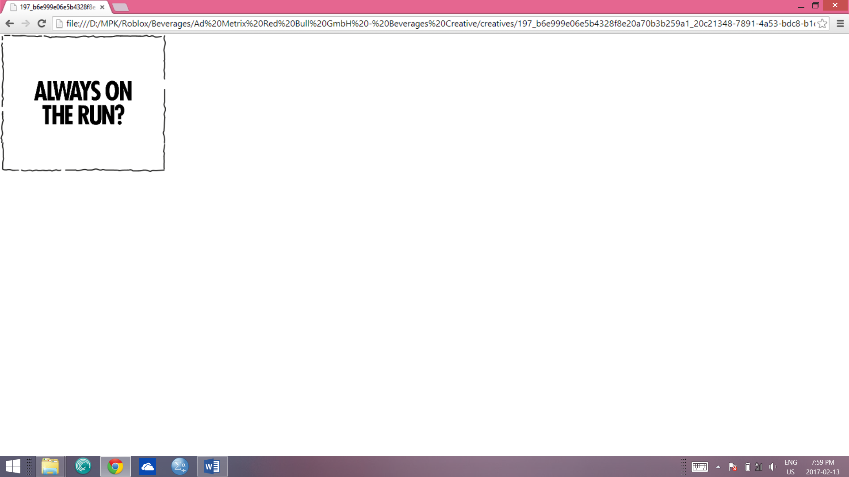

**Figure 4** Red Bull Energy Drink Ad Creative (example),3 still images from the same animated ad, viewed on Roblox.com

**Source:** comScore

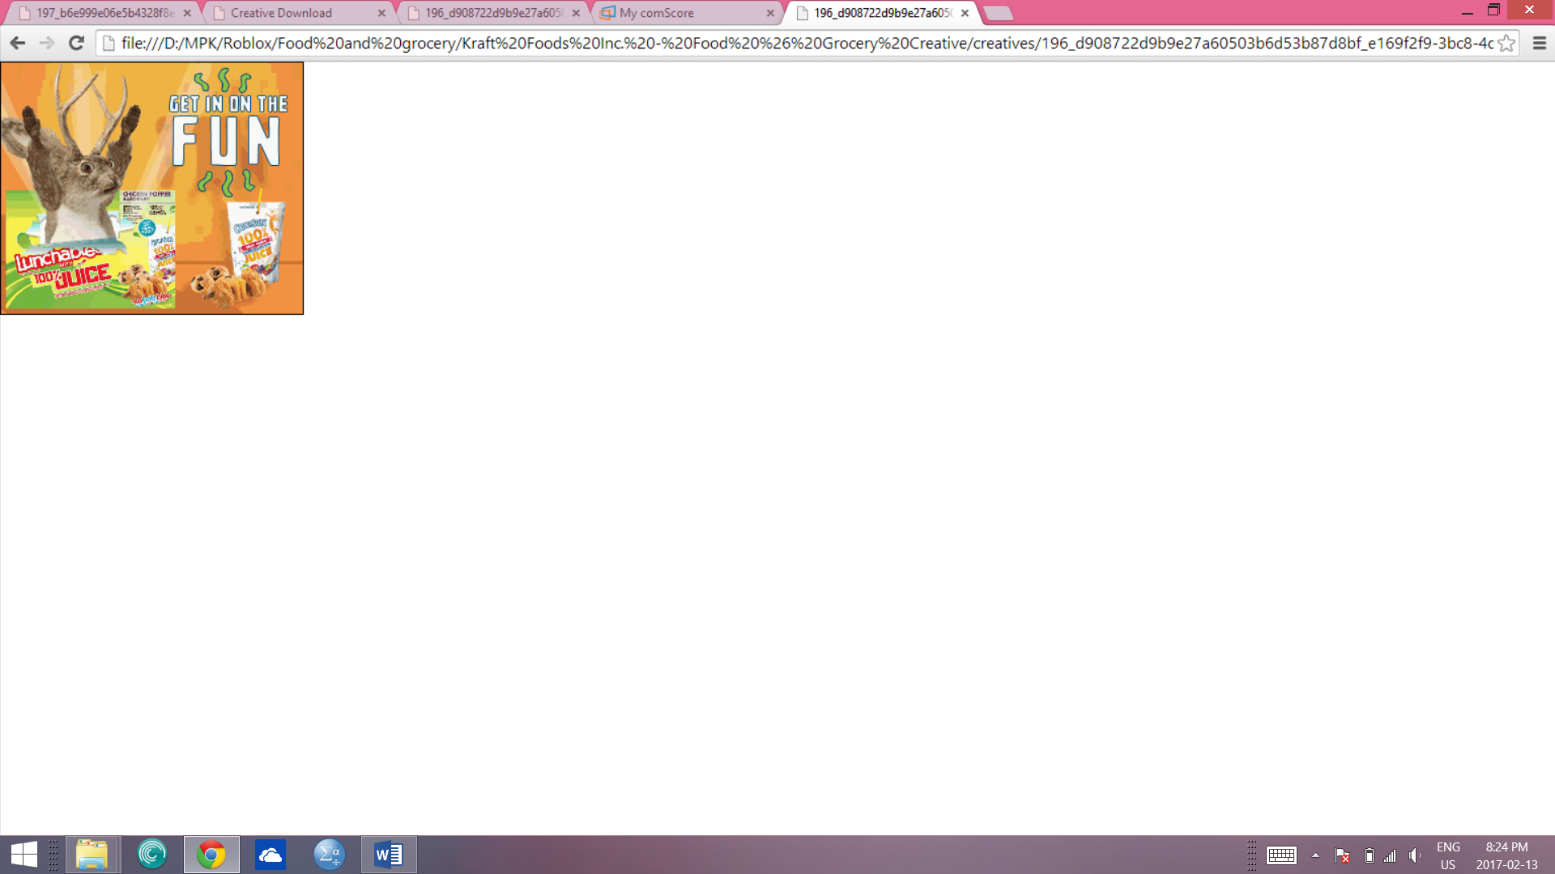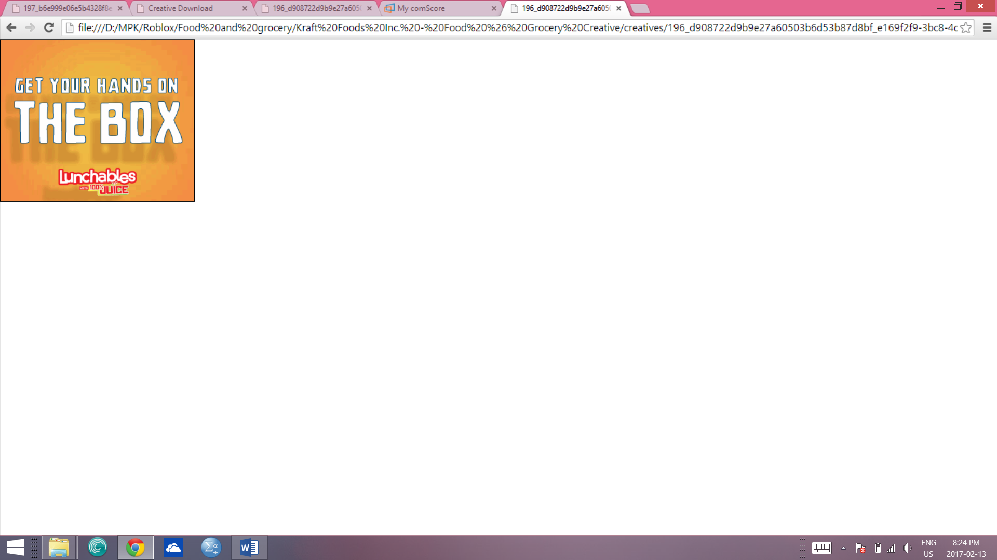

**Figure 5** Lunchables with 100% juice Ad Creative, 2 still images from the same ad, viewed on Roblox.com

**Source:** comScore

**Examples of Canadian company advertisements**

**Frosted Flakes (Kellogg’s)**



**Source:** Roblox.com, comScore, Ad creative, April 2016, 461,000 ad impressions, “Kellogg Canada Inc.” can be seen in the advertisement

**Froot Loops (Kellogg’s)**

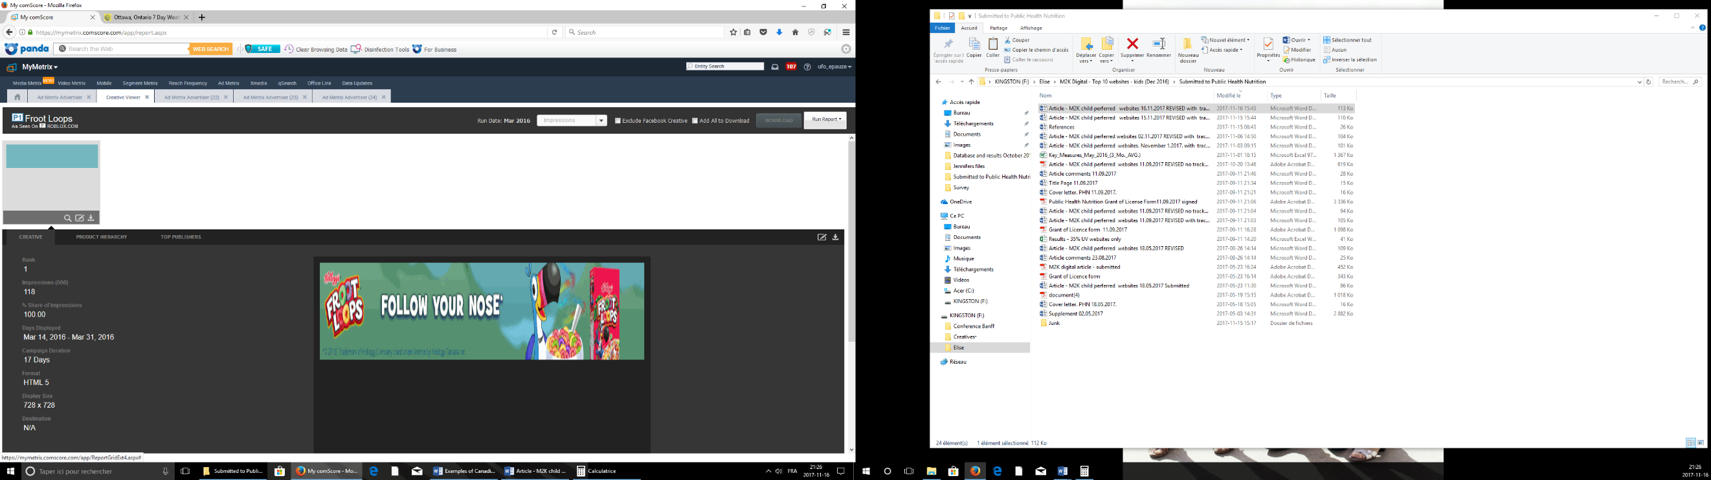

**Source:** Roblox.com, comScore, Ad creative, March 2016, 118,000 ad impressions, “Kellogg Canada Inc.” can be seen in the advertisement

**Tic Tac Mixers (Ferrero)**

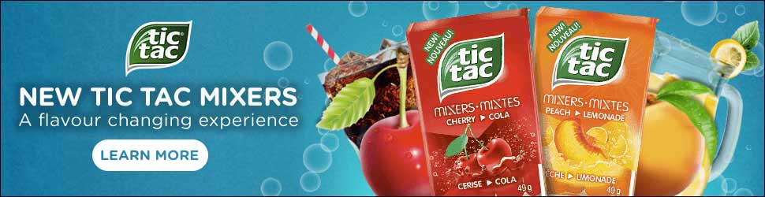**Example 1:**

**Source:** Roblox.com, ComScore, Ad Creative, April 2016, 67,000 ad impressions, bilingual (English and French) food packaging featured in the advertisement suggest that they are Canadian ads

**Example 2:**

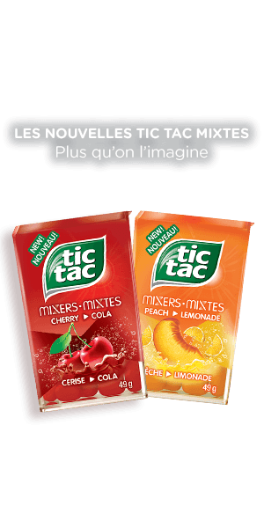

**Source:** Roblox.com, comScore, Ad creative, April 2016, French advertisement with bilingual (English and French) food packaging featured

**Uncle Ben Brand (Mars)**

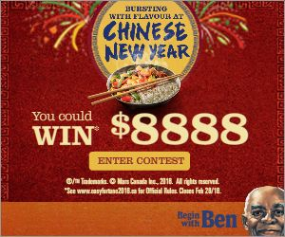

**Source:** Roblox.com, comScore’s, Ad Creative, January 2016, 31,000 ad impressions, Mars Canada specified in the ad

**Danette pudding (Danone)**

**Example 2**

**Example 1**

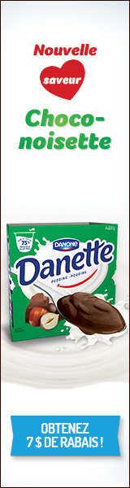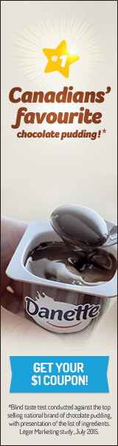

**Source (example 1):** coolmath-games.com, comScore, Ad Metrix Creative, Jan-March 2016, 15,000 ad impressions, reference to Canada

**Source (example 2):** roblox.com, comScore, Ad Creative, February 2016, 8,000 ad impressions, French advertisement

**Happy Meal (McDonald’s)**



**Source:** Roblox.com, comScore, Ad Creative, August 2015, 289,000 ad impressions, McDonald’s Restaurant Canada’s logo can be seen in the ad (maple leaf depicted in the golden arches)

**CBO Burger (McDonald’s)**

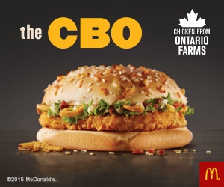

**Source:** Roblox.com, comScore, Ad Creative, September 2015, 186,000 ad impressions, Canadian maple leaf depicted (one of which is in the company logo) and reference to a Canadian province (Ontario)

**Big Mac (McDonald’s)**

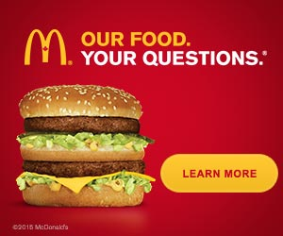

**Source:** Roblox.com, comScore, Ad Creative, September 2015, 21,000 ad impressions, Canadian maple leaf depicted in the company logo

**Smarties (Nestle)**

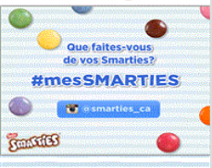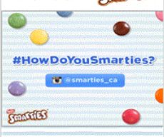

**Source:** Roblox.com, comScore, Ad Creative, June 2015, 45,000 ad impressions, reference to the Canadian Smarties twitter account (@smarties_ca)

**Black Diamond Cheese Spread (Parmalat)**

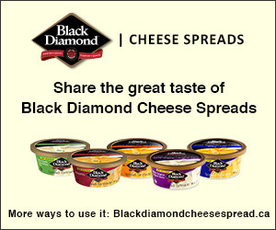

**Source:** Roblox.com, comScore, Ad Creative, June 2015, 68,000 ad impressions, reference to the Canadian Black Diamond cheese website