Supplemental Fig. 1

School lunch example 1
White rice, furikake (a seasoned powder for sprinkling over rice), mackerel cooked with miso (fermented soybean paste), vegetables dressed with sesame sauce, Noppei-jiru (vegetable soup), milk
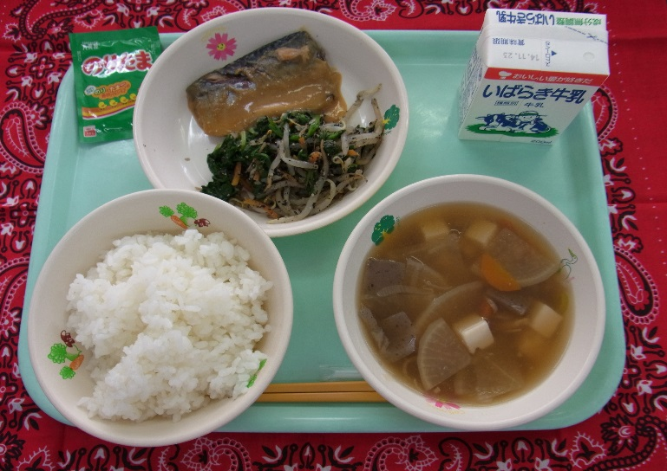

School lunch example 2
Deep-fried bread topped in sugar, meat balls with ketchup, boiled vegetables, soup with won ton dumplings, milk, pineapple
