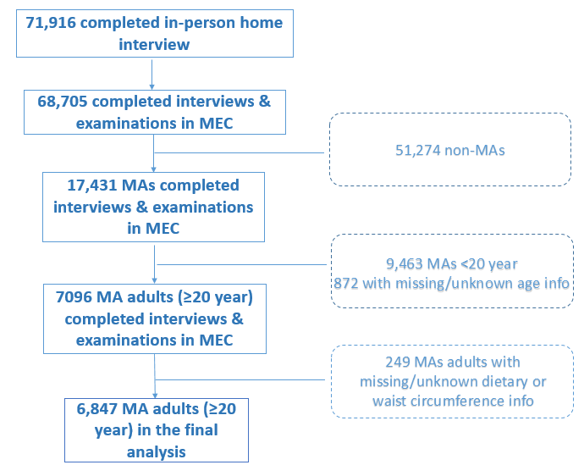

Supplemental Fig. 1: Sample Flow Chart

