Supplementary material

to

Effect of waist circumference on the association between serum 25(OH)D and serum lipids: results from NHANES 2001-2006

Supplemental Table 1 Association between serum 25(OH)D and serum lipids in the total sample and stratified by WC category
 | 25(OH)D category | N | Total cholesterol |  | LDL-C |  | HDL-C‡ |  | LDL-C/HDL-C ratio‡ |  | Triglycerides
 |  | 4342 | [mmol/l] |  | [mmol/l] |  | [mmol/l] |  |  |  | [mmol/l]
Total sample* |  |  | β | P | β | P | β | P | β | P | GMR§ | P
 | <15 ng/ml | 820 | -0.06 | 0.43 | -0.03 | 0.71 | -0.11 | < 0.0001 | 0.14 | 0.05 | 1.10 | 0.006
 | 15–<20 ng/ml | 808 | -0.10 | 0.07 | -0.07 | 0.18 | -0.10 | < 0.0001 | 0.11 | 0.05 | 1.08 | 0.014
 | 20–<30 ng/ml | 1799 | -0.03 | 0.52 | -0.02 | 0.65 | -0.06 | 0.0007 | 0.06 | 0.19 | 1.07 | 0.004
 | >30 ng/ml | 915 | Ref. |  | Ref. |  | Ref. |  | Ref. |  | Ref.
WC category |  |  | β | P | β | P | β | P | β | P | GMR§ | P
Normal†  < 80 cm (f)  < 94 cm (m) | <15 ng/ml | 174 | -0.21 | 0.08 | -0.23 | 0.01 | -0.01 | 0.86 | -0.14 | 0.20 | 1.02 | 0.75
 | 15–<20 ng/ml | 175 | -0.16 | 0.08 | -0.19 | 0.04 | -0.04 | 0.28 | -0.10 | 0.37 | 1.07 | 0.24
 | 20–<30 ng/ml | 507 | -0.04 | 0.58 | -0.08 | 0.16 | -0.02 | 0.54 | -0.07 | 0.20 | 1.08 | 0.04
 | >30 ng/ml | 325 | Ref. |  | Ref. |  | Ref. |  | Ref. |  | Ref.
Abdominally overweight†  80-<88 cm (f)  94-<102 cm (m) | <15 ng/ml | 135 | -0.10 | 0.44 | -0.12 | 0.32 | -0.05 | 0.27 | -0.04 | 0.76 | 1.09 | 0.20
 | 15–<20 ng/ml | 155 | -0.30 | 0.004 | -0.24 | 0.03 | -0.05 | 0.33 | 0.01 | 0.93 | 0.97 | 0.48
 | 20–<30 ng/ml | 385 | -0.07 | 0.45 | -0.04 | 0.69 | -0.06 | 0.13 | 0.05 | 0.64 | 1.04 | 0.56
 | >30 ng/ml | 194 | Ref. |  | Ref. |  | Ref. |  | Ref. |  | Ref.
Abdominally  obese†  ≥ 88 cm (f)  ≥ 102 cm (m) | <15 ng/ml | 511 | 0.009 | 0.94 | 0.08 | 0.49 | -0.17 | < 0.0001 | 0.32 | 0.001 | 1.14 | 0.004
 | 15–<20 ng/ml | 478 | -0.03 | 0.72 | 0.03 | 0.69 | -0.14 | < 0.0001 | 0.25 | 0.001 | 1.11 | 0.02
 | 20–<30 ng/ml | 907 | -0.03 | 0.65 | 0.01 | 0.90 | -0.10 | 0.0002 | 0.14 | 0.03 | 1.08 | 0.04
 | >30 ng/ml | 396 | Ref. |  | Ref. |  | Ref. |  | Ref. |  | Ref.
25(OH)D, 25-hydroxyvitamin D. LDL-C, LDL cholesterol. HDL-C, HDL cholesterol. WC, waist circumference. (f), females. (m), males. GMR, geometric mean ratio.
Significant results are printed in bold
All models adjusted for age, sex, ethnicity, season of examination, physical activity, alcohol consumption, smoking status, level of education, kidney disease and intake of cholesterol lowering medication
* adjusted for WC category
† stratified by WC category
‡ models additionally adjusted for survey cycle
§ Change in the ratio of the expected geometric means of the untransformed triglycerides. GMR = 1.09: compared to participants with serum 25(OH)D levels >30 ng/ml, the mean serum triglyceride level in participants with serum 25(OH)D levels <15 ng/ml is 9% higher.

Supplemental Table 2 Association between serum 25(OH)D and serum lipids in the total sample and stratified by WC category - further adjusted for HOMA-IR
 | 25(OH)D category | N | Total cholesterol§ |  | LDL-C§ |  | HDL-C‡ |  | LDL-C/HDL-C ratio‡ |  | Triglycerides
 |  | 4342 | [mmol/l] |  | [mmol/l] |  | [mmol/l] |  |  |  | [mmol/l]
Total sample* |  |  | β | P | β | P | β | P | β | P | GMR|| | P
 | <15 ng/ml | 820 | -0.04 | 0.62 | 0.002 | 0.97 | -0.09 | 0.0006 | 0.13 | 0.08 | 1.06 | 0.09
 | 15–<20 ng/ml | 808 | -0.09 | 0.10 | -0.05 | 0.30 | -0.09 | 0.0002 | 0.11 | 0.07 | 1.06 | 0.05
 | 20–<30 ng/ml | 1799 | -0.03 | 0.58 | -0.01 | 0.76 | -0.06 | 0.001 | 0.06 | 0.21 | 1.06 | 0.01
 | >30 ng/ml | 915 | Ref. |  | Ref. |  | Ref. |  | Ref. |  | Ref.
WC category |  |  | β | P | β | P | β | P | β | P | GMR|| | P
Normal†  < 80 cm (f)  < 94 cm (m) | <15 ng/ml | 174 | -0.21 | 0.08 | -0.23 | 0.01 | 0.002 | 0.96 | -0.17 | 0.13 | 1.00 | 0.97
 | 15–<20 ng/ml | 175 | -0.17 | 0.06 | -0.19 | 0.03 | -0.03 | 0.43 | -0.12 | 0.27 | 1.04 | 0.44
 | 20–<30 ng/ml | 507 | -0.04 | 0.54 | -0.08 | 0.15 | -0.01 | 0.73 | -0.08 | 0.13 | 1.06 | 0.09
 | >30 ng/ml | 325 | Ref. |  | Ref. |  | Ref. |  | Ref. |  | Ref.
Overweight†  80-<88 cm (f)  94-<102 cm (m) | <15 ng/ml | 135 | -0.13 | 0.31 | -0.13 | 0.29 | -0.04 | 0.39 | -0.06 | 0.67 | 1.06 | 0.44
 | 15–<20 ng/ml | 155 | -0.32 | 0.003 | -0.24 | 0.03 | -0.04 | 0.47 | -0.01 | 0.93 | 0.93 | 0.19
 | 20–<30 ng/ml | 385 | -0.09 | 0.36 | -0.04 | 0.69 | -0.05 | 0.21 | 0.04 | 0.75 | 1.00 | 0.94
 | >30 ng/ml | 194 | Ref. |  | Ref. |  | Ref. |  | Ref. |  | Ref.
Obese†  ≥ 88 cm (f)  ≥ 102 cm (m) | <15 ng/ml | 511 | 0.06 | 0.62 | 0.14 | 0.26 | -0.15 | < 0.0001 | 0.32 | 0.001 | 1.10 | 0.06
 | 15–<20 ng/ml | 478 | -0.001 | 0.99 | 0.06 | 0.42 | -0.13 | < 0.0001 | 0.25 | 0.001 | 1.09 | 0.06
 | 20–<30 ng/ml | 907 | -0.02 | 0.78 | 0.02 | 0.75 | -0.09 | 0.0004 | 0.14 | 0.03 | 1.08 | 0.05
 | >30 ng/ml | 396 | Ref. |  | Ref. |  | Ref. |  | Ref. |  | Ref.
HOMA-IR, homeostatic model assessment insulin resistance.25(OH)D, 25-hydroxyvitamin D. LDL-C, LDL cholesterol. HDL-C, HDL cholesterol. WC, waist circumference. (f), females. (m), males. GMR, geometric mean ratio.
Significant results are printed in bold
All models adjusted for age, sex, ethnicity, season of examination, physical activity, alcohol consumption, smoking status, level of education, kidney disease and intake of cholesterol lowering medication and HOMA-IR
* adjusted for WC category
† stratified by WC category
‡ models additionally adjusted for survey cycle
§ models additionally adjusted for HOMA-IR²
|| Change in the ratio of the expected geometric means of the untransformed triglycerides. GMR = 1.06: compared to participants with serum 25(OH)D levels >30 ng/ml, the mean serum triglyceride level in participants with serum 25(OH)D levels <15 ng/ml is 6 % higher.
Supplemental Fig. 1 Description of the study population

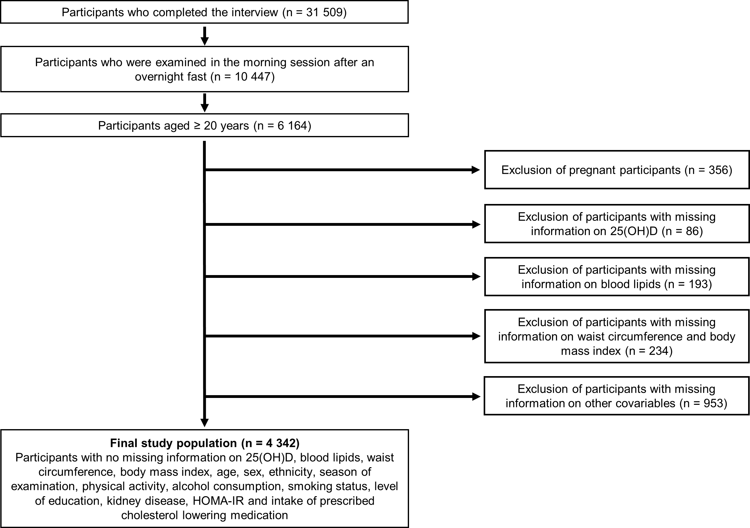

Supplemental Fig. 2 Adjusted β-coefficients and 95% confidence intervals for the 25(OH)D categories from the interaction models on total cholesterol, LDL-C, HDL-C and the LDL-C/HDL-C ratio, with BMI used to operationalize obesity*
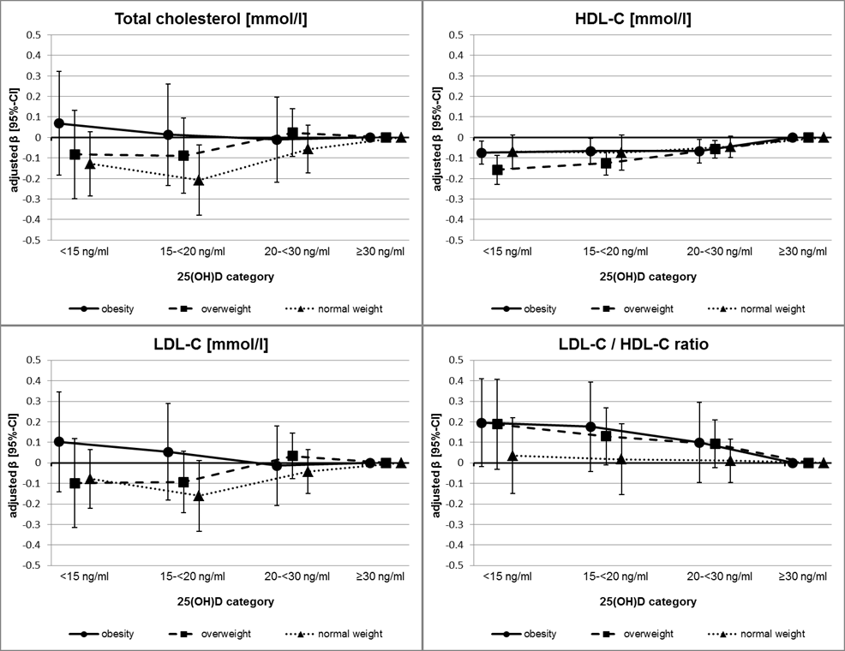
Reference category: 25(OH)D ≥30 ng/ml
25(OH)D, 25-hydroxyvitamin D. LDL-C, LDL cholesterol. HDL-C, HDL cholesterol.
* All models adjusted for age, sex, ethnicity, season of examination, physical activity, alcohol consumption, smoking status, level of education, kidney disease and intake of prescribed cholesterol lowering medication. HDL-C and LDL-C/HDL-C models additionally adjusted for survey cycle.

Supplemental Fig. 2 (continued) Adjusted geometric mean ratios and 95% confidence intervals for the 25(OH)D categories from the interaction model on triglycerides, with BMI used to operationalize obesity†
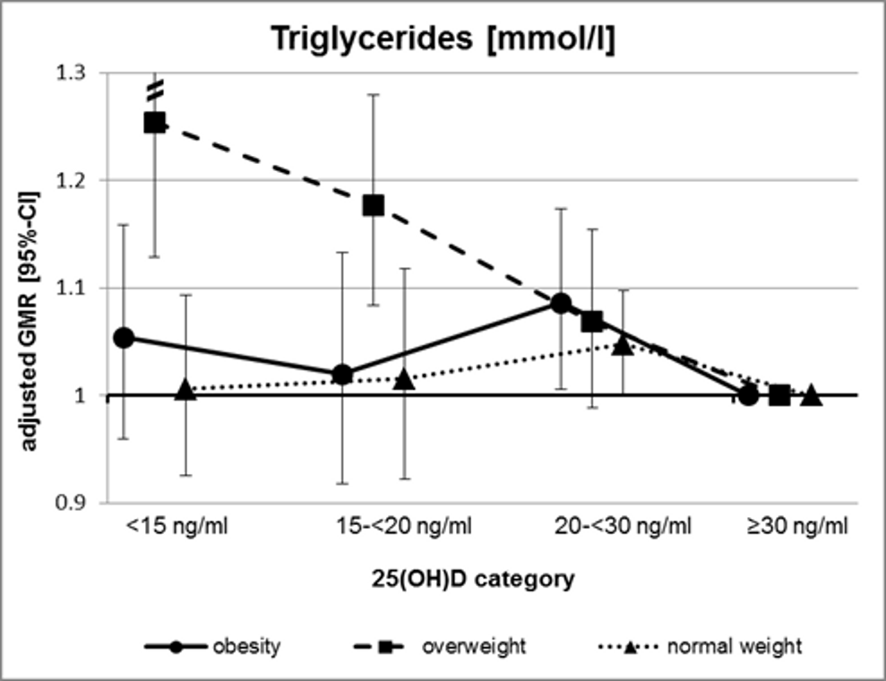
Reference category: 25(OH)D ≥30 ng/ml
25(OH)D, 25-hydroxyvitamin D.
† All models adjusted for age, sex, ethnicity, season of examination, physical activity, alcohol consumption, smoking status, level of education, kidney disease and intake of prescribed cholesterol lowering medication

