Supplemental Fig. 1. Food diary for elementary school aged children
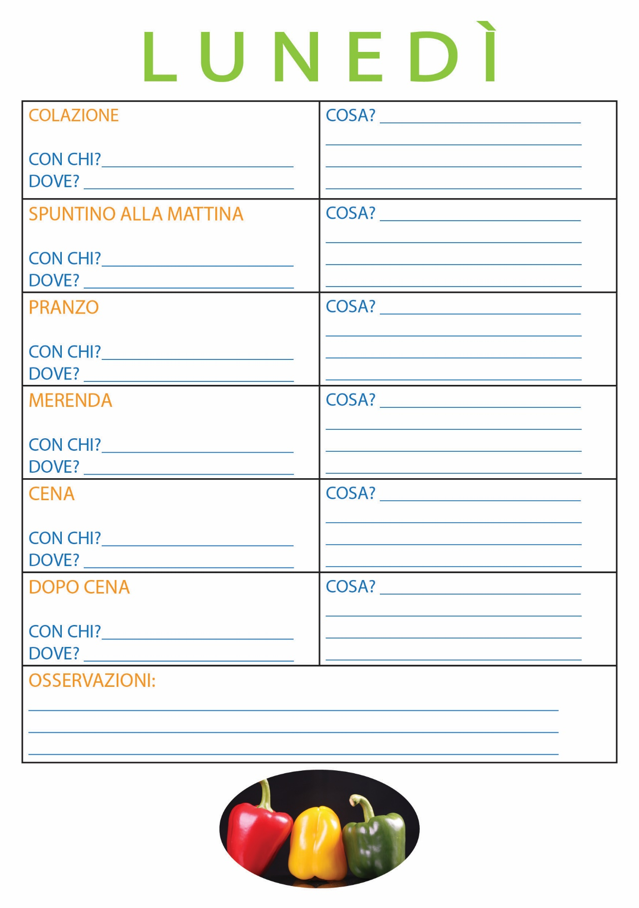
Note: The elementary school aged children had one page per each day. This is the page for Monday

