Appendix A
Here, we provide descriptive information about participants’ home, spoken, and written languages, the language(s) they were formally taught in during primary and secondary schooling, as well as their age milestone (e.g., age speaking, writing) and use of English among various interlocutors.
Overall, participants reported to have between 1 to 5 home languages (M = 1.83, SD = 1.07), reported to speak between 1 to 11 languages (M = 4.00, SD = 2.13), and could write in 1 to 7 languages (M = 2.91, SD = 1.23). The distribution across the whole sample and each L1 group is illustrated in Tables S1, S2, S3, and S4.

Table S1. Descriptive statistics of participants’ home, spoken, and written languages
Languages | L1-Zulu | L1-English | L1-Zulu | L1-English
 | Range |  | M (SD)
Home | 1-4 | 1-5 | 2.00 (1.16) | 1.68 (.99)
Spoken | 1-9 | 2-11 | 3.45 (1.87) | 4.48 (2.26)
Written | 1-6 | 1-7 | 2.68 (1.09) | 3.12 (1.33)

Table S2. Number (%) of home languages reported by participants
Number of home languages | All participants | L1-Zulu  (n = 22) | L1-English  (n = 25)
1 | 23 (48.9) | 10 (45.5) | 13 (52.0)
2 | 16 (34.0) | 6 (27.3) | 10 (40.0)
3 | 2 (4.3) | 2 (9.1) | 0 (0)
4 | 5 (10.6) | 4 (18.2) | 1 (4.0)
5 | 1 (2.1) | 0 (0) | 1 (4.0)

Table S3. Number (%) of spoken languages reported by participants
Number of spoken languages | All participants | L1-Zulu  (n = 22) | L1-English  (n = 25)
1 | 1 (2.1) | 1 (4.5) | 0 (0)
2 | 10 (21.3) | 7 (31.8) | 3 (12.0)
3 | 12 (25.5) | 5 (22.7) | 7 (28.0)
4 | 12 (25.5) | 6 (27.3) | 6 (24.0)
5 | 3 (6.4) | 0 (0) | 3 (12.0)
6 | 4 (8.5) | 1 (4.5) | 3 (12.0)
7 | 2 (4.3) | 1 (4.5) | 1 (4.0)
8 | 1 (2.1) | 0 (0) | 0 (0)
9 | 1 (2.1) | 1 (4.5) | 0 (0)
10 | 1 (2.1) | 0 (0) | 1 (4.0)
11 | 1 (2.1) | 0 (0) | 1 (4.0)

Table S4. Number (%) of written languages reported by participants
Number of written languages | All participants | L1-Zulu  (n = 22) | L1-English  (n = 25)
1 | 2 (4.3) | 1 (4.5) | 1 (4.0)
2 | 18 (38.3) | 11 (50.0) | 7 (28.0)
3 | 17 (36.2) | 6 (27.3) | 11 (44.0)
4 | 6 (12.8) | 3 (13.6) | 3 (12.0)
5 | 1 (2.1) | 0 (0) | 1 (4.0)
6 | 2 (4.3) | 1 (4.5) | 1 (4.0)
7 | 1 (2.1) | 0 (0) | 1 (4.0)

For a finer-grained analysis into participants’ home language background in relation to English, Figures S1 shows the distribution of participants according to English reported as a home language or not, and Figure S2 shows the distribution of participants who report English as their only first language, one of a number of home languages, or not a home language, per L1-group.

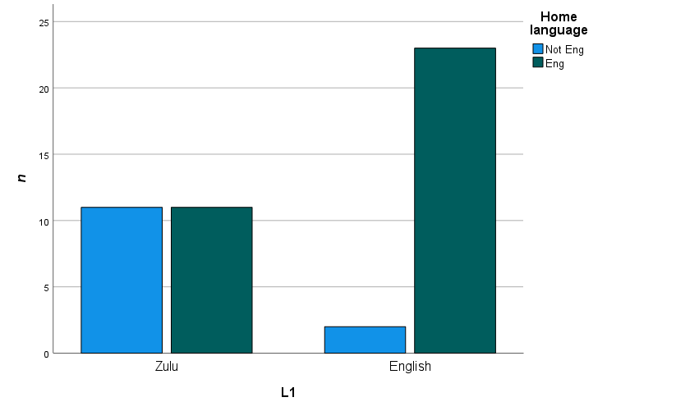
Figure S1. Distribution of L1-Zulu and L1-English participants who report English as a first language.

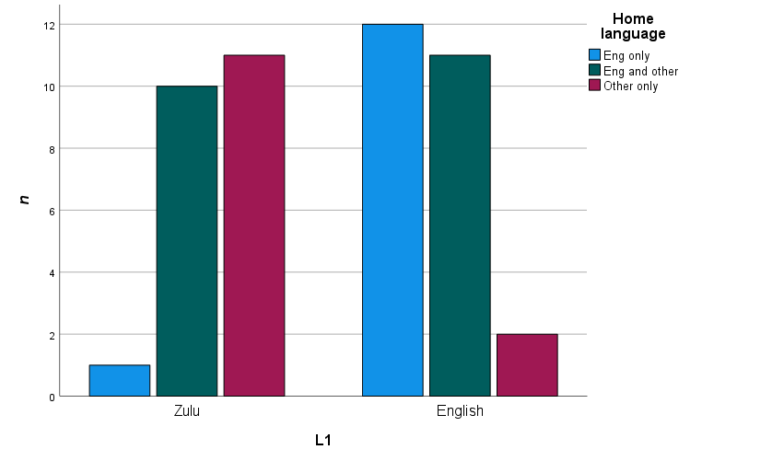
Figure S2. Distribution of L1-Zulu and L1-English participants who report English as their only first language, one of a number of home languages, or not a home language.

Table S5 and Table S6 outline the various languages reported by participants (L1-Zulu and L1-English, respectively) across a range of contexts (home, school) and modalities (spoken, written), and the number of participants who listed each of these languages in each category.

Table S5. Number of L1-Zulu participants who report using various languages across a range of modalities and context (n = 22)
Languages reported | Home | Speak | Write | Primary school MoI | Secondary school MoI
Afrikaans | - | 6 | 5 | - | -
English | 11 | 22 | 22 | 16 | 18
Chewa | 1 | 1 | 1 | - | -
French | 1 | 1 | 3 | 1 | 1
German | - | 1 | 1 | - | -
Ndebele (isiNdebele) | 1 | 2 | - | - | -
Northern Sotho (SePedi) | 2 | 3 | 1 | - | -
Portuguese | - | 2 | 1 | - | -
Southern Sotho (Sesotho sa Leboa) | 2 | 7 | 3 | - | -
Spanish | - | 1 | 1 | - | -
Swahili | - | 1 | - | - | -
Swati (siSwati) | 3 | 5 | 2 | - | -
Tsonga (Xitsonga) | 1 | 2 | 1 | - | -
Tswana (Setswana) | 1 | 6 | 1 | - | -
Xhosa (isiXhosa) | 2 | 5 | 1 | - | -
Zulu (isiZulu) | 20 | 21 | 17 | 5 | 3
Note. MoI = medium of instruction.

Table S6. Number of L1-English participants who report using various languages across a range of modalities and context (n = 25)
Languages reported | Home | Speak | Write | Primary school MoI | Secondary school MoI
Afrikaans | 4 | 14 | 14 | 1 | -
English | 23 | 25 | 25 | 24 | 25
Dioula | 1 | 1 | - | - | -
German | - | 1 | 1 | - | -
Hebrew | - | - | 1 | - | -
Hindi | - | 1 | - | - | -
Korean | - | 1 | 1 | - | -
Mandarin | 2 | 2 | 2 | - | -
Ndebele (isiNdebele) | 2 | 2 | 1 | - | -
Northern Sotho (SePedi) | 1 | 1 | 1 | - | -
Southern Sotho (Sesotho sa Leboa) | - | 2 | - | - | -
Portuguese | 1 | 1 | 1 | - | -
Shona | 1 | 1 | 1 | - | -
South African Sign language | - | 2 | 1 | - | -
Swati (siSwati) | 1 | 1 | 1 | - | -
Tswana (Setswana) | 1 | 1 | - | - | -
Zulu (isiZulu) | 5 | 11 | 8 | - | -
Note. MoI = medium of instruction

Table S7 present age milestones for each L1 group in terms of their Zulu and English acquisition, where this information was reported.

Table S7. Mean (SD) of age milestones per L1 group for English and Zulu
Age milestones (months) | L1-Zulu |  | L1-English
 | Zulu | English | English | Zulu
Age of acquisition | 11.10 (30.76) | 37.81(26.97) | 47.65 (29.69) | 73.83 (61.17)
Age beginning to read | 113.56 (51.87) | 66.95 (17.20) | 71.63 (13.16) | 134.08 (45.73)
Age beginning to write | 137.44 (47.81) | 72.50 (12.57) | 75.33 (14.37) | 137.25 (56.24)
Use at home | 23.20 (49.73) | 69.27 (58.37) | 63.92 (43.00) | 77.64 (69.40)
Use with friends | 44.20 (48.06) | 72.05 (44.22) | 72.08 (38.96) | 80.50 (67.89)
Use at school | 86.00 (39.35) | 64.36 (34.00) | 70.92 (25.57) | 103.42 (53.42)
Use at work (if applicable) | 214.50 (2.12) | 214.80 (22.61) | 219.13 (33.07) | -

Participants reported varying degrees of English use amongst interlocutors, where it was found that L1-English participants used more English than L1-Zulu participants across the range of speakers (Figure S3).

Figure S3. English language use amongst various interlocutors for L1-Zulu and L1-English participants (1 = Only other language(s), 2 = Mostly other language(s), 3 = Half English, half other language(s), 4 = Mostly English, 5 = All English). Independent samples t-tests indicate significant English use differences between the groups across all interlocutors (all ps < .01).

