S1. Word list

Emotionality information of emotion words are from Lin and Yao (2016). Emotionality information of emotion-laden words are from Chen et al. (2015). Cantonese and Mandarin pronunciations are transcribed in IPA, with 5-level tone transcription (1 = low, 5 = high).

Word | Gloss | Cantonese pronunciation | Mandarin Pronunciation | WordType | Valence | Emotion Category | Emotion Intensity
畜生 | ‘bastard’ | tsʰʊk̚55 saːŋ55 | ʈʂʰu51 ʂəŋ55 | Taboo | Negative | NA | NA
大便 | ‘feces’ | taːi22 piːn25 | ta51 pjɛn51 | Taboo | Negative | NA | NA
放屁 | ‘fart’ | fɔːŋ33 pʰei33 | faŋ51 pʰi51 | Taboo | Negative | NA | NA
狗屎 | ‘dog shit’ | kɐu25 siː25 | kou214 ʂɻ̩̩214 | Taboo | Negative | NA | NA
賤人 | ‘bitch’ | tsiːn22 jɐn21 | tɕjɛn51 ɻən25 | Taboo | Negative | NA | NA
強奸 | ‘rape’ | kʰœːŋ23 kaːn55 | tɕʰjaŋ25 tɕjɛn55 | Taboo | Negative | NA | NA
去死 | ‘go to die’ | hɵy33 sei25 | tɕʰy51 si214 | Taboo | Negative | NA | NA
死亡 | ‘death’ | sei25 mɔːŋ21 | si214 waŋ25 | Taboo | Negative | NA | NA
性交 | ‘intercourse’ | sɪŋ33 kaːu55 | ɕiŋ51 tɕjau55 | Taboo | Negative | NA | NA
雜種 | ‘bastard’ | tsaːp̚22 tsʊŋ25 | tsa25 ʈʂʊŋ214 | Taboo | Negative | NA | NA
憤恨 | ‘resentful’ | fɐn23 hɐn22 | fən51 həŋ51 | Emotion Word | Negative | Anger | High
憤怒 | ‘rage’ | fɐn23 nou22 | fən51 nu51 | Emotion Word | Negative | Anger | High
激憤 | ‘wrathful’ | kɪk̚55 fɐn23 | tɕi55 fən51 | Emotion Word | Negative | Anger | High
忿怒 | ‘angry’ | fɐn23 nou22 | fən51 nu51 | Emotion Word | Negative | Anger | Low
不平 | ‘unhappy about unjust treatment to oneself or others’ | pɐt̚55 pʰɪŋ21 | pu51 pʰiŋ25 | Emotion Word | Neutral | Anger | Low
驚惶 | ‘frightened’ | kɪŋ55 wɔːŋ21 | tɕiŋ55 hwaŋ214 | Emotion Word | Negative | Fear | High
恐慌 | ‘panic’ | hʊŋ25 fɔːŋ55 | kʰʊŋ214 hwaŋ55 | Emotion Word | Negative | Fear | High
恐懼 | ‘fear’ | hʊŋ25 kɵy22 | kʰʊŋ214 tɕy51 | Emotion Word | Negative | Fear | High
害怕 | ‘afraid’ | hɔːy22 pʰaː33 | hai51 pʰa51 | Emotion Word | Negative | Fear | Low
驚慌 | ‘terrified’ | kɪŋ55 fɔːŋ55 | tɕiŋ55 hwaŋ55 | Emotion Word | Negative | Fear | Low
心虛 | ‘feeling guilty’ | sɐm55 hɵy55 | ɕin55 ɕy55 | Emotion Word | Negative | Fear | Low
熱愛 | ‘love passionately’ | jiːt̚22 ɔːy33 | ɻɤ51 ai51 | Emotion Word | Positive | Happy | High
振奮 | ‘be inspired with enthusiasm’ | tsɐn55 fɐn23 | ʈʂən51 fən51 | Emotion Word | Positive | Happy | High
自豪 | ‘proud of oneself’ | tsiː22 hou21 | tsɹ̩51 hao25 | Emotion Word | Positive | Happy | High
寬心 | ‘relieved’ | fuːn55 sɐm55 | kʰwan55 ɕin55 | Emotion Word | Positive | Happy | Low
逍遙 | ‘leisurely’ | siːu55 jiːu21 | ɕjau55 jau25 | Emotion Word | Positive | Happy | Low
自在 | ‘comfortable with oneslef’ | tsiː22 tsɔːy22 | tsɹ̩51 tsai51 | Emotion Word | Positive | Happy | Low
悲愴 | ‘grief’ | pei55 tsʰɔːŋ33 | pei55 ʈʂʰwaŋ51 | Emotion Word | Negative | Sad | High
沉痛 | ‘grief’ | tsʰɐm21 tʰʊŋ33 | ʈʂʰən25 tʊŋ51 | Emotion Word | Negative | Sad | High
絕望 | ‘desperate’ | tsy:t̚22 mɔːŋ22 | tɕɥe25 waŋ51 | Emotion Word | Negative | Sad | High
後悔 | ‘regretful’ | hɐu22 fuːy33 | hou51 hwei214 | Emotion Word | Negative | Sad | Low
寂寞 | ‘lonely’ | tsɪk̚22 mɔːk̚22 | tɕi51 mwo51 | Emotion Word | Neutral | Sad | Low
可惜 | ‘pity’ | hɔː25 sɪk̚55 | kʰɤ214 ɕi55 | Emotion Word | Neutral | Sad | Low
驚詫 | ‘astonished’ | kɪŋ55 tsʰaː33 | tɕiŋ55 ʈʂʰa51 | Emotion Word | Neutral | Surprise | High
驚奇 | ‘surprised’ | kɪŋ55 kʰei21 | tɕiŋ55 tɕʰi25 | Emotion Word | Neutral | Surprise | High
震驚 | ‘shocked’ | tsɐn33 kɪŋ55 | ʈʂən51 tɕiŋ55 | Emotion Word | Neutral | Surprise | High
吃驚 | ‘surprised’ | hɛːk̚33 kɪŋ55 | ʈʂʰɻ̩̩̩55 tɕiŋ55 | Emotion Word | Neutral | Surprise | Low
驚訝 | ‘surprised’ | kɪŋ55 ŋaː22 | tɕiŋ55 ya51 | Emotion Word | Neutral | Surprise | Low
奇怪 | ‘strange’ | kʰei21 kʷaːi33 | tɕʰi25 kwai51 | Emotion Word | Neutral | Surprise | Low
悲劇 | ‘tragedy’ | pei55 kʰɛːk̚22 | pei55 tɕy51 | Emotion-laden Word | Negative | NA | NA
醜陋 | ‘ugly’ | tsʰɐu25 lɐu22 | ʈʂʰou214 lou51 | Emotion-laden Word | Negative | NA | NA
洪水 | ‘flood’ | hʊŋ21 sɵy25 | hʊŋ25 ʂwei214 | Emotion-laden Word | Negative | NA | NA
疾病 | ‘disease’ | tsɐt22 pɪŋ22 | tɕi25 piŋ51 | Emotion-laden Word | Negative | NA | NA
禁止 | ‘forbid’ | kɐm33 tsiː25 | tɕin51 ʈʂɻ̩̩214 | Emotion-laden Word | Negative | NA | NA
苦難 | ‘hardship’ | fu25 naːn22 | kʰu214 nan51 | Emotion-laden Word | Negative | NA | NA
濫用 | ‘abuse’ | laːm22 jʊŋ22 | lan51 jʊŋ51 | Emotion-laden Word | Negative | NA | NA
奴隸 | ‘slave’ | nou21 tɐi22 | nu25 li51 | Emotion-laden Word | Negative | NA | NA
貧窮 | ‘poverty’ | pʰɐn21 kʰʊŋ21 | pʰin25 tɕʰjʊŋ25 | Emotion-laden Word | Negative | NA | NA
囚犯 | ‘prisoner’ | tsʰɐu21 faːn25 | tɕʰiu25 fan51 | Emotion-laden Word | Negative | NA | NA
弱點 | ‘weakness’ | jœːk̚̚22 tiːm25 | ɻwo51 tjɛn214 | Emotion-laden Word | Negative | NA | NA
損害 | ‘harm’ | syːn25 hɔːy22 | swən214 hai51 | Emotion-laden Word | Negative | NA | NA
陰暗 | ‘dark and dim’ | jɐm55 ɐm33 | in55 an51 | Emotion-laden Word | Negative | NA | NA
有害 | ‘harmful’ | jɐu23 hɔːy22 | jou214 hai51 | Emotion-laden Word | Negative | NA | NA
災難 | ‘disaster’ | tsɔːy55 naːn22 | tsai55 nan51 | Emotion-laden Word | Negative | NA | NA
純潔 | ‘pure, innocent’ | sɵn21 kiːt̚33 | ʈʂʰwən25 tɕjɛ25 | Emotion-laden Word | Positive | NA | NA
繁榮 | ‘prosperous’ | faːn21 wɪŋ21 | fan25 ɻʊŋ25 | Emotion-laden Word | Positive | NA | NA
假日 | ‘holiday’ | kaː33 jɐt̚22 | tɕia51 ɻ51 | Emotion-laden Word | Positive | NA | NA
獎賞 | ‘reward’ | tsœːŋ25 sœːŋ25 | tɕjaŋ214 ʂaŋ214 | Emotion-laden Word | Positive | NA | NA
明亮 | ‘bright’ | mɪŋ21 lœːŋ22 | miŋ25 ljaŋ51 | Emotion-laden Word | Positive | NA | NA
舒適 | ‘comfortable’ | syː55 sɪk̚55 | ʂu55 ʂɻ̩̩51 | Emotion-laden Word | Positive | NA | NA
甜蜜 | ‘sweet’ | tʰiːm21 mɐt̚22 | tʰjɛn25 mi51 | Emotion-laden Word | Positive | NA | NA
微笑 | ‘smile’ | mei21 siːu33 | wei55 ɕjau51 | Emotion-laden Word | Positive | NA | NA
先進 | ‘advanced’ | siːn55 tsɵn33 | ɕjɛn55 tɕin51 | Emotion-laden Word | Positive | NA | NA
幽默 | ‘humor’ | jɐu55 mɐk̚22 | jou55 mwo51 | Emotion-laden Word | Positive | NA | NA
淵博 | ‘knowledgeable’ | jyːn55 pɔːk̚33 | ɥɛn55 pwo25 | Emotion-laden Word | Positive | NA | NA
真誠 | ‘sincere’ | tsɐn55 sɪŋ21 | ʈʂən55 ʈʂʰəŋ25 | Emotion-laden Word | Positive | NA | NA
珍貴 | ‘precious’ | tsɐn55 kʷɐi33 | ʈʂən55 kwei51 | Emotion-laden Word | Positive | NA | NA
珠寶 | ‘jewelry’ | tsyː55 pou25 | ʈʂu55 pao214 | Emotion-laden Word | Positive | NA | NA
背景 | ‘background’ | puːy33 kɪŋ25 | pei51 tɕiŋ214 | Neutral Filler | NA | NA | NA
編輯 | ‘edit’ | pʰiːn55 tsʰɐp̚55 | pjɛn55 tɕi25 | Neutral Filler | NA | NA | NA
操場 | ‘stadium’ | tsʰou55 tsʰœːŋ21 | tsʰao55 ʈʂʰaŋ214 | Neutral Filler | NA | NA | NA
茶壺 | ‘teapot’ | tsʰaː21 wuː25 | ʈʂʰa25 hu25 | Neutral Filler | NA | NA | NA
車輛 | ‘vehicle’ | tsʰɛː55 lœːŋ25 | ʈʂʰɤ55 ljaŋ51 | Neutral Filler | NA | NA | NA
襯衫 | ‘shirt’ | tsʰɐn33 saːm55 | ʈʂʰən51 ʂan55 | Neutral Filler | NA | NA | NA
抽屜 | ‘drawer’ | tsʰɐu55 tʰɐi33 | ʈʂʰou55 tʰi51 | Neutral Filler | NA | NA | NA
窗簾 | ‘curtain’ | tsʰœːŋ55 liːm25 | ʈʂʰwaŋ55 ljɛn25 | Neutral Filler | NA | NA | NA
詞典 | ‘dictionary’ | tsʰiː21 tiːn25 | tsʰɹ̩25 tjɛn214 | Neutral Filler | NA | NA | NA
村莊 | ‘village’ | tsʰyːn55 tsɔːŋ55 | tsʰwən55 ʈʂwaŋ55 | Neutral Filler | NA | NA | NA
地址 | ‘address’ | tei22 tsiː25 | ti51 ʈʂɻ̩̩214 | Neutral Filler | NA | NA | NA
電報 | ‘telegraph’ | tiːn22 pou33 | tjɛn51 pao51 | Neutral Filler | NA | NA | NA
電梯 | ‘elevator’ | tiːn22 tʰɐi55 | tjɛn51 tʰi55 | Neutral Filler | NA | NA | NA
調查 | ‘investigate’ | tiːu22 tsʰaː21 | tjau51 ʈʂʰa25 | Neutral Filler | NA | NA | NA
段落 | ‘paragraph’ | tyːn22 lɔːk̚22 | twan51 lwo51 | Neutral Filler | NA | NA | NA
飛機 | ‘airplane’ | fei55 kei55 | fei55 tɕi55 | Neutral Filler | NA | NA | NA
風俗 | ‘conventions’ | fʊŋ55 tsʊk̚22 | fəŋ55 su25 | Neutral Filler | NA | NA | NA
覆蓋 | ‘cover’ | fʊk̚55 kɔːy33 | fu51 kai51 | Neutral Filler | NA | NA | NA
附近 | ‘nearby’ | fuː22 kɐn22 | fu51 tɕin51 | Neutral Filler | NA | NA | NA
觀察 | ‘observe’ | kuːn55 tsʰaːt̚33 | kwan55 ʈʂʰa25 | Neutral Filler | NA | NA | NA
黑板 | ‘blackboard’ | hɐk̚55 paːn25 | hei55 pan214 | Neutral Filler | NA | NA | NA
機場 | ‘airport’ | kei55 tsʰœːŋ21 | tɕi55 ʈʂʰaŋ214 | Neutral Filler | NA | NA | NA
家具 | ‘furniture’ | kaː55 kɵy22 | tɕia55 tɕy51 | Neutral Filler | NA | NA | NA
假設 | ‘hypothesis’ | kaː25 tsʰiːt̚33 | tɕia214 ʂɤ51 | Neutral Filler | NA | NA | NA
肩膀 | ‘shoulder’ | kiːn55 pɔːŋ25 | tɕjɛn55 paŋ214 | Neutral Filler | NA | NA | NA
剪刀 | ‘scissors’ | tsiːn25 tou55 | tɕjɛn214 tao55 | Neutral Filler | NA | NA | NA
鏡子 | ‘mirror’ | kɛːŋ33 tsiː25 | tɕiŋ51 tsɹ̩0 | Neutral Filler | NA | NA | NA
居民 | ‘resident’ | kɵy55 mɐn21 | tɕy55 min25 | Neutral Filler | NA | NA | NA
卡車 | ‘truck’ | kʰaː55 tsʰɛː55 | kʰa214 ʈʂʰɤ55 | Neutral Filler | NA | NA | NA
蠟燭 | ‘candle’ | laːp̚22 tsʊk̚55 | la51 ʈʂu25 | Neutral Filler | NA | NA | NA
邏輯 | ‘logic’ | lɔː21 tsʰɐp̚55 | lwo25 tɕi25 | Neutral Filler | NA | NA | NA
模仿 | ‘imitate’ | mou21 fɔːŋ25 | mwo214 faŋ214 | Neutral Filler | NA | NA | NA
蘑菇 | ‘mushroom’ | mɔː21 kuː25 | mwo25 ku55 | Neutral Filler | NA | NA | NA
皮膚 | ‘skin’ | pʰei21 fuː55 | pʰi25 fu55 | Neutral Filler | NA | NA | NA
頻率 | ‘frequency’ | pʰɐn21 lɵt̚22 | pʰin25 lv51 | Neutral Filler | NA | NA | NA
平衡 | ‘balance’ | pʰɪŋ21 hɐŋ21 | pʰiŋ25 həŋ25 | Neutral Filler | NA | NA | NA
平臺 | ‘platform’ | pʰɪŋ21 tʰɔːy21 | pʰiŋ25 tʰai25 | Neutral Filler | NA | NA | NA
氣球 | ‘balloon’ | hei33 kʰɐu21 | tɕʰi51 tɕʰiu25 | Neutral Filler | NA | NA | NA
趨勢 | ‘trend’ | tsʰɵy55 sɐi33 | tɕʰy55 ʂɻ̩̩51 | Neutral Filler | NA | NA | NA
時鐘 | ‘clock’ | siː21 tsʊŋ55 | ʂɻ̩̩25 ʈʂʊŋ55 | Neutral Filler | NA | NA | NA
手錶 | ‘watch’ | sɐu25 piːu55 | ʂou214 pjau214 | Neutral Filler | NA | NA | NA
手指 | ‘finger’ | sɐu25 tsiː25 | ʂou214 ʈʂɻ̩̩̩214 | Neutral Filler | NA | NA | NA
蔬菜 | ‘vegetable’ | sɔː55 tsʰɔːy33 | ʂu55 tsʰai51 | Neutral Filler | NA | NA | NA
提醒 | ‘remind’ | tʰɐi21 sɛːŋ25 | tʰi25 ɕiŋ214 | Neutral Filler | NA | NA | NA
習慣 | ‘habit’ | tsaːp̚22 kʷaːn33 | ɕi25 kwan51 | Neutral Filler | NA | NA | NA
細胞 | ‘cell’ | sɐi33 paːu55 | ɕi51 pao55 | Neutral Filler | NA | NA | NA
細節 | ‘detail’ | sɐi33 tsiːt̚33 | ɕi51 tɕjɛ25 | Neutral Filler | NA | NA | NA
信封 | ‘envelope’ | sɵn33 fʊŋ55 | ɕin51 fəŋ55 | Neutral Filler | NA | NA | NA
信號 | ‘signal’ | sɵn33 hou22 | ɕin51 hao51 | Neutral Filler | NA | NA | NA
行李 | ‘luggage’ | hɐŋ21 lei23 | ɕiŋ25 li214 | Neutral Filler | NA | NA | NA
形狀 | ‘shape’ | jɪŋ21 tsɔːŋ22 | ɕiŋ25 ʈʂwaŋ51 | Neutral Filler | NA | NA | NA
鑰匙 | ‘key’ | jœːk̚22 siː21 | jao51 ʂɻ̩̩25 | Neutral Filler | NA | NA | NA
椅子 | ‘chair’ | jiː25 tsiː25 | i214 tsɹ̩0 | Neutral Filler | NA | NA | NA
浴室 | ‘bathroom’ | jʊk̚22 sɐt̚55 | y51 ʂɻ̩̩51 | Neutral Filler | NA | NA | NA
圓圈 | ‘circle’ | jyːn21 hyːn55 | ɥɛn25 tɕʰɥɛn55 | Neutral Filler | NA | NA | NA
雜志 | ‘magazine’ | tsaːp̚22 tsiː33 | tsa25 ʈʂɻ̩̩51 | Neutral Filler | NA | NA | NA
帳篷 | ‘tent’ | tsœːŋ33 pʰʊŋ21 | ʈʂaŋ51 pʰəŋ25 | Neutral Filler | NA | NA | NA
姿勢 | ‘pose’ | tsiː55 sɐi33 | tsɹ̩55 ʂɻ̩̩51 | Neutral Filler | NA | NA | NA
嘴巴 | ‘mouth’ | tsɵy25 paː55 | tswei214 pa55 | Neutral Filler | NA | NA | NA
座位 | ‘seat’ | tsɔː22 wɐi25 | tswo51 wei51 | Neutral Filler | NA | NA | NA

S2. Baseline pupil diameter (averaged across the 200-ms window before stimulus onset) over trials by block by language.

Vertical bars indicate standard deviations.

S3. Average task-evoked pupil diameter in the 3000-ms analysis window, separated by block by language.

Vertical bars indicate standard deviations.

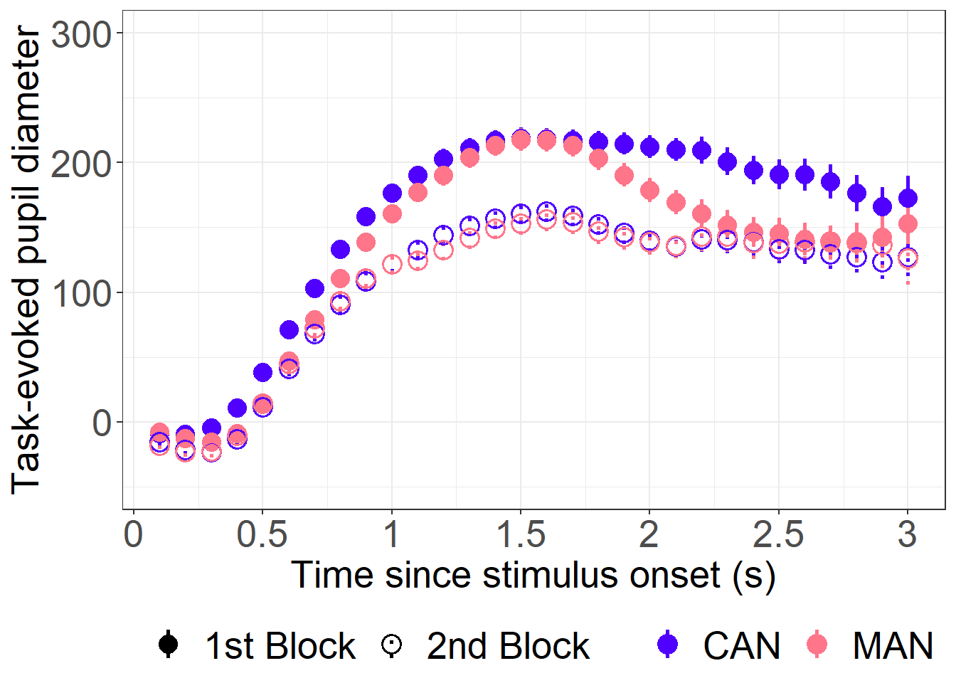

S4. Summary of gamm.1a.AR in the analysis of Language × WordType effects

1. Model formula, with critical predictor terms in bold (the value of rho is obtained from a maximally similar model without autoregressive-1 correction, same in all subsequent models)

gamm.1a.AR <- bam(PupilDiaAdjusted ~ Lang.WordType + s(Time) + s(Time, by = IsBlock2) + s(Gaze_x, Gaze_y, k=160) + s(TrialNO, k=40) + ti(Time, TrialNO, k = c(10, 20)) + s(SubjectiveFreq, k = 7) + ti(Time, SubjectiveFreq, k = c(10, 7)) + s(Time, by=Lang.WordType) +
s(Time, SubjID, bs = "fs", m = 1, k = 4) +
s(Time, WordID, bs = "fs", m = 1, k = 4),
data= pupildata,
method="fREML", discrete = TRUE,
rho=0.93, AR.start= pupildata$start.event, family = "scat")
2. Model summary

Parametric coefficients:
 | Estimate | Std. Error | t value | Pr(>|t|)
(Intercept) | 26.52 | 13.73 | 1.93 | 0.053 | .
LangWtypeC.NT | -1.29 | 7.27 | -0.18 | 0.860
LangWtypeM.EL | 14.34 | 9.01 | 1.59 | 0.111
LangWtypeC.EL | -10.36 | 8.87 | -1.17 | 0.243
LangWtypeM.EW | -11.31 | 9.24 | -1.22 | 0.221
LangWtypeC.EW | -2.34 | 9.02 | -0.26 | 0.796
LangWtypeM.TB | 53.16 | 13.68 | 3.89 | 1.0E-04 | ***
LangWtypeC.TB | 74.61 | 13.39 | 5.57 | 2.5E-08 | ***
---
Signif. Codes: 0 ‘***’ 0.001 ‘**’ 0.01 ‘*’ 0.05 ‘.’ 0.1 ‘ ‘ 1
Approximate significance of smooth terms:
 | edf | Ref.df | F | p-value
s(Time) | 9.13 | 8.89 | 49.61 | < 2E-16 | ***
s(Time):IsBlock2 | 7.00 | 8.45 | 9.17 | < 2E-16 | ***
s(Gaze_x,Gaze_y) | 123.58 | 145.06 | 187.97 | < 2E-16 | ***
s(TrialNO) | 3.25 | 4.06 | 6.75 | 1.8E-05 | ***
ti(Time,TrialNO) | 33.01 | 48.66 | 2.01 | 4.2E-05 | ***
s(SubjectiveFreq) | 1.59 | 1.97 | 1.23 | 0.247
ti(SubjectiveFreq,  Time) | 13.82 | 21.40 | 1.62 | 0.038 | *
s(Time):LangWtypeM.NT | 1.47 | 1.83 | 0.14 | 0.868
s(Time):LangWtypeC.NT | 1.00 | 1.01 | 0.00 | 0.997
s(Time):LangWtypeM.EL | 1.74 | 2.25 | 0.50 | 0.608
s(Time):LangWtypeC.EL | 1.05 | 1.09 | 0.02 | 0.955
s(Time):LangWtypeM.EW | 3.73 | 4.96 | 1.33 | 0.219
s(Time):LangWtypeC.EW | 1.01 | 1.02 | 0.00 | 0.980
s(Time):LangWtypeM.TB | 3.63 | 4.83 | 1.02 | 0.369
s(Time):LangWtypeC.TB | 7.72 | 8.67 | 10.33 | < 2E-16 | ***
s(Time,SubjID) | 189.62 | 207.00 | 15.07 | < 2E-16 | ***
s(Time,WordID) | 61.30 | 508.00 | 0.19 | < 2E-16 | ***
---
Signif. Codes: 0 ‘***’ 0.001 ‘**’ 0.01 ‘*’ 0.05 ‘.’ 0.1 ‘ ‘ 1
R-sq.(adj) = 0.212 Deviance explained = 17.8%
fREML = 71605 Scale est. = 1 n = 132173

S5. Visualization of the effects of IsBlock2, TrialID, and SubjectiveFreq over time in gamm.1a.AR.

For TrialID, the fitted response curves are plotted at the 25%- and 75%-point of the block; for SubjectiveFreq, the fitted curves are plotted at SubjectiveFreq is 2 and 6 (on a scale of 1-7). The shaded bands denote the pointwise 95%-confidence intervals.
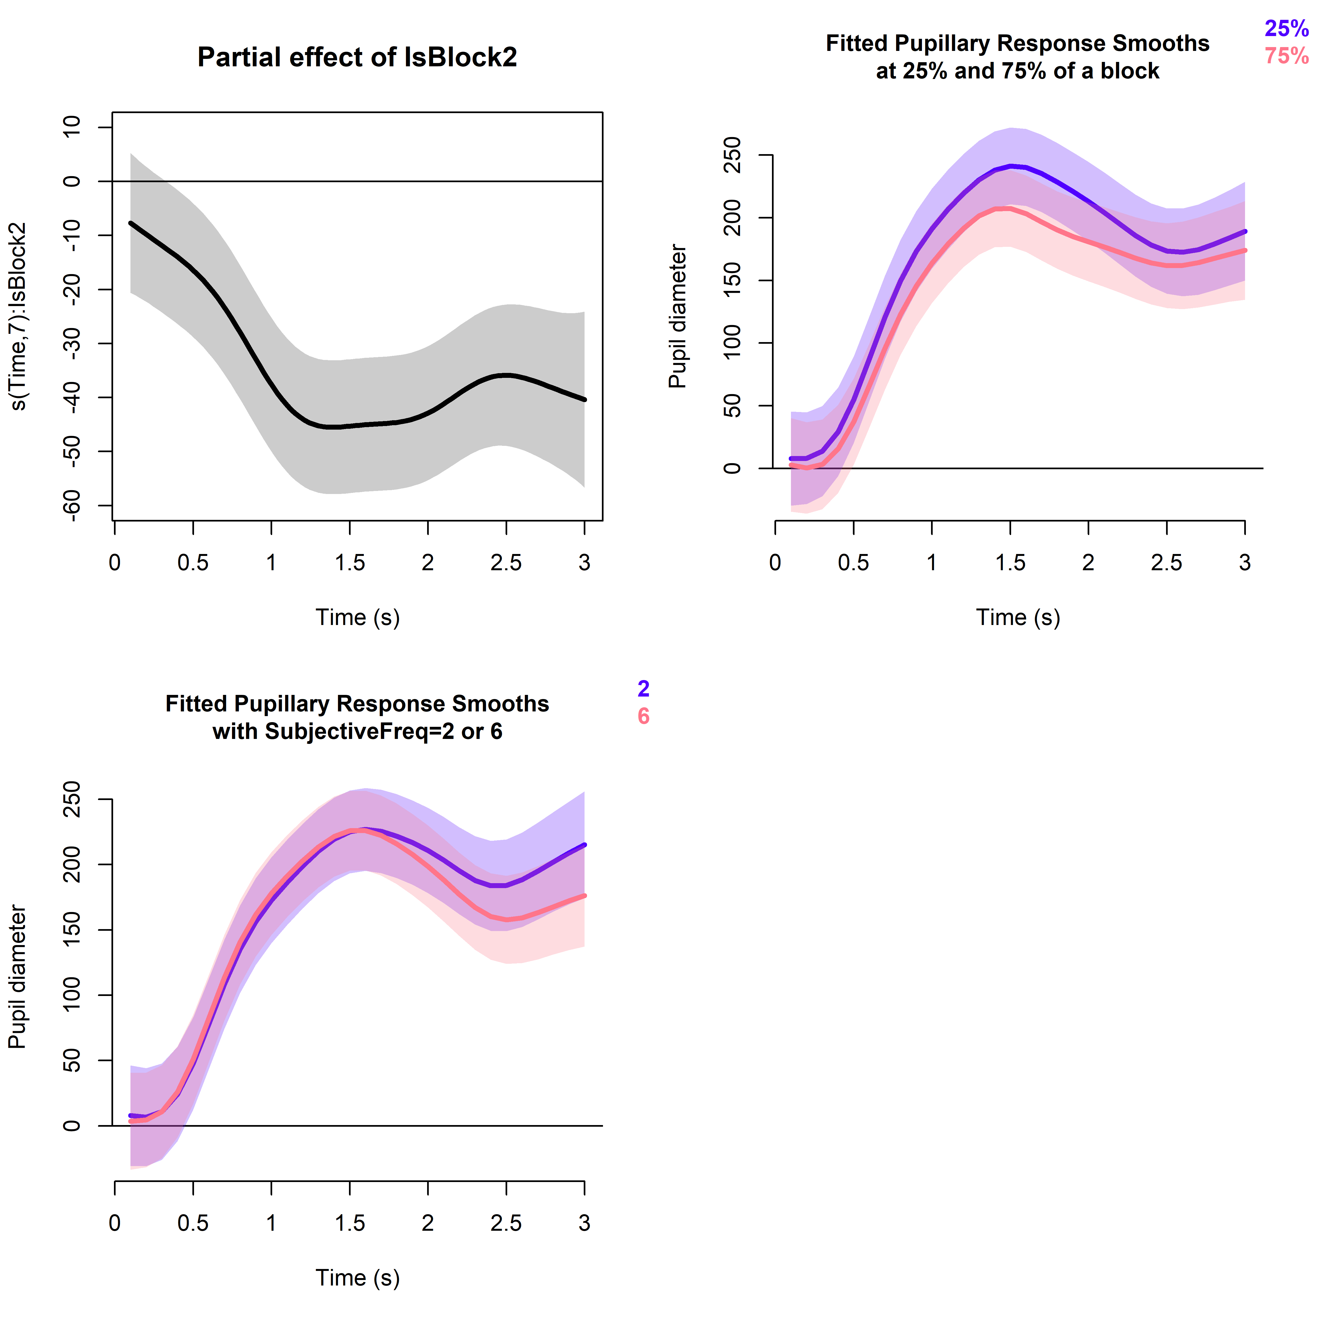

S6. Summary of gamm.1b.AR in the analysis of Language × WordType effects

1. Model formula, with critical predictor terms in bold (the value of rho is obtained from a maximally similar model without autoregressive-1 correction, same in all subsequent models)

gamm.1b.AR <- bam(PupilDiaAdjusted ~ s(Time) + s(Time, by = IsBlock2) + s(Gaze_x, Gaze_y, k=160) + s(TrialNO, k=40) + ti(Time, TrialNO, k = c(10, 20)) + s(SubjectiveFreq, k = 7) + ti(Time, SubjectiveFreq, k = c(10, 7)) + s(Time, by = IsCantonese) + s(Time, by = IsEL) + s(Time, by = IsEW) + s(Time, by = IsTB) + s(Time, by = IsC.EL) + s(Time, by = IsC.EW) + s(Time, by = IsC.TB) +
s(Time, SubjID, bs = "fs", m = 1, k = 4) +
s(Time, WordID, bs = "fs", m = 1, k = 4),
data= pupildata,
method= "fREML", discrete = TRUE,
rho=0.93, AR.start= pupildata$start.event, family = "scat")
2. Model summary

Parametric coefficients:
 | Estimate | Std. Error | t value | Pr(>|t|)
(Intercept) | 23.85 | 13.69 | 1.74 | 0.081 | .
---
Signif.codes:0 '***' 0.001 '**' 0.01 '*' 0.05 '.' 0.1 ' ' 1
Approximate significance of smooth terms:
 | edf | Ref.df | F | p-value
s(Time) | 8.87 | 8.95 | 49.84 | < 2e-16 | ***
s(Time):IsBlock2 | 6.92 | 8.37 | 9.17 | < 2e-16 | ***
s(Gaze_x,Gaze_y) | 122.14 | 144.05 | 189.54 | < 2e-16 | ***
s(TrialNO) | 3.35 | 4.19 | 6.81 | 1.4E-05 | ***
ti(Time,TrialNO) | 33.25 | 49.00 | 2.04 | 2.6E-05 | ***
s(SubjectiveFreq) | 1.62 | 2.01 | 1.42 | 0.237
ti(SubjectiveFreq,  Time) | 13.95 | 21.58 | 1.62 | 0.036 | *
s(Time):IsCantonese | 5.58 | 6.97 | 1.12 | 0.345
s(Time):IsEL | 3.53 | 4.36 | 1.36 | 0.242
s(Time):IsEW | 2.00 | 2.01 | 0.51 | 0.570
s(Time):IsTB | 5.40 | 6.67 | 5.92 | 6.3E-06 | ***
s(Time):IsC.EL | 2.00 | 2.00 | 2.42 | 0.090 | .
s(Time):IsC.EW | 2.01 | 2.01 | 0.32 | 0.724
s(Time):IsC.TB | 8.10 | 9.19 | 4.15 | 2.2E-05 | ***
s(Time,SubjID) | 189.51 | 208.00 | 14.65 | < 2e-16 | ***
s(Time,WordID) | 60.77 | 508.00 | 0.24 | < 2e-16 | ***
---
Signif. codes:0 '***' 0.001 '**' 0.01 '*' 0.05 '.' 0.1 ' ' 1
R-sq.(adj) = 0.212 Deviance explained = 17.8%
fREML = 71636 Scale est. = 1 n = 132173

S7. Visualization of the partial effects of IsTB and IsC.TB over time in gamm.1b.AR.
The shaded bands denote the pointwise 95%-confidence intervals.
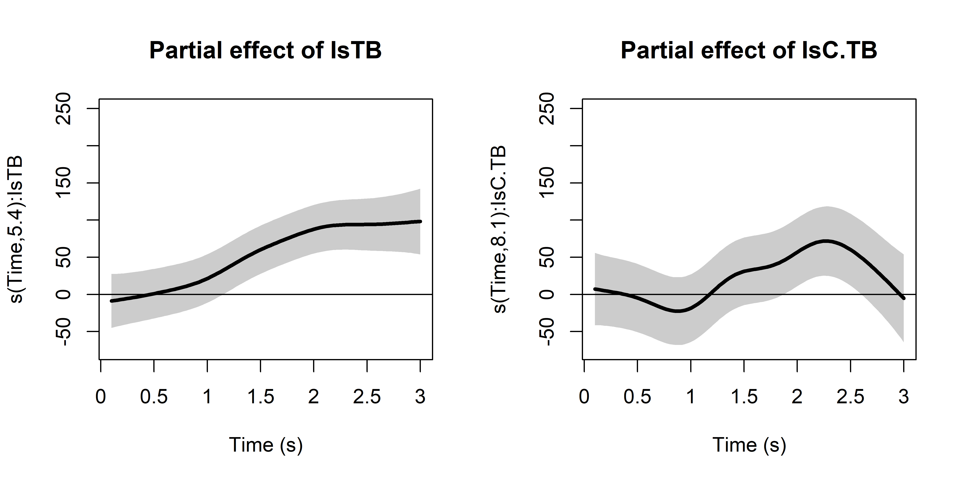

S8. Summary of gamm.2a.AR in the analysis of Language × WordType × MandarinProficiency effects

1. Model formula, with critical predictor terms in bold (the value of rho is obtained from a maximally similar model without autoregressive-1 correction, same in all subsequent models)

gamm.2a.AR <- bam(PupilDiaAdjusted ~ LangWtypeMprof + s(Time) + s(Time, by = IsBlock2) + s(Gaze_x, Gaze_y, k=160) + s(TrialNO, k=64) + ti(Time, TrialNO, k = c(10, 64)) + s(SubjectiveFreq, k = 7) + ti(Time, SubjectiveFreq, k = c(10, 7)) +
s(Time, by = LangWtypeMprof) +
s(Time, SubjID, bs = "fs", m = 1, k = 4) +
s(Time, WordID, bs = "fs", m = 1, k = 4),
data= pupildata.NeuTB,
method= "fREML", discrete = TRUE,
rho=0.94, AR.start= pupildata.NeuTB$start.event, family = "scat")
2. Model summary

Parametric coefficients:
 | Estimate | Std. Error | t value | Pr(>|t|)
(Intercept) | 38.61 | 36.66 | 1.05 | 0.292
LangWtypeMprofC.NT.LowP | -0.05 | 19.43 | 0.00 | 0.998
LangWtypeMprofM.TB.LowP | 44.07 | 38.23 | 1.15 | 0.249
LangWtypeMprofC.TB.LowP | 157.53 | 34.18 | 4.61 | 4.1E-06 | ***
LangWtypeMprofM.NT.HighP | 4.85 | 48.50 | 0.10 | 0.920
LangWtypeMprofC.NT.HighP | 6.67 | 48.46 | 0.14 | 0.890
LangWtypeMprofM.TB.HighP | 31.80 | 54.48 | 0.58 | 0.559
LangWtypeMprofC.TB.HighP | 64.79 | 54.44 | 1.19 | 0.234
LangWtypeMprofM.NT.MidP | -7.66 | 40.43 | -0.19 | 0.850
LangWtypeMprofC.NT.MidP | -12.31 | 40.42 | -0.31 | 0.761
LangWtypeMprofM.TB.MidP | 55.56 | 42.73 | 1.30 | 0.194
LangWtypeMprofC.TB.MidP | 50.56 | 42.68 | 1.19 | 0.236
---
Signif. codes: 0 '***' 0.001 '**' 0.01 '*' 0.05 '.' 0.1 ' ' 1
Approximate significance of smooth terms:
 | edf | Ref.df | F | p-value
s(Time) | 7.76 | 7.90 | 30.10 | < 2E-16 | ***
s(Time):IsBlock2 | 5.59 | 6.99 | 7.07 | < 2E-16 | ***
s(Gaze_x,Gaze_y) | 112.38 | 136.50 | 109.05 | < 2E-16 | ***
s(TrialNO) | 1.00 | 1.01 | 10.99 | 0.001 | **
ti(Time,TrialNO) | 23.16 | 34.78 | 1.44 | 0.046 | *
s(SubjectiveFreq) | 1.84 | 2.29 | 0.70 | 0.433
ti(SubjectiveFreq,Time) | 11.43 | 17.62 | 1.56 | 0.064 | .
s(Time):  LangWtypeMprofM.NT.LowP | 5.43 | 6.85 | 3.84 | 0.000 | ***
s(Time):  LangWtypeMprofC.NT.LowP | 6.34 | 7.68 | 3.07 | 0.006 | **
s(Time):  LangWtypeMprofM.TB.LowP | 1.00 | 1.00 | 6.89 | 0.008 | **
s(Time):  LangWtypeMprofC.TB.LowP | 5.44 | 6.91 | 5.50 | 2.4E-06 | ***
s(Time):  LangWtypeMprofM.NT.HighP | 6.52 | 7.82 | 5.49 | 7.8E-07 | ***
S(Time):  LangWtypeMprofC.NT.HighP | 6.44 | 7.77 | 5.50 | < 2E-16 | ***
s(Time):  LangWtypeMprofM.TB.HighP | 4.53 | 5.90 | 3.55 | 0.002 | **
s(Time):  LangWtypeMprofC.TB.HighP | 1.01 | 1.01 | 19.46 | 9.8E-06 | ***
s(Time):  LangWtypeMprofM.NT.MidP | 1.00 | 1.00 | 20.19 | 6.9E-06 | ***
s(Time):  LangWtypeMprofC.NT.MidP | 5.55 | 6.95 | 4.83 | 2.0E-05 | ***
s(Time):  LangWtypeMprofM.TB.MidP | 4.71 | 6.11 | 8.26 | < 2E-16 | ***
S(Time):  LangWtypeMprofC.TB.MidP | 7.54 | 8.56 | 11.87 | < 2E-16 | ***
s(Time,SubjID) | 177.70 | 208.00 | 9.80 | < 2E-16 | ***
s(Time,WordID) | 45.12 | 279.00 | 0.22 | 0.000 | ***
---
Signif. codes: 0 '***' 0.001 '**' 0.01 '*' 0.05 '.' 0.1 ' ' 1
Rank: 1475/1476
R-sq.(adj) = 0.238 Deviance explained = 20.1%
fREML = 41084 Scale est. = 1 n = 72042

S9. Summary of gamm.2b.AR in the analysis of Language × WordType × MandarinProficiency effects

1. Model formula, with critical predictor terms in bold (the value of rho is obtained from a maximally similar model without autoregressive-1 correction, same in all subsequent models)

gamm.2b.AR <- bam(PupilDiaAdjusted ~ Mprof + s(Time) + s(Time, by = IsBlock2) + s(Gaze_x, Gaze_y, k=160) + s(TrialNO, k=64) + ti(Time, TrialNO, k = c(10, 64)) + s(SubjectiveFreq, k = 7) + ti(Time, SubjectiveFreq, k = c(10, 7)) +
s(Time, by = Mprof) +
s(Time, by= IsC.LowP) + s(Time, by= IsTB.LowP) + s(Time, by= IsC.TB.LowP) +
s(Time, by= IsC.MidP) + s(Time, by= IsTB.MidP) + s(Time, by= IsC.TB.MidP) +
s(Time, by= IsC.HighP) + s(Time, by= IsTB.HighP) + s(Time, by= IsC.TB.HighP) +
s(Time, SubjID, bs = "fs", m = 1, k = 4) +
s(Time, WordID, bs = "fs", m = 1, k = 4),
data= pupildata.NeuTB,
method= "fREML", discrete = TRUE,
rho=0.94, AR.start= pupildata.NeuTB$start.event, family = "scat")

2. Model summary

Parametric coefficients:
 | Estimate | Std.  Error | t value | Pr(>|t|)
(Intercept) | 41.14 | 36.49 | 1.13 | 0.260
MprofHighP | 0.72 | 48.26 | 0.02 | 0.988
MprofMidP | -10.64 | 40.24 | -0.26 | 0.791
Approximate significance of smooth terms:
 | edf | Ref.df | F | p-value
s(Time) | 7.71 | 7.87 | 25.22 | < 2E-16 | ***
s(Time):IsBlock2 | 5.69 | 7.10 | 6.94 | < 2E-16 | ***
s(Gaze_x,Gaze_y) | 111.37 | 135.67 | 109.49 | < 2E-16 | ***
s(TrialNO) | 1.01 | 1.01 | 11.71 | 0.001 | **
ti(Time,TrialNO) | 23.73 | 35.64 | 1.53 | 0.022 | *
s(SubjectiveFreq) | 1.85 | 2.31 | 0.78 | 0.389
ti(SubjectiveFreq,  Time) | 11.58 | 17.86 | 1.55 | 0.064 | .
s(Time):MprofLowP | 7.40 | 8.25 | 5.37 | < 2E-16 | ***
s(Time):MprofHighP | 6.40 | 7.51 | 3.71 | 0.000 | ***
s(Time):MprofMidP | 1.00 | 1.00 | 4.83 | 0.027 | *
s(Time):IsC.LowP | 3.22 | 3.94 | 0.48 | 0.704
s(Time):IsTB.LowP | 2.33 | 2.59 | 0.29 | 0.706
s(Time):IsC.TB.LowP | 6.22 | 7.67 | 3.15 | 0.002 | **
s(Time):IsC.MidP | 5.88 | 7.25 | 0.86 | 0.525
s(Time):IsTB.MidP | 5.99 | 7.30 | 5.12 | 0.000 | ***
s(Time):IsC.TB.MidP | 8.01 | 9.10 | 3.65 | 0.000 | ***
s(Time):IsC.HighP | 2.00 | 2.00 | 1.02 | 0.354
s(Time):IsTB.HighP | 6.98 | 8.41 | 3.79 | 0.000 | ***
s(Time):IsC.TB.HighP | 2.00 | 2.00 | 0.18 | 0.834
s(Time,SubjID) | 176.30 | 207.00 | 9.65 | < 2E-16 | ***
s(Time,WordID) | 43.61 | 279.00 | 0.23 | 4.8E-06 | ***
---
Signif. codes: 0 '***' 0.001 '**' 0.01 '*' 0.05 '.' 0.1 ' ' 1
Rank: 1475/1476
R-sq.(adj) = 0.238 Deviance explained = 20.1%
fREML = 41060 Scale est. = 1 n = 72042

S10. Visualization of the partial effects of the critical binary variables over time for low-proficiency (top row), mid-proficiency (middle row), and high-proficiency (bottom row) bilinguals in gamm.2b.AR.

The shaded bands denote the pointwise 95%-confidence intervals.
