Supplementary Material
This document contains additional tables and figures for the paper An Ex-Gaussian Analysis of Eye Movements in L2 Reading

Study 1
Table 4. Demographic Characteristics of Participants
 | Native English Speakers | Native Chinese Speakers
N | 22 | 17
Age | 21.77 (20-24) | 24.4 (21-43)
LexTale Score (English) | 92.5 (77.5-100) | 63.16 (45-92.5)
Age of Initial L2 Learning | 14.86 years | 7.88 years
Self-Rated L2 Proficiency – Speaking  (1 = low, 10 = perfect) | 7.9 | 6.76
Self-Rated L2 Proficiency – Understanding  (1 = low, 10 = perfect) | 7.56 | 7.29
Self-Rated L2 Proficiency – Reading  (1 = low, 10 = perfect) | 6.64 | 6.29
Current L2 Exposure (% of day) | 11 | 52.53

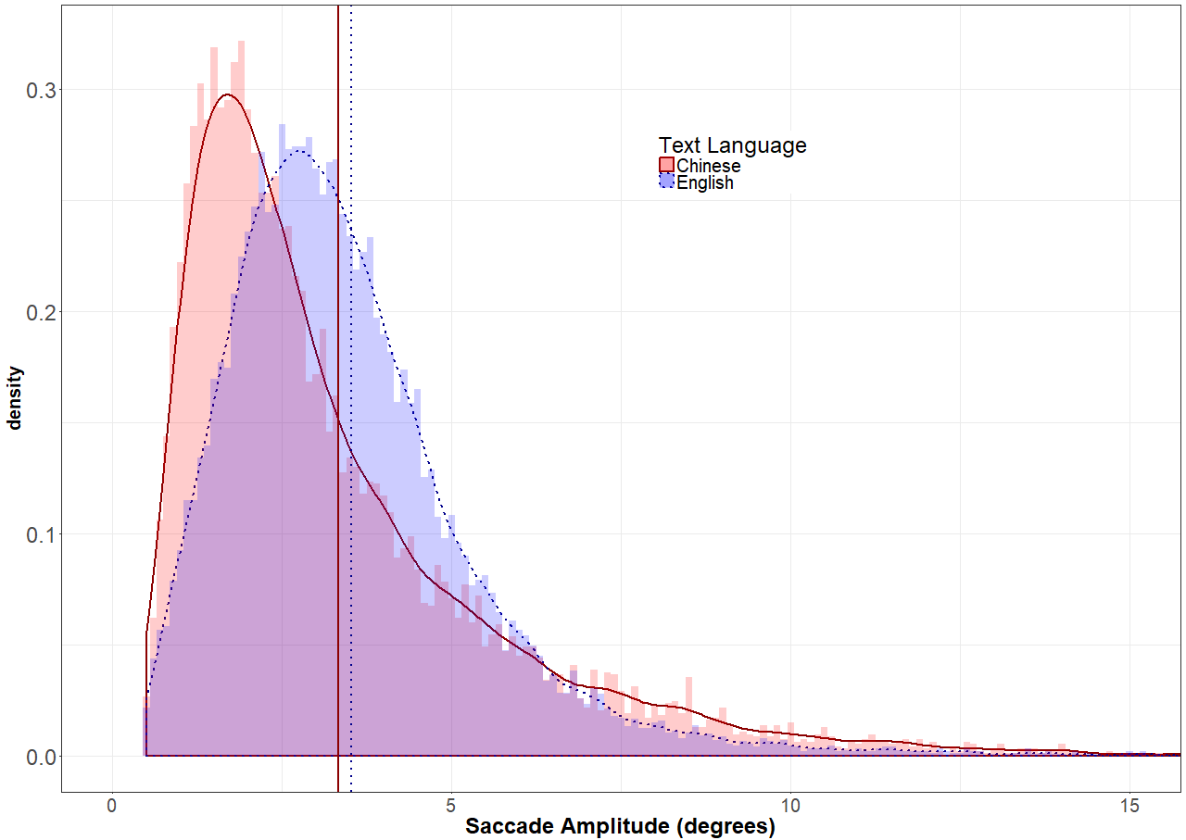
Figure 6. Distribution of rightward saccade amplitudes in Study 1 for native speakers of Chinese reading Chinese text (red, solid lines) and native speakers of English reading English text (blue, dotted lines). The vertical lines represent the mean saccade amplitudes for each group. Histogram bin width was 0.1 degrees.

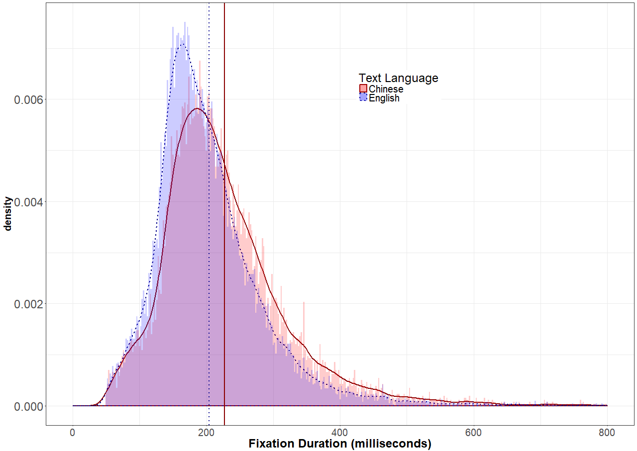
Figure 7. Distribution of fixation durations in Study 1 for native speakers of Chinese reading Chinese text (red, solid lines) and native speakers of English reading English text (blue, dotted lines). The vertical lines represent the mean fixation durations for each group. Histogram bin width was 2 ms.

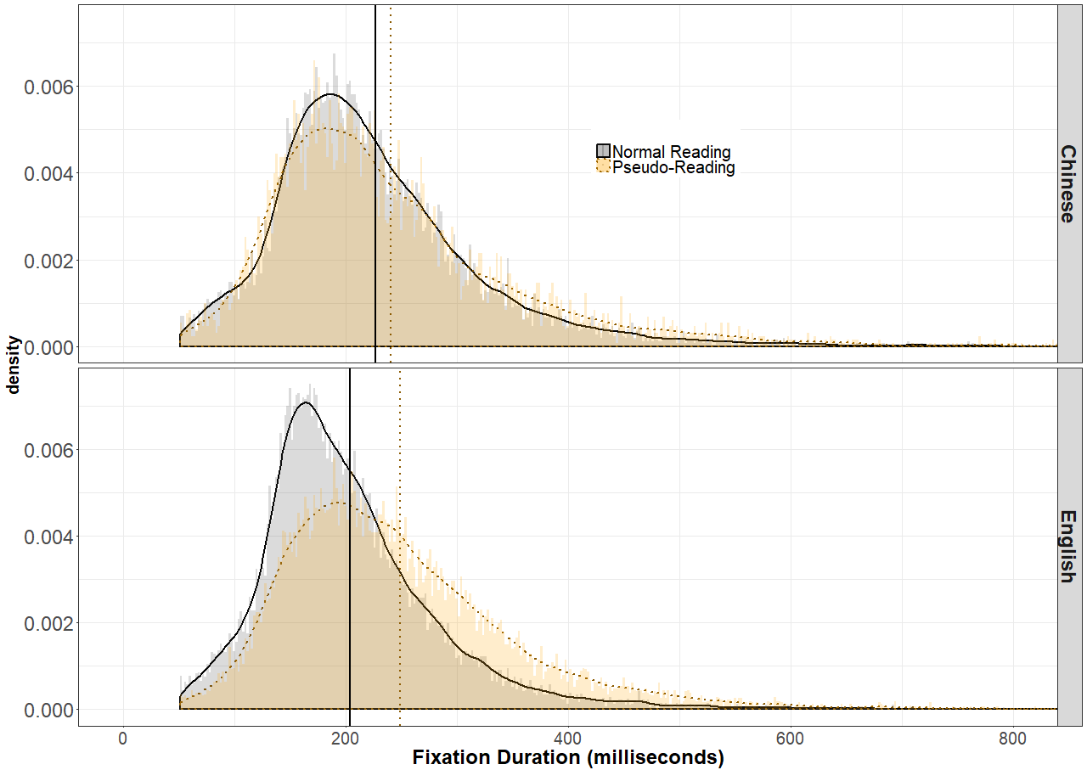Figure 8. Distribution of fixation durations in Study 1 for native speakers reading normal text (black, solid lines) and pseudo-text (orange, dotted lines). Distributions in the top panel are from reading Chinese text, while the distributions in the bottom panel are from reading English text. The vertical lines represent the mean fixation durations for each group. Histogram bin width was 2 ms.

Table 5. Results of Analysis of Saccade Amplitude in Study 1
 | b | SE | t value | p-value
(Intercept) | 3.69 | 0.23 | 16.35 | < .0001
Text Language = English | 0.013 | 0.3 | 0.042 | 0.97
Task = Pseudo-Reading | 2.028 | 0.39 | 5.14 | < .0001
Reader = L2 | -2.57 | 0.26 | -10.027 | < .0001
Text Language = English X Task = Pseudo-Reading | -1.16 | 0.52 | -2.21 | 0.033
Text Language = English X Reader = L2 | 1.81 | 0.4 | 4.55 | < .0001
Task = Pseudo-Reading X Reader = L2 | 0.6 | 0.52 | 1.14 | < .0001
Text Language = English X Task = Pseudo-Reading X Reader = L2 | 0.67 | 1.048 | 0.64 | 0.53

Table 6. Results of Analysis of Fixation Duration in Study 1
 | b | SE | t value | p-value
(Intercept) | 220.66 | 7.92 | 27.88 | < .0001
Text Language = English | -18.086 | 9.43 | -1.92 | 0.062
Task = Pseudo-Reading | 14.94 | 7.84 | 1.91 | 0.064
Reader = L2 | 122.15 | 10.47 | 11.67 | < .0001
Text Language = English X Task = Pseudo-Reading | 25.005 | 10.38 | 2.41 | 0.021
Text Language = English X Reader = L2 | -89.65 | 15.87 | -5.65 | < .0001
Task = Pseudo-Reading X Reader = L2 | -80.59 | 10.36 | -7.78 | < .0001
Text Language = English X Task = Pseudo-Reading X Reader = L2 | 47.55 | 20.41 | 2.33 | 0.025
Language = English X Task = Pseudo-Reading X Status = L2 | 220.66 | 7.92 | 27.88 | < .0001

Table 7. Results of Analysis of Mu in Study 1
 | b | SE | t value | p-value
(Intercept) | 157.98 | 4.18 | 37.77 | < .0001
Text Language = English | -18.33 | 5.57 | -3.29 | 0.0019
Task = Pseudo-Reading | -10.38 | 5.21 | -1.99 | 0.05
Reader = L2 | 20.98 | 5.98 | 3.51 | 0.00084
Text Language = English X Task = Pseudo-Reading | 28.37 | 6.94 | 4.089 | 0.00012
Text Language = English X Reader = L2 | 7.25 | 10.4 | 0.7 | 0.49
Task = Pseudo-Reading X Reader = L2 | -19.55 | 6.94 | -2.82 | 0.0063
Text Language = English X Task = Pseudo-Reading X Reader = L2 | -6.76 | 11.24 | -0.6 | 0.55

Table 8. Results of Analysis of Sigma in Study 1
 | b | SE | t value | p-value
(Intercept) | 47.38 | 2.156 | 21.98 | < .0001
Text Language = English | -9.19 | 2.87 | -3.2 | 0.0024
Task = Pseudo-Reading | -3.3 | 2.77 | -1.192 | 0.24
Reader = L2 | 12.32 | 2.95 | 4.18 | < .0001
Text Language = English X Task = Pseudo-Reading | 9.96 | 3.68 | 2.704 | 0.0087
Text Language = English X Reader = L2 | -0.22 | 4.91 | -0.044 | 0.97
Task = Pseudo-Reading X Reader = L2 | -10.97 | 3.68 | -2.98 | 0.004
Text Language = English X Task = Pseudo-Reading X Reader = L2 | 3.74 | 6.069 | 0.616 | 0.54

Table 9. Results of Analysis of Tau in Study 1
 | b | SE | t value | p-value
(Intercept) | 61.97 | 5.42 | 11.44 | < .0001
Text Language = English | 0.15 | 7.22 | 0.021 | 0.98
Task = Pseudo-Reading | 25.74 | 6.78 | 3.8 | 0.00031
Reader = L2 | 102.14 | 7.98 | 12.8 | < .0001
Text Language = English X Task = Pseudo-Reading | -1.4 | 9.026 | -0.16 | 0.88
Text Language = English X Reader = L2 | -97.21 | 13.54 | -7.18 | < .0001
Task = Pseudo-Reading X Reader = L2 | -64.37 | 9.026 | -7.13 | < .0001
Text Language = English X Task = Pseudo-Reading X Reader = L2 | 55.58 | 14.43 | 3.85 | 0.00045

Study 2
Table 10. Demographic Characteristics of Participants
 | L2 Chinese | L2 English
N | 27 | 15
Age | 21.36 (18-23) | 31.67 (18-56)
ACTFL L2 Proficiency | 3 Novice,  9 Intermediate,  15 Advanced | 6 Novice,  8 Intermediate,  1 Advanced
Age of Initial L2 Learning | 15.46 years (3.52) | 8.86 years (4.55)
Self-Rated L2 Proficiency – Speaking  (1 = low, 10 = perfect) | 6.71 (1.41) | 5.79 (2.72)
Self-Rated L2 Proficiency – Reading  (1 = low, 10 = perfect) | 6.62 (1.65) | 5.71 (2.76)

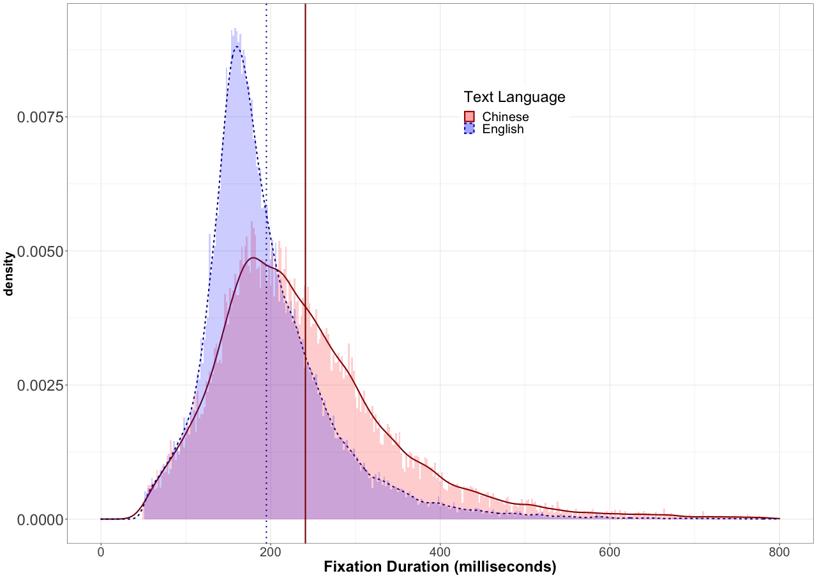
Figure 9. Distribution of fixation durations for native speakers of Chinese reading Chinese text (red, solid lines) and native speakers of English reading English text (blue, dotted lines) in Study 2. The vertical lines represent the mean fixation durations for each group. Histogram bin width was 2 ms.

Table 11. Results of Analysis of Saccade Amplitude in Study 2
 | b | SE | t value | p-value
(Intercept) | 2.61 | 0.25 | 10.49 | < .0001
Text Language = English | 1.03 | 0.31 | 3.3 | 0.002
Reader = L2 | -1.5 | 0.26 | -5.82 | < .0001
Text Language = English X Reader = L2 | 0.17 | 0.39 | 0.45 | 0.66

Table 12. Results of Analysis of Fixation Durations in Study 2
 | b | SE | t value | p-value
(Intercept) | 239 | 6.4 | 37.2 | < .0001
Text Language = English | -44.03 | 8.03 | -5.48 | < .0001
Reader = L2 | 110.36 | 8.02 | 13.76 | < .0001
Text Language = English X Reader = L2 | -60.9 | 15.96 | -3.82 | 0.00044

Table 13. Results of Analysis of Mu in Study 2
 | b | SE | t value | p-value
(Intercept) | 150.914 | 4.57 | 33 | < .0001
Text Language = English | -16.77 | 5.7 | -2.94 | 0.0044
Reader = L2 | 13.34 | 5.7 | 2.34 | 0.022
Text Language = English X Reader = L2 | 9.82 | 9.12 | 1.08 | 0.29

Table 14. Results of Analysis of Sigma in Study 2
 | b | SE | t value | p-value
(Intercept) | 50.89 | 2.2 | 23.1 | < .0001
Text Language = English | -16.45 | 2.75 | -5.99 | < .0001
Reader = L2 | 0.18 | 2.75 | 0.067 | 0.95
Text Language = English X Reader = L2 | 18.38 | 4.85 | 3.79 | 0.0005

Table 15. Results of Analysis of Tau in Study 2
 | b | SE | t value | p-value
(Intercept) | 88.45 | 7.73 | 11.44 | < .0001
Text Language = English | -27.57 | 9.64 | -2.86 | 0.0056
Reader = L2 | 96.27 | 9.64 | 9.99 | < .0001
Text Language = English X Reader = L2 | -67.52 | 16.07 | -4.2 | 0.00015

Study 3
Table 16. Demographic Characteristics of Participants
 | L2 Portuguese | L2 English
N | 34 | 18
Age | 22.21 (20-25) | 24.41 (18-40)
ACTFL L2 Proficiency | 6 Intermediate,  11 Advanced,  17 Superior | 4 Novice,  12 Intermediate,  2 Advanced
Age of Initial L2 Learning | 18.76 years (0.96) | 13.46 years (3.87)
Self-Rated L2 Proficiency – Speaking  (1 = low, 10 = perfect) | 7.76 (0.65) | 6.24 (2.02)
Self-Rated L2 Proficiency – Reading  (1 = low, 10 = perfect) | 8.03 (0.93) | 6.47 (2.32)

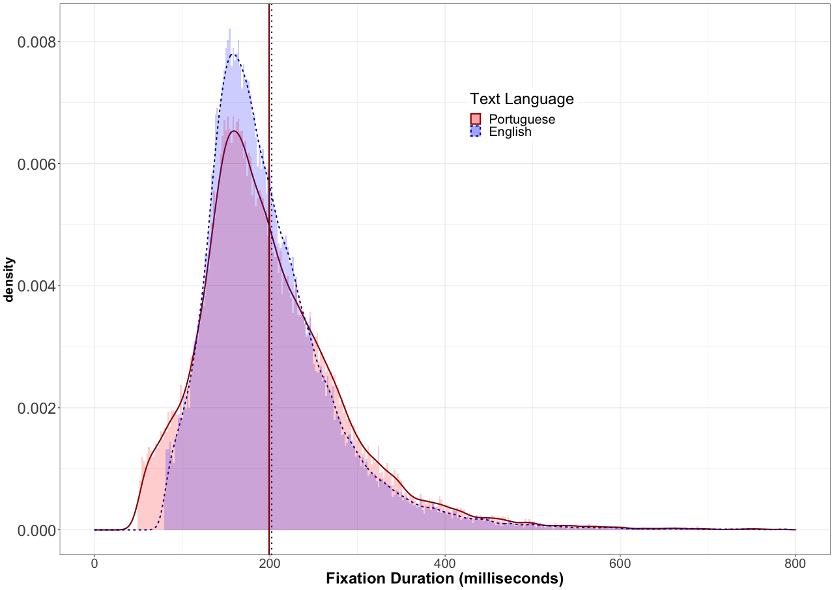
Figure 10. Distribution of fixation durations for native speakers of Portuguese reading Portuguese text (red, solid lines) and native speakers of English reading English text (blue, dotted lines) in Study 3. The vertical lines represent the mean fixation durations for each group. Histogram bin width was 2 ms.

Table 17. Results of Analysis of Saccade Amplitude in Study 3
 | b | SE | t value | p-value
(Intercept) | 2.65 | 0.15 | 17.42 | < .0001
Text Language = English | 0.61 | 0.19 | 3.27 | 0.002
Reader = L2 | -0.2 | 0.18 | -1.09 | 0.28
Text Language = English X Reader = L2 | -0.81 | 0.34 | -2.39 | 0.021

Table 18. Results of Analysis of Fixation Durations in Study 2
 | b | SE | t value | p-value
(Intercept) | 205 | 4.57 | 44.86 | < .0001
Text Language = English | -5.78 | 5.65 | -1.02 | 0.31
Reader = L2 | 19.18 | 6.02 | 3.18 | 0.0024
Text Language = English X Reader = L2 | 0.77 | 12.09 | 0.063 | 0.95

Table 19. Mu in Analysis of Study 3 Data
 | b | SE | t value | p-value
(Intercept) | 134.82 | 3.26 | 41.4 | < .0001
Text Language = English | -0.084 | 4.03 | -0.021 | 0.98
Reader = L2 | 3.31 | 4.03 | 0.82 | 0.42
Text Language = English X Reader = L2 | -0.47 | 7.79 | -0.061 | 0.95

Table 20. Sigma in Analysis of Study 3 Data
 | b | SE | t value | p-value
(Intercept) | 43.39 | 1.6 | 27.18 | < .0001
Text Language = English | -14.9 | 1.97 | -7.55 | < .0001
Reader = L2 | -12.07 | 1.97 | -6.12 | < .0001
Text Language = English X Reader = L2 | 27.27 | 3.75 | 7.28 | < .0001

Table 21. Tau in Analysis of Study 3 Data
 | b | SE | t value | p-value
(Intercept) | 69.78 | 4.02 | 17.37 | < .0001
Text Language = English | -5.53 | 4.97 | -1.11 | 0.27
Reader = L2 | 16.11 | 4.97 | 3.24 | 0.002
Text Language = English X Reader = L2 | 0.73 | 9.54 | 0.077 | 0.94

