Table S1 (Word Document, 625 kB) provides soundwaves and spectograms of the 7 phonetic categories coded in the data. The table includes 7 images and a short description of each category.

Categories | Sound wave and spectrogram
Trill (two or more strong constrictions)
Approximant trill (two or more weak constrictions) | 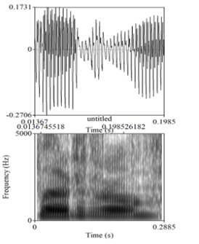
Tap + fricative | 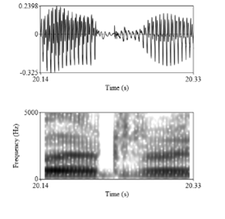
Fricative | 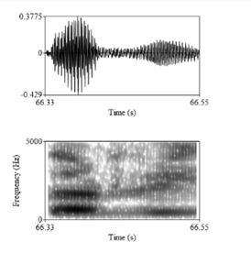
Tap | 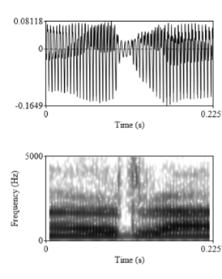
Approximant tap (tap with weak constriction)
Perceptual tap | 