Figure S1.
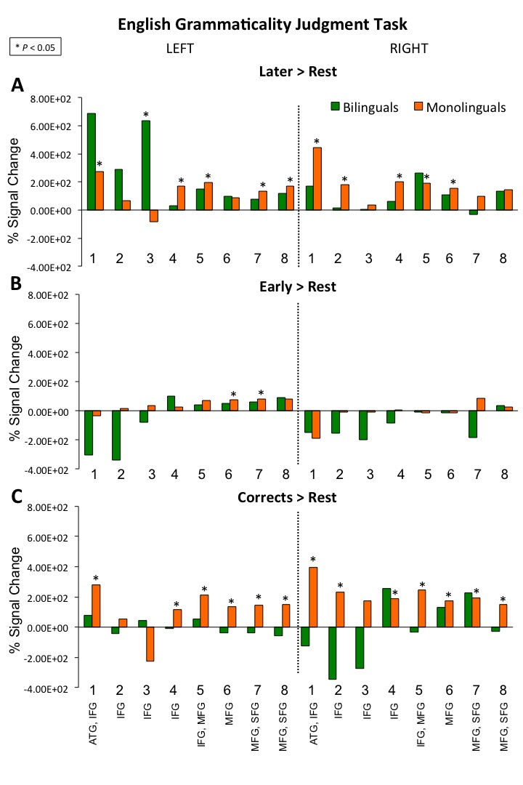
Bilinguals’ and monolinguals’ within-group brain activation for all conditions relative to resting baseline: (A) errors on Later-acquired morpho-syntactic features, (B) errors on Early-acquired morpho-syntactic features, and (C) Correct sentences.

Figure S2.

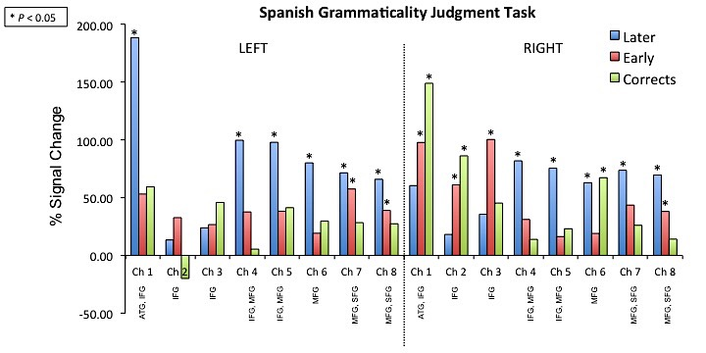

Bilinguals’ brain activation for Spanish conditions in Study 2, relative to resting baseline: (A) errors on Later-acquired morpho-syntactic features, (B) errors on Early-acquired morpho-syntactic features, and (C) Correct sentences.
Table S1
Deoxygenated hemoglobin values (HbR; in beta values) for bilingual and monolingual participants for the English Grammaticality Judgment task comparison (*p < 0.05). Positive values represent decrease in HbR signal.
HbR |  |  | Left |  |  |  |  |  |  |  |  | Right
 |  | Monolinguals
Beta-values |  |  | 1 | 2 | 3 | 4 | 5 | 6 | 7 | 8 | 1 |  | 2 | 3 | 4 | 5 | 6 | 7 | 8
Later |  |  | 5.13* | 3.90* | 7.92* | 1.81 | 3.76* | 1.01 | -0.30 | 1.86 | 6.75* |  | 1.70 | 2.51 | 2.21 | 6.21* | 0.50 | -0.99 | 1.41
Early |  |  | 2.54 | -2.53 | -2.08 | -1.97 | -0.07 | -0.49* | -2.21 | 0.48 | -3.64* |  | -0.59 | 0.89 | 0.68 | 1.76 | 0.03 | -0.22 | 1.68
Correct |  |  | 4.48* | 1.36 | 2.35 | -0.37 | 4.49* | 1.06 | -0.55 | 2.16 | 9.57* |  | 5.14* | 8.03* | 1.59 | 6.90* | 1.83 | -1.47 | 1.87
 |  | Bilinguals
Beta-values |  |  | 1 | 2 | 3 | 4 | 5 | 6 | 7 | 8 | 1 |  | 2 | 3 | 4 | 5 | 6 | 7 | 8
Later |  |  | 8.70* | 11.3* | 11.9* | 2.30 | 2.40 | 0.45 | 3.32* | 1.73 | 5.52* |  | 3.64* | -3.67 | -2.70 | 2.31 | 4.53* | -6.49* | 1.38
Early |  |  | 23.6* | 1.25 | -7.71* | -0.50 | -0.19 | 3.51* | 0.60 | 4.20* | -8.49* |  | -4.31* | -8.98* | -5.31* | 1.31 | -3.28* | -6.46* | -0.59
Correct |  |  | 0.14 | 3.67* | 0.88 | 1.66 | -2.24 | 3.43* | 3.82* | 3.34* | 3.66* |  | -2.33 | -3.52 | 1.80 | 2.84 | 0.47 | -3.71 | -0.92

Table S2
Deoxygenated hemoglobin values (HbR; in beta values) for bilingual participants for the Spanish Grammaticality Judgment task comparison (*p < 0.05). Positive values represent decrease in HbR signal.
HbR |  |  | Left |  |  |  |  |  |  |  |  | Right
 |  | Monolinguals
Beta-values |  |  | 1 | 2 | 3 | 4 | 5 | 6 | 7 | 8 | 1 |  | 2 | 3 | 4 | 5 | 6 | 7 | 8
Later |  |  | -13.67* | 1.68 | -3.94 | -11.73 | -12.62 | -17.13 | -30.33 | -1.91 | 4.50 |  | 25.24 | 20.39 | 0.86 | -18.32 | -12.63 | -15.96 | -16.87*
Early |  |  | -20.69 | -7.49 | -2.87 | 13.21 | -6.10 | -8.79 | 21.57 | -12.92 | -23.29 |  | 41.25* | 69.29* | 13.07 | 6.02 | 13.99 | 29.73 | 3.13
Correct |  |  | 12.68 | 12.11 | 37.34* | 3.36 | -10.24 | 15.70 | 19.67 | -6.75 | 19.57 |  | 7.05 | 8.30 | 19.01 | 13.86 | 12.95 | 13.55 | 3.74

