Supplementary material for Recent change in stative progressives: A collostructional investigation of British English in 1994 and 2014

Appendix 1. List of verbs included in the study (those marked with ‘*’ are represented by a random sample of 1,000 tokens per corpus).
ache, afford, agree, appear, appreciate, average, be+adj*, bear, believe, belong, bore, bug, care, concern, consist, constitute, contain, cost, depend, deserve, disagree, dislike, doubt, enjoy, exist, expect, face, fear, feel, find, fit, forget, hang, hate, have*, have to*, hear, hold, hope, hurt, imagine, include, indicate, intend, involve, itch, know*, lack, lie, like*, live, long, look*, loom, love, matter, mean*, mind, miss, need*, owe, own, pity, possess, prefer, reali(s)ze, reflect, regret, relate, rely, remain, remember, represent, require, resemble, reside, reveal, see*, seem, sit, smell, sound, stand, stay, suit, suppose, suspect, taste, tend, think*, tickle, understand, wait, want*, vary, wear, verge on, wish, witness, wonder

Appendix 2. List of stative verbs that have no progressive occurrences in the data.
believe, consist, constitute, contain, depend, deserve, exist, fear, hate, include, know*, loom, matter, owe, pity, possess, prefer, require, resemble, reside, reveal, seem, suit, suppose, suspect, vary, verge on

Appendix 3a. Lemmata with statistically significant changes in the proportion of occurrences in the progressive. LL value of 3.8 or higher is significant at the level of p < 0.05 (marked with ‘*’), and LL value of 6.6 or higher is significant at p < 0.01 (marked with ‘**’).
Lemma |  | Prog (pmw) | Non-prog (pmw) | Prog% of all | Log likelihood | %DIFF
agree | 1994 | 4 (1.5) | 113 (43.2) | 3.42% | 9.69** | -100
 | 2014 | 0 (0) | 276 (78.0) | 0%
belong | 1994 | 0 (0) | 50 (19.1) | 0% | 4.78*
 | 2014 | 3 (0.9) | 38 (10.7) | 7.32%
expect | 1994 | 40 (15.3) | 245 (93.6) | 14.04% | 8.52** | +78.83
 | 2014 | 63 (17.8) | 188 (53.1) | 25.10%
feel | 1994 | 88 (33.6) | 722 (278.2) | 10.86% | 9.98** | -37.82
 | 2014 | 91 (25.7) | 1,256 (355.8) | 6.76%
hear | 1994 | 2 (0.8) | 805 (307.6) | 0.25% | 5.12* | +356.45
 | 2014 | 10 (2.8) | 874 (247.0) | 1.13%
hold | 1994 | 1 (0.4) | 25 (9.6) | 3.85% | 4.16* | +524.00
 | 2014 | 6 (1.7) | 19 (5.4) | 24.00%
hope | 1994 | 79 (30.2) | 310 (118.4) | 20.31% | 4.80* | +37.82
 | 2014 | 110 (31.1) | 283 (80.0) | 27.99%
love | 1994 | 0 (0) | 355 (135.6) | 0% | 5.57*
 | 2014 | 9 (2.5) | 969 (273.8) | 0.92%
relate | 1994 | 2 (0.8) | 2 (0.8) | 50.00% | 4.40* | -92.00
 | 2014 | 1 (0.3) | 24 (6.8) | 4.00%
tend | 1994 | 2 (0.8) | 84 (32.1) | 2.33% | 4.85* | -100
 | 2014 | 0 (0) | 203 (57.4) | 0%
think (s) | 1994 | 19 (7.3) | 790 (301.8) | 2.35% | 8.16** | +111.72
 | 2014 | 45 (12.7) | 860 (243.0) | 4.97%
wonder | 1994 | 74 (28.3) | 472 (180.3) | 13.55% | 4.09* | +37.20
 | 2014 | 90 (25.4) | 394 (111.3) | 18.60%

Appendix 3b. Frequency of progressive statives, per million words (left-hand panel), and change between BNC1994DS (the vertical line) and BNC2014S (the dot) (right-hand panel). 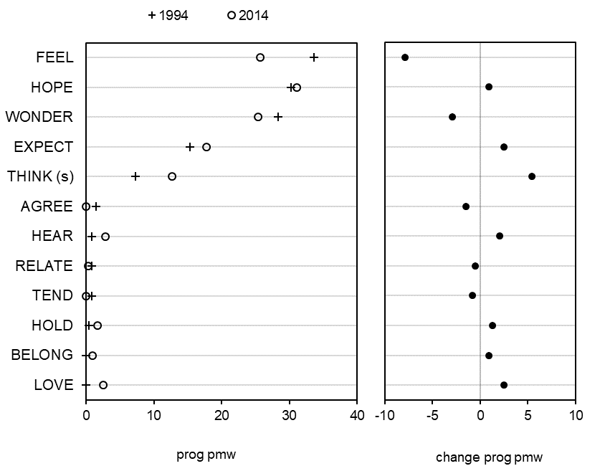

Appendix 4a. All statistically significant collexemes for BNC1994DS (‘s’=sample).
Non-progressive | Coll.strength | Progressive | Coll.strength
mean (s) | 29.6204 | wait | 128.149
hear | 25.4105 | sit | 86.493
need (s) | 25.3038 | stand | 34.089
like (s) | 24.8746 | lie | 30.438
remember | 24.8034 | stay | 28.4488
want (s) | 24.7637 | wear | 27.1252
be + adj (s) | 18.3499 | hang | 23.4618
love | 12.4849 | hope | 15.1438
think (s) | 10.7875 | live | 7.2151
find | 10.0545 | wonder | 5.9569
have to (s) | 9.9983 | enjoy | 4.6584
mind | 8.6550 | expect | 3.8184
sound | 7.1419 | feel | 3.2524
forget | 7.0369 | hurt | 2.9154
realis(z)e | 6.3707 | face | 2.8742
wish | 5.0840 | ache | 2.6916
see (s) | 4.9427 | rely | 1.7226
understand | 4.1694 | average | 1.4958
care | 3.9751 | itch | 1.4958
doubt | 2.6828 | long | 1.4958
smell | 2.1747
taste | 1.9497
fit | 1.8407
belong | 1.7405
have (s) | 1.5093
tend | 1.4676
agree | 1.3190

Appendix 4b. All statistically significant collexemes for BNC2014S (‘s’=sample).
Non-progressive | Coll.strength | Progressive | Coll.strength
remember | 36.0101 | sit | 125.8838
need (s) | 30.5845 | wait | 108.2626
mean (s) | 28.8914 | stay | 51.3208
sound | 22.7283 | wear | 42.3756
love | 22.5846 | stand | 40.09
want (s) | 22.3319 | hope | 33.819
hear | 18.7354 | live | 28.1931
like (s) | 17.9435 | expect | 16.9354
be + adj (s) | 16.8605 | wonder | 14.8471
have to (s) | 14.1361 | face | 12.6295
forget | 13.186 | lie | 11.0698
understand | 12.2449 | enjoy | 6.8292
find | 11.1829 | hang | 6.0011
realis(z)e  e | 10.4895 | intend | 2.5803
care | 9.7134 | ache | 2.4089
agree | 9.5395 | bear | 2.1331
mind | 8.7587 | bug | 2.4089
tend | 7.0039 | itch | 2.4089
see (s) | 4.5647 | hold | 2.0163
wish | 4.2844 | rely | 1.9986
look (s) | 3.6197 | afford | 1.5053
own | 3.4383 | hurt | 1.4485
taste | 3.1558
think (s) | 3.075
have (s) | 2.4268
smell | 2.1965
doubt | 1.9303
fit | 1.7539
imagine | 1.4585

Appendix 5. Changes in the semantic categories in BNC1994DS and BNC2014S.
Semantic category |  | Prog (pmw) | Non-prog (pmw) | Prog% of all | Log likelihood | %DIFF
Cognitive | 1994 | 161 (61.5) | 6335 (2420.4) | 2.48% | 8.44** | +32.86
 | 2014 | 280 (79.1) | 8223 (2323.8) | 3.29%
Relational | 1994 | 60 (22.9) | 3123 (1193.2) | 1.89% | 0.10 | -5.43
 | 2014 | 74 (20.9) | 4077 (1152.1) | 1.78%
Perception | 1994 | 122 (46.6) | 3191 (1219.2) | 3.68% | 9.54** | -33.61
 | 2014 | 106 (30.0) | 4230 (1195.4) | 2.44%
Affective | 1994 | 156 (59.6) | 3623 (1384.3) | 4.13% | 0.18 | +4.54
 | 2014 | 232 (65.6) | 5144 (1453.7) | 4.32%
Stance | 1994 | 704 (269.0) | 1220 (466.1) | 36.59% | 5.48* | -11.02
 | 2014 | 953 (269.3) | 1974 (557.8) | 32.56%

Appendix 6. Diachronic change in collocations strength by verb semantic category.
Semantic category |  | Pref.occur | Coll.strength
Cognitive | 1994 | nonprog | 66.3748
 | 2014 | nonprog | 53.9399
Relational | 1994 | nonprog | 38.2307
 | 2014 | nonprog | 53.0551
Perception | 1994 | nonprog | 13.6108
 | 2014 | nonprog | 39.3348
Affective | 1994 | nonprog | 11.1289
 | 2014 | nonprog | 13.9271
Stance | 1994 | prog | Inf
 | 2014 | prog | Inf

