Appendix B.
Maps

Paris

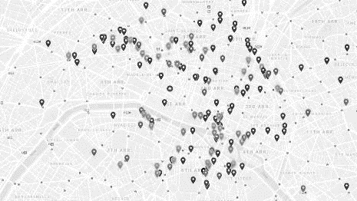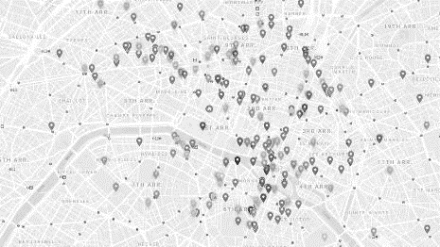
Map 1. Paris. Issues 1-90 (1872-1879) Map 2. Paris. Issues 91-190 (1879-1887)

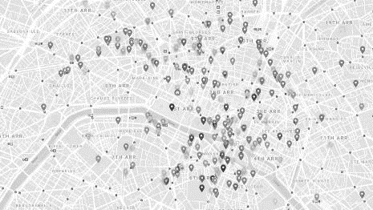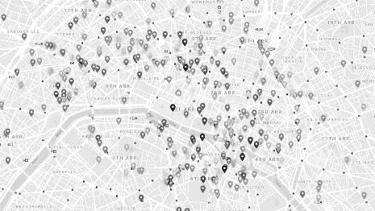
Map 3. Paris. Issues 191-290 (1887-1896) Map 4. Paris. Issues 291-390 (1896-1904)

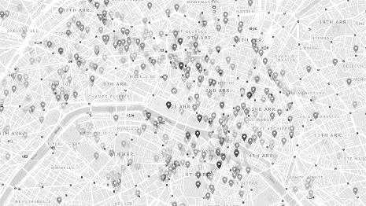
Map 5. Paris. Issues 391-500 (1904-1914)

France
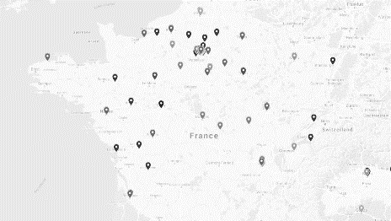 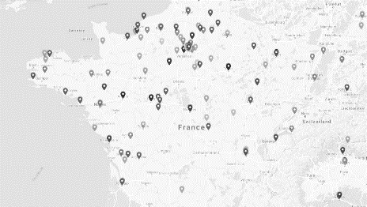Map 6. France. Issues 0-91 (1872-1879) Map 7. France. Issues 91-190 (1879-1887)

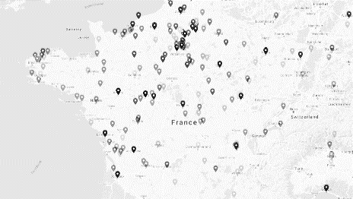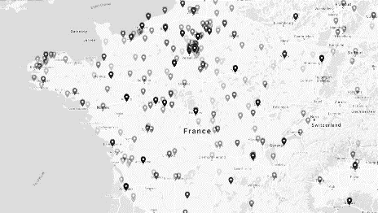
Map 8. France. Issues 191-290 (1887-1896) Map 9. France. Issues 291-390 (1896-1904)

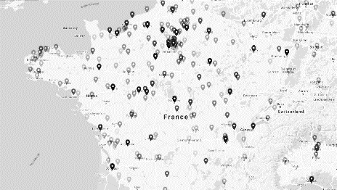
Map 10. France. Issues 391-500 (1904-1914)

Europe

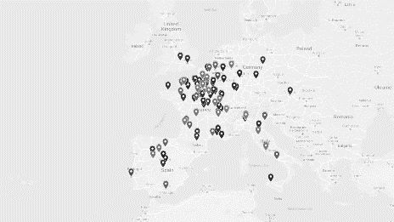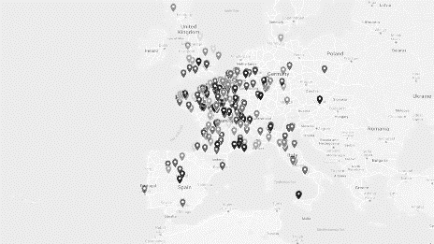
Map 11. Europe. Issues 0-91 (1872-1879) Map 12. Europe. Issues 91-190 (1879-1887)

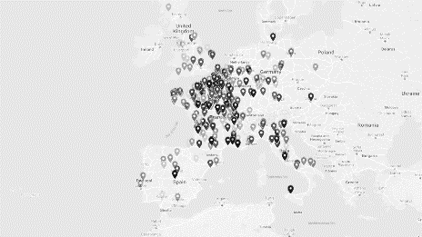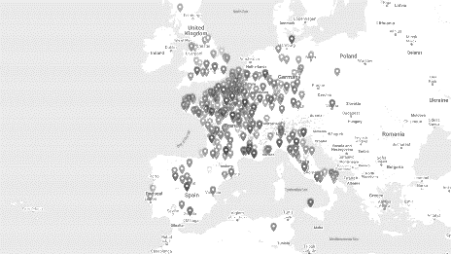
Map 13. Europe. Issues 191-290 (1887-1896) Map 14. Europe. Issues 291-390 (1896-1904)

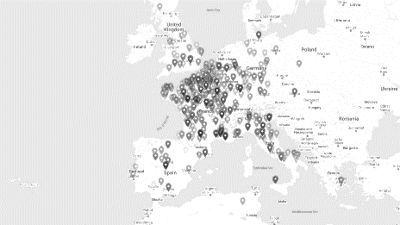
Map 15. Europe. Issues 391-500 (1904-1914)

