**Examining the impact of conservation agriculture on environmental efficiency among maize farmers in Zambia**

ABDUL-NAFEO ABDULAI

*Department of Food Economics and Consumption Studies, University of Kiel, Germany. Email: anabdul@food-econ.uni-kiel.de*

AWUDU ABDULAI, Corresponding Author

*Department of Food Economics and Consumption Studies, University of Kiel, Johanna-Mestorf-Str. 5, 24118 Kiel, Germany. Tel: +49 431 880 4426. Email:* [*aabdula@food-econ.uni-kiel.de*](mailto:aabdula@food-econ.uni-kiel.de)

**ONLINE APPENDIX**

**Nitrogen Index Tier Zero (NITZ) tool**

The NITZ is a simple user-friendly tool that conducts a quick assessment of the effects of nitrogen fertilizer or manure management practices without using any laboratory data inputs. Depending on project needs and level of complexity, a tier classification system has been developed within the NITZ (Delgado *et al*., 2008, 2011; Saynes *et al*., 2014).[1] Figure A1 displays quantitative and qualitative results of the NITZ (see Saynes *et al*., 2014 for details on the implementation of the NITZ).[2] Total nitrogen in the system is calculated as the sum of both inorganic and organic nitrogen from all sources in the system. These include initial soil nitrogen, atmospheric added nitrogen and liquid nitrogen added through irrigation and dry matter nitrogen from organic and inorganic sources.[3]

Above ground uptake indicated in figure A1 is estimated from the NITZ as the product of crop yield and the quantity of nitrogen used per unit of output. Farm level quantities of nitrogen fertilizers were readily available to implement the NITZ tool. The NITZ explicitly splits the quantity of nitrogen applied into nitrogen in the output and nitrogen surplus, hence complying with the material balance principle. Generally, Zambian maize farmers, and the farmers in the sample in particular, apply D-Compound (10-20-10) as basal and urea as top dress (IFDC, 2013). The D-compound and urea fertilizers contain 10 per cent and 46 per cent nitrogen, respectively. Given that there are no differences in atmospheric and other nitrogen deposition sources between adopters and non-adopters, we limit the nitrogen quantities to only quantities applied in the 2012 production season. We use rainfall data from the Climate Change Knowledge Portal of the World Bank Group in the NITZ. We also adopt soil type bulk density in the estimation process (e.g., 1.4 for loam soils). In line with the farming practices in Zambia, while non-CA farmers adopt surface placement, CA farmers incorporate fertilizers in the soil.

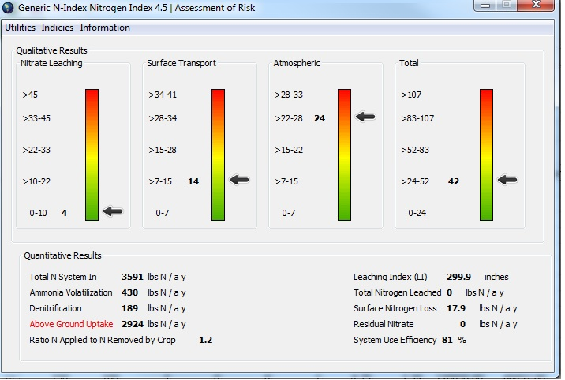

Figure A1. *Assessment screen of the Nitrogen Index Tier Zero tool with both qualitative and quantitative results*

*Source*:Authors’ estimates

|  |  |  |
| --- | --- | --- |
| Table A1.  *Propensity score for CA technology adoption* | | |
| *Variable* | *Coeff.* | *S.E.* |
| Constant | −3.855*** | 1.150 |
| Age | 0.009 | 0.014 |
| Education | 0.112* | 0.066 |
| Household size | −0.051 | 0.093 |
| Credit | 3.126*** | 0.396 |
| extension | 2.895*** | 0.425 |
| loam | −0.130 | 0.341 |
| Season | 0.326 | 0.338 |
| Market distance | −0.055 | 0.054 |
| Farm size | −0.123 | 0.095 |
| seed | 0.012** | 0.006 |
| Machinery | −0.802 | 0.803 |
| East | −0.518 | 0.584 |
| West | −0.567 | 0.492 |
| South | −0.248 | 0.505 |
| Log likelihood | −37.281*** |  |
| Pseudo *R*² | 0.867 |  |
| No. of observations | 407 |  |

*Notes*: Coefficients followed by *, ** and *** indicate significance at the 10%, 5% and 1% levels, respectively.



Figure A2. *Density plot of the propensity scores for adopters and non-adopters*

**References**

Delgado, J.A., M. Shaffer, C. Hu, *et al*. (2008), ‘An index approach to assess nitrogen losses to the environment’, *Ecological Engineering* **32**:108–120.

Delgado, J.A., P.M. Groffman, M.A. Nearing, *et al*. (2011), ‘Conservation practices to mitigate and adapt to climate change’, *Journal of Soil and Water Conservation* **66**: 118A–129A.

IFDC (International Fertiliser Development Centre) (2013), *Zambia Fertiliser Assessment*. In support of the African Fertiliser and Agribusiness Partnership, USA.

Saynes, V., J.A. Delgado, C. Tebbe, J.D. Etchevers, D. Lapidus, and A. Otero-Arnaiz (2014), ‘Use of the new Nitrogen Index Tier Zero to assess the effects of nitrogen fertiliser on N2O emissions from cropping systems in Mexico’, *Ecological Engineering* **73**: 778–785.

Shaffer, M.J. and J.A. Delgado (2002), ‘Essentials of a national nitrate leaching index assessment tool’, *Journal of Soil and Water Conservation* **57**: 327–335.

1. Complex models are tier three tools, while simpler models are tier two and one tools (Shaffer and Delgado, 2002; Delgado *et al*., 2008).
2. In consultation with the developers of the Nitrogen Index Tier Zero tool, we use the regional N-Index Malawi.
3. For the purpose of this study, we consider only nitrogen fertilizer applications in 2012.