Land inequality and deforestation in the Brazilian Amazon

André Albuquerque SANT'ANNA, Corresponding Author
Brazilian Development Bank (BNDES) and Universidade Federal do Rio de Janeiro (UFRJ); Av. Chile, 330, 13th floor. Rio de Janeiro, RJ, 20031-170, Brazil. Email: andre.santanna@bndes.gov.br

Online Appendix

A. Conceptual framework in a graphic version
The model presented in the paper can be translated into a graphic version. In figure A.1, all the main features of the model are present. As figure A.1 demonstrates, land inequality determines the amount of accessible land. The maximum of land that can be used for farming, L^{F}, in turn, is, ceteris paribus, the determinant of the wealth threshold, W₂. Above that threshold, the individual will decide to clear land and not to farm. From figure A.1, if land inequality increases, the wealth threshold W₂ moves down and there is an increase in deforestation.
It is also possible to devise the impacts of a policy shift that increases the cost of deforestation, for example. This translates into a decrease in the relative return of deforestation, which leads to an increase in the slope of the curve. In such a framework, there is an increase in the wealth threshold, W_{2,} and therefore a decrease in the rate of deforestation.

B. Proof of Proposition 1
The effects on deforestation are driven by the effects on the wealth threshold, W₂. A higher W₂ implies less demand for deforestation. Thus, it is sufficient to analyze the determinants of W₂. Record that:

It is, therefore, straightforward that

On the other hand,

As wage increases, there will be a point where w>r_{L}pL^{F}. If such a situation occurs, the relevant wealth threshold becomes W₁. At that point, the effect of wages on deforestation is negative.

C. Descriptive statistics
Table A.1 shows descriptive statistics of the variables used in the empirical model. Table A.1 is divided into two panels with two distinct periods: 2002-2005 and 2006-2011. As already discussed, this division represents the policy shift that occurred in command and control policies in Brazil.
Comparing Panel A and Panel B, table A.1 shows that there was a significant decline in deforestation rates as a share of total municipality area from the first period to the second. Besides deforestation, only settled areas for land reform have declined from 2002-2005 to 2006-2011. On the other hand, heterogeneity across municipalities has increased with the exception of rainfall and, again, of settlements. As regards land inequality, as measured by the Composed Gini index, it shows stability between the two periods. This reflects a structural feature of the Brazilian economy that has not been fully addressed.

D. Choice of the variable related to land distribution
Land concentration may act as a push factor, expelling workers without opportunities to access land in a given municipality. Thus, it is expected that land concentration in municipality j affects deforestation in municipality i. In order to account for this spatial pattern, a variable has been used that considers these effects of land inequality in other localities. The measure of migration-weighted land concentration for municipality i is based on the municipalities of origin of its migrants.
In the paper, two possible variables related to migration are provided. Nevertheless, I argue for the use of the Composed_Gini as the Gini_Migrants, as it takes account of the number of migrants that might suffer from potential endogeneity problems. As relates to the Composed_Gini, it can be argued that the number of municipalities sending migrants to each municipality in the Amazon is quite large and, therefore, endogeneity problems are not expected to arise. Table A.1 shows the number of municipalities that sent migrants to Amazon’s municipalities.

W
i
w/(q-w)
W₃
W₂
deforest
farmer
worker
L^{F}
slope: r_{L}p/(r_{D}+g_{D})

Figure A.1

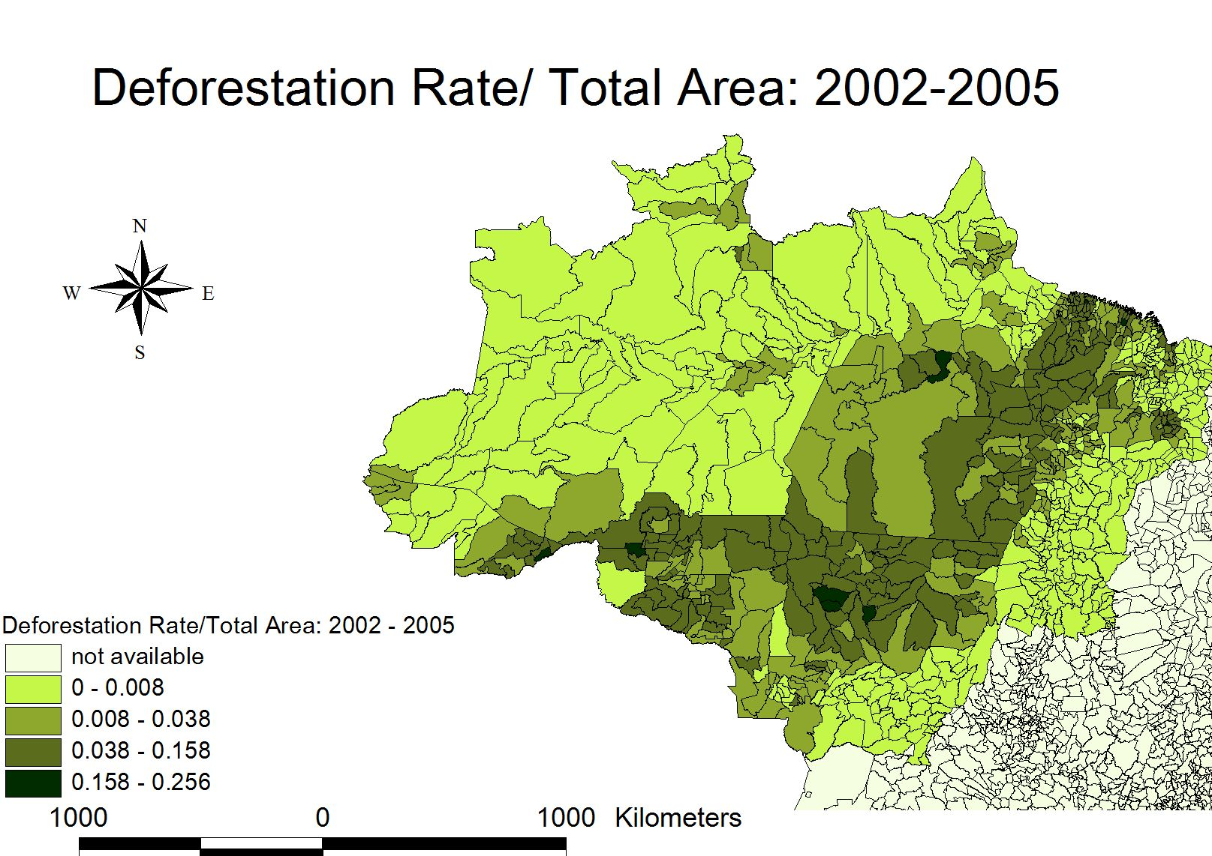

Figure A.2
Source: author’s own elaboration.

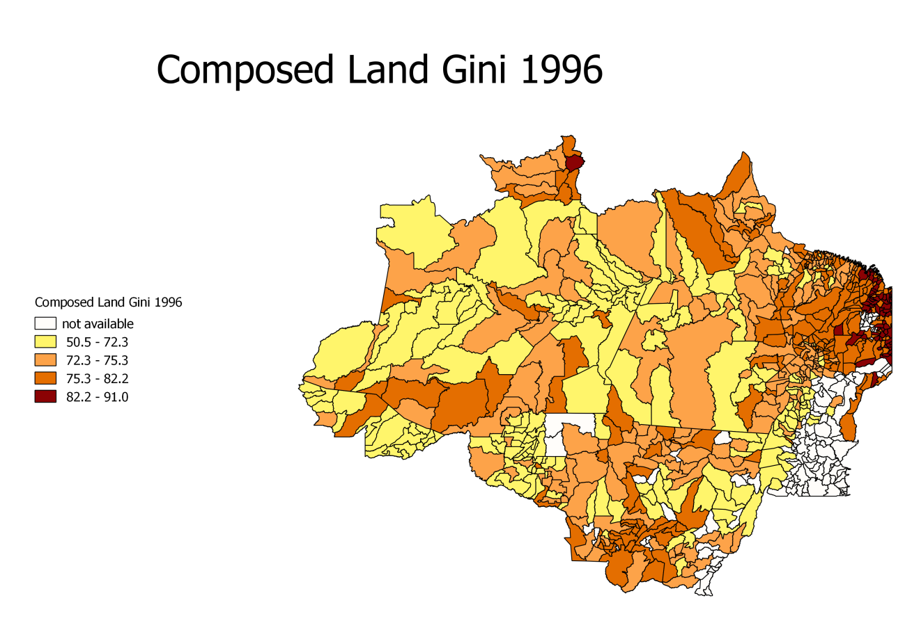
Figure A.3
Source: author’s own elaboration.

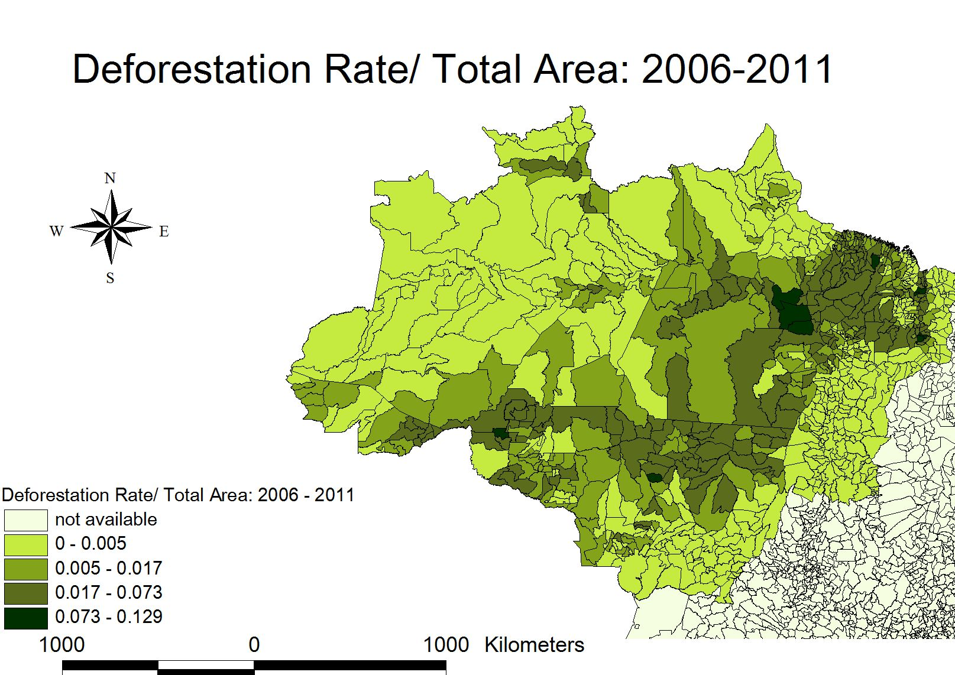

Figure A.4

Source: author’s own elaboration

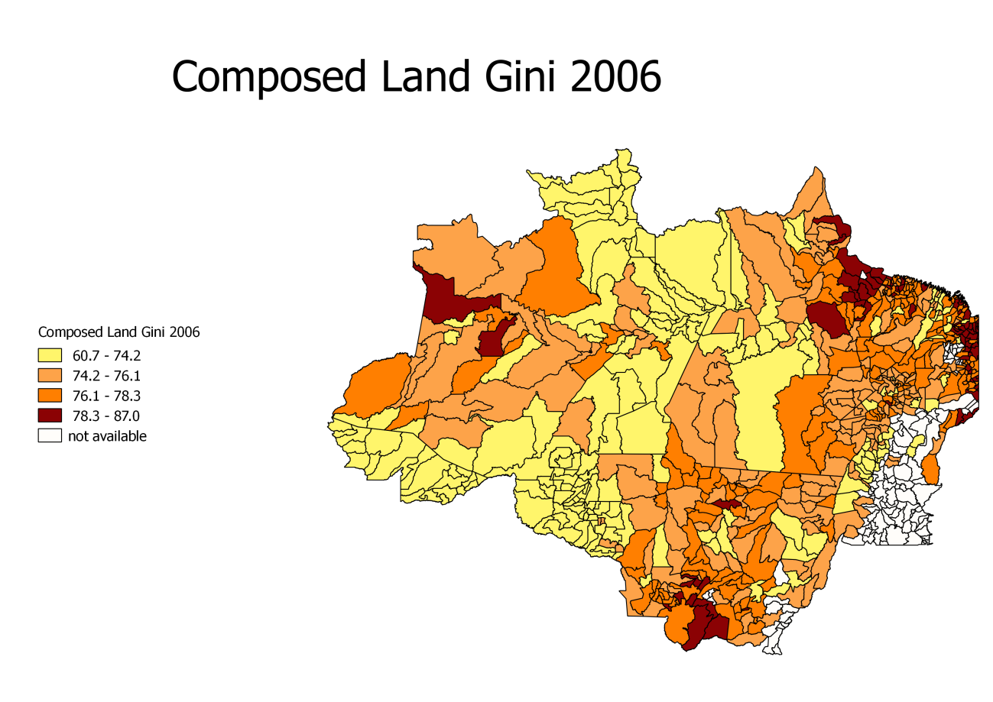
Figure A.5
Source: author’s own elaboration.

Table A.1. Summary statistics

VARIABLES | N | mean | sd | min | max
Panel A: 2002-2005
Ln (Deforestation_0205) | 626 | -4.342 | 1.769 | -10.39 | -1.363
Composed_Gini_95 | 636 | 74.77 | 4.839 | 50.53 | 88.72
Credit_area_05 | 627 | 6.752 | 1.863 | -0.596 | 11.06
Settlements_05 | 636 | 0.956 | 3.116 | 0 | 45.41
Cattle_prices_05 | 645 | 2.177 | 1.929 | -6.282 | 4.996
Ln(Rain_05) | 651 | 7.501 | 0.226 | 6.964 | 8.092
Ln(Temperature_05) | 651 | 3.261 | 0.0479 | 2.9 | 3.352
Altitude | 651 | 152.1 | 134.1 | 1 | 912.1
Composed Idle_land_85 | 636 | 5.977 | 3.702 | 0.409 | 17.35
N_municipalities_mig_00 | 636 | 56.3 | 61.105 | 3 | 540
Panel B: 2006-2011
Ln(Deforestation_0611) | 626 | -5.011 | 1.617 | -10.89 | -2.050
Composed_Gini_05 | 651 | 75.18 | 3.148 | 60.69 | 83.03
Credit_area_11 | 642 | 7.111 | 1.823 | -2.302 | 10.49
Settlements_11 | 636 | 0.593 | 2.211 | 0 | 36.12
Cattle_prices_11 | 648 | 2.492 | 1.973 | -6.161 | 5.393
Ln(Rain_11) | 651 | 7.588 | 0.245 | 7.078 | 8.227
Ln(Temperature_11) | 651 | 3.264 | 0.0476 | 2.934 | 3.359
Altitude | 651 | 152.1 | 134.1 | 1 | 912.1
Composed Idle_land_95 | 651 | 3.476 | 2.308 | 0.083 | 11.75
N_municipalities_mig_00 | 651 | 95.7 | 89.404 | 6 | 809

