“Environment and Development Economics appendix for ‘Accounting for carbon in avoided degradation and reforestation programmes in Mediterranean forests”

Alejandro Caparrós, Paola Ovando, José L. Oviedo and Pablo Campos

December, 21 2009

“Note: The material contained herein is supplementary to the article named in the title and published in the Environment and Development Economics Journal”

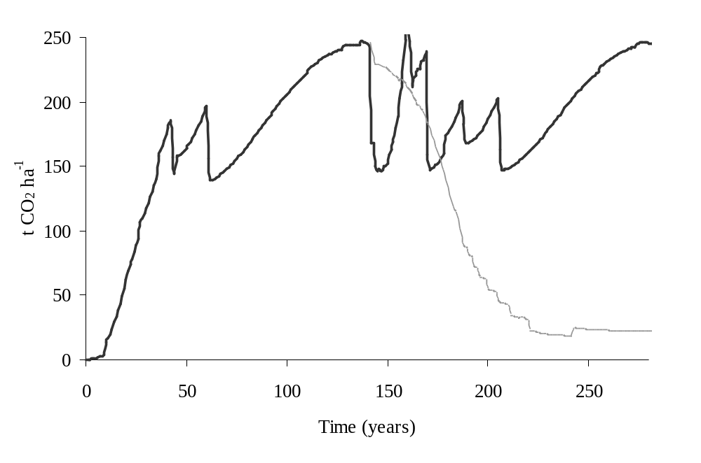
Reforestation or avoided degradation
Degradation
Reforestation
Degradation/avoided degradation

Source: Own elaboration based on Montero et al. (2003 and 2006).

Figure A.1. Carbon sequestration in reforestation and in degradation or avoided degradation scenarios for cork oaks in Monfragüe (Spain)

Characteristics | CHOICE 5 (Code 5)
Biodiversity (tree species used, including cork oak trees) | 4 native species  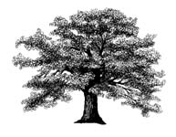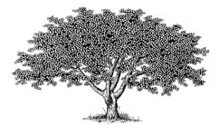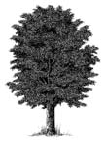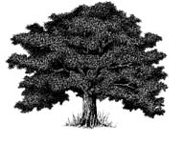 |  |  | 1 native species |  |  | No reforestation
Technique employed | Artificial plantation |  |  | Natural Regeneration |  |  | None
Recreational areas created | 2 recreational areas | 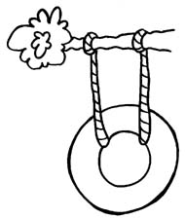 |  | None |  |  | None
Additional employees (equivalent permanent employees) | 20 employees   |  |  | 20 employees |  |  | None
Forestry surface area conserved (forest cover in black) | 100% current  (mantain the same) |  |  | 90% current  (reduction 10%) |  |  | 80% current  (reduction 20%) | 
Increase in taxes for this year | 24 euros  (4,000 pesetas) |  |  | 6 euros  (1,000 pesetas) |  |  | 0 euros
Mark ONLY ONE OPTION (A, B or C) | Option A |  |  | Option B |  |  | Option C

Figure A.2. Example of a choice set

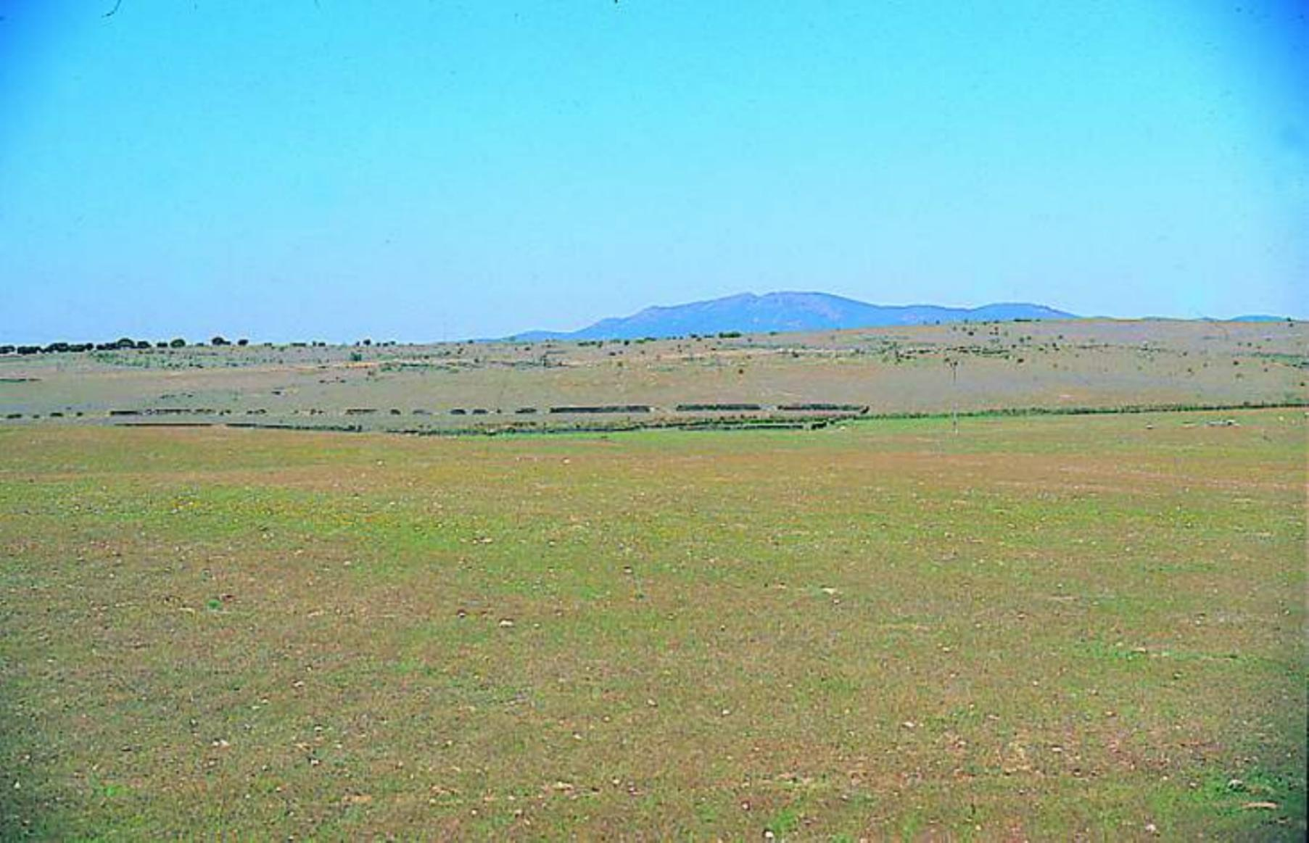  a) Pasturelands | 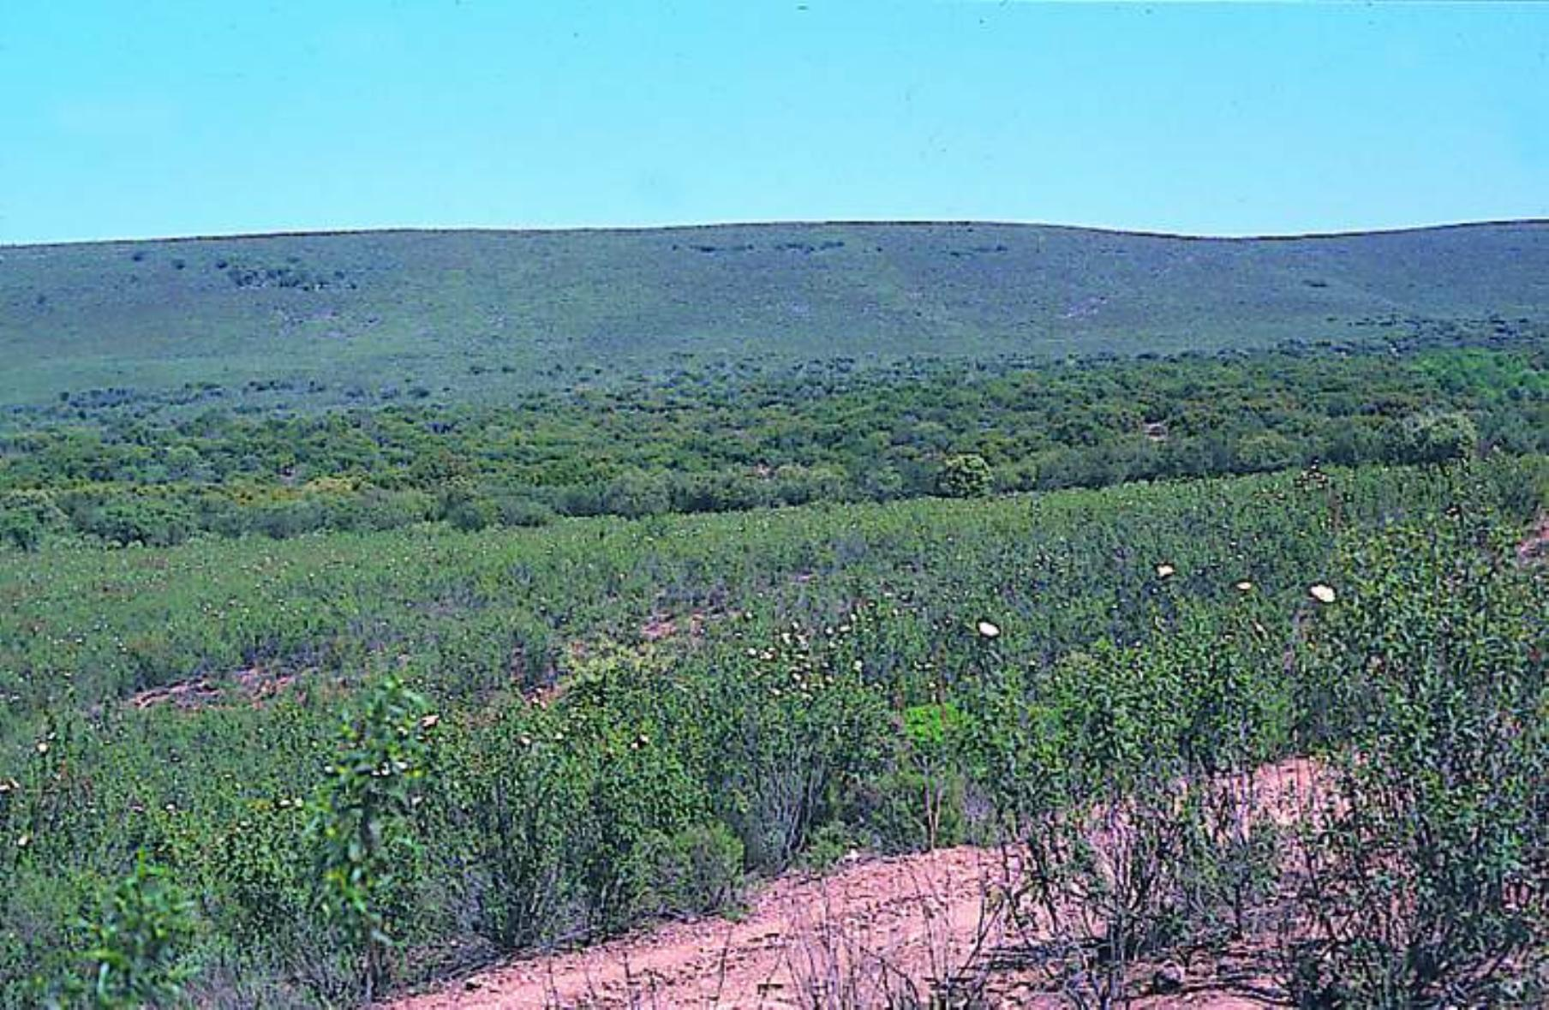  b) Scrubland
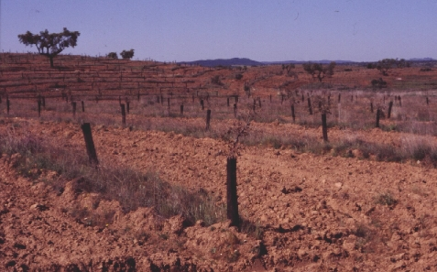  c) Initial appearance of the artificial plantation | 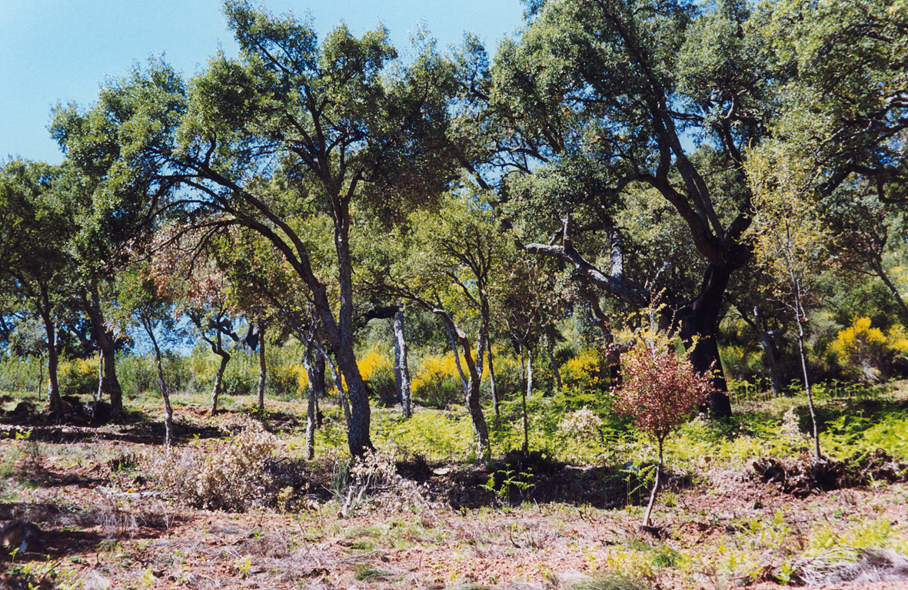  d) Initial appearance of the regeneration treatment
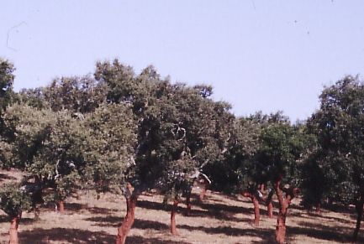  e) Appearance of the forest after 60 years | 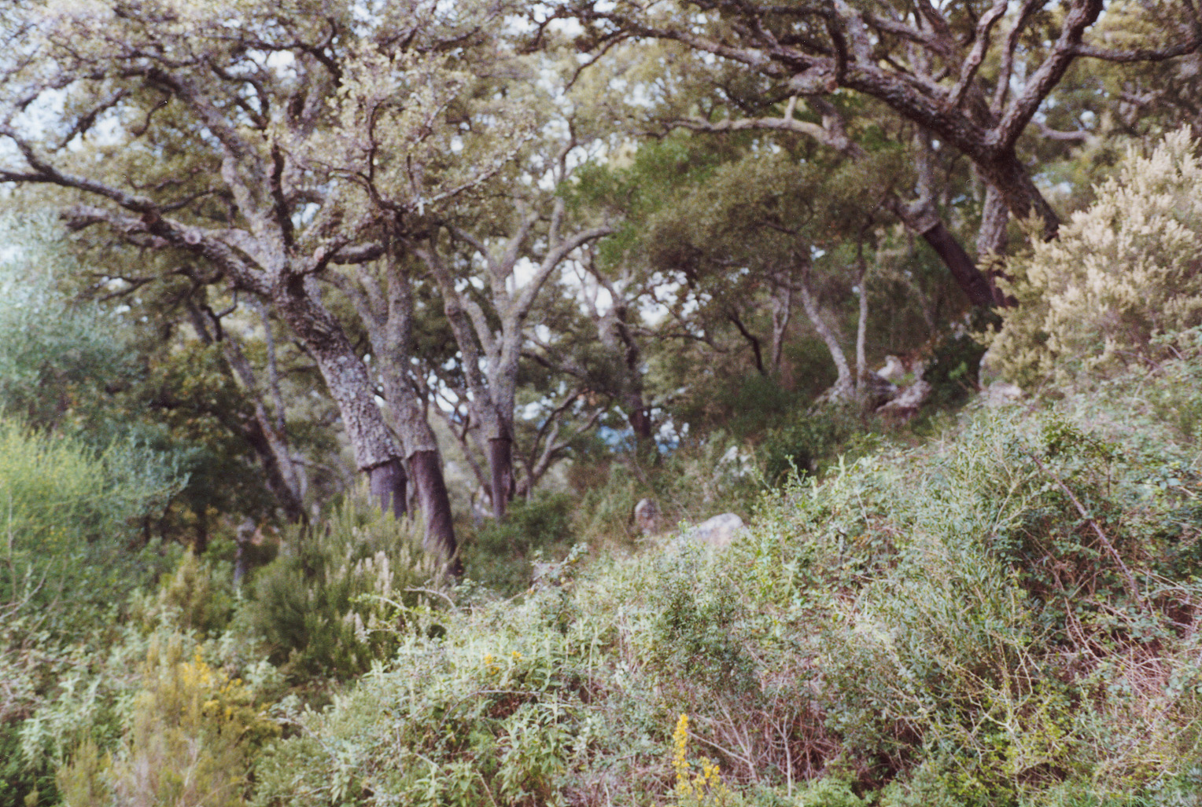  f) Appearance of the forest after 100 years

Figure A.3. Photographs featured in the booklet to explain the reforestation/avoided degradation process

Table A.1 Carbon budget over a 100-year period for avoided degradation (t CO₂ ha⁻¹)
Class ⁽¹⁾ | Avoided degradation |  |  |  |  |  | Non-regeneration scenario |  |  |  | Net CO₂ gains
Class ⁽¹⁾ | Biomass |  | Emission savings | Fossil fuel emissions | Total |  | Biomass |  | Fossil fuel emissions | Total | Net CO₂ gains
Class ⁽¹⁾ | Live | Dead | Emission savings | Fossil fuel emissions | Total |  | Live | Dead | Fossil fuel emissions | Total | Net CO₂ gains
CFM
Cork oaks
Aljibe (Spain) | -51,0 | -13,6 | 53,5 | -16,5 | -27,5 |  | -166.1 | 49.5 | -8.2 | -124.8 | 97.3
Monfragüe (Spain) | -44,0 | 2,6 | 74,4 | -4,8 | 28,2 |  | -194.2 | 4.8 | -16.2 | -205.6 | 233.8
Ain Snoussi (Tunisia) | 26,0 | 22,4 | 42,9 | -8,1 | 83,2 |  | -95.9 | 28.6 | -5.5 | -72.8 | 156.0
Holm oaks
Monfragüe (Spain) | -5,5 | 4,4 | 83,2 | -12,1 | 70,0 |  | -303.5 | 12.3 | -4.7 | -295.8 | 365.8
TYAM
Cork oaks
Aljibe (Spain) | 316,1 | 90,9 | 53,5 | -16,5 | 444.0 |  | 195.1 | 79.9 | -8.2 | 266.8 | 177.2
Monfragüe (Spain) | 248,6 | 78,5 | 74,4 | -4,8 | 396.7 |  | 177.1 | 25.3 | -16.2 | 186.2 | 210.5
Ain Snoussi (Tunisia) | 320,8 | 60,1 | 42,9 | -8,1 | 415.7 |  | 43.3 | 65.3 | -5.5 | 103.1 | 312.6
Holm oaks
Monfragüe (Spain) | 359,7 | 91,7 | 83,2 | -12,1 | 522.5 |  | 304.3 | 31.5 | -4.7 | 331.1 | 191.4
⁽¹⁾ CFM: Carbon flow method; TYAM: Ton year accounting method.
Table A.2 Welfare measures from the random parameters logit models. Parametric and bootstrapping measures
Attributes | Parametric |  |  |  | Bootstrapping
Attributes | Model I | Model II | Model III |  | Model I |  | Model II |  | Model III
Attributes | Mean (median) | Mean (median) | Mean (median) |  | Mean | Median | Mean | Median | Mean | Median
ASC | 264.60*** | 371.26*** | 257.70*** |  | 268.55*** | 264.88 | 375.47*** | 377.16 | 257.66*** | 260.48
 | [170.96 , 358.23] | [141.88 , 600.64] | [155.78 , 359.62] |  | [166.92 , 405.12] |  | [109.87 , 622.44] |  | [154.95 , 362.29]
ASC*INC |  |  | 0.03*** |  |  |  |  |  | 0.03*** | 0.03
 |  |  | [0.01 , 0.05] |  |  |  |  |  | [0.01 , 0.05]
BIO1 | -30.48*** | -34.14*** | -32.82*** |  | -31.02*** | -30.49 | -34.30*** | -34.32 | -32.96*** | -32.98
 | [-35.64 , -25.33] | [-40.51 , -27.77] | [-39.03 , -26.61] |  | [-39.29 , -26.06] |  | [-41.50 , -27.49] |  | [-39.70 , -27.02]
BIO2 | -6.47*** | -8.38*** |  |  | -6.74*** | -6.50 | -8.58*** | -8.51
 | [-9.82 , -3.11] | [-12.21 , -4.55] |  |  | [-12.36, 3.56] |  | [-13.54 , -4.51]
BIO2*INC |  |  | 0.00*** |  |  |  |  |  | 0.00*** | 0.00
 |  |  | [-0.01 , 0.00] |  |  |  |  |  | [-0.01 , 0.00]
BIO3 | 12.23*** | 12.93*** | 12.45*** |  | 12.31*** | 12.14 | 13.02*** | 13.01 | 12.48*** | 12.47
 | [8.99 , 15.47] | [9.02 , 16.84] | [8.53 , 16.36] |  | [8.77 , 16.81] |  | [8.64 , 17.56] |  | [8.31 , 16.77]
TEC | 18.24*** | 16.72*** | 15.56*** |  | 18.48*** | 18.23 | 16.67*** | 16.62 | 15.55*** | 15.49
 | [15.31 , 21.17] | [13.06 , 20.38] | [11.96 , 19.15] |  | [15.50 , 23.07] |  | [12.59 , 20.77] |  | [11.52 , 19.48]
TEC*REA |  | 10.91*** | 10.29*** |  |  |  | 11.07*** | 11.13 | 10.44*** | 10.33
 |  | [5.57 , 16.24] | [4.88 , 15.70] |  |  |  | [4.93 , 17.10] |  | [4.82 , 16.23]
REC | 19.02*** | 20.46*** | 15.47*** |  | 19.42*** | 19.02 | 20.68*** | 20.56 | 15.36*** | 15.51
 | [14.70 , 23.33] | [15.45 , 25.46] | [7.68 , 23.26] |  | [14.95 , 26.48] |  | [15.70 , 26.05] |  | [6.79 , 23.14]
REC*REA |  |  | -19.44*** |  |  |  |  |  | -19.47*** | -19.46
 |  |  | [-29.67 , -9.22] |  |  |  |  |  | [-31.39 , -9.03]
REC*SUS |  |  | 15.94*** |  |  |  |  |  | 16.05*** | 16.01
 |  |  | [6.50 , 25.39] |  |  |  |  |  | [6.33 , 25.79]
EMP | 1.16*** | 1.26*** | 0.63*** |  | 1.18*** | 1.17 | 1.26*** | 1.27 | 0.63*** | 0.63
 | [0.72 , 1.61] | [0.73 , 1.79] | [-0.70 , 1.96] |  | [0.68 , 1.70] |  | [0.72 , 1.88] |  | [0.50 , 0.77]
EMP² | -0.01** | -0.01* |  |  | -0.01** | -0.01 | -0.01* | -0.01
 | [-0.01 , 0.00] | [-0.01 , 0.00] |  |  | [-0.01 , 0.00] |  | [-0.01 , 0.00]
EMP*ATT |  |  | 0.65** |  |  |  |  |  | 0.66** | 0.64
 |  |  | [0.09 , 1.22] |  |  |  |  |  | [0.11 , 1.31]
SUR | 2.38*** | 2.80*** | 2.54*** |  | 2.40*** | 2.37 | 2.80*** | 2.81 | 2.54*** | 2.54
 | [1.82 , 2.94] | [2.09 , 3.52] | [1.86 , 3.22] |  | [1.81 , 3.19] |  | [1.99 , 3.61] |  | [1.77 , 3.36]
SUR² | -0.02*** | -0.02*** | -0.02*** |  | -0.02*** | -0.02 | -0.02*** | -0.02 | -0.02*** | -0.02
 | [-0.03 , -0.01] | [-0.03 , -0.01] | [-0.03 , -0.01] |  | [-0.03 , 0.01] |  | [-0.03 , -0.01] |  | [-0.03 , -0.01]
AR hicksian surplus | 301.61*** | 414.62 | 335.17*** |  | 306.03*** | 301.65 | 418.84*** | 422.25 | 334.31*** | 334.86
 | [206.25 , 396.98] | [185.92 , 643.32] | [220.70 , 449.64] |  | [201.95 , 448.58] |  | [152.25 , 672.70] |  | [221.10 , 444.01]
AD hicksian surplus | 336.81*** | 453.36 | 371.27** |  | 341.67*** | 337.22 | 457.59*** | 459.98 | 370.49*** | 370.11
 | [239.82 , 433.80] | [222.71 , 684.01] | [254.83 , 487.72] |  | [239.54 , 491.27] |  | [191.44 , 705.63] |  | [254.65 , 483.14]
Asterisks (e.g.,*,**,***) denote significance at the 10%, 5%, and 1% level, respectively.

