Online Appendix for Environment and Development Economics:
Energy Savings via FDI? Empirical Evidence from Developing Countries,
Michael Hübler and Andreas Keller
Section 2.2
Figure A1 Trends of the variables in the simplified model with 20 countries, 1979-2003
Energy intensity FDI as a fraction of total investment
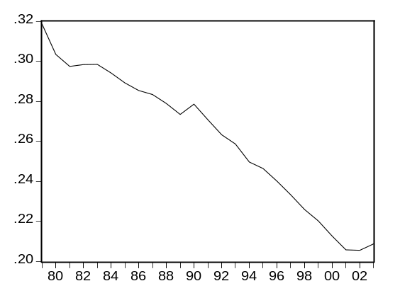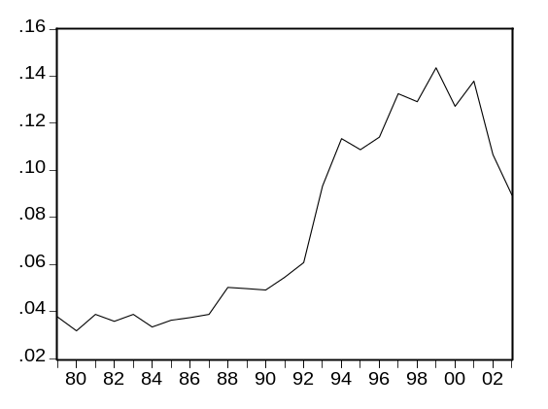
Table A1 Unit root test statistics (Augmented Dickey Fuller) for the variables in the simplified model
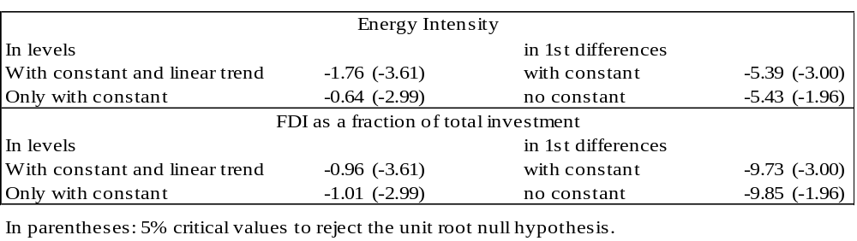
Table A2 Johansen cointegration test of the variables in the simplified model
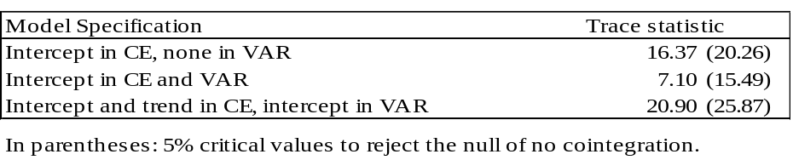
Section 3
Detailed data description
Table A3 gives an overview on the data that is used in our empirical estimations. The large differences between the minimal and maximal values of the variables in the sample indicate an obvious heterogeneity of countries and years. For instance, per capita income YPC ranges from about 485 to 23,266 dollars in PPP. The heterogeneity of countries is also apparent from the rising, falling and undefined time trends of energy intensity and foreign direct investment. Figures A2 and A3 visualize that in graphs of four typical countries of the sample. It is also noteworthy that some countries exhibit negative FDI inflows in certain years. This can for instance be the case when foreign companies withdraw from the market or disinvest.
Table A3 Descriptive statistics of the sample of 60 developing countries in 1975-2004
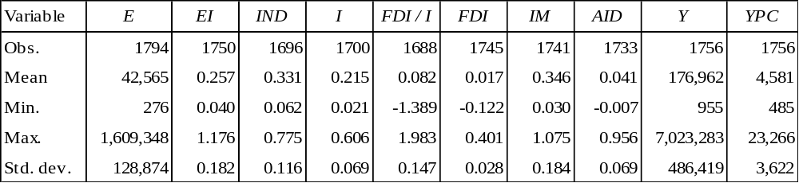
Obs. = number of available observations, which differs between variables; std. dev. = standard deviation.
Figure A2 Time trends of energy intensity 1975-2004 in four countries of the sample
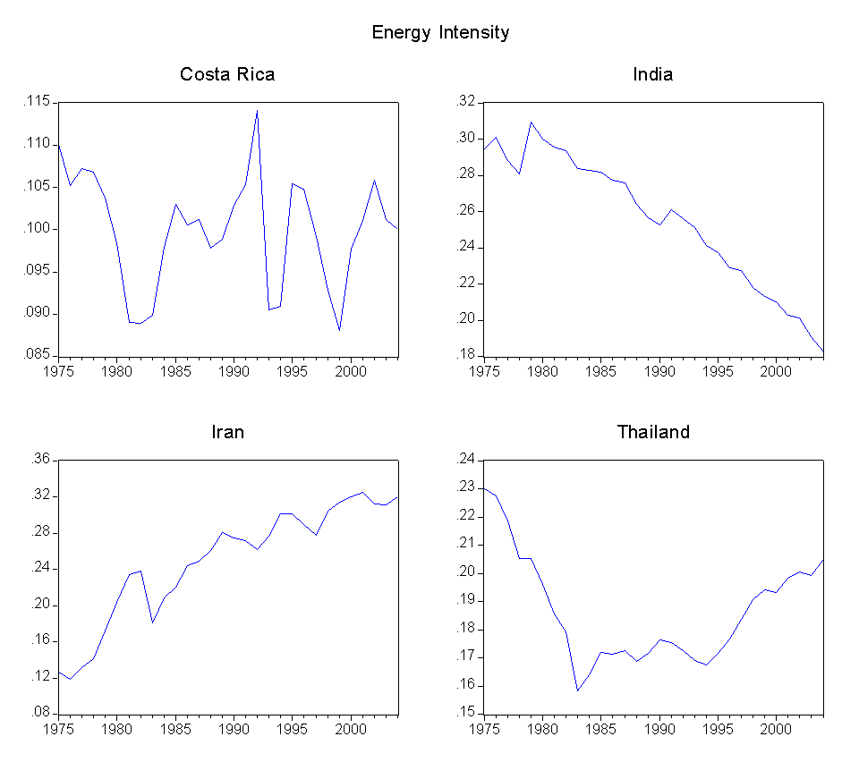
Figure A3 Time trends of FDI in percent of GDP 1975-2004 in four countries of the sample
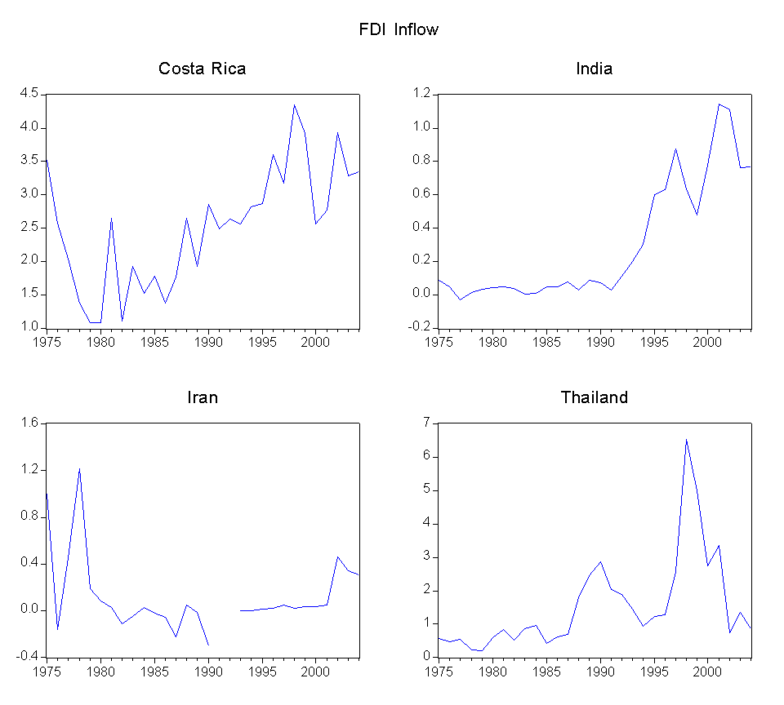
The following paragraphs describe obvious trends of important variables revealed by a closer look at the distinct time series.
As expected, GDP (in PPP), denoted by Y, rose during this period in all countries. A number of countries show a continuous increase, for example China, India and Pakistan. While India’s and Pakistan’s GDP expanded during these 30 years by a factor of almost 5, China’s GDP exploded by a factor of 13. However, there are economies with tremendous GDP fluctuations such as Nicaragua or Peru. In many countries YPC, income per capita, grew in a similar way as total GDP, but this is not necessarily the case. Nicaragua and Venezuela for instance show a falling trend, other countries’ income per capita fluctuated around a constant level.
Since increasing production and consumption reflected by GDP growth lead to higher energy demand, it is not surprising that total primary energy supply E clearly rose in all countries as well. While most countries’ total energy use increased in a smooth continuous way, some countries like Peru and Uruguay show large fluctuations. Such energy use and GDP changes might stem from political disturbances or other economic shocks, which cannot be captured in the econometric analysis and will probably create estimation errors. The development of energy intensities EI is ambiguous across countries. In 17 countries (including China, India and Peru) energy intensity declined. China’s energy intensity, starting from a high level in 1975, decreased by approximately 75 % until 2004. On the other hand, energy intensity increased in 21 countries (Algeria, Saudi Arabia, Iran and others). 22 countries show no obvious tendency. Having a closer look at the time series of energy use E and GDP Y, it becomes obvious in a number of cases that GDP short-time fluctuations or shocks do not correspond with proportional fluctuations of energy supply. In these cases, GDP jumps up or down while energy supply is sluggish. As a consequence energy intensity defined as E / Y moves to the opposite direction of the GDP fluctuation. This is an important observation, which has to be taken into account in the specification of the estimation models. (Another question not discussed here is the role of measurement errors and measurement difficulties.)
A number of countries (such as Bangladesh, Honduras, India, Indonesia, Republic of Korea, Senegal and Thailand) show a clearly rising share of the industry sector IND over time. Other countries (like Argentina, Oman and Zambia) have falling shares. In the remaining cases IND fluctuates or shows upward or downward trends within the time frame of the sample. In China the industry share remained relatively stable over time, reaching its maximum of 48.2 % relative to GDP in 1978 and its minimum of 41.6 % in 1990, while the 2004 share was 46.2 % of GDP.
Gross investment in absolute terms had an upward sloping tendency, and several economies had a stable continuing increase in investment during the sample period (Chile, China, India, Korea, Pakistan and others). This upward trend vanishes in many cases when looking at I, gross investment relative to GDP. Investments in China rose from 39.2 billion USD (29.4 % of GDP) in 1975 to 658.2 billion USD (38.4 % of GDP) in 2004.
Net FDI inflows (In US Dollars referring to the year 2000) show a rising tendency in most countries, especially during the 1990s. FDI relative to GDP, here labeled FDI, also rose in many countries, but this trend is less obvious than the increase in absolute FDI inflows. Some countries show periods with high fluctuations or plummeting FDI shares. FDI inflows to China increased strongly from 51 million USD (0.03 % of GDP) in 1980 to 48.7 billion USD (2.8 % of GDP) in 2003. The highest ratio of FDI to GDP (in other words the highest intensity of FDI inflows) was reached in 1993 with 6.3 %. When dividing FDI inflows by gross investment instead of GDP, the resulting time series data are very similar.
Besides FDI, imports are another indicator for the integration of a country into the world economy and a potential channel for technology transfer. Their value had an upward sloping trend between 1975 and 2004 in all countries, while periods of decline or years of plummeting imports occurred in some countries. The imports relative to a country’s GDP, denoted by IM, clearly rose only in 23 countries. The other countries show decreases in import intensities or fluctuations. China’s import value increased from roughly 6.1 billion USD (4.6 % of GDP) in 1975 to 538.5 billion USD (31.4 % of GDP) in 2004. The reception of international aid is a further potential source of international technology transfer. In contrast to FDI and trade, there is no clear trend of aid inflows when examining the time series of the 60 countries in the sample. Referring to aid inflows relative to GDP, called AID in the data set, some countries show an upward trend (e.g. Ghana) and other countries have falling aid intensities (e.g. India, Tunisia). Absolute and relative aid flows to China reached their maximum in 1993 and declined in the following years.
We conclude that there are increasing time trends of energy supply, imports and foreign as well as gross investment in accordance with GDP growth. It is difficult to observe any direct relationship between energy and these variables besides the time trend. When looking at intensities, i.e. the variables divided by GDP, a different picture with considerable heterogeneity of the 60 countries arises. An econometric analysis of this panel data may reveal whether FDI has a significant influence on energy intensity. Figure A4 visualizes the facts about the Chinese economy discussed before. Obviously FDI and international trade have played an increasingly important role. However, this effect is weaker or not detectable in other developing countries.
Figure A4 Indicators of the Chinese economy, 1975-2004
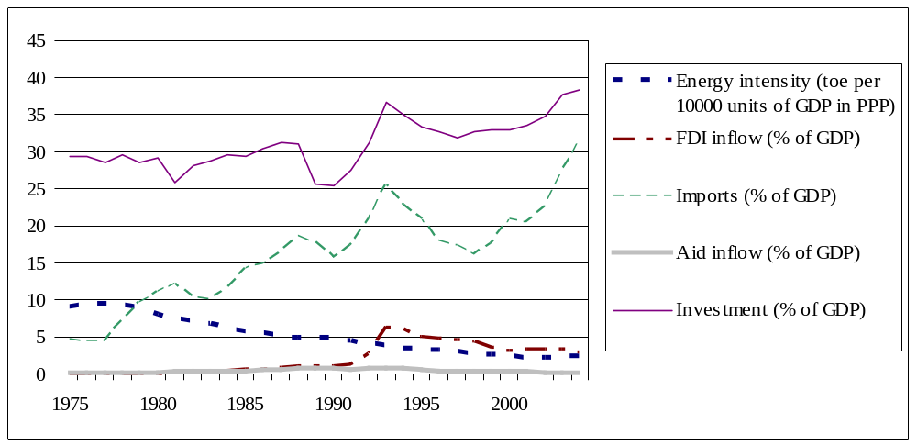

Section 3.2
Table A4 Pair wise correlations of the explanatory variables
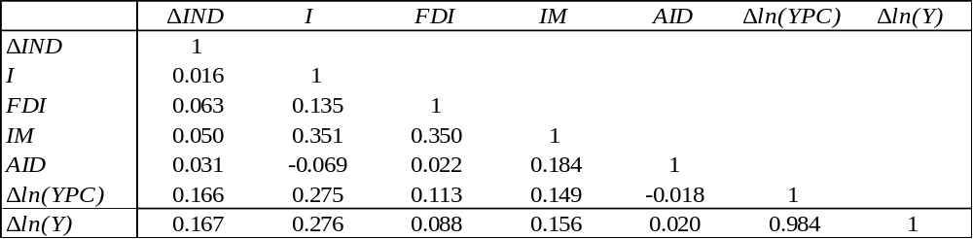
Section 4.1
Table A5 Estimation results for specifications A, B and C with M&A corrected FDI
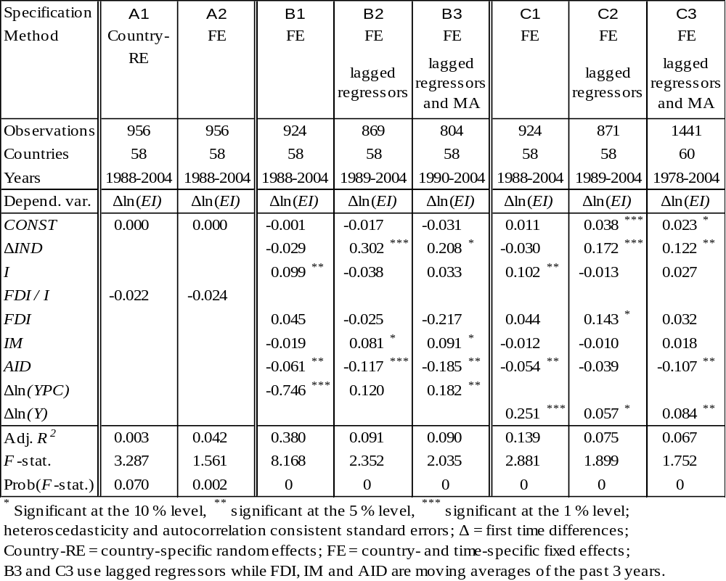
Section 4.2
Table A6 Estimation results for the sectoral dataset with the United States as source country


