Stricker Learning Span criterion validity: a remote self-administered multi-device compatible digital word list memory measure shows similar ability to differentiate amyloid and tau PET-defined biomarker groups as in-person Auditory Verbal Learning Test

Nikki H. Stricker ¹, John L. Stricker ², Ryan D. Frank ³, Winnie Z. Fan ³, Teresa J. Christianson ³, Jay S. Patel ¹, Aimee J. Karstens ¹, Walter K. Kremers ³, Mary M. Machulda¹, Julie A. Fields¹, Jonathan Graff-Radford ⁵, Clifford R. Jack, Jr. ⁴, David S. Knopman ⁵, Michelle M. Mielke ⁶, Ronald C. Petersen ⁵

Supplemental Online Resources
Journal of the International Neuropsychological Society

¹ Division of Neurocognitive Disorders, Department of Psychiatry and Psychology, Mayo Clinic, Rochester, Minnesota, USA
² Department of Information Technology, Mayo Clinic, Rochester, Minnesota, USA
³ Division of Biomedical Statistics and Informatics, Department of Quantitative Health Sciences, Mayo Clinic, Rochester, Minnesota, USA
⁴ Department of Radiology, Mayo Clinic, Rochester, Minnesota, USA
⁵ Department of Neurology, Mayo Clinic, Rochester, Minnesota, USA
⁶ Department of Epidemiology and Prevention, Wake Forest University School of Medicine, Winston-Salem, NC, USA

Corresponding Author: Nikki H. Stricker, Ph.D., Mayo Clinic, 200 First Street SW, Rochester, MN 55905; 507-284-2649 (phone), 507-284-4158 (fax), stricker.nikki@mayo.edu (email).

Copyright 2022 Mayo Foundation for Medical Education and Research.

Supplemental Figure 1. Full Pearson r correlation matrix for associations between AVLT and SLS variables.
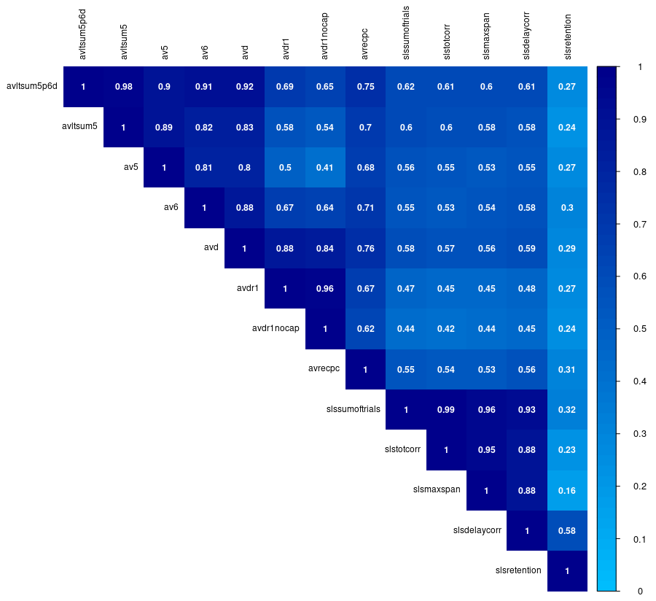
Note. All correlations are significant (p’s <0.001). AVLT = Auditory Verbal Learning Test; SLS = Stricker Learning Span;
avltsum5p6d = AVLT Sum of Trials (AVLT 1-5 total + Trial 6 + 30-minute delay); avltsum5 = AVLT Trials 1-5 total correct; av5 = AVLT Trial 5; av6 = AVLT Trial 6 (Short Delay); avd = AVLT 30-minute delay; avdr1 = long-term percent retention (AVLT 30-minute delay / Trial 5 but capped at 100% as typically done in the Mayo Clinic Study of Aging database); avdr1nocap = long-term percent retention (AVLT 30-minute delay / Trial 5 but without a cap, as presented in the primary manuscript for this study); avrecpc = AVLT Recognition Percent Correct {[recognition hits+(15 – recognition false positive errors)]/30} x 100; slssumoftrials = SLS Sum of Trials = SLS 1-5 total + delay; slstotcorr = SLS 1-5 Total (sum of words correctly recognized across trials 1-5); slsmaxspan = SLS Max Span (maximum number of words recognized across any of the 5 learning trials); slsdelaycorr = SLS delay correct; slsretention = SLS Retention (slsdelaycorr / slsmaxspan). Figure used with permission of Mayo Foundation for Medical Education and Research; all rights reserved.

Supplemental Figure 2. Scatterplot of SLS sum of trials and AVLT sum of trials (r=0.62). Figure used with permission of Mayo Foundation for Medical Education and Research; all rights reserved.
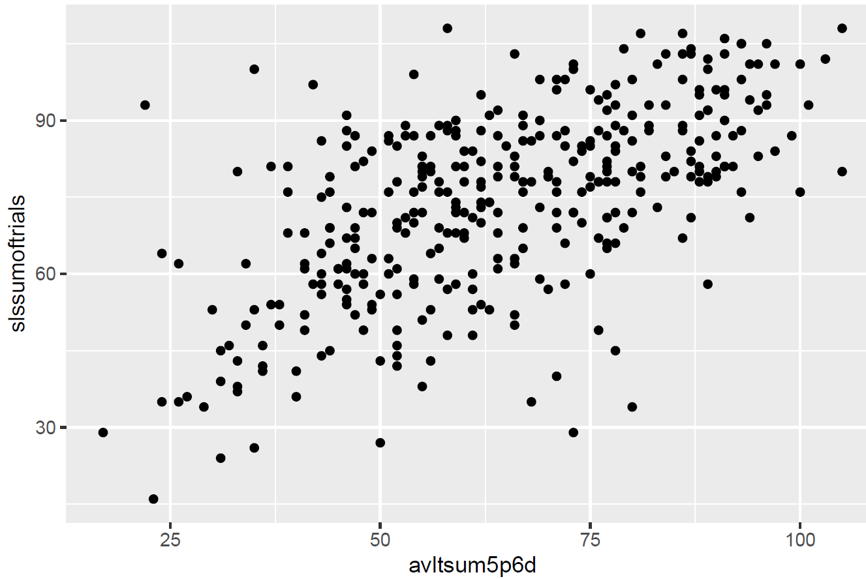

Supplemental Table 1. Additional memory test variable means (SDs) by biomarker subgroups.
 | A- vs A+ |  |  |  | A-T- vs A+T+
 | All participants |  | CU participants only |  | All participants |  | CU participants only
 | A- (N=228) | A+ (N=125) | CU A- (N=215) | CU A+ (N=111) | A-T- (n=195) | A+T+ (n=55) | CU A-T- (n=185) | CU A+T+ (n=42)
SLS Trial 1 | 6.68 (1.25) | 6.27 (1.30) | 6.77 (1.19) | 6.36 (1.17) | 6.73 (1.24) | 6.04 (1.47) | 6.81 (1.19) | 6.21 (1.22)
AVLT Trial 1 | 6.71 (2.36) | 5.29 (2.03) | 6.86 (2.33) | 5.57 (1.96) | 6.72 (2.38) | 4.89 (1.71) | 6.84 (2.36) | 5.43 (1.52)
SLS Trial 2 | 10.04 (2.14) | 8.90 (2.54) | 10.20 (1.97) | 9.20 (2.35) | 10.07 (2.15) | 8.24 (2.52) | 10.21 (2.01) | 8.76 (2.20)
AVLT Trial 2 | 8.84 (2.65) | 7.42 (2.61) | 9.05 (2.56) | 7.79 (2.47) | 8.86 (2.66) | 6.98 (2.34) | 9.04 (2.59) | 7.71 (2.06)
SLS Trial 3 | 12.88 (3.04) | 11.47 (3.46) | 13.14 (2.84) | 11.89 (3.18) | 12.89 (3.02) | 10.76 (3.77) | 13.11 (2.87) | 11.52 (3.38)
AVLT Trial 3 | 10.18 (2.72) | 8.99 (2.92) | 10.38 (2.65) | 9.44 (2.70) | 10.24 (2.75) | 8.38 (2.81) | 10.42 (2.68) | 9.26 (2.40)
SLS Trial 4 | 15.72 (4.12) | 13.76 (4.80) | 16.04 (3.94) | 14.38 (4.47) | 15.90 (4.13) | 12.31 (4.83) | 16.15 (4.00) | 13.29 (4.48)
AVLT Trial 4 | 11.01 (2.71) | 9.93 (2.90) | 11.25 (2.55) | 10.41 (2.67) | 11.15 (2.66) | 9.15 (2.92) | 11.34 (2.54) | 10.07 (2.59)
SLS Trial 5 | 16.55 (4.06) | 14.63 (4.56) | 16.92 (3.81) | 15.28 (4.11) | 16.70 (4.05) | 13.33 (4.69) | 17.01 (3.85) | 14.48 (4.00)
AVLT Trial 5 | 11.50 (2.59) | 10.26 (2.86) | 11.71 (2.44) | 10.68 (2.70) | 11.63 (2.54) | 9.71 (2.67) | 11.80 (2.43) | 10.52 (2.33)
SLS Max Span | 17.08 (3.88) | 15.24 (4.46) | 17.40 (3.64) | 15.87 (4.02) | 17.22 (3.85) | 13.95 (4.64) | 17.48 (3.69) | 15.05 (4.02)
AVLT Trial 6 | 9.96 (3.44) | 8.19 (3.58) | 10.20 (3.36) | 8.77 (3.36) | 10.12 (3.31) | 7.27 (3.50) | 10.34 (3.22) | 8.45 (3.13)
SLS 1-3 Total | 29.60 (5.64) | 26.64 (6.56) | 30.11 (5.16) | 27.45 (5.96) | 29.70 (5.60) | 25.04 (7.07) | 30.12 (5.19) | 26.50 (6.12)
AVLT 1-3 Total | 25.78 (7.11) | 22.17 (6.69) | 26.28 (6.94) | 22.80 (6.32) | 25.88 (7.16) | 21.21 (5.87) | 26.30 (7.03) | 22.40 (5.09)
SLS 1-4 Total | 45.32 (9.25) | 40.40 (10.96) | 46.15 (8.55) | 41.83 (10.00) | 45.59 (9.19) | 37.35 (11.57) | 46.27 (8.62) | 39.79 (10.27)
SLS Retention | 89.94 (13.50) | 85.24 (17.31) | 90.29 (13.06) | 87.17 (15.59) | 90.62 (12.93) | 82.81 (18.28) | 90.92 (12.80) | 86.03 (16.06)
AVLT Retention | 83.00 (24.60) | 71.74 (31.73) | 84.99 (23.12) | 78.50 (21.21) | 84.08 (23.32) | 63.84 (32.82) | 85.73 (21.97) | 77.78 (21.62)
AVLT Ret. Alt. | 80.79 (20.76) | 70.73 (30.13) | 82.65 (18.95) | 77.29 (24.38) | 81.95 (19.38) | 63.36 (32.07) | 83.49 (17.67) | 77.14 (20.53)
AVLT Rec. PC | 92.83 (7.96) | 88.52 (10.93) | 93.60 (7.41) | 90.59 (9.22) | 93.09 (7.89) | 86.12 (12.35) | 93.75 (7.45) | 90.33 (9.77)
Memory z ¹ | 0.69 (1.01) | 0.74 (1.12) | 0.80 (0.91) | 0.87 (0.99) | 0.70 (1.00) | 0.45 (1.28) | 0.80 (0.91) | 0.71 (1.09)
LM I ¹ | 27.54 (7.72) | 25.94 (7.88) | 28.27 (7.20) | 26.67 (7.38) | 27.70 (7.56) | 24.54 (8.03) | 28.31 (7.16) | 26.02 (6.99)
LM II ¹ | 24.09 (9.19) | 22.08 (9.18) | 25.03 (8.44) | 22.95 (8.62) | 24.44 (8.89) | 19.77 (9.49) | 25.23 (8.25) | 21.43 (8.63)
VR I ¹ | 30.98 (4.66) | 29.14 (5.30) | 31.40 (4.10) | 29.59 (4.93) | 31.22 (4.47) | 28.10 (5.74) | 31.56 (4.17) | 28.98 (5.08)
VR II ¹ | 27.44 (7.17) | 24.14 (9.06) | 28.24 (6.24) | 25.16 (8.21) | 27.72 (6.96) | 22.77 (9.75) | 28.44 (6.05) | 24.79 (8.43)
¹ Data unavailable for Alzheimer’s Disease Research Center (ADRC) participants due to differences in test battery administered (n=8).
Note. The most similar AVLT and MTD measures and grouped together to facilitate qualitative comparison; note that the retention variables should not be directly compared due to fundamental differences in test design that is expected to yield discrepant results (e.g., randomization of SLS word list presentation to minimize recency effect on leaning trials). AVLT = Auditory Verbal Learning Test; AVLT Retention = AVLT 30-minute delay / Trial 5; AVLT Ret. Alt. = AVLT Retention alternative with cap at 100% (typical calculation of retention in the Mayo Clinic Study of Aging (MCSA) data); AVLT Trial 6 = AVLT short-delay; AVLT 1-3 Total = total correctly recalled trial 1 + trial 2 + trial 3; LM I = Wechsler Memory Scale-Revised Logical Memory I total; LM II = Wechsler Memory Scale-Revised Logical Memory II total; Memory z = Memory composite reflecting average (z) of three delayed recall scores including AVLT 30-minute delay, LM II and VR II (z-scores previously derived using CU participants 50 and older enrolled from 2004-2012, weighted by the age and sex distribution of the 2013 Olmsted county population [Rocca et al., 2021 DOI: 10.1136/bmjopen-2020-042633]); SLS = Stricker Learning Span; SLS Max Span = maximum number of words recognized across any learning trial; SLS 1-3 Total = total correct trial 1 + trial 2 + trial 3; SLS 1-4 Total = total correct trial 1 + trial 2 + trial 3 + trial 4. slst13totcorr (create new variable slsr1corr + slsr2corr + slsr3corr); SLS Retention = SLS Delay / SLS Max Span; VR I = Wechsler Memory Scale-Revised Visual Reproduction I total; VR II = Wechsler Memory Scale-Revised Visual Reproduction II total; total correct for fewer learning trials are presented to examine the potential impact of a shorter version of each test, such as what is provided in the NIH Toolbox Cognition app for the AVLT. Data for key SLS and AVLT variables are in the primary manuscript. Table used with permission of Mayo Foundation for Medical Education and Research; all rights reserved.

Supplemental Table 2. Unadjusted and age, sex and education adjusted Hedge’s g effect sizes (95% CI) from group mean comparisons between biomarker subgroups for all SLS and AVLT variable and for additional memory test variables.
 | A- vs A+ |  |  |  | A-T- vs A+T+
 | All A participants (N=353) |  | CU A participants (N=326) |  | All AT participants (N=250) |  | CU AT participants (N=227)
 | Unadj g | Adj g | Unadj g | Adj g | Unadj g | Adj g | Unadj g | Adj g
Primary variables
SLS sum of trials | -0.51*  (-0.73, -0.28) | -0.26*  (-0.47, -0.05) | -0.47*  (-0.71, -0.24) | -0.22  (-0.44, 0.00) | -0.88*  (-1.19, -0.57) | -0.53*  (-0.78, -0.28) | -0.74*  (-1.08, -0.39) | -0.37*  (-0.63, -0.10)
AVLT sum of trials | -0.55*  (-0.77, -0.33) | -0.27*  (-0.48, -0.06) | -0.48*  (-0.72, -0.25) | -0.18  (-0.40, 0.04) | -0.88*  (-1.19, -0.57) | -0.51*  (-0.76, -0.25) | -0.62*  (-0.96, -0.28) | -0.25  (-0.52, 0.01)
Secondary Variables
SLS 1-5 Total | -0.50*  (-0.72, -0.28) | -0.26*  (-0.47, -0.05) | -0.47*  (-0.71, -0.24) | -0.23*  (-0.44, -0.01) | -0.86*  (-1.16, -0.55) | -0.51*  (-0.76, -0.26) | -0.73*  (-1.07, -0.38) | -0.36*  (-0.63, -0.10)
AVLT 1-5 Total | -0.54*  (-0.76, -0.32) | -0.28*  (-0.49, -0.07) | -0.48*  (-0.72, -0.25) | -0.21  (-0.43, 0.00) | -0.82*  (-1.13, -0.51) | -0.48*  (-0.73, -0.23) | -0.59*  (-0.93, -0.25) | -0.25  (-0.52, 0.01)
SLS Delay | -0.48*  (-0.70, -0.26) | -0.25*  (-0.46, -0.04) | -0.42*  (-0.65, -0.19) | -0.18  (-0.39, 0.04) | -0.88*  (-1.19, -0.57) | -0.54*  (-0.79, -0.29) | -0.69*  (-1.03, -0.35) | -0.34*  (-0.60, -0.07)
AVLT 30-min delay | -0.48*  (-0.71, -0.26) | -0.20  (-0.41, 0.01) | -0.40*  (-0.63, -0.17) | -0.10  (-0.32, 0.12) | -0.86*  (-1.17, -0.55) | -0.50*  (-0.75, -0.25) | -0.56*  (-0.90, -0.22) | -0.22  (-0.48, 0.04)
Additional variables
SLS Trial 1 | -0.32*  (-0.54, -0.1) | -0.17  (-0.38, 0.04) | -0.34*  (-0.57, -0.11) | -0.20  (-0.42, 0.02) | -0.54*  (-0.84, -0.23) | -0.30*  (-0.55, -0.05) | -0.49*  (-0.83, -0.16) | -0.26  (-0.52, 0.01)
AVLT Trial 1 | -0.63*  (-0.85, -0.41) | -0.47*  (-0.68, -0.26) | -0.58*  (-0.82, -0.35) | -0.43*  (-0.64, -0.21) | -0.81*  (-1.12, -0.50) | -0.55*  (-0.80, -0.30) | -0.63*  (-0.97, -0.29) | -0.37*  (-0.63, -0.11)
SLS Trial 2 | -0.50*  (-0.72, -0.28) | -0.28*  (-0.49, -0.07) | -0.47*  (-0.71, -0.24) | -0.25*  (-0.47, -0.03) | -0.82*  (-1.13, -0.51) | -0.50*  (-0.75, -0.25) | -0.70*  (-1.05, -0.36) | -0.37*  (-0.63, -0.11)
AVLT Trial 2 | -0.54*  (-0.76, -0.32) | -0.31*  (-0.52, -0.10) | -0.49*  (-0.73, -0.26) | -0.27*  (-0.48, -0.05) | -0.72*  (-1.03, -0.42) | -0.41*  (-0.66, -0.16) | -0.53*  (-0.87, -0.19) | -0.23  (-0.49, 0.04)
SLS Trial 3 | -0.44*  (-0.66, -0.22) | -0.19  (-0.4, 0.02) | -0.42*  (-0.65, -0.19) | -0.17  (-0.39, 0.05) | -0.66*  (-0.97, -0.36) | -0.32*  (-0.58, -0.07) | -0.53*  (-0.87, -0.19) | -0.18  (-0.45, 0.08)
AVLT Trial 3 | -0.42*  (-0.65, -0.20) | -0.18  (-0.39, 0.03) | -0.35*  (-0.58, -0.12) | -0.09  (-0.31, 0.13) | -0.67*  (-0.97, -0.36) | -0.35*  (-0.60, -0.10) | -0.44*  (-0.78, -0.10) | -0.14  (-0.40, 0.12)
SLS Trial 4 | -0.45*  (-0.67, -0.23) | -0.24*  (-0.45, -0.03) | -0.40*  (-0.63, -0.17) | -0.20  (-0.42, 0.02) | -0.83*  (-1.14, -0.52) | -0.54*  (-0.79, -0.29) | -0.70*  (-1.04, -0.36) | -0.40*  (-0.67, -0.14)
AVLT Trial 4 | -0.39*  (-0.61, -0.17) | -0.13  (-0.34, 0.08) | -0.32  (-0.55, -0.09) | -0.05  (-0.27, 0.17) | -0.73*  (-1.04, -0.43) | -0.40*  (-0.65, -0.15) | -0.50*  (-0.83, -0.16) | -0.18  (-0.44, 0.09)
SLS Trial 5 | -0.45*  (-0.67, -0.23) | -0.23*  (-0.44, -0.02) | -0.42*  (-0.65, -0.19) | -0.17  (-0.39, 0.05) | -0.80*  (-1.11, -0.49) | -0.48*  (-0.73, -0.23) | -0.65*  (-0.99, -0.31) | -0.30*  (-0.57, -0.04)
AVLT Trial 5 | -0.46*  (-0.68, -0.24) | -0.18  (-0.39, 0.03) | -0.41*  (-0.64, -0.17) | -0.12  (-0.34, 0.1) | -0.74*  (-1.05, -0.44) | -0.40*  (-0.65, -0.15) | -0.53*  (-0.87, -0.19) | -0.19  (-0.46, 0.07)
SLS Max Span | -0.45*  (-0.67, -0.23) | -0.21  (-0.42, 0.00) | -0.40*  (-0.64, -0.17) | -0.16  (-0.37, 0.06) | -0.81*  (-1.12, -0.50) | -0.47*  (-0.73, -0.22) | -0.65*  (-0.99, -0.30) | -0.30*  (-0.56, -0.03)
AVLT Trial 6 | -0.51*  (-0.73, -0.28) | -0.20  (-0.41, 0.01) | -0.42*  (-0.66, -0.19) | -0.11  (-0.33, 0.11) | -0.85*  (-1.16, -0.54) | -0.46*  (-0.71, -0.21) | -0.59*  (-0.93, -0.25) | -0.22  (-0.48, 0.04)
SLS 1-3 Total | -0.49*  (-0.72, -0.27) | -0.25*  (-0.46, -0.04) | -0.49*  (-0.72, -0.26) | -0.24*  (-0.46, -0.02) | -0.78*  (-1.09, -0.47) | -0.43*  (-0.68, -0.18) | -0.67*  (-1.01, -0.33) | -0.30*  (-0.57, -0.04)
AVLT 1-3 Total | -0.52*  (-0.74, -0.29) | -0.26*  (-0.48, -0.05) | -0.52*  (-0.75, -0.28) | -0.28*  (-0.5, -0.06) | -0.67*  (-1.00, -0.35) | -0.32*  (-0.58, -0.07) | -0.58*  (-0.92, -0.24) | -0.27*  (-0.53, 0.00)
SLS 1-4 Total | -0.50*  (-0.72, -0.28) | -0.26*  (-0.47, -0.05) | -0.48*  (-0.71, -0.24) | -0.24*  (-0.45, -0.02) | -0.84*  (-1.15, -0.53) | -0.50*  (-0.75, -0.25) | -0.72*  (-1.06, -0.38) | -0.37*  (-0.63, -0.11)
SLS Retention | -0.31*  (-0.53, -0.09) | -0.24*  (-0.45, -0.03) | -0.22  (-0.45, 0.01) | -0.14  (-0.36, 0.08) | -0.55*  (-0.85, -0.24) | -0.40*  (-0.65, -0.15) | -0.36*  (-0.70, -0.03) | -0.22  (-0.48, 0.05)
AVLT Retention | -0.41*  (-0.63, -0.19) | -0.21  (-0.42, 0.00) | -.27*  (-0.50, -0.04) | -.08  (-0.30, 0.14) | -0.79*  (-1.09, -0.48) | -0.50*  (-0.75, -0.25) | -0.36*  (-0.70, -0.02) | -0.15  (-0.41, 0.11)
AVLT Ret. Alt. | -0.41*  (-0.63, -0.19) | -0.20  (-0.41, 0.01) | -0.26*  (-0.49, -0.03) | -0.06  (-0.28, 0.16) | -0.81*  (-1.12, -0.51) | -0.53*  (-0.78, -0.28) | -0.35*  (-0.68, -0.01) | -0.15  (-0.41, 0.11)
AVLT Recogn. PC | -0.47*  (-0.69, -0.25) | -0.28*  (-0.50, -0.07) | -0.37*  (-0.60, -0.14) | -0.17  (-0.39, 0.04) | -0.77*  (-1.08, -0.46) | -0.49*  (-0.74, -0.24) | -0.43*  (-0.77, -0.09) | -0.17  (-0.44, 0.09)
Other measures
Memory z ¹ | 0.04  (-0.18, 0.26) | 0.01  (-0.20, 0.22) | 0.08*  (-0.15, 0.31) | -0.02  (-0.23, 0.20) | -0.24  (-0.55, 0.08) | -0.25  (-0.51, 0.00) | -0.09  (-0.43, 0.24) | -0.20  (-0.46, 0.07)
LM I ¹ | -0.21  (-0.43, 0.02) | 0.01  (-0.20, 0.22) | -0.22  (-0.45, 0.01) | -0.03  (-0.25, 0.19) | -0.41*  (-0.73, -0.09) | -0.16  (-0.42, 0.09) | -0.32  (-0.66, 0.02) | -0.13  (-0.40, 0.13)
LM II ¹ | -0.22  (-0.44, 0.00) | 0.02  (-0.20, 0.23) | -0.24*  (-0.47, -0.01) | -0.04  (-0.26, 0.18) | -0.52*  (-0.84, -0.20) | -0.24  (-0.49, 0.02) | -0.46*  (-0.79, -0.12) | -0.23  (-0.49, 0.03)
VR I ¹ | -0.38*  (-0.60, -0.15) | -0.01  (-0.22, 0.20) | -0.41*  (-0.64, -0.18) | -0.06  (-0.28, 0.16) | -0.65*  (-0.98, -0.33) | -0.17  (-0.43, 0.08) | -0.59*  (-0.93, -0.25) | -0.16  (-0.43, 0.10)
VR II ¹ | -0.42  (-0.64, -0.19) | -0.08  (-0.29, 0.13) | -0.44*  (-0.67, -0.21) | -0.10  (-0.32, 0.12) | -0.65*  (-0.97, -0.33) | -0.22  (-0.48, 0.03) | -0.56*  (-0.90, -0.22) | -0.16  (-0.43, 0.10)
* p < .05
¹ Data unavailable for Alzheimer’s Disease Research Center (ADRC) participants due to differences in test battery administered (n=8).
Note. The most similar AVLT and MTD measures and grouped together to facilitate qualitative comparison; note that the retention variables should not be directly compared due to fundamental differences in test design that is expected to yield discrepant results (e.g., randomization of SLS word list presentation to minimize recency effect on leaning trials). AVLT = Auditory Verbal Learning Test; AVLT Retention = AVLT 30-minute delay / Trial 5; AVLT Ret. Alt. = AVLT Retention alternative with cap at 100% (typical calculation of retention in the Mayo Clinic Study of Aging (MCSA) data that differs from version presented in manuscript that does not use a cap); AVLT sum of trials = trials 1-5 total correct + trial 6 short-delay correct + 30-minute delay correct; AVLT Trial 6 = AVLT short-delay; AVLT 1-3 Total = total correctly recalled trial 1 + trial 2 + trial 3; LM I = Wechsler Memory Scale-Revised Logical Memory I total; LM II = Wechsler Memory Scale-Revised Logical Memory II total; Memory z = Memory composite reflecting average (z) of three delayed recall scores including AVLT 30-minute delay, LM II and VR II; SLS = Stricker Learning Span; SLS sum of trials = 1-5 correct + delay correct; SLS 1-5 Total = sum of words correctly recognized across trials 1-5; SLS Max Span = maximum number of words recognized across any learning trial; SLS 1-3 Total = total correct trial 1 + trial 2 + trial 3; SLS 1-4 Total = total correct trial 1 + trial 2 + trial 3 + trial 4. slst13totcorr (create new variable slsr1corr + slsr2corr + slsr3corr); SLS Retention = SLS Delay / SLS Max Span; VR I = Wechsler Memory Scale-Revised Visual Reproduction I total; VR II = Wechsler Memory Scale-Revised Visual Reproduction II total; total correct for fewer learning trials are presented to examine the potential impact of a shorter version of each test, such as what is provided in the NIH Toolbox Cognition app for the AVLT. Table used with permission of Mayo Foundation for Medical Education and Research; all rights reserved.

