Supplementary material (online only)
Participants:
The sample consisted of 160 males and 90 females; no gender differences were found between groups and sites (Χ²₁=2.5; p=.14). No age differences were found between SCZ (34.30+/-8.61) and HC (32.40+/-8.16; F_{1,249}=2.61; p=.11). Participants from UNC (34.76+/-8.39; n=97) were slightly older than participants from the SONATA sample (32.07+/-7.90; n=153; F_{1,249)}= 11.29; p=.001). No interaction between group and site was found (F_{1,249}<.01; p=.95). Patients also reported fewer years of education compared to controls (F_{1,246}=25.23; p<.001). All of the participants from the SONATA sample and 56% of UNC participants were identified as Caucasian. Of the remaining UNC participants most (40%) were African American. One participant was Native American, one was Asian American and 3 participants identified as Other races. No between site differences were found for negative and cognitive PANSS scores, however patients from SONATA had fewer positive symptoms (F_{1,146}=9.67; p=.002) and affective symptoms (F_{1,146)}=25.19; p<.001) compared to patients from UNC. No difference in the CPZ equivalent or type of medication was found between the sites.
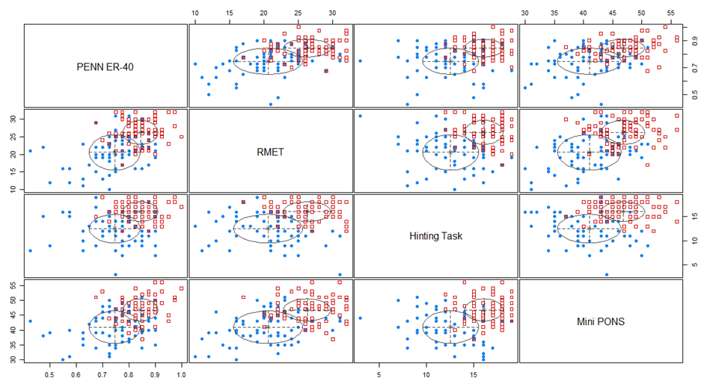
Figure S1. Two-cluster classification produced with Latent Class Analysis.
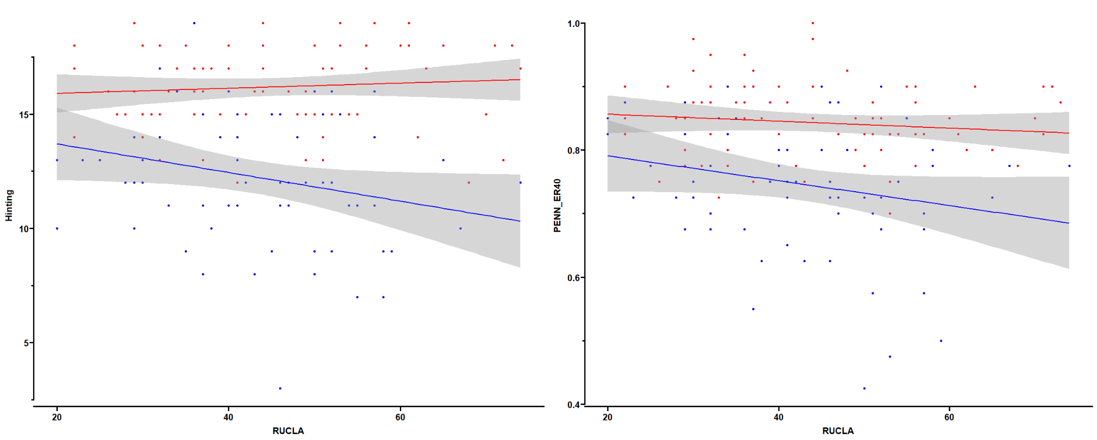
Figure S2. Association between RUCLA scores and Hinting task (left panel) and PENN ER40 (right panel) performance in SC-IMP (blue) and SC-NP (red) clusters.

