Supplementary Material

**Factor structure of the Harmonized Cognitive Assessment Protocol neuropsychological battery in the Health and Retirement Study**

Richard N. Jones, ScDa, b; Jennifer J. Manly, PhDc; Kenneth M. Langa, MD PhDd, e, f, h;

Lindsay H. Ryan, PhDd; Deborah A. Levine, MD MPHe, f, g; Ryan McCammon, MSd;

David Weir, PhDd

February 16, 2022

**Contents**

Table S1. Factor correlations from Model VIII: correlated factors model with methods effects 2

Figure S1: General approach to factor models 3

Figure S2 Density plot of factor score estimates obtained as expected a priori (EAP) estimates and Bayesian plausible values. 4

Figure S3. Participant flow in HRS/HCAP and in deriving analytic sample for this study 5

# Table S1. Factor correlations from model VIII: correlated factors model with methods effects. This table presents the correlations among all pairs of latent variables (and the single indicator domains: orientation, visuospatial) deriving from model VIII. Factor 1 and Factor 2 are arbitrary designations. For example, the correlation of delayed episodic memory and immediate episodic memory is 0.95. The entries in the table are sorted in descending order based on the magnitude of the correlation.

|  |  |  |
| --- | --- | --- |
| **Factor 1** | **Factor 2** | **Correlation** |
| Memory, delayed episodic | Memory, immediate episodic | 0.95 |
| Attention, speed | Set shifting | 0.94 |
| Language, fluency | Memory, immediate episodic | 0.94 |
| Language, fluency | Set shifting | 0.93 |
| Memory, recognition | Memory, delayed episodic | 0.91 |
| Memory, recognition | Memory, immediate episodic | 0.89 |
| Language, fluency | Attention, speed | 0.89 |
| Language, fluency | Memory, delayed episodic | 0.88 |
| Language, fluency | Memory, recognition | 0.84 |
| Set shifting | Memory, immediate episodic | 0.81 |
| Attention, speed | Memory, immediate episodic | 0.80 |
| Attention, speed | Memory, delayed episodic | 0.79 |
| Set shifting | Memory, delayed episodic | 0.78 |
| Orientation | Memory, recognition | 0.72 |
| Orientation | Language, fluency | 0.70 |
| Attention, speed | Memory, recognition | 0.70 |
| Set shifting | Memory, recognition | 0.68 |
| Visuospatial | Set shifting | 0.65 |
| Orientation | Memory, immediate episodic | 0.64 |
| Visuospatial | Language, fluency | 0.59 |
| Orientation | Memory, delayed episodic | 0.59 |
| Visuospatial | Attention, speed | 0.57 |
| Orientation | Attention, speed | 0.56 |
| Orientation | Set shifting | 0.52 |
| Visuospatial | Memory, delayed episodic | 0.52 |
| Visuospatial | Memory, immediate episodic | 0.50 |
| Visuospatial | Memory, recognition | 0.42 |
| Visuospatial | Orientation | 0.33 |

# Figure S1: General approach to factor models

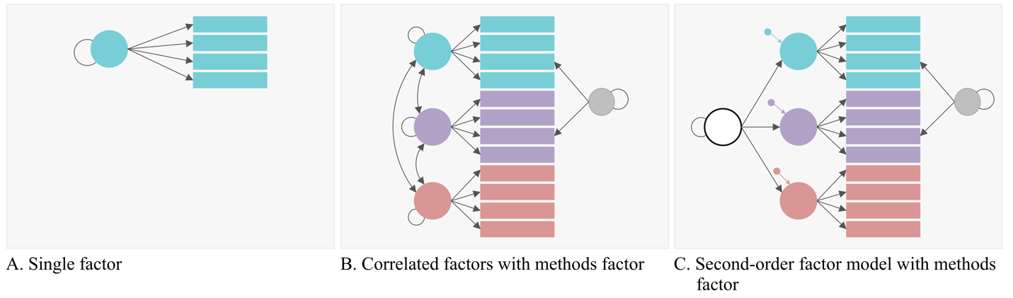

**Figure S1 Caption**

Figure S1 illustrates the general approach to modeling we used. First, we estimated single domain factor models (Panel A). Once these were adequately fitting, we estimated a multiple latent dimension correlated factors model, combining the single domain models (Panel B). In some cases, results of initial correlated factors models required re-specification of single factor models, and estimation of a new correlated factors model. With a well-fitting correlated factors model, we estimated a second-order factor model (Panel C). Methods factors (in gray) capture residual correlation for tasks with shared stimuli (common word lists, common story prompts). The methods factors are uncorrelated with other factors.

# Figure S2 Density plot of factor score estimates obtained as expected a priori (EAP) estimates and Bayesian plausible values.



**Figure S2 Caption**

Figure S2 illustrates the density of EAP factor score estimates (black line) and the density of plausible values (gray-filled density). Estimates were derived from the single factor models for specific domains (corresponding to models IID, IIIA, V, and XI in Tables 3 & 4. Bayesian plausible values are draws from the posterior distribution of the latent trait, given what is observed for item responses and given fixed item parameters from the estimated models. Regions where the plausible value density exceeds the EAP density indicate regions of poor measurement precision.

# Figure S3. Participant flow in HRS/HCAP and in deriving analytic sample for this study

Figure S3 Caption

Figure S3 displays the flow of participants in HRS/HCAP and in deriving the analytic sample for this study. Participant disposition variables extracted from the HRS tracker file (version trk2018tr_r.dta) available at <https://hrsdata.isr.umich.edu/data-products/public-survey-data>

Abbreviations: HRS, Health and Retirement Study; HCAP, Harmonized Cognitive Assessment Protocol