Supplementary
Distribution of Reported Number of Adults in the Household at Age 10
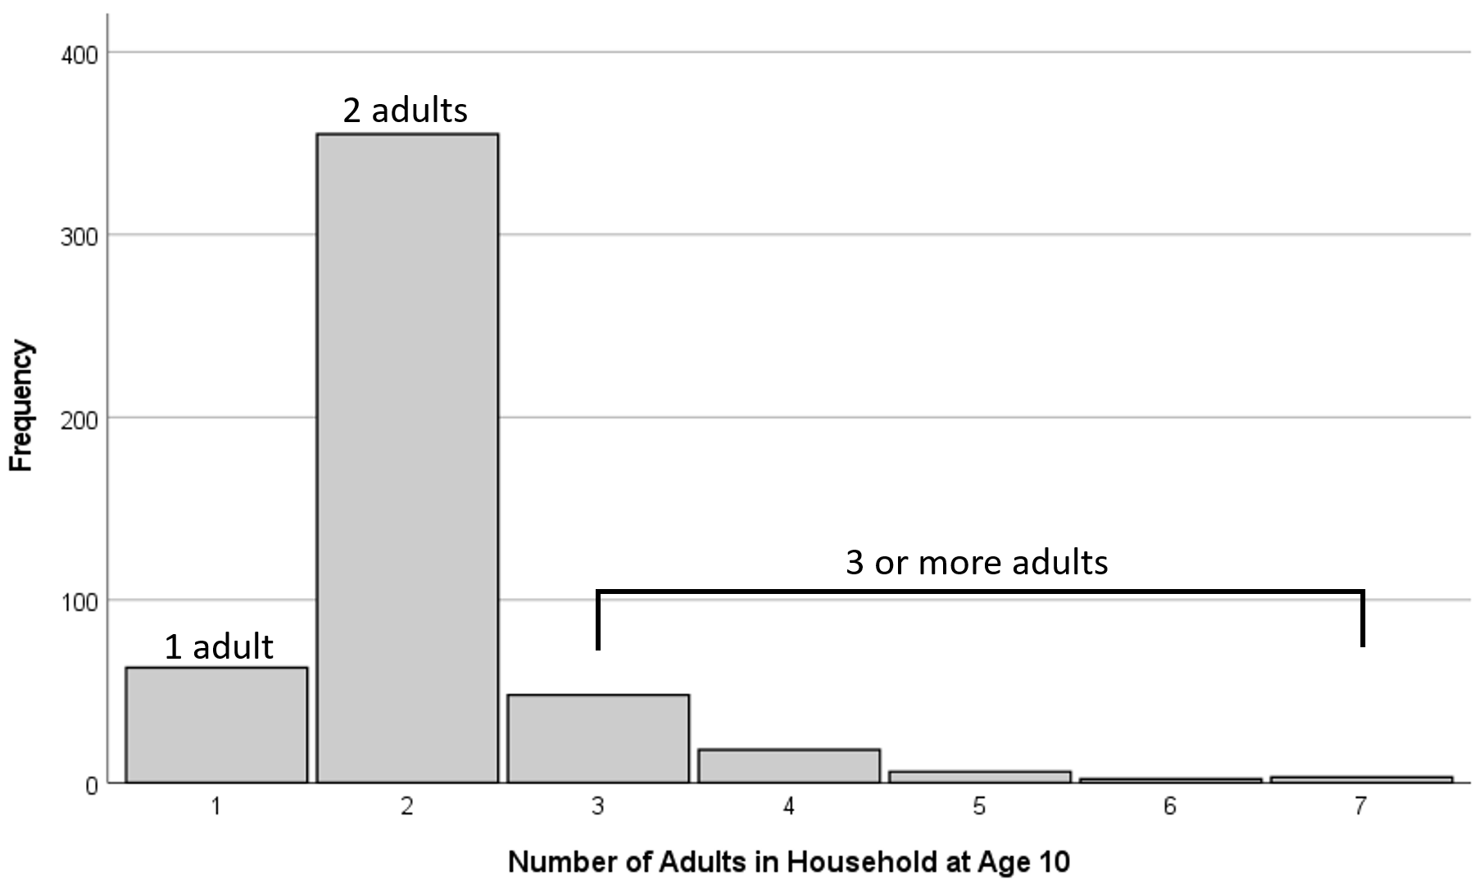

Standardized Regression Estimates Between Early-Life Factors and Individual Cognitive Domains
 | Episodic Memory | SE | Executive Functioning | SE | Processing Speed | SE | Language | SE | Visuospatial Functioning | SE
Region
Northeast/West | 0.03 | 0.04 | 0.03 | 0.04 | 0.03 | 0.04 | 0.07 | 0.04 | 0.03 | 0.04
South | 0.03 | 0.04 | -0.004 | 0.04 | 0.003 | 0.04 | 0.002 | 0.04 | -0.02 | 0.04
Parental Education | 0.07 | 0.04 | 0.08* | 0.04 | 0.06 | 0.04 | 0.09* | 0.04 | 0.10* | 0.04
# of Children in the Home | -0.03 | 0.04 | -0.07 | 0.04 | -0.08* | 0.04 | -0.07* | 0.04 | -0.06 | 0.04
# of Adults in the Home
1 Adult | -0.003 | 0.04 | -0.03 | 0.04 | -0.04 | 0.04 | -0.04 | 0.04 | -0.03 | 0.04
3+ Adults | -0.09* | 0.04 | -0.09* | 0.04 | -0.09* | 0.04 | -0.10* | 0.04 | -0.09* | 0.04
School Type | 0.11* | 0.04 | 0.12* | 0.04 | 0.13* | 0.04 | 0.11* | 0.04 | 0.11* | 0.04
School Demographics
Predominantly Black | -0.09 | 0.06 | -0.14* | 0.06 | -0.15* | 0.06 | -0.12* | 0.05 | -0.15* | 0.05
Diverse | -0.15* | 0.05 | -0.17* | 0.05 | -0.15* | 0.05 | -0.18* | 0.05 | -0.18* | 0.05
Educational Quality† | 0.10* | 0.04 | 0.12* | 0.04 | 0.12* | 0.04 | 0.11* | 0.04 | 0.12* | 0.04
†Direct Effect
*p<.05

