Supplemental Information

Cumulative distribution functions for DDM parameters in the ABCD sample p. 2
Parameter Recovery Studies pp. 3-9
Results of parameter recovery p. 3
Q-Q plots for simulated/recovered parameters (Figures S2-S5) p. 4-7
Raw bias and mean percent error values (Table S1) p. 8
Correlations between simulated & recovered parameters (Table S2) p. 9
Relationships between performance parameters (Figure S6) p. 10

Supplemental Figure 1: shows the cumulative distribution functions for A) the full ABCD sample and B) the simulated data from the parameter recovery study.
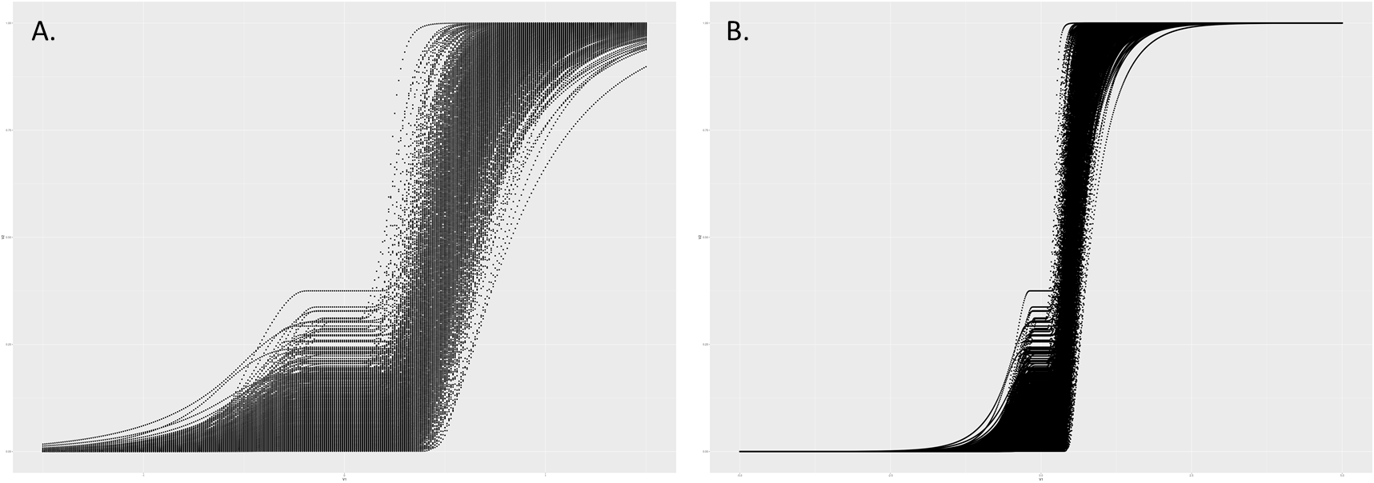

Parameter Recovery
Results for ex-Gaussian parameters indicate good recovery at both the run and block level. Raw bias values ranged from -1.35 to 1.68ms at the run level and from -4.6 to 3.8ms at the block level, indicating that on average mu, sigma, and tau values differed from known starting values by 1-4ms, even at the lowest trial numbers. When considered in relation to the average magnitude of these parameters, this reflects a mean percent error of -1.5% to 1% at the run level and a -3.2% to 2.4% at the block level. Raw bias and mean percent error for each parameter are provided in Table S1.
For diffusion model parameters, we saw slightly larger differences between simulated and recovered values but were overall reassured in our ability to use and interpret these values. Raw average bias values ranged from -0.0 to 0.16 at the run level and from 0.0 to 0.12 at the block level, however, because the majority of diffusion model parameters are unit free the percent differences are more informative. Mean percent error for run-level recovered parameters ranged from -2.1% to 6.2% and for block-level parameters ranged from -0.9% to 4.4% from simulated parameters. Raw and percent bias for each parameter are provided in Table S1.
Correlations between simulated and recovered values are also useful in determining the adequacy of parameter recovery. We interpreted based on guidelines from White et al. (2018): r below .5 poor, 0.5 < r < 0.75 fair, 0.75 < r < 0.9 good, and r > 0.9 excellent. Correlations for ex-Gaussian parameters were excellent for the full task (range .94-.99) and the run level (range .90-.97) and good to excellent at the block level (range .86-.96). Correlations for diffusion model parameters were good to excellent for the full task (range .88 to .93), good to excellent for the run level (range .77-.90), and fair to good for the block level recovery (range .56-.89). Table S2 presents the correlations between simulated and recovered parameters. Figures S2-S5 shows Q-Q plots of the simulated and recovered parameters for the full task, as well as the run and block level parameter recovery studies.

White, C. N., Servant, M., & Logan, G. D. (2018). Testing the validity of conflict drift-diffusion models for use in estimating cognitive processes: A parameter-recovery study. Psychonomic Bulletin & Review, 25(1), 286-301.

Supplemental Figure 2: shows Q-Q plots of the simulated and recovered parameters for the full task parameter recovery study for A) ex-Gaussian and B) drift diffusion model (DDM) parameters.
Supplemental Figure 3: shows Q-Q plots of the simulated and recovered parameters for run-level parameter recovery studies for A) ex-Gaussian and B) drift diffusion model parameters.
Supplemental Figure 4: shows Q-Q plots of the simulated and recovered parameters for ex-Gaussian parameter block-level parameter recovery study.

Supplemental Figure 5: shows Q-Q plots of the simulated and recovered parameters for the drift diffusion model block-level parameter recovery study.
Table S1: provide the raw and percent bias values for each parameter for the full task, as well as the run and block-level parameter recovery studies.

Parameter | Task Unit
 | Average Block-Level Bias |  | Average Run-level Bias |  | Full Task Bias
Ex-Gaussian | Raw Bias | Mean  Percent Error | Raw Bias | Mean  Percent Error | Raw Bias | Mean  Percent Error
Mu | 3.82 | 1.0 | 1.68 | 0.4 | 0.69 | 0.2
Sigma | -1.61 | 2.4 | -0.95 | -1.5 | -0.30 | -0.7
Tau | -4.56 | -3.2 | -1.35 | 1.0 | -1.21 | -1.1
Diffusion Model
v (drift rate) | 0.12 | 4.4 | 0.16 | 5.8 | 0.06 | 3.5
a (boundary) | 0.03 | 3.7 | 0.08 | 6.2 | 0.10 | 4.4
t0 (non-decision time) | 0.00 | -0.9 | -0.01 | -2.1 | -0.01 | -1.7
st0 (non-decision time variability) | -0.02 | 0.4 | 0.00 | 3.9 | 0.00 | 3.6

Table S2: shows the correlations (r) bewteen simulated and recovered parameters for the full task, as well as the run and block-level parameter recovery studies.
Parameter | Task Unit
Ex-Gaussian | Block 1 | Block 2 | Block 3 | Block 4 | Average  Block-Level r | Run 1 | Run 2 | Average  Run-level r | Full Task
Mu | 0.95 | 0.96 | 0.95 | 0.95 | 0.95 | 0.97 | 0.97 | 0.97 | 0.99
Sigma | 0.87 | 0.87 | 0.86 | 0.86 | 0.87 | 0.90 | 0.91 | 0.90 | 0.95
Tau | 0.87 | 0.86 | 0.87 | 0.87 | 0.87 | 0.90 | 0.91 | 0.90 | 0.94
Diffusion Model
v (drift rate) | 0.80 | 0.75 | 0.82 | 0.82 | 0.80 | 0.85 | 0.88 | 0.87 | 0.93
a (boundary) | 0.63 | 0.56 | 0.68 | 0.65 | 0.63 | 0.77 | 0.78 | 0.77 | 0.88
t0 (non-decision time) | 0.88 | 0.88 | 0.89 | 0.86 | 0.88 | 0.91 | 0.89 | 0.90 | 0.93
st0 (non-decision time variability) | 0.70 | 0.66 | 0.69 | 0.65 | 0.68 | 0.83 | 0.78 | 0.80 | 0.88

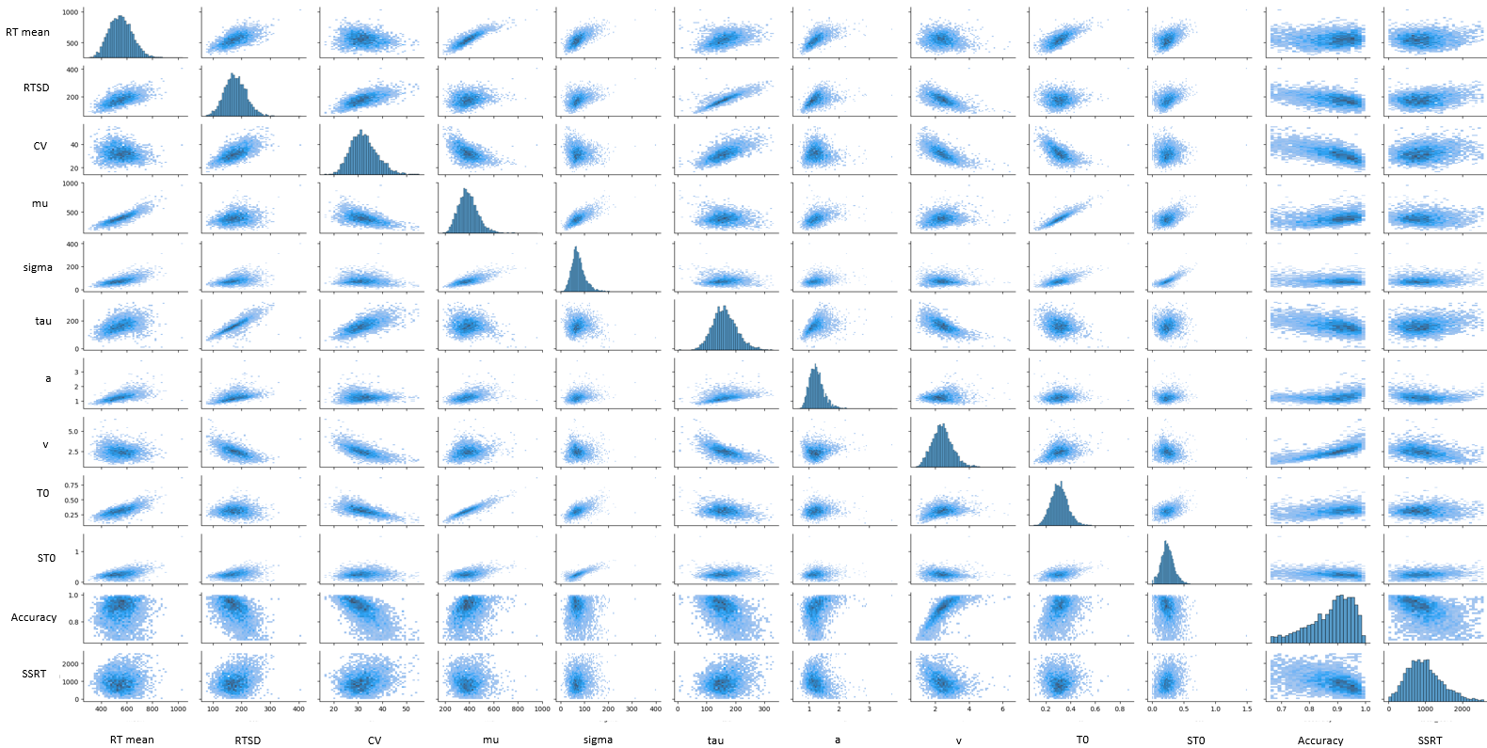
Supplemental Figure 6: Distributions of each performance measure (along diagonal) and scatterplots of relations between performance measures

