Supplemental Materials
Table 1. Intraindividual Variability on ARC Tasks
Intraindividual Variability
CDR | 0, N = 268¹ | 0.5, N = 22¹ | p-value²
Symbols MSSD³ | 0.68 (2.03) | 1.08 (1.81) | 0.33
Prices MSSD | 0.023 (0.010) | 0.019 (0.013) | 0.17
Grids MSSD | 0.26 (0.16) | 0.31 (0.20) | 0.34
¹ Mean (SD)
² Welch Two Sample t-test
³ Mean Square of Successive Differences

Note. Intraindividual variability was examined using the mean square of successive differences (MSSD) for the three different ARC tasks. There were no differences between CDR 0 and 0.5 individuals, as shown.

Table 2. Influence of Device Supply Status on ARC and Biomarker Measures
BYOD Participants vs. Participants Supplied w/ a Device
 | BYOD, N = 231¹ | Device Supplied, N = 59¹ | p-value²
Age | 76.2 (5.6) | 78.3 (6.0) | 0.014
CDR |  |  | 0.57
0 | 215 (93%) | 53 (90%)
0.5 | 16 (6.9%) | 6 (10%)
Prices | 0.25 (0.06) | 0.25 (0.05) | 0.94
Grids | 0.71 (0.26) | 0.80 (0.31) | 0.071
Symbols | 3.24 (0.98) | 3.45 (1.03) | 0.16
AD ROI Cortical Thickness | 2.56 (0.11) | 2.54 (0.11) | 0.23
Hippocampal Volume | 7,770 (943) | 7,596 (919) | 0.37
Amyloid PET | 19 (28) | 23 (32) | 0.46
Tau PET | 1.22 (0.20) | 1.20 (0.09) | 0.31
CSF AB42 | 924 (412) | 947 (397) | 0.78
CSF Tau | 357 (194) | 364 (169) | 0.85
CSF pTau | 46 (26) | 46 (23) | 0.91
CSF pTau:AB42 | 0.06 (0.07) | 0.06 (0.06) | 0.95
Adherence | 81 (17) | 83 (19) | 0.54
Tech. Frequency | 2.57 (0.64) | 2.12 (0.67) | 0.001
Tech. Difficulty | 2.38 (0.91) | 2.80 (0.92) | 0.011
Tech. Icon Recognition | 84 (15) | 77 (21) | 0.032
¹ Mean (SD); n (%)
² Welch Two Sample t-test; Pearson's Chi-squared test

Note. Of the 290 participants, 59 were suppled with a device in order to participate in the study. Although there were significant differences in age and technology familiarity between individuals who used their own device vs. were supplied a device, there were no differences in CDR, ARC task performance, adherence, or AD biomarkers.

Figure 1. ARC, Conventional, and AD Biomarker Correlations in CDR 0s

Note. Correlations amongst ARC and conventional measures (raw scores) and AD biomarkers. Significant correlations (p < 0.05) are displayed with colored circles, non-significant correlations are blank.

Figure 2. ARC Feasibility and Conventional Measure Correlations
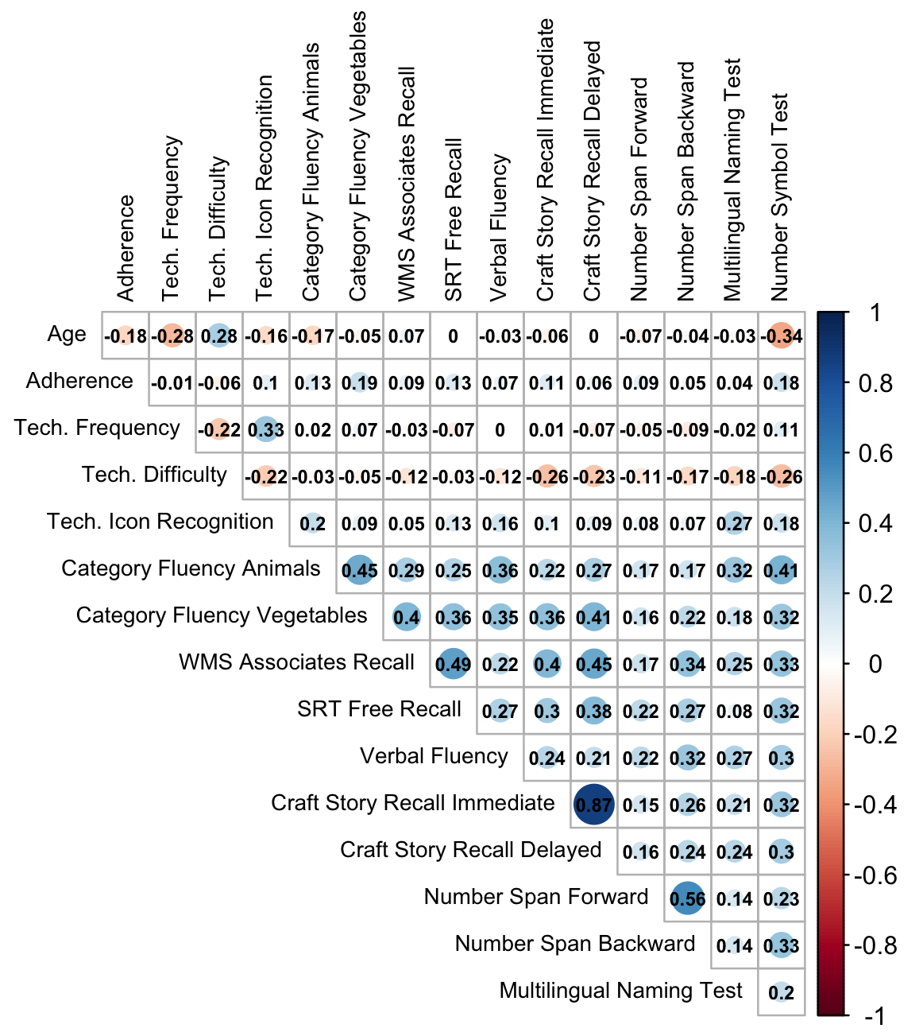
Note. Of the 290 participants included in the present analyses, 220 completed the technology familarity survey. Technology familiarity correlations with conventional measures are similar to those shown in Figure 5.

Figure 3. Factors Influencing ARC Adherence
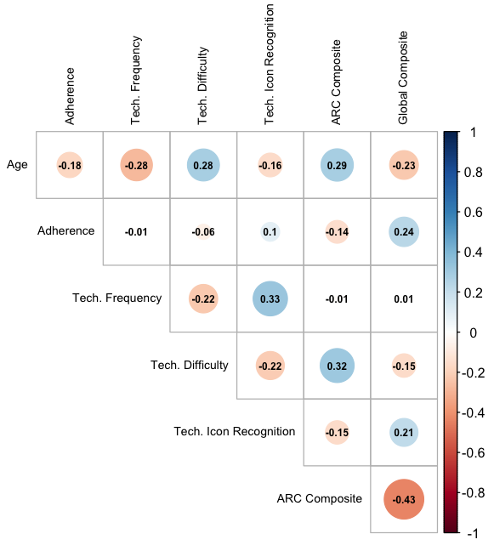
Note. Of the 290 participants included in the present analyses, 220 completed the technology familarity survey (see Nicosia et al., 2021) which assessed the frequency with which participants perform smartphone-related tasks, how difficult participants find various technology-related tasks, and how well participants could recognize technology-related icons. Significant correlations (p < 0.05) are displayed with colored circles whereas non-significant relationships are blank. This correlogram explores various factors including cognitive ability and technology familiarity, which may influence adherence.

