Definition of social cognitive domains

Emotion recognition
In this study, we defined emotion recognition as any task that required participants to label, recognize, rate, match or select the emotions expressed within the stimuli. Stimuli could be visual or auditory and may consist of static faces, videos, or sounds. As reported in Table 1, our review was limited to the universal emotions (fear, happiness, disgust, anger, and sadness) and thus, did not include studies measuring complex emotions such as trustworthiness, pride, or embarrassment. We excluded studies looking exclusively at mood, emotion production, or semantic knowledge (e.g., about situations expected to induce emotions). In epilepsy samples, tasks requiring identification and discrimination of emotions conveyed by facial expression have been used most frequently (e.g., stimuli from Ekman, NimStim, Karolinska, and FACES databases). All eligible studies of emotion recognition and their effect sizes are reported in Table 2.

Theory of mind
As reported in Table 1, we only included studies that used the following commonly used measures in theory of mind literature: Reading the Mind in the Eyes Test (RMET), Cartoon theory of mind vignettes, Strange Stories Test, False Belief tasks, Faux-Pas Test, Moving triangles test, The Awareness of Social Inference Test (TASIT) and the Story-Based Empathy Task. All eligible theory of mind studies and their effect sizes are reported in Table 3.

Empathy
We included studies that looked at the generalized construct as well as the cognitive and affective sub-components. Compared to other social cognitive domains, fewer studies have investigated empathy in people with epilepsy; self-report using the interpersonal reactivity index (IRI) has been the most common method of enquiry. All eligible studies of empathy and their effect sizes are reported in Table 4.

Social behavior
Given that social behavior has been operationalized differently in the literature, we only included studies that employed one or more widely used measures considered relevant to this construct (See Table 1) such as: Frontal Systems Behaviour Scale (previously known as the Frontal Lobe Personality Scale), Frontal Behavioral Inventory, Socioemotional Dysfunction Scale, Peer-Report Social Functioning Scale, Social Impairment Rating Scale, and the Disturbed Social Behaviour subscale of the Iowa Scales of Personality Change; Social Responsiveness Scale, Child Behavior Checklist (CBCL) and Social Adjustment Scale. All eligible studies evaluating social behavior and their effect sizes are reported in Table 4.
Forest plots
Emotion
TLE vs. non-clinical controls
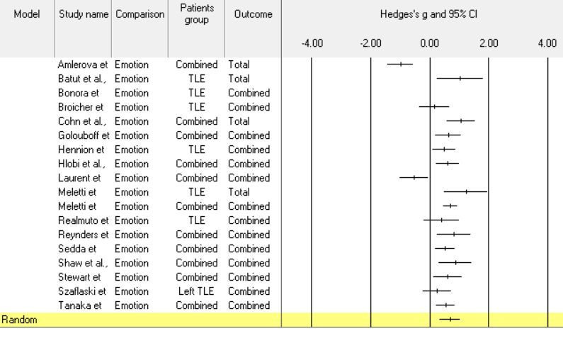
FLE vs. non-clinical controls
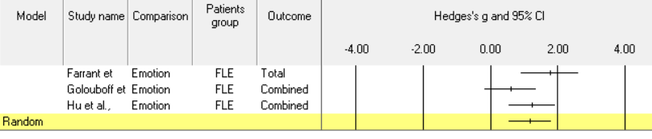
Theory of mind
TLE vs. non-clinical controls
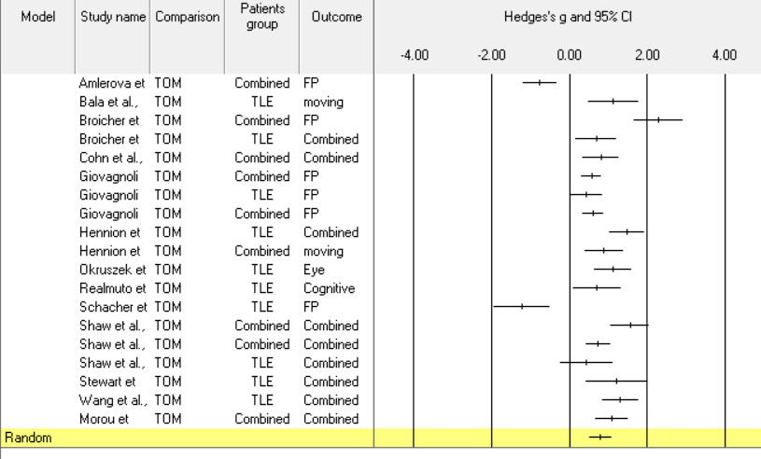
FLE vs. non-clinical controls
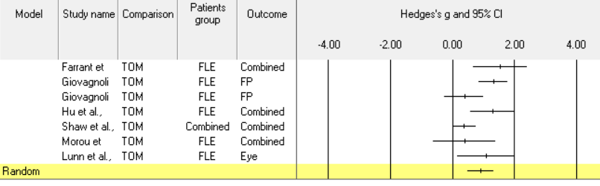
Empathy
TLE vs. non-clinical controls
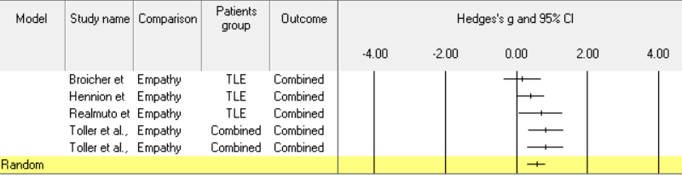
FLE vs. non-clinical controls
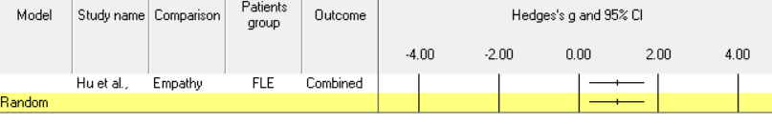
Social behavior
TLE vs. non-clinical controls
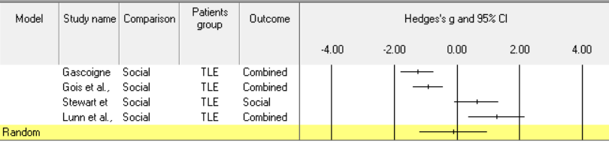
FLE vs. non-clinical controls
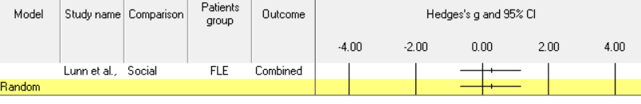

Exploratory analyses
Although the primary aim of this study was to compare the profile of patients with TLE and FLE in social cognitive functioning, two other exploratory analyses were conducted to measure whether patients (combined TLE and FLE groups) were significantly different from non-clinical controls when specific emotions were considered. Additionally, we investigated whether there were any differences between patients and non-clinical control group across specific theory of mind tasks (Table 5).

Supplementary Table 2. Temporal and frontal lobe epilepsy in the recognition of basic emotions
First author | Total | Happiness | Anger | Fear | Sadness | Disgust
Temporal lobe epilepsy
Visual/Facial stimuli
Amlerova (2014) | TLE < HC | - | - | - | - | -
Banks (2014) | - | NS | NS | NS | NS | NS
Batut (2006) | MTLE < HC | NS | - | MTLE < HC | MTLE < HC | -
Bonora (2011) | MTLE < HC | NS | MTLE < HC | MTLE < HC | MTLE < HC | MTLE < HC
Broicher (2012b) | MTLE < HC | NS | NS | MTLE < HC | NS | MTLE < HC
Cohn (2015) | LTLE & RTLE < HC | RTLE < HC | - | - | NS | NS
Fowler (2006) | NS | NS | NS | NS | NS | NS
Golobouff (2008) | LTLE < HC | NS | NS | LTLE < HC | NS | RTLE < HC
Gomez-Ibanez (2014) | MTLE < HC | NS | NS | MTLE < HC | NS | MTLE < HC
Hennion (2015a) | TLE < HC | NS | NS | TLE < HC | NS | TLE < HC
Hlobil (2008) | - | - | - | RMTLE (EOS) < HC | - | -
Laurent (2014) | TLE < HC | - | - | - | - | -
Meletti (2003a) | - | - | - | - | RTLE (EOS) < HC | RTLE (EOS) < HC
Meletti (2003b) | TLE (MTS) < HC | NS | NS | RTLE < HC | RTLE < HC | RTLE < HC
Meletti (2009) | MTLE < HC | NS | MTLE < HC | MTLE < HC | MTLE < HC | MTLE < HC
Realmutto (2015) | TLE < HC | NS | NS | NS | NS | NS
Reynders (2005) | TLE < HC | NS | NS | TLE < HC | NS | NS
Sedda (2013) | 35%, 50%: RTLE < HC  75%: RTLE < HC  100%: NS | NS | NS | NS | NS | NS
Shaw (2007) | - | NS | NS | NS | NS | NS
Stewart (2019) | TLE < HC | NS | NS | NS | TLE < HC | TLE < HC
Szaflarski (2014) | - | NS | - | NS | NS | -
Tanaka (2013) | MTLE < HC | NS | NS | MTLE < HC | NS | MTLE < HC
Walpole (2008) | TLE < HC | - | - | - | - | -
Auditory stimuli
Bonora (2011) | MTLE < HC | NS | MTLE < HC | MTLE < HC | MTLE < HC | MTLE < HC
Broicher (2012) | MTLE < HC | - | - | - | - | -
Fowler (2006) | NS | NS | NS | NS | NS | NS
Hennion (2015a) | TLE < HC | NS | NS | TLE < HC | NS | NS
Laurent (2014) | NS | - | - | - | - | -
Frontal lobe epilepsy
Farrant (2005) | FLE < HC | NS | FLE < HC | FLE < HC | FLE < HC | NS
Golouboff (2008) | NS | NS | NS | NS | NS | NS
Hu (2016) | - | FLE < HC | FLE < HC | FLE < HC | FLE < HC | FLE < HC

Studies are included if they reported results comparing focal epilepsy and non-clinical controls, the different lesion sides to non-clinical controls and the different lesion sides to each other.
LTLE = Left temporal lobe epilepsy. RTLE = Right temporal lobe epilepsy. BTLE = Bilateral temporal lobe epilepsy. FLE = frontal lobe epilepsy. LADD = Left asymmetrical amy .
RADD = . EOS = Early onset. LOS = Late onset. % = Intensity of the facial expression presented in Sedda et al. (2013). NS = non-significant difference between focal epilepsy
and non-clinical controls.

Supplementary Table 3. Temporal and frontal lobe epilepsy in the recognition of theory of mind
First author | Faux Pas | False Belief | RMET | Strange Stories | Cartoon Vignettes | TASIT | Moving shapes | Sarcasm Comp. | Action Comp. | Yoni | Metaphor Irony | Conflicting belief and emotion
Temporal lobe epilspey
Amlerova  (2014) | TLE < HC
Bala  (2018) |  |  |  |  |  |  | MTLE < HC
Broicher  (2012a) | MTLE < HC
Broicher  (2012b) | MTLE < HC |  | NS |  |  |  | MTLE < HC
Cohn  (2015) |  |  |  |  |  | TLE < HC  (deceitful exchanges)
Giovagnoli  (2011) | LTLE & RTLE < HC
Giovagnoli  (2013) | TLE < HC
Giovagnoli  (2016) | LTLE & RTLE < HC
Hennion  (2015b) | TLE < HC |  |  |  |  |  |  | TLE < HC | TLE < HC
Hennion  (2016) |  |  |  |  |  |  | RMTLE & LTLE < HC
Li  (2013) | TLE < HC | TLE < HC |  | TLE < HC | TLE < HC
Okruzek  (2017) |  |  | MTLE < HC
Schacher  (2006) | Pre-MTLE < HC
Shaw  (2004) | TLE (EA) < HC | NS |  | TLE (EA) < HC |  |  |  |  |  |  | TLE (EA) < HC on irony; NS on metaphor | TLE (EA) < HC
Shaw  (2007) | NS |  |  | NS
Stewart (2019) | TLE < HC |  |  | TLE < HC
Wang  (2015) | TLE < HC | TLE < HC |  | TLE < HC | TLE < HC
Frontal lobe epilepsy
Farrant | NS |  | FLE < HC | NS | FLE < HC
Giovagnoli (2011) | FLE < HC
Giovagnoli (2013) | FLE < HC
Hu (2016) |  |  | FLE < HC |  |  |  |  |  |  | FLE < HC

Studies are included if they reported results comparing focal epilepsy and non-clinical controls, the different lesion sides to non-clinical controls and the different lesion sides to each other.
LTLE = Left temporal lobe epilepsy. RTLE = Right temporal lobe epilepsy. BTLE = Bilateral temporal lobe epilepsy. FLE = frontal lobe epilepsy. EA = Early amygdala

Supplementary Table 4. Quality assessment of emotion recognition studies included in the review from quality rating checklist adapted from Downs & Black checklist
Studies | Quality of reporting |  |  |  |  |  |  |  | External validity | Statistical and methodological bias |  |  | Selection bias
Amlerova (2014) | 1 | 1 | 1 | 2 | 1 | 0 | 1 | 1 | 0 | 1 | 1 | 1 | 1 | 1 | 0 | 0 | 1 | 14/18
Banks (2013) | 1 | 1 | 1 | 1 | 1 | 1 | NA | 1 | 0 | 0 | 1 | 1 | 0 | 0 | 0 | NA | 1 | 10/18
Batut (2006) | 1 | 1 | 1 | 2 | 1 | 0 | NA | 1 | 1 | 1 | 1 | 1 | 1 | 1 | 0 | NA | 1 | 14/16
Bonora (2011) | 1 | 1 | 1 | 2 | 1 | 1 | NA | 1 | 0 | 1 | 1 | 1 | 0 | 0 | 1 | NA | 1 | 13/16
Broicher (2012b) | 1 | 1 | 1 | 2 | 1 | 1 | NA | 1 | 1 | 1 | 1 | 1 | 1 | 0 | 1 | NA | 1 | 15/16
Cohn (2015) | 1 | 1 | 1 | 2 | 1 | 0 | 1 | 1 | 1 | 1 | 1 | 1 | 1 | 1 | 1 | 0 | 1 | 16/18
Farrant (2005) | 1 | 1 | 1 | 2 | 1 | 1 | NA | 1 | 0 | 1 | 1 | 1 | 0 | 0 | 0 | NA | 1 | 12/16
Fowler (2006) | 1 | 1 | 1 | 1 | 1 | 1 | NA | 1 | 0 | 1 | 1 | 1 | 1 | 0 | 1 | NA | 1 | 13/16
Golobouff (2008) | 1 | 1 | 1 | 1 | 1 | 1 | NA | 1 | 0 | 1 | 1 | 1 | 0 | 0 | 1 | NA | 1 | 12/16
Gomez-Ibanez (2014) | 1 | 1 | 1 | 1 | 1 | 0 | NA | 1 | 0 | 1 | 1 | 1 | 1 | 0 | 1 | NA | 1 | 12/16
Hennion (2015a) | 1 | 1 | 1 | 2 | 1 | 1 | NA | 1 | 1 | 1 | 1 | 1 | 0 | 0 | 1 | NA | 1 | 14/16
Hlobil (2008) | 1 | 1 | 1 | 2 | 1 | 1 | NA | 1 | 1 | 1 | 1 | 1 | 1 | 0 | 1 | NA | 1 | 15/16
Laurent (2014) | 1 | 1 | 1 | 2 | 1 | 0 | NA | 0 | 1 | 1 | 1 | 1 | 1 | 1 | 1 | NA | 1 | 14/16
Meletti (2003a) | 1 | 1 | 1 | 1 | 1 | 0 | NA | 0 | 0 | 0 | 0 | 1 | 0 | 0 | 0 | NA | 1 | 7/16
Meletti (2003b) | 1 | 1 | 1 | 2 | 1 | 0 | NA | 0 | 0 | 1 | 1 | 1 | 0 | 1 | 0 | NA | 1 | 11/16
Meletti (2009) | 1 | 1 | 1 | 2 | 1 | 0 | NA | 1 | 1 | 1 | 1 | 1 | 0 | 0 | 1 | NA | 1 | 13/16
Realmuto (2015) | 1 | 1 | 1 | 2 | 1 | 1 | NA | 1 | 1 | 1 | 1 | 1 | 1 | 0 | 0 | NA | 1 | 14/16
Reynders (2005) | 1 | 1 | 1 | 1 | 1 | 1 | NA | 1 | 0 | 1 | 1 | 1 | 1 | 0 | 1 | NA | 1 | 13/16
Sedda (2013) | 1 | 1 | 1 | 2 | 1 | 0 | NA | 1 | 0 | 1 | 1 | 1 | 1 | 0 | 1 | NA | 1 | 13/16
Shaw (2007) | 1 | 1 | 1 | 2 | 1 | 1 | 0 | 1 | 0 | 1 | 1 | 1 | 0 | 0 | 1 | 0 | 1 | 13/18
Szaflarski (2014) | 1 | 1 | 1 | 2 | 1 | 0 | NA | 1 | 1 | 1 | 1 | 1 | 0 | 0 | 1 | NA | 1 | 13/16
Stewart (2019a) | 1 | 1 | 1 | 2 | 1 | 1 | NA | 1 | 1 | 1 | 1 | 1 | 1 | 1 | 1 | NA | 1 | 16/16
Tanaka (2013) | 1 | 1 | 1 | 1 | 1 | 0 | 1 | 0 | 1 | 1 | 1 | 1 | 1 | 0 | 0 | 0 | 1 | 12/18
Walpole (2008) | 1 | 1 | 1 | 1 | 1 | 1 | NA | 1 | 0 | 1 | 1 | 1 | 0 | 0 | 1 | NA | 1 | 12/16

Supplementary Table 5. Quality assessment of theory of mind studies included in the review from quality rating checklist adapted from Downs & Black checklist
Studies | Quality of reporting |  |  |  |  |  |  |  | External validity | Statistical and methodological bias |  |  | Selection bias
Amlerova (2014) | 1 | 1 | 1 | 1 | 1 | 1 | 0 | 1 | 0 | 1 | 1 | 1 | 1 | 1 | 0 | 0 | 1 | 13/18
Bala (2018) | 1 | 1 | 1 | 2 | 1 | 1 | NA | 1 | 0 | 1 | 1 | 1 | 1 | 1 | 1 | NA | 1 | 15/16
Broicher (2012a) | 1 | 1 | 1 | 2 | 1 | 1 | NA | 0 | 1 | 1 | 1 | 1 | 1 | 1 | 1 | NA | 1 | 15/16
Broicher (2012b) | 1 | 1 | 1 | 2 | 1 | 1 | NA | 1 | 1 | 1 | 1 | 1 | 1 | 1 | 0 | NA | 1 | 15/16
Cohn (2015) | 1 | 1 | 1 | 2 | 1 | 0 | 1 | 1 | 1 | 1 | 1 | 1 | 1 | 1 | 1 | 0 | 1 | 16/18
Farrant (2005) | 1 | 1 | 1 | 2 | 1 | 1 | NA | 1 | 0 | 1 | 1 | 1 | 0 | 0 | 1 | NA | 1 | 13/16
Giovagnolini (2011) | 1 | 1 | 1 | 2 | 1 | 1 | NA | 1 | 1 | 1 | 1 | 1 | 1 | 1 | 1 | NA | 1 | 16/16
Giovagnolini (2013) | 1 | 1 | 1 | 2 | 1 | 1 | NA | 1 | 0 | 1 | 1 | 1 | 1 | 0 | 1 | NA | 1 | 15/16
Giovagnolini (2016) | 1 | 1 | 1 | 2 | 1 | 0 | 1 | 1 | 1 | 1 | 1 | 1 | 1 | 0 | 1 | 0 | 1 | 15/18
Hennion (2015b) | 1 | 1 | 1 | 2 | 1 | 0 | NA | 1 | 1 | 1 | 1 | 1 | 1 | 1 | 1 | NA | 1 | 15/16
Hennion (2016) | 1 | 1 | 1 | 2 | 1 | 0 | NA | 1 | 1 | 1 | 1 | 1 | 1 | 1 | 1 | NA | 1 | 15/16
Hu (2016) | 1 | 1 | 1 | 2 | 1 | 0 | NA | 1 | 1 | 1 | 1 | 1 | 1 | 1 | 0 | NA | 1 | 14/16
Li (2013) | 1 | 1 | 1 | 2 | 1 | 1 | NA | 1 | 1 | 1 | 1 | 1 | 0 | 0 | 1 | NA | 1 | 14/16
Okruzek (2017) | 1 | 1 | 1 | 1 | 1 | 0 | NA | 0 | 1 | 1 | 1 | 1 | 1 | 1 | 0 | NA | 1 | 12/16
Schacher (2006) | 1 | 1 | 1 | 2 | 1 | 1 | NA | 1 | 1 | 1 | 1 | 1 | 1 | 0 | 1 | NA | 1 | 15/16
Shaw (2004) | 1 | 1 | 1 | 2 | 1 | 1 | NA | 1 | 0 | 1 | 1 | 1 | 1 | 0 | 1 | NA | 1 | 14/16
Shaw (2005) | 1 | 1 | 1 | 1 | 1 | 0 | 1 | 1 | 1 | 1 | 1 | 1 | 1 | 1 | 1 | 0 | 1 | 14/16
Shaw et al (2007) | 1 | 1 | 1 | 2 | 1 | 0 | 1 | 1 | 1 | 1 | 1 | 1 | 1 | 1 | 0 | 0 | 1 | 16/18
Stewart (2019b) | 1 | 1 | 1 | 2 | 1 | 1 | NA | 1 | 1 | 1 | 1 | 1 | 1 | 1 | 0 | NA | 1 | 15/16
Wang (2015) | 1 | 1 | 1 | 2 | 1 | 1 | NA | 1 | 0 | 1 | 1 | 1 | 0 | 0 | 1 | NA | 1 | 13/16

Supplementary Table 6. Quality assessment of empathy and social behavior studies included in the review from quality rating checklist adapted from Downs & Black checklist
Studies | Quality of reporting |  |  |  |  |  |  |  | External validity | Statistical and methodological bias |  |  | Selection bias
Empathy
Broicher (2012b) | 1 | 1 | 1 | 2 | 1 | 1 | NA | 1 | 1 | 1 | 1 | 1 | 1 | 1 | 0 | NA | 1 | 15/16
Hennion (2015a) | 1 | 1 | 1 | 2 | 1 | 1 | NA | 1 | 1 | 1 | 1 | 1 | 0 | 0 | 1 | NA | 1 | 14/16
Hu (2016) | 1 | 1 | 1 | 2 | 1 | 0 | NA | 1 | 1 | 1 | 1 | 1 | 1 | 1 | 0 | NA | 1 | 14/16
Realmuto (2015) | 1 | 1 | 1 | 2 | 1 | 1 | NA | 1 | 1 | 1 | 1 | 1 | 1 | 0 | 0 | NA | 1 | 14/16
Toller (2015a) | 1 | 1 | 1 | 2 | 1 | 0 | NA | 0 | 1 | 1 | 1 | 1 | 1 | 1 | 1 | NA | 1 | 14/16
Toller (2015b) | 1 | 1 | 1 | 2 | 1 | 0 | NA | 1 | 1 | 1 | 1 | 1 | 1 | 1 | 1 | NA | 1 | 15/16
Social behavior
Gois (2011) | 1 | 1 | 1 | 2 | 1 | 0 | Na | 1 | 1 | 1 | 1 | 1 | 1 | 1 | 1 | NA | 1 | 15/16
Gascoigne (2019) | 1 | 1 | 1 | 2 | 1 | 1 | NA | 1 | 1 | 1 | 1 | 1 | 1 | 1 | 1 | NA | 1 | 16/16
Stewart (2019a) | 1 | 1 | 1 | 2 | 1 | 1 | NA | 1 | 1 | 1 | 1 | 1 | 1 | 1 | 1 | NA | 1 | 16/16
Stewart (2019b) | 1 | 1 | 1 | 2 | 1 | 1 | NA | 1 | 1 | 1 | 1 | 1 | 1 | 1 | 0 | NA | 1 | 15/16

Items: (1) Is the hypothesis/aim/objective of the study clearly described? (2) Are the main outcomes to be measured clearly described in the Introduction or Methods section? (3) Are the characteristics of the patients included in the study described clearly? (4) Are the distributions of principal confounders in each group of subjects to be compared described clearly? (5) Are the main findings of the study described clearly? (6) Does the study provide estimates of the random variability in the data for the main outcomes? (7) Have the characteristics of patients lost to follow-up been described? (8) Have actual probability values been reported (for example, 0.035 rather than < 0.05) for the main outcomes except where the probability value is less than 0.001? (9) Were the subjects asked to participate in the study representative of the entire population from which they were recruited? (10) If any of the results of the study were based on ‘data dredging’, was this made clear? (11) Were the statistical tests used to assess the main outcomes appropriate? (12) Were the main outcome measures used accurate (valid and reliable)? (13) Were the patients in different groups recruited from the same population? (14) Were study subjects recruited over the same period of time? (15) Was there adequate adjustment for confounding in the analyses from which the main findings were drawn? (16) Were losses of patients to follow-up taken into account? (17) Did the study have sufficient power to detect a clinically important effect where the probability value for a difference being due to chance is less than 5 %?
All items are scored from 0 (no, or unable to be determined) to 1 (yes), except for item 4, which is scored 0 (no, unable to be determined), 1 (partially), or 2 (yes). Items 7 and 16 were only scored for studies with a longitudinal design. Therefore, scores for cross-sectional studies, ranged from 0-16, while longitudinal studies scores ranged from 0-18. Papers were categorized into three categories with high (0-5 points for cross-sectional and longitudinal studies), average (6-10 points for cross-sectional and 6-11 points for longitudinal), and low (11-16 points for cross-sectional and 12-18 points for longitudinal studies) risk of bias. NA = not applicable.

Discussion:
In this section we provide a general guide for tests that can be used in clinical settings. We based our suggestions on the most frequently used measures within this review. We also provide contextual information regarding the age-appropriateness, availability and considerations for use in clinical and research contexts. This list is not exhaustive. Many other potentially useful measures exist, some of which have been included in this review (see Table 1 in the manuscript) but remain minimally investigated, and other measures exist in clinical and research spheres that have yet to be applied to focal epilepsy populations at all.
Supplementary Table 7

Clinical indicators of possible social cognitive impairment should prompt comprehensive psychometric evaluation, incorporating tests of social cognition. To assist Table 8. Suggestion of Commonly Used Social Cognition Tasks in Focal Epilepsy
Domain / Measure | Discriminate from non-clinical Controls | Target Age Group | Availability | Considerations
Emotional Recognition¹
Emotion Labelling Tasks (e.g., Ekman and Friesan, NimStim Set of Facial Expressions, or Karolinska's facial databases) | All of studies reported impaired performance among patients relative to HC in either total score or in the subcategory of emotions.⁵ | No age limit | Some publicly available  Ekman faces  (https://www.paulekman.com/resources/photographs/)  NimStim; Tottenham et al., 2009 http://www.macbrain.org/resources)  Karolinska Facial Databases; Lundqvist (https://www.kdef.se/) | Differing stimuli types need to be considered based on goal of the assessment e.g., black and white vs. colour photos, faces of single age group vs. range of ages.
Theory of Mind²
Faux Pas Test | Twelve out of 14 studies resported impaired performance among patients relative to HC⁶. | Adult | Freely Available  (Adult version: Gregory et al., 2002; https://www.autismresearchcentre.com/tests/faux-pas-test-adult/;  Child version: Baron-Cohen et al., 1999: (https://www.autismresearchcentre.com/tests/faux-pas-test-child/) | Concentration and language demand due to need to process lengthy verbal passages. Short version of this test has been used in some studies with 10 or 12 stories.
RMET | Four out of 5 studies reported impaired performance among patients relative to HC. ⁷ | Adult | Freely Available  (Adult version: Baron-Cohen et al., 2001; https://www.autismresearchcentre.com/tests/eyes-test-adult/; Child version: Baron-Cohen et al., 2001; https://www.autismresearchcentre.com/tests/eyes-test-child/) | This test requires a broad vocabulary knowledge. Ensure that participants know the words when administering this test.
Empathy³
IRI | Five out of 6 studies reported impaired performance among patients relative to HC.⁸ | Adolescent / Adult | Freely Available  (Davis et al., 1980; https://www.eckerd.edu/psychology/iri/) | There are four subcomponents: empathic concern, personal distress; perspective tasking, and fantasy scales. Ensure to report performance within each of this subscale when using this scale.
Social Behavior⁴
Social Adjustment Scale | Only one study reported impaired performance among patients relative to HC. | Adult | Rzepa and Weissman (https://link.springer.com/referenceworkentry/10.1007%2F978-94-007-0753-5_103620) | Only one study has used this scale in this patients’ population
Child Behaviour Checklist | All three studies reported impaired performance among patients relative to HC. | Child / adolescent | Licenced | Three studies have used this scale in this patients’ population
¹ Selected tasks represent one visual and one auditory task within this domain.
² Selected tasks represent one visual and verbal tasks within this domain.
³ Only a single empathy measure was used across all studies included in this review.
⁴ Selected questionnaires represent one adult and one paediatric measure.
⁵ Most studies failed to report differences between patients and non-clinical controls for happy expression.
⁶ Shaw et al., 2007 & Farrant et al., 2005 did not report any difference using this measure.
⁷ Broicher et al., (2012b) did not report any difference using this measure.
⁷ Hennion et al., (2015a) did not report any difference using this measure.

Table 8. Summary of background measures and overlap with social cognitive measures among people with epilepsy
Studies |  | Visual/language deficits | Neuropsychological measures including working memory deficits | Psychopathology/mood disorders | Relationships between background measures and ToM and ER
Amlerova (2014) | NR |  | NR | NR | -
Bala (2018) | Exclusion of patients with verbal dysfunction |  | TLE < HC. Digit Symbol Task, TMT-B. | Exclusion of psychiatric conditions | - NS correlation between ToM test scores and Digit Symbol Task and TMT-B.
Banks (2013) | NR |  | NR | NR
Batut (2006) | Mean average of Visual IQ scores fell within low average to average range. Mean average of Verbal IQ scores fell within low average range (WAIS).  Mean average of Visual Memory scores fell within low average to average range. Mean average of Verbal memory scores fell within the low range (WMS). |  | NR | TLE = HC (ns). Depression and anxiety scores | -
Bonora (2011) | Mean average of Performance and Verbal IQ scores fell within average range (WAIS). |  | NR | Mean average of depression scores fell within mildly depressed range | - Sig correlation between auditory ER and Verbal IQ. Remaining correlations NS between IQ scores and FER/auditory ER.  - NS correlations between depression scores and FER/auditory ER.
Broicher (2012a) | Mean average of Verbal IQ scores fell within average range (MTW-B).  Verbal IQ included as a covariate and was found not to influence performance on Faux Pas Test. |  | NR | NR | -
Broicher (2012b) | Mean average of Verbal IQ scores fell within average range (MTW-B).  MTLE = HC (ns). Verbal IQ. |  | MTLE < HC. Iowa Gambling Task | Exclusion of psychiatric conditions.  Mean average of depression scores fell within minimal range.  MTLE > HC. Depression scores. | - ToM: Verbal IQ sig correlated with Moving Triangles but not Faux Pas Test or RMET. NS correlations between ToM measures and depression scores.  - ER: NS correlations between depression scores and FER/auditory ER.
Cohn (2015) | NR |  | NR | Exclusion of psychiatric conditions. | -
Farrant (2005) | Mean average of Performance and Verbal IQ scores fell within average range (Wechsler Abbreviated Scale for Intelligence).  FLE = HC (ns). Verbal IQ, Performance IQ.  FLE < HC. Verbal Fluency tests. |  | FLE = HC (ns). TMT-B, Brixton Spatial Anticipation Test, Logical Memory, Visual Reproduction Memory.  FLE < HC. TMT-A, Hayling test, Controlled Oral Word Association Test. | Exclusion of psychiatric conditions. | - NS correlations between ToM tasks and executive functioning tasks.
Fowler (2006) | AD groups = HC (ns). Verbal IQ (NART), Visuo-perceptual abilities (BFRT). |  | NR | Exclusion of psychiatric conditions.  AD = HC (ns). Depression and anxiety scores. | -
Giovagnolini (2011) | Factor analysis yielded Language (Fluency on Phonemic Cue, Fluency on Semantic Cue, Boston Naming, Short Story Recall, Digit Span) and Visual Matching factors (Rey Figure Copying, Rey Figure Recall, Weigl Sorting Test, Street Completion Test) distinct from two ToM factors.  Neuropsychological variables did not predict faux pas recognition score in a regression analysis. |  |  | Exclusion of psychiatric conditions. | - Factor analysis yielded a Control factor (Raven Matrices, Attentive Matrices, TMT-A, TMT-B, Token Test, Tower of London), distinct from two ToM factors.  - Neuropsychological variables did not predict faux pas recognition score in a regression analysis.
Giovagnolini (2013) | PWE (TLE, FLE) < HC. Verbal fluency tests. |  | PWE (TLE, FLE) = HC (ns). Attentive Matrices, TMT-A, TMT-B, Raven Colored Progressive Matrices, Weigl Sorting Test, Digit Span.  PWE (TLE, FLE) < HC. Word Fluency Tests, Corsi Blocks Span, Short Story, Rey Complex Figure Delayed Recall. | Exclusion of psychiatric conditions  Mean average of depression scores fell within minimal range.  Mean average of anxiety scores fell within moderately anxious range. | -
Giovagnolini (2016) | TLE < HC. Naming ability. |  | TLE < HC. Boston Naming Test, Short Story | Exclusion of psychiatric conditions
Golobouff (2008) | Mean average of Performance and Verbal IQ scores fell within average range (WISC– III).  Performance on a face-matching task indicated normal visuo-perceptual abilities. |  | NR | Exclusion of psychiatric conditions | -
Gomez-Ibanez (2014) | MTLE < HC. Verbal fluency.  MTLE < HC. Visuo-perceptual abilities (BFRT). |  | MTLE = HC (ns). Word list recall test.  MTLE < HC. TMT-A, TMT-B, Digit Span Test, Word Fluency tests. | Exclusion of current depression | -
Hennion (2015a) | MTLE patients demonstrated normal visual and auditory perceptual abilities (BFRT, Protocol of Auditory Gnosis Assessment) |  | TLE < HC. Montreal Cognitive Assessment score.  This score was included as a covariate in inter-group comparisons of ER scores. | Exclusion of psychiatric conditions (except depression and anxiety).  Depression scores fell within mildly depressed range.  Anxiety scores fell within the moderate to high anxiety range. | - Sig negative correlation between perception of facial disgust and depression scores. Remaining correlations NS between ER and depression scores.
Hennion (2015b) | NR |  | TLE < HC. Montreal Cognitive Assessment score. This score was included as a covariate in inter-group comparisons of ER scores. | Exclusion of psychiatric conditions (except depression and anxiety)  Depression scores fell within mildly depressed range.  Anxiety scores fell within the moderate to high anxiety range. | - NS correlation between performance on Faux Pas Test and depression and anxiety scores.  - Sig correlation between comprehension of sarcasm and depression scores.
Hennion (2016) | NR |  | TLE < HC. Montreal Cognitive Assessment score. This score was included as a covariate in inter-group comparisons of ER scores. | Exclusion of psychiatric conditions (except depression and anxiety)  Depression scores fell within minimal to mildly depressed range.  Anxiety scores fell within the moderate to high anxiety range. | - NS correlation between ToM and Montreal Cognitive Assessment, depression and anxiety scores.
Hlobil (2008) | Excluded patient with visuo-perceptual problem. |  | NR | Exclusion of psychiatric conditions | -
Hu (2016) | FLE < HC. Performance in verbal fluency. |  | FLE = HC (ns). Stroop Test, Digit Span (forward), Montreal Cognitive Assessment  FLE < HC. Verbal Fluency Test, Digit Span Test, backward) | Exclusion of psychiatric conditions. Depression scores fell within minimal range.  Anxiety scores fell within the mild anxiety range | -
Laurent (2014) | Mean average of Verbal IQ scores fell within average range (WISC-III, WPPSI-R).  TLE = HC (ns). Visual and auditory perceptual abilities. |  | NR | NR | -
Li (2013) | Mean average of Verbal Comprehension Index fell within average range (WAIS-III).  TLE = HC (ns). Verbal comprehension Index. |  | TLE = HC (ns). Modified Card Sorting Test  TLE < HC. Immediate and delayed recall of logical memory tests | Exclusion of psychiatric conditions | - NS correlation between performance on logical memory tests and ToM tasks.
Meletti (2003a) | NR |  | NR | NR | -
Meletti (2003b) | TLE = HC (ns). Visuo-perceptual abilities using a face-matching task. |  | NR | Exclusion of psychiatric conditions | -
Meletti (2009) | TLE = HC (ns). Visuo-perceptual abilities using a face-matching task. |  | NR | NR | -
Okruzek (2017) | NR |  | MTLE < HC. Digit Symbol test, TMT-B. | Exclusion of psychiatric conditions | - NS correlation between RMET and Digit Symbol Test and TMT-B scores.
Realmuto (2015) | TLE < HC. Verbal fluency, naming and auditory comprehension.  TLE < HC. Visuo-perceptual and visuo-spatial abilities |  | TLE = HC (ns). Attentive Matrices.  TLE < HC. Rey Auditory Verbal Learning Test, Rey's Figure Recall Test, Verbal and Visual Digit Span Task, Phonological and Semantic Fluency, Token test, Aachener Aphasie Test, Rey's Figure Copy Test. | Exclusion of psychiatric conditions | - Sig correlation between Verbal Digit Span Task and Story-Based Empathy Task and ER.
Reynders (2005) | TLE = HC (ns). Visuo-perceptual abilities (BFRT, The Visual Object and Space Perception Battery).  Mean average of Verbal IQ scores fell within average range (NART).  TLE = HC (ns). Verbal IQ. |  | NR | Fifty-one percent of patients had SCL-90-R General Severity Index scores at or above the cutoff for clinical cases.  Thirty-eight percent of patients had scores indicating clinically significant levels of anxiety. Six percent had depression scores within clinically significant levels. | - NS correlation between affective disorder and deficits in ER.
Schacher (2006) | MTLE patients demonstrated intact language comprehension scores (Chapman-Cook test). |  | NR | NR | -
Sedda (2013) | TLE patients demonstrated normal performance on visuo-spatial and visual memory tasks (Benton Judgment of Line Orientation Test, Camden Recognition Test) |  | Inclusion of patients with preserved executive functions and abstract reasoning (TMT, Attentive Matrices, Raven’s Coloured Progressive Matrices) | Exclusion of psychiatric conditions | -
Shaw (2004) | Mean average of Performance and Verbal IQ scores fell within average range (WAIS-R).  AD groups < HC. Performance and Verbal IQ scores. |  | AD groups = HC (ns). Brixton test.  AD groups < HC.  Immediate and delayed logical memory tests, Hayling test | NR | - NS correlation between ToM tests and logical memory tests, and Brixton and Hayling tests.
Shaw (2005) | TLE = HC (ns). Visuo-perceptual abilities (BFTR).  Mean average of Verbal IQ scores fell within average range (NART). |  | NR | NR | - Sig correlation between RMET and Verbal IQ.
Shaw (2007) | Mean average of Performance and Verbal IQ scores fell within average range (WAIS).  TLE < HC. Performance and Verbal IQ scores. |  | NR | NR | -
Szaflarski (2014) | NR |  | NR | Exclusion of psychiatric conditions (except depression).  LTLE = HC (ns). Depression and fluctuating mood state scores. | -
Stewart (2019a) | NR |  | NR | Exclusion of psychiatric conditions (except depression).
Stewart (2019b) | Mean average of Verbal Comprehension Index fell within average range (WISC).  TLE < HC. Verbal Comprehension Index. |  | TLE = HC (ns). Backward Digit Recall,  Colour-Word Inference,  Creature Counting | Exclusion of psychiatric conditions | - NS correlations between ToM and Backward Digit Recall, Colour-Word Inference, Creature Counting
Tanaka (2013) | NR |  | NR | Exclusion of clinical depression. | -
Walpole (2008) | NR |  | NR | Exclusion of psychiatric conditions (except depression and anxiety).  Depression scores did not reach threshold.  Anxiety scores fell within the mild range.  TLE > HC. Depression and anxiety scores. | -
Wang (2015) | Mean average of Verbal Comprehension Index fell within average range (WAIS).  TLE < HC. Verbal Comprehension Index (WAIS).  TLE = HC (ns). Verbal fluency.  Mean average of Perceptual Organisation Index fell within average range (WAIS).  TLE = HC (ns). Perceptual Organisation Index |  | TLE = HC (ns). Modified Card Sorting test, Semantic Association of Verbal Fluency  TLE < HC. Working Memory Index, Processing Speed Index, psychomotor speed. | Exclusion of psychiatric conditions  TLE > HC. SCL-90-R Global Severity Index scores | -

Note. NR = not reported. TLE = Temporal Lobe Epilepsy. MTLE = Mesial Temporal Lobe Epilepsy. FLE = Frontal Lobe Epilepsy. AD = Amygdala Damage. PWE = patients with epilepsy. HC = healthy control. IQ = intelligence quotient. WAIS = Wechsler Adult Intelligence Scale. WISC = Wechsler Intelligence Scale for Children. WPPSI = Wechsler Preschool and Primary Scale of Intelligence. WMS = Wechsler Memory Scale. MWT-B = Multiple Choice Vocabulary Test. NART = National Adult Reading Test. BFRT = Benton Facial Recognition Test . TMT = Trail Making Test. RMET = Reading the Mind in the Eyes test. ToM = theory of mind. FER = facial emotion recognition. ER = emotion recognition. SCL-90-R = Symptom Checklist – 90 – Revised. NS = non-significant (p > .05). Sig = significant (p < .05). Measures in bold = typical measures of working memory capacity.

PRISMA 2009 Checklist
Section/topic | # | Checklist item | Reported  on page #
TITLE
Title | 1 | Identify the report as a systematic review, meta-analysis, or both.
ABSTRACT
Structured summary | 2 | Provide a structured summary including, as applicable: background; objectives; data sources; study eligibility criteria,  participants, and interventions; study appraisal and synthesis methods; results; limitations; conclusions and  implications of key findings; systematic review registration number.
INTRODUCTION
Rationale | 3 | Describe the rationale for the review in the context of what is already known.
Objectives | 4 | Provide an explicit statement of questions being addressed with reference to participants, interventions, comparisons,  outcomes, and study design (PICOS).
METHODS
Protocol and registration | 5 | Indicate if a review protocol exists, if and where it can be accessed (e.g., Web address), and, if available, provide  registration information including registration number.
Eligibility criteria | 6 | Specify study characteristics (e.g., PICOS, length of follow-up) and report characteristics (e.g., years considered,  language, publication status) used as criteria for eligibility, giving rationale.
Information sources | 7 | Describe all information sources (e.g., databases with dates of coverage, contact with study authors to identify  additional studies) in the search and date last searched.
Search | 8 | Present full electronic search strategy for at least one database, including any limits used, such that it could be  repeated.
Study selection | 9 | State the process for selecting studies (i.e., screening, eligibility, included in systematic review, and, if applicable,  included in the meta-analysis).
Data collection process | 10 | Describe method of data extraction from reports (e.g., piloted forms, independently, in duplicate) and any processes  for obtaining and confirming data from investigators.
Data items | 11 | List and define all variables for which data were sought (e.g., PICOS, funding sources) and any assumptions and  simplifications made.
Risk of bias in individual  studies | 12 | Describe methods used for assessing risk of bias of individual studies (including specification of whether this was  done at the study or outcome level), and how this information is to be used in any data synthesis.
Summary measures | 13 | State the principal summary measures (e.g., risk ratio, difference in means).
Synthesis of results | 14 | Describe the methods of handling data and combining results of studies, if done, including measures of consistency  (e.g., I2) for each meta-analysis.
Risk of bias across studies | 15 | Specify any assessment of risk of bias that may affect the cumulative evidence (e.g., publication bias, selective  reporting within studies).
Additional analyses | 16 | Describe methods of additional analyses (e.g., sensitivity or subgroup analyses, meta-regression), if done, indicating  which were pre-specified.
RESULTS
Study selection | 17 | Give numbers of studies screened, assessed for eligibility, and included in the review, with reasons for exclusions at  each stage, ideally with a flow diagram.
Study characteristics | 18 | For each study, present characteristics for which data were extracted (e.g., study size, PICOS, follow-up period) and  provide the citations.
Risk of bias within studies | 19 | Present data on risk of bias of each study and, if available, any outcome level assessment (see item 12).
Results of individual studies | 20 | For all outcomes considered (benefits or harms), present, for each study: (a) simple summary data for each  intervention group (b) effect estimates and confidence intervals, ideally with a forest plot.
Synthesis of results | 21 | Present results of each meta-analysis done, including confidence intervals and measures of consistency.
Risk of bias across studies | 22 | Present results of any assessment of risk of bias across studies (see Item 15).
Additional analysis | 23 | Give results of additional analyses, if done (e.g., sensitivity or subgroup analyses, meta-regression [see Item 16]).
DISCUSSION
Summary of evidence | 24 | Summarize the main findings including the strength of evidence for each main outcome; consider their relevance to  key groups (e.g., healthcare providers, users, and policy makers).
Limitations | 25 | Discuss limitations at study and outcome level (e.g., risk of bias), and at review-level (e.g., incomplete retrieval of  identified research, reporting bias).
Conclusions | 26 | Provide a general interpretation of the results in the context of other evidence, and implications for future research.
FUNDING
Funding | 27 | Describe sources of funding for the systematic review and other support (e.g., supply of data); role of funders for the  systematic review.
From: Moher D, Liberati A, Tetzlaff J, Altman DG, The PRISMA Group (2009). Preferred Reporting Items for Systematic Reviews and Meta-Analyses: The PRISMA Statement. PLoS Med 6(7): e1000097.
doi:10.1371/journal.pmed1000097
For more information, visit: www.prisma-statement.org.

