Appendix 1

THE DAILIES STUDY CHECKLIST

Monday through Saturday, complete the following:

- Complete the DAILIES task
- Complete the Daily Diary and the Thinking Tasks any time after 7 pm (or later, if still working on completion of the DAILIES task)

DAILIES TASKS

- Check the night before or first thing in the morning what time of the day you’ll be completing the next task.
- Each day, complete the task and fill out the task completion log.
- Don’t forget to communicate with us about the answers/solutions to each task.
- If you cannot complete a task, call us at (XXX)XXX-XXXX or email us at XXXXX@gmail.com, preferably during the time window designated for that task.
If not able to contact us during that time, just do it later, whenever you can.
- If you forget to do a task during the correct time window, again, just let us know.
- If you complete the task but forget to communicate with us about it, just do it later and let us know it slipped your mind.
- If a conflict develops preventing you from completing a task and you know ahead of time, contact us by phone (XXX) XXX - XXXX or email XXXXX@gmail.com to arrange for an alternative
time for task completion.
- You will be paid $4 for each completed task.

DAILY DIARIES
● Please be honest with us! Your honest answers about your day are MORE important than any other aspect of the study!

REIMBURSEMENT
- $4 for each completed DAILIES task
- $4 for each completed DAILY DIARY

PRACTICE DAILIES #1 Participant ID# ________________

Planning Commute

Imagine you are taking this bus route from the Library to the Florist shop. The Florist is located halfway down NE 7th Avenue. At which stop would you get off?

Please email us the answers at neuropsychologylab@gmail.com during the time indicated on today’s envelope.

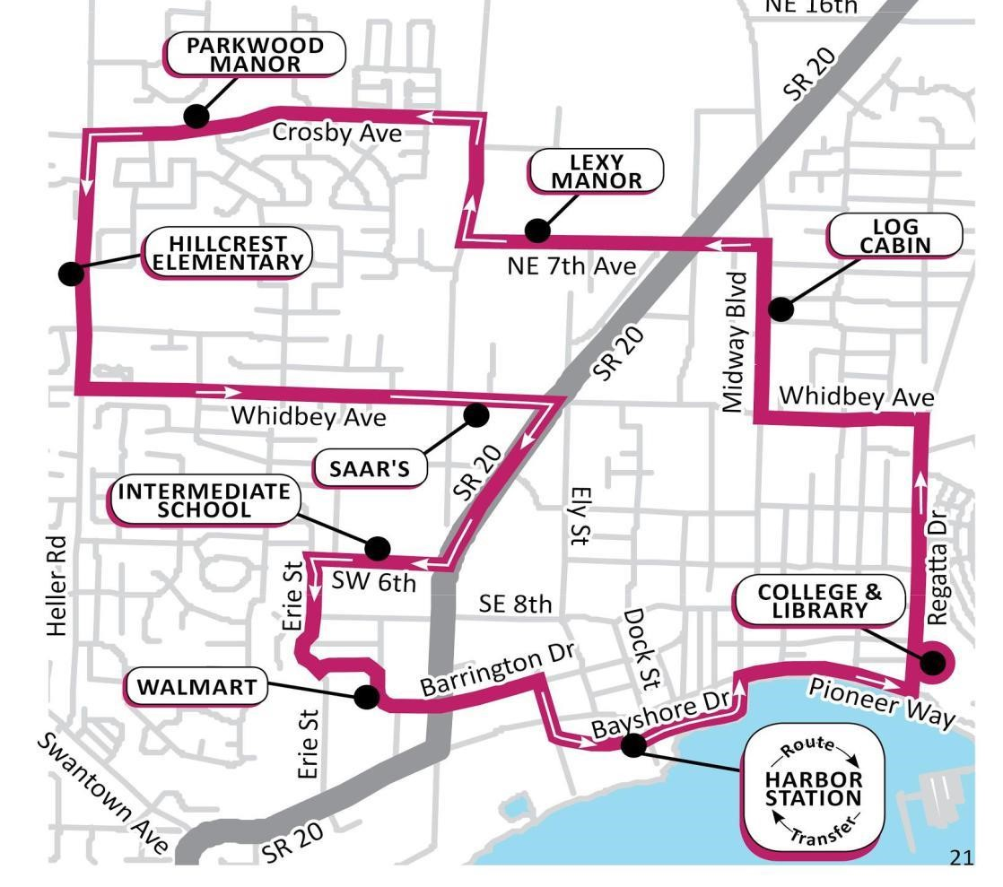
https://www.islandtransit.org/ROUTES-SCHEDULES/North-Whidbey/10-City-Center

PRACTICE DAILIES #2 Participant ID# ________________

Problem Solving

Imagine you and a friend are meeting at 2:30 pm this afternoon to play miniature golf together. You want to arrive 10 minutes early to find parking, and it will take you 5 minutes to buy tickets. If you live 15 minutes away from the course, at what time should you leave your house to meet your friend at 2:30 pm?

Please call this phone number (801) 585 - 6058 by the time indicated on today’s envelope: Leave a message, providing your participant ID#, and the answer to this problem.

Week 1: Monday Participant ID# __________________

PLAN/PROBLEM SOLVE

Imagine you need to take the Trax Green Line from the River Trail Station to the Airport. Your flight is at 11:45 PM. You want to get to the airport 2 hours before the departure. At what time do you need to board the train at the River Trail Station (that is, which specific train according to the TRAX schedule will you need to take)? Use the enclosed Trax Schedule to find the answer.

Please email us at neuropsychologylab@gmail.com the answer during the time indicated on today’s envelope.
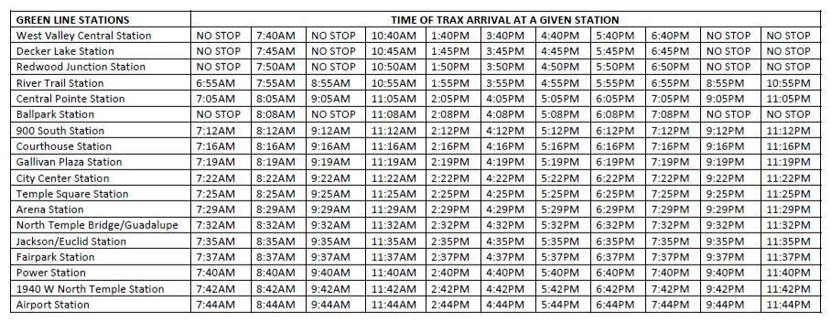
Week 1: Tuesday Participant ID# __________________

PASSWORD CREATION

Imagine that you want to open an online account for a purchase at FANTASTIC FLOWERS STORE and need to generate a username and password. The password for the account must be 7 characters long, contain exactly 2 numbers, at least 1 lower case letter, at least 2 uppercase letters, and at least one of the following special characters: ! ? $ %. The password must NOT begin with a letter. SAVE THE USERNAME AND PASSWORD in your records for later. Please DO NOT use one of your real passwords!

Please email us the username and password at neuropsychologylab@gmail.com during the time
indicated on today’s envelope.

Week 1: Wednesday Participant ID# __________________

CHECK EMAIL AND REPLY

Check your email for a message titled “STUDY INSTRUCTIONS”. Follow e-mail instructions.

Week 1: Thursday Participant ID# __________________

PLAN/PROBLEM SOLVE

Solve these math problems and call this phone number (801) 585 - 6058 by the time indicated on today’s envelope: Leave a message, providing your participant ID#, and the three answers:

- 26 x 47

- 10038 – 9879
- 12 x 17

Week 1: Friday Participant ID# __________________

SHOPPING/ERRANDS

Go to any grocery store and purchase EITHER 1 can of kidney beans and 1 cans of green peas and 1 can of tomato sauce, OR 2 cans of kidney beans and 1 can of garbanzo beans (chickpeas), OR 3 cans of garbanzo
beans (chickpeas). SAVE THE RECEIPT. Ensure the receipt has today’s date on it and is itemized. Call us at

(801) 585 - 6058 and leave a message during the time indicated on today’s envelope, explaining how or why you made the choice you made, and provide your participant ID#.

Week 1: Saturday Participant ID# __________________

FINANCES/BILLS

Fill out the attached reimbursement form for the canned goods purchased yesterday and follow instructions on the form. Using the enclosed envelope, mail the reimbursement form today. The envelope must be postmarked TODAY.
_________________________________________________________________________________________

Itemized Expense Reimbursement Form

Instructions: Make sure to mail this form along with the dated receipt. Please circle the date on the receipt, and the items for which you are seeking reimbursement.
Date | Description of Item | Cost

TOTAL [with tax] ______________

(Participant ID#) _______________________________________ Date ______________
Week 2: Monday Participant ID# __________________

PLAN/PROBLEM SOLVE

Imagine you receive the following notice in the mail:

“Your Local Water Company will be conducting repairs in your area, and all water service will be shut off to all households in the area for 24 hours starting at 8:30 am tomorrow. For your safety and comfort, please plan accordingly.”

You cannot stay in a hotel or at someone else’s house because you have an elderly dog who needs to be let out frequently and who becomes aggressive if moved to unfamiliar surroundings. Call us at (801) 585 - 6058 and leave a message during the time indicated on today’s envelope, providing us with 3 examples of how you’ll plan for the water service interruption. Also provide your participant ID#.

Week 2: Tuesday Participant ID# __________________

CHECK EMAIL AND REPLY

Check your email for a message titled “STUDY INSTRUCTIONS.” Follow e-mail instructions.

Week 2: Wednesday Participant ID# __________________

FIND INFORMATION ONLINE

Imagine your friend suggests that you join the Gym at the City Creek Center so you could go work out together every Monday and Thursday. You offer to look up the phone number and the times the gym is open on Mondays and Thursdays. Please call us (801) 585 - 6058 during the time indicated on today’s envelope. Leave a message, providing the phone number for the gym and the time the gym is open on Mondays and Thursdays. Also provide your participant ID#.

Week 2: Thursday Participant ID# __________________

PLAN/PROBLEM SOLVE

Solve these math problems and email us the answers at neuropsychologylab@gmail.com during the time indicated on today’s envelope. Leave a message, and the three answers to the following:

- 17 x 45
- 734 – 695
- 12 x 17
Week 2: Friday Participant ID# __________________

SHOPPING/ERRANDS

Imagine you have several errands to run this afternoon. You need to use a car, since they are too far to walk.
Study the enclosed map and select the most efficient route to travel. The places you need to go to include the Home Depot, the Butcher Shop, the Post Office, and a Grocery Store. While on the way, you also want to stop for gas and pick up a bite to eat at any local fast food restaurant. List the order in which you’ll do things to get everything done with as little driving as possible.

Please email us the answer at neuropsychologylab@gmail.com during the time indicated on today’s envelope.
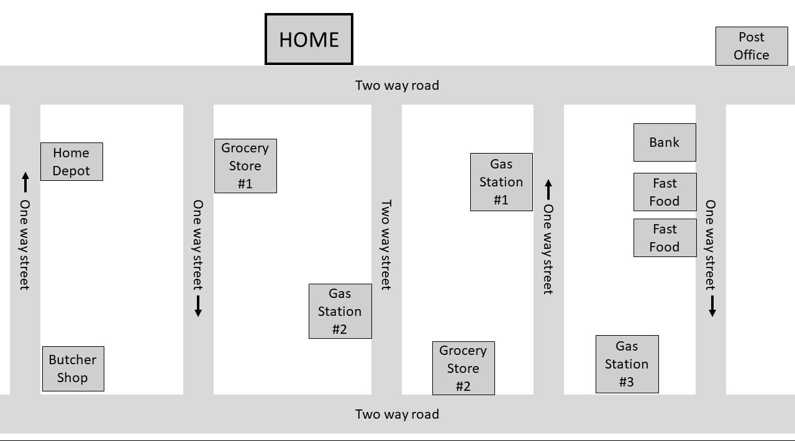

Week 2: Saturday Participant ID# __________________

FINANCES/BILLS

Imagine you were late paying your electricity and gas bills last month. By the time your payments arrived, the new bills were on their way, and reflected the old charges (which you already paid), the late fees, and the new charges. Fill out the enclosed payment slips and the check for the correct amount and mail them back to us, each in the correct envelope. The envelope must be postmarked TODAY.

______________________________________________________________________________________________________
 | CUSTOMER INFORMATION
Service Location |  |  | Customer Na | me: SMITH, JOHN
1000 S 2000 E, Salt Lake City, UT 84102 |  |  | ACC | T# 0044 - 669955
BILLING DATE |  |  | DUE DATE | AMOUNT DUE
01 / 31 / 2020 |  |  | 02 / 28 / 2020 | $ 243.62

January 2020 | 11,112 kWh …….. | $ 107.34
 | Late Fee ……....... | $ 31.00
February 2020 | 12,567 kWh ..….. | $ 106.28

PAY TO THE ORDER OF UTAH POWER COMPANY :
TOTAL:

PAYMENT AMOUNT : ____________________

(Participant ID#) ________________________________________________ Date _____________

Northern
Utah Gas Service Location: Account #: 8675309000
1000 S 2000 E Customer: SMITH, JOHN
Salt Lake City, UT 84102

PAST DUE CURRENT CHARGES
January 2019...……….................... $106.50 February 2019……………………...$100.50 Late Fee…………...……………..….$27.50

TOTAL PAYMENT DUE:.......... $234.50

PAY TO THE ORDER OF NORTHERN UTAH GAS / PAYMENT AMOUNT : ____________________

(Participant ID#) _________________________________________ Date _______________

Week 3: Monday Participant ID# _________________

CHECK EMAIL AND REPLY

Check your email for a message titled “STUDY INSTRUCTIONS.” Follow e-mail instructions.

Week 3: Tuesday Participant ID# __________________

PASSWORD CREATION

Over the last couple of weeks, we asked you to create a username and password for the
FANTASTIC FLOWERS STORE and the BIRTHDAY GIFTS STORE. Send us an email at neuropsychologylab@gmail.com during the time indicated on today’s envelope, providing the user name and password for each of the two imaginary stores.

Week 3: Wednesday Participant ID# __________________

FINANCES/BILLS

Imagine you just purchased some vitamins (see the enclosed receipt). Fill out the enclosed rebate forms, making sure you claim rebate for the correct items. Mail the rebate form to us in an envelope provided.
The envelope must be postmarked TODAY.

____________________________________________________________________________________
Natural Vitamin and Drug Co

Mail-in Rebate--VITAMINS ONLY

Please itemize the qualifying items in the table below. Mail this form along with your itemized receipt using the envelope provided.

Participant ID # _________________

Product Description | Dollar Amount

NATURAL VITAMIN and DRUG COMPANY
RECEIPT

Vitamin A | 15.99
Cotton swabs | 5.75
Vitamin D | 9.55
Multivitamin for men | 15.99
Band-aids | 4.99
Lozenges | 3.99
Ibuprofen Extra | 6.50
Multivitamin for women | 16.90

Week 3: Thursday Participant ID# __________________

PLAN/PROBLEM SOLVE

Imagine you received a $100.- gift card. You can use the card to purchase only Italian salami, and only once. In other words, once your purchase is complete, your gift card will be expired. If you order at least 4 salami packages, you will instantly receive a $10 discount that will be automatically applied to this order. What is the best combination of items to purchase so that you would get the most salami for your gift card? You can choose any combination of the following 3 items:
- Italian salami 10-ounce pack----$10.-
- Italian salami 30-ounce pack----$27.-

- Italian salami 50-ounce pack----$40.-

Fill out the enclosed order form and send it to us in the enclosed envelope. The envelope must be postmarked
TODAY.
Participant ID# __________________

Salumeria Italiana

- Utah’s finest delicatessen products -

Since 1894

ORDER FORM

SEND BY MAIL using the enclosed envelope.

ITEM

QUANTITY

PRICE

DISCOUNT (4 packages o
r more)

TOTAL DUE

Week 3: Friday Participant ID# __________________

SHOPPING/ERRANDS

Imagine you have several errands to run this afternoon. Study the enclosed map and select the most efficient route to travel. The places you need to go to include the Butcher Shop, the Bank, and a Grocery Store. However, the very first thing you need to do is to get some gas for your car, since you are almost running on empty. You also want to get some fast food to take home with you, so you want to do that last, so the food won’t get cold. List the order in which you’ll do things to get everything done with as little driving as possible. Call us with the answer using this number: (801) 585 - 6058. Leave a message, providing your name and the full list of the places you will go to. Make sure to call during the time indicated on today’s envelope and provide your participant ID#.

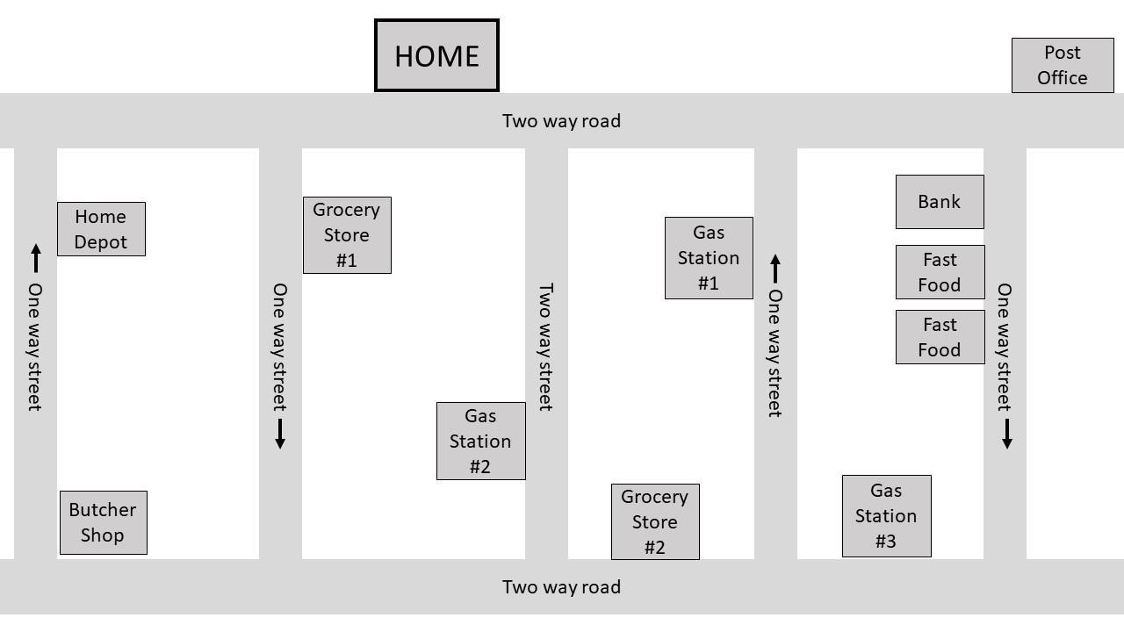

Week 3: Saturday Participant ID# __________________

PROBLEM SOLVE

Solve these math problems and email us at neuropsychologylab@gmail.com the answers during the
time indicated on today’s envelope. Leave a message, and the three answers:

- 9 x 45

- 937 – 395
- 283 x 457

Appendix 2

