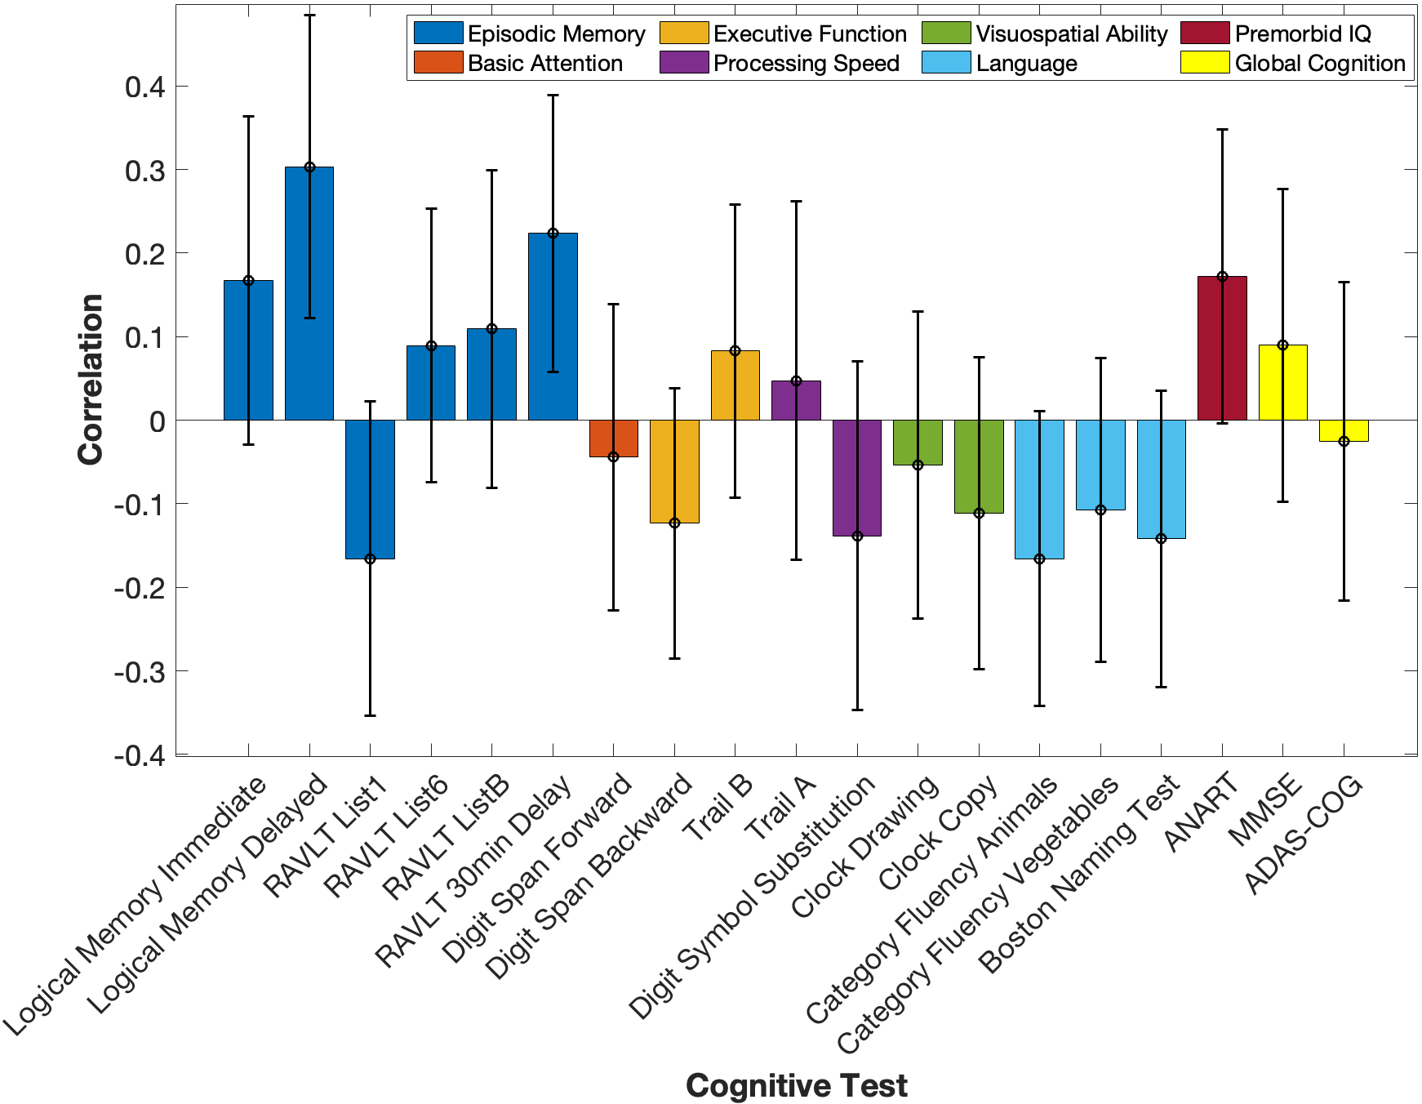
+
+
+
+
+Higher Score = Poorer Performance
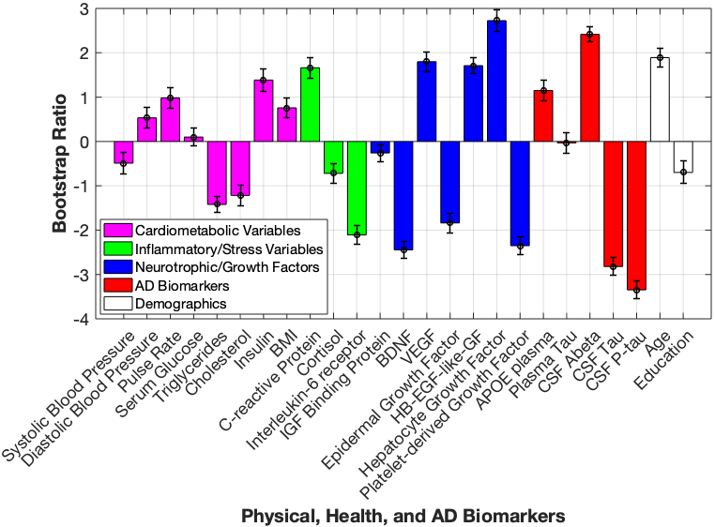
*Bootstrap Ratio is Significant
*
*
*
*
*
*
*
Supplemental Figure 1. Correlation profile and bootstrap ratios for Latent Variable 2. A. The correlation between each cognitive test variable to the identified physical, health, and AD variables listed in panel B. Significant variables have 95% confidence intervals (error bars) that do not cross the x-axis (0). B. Each Physical, Health, and AD Variable’s contribution to LV2 represented by their bootstrap ratios, indicating directionality with significant cognitive tests represented in A (for instance, performance on logical memory delayed was positively correlated with CSF Aß₁₋₄₂, and had a negative correlation with CSF tau). Error bars represent 95% confidence intervals. Variables with bootstrap ratios > |1.96| (equivalent to a p-value of < 0.05) are considered significant contributors to the LV and are indicated by *. (KEY PANEL A: ADAS-COG = Alzheimer’s Disease Assessment Scale, Cognitive Subsection; ANART = American National Adult Reading Test; MMSE = Mini Mental State Examination; RAVLT = Rey Auditory Verbal Learning Test; KEY PANEL B: APOE = apolipoprotein E; BDNF = brain-derived neurotrophic factor; BMI = body mass index; CSF = cerebrospinal fluid; HB-EGF-like-GF = heparin-binding epidermal growth factor-like growth factor; IGF = insulin-like growth factor; P-tau = phospho-tau 181; VEGF = vascular endothelial growth factor).

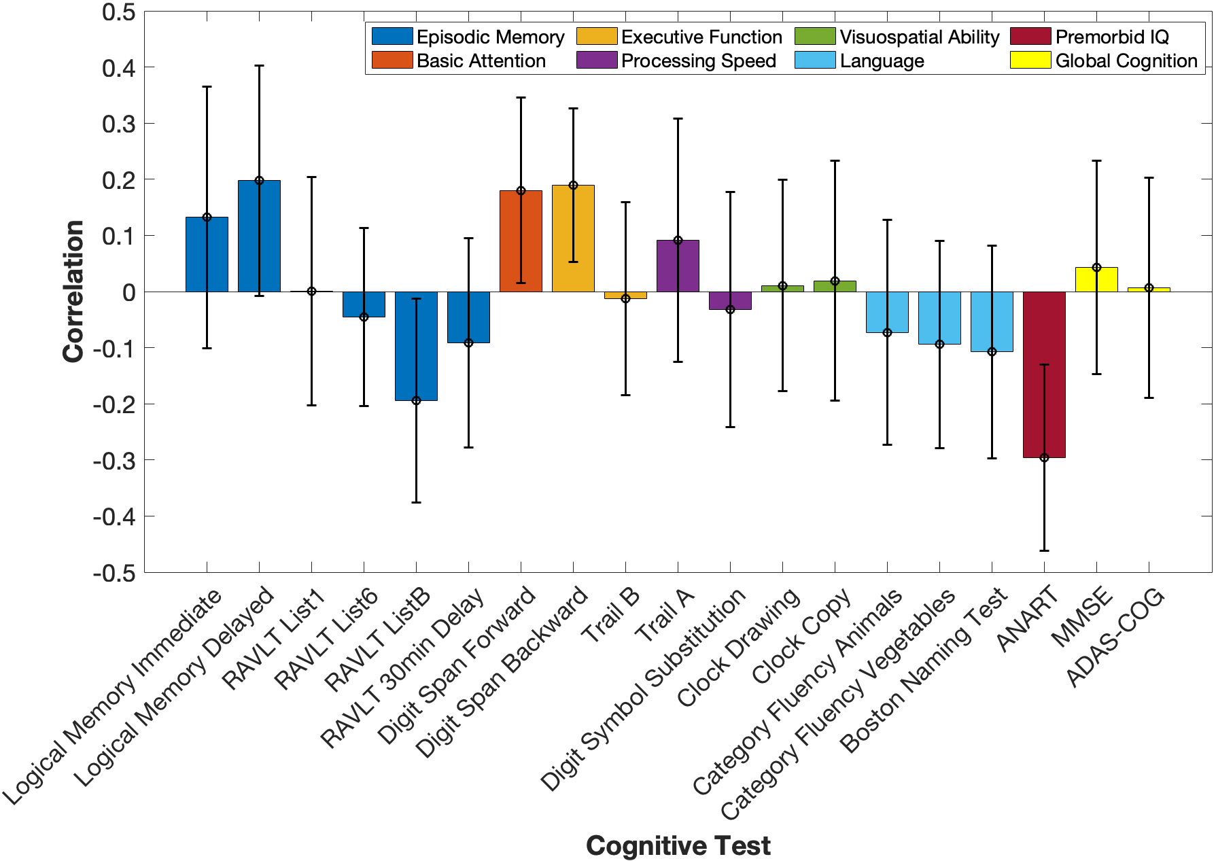
+
+
+
+
+Higher Score = Poorer Performance
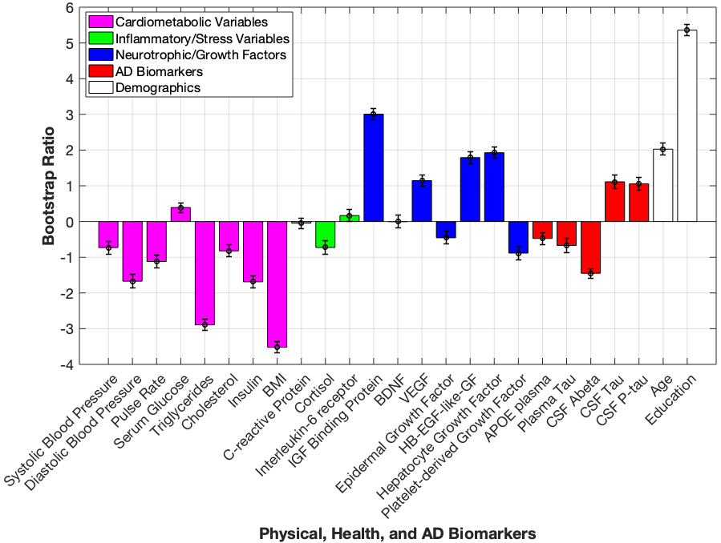
*
*
*
*
*
*Bootstrap Ratio is Significant
Supplemental Figure 2. Correlation profile and bootstrap ratios for Latent Variable 3. A. The correlation between each cognitive test variable to the identified physical, health, and AD variables listed in panel B. Significant variables have 95% confidence intervals (error bars) that do not cross the x-axis (0). B. Each Physical, Health, and AD Variable’s contribution to LV3 represented by their bootstrap ratios, indicating directionality with significant cognitive tests represented in A (for instance, performance on digit span backward was positively correlated with education, and had a negative correlation with BMI). Error bars represent 95% confidence intervals. Variables with bootstrap ratios > |1.96| (equivalent to a p-value of < 0.05) are considered significant contributors to the LV and are indicated by *. (KEY PANEL A: ADAS-COG = Alzheimer’s disease Assessment Scale, Cognitive Subsection; ANART = American National Adult Reading Test; MMSE = Mini Mental State Examination; RAVLT = Rey Auditory Verbal Learning Test; KEY PANEL B: APOE = apolipoprotein E; BDNF = brain-derived neurotrophic factor; BMI = body mass index; CSF = cerebrospinal fluid; HB-EGF-like-GF = heparin-binding epidermal growth factor-like growth factor; IGF = insulin-like growth factor; P-tau = phospho-tau 181; VEGF = vascular endothelial growth factor).

